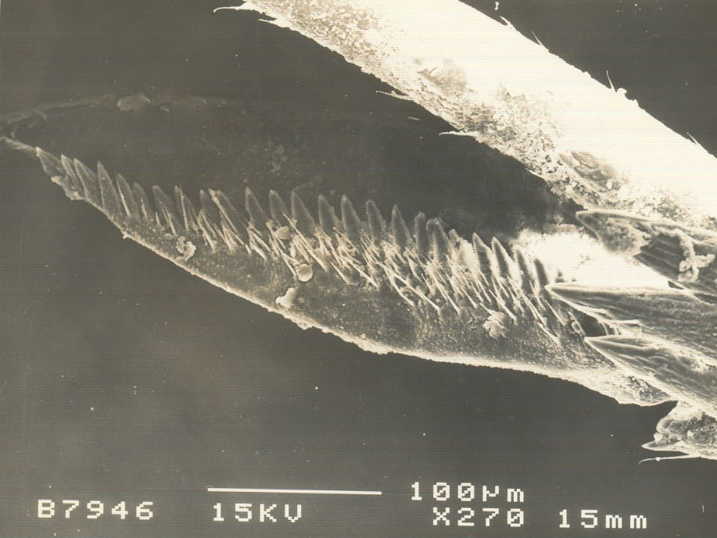
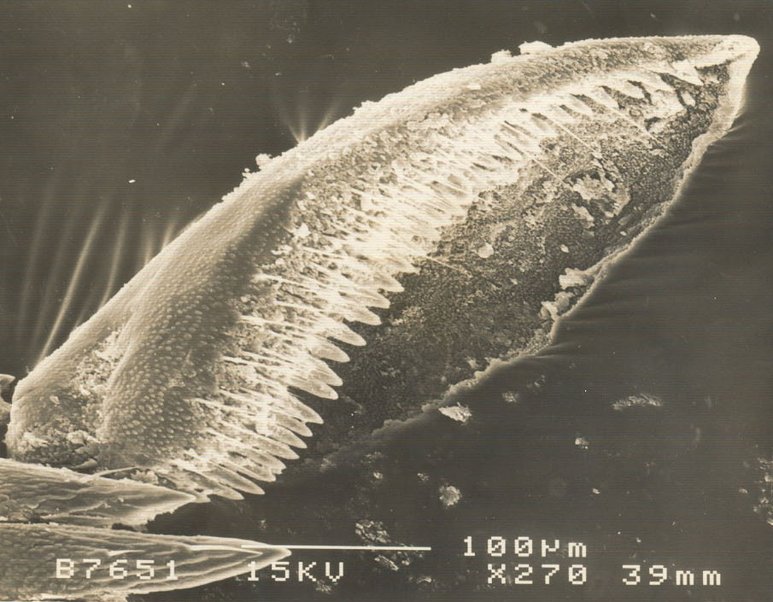
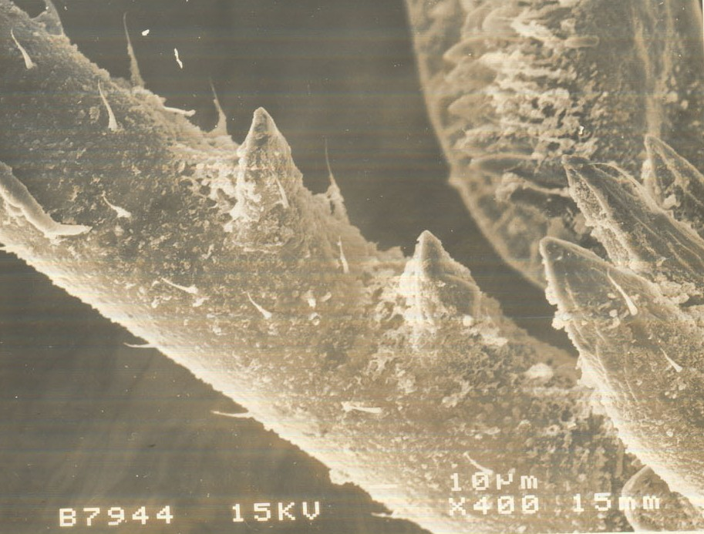
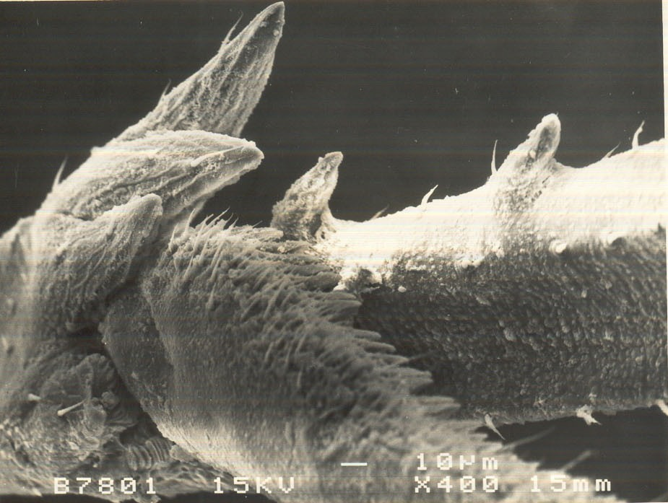
i (A) i (B)
s
s
p
p

ii (C) ii (D)

Fig. 1S. Scanning electron micrograph showing i) spine with tibial spur (s) of N. lugens (A) rice infesting population; (B) Leersia infesting population; ii) spine (p) of basal segments of hind tersus of N. lugens (C) rice infesting population; (D) Leersia infesting population

i (A) i (B)
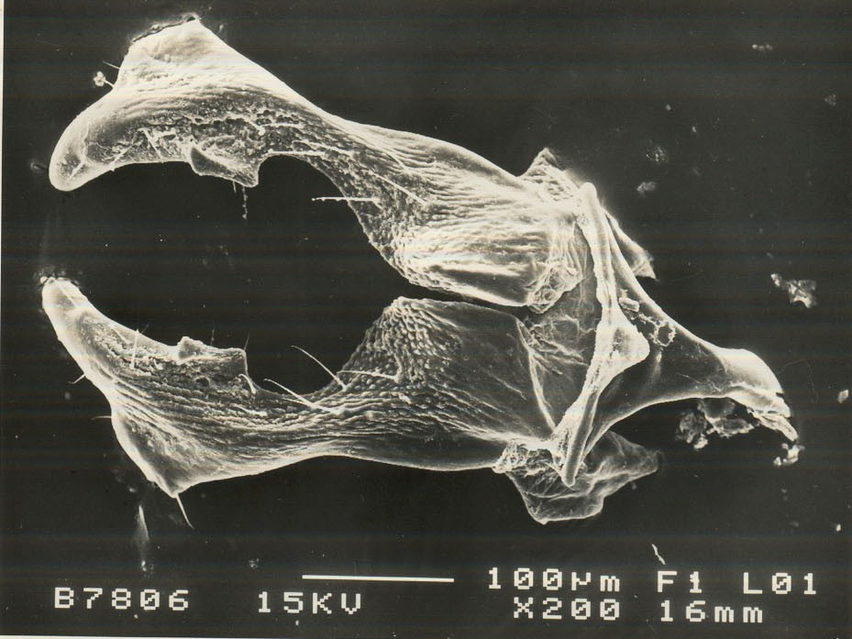
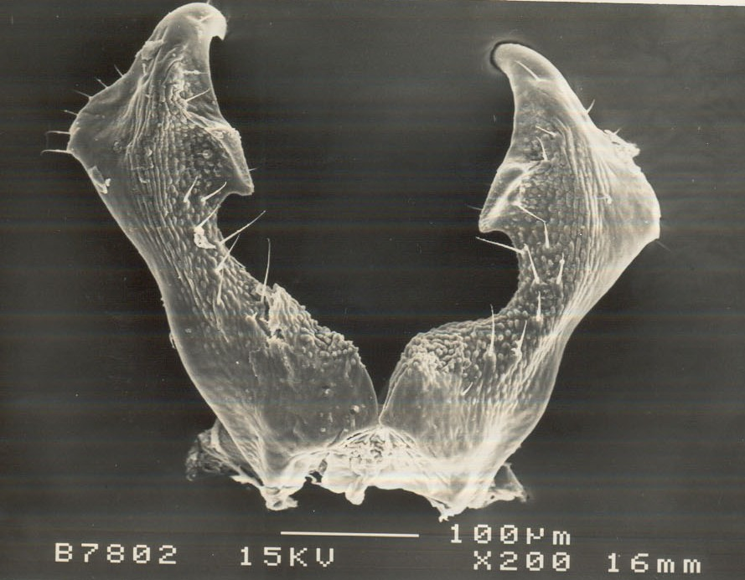

ii (C) ii (D)
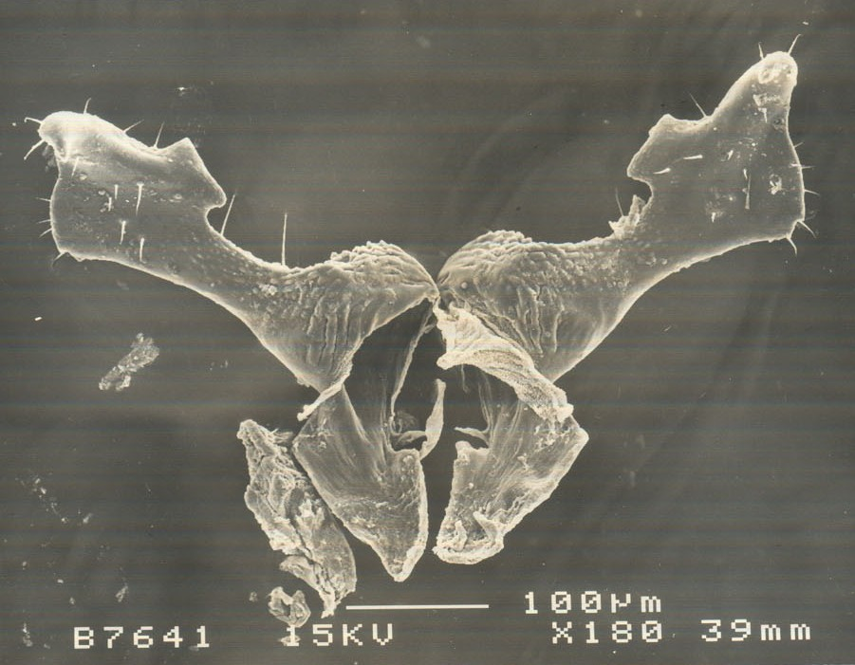
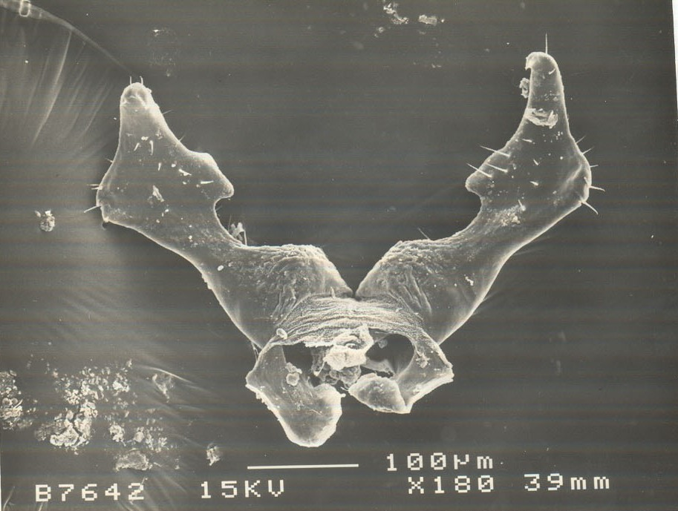

Fig. 2S. Scanning electron micrograph showing i) dorsal view of parameres of N. lugens (A) rice infesting population; (B) Leersia infesting population ii) ventral view of parameres of N. lugens (C) rice infesting population; (D) Leersia infesting population;

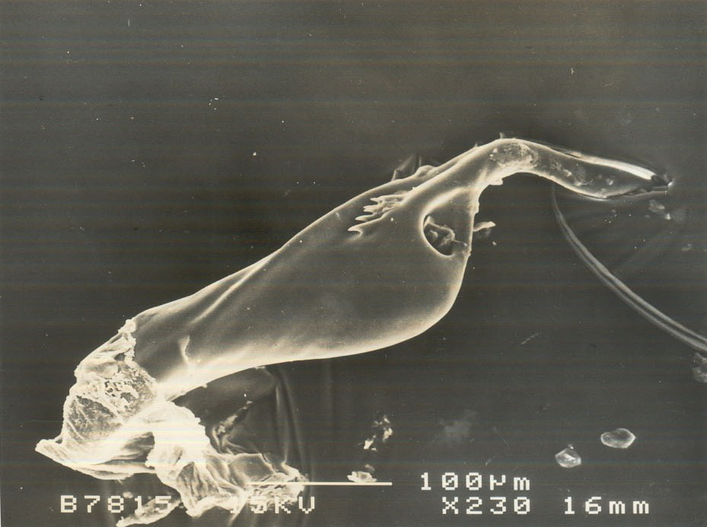
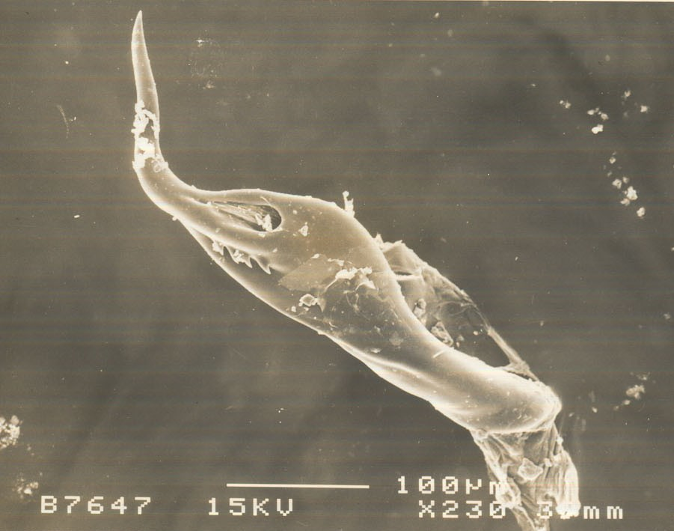
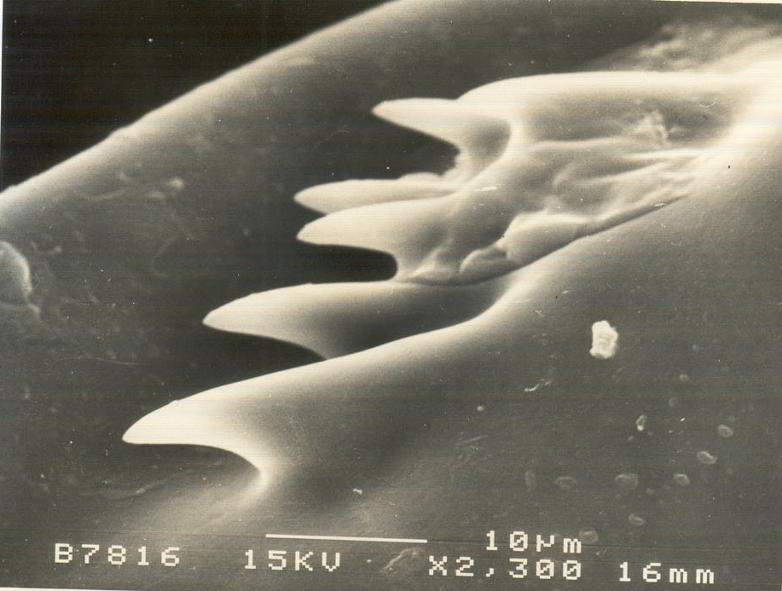
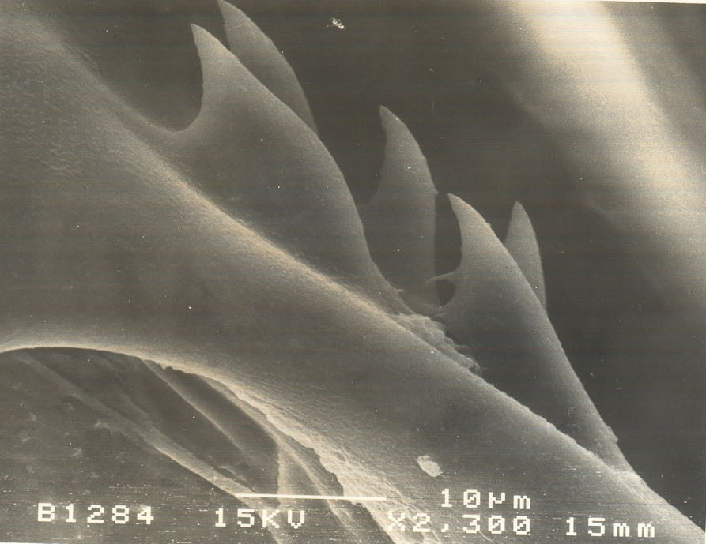
i (A) i (B)
a
a

ii (C) ii (D)

Fig. 3S. Scanning electron micrograph showing i) aedeagus of N. lugens (A) rice infesting population; (B) Leersia infesting population; ii) aedeagal spine (a) of N. lugens (C) rice infesting population; (D) Leersia infesting population

(A)
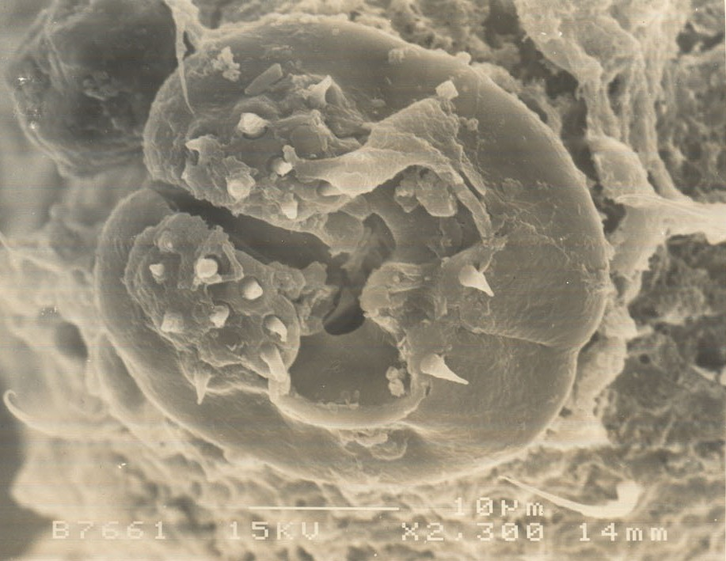
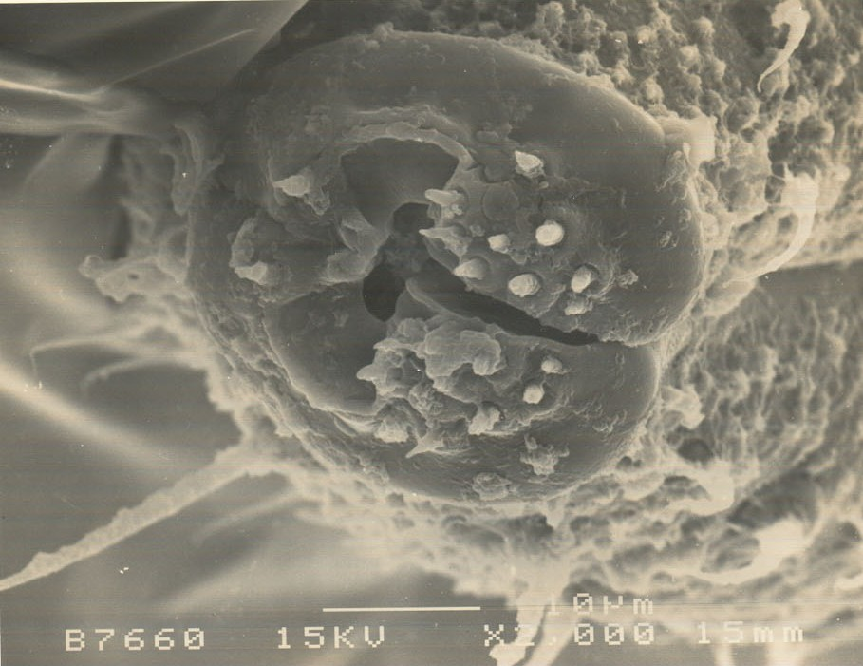
g
l
s
g
l
s
s
s

s

(B)

Fig. 4S. Scanning electron micrograph showing labial tip (l) with symmetrical sensory fields with sensilla (s) on either side of the stylet groove (g) of N. lugens (A) rice infesting population; (B) Leersia infesting population

