Supplemetary material :
Alignment of known sequences having similarity with LlaDRT protein sequences deduced using Clustal W software
AtPlastocyanin MASVTS-ATVAIPSFTGLKASTIKS---SATVRIQTAAVASPKLTVKSSL-KNFGVAAVA 55
AtDRT112 MASVTS-TTVPIPSFTGLKASTTKS---SATVRTQTAAVASPKLTVKSSL-KNFGVAAVA 55
AlDRT112 MASVTS-ATVAIPSFTGLKASTIKS---SATVRIQTAAVASPKLTVKSSL-KNFGVAAVA 55
LlaDRT MASVTS-AAVAIPSFTGLKAASIKS---SATVRIQTAAVASPKLTVKSSL-KDFGVVAVA 55
RcPlastocyanin MATVTS-AAVAIPSFTGLKAASAASTKVN--ASAKVAAPSLPRMSIKASM-KEVGVAVMA 56
PtPlastocyanin MATVTS-AAVSIPSFTGLKAGSASNAKVS--ASAKVSASPLPRLSIKASM-KDVGAAVVA 56
Stplastocyanin MATVTS-AAVAIPSFTGLKAGASSSSRVSTAASAKVAAAPAARLTVKASL-KDVGAVVAA 58
ScPlastocyanin MATVTS-AAVAIPSFTGLKAGASSSSRVSTAASAKVAAAPAARLTVKASL-KDVGAVVAA 58
NbPlastocyanin MATVTS-AAVAIPSFTGLKAGACSTSRVSTTAKV-AASTPATKLAVKASL-KDVGAVVVA 57
CsPlastocyanin MAAVTS-AAVAIPSFTGLKSTSSS----KPTSLIRLPSPASPKLCIKASL-KDVGVAVAA 54
PmPlastocyanine MATVTS-ASIKIQLSPLLKTTS------RLTTATFKP---TPKFAIKASL-KDFGVAVAA 49
PsPlastocyanin MATVTS-TTVAIPSFSGLKTNAAT--KVSAMAKIPTSTSQSPRLCVRASL-KDFGVALVA 56
MtPlastocyanin MATVTS-TTVAIPSFTGLKANAS---KVSAIAKVPTSNSQLPRLCVRASL-KDFGVAVVA 55
LjUnknown MATVTS-TAVAIPSFTGLKSAGS---KVSASAKVSSSPSQMPRLSVKASL-KDFGVAVVA 55
SlPlastocyanin MATVTSSAAVAIPSFAGLKASS------TTRAATVKVAVATPRMSIKASL-KDVGVVVAA 53
HvPlatocyanin MAALSS-AAVSVPSFA--------------AATPMRSSRSSR-MVVRASLGKKAASAAVA 44
OsPlastocyanin MAALSS-AAVTIPSMA--------------PSAPGRRRMSIS-LVVRASLGKAAGAAAVA 44
ZmPlastocyanin MASLSS-AAVTAPSFA--------------APAPARAVVRRRSFTVRASLRKATGTAAVA 45
**:::* ::: . : :::*: * . . *

AtPlastocyanin AAASIALAGN-AMAIEVLLGGGDGSLAFIPNDFSIAKGEKIVFKNNAGYPHNVVFDEDEI 114
AtDRT112 PAASIALAGN-AMAIEVLLGGGDGSLAFIPNDFSIAKGEKIVFKNNAGYPHNVVFDEDEI 114
AlDRT112 AVASISLAGN-AMAIEVLLGGGDGALAFIPNDFSVAKGEKIVFKNNAGFPHNVVFDEDEI 114
LlaDRT AAASIALAGN-AMAMEVLLGSGDGALAFVPNDFTVAKGETKELKNNAGFPHNVVFDEDEI 114
RcPlastocyanin TAASAMLASN-AMAIEILLGSDDGGLAFVPNSFSVAPGEKIVFKNNAGFPHNIVFDEDEV 115
PtPlastocyanin TAASAMIASN-AMAIDVLLGADDGSLAFVPSEFSISPGEKIVFKNNAGFPHNIVFDEDSI 115
Stplastocyanin TAVSAMLASN-AMALDVLLGGDDGSLAFIPGNFSVSAGEKITFKNNAGSPHNVVFDEDEI 117
ScPlastocyanin TAVSAMLASN-AMALDVLLGGDDGSLAFIPGNFSVSAGEKITFKNNAGFPHNIVFDEDEI 117
NbPlastocyanin TAASAMLASN-AMAIEVLLGSDDGGLAFVPGNFSVSSGEKITFKNNAGFPHNVVFDEDEI 116
CsPlastocyanin TAASALLASN-AMAIEILLGGDDGSLAFVPNNFTVASGEKITFKNNAGFPHNVVFDEDEI 113
PmPlastocyanine TAASALIASN-AMAIDVLLGGDDGSLAFIPGNFEVAAGEKITFKNNAGFPHNVVFDEDEC 108
PsPlastocyanin TAASAVLASN-ALAVEVLLGASDGGLAFVPSSLEVSAGETIVFKNNAGFPHNVVFDEDEI 115
MtPlastocyanin TAASALLASN-ALAVEVLLGASDGGLAFVPNNFTVNAGDTITFKNNAGFPHNVIFDEDEI 114
LjUnknown TAASAVLASN-AMAIEILLGSDDGGLAFVPNSFSVAPGEKITFKNNAGFPHNVVFDEDEV 114
SlPlastocyanin TAAAGILAGN-AMAAEVLLGSSDGGLAFVPSDLSIASGEKITFKNNAGFPHNVVFDEDEV 112
HvPlatocyanin MAAGAMLLGGSAMAQDVLLGANGGVLVFEPNDFSVKAGETITFKNNAGYPHNVVFDEDAV 104
OsPlastocyanin VAASAMLAGG-AMAQEVLLGANGGVLVFEPNDFTVKSGETITFKNNAGFPHNVVFDKDAV 103
ZmPlastocyanin MAASALLAGG-AMAQEVLLGAGDGGLVFEPSQFTVKAGDTITFKNNAGFPHNVVFDEDEV 104
... : .. *:* ::***...* *.* *..: : *:. :***** ***::**:*

AtPlastocyanin PSGVDVAKISMDEQDLLNGAGETYEVALTEPGTYSFYCAPHQGAGMVGK-VTVN 167
AtDRT112 PSGVDVAKISMDEQDLLNGAGETYEVALTEPGTYSFYCAPHQGAGMVGK-VTVN 167
AlDRT112 PSGVDVAKISMDEQDLLNAAGETYEVALTEPGTYSFYCAPHQGAGMVGK-VTVN 167
LlaDRT PSGVDASKISMDEQDTRNDPGEKYEVALTEPGTYSFYCAPHQGAGMVGK-VTVN 167
RcPlastocyanin PSGVDAGKISMSEEDLLNGPGETYAVTLTEKGTYSFYCAPHQGAGMVGK-VTVN 168
PtPlastocyanin PSGVDASKISMSEEDLLNAKGETFEVALSNKGEYSFYCSPHQGAGMVGK-VTVN 168
Stplastocyanin PAGVDASKISMAEEDLLNAAGETYSVTLSEKGTYTFYCAPHQGAGMVGK-VTVN 170
ScPlastocyanin PAGVDASKISMAEEDLLNAPGETYSVTLSEKGTYTFYCAPHQGAGWLAKLLTVN 171
NbPlastocyanin PAGVDVSKISMPEEEYLNGPGETYSVTLNEKGTYSFYCAPHQGAGMVGK-VTVN 169
CsPlastocyanin PSGVDVGKISMDEENLLNAPGEVYEVQLTEKGSYSFYCSPHQGAGMVGK-VTVN 166
PmPlastocyanine PSGVNTGAISMSEEDYLNAKDEVYSVTLTEKGTYTFYCAPHQGAGMVGK-VTV- 160
PsPlastocyanin PAGVDASKISMPEEDLLNAPGETYSVKLDAKGTYKFYCSPHQGAGMVGQ-VTVN 168
MtPlastocyanin PSGVDAAKISMPEEDLLNAPGETYSVTLDAKGTYKFYCSPHAGAGMVGQ-VTVN 167
LjUnknown PGGVDASKISMSDEDLLNAPGETYSVTLDAKGTYKFYCSPHQGAGMVGS-VTVN 167
SlPlastocyanin PAGVDVTKISMPEEDLLNAPGEEYSVTLTEKGTYKFYCAPHAGAGMVGK-VTVN 165
HvPlatocyanin PSGVDVSKISQ--EEYLNAPGETFSVTLTVPGTYGFYCEPHAGAGMVGK-VTVN 155
OsPlastocyanin PSGVNLSKISQ--EEYLNAPGETFSVTLTVPGTYGFYCEPHAGAGMVGK-VTVN 154
ZmPlastocyanin PSGVDATKISQ--EEYLNAPGETYSVTLTVPGTYGFYCEPHQGAGMVGK-ITVN 155
*.**: ** :: * .* : * * * * *** ** *** :.. :**

Figure: Showing motif identification by MAST
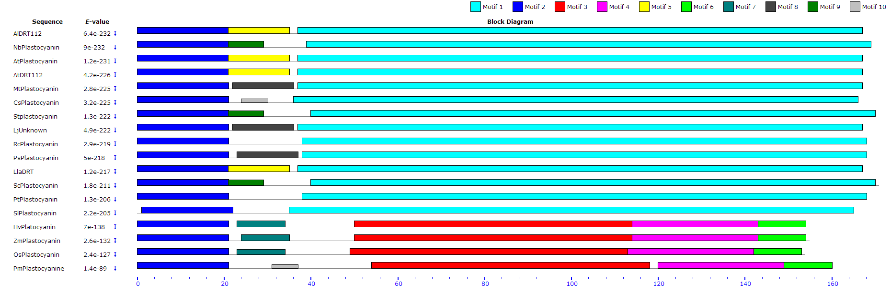

Figure :Predicted functinal partners of DRT (PETE2) gene

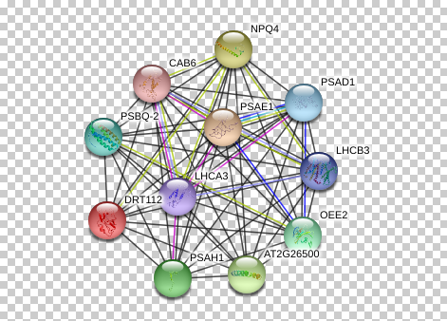
Source: http://string90.embl.de/newstring_cgi/show_network_section.pl?identifier=3702.AT1G20340.1-P&all_channels_on=1

