Genetic analysis of two spawning stocks of the short-finned squid (Illex argentinus) using nuclear and mitochondrial data.

María Inés Roldán *, Laia Planella, Sandra Heras, María Victoria Fernández

Appendix 1.
Table S1. Variable nucleotide positions defining 7 haplotypes in the 556 bp of COI region with respective GenBank accession numbers. Identical nucleotide is indicated with a dot (·).
COI haplotype | Variable nucleotide position |  |  |  |  |  | Accession number
 | 136 | 195 | 225 | 330 | 348 | 402
Iah1 | C | A | T | A | C | G | KC594174
Iah2 | T | · | · | · | · | · | KC594175
Iah3 | · | · | · | G | T | · | KC594176
Iah4 | · | · | · | G | · | · | KC594177
Iah5 | · | · | C | · | · | A | KC594178
Iah6 | · | · | · | · | · | A | KC594179
Iah7 | · | G | · | · | · | · | KC594180

Table S2. Variable nucleotide positions defining 7 haplotypes in the 439 bp of 16S rDNA region with respective GenBank accession numbers. Identical nucleotide is indicated with a dot (·) and absence of nucleotide is indicated with a dash (−).
16S rDNA haplotype | Variable nucleotide position |  |  |  |  |  |  |  |  | Accession number
 | 7 | 68 | 108 | 202 | 203 | 204 | 268 | 303 | 304
Iah1 | − | − | C | − | − | − | T | − | − | KC594167
Iah2 | T | − | · | − | − | − | · | − | − | KC594168
Iah3 | − | − | · | − | − | − | · | T | A | KC594169
Iah4 | T | G | · | − | − | − | · | − | − | KC594170
Iah5 | − | − | T | − | − | − | · | − | − | KC594171
Iah6 | − | − | · | T | T | A | · | − | − | KC594172
Iah7 | − | − | · | − | − | − | C | − | − | KC594173

Figure S1. Median-joining network of COI haplotypes (556 bp) detected for Illex argentinus. The area of each circle is proportional to the number of individuals exhibiting that haplotype. Each line in the network represents one mutational step. Summer Spawning Stock (SSS), South Patagonic Stock (SPS).

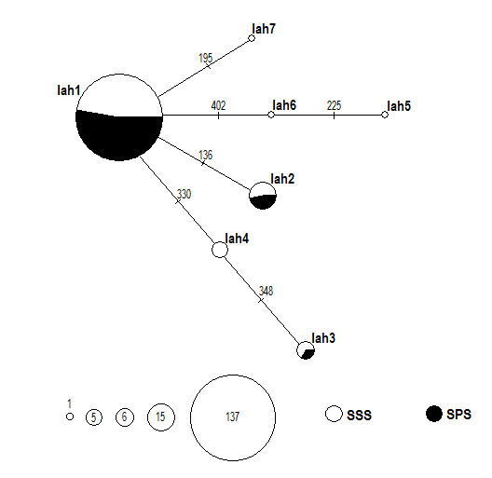

Figure S2. Median-joining network of 16S rDNA haplotypes (439 bp) detected for Illex argentinus. The area of each circle is proportional to the number of individuals exhibiting that haplotype. Each line in the network represents one mutational step. Summer Spawning Stock (SSS), South Patagonic Stock (SPS).

