**Appendices**

**Appendix 1. Neighbour-joining tree reconstructed from *Cytb* sequences.**

Genomes sequenced for this study are indicated in green. Sequences from GenBank highlighted in red are suspected to have been misidentified. The percentages written in red represent nucleotide distances. Values on the branches are bootstrap percentages more than 90%.

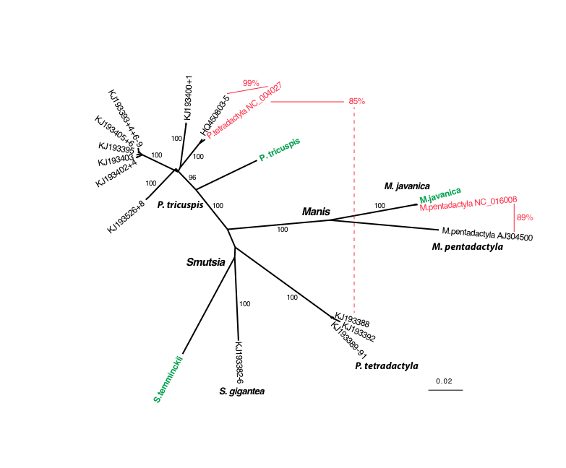 **Appendix 2. Neighbour-joining tree reconstructed from *12S* sequences.**

Genomes sequenced for this study are indicated in green. Sequences from GenBank highlighted in red are suspected to have been misidentified. The percentages written in red represent nucleotide distances. Values on the branches are bootstrap percentages more than 90%.

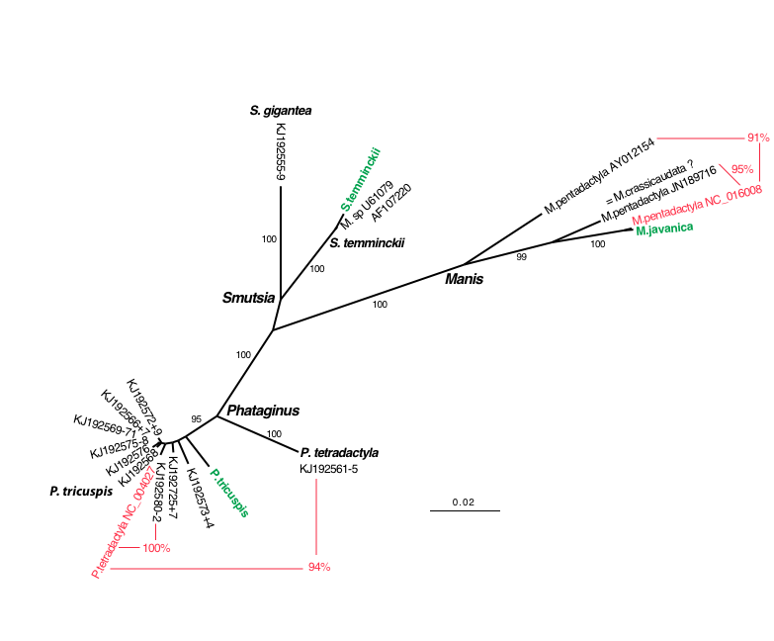**Appendix 3. Neighbour-joining tree reconstructed from *16S* sequences.** Genomes sequenced for this study are indicated in green. Sequences from GenBank highlighted in red are suspected to have been misidentified. The percentages written in red represent nucleotide distances. Values on the branches are bootstrap percentages more than 90%.

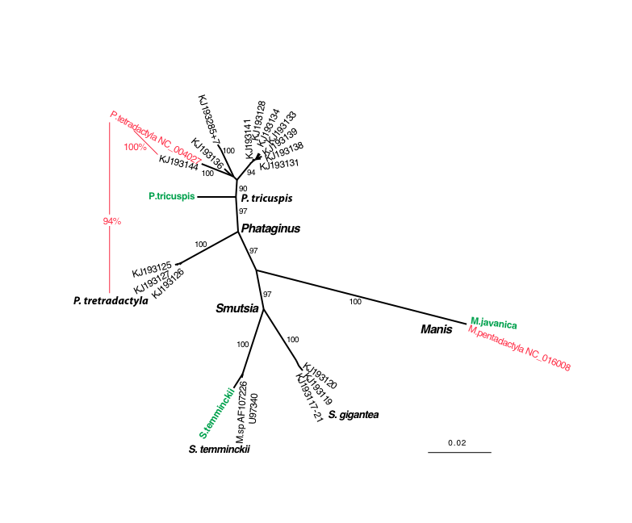

**Appendix 4. Neighbour-joining tree reconstructed from sequences of the control region.**

Genomes sequenced for this study are indicated in green. Sequences from GenBank highlighted in red are suspected to have been misidentified. The percentages written in red represent nucleotide distances. Values on the branches are bootstrap percentages more than 90%.

