Supplementary material 1

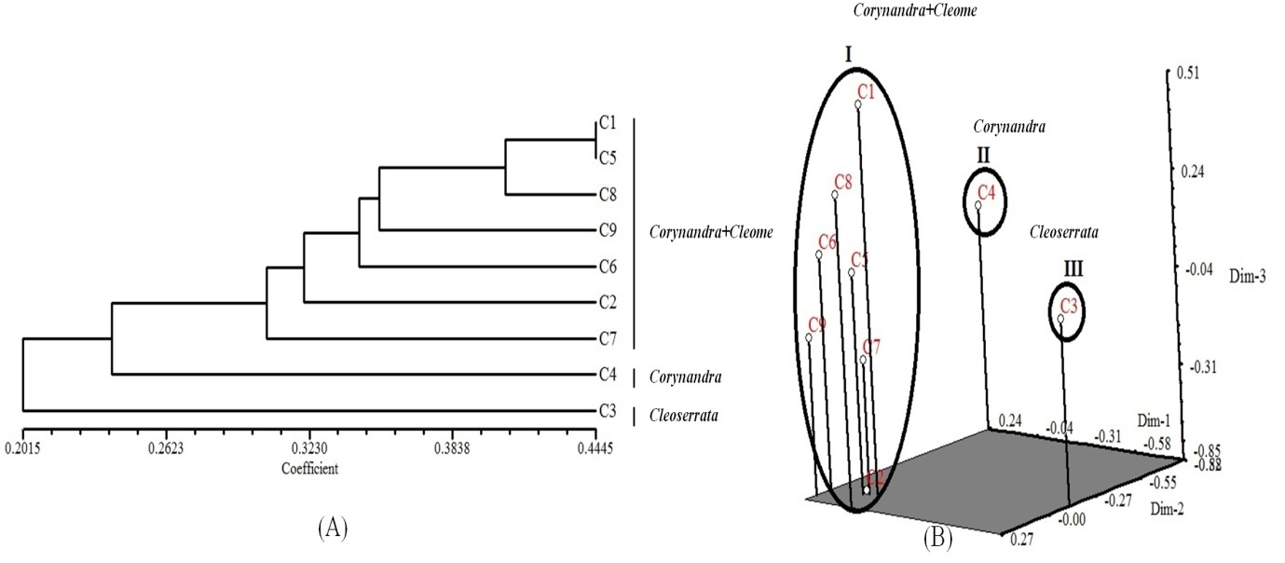
Fig. S1-(A) - UPGMA dendrogram of 9 species based on selected RAPD markers. (B) PCA
analysis of 9 species based on selected RAPD marker data. C1- Corynandra viscosa, C2- Cleome monophylla, C3- Cleoserrata speciosa, C4- Corynandra chelidonii, C5- Cleome simplicifolia, C6- Cleome gynandra, C7- Cleome rutidosperma, C8- Cleome aspera, C9- Corynandra felina

Supplementary material 2

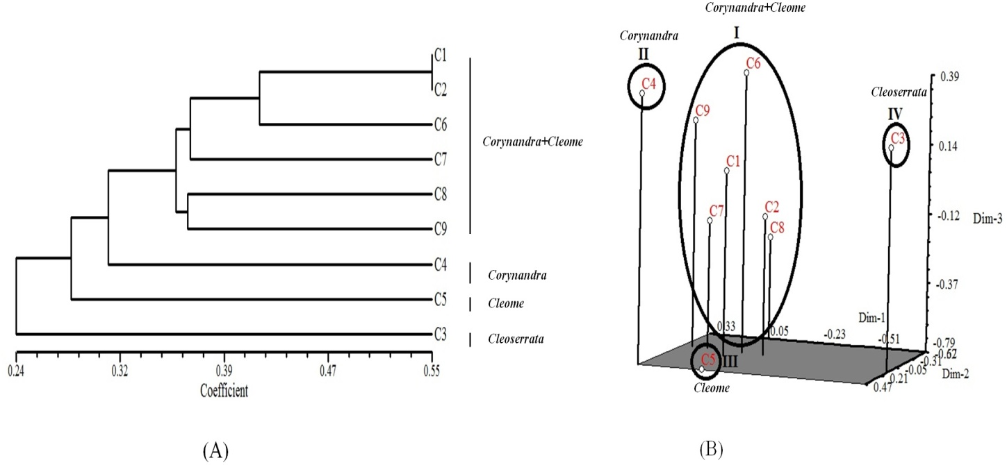
Fig. S2-(A) - UPGMA dendrogram of 9 species based on selected ISSR markers. (B) PCA
analysis of 9 species based on selected ISSR marker data. C1- Corynandra viscosa, C2- Cleome monophylla, C3- Cleoserrata speciosa, C4- Corynandra chelidonii, C5-Cleome simplicifolia, C6- Cleome gynandra, C7- Cleome rutidosperma, C8- Cleome aspera, C9- Corynandra felina

Supplementary material 3
RAPD and ISSR profiles
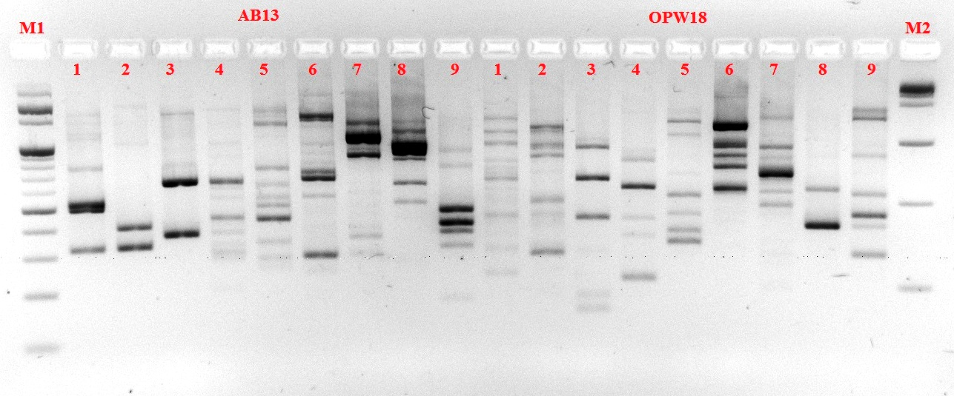
RAPD profile generated by AB 13 and OPW 18 primer. M1-100bp ladder,1-Corynandra viscosa,2-Cleome monophylla,3-Cleoserrata speciosa, 4-Corynandra chillidoni, 5-Cleome simplicifolia, 6-Cleome gynandra, 7-Cleome rutidosperma, 8-Cleome aspera, 9-Corynandra felina, M2-1Kb ladder
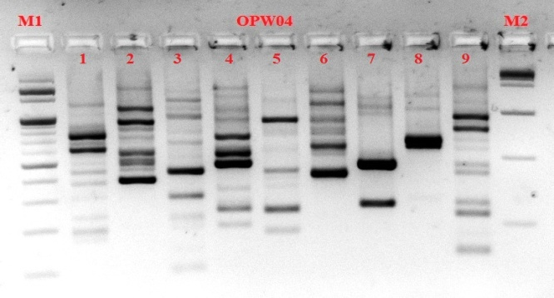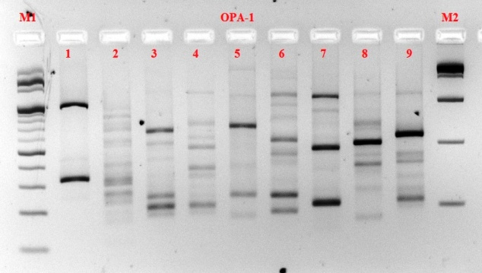
RAPD profile generated by OPW 04 and OPA-1 primer
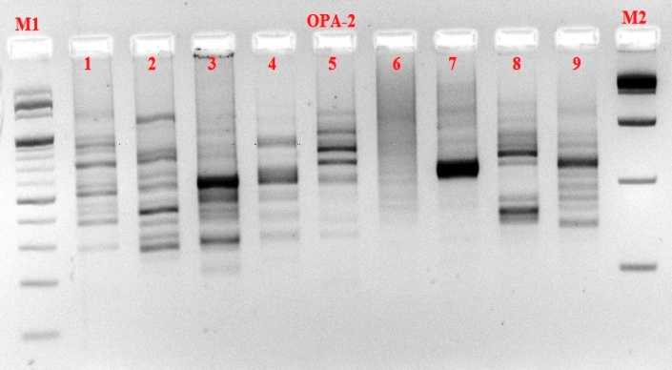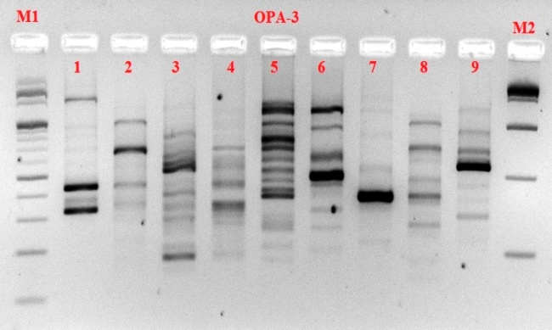
RAPD profile generated by OPA-2and OPA-3 primer

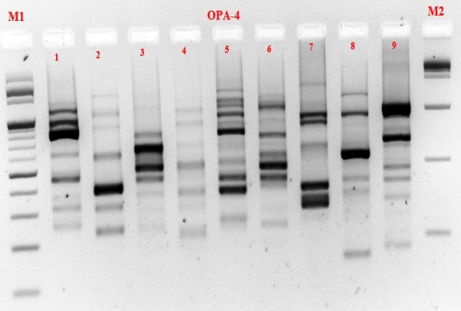
RAPD profile generated by OPA-4 and OPA-5 primer
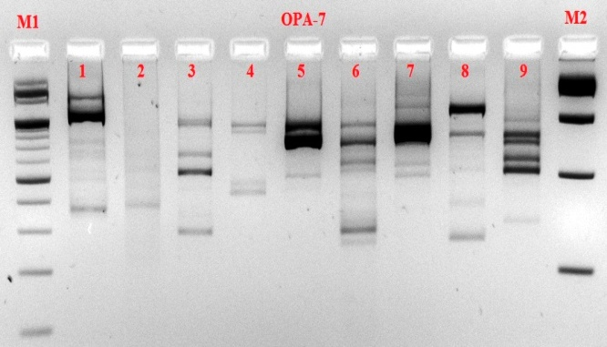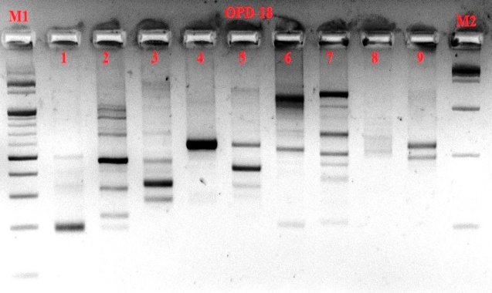
RAPD profile generated by OPA-7and OPD-18 primer
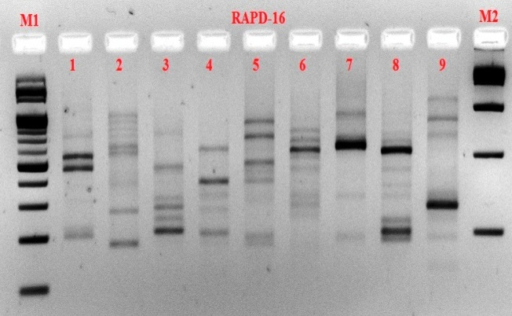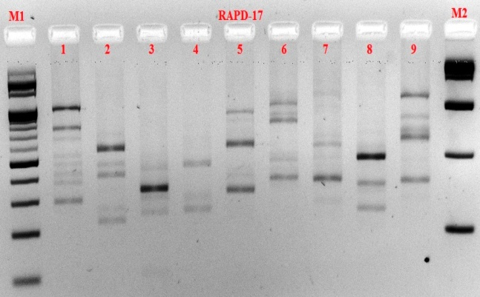
RAPD profile generated by RAPD-16 and RAPD-17 primer
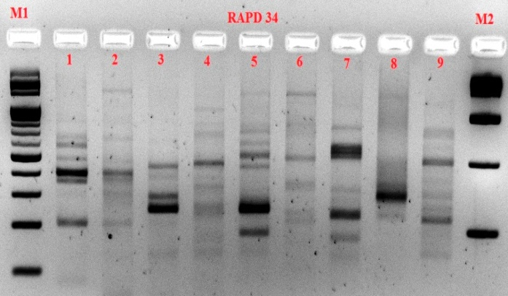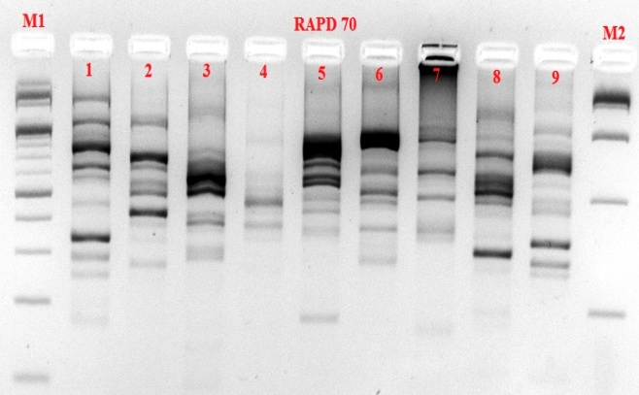
RAPD profile generated by RAPD-16 and RAPD-17 primer

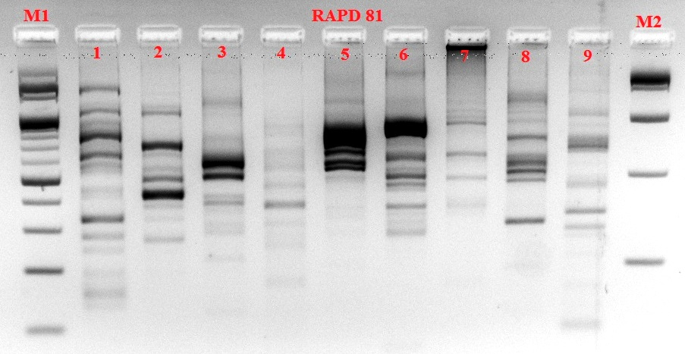
RAPD profile generated by RAPD-81 primer
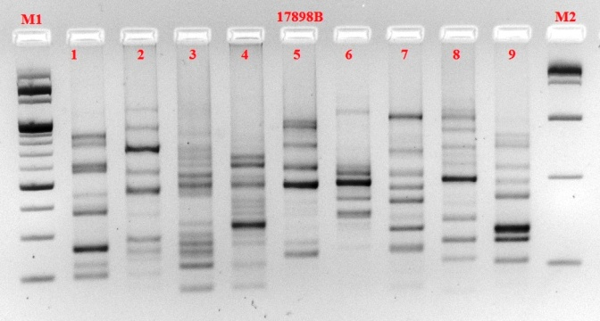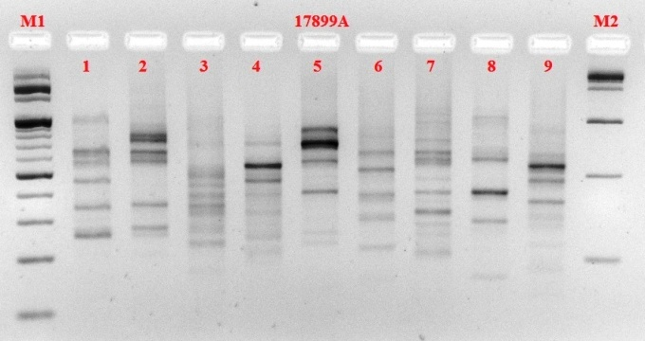
ISSR profile generated by 17898B and 17899A primer
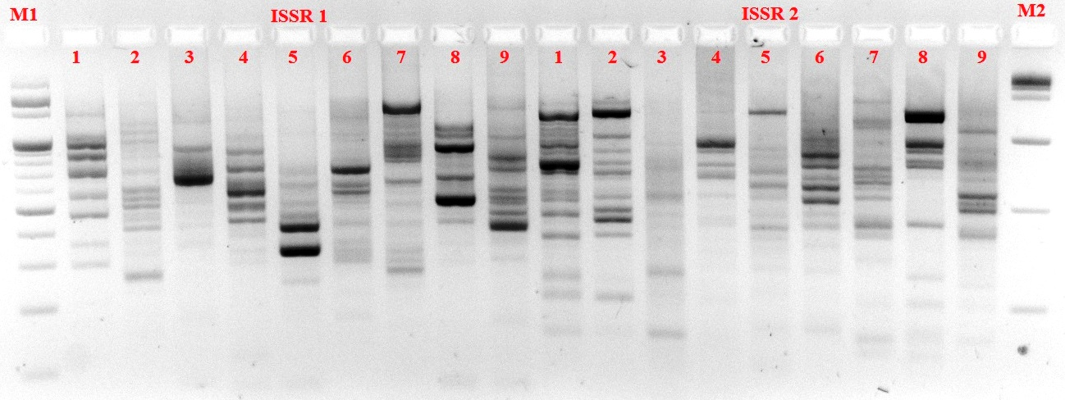
ISSR profile generated by ISSR 1 and ISSR 2 primer
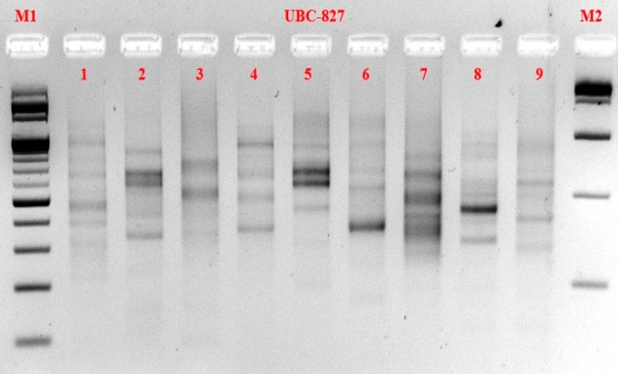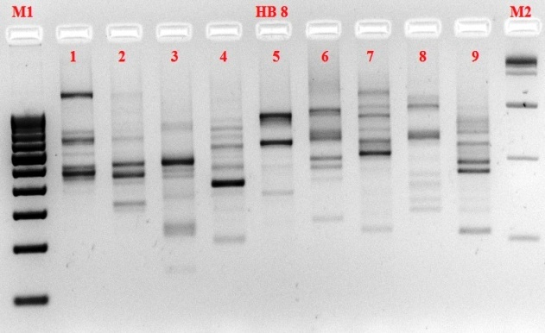
ISSR profile generated by UBC-827 and HB 8 primer
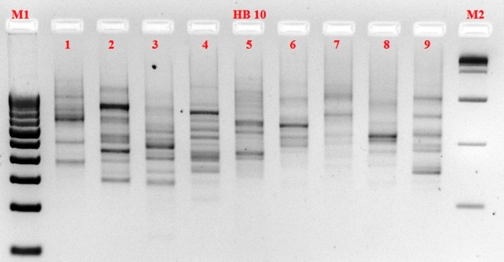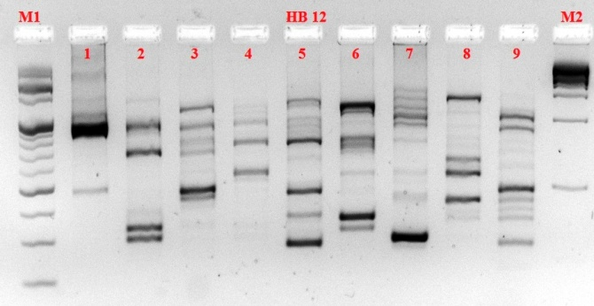
ISSR profile generated by HB 10 and HB 12 primer
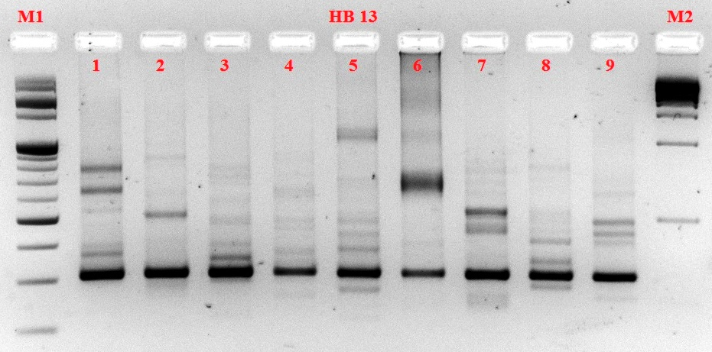
ISSR profile generated by HB 13 primer

