Supplementary data
A mimetic nesting association between a timid social wasp and an aggressive arboreal ant
Corbara et al.

Figure S1. A Protopolybia emortualis nest with the shelter slightly opened
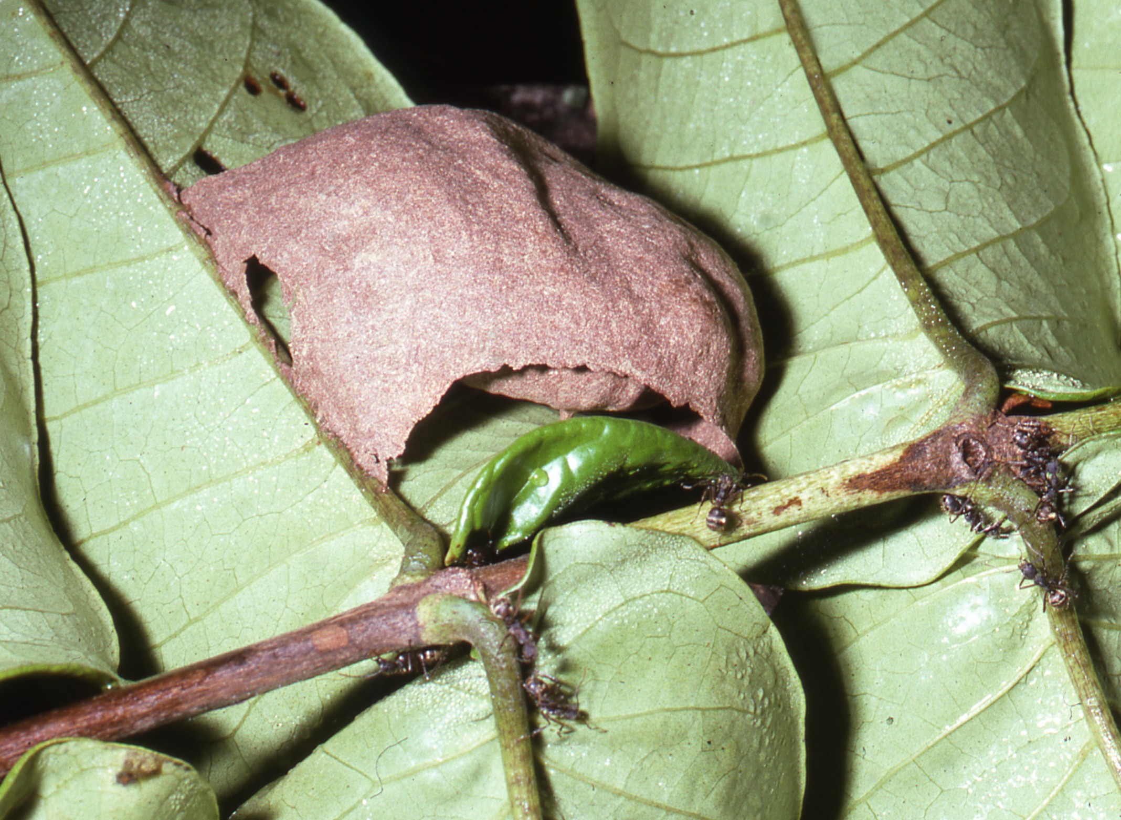

Figure S2. A Protopolybia emortualis nest with the shelter removed

