Supplementary Material for

Ultrasound assisted synthesis of Cs_{2.5}H_{0.5}PW₁₂O₄₀: an efficient nano-catalyst for preparation of β-amino ketones via aza-Michael addition reactions

Zohreh Shobeiri, ^{[a]} Mehrdad Pourayoubi, ^{[a]} Akbar Heydari, ^{[b]} Teresa Mancilla Percino, ^{[c]}
and Marco A. Leyva Ramírez, ^{[c]}

[a] Department of Chemistry, Ferdowsi University of Mashhad, Mashhad, Iran
[b] Department of Chemistry, Tarbiat Modares University, Chamran Street, Tehran, Iran
[c] Departamento de Química, Centro de Investigación y de Estudios Avanzados, del Instituto Politécnico Nacional, Apartado Postal 14-740, 07000 México, D.F., México

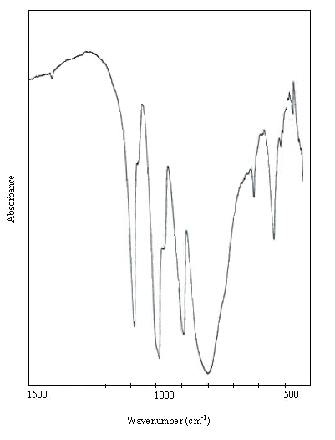
Fig. S1. IR spectrum of nanoparticles Cs_{2.5}H_{0.5}PW₁₂O₄₀.

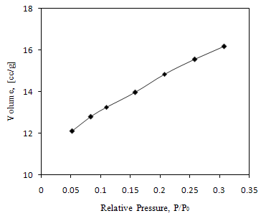
Fig. S2. N₂ adsorption isotherm of nanoparticles Cs_{2.5}H_{0.5}PW₁₂O₄₀.

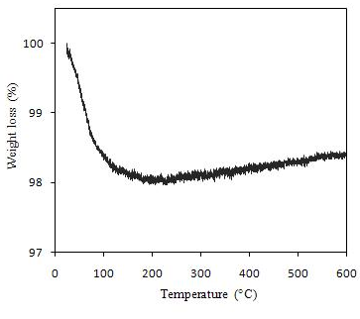
Fig. S3. TGA curve of nanoparticles Cs_{2.5}H_{0.5}PW₁₂O₄₀.

Corresponding author. Tel.: +989155143058 Email address: mehrdad_pourayoubi@yahoo.com

