Structural properties of trimetallic acetylide complex
 | EXP | LDA | PB86 | BLYP
C1-C2(Ǻ) | 1.222 | 1.268 | 1.274 | 1.272
Ru1-C1(Ǻ) | 2.065 | 2.036 | 2.090 | 2.133
Ru2-C1(Ǻ) | 2.323 | 2.319 | 2.385 | 2.416
Ru2-C2(Ǻ) | 2.388 | 2.369 | 2.485 | 2.594
Ru3-C2(Ǻ) | 2.043 | 2.033 | 2.072 | 2.096
Ru1-C1-C2(°) | 152.5 | 153.6 | 149.9 | 146.4
Ru3-C2-C1(°) | 155.2 | 157.4 | 159.1 | 161.8
Ru2-C1-Ru1(°) | 132.8 | 129.9 | 130.7 | 130.3
Ru2-C2-Ru3(°) | 129.5 | 129.6 | 129.4 | 129.8
[{Ru(CO)₂(η⁵C₅H₅)}₃(η¹:η¹:η²:-CC)]⁺
Supplementary Information:

S1-Table 1. Comparison between geometry parameters in the Calculated and experiment structures

MO | Energy(ev) | %C≡C⁻² | %[Ru] | OP(C≡C⁻²/[Ru])
H-17 | -12.889 | 40 | 32 | 0.105
H-16 | -12.402 | 36 | 38 | 0.026
H-5 | -12.021 | 39 | 38 | 0.119
H-1 | -9.442 | 14 | 50 | -0.124
HOMO | -8.738 | 49 | 38 | -0.307
LUMO | -6.423 | 17 | 44 | -0.288
S2-Table 2. Main contribution of [C2] and [Ru] fragment;
OP is the overlap population between each fragment

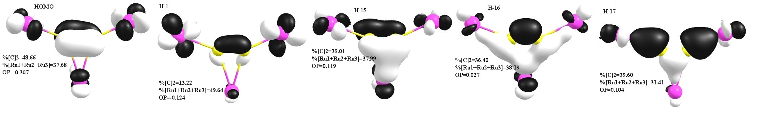

S1-figure 1. Plot of HOMO, H-1, H-15, H-16, H-17 for G
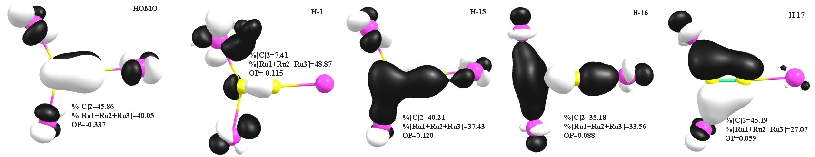
S2-figure 2. Plot of HOMO, H-1, H-15, H-16, H-17 for TS

