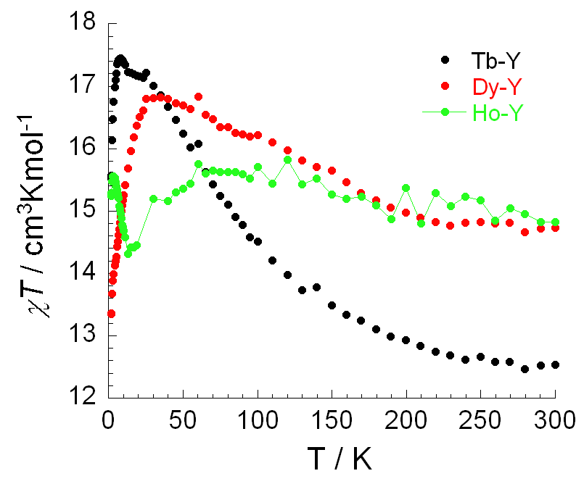

Figure S3. The ‘subtracted’ χT versus T plots at 0.1 T for complexes 1-3.

