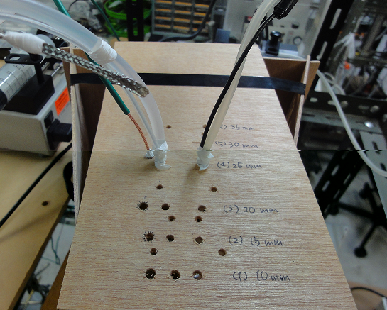
Fig. S3 Trial settings for the optimization of inter-nozzle distance.

