**Solid State Synthesis of Novel 3-Substituted Indoles**

**Supporting Information**

Ramin Ghorbani-Vaghei*, Hajar Shahbazi and Zahra Toghraei-Semiromi

Department of Organic Chemistry, Faculty of Chemistry, Bu-Ali Sina University, 65174, Hamedan, Iran

Fax/Tel +98 (811) 8380709; E-mail: [rgvaghei@yahoo.com](mailto:rgvaghei@yahoo.com)

1H-NMR

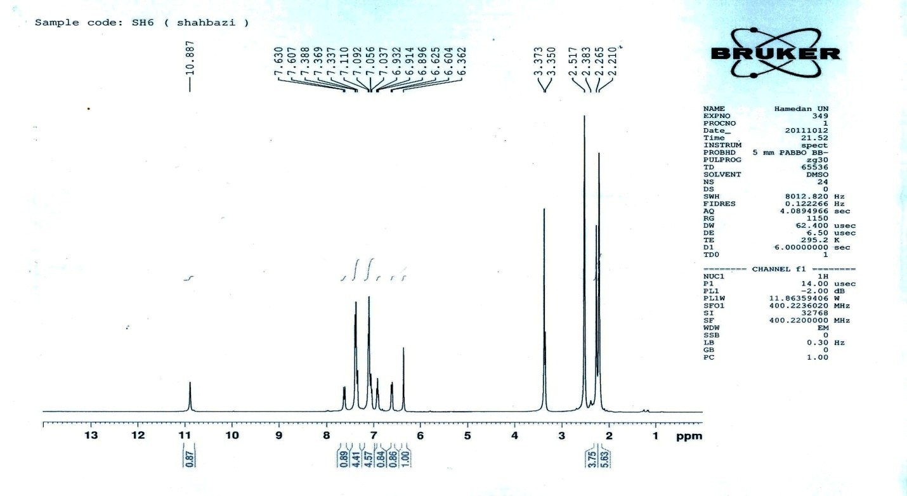



13C-NMR

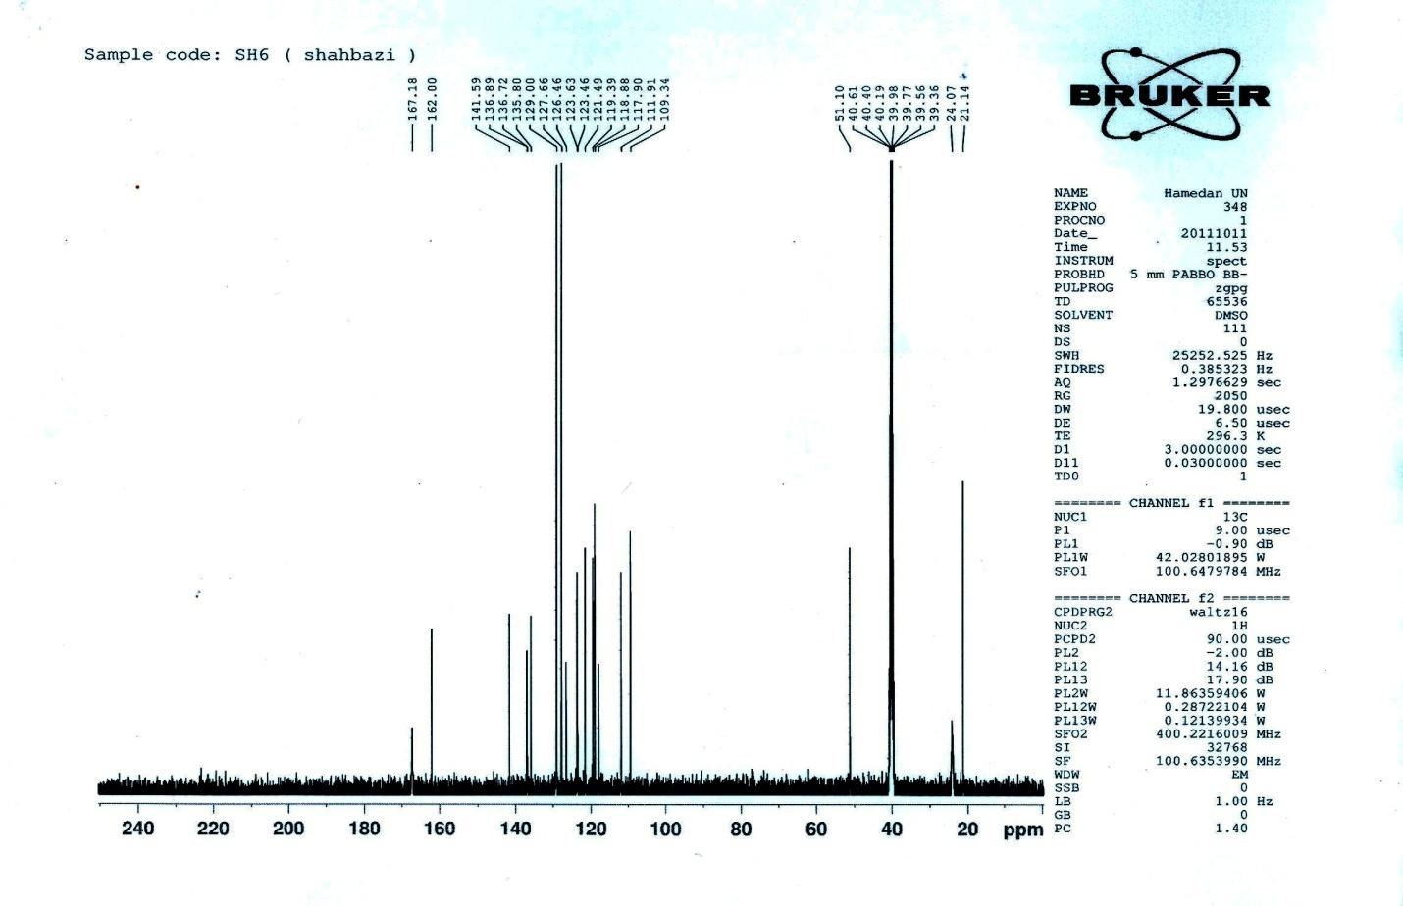



Mass

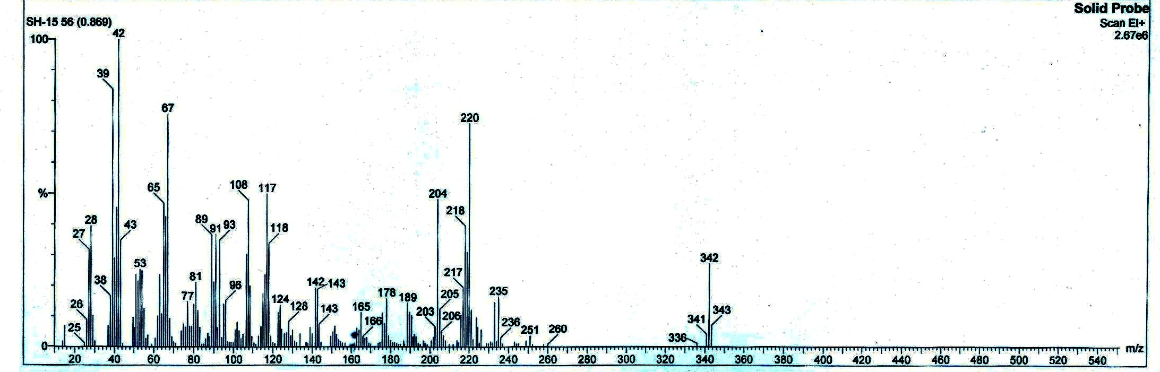



1H-NMR

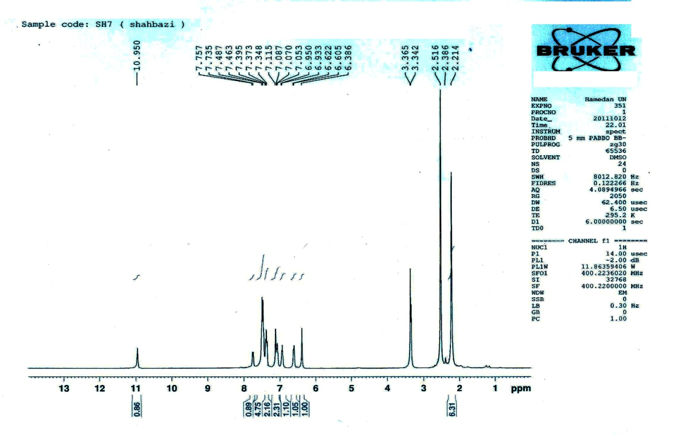



13C-NMR

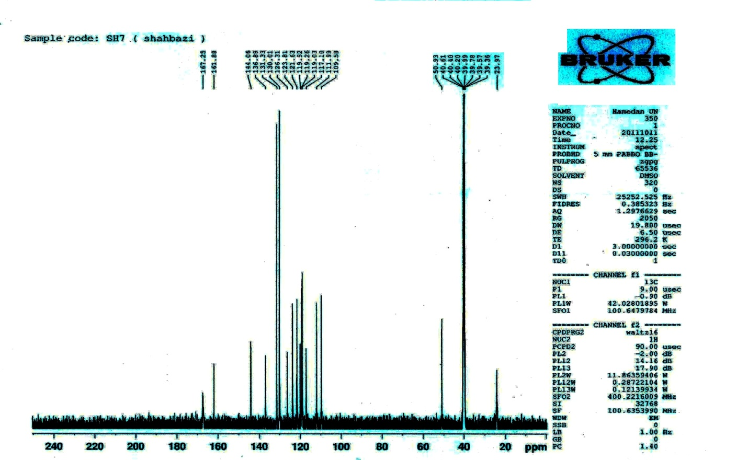



Mass

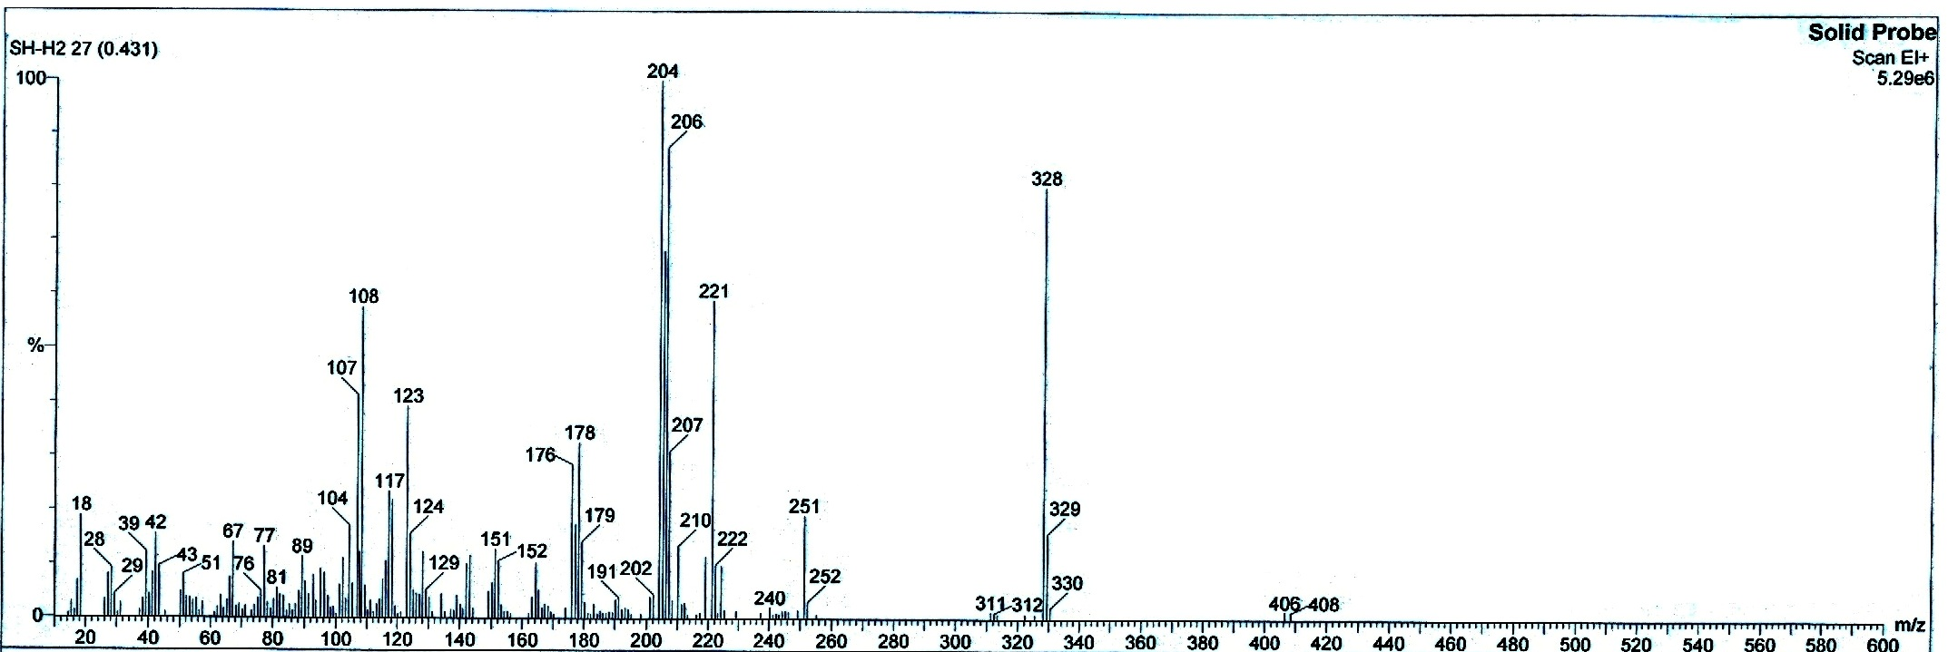



1H-NMR

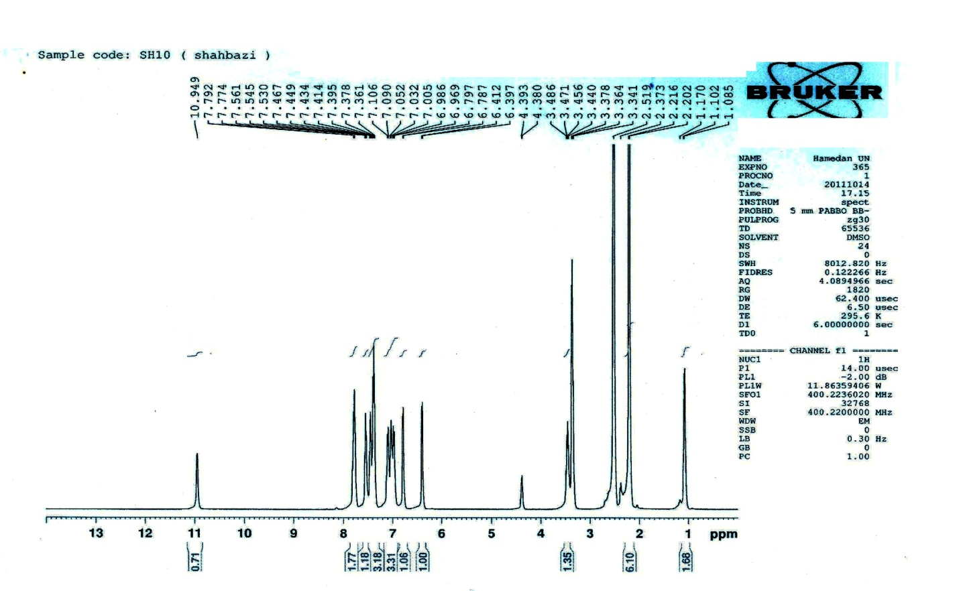



13C-NMR

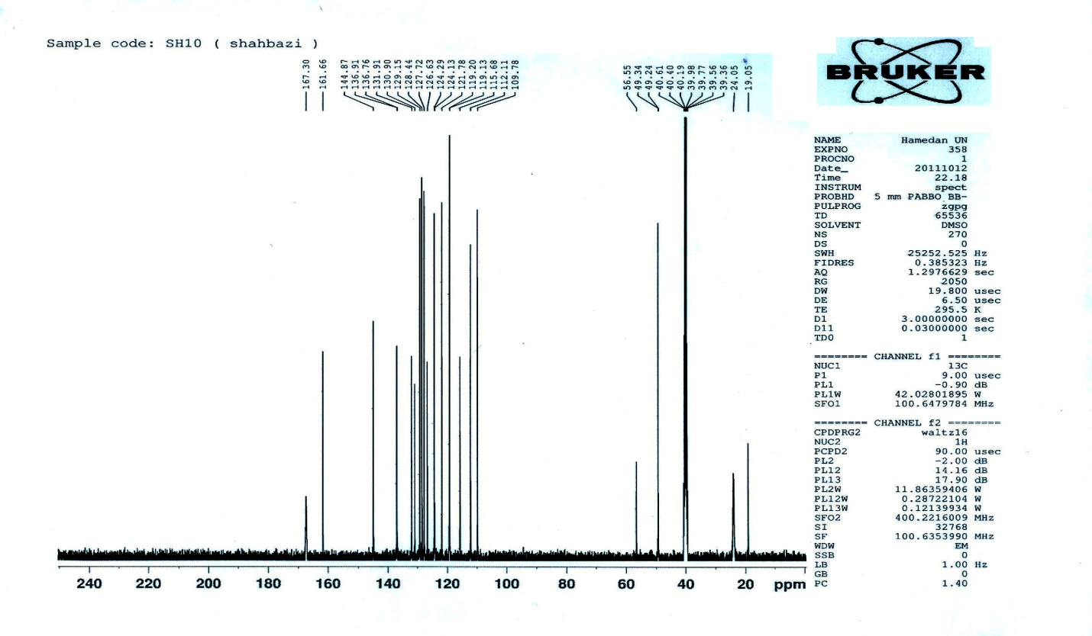



Mass

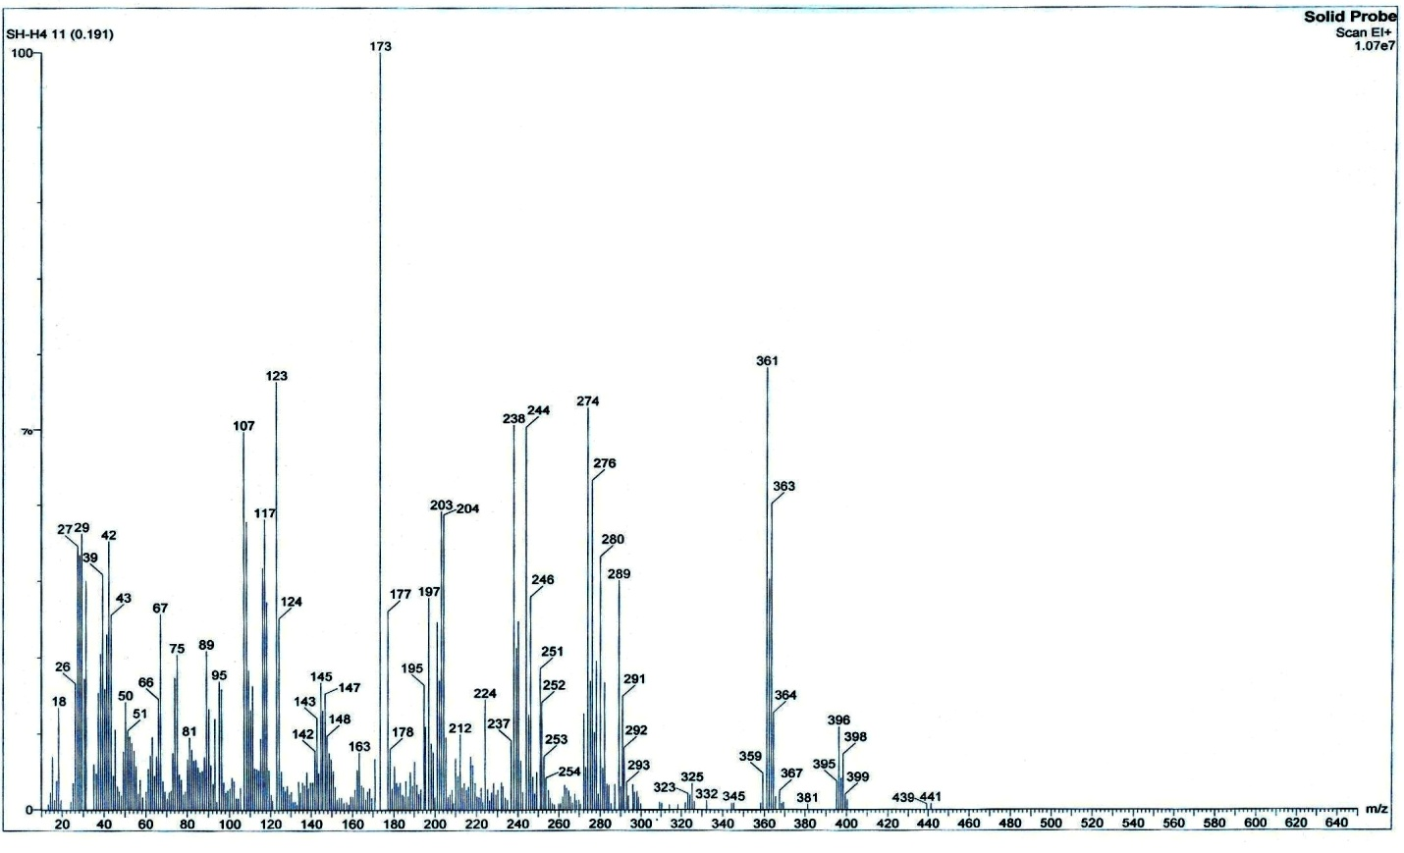



1H-NMR

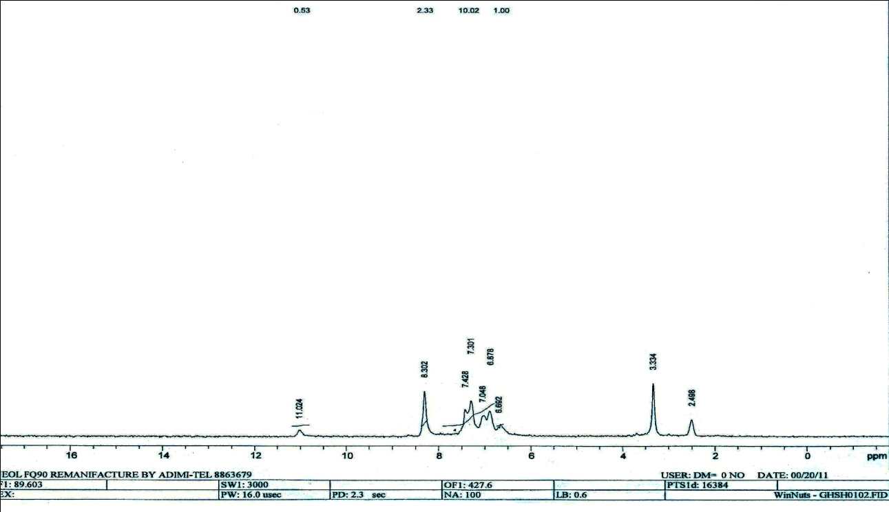



13C-NMR

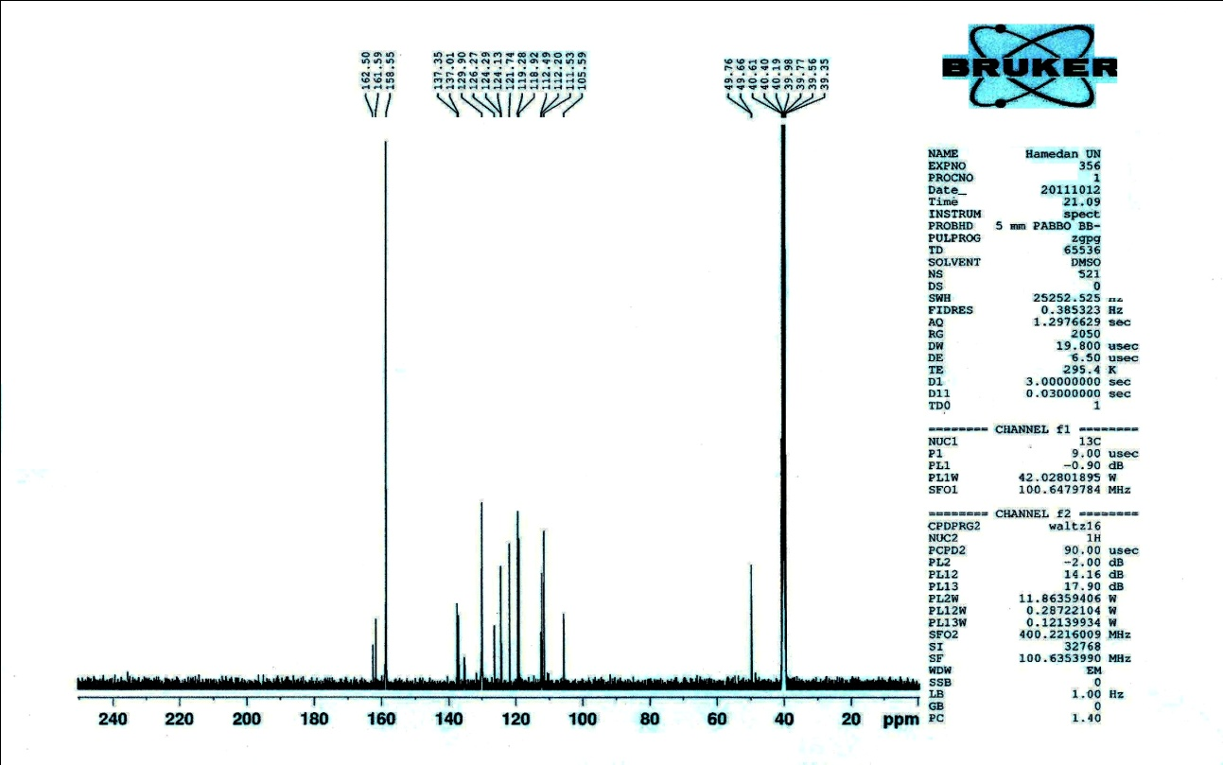



Mass

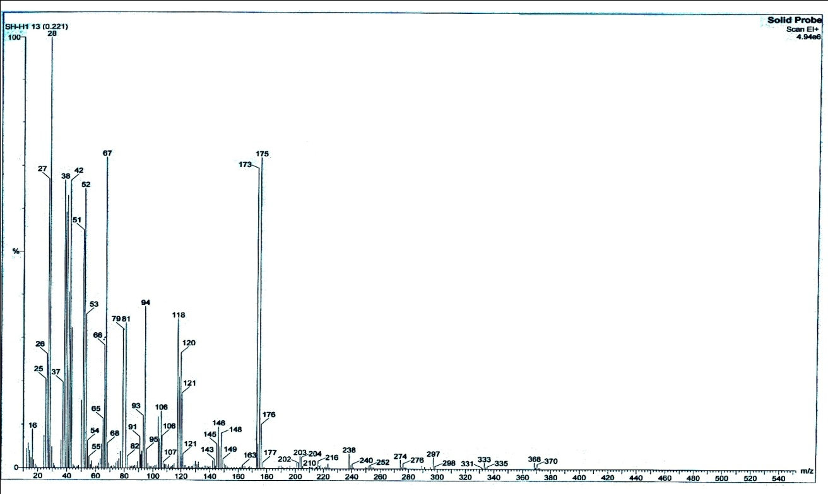



1H-NMR

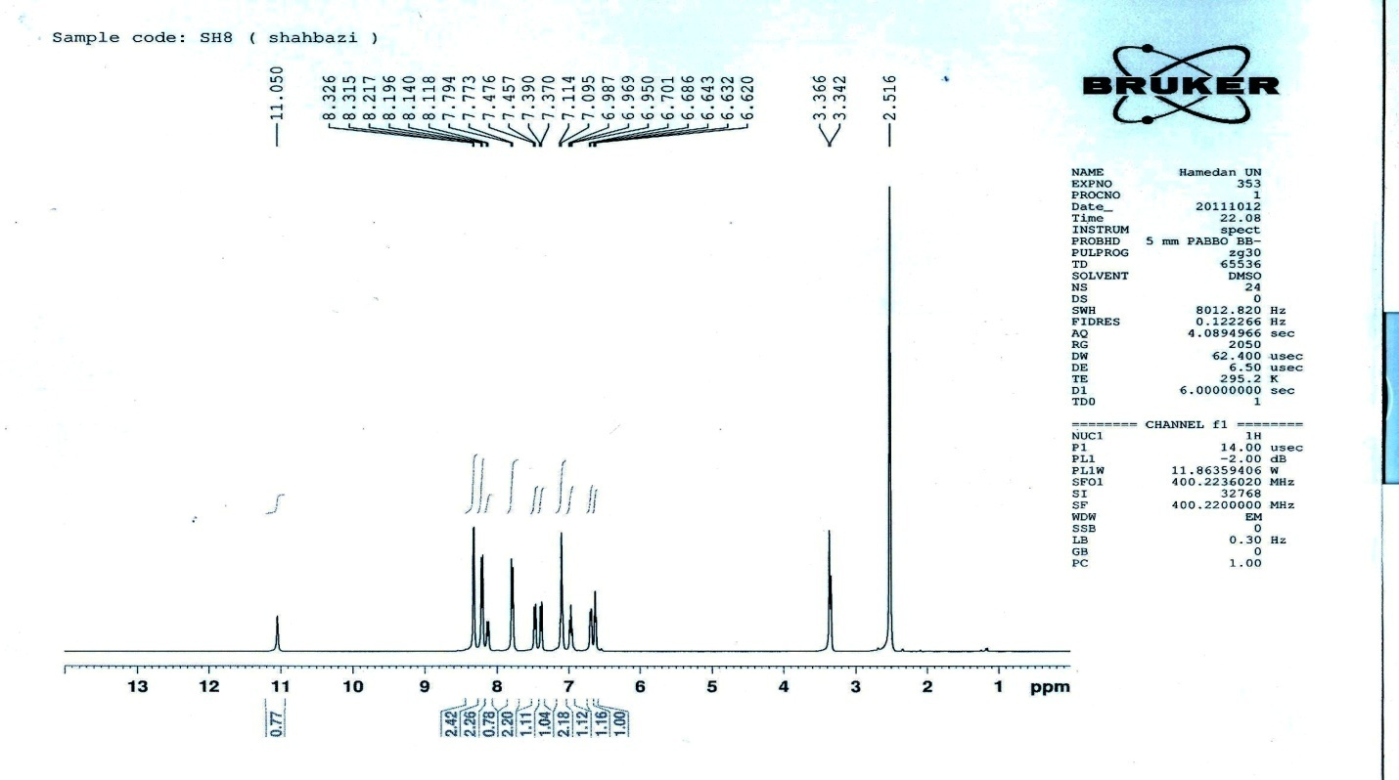



13C-NMR

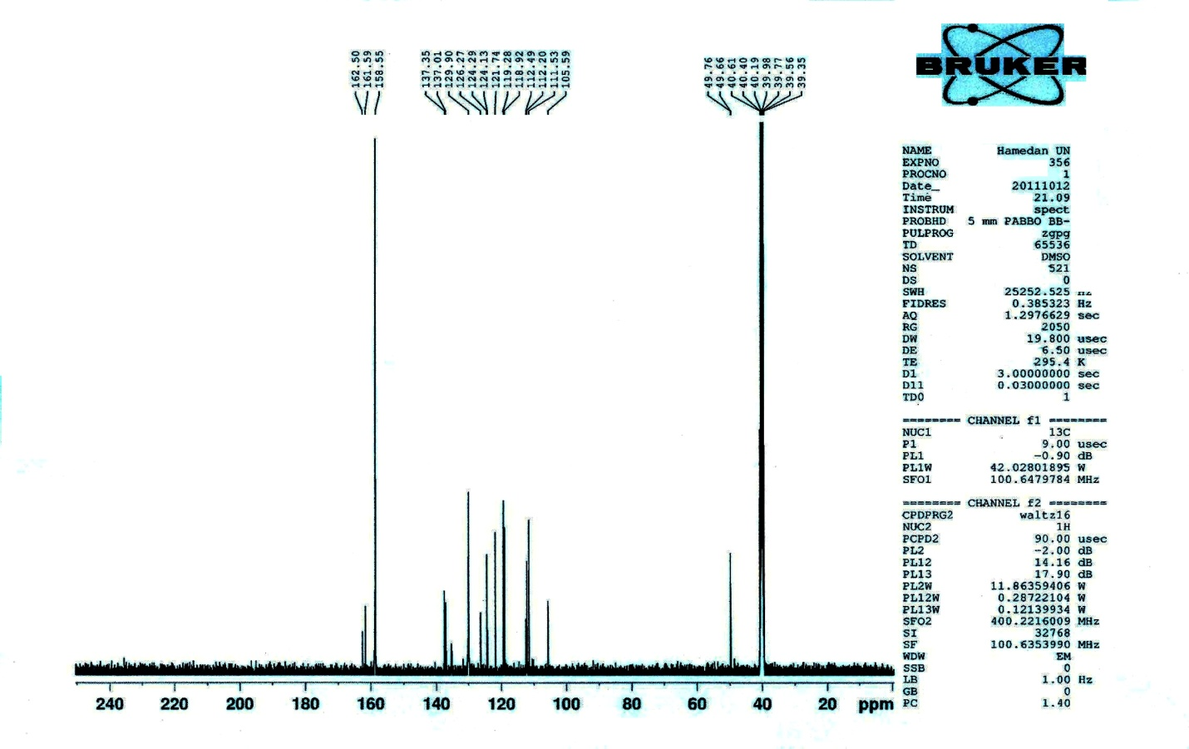



Mass

