Supplementary data

- Supplementary data of [Mn(salabza)(µ-1,3-N₃)]_{n}
Fig 1.1. FT-IR spectrum of [Mn(salabza)(µ-1,3-N₃)]_{n}
Fig. 1.2. UV–Vis spectrum of [Mn(salabza)(µ-1,3-N₃)]_{n} in DMF
2. Supplementary data of [Cu₄(salabza)₂(µ-1,1-N₃)₂(N₃)₂(|HOCH₃)₂]
Fig. 2.1. FT-IR spectrum of [Cu₄(salabza)₂(µ-1,1-N₃)₂(N₃)₂(HOCH₃)₂]
Fig. 2.2. UV–Vis spectrum of [Cu₄(salabza)₂(µ-1,1-N₃)₂(N₃)₂(HOCH₃)₂] in DMF

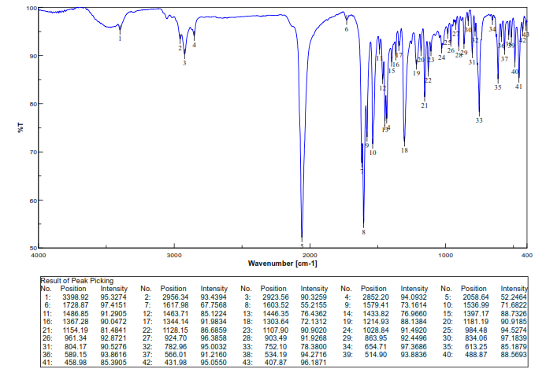
Fig 1.1. FT-IR spectrum of [Mn(salabza)(µ-1,3-N₃)]_{n}

Fig. 1.2. UV–Vis spectrum of [Mn(salabza)(µ-1,3-N₃)]_{n} in DMF

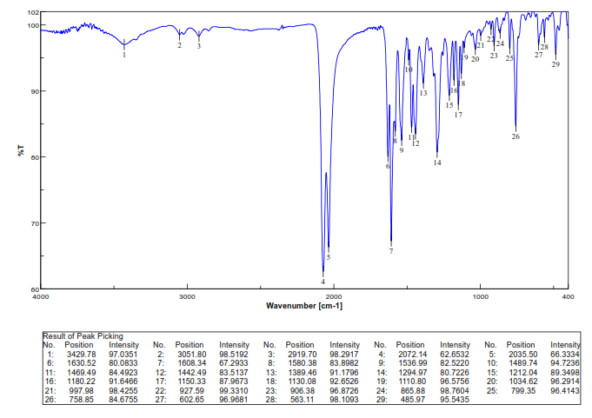
Fig. 2.1. FT-IR spectrum of [Cu₄(salabza)₂(µ-1,1-N₃)₂(N₃)₂(HOCH₃)₂]

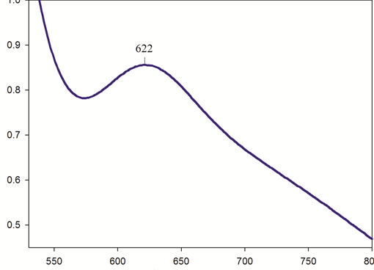
Fig. 2.2. UV–Vis spectrum of [Cu₄(salabza)₂(µ-1,1-N₃)₂(N₃)₂(HOCH₃)₂] in DMF

