Supplementary data

Modification of poly(vinyl chloride) with pendant metal complex for catalytic applications
G. Rajesh Krishnan^{1, 2}*, M.K. Sreeraj¹ and K. Sreekumar¹
¹Department of Applied Chemistry, Cochin University of Science and Technology, Kochi, Kerala, India
Phone: +91–484–2862420, Fax: +91–484–2575804
²Present address: School of Biomedical Engineering, State University of New York, Buffalo, New York, USA

Thermogravimetric curve of the catalyst

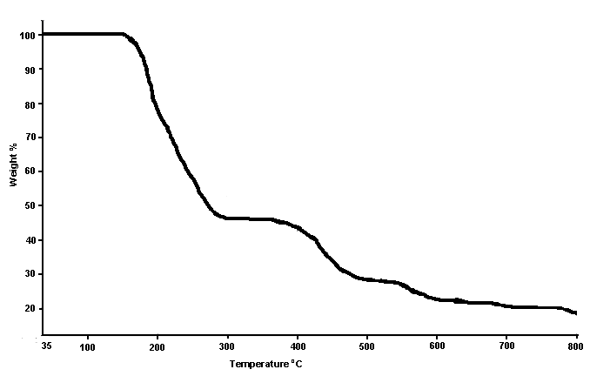

Electronic spectrum of the catalyst
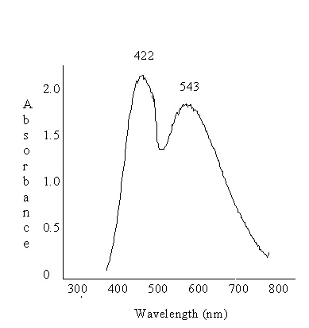

Characterization data of β-keto amines prepared

2-[1'-(N-phenylamino)-1'-(phenyl)methylcyclohexanone (Table3, Entry 1)
FTIR (KBr) ν_{max} cm^{–1}: 3328, 3021, 2932, 2858, 1702, 1590, 1520, 1495, 1300; ¹H NMR (400MHz, CDCl₃): δ 1.73–1.81 (m, 2H), 1.91–1.98 (m, 4H), 2.36–2.38 (m, 1H), 2.45–2.49 (m, 1H), 2.73–2.77 (m, 1H), 4.63 (d, J = 6.81 Hz, 1H), 4.74 (s, 1H), 6.52 (d, J = 7.73 Hz, 2H), 6.63 (t, J = 7.26 Hz, 1H), 7.06 (t, J = 7.37 Hz, 2H), 7.24 (t, J = 6.30 Hz, 1H), 7.33 (t, J = 6.76 Hz, 2H), 7.40 (d, J = 7.09 Hz, 2H).
2-[1'-(N-phenylamino)-1'-(4-methoxyphenyl)]methylcyclohexanone (Table 3,Entry 2)
FTIR (KBr) ν_{max} cm^{–1}: 3364, 2935, 1706, 1604, 1512; ¹H NMR (300MHz, CDCl₃): δ 1.49–1.67 (m, 3H), 1.73–1.84 (m, 3H), 2.18–2.40 (m, 2H), 2.69–2.72 (m, 1H), 3.68 (s, 3H ), 4.65 (d, J = 4.4 Hz, 1H), 6.47–6.50 (m, J = 7.0 Hz, 2H ), 6.55–6.62 (m, 1H ), 6.73–6.77 ( m, 2H ), 6.97–7.01 (t, J = 7.8 Hz, 2H ), 7.18–7.22 (m, 2H ).
2-[1'-(N-phenylamino)-1'-(4-chlorophenyl)]methylcyclohexanone (Table 3, Entry 3)
FTIR (KBr) ν_{max} cm^{–1}: 3390, 3119, 1712, 1142, 1090; ¹H NMR (300MHz, CDCl₃):  δ  1.48–1.63 (m, 3H), 1.79–1.97 (m, 3H), 2.19–2.36 (m, 2H), 2.68–2.72 (m, 1H), 4.65–4.66 (d, J = 4.4 Hz, 1H), 6.43–6.46 (m, 2H), 6.57–6.60 (t, J = 7.2 Hz, 1H), 6.98–7.02 (t, J = 8.0 Hz, 2H), 7.16–7.24 (m, 4H).
2-[1'-(N-phenylamino)-1'-(4-nitrophenyl)]methylcyclohexanone (Table 3, Entry 4)
FTIR (KBr) ν_{max} cm^{–1}:3386, 3021, 1673, 1527, 1348; ¹H NMR (400MHz, CDCl₃):  δ1.58–1.66 (m, 2H),1.75–1.79 (m, 1H), 1.95–2.08 (m, 3H), 2.34–2.42 (m, 2H), 2.86–2.89 (m, 1H), 4.59 (s, br, 1H), 4.84 (d, J = 5.2 Hz, 1H), 6.52–6.54 (d, J = 8.0 Hz, 2H), 6.66–6.70 (m, 1H), 7.08–7.12 (t, J = 8.0 Hz, 2H), 7.45–7.49 (t, J = 8.0 Hz, 1H), 7.77–7.80(m, 1H), 8.07–8.09 (d, J = 8.0 Hz, 1H), 8.24–8.26 (d, J = 7.6 Hz, 1H)
2-[1'-(N-4-methoxyphenylamino)-1'-(4-methoxyphenyl)]methylcyclohexanone (Table 3, Entry 5)
FTIR (KBr) ν_{max} cm^{–1}: 3362, 2964, 1703, 1603, 1512; ¹H NMR (300MHz, CDCl₃):  δ 1.63–1.68 (m, 2H) 1.81–1.93 (m, 4H), 2.32–2.37 (m, 1H), 2.38–2.42 (m, 1H), 2.68–2.69 (m, 1H), 3.78 (s, 6H), 4.75 (d, J = 4.8 Hz, 1H), 6.33–6.37 (d, J = 7.8 Hz, 2H), 6.53–6.56 (d, J = 7.8 Hz, 2H), 6.73–6.76 (d, J = 7.8 Hz, 2H), 7.02–7.04 (t, J = 7.2 Hz, 2H),
2-[1'-(N-4-chlorophenylamino)-1'-(4-hydroxyphenyl)]methylcyclohexanone (Table 3, Entry 6) FTIR (KBr) ν_{max} cm^{–1}: 3362, 2964, 1703, 1603, 1512; ¹H NMR (400MHz, CDCl₃):  δ 1.63–1.68 (m, 2H); 1.81–1.93 (m, 4H), 2.32–2.37 (m, 1H), 2.38–2.42 (m, 1H), 2.68–2.69 (m, 1H), 4.31 (s, br, 1H), 4.59 (d, J = 6.4 Hz, 1H), 4.91 (s, br, 1H), 6.43–6.46 (d, J = 8.2 Hz, 2H), 6.83–6.85 (d, J = 8.2 Hz, 2H), 6.99–7.01 (d, J = 8.2 Hz, 2H), 7.24–7.27 (t, J = 7.4 Hz, 2H)
2-[1'-(N-4-methoxyphenylamino)-1'-(phenyl)]methylcyclohexanone, (Table 3, Entry 7)
FTIR (KBr) ν_{max} cm^{–1}: 3324, 2960, 1703 1600, 1510; ¹H NMR (400MHz, CDCl₃):  δ 1.68–1.93 (m, 6H), 2.42–2.47 (m, 2H), 2.72–2.76 (m, 1H), 3.69 (s, 3H), 4.65 (d, J=6.83 Hz, 1H), 4.72 (br, s, 1H), 6.64–6.61 (m, 1H), 6.68 (d, J = 8.3 Hz, 2H), 7.10–7.03 (m, 2H), 7.16 (d, J = 7.6 Hz, 2H), 7.27 (d, J = 8.4 Hz, 2H).
2-[1'-(N-4-nitrophenylamino)-1'-(phenyl)]methylcyclohexanone (Table 3, Entry8)
FTIR (KBr) ν_{max} cm^{–1}: 3380, 3015, 1661, 1535, 1340; ¹H NMR (300 MHz, CDCl₃):  1.25–2.13 (m, 6H), 2.28–2.40 (m, 2H), 2.91 (m, 1H), 4.13 (d, J = 6.1 Hz, 1H), 4.70 (br, s, 1H), 6.40–6.61 (m, 2H), 7.10–7.35 (m, 5H), 7.95–8.05 (m, 2H).
2-((E)-1-(4-methoxyphenylamino)-3-phenylallyl)cyclohexanone (Table 3, Entry 9)
FTIR (KBr) ν_{max} cm^{–1}: 3374, 2934, 1710, 1600, 1515, 1400, 978;¹H NMR (300 MHz, CDCl3): δ 1.63–1.89 (m, 6H), 2.18–2.28 (m, 2H), 2.43 (m, 1H), 3.54 (t, J=2.9 Hz, 1H), 3.79 (s, 3H), 4.26 (s, br, 1H), 6.19 (d, J = 16 Hz 1H), 6.34 (d, J = 9.0 Hz, 2H), 6.53–6.55 (m, 3H),7.15–7.30 (m, 5H),
2-[(p-Methoxyphenylamino)(thiophen-2-yl)methyl]cyclohexanone (Table 3, Entry 10)
FTIR (KBr) ν_{max} cm^{–1}: 3370, 2930, 1700, 1608, 1510; ¹H NMR (400 MHz, CDCl3): δ 1.60–2.03 (m, 6H), 2.32–2.47 (m, 2H), 2.82 (m, 1H), 4.36 (s, br, 1H), 4.87 (d, 1H, J = 6.0 Hz), 6.59 (d, 2H, J = 9.0 Hz), 6.71 (d, 2H, J = 9.0 Hz), 6.90 (dd, 1H, J = 3.5 Hz, 5.0 Hz), 6.94 (d, 1H, J = 3.5 Hz), 7.15 (dd, 1H, J = 1.0Hz, 5.0 Hz).

