Supplementary Material

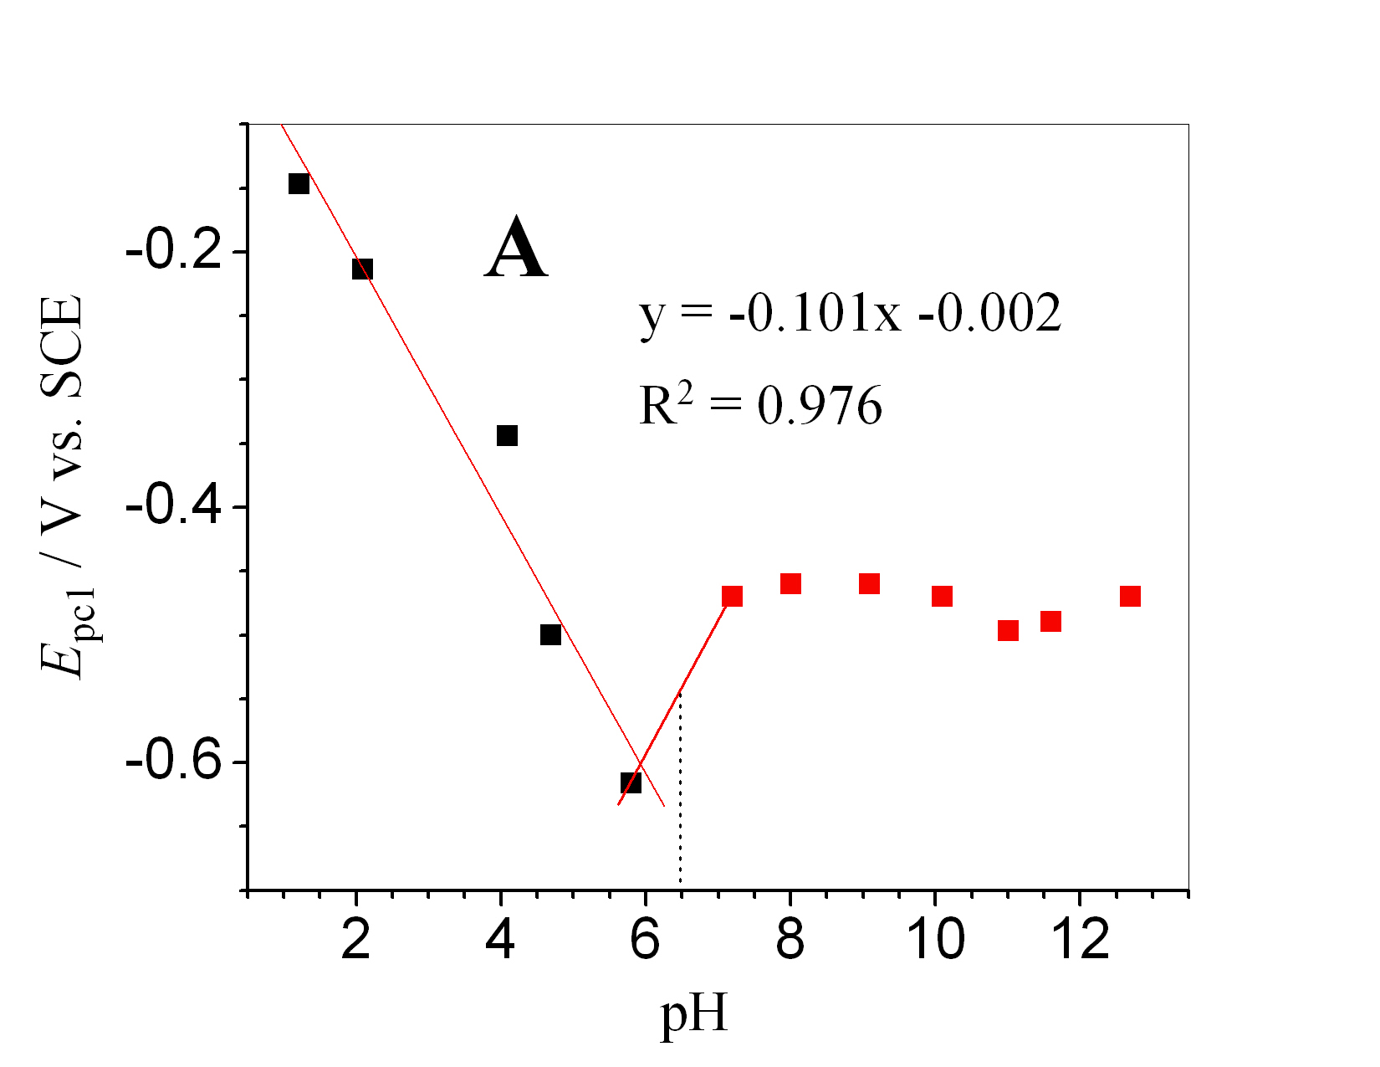
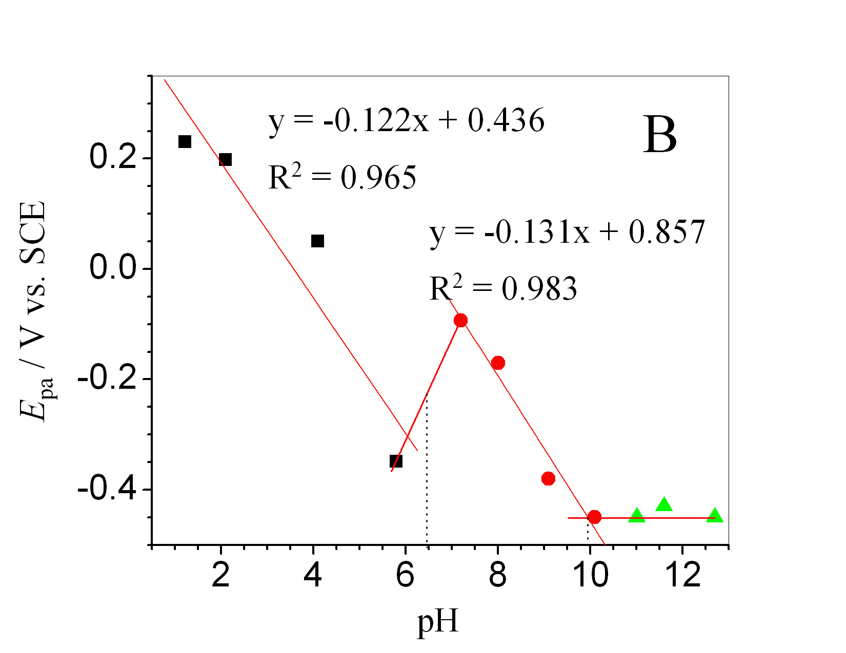
Fig. S-1. (A) E_{pc1} vs. pH plot and (B) E_{pa} vs. pH plot of 1 mM HND.

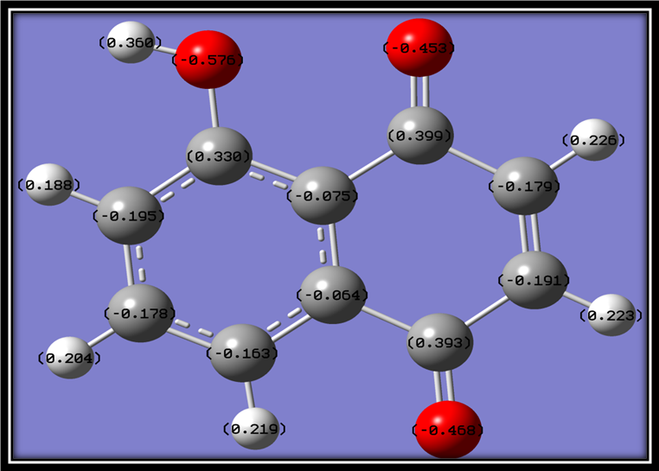
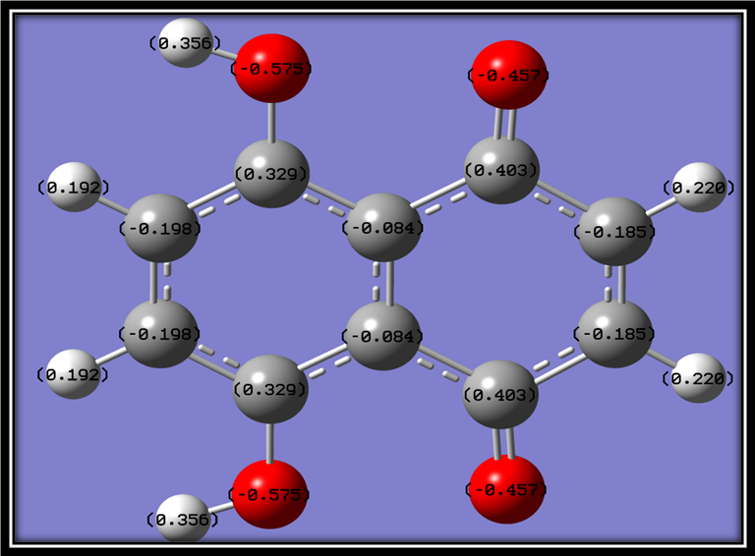
Fig. S-2. Charge densities of HND and 5,8-dihydroxynaphthalene-1,4-dione.

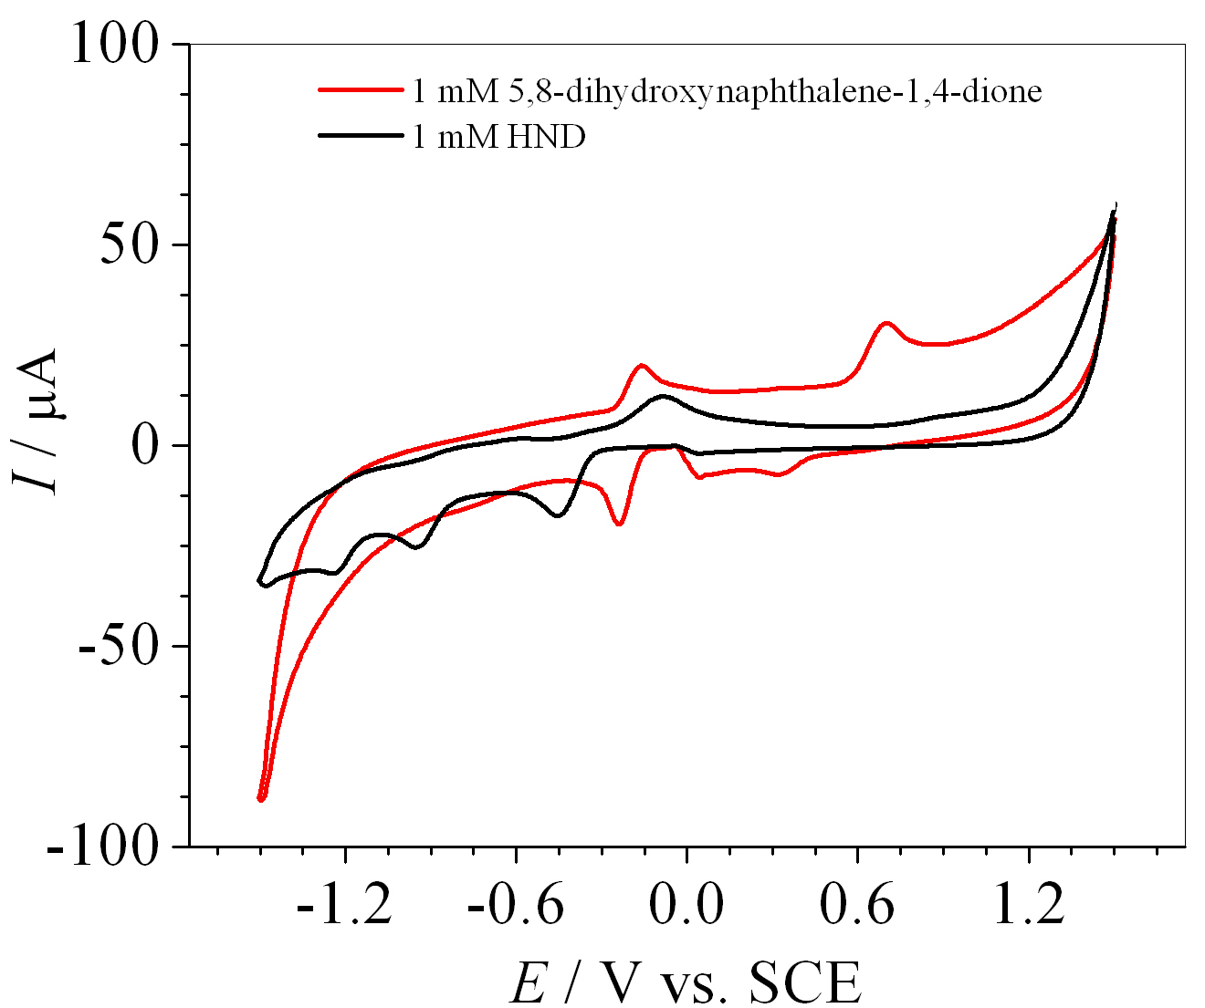
Fig. S-3. Comparison of cyclic voltammograms of 1.0 mM HND and 5,8-dihydroxynaphthalene-1,4-dione.

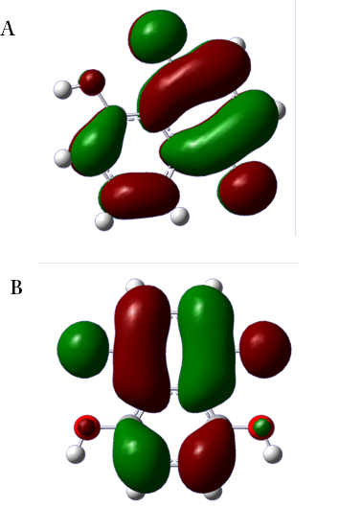
Fig. S-4. Graphical representation of LUMO of HND and 5,8-dihydroxynaphthalene-1,4-dione.

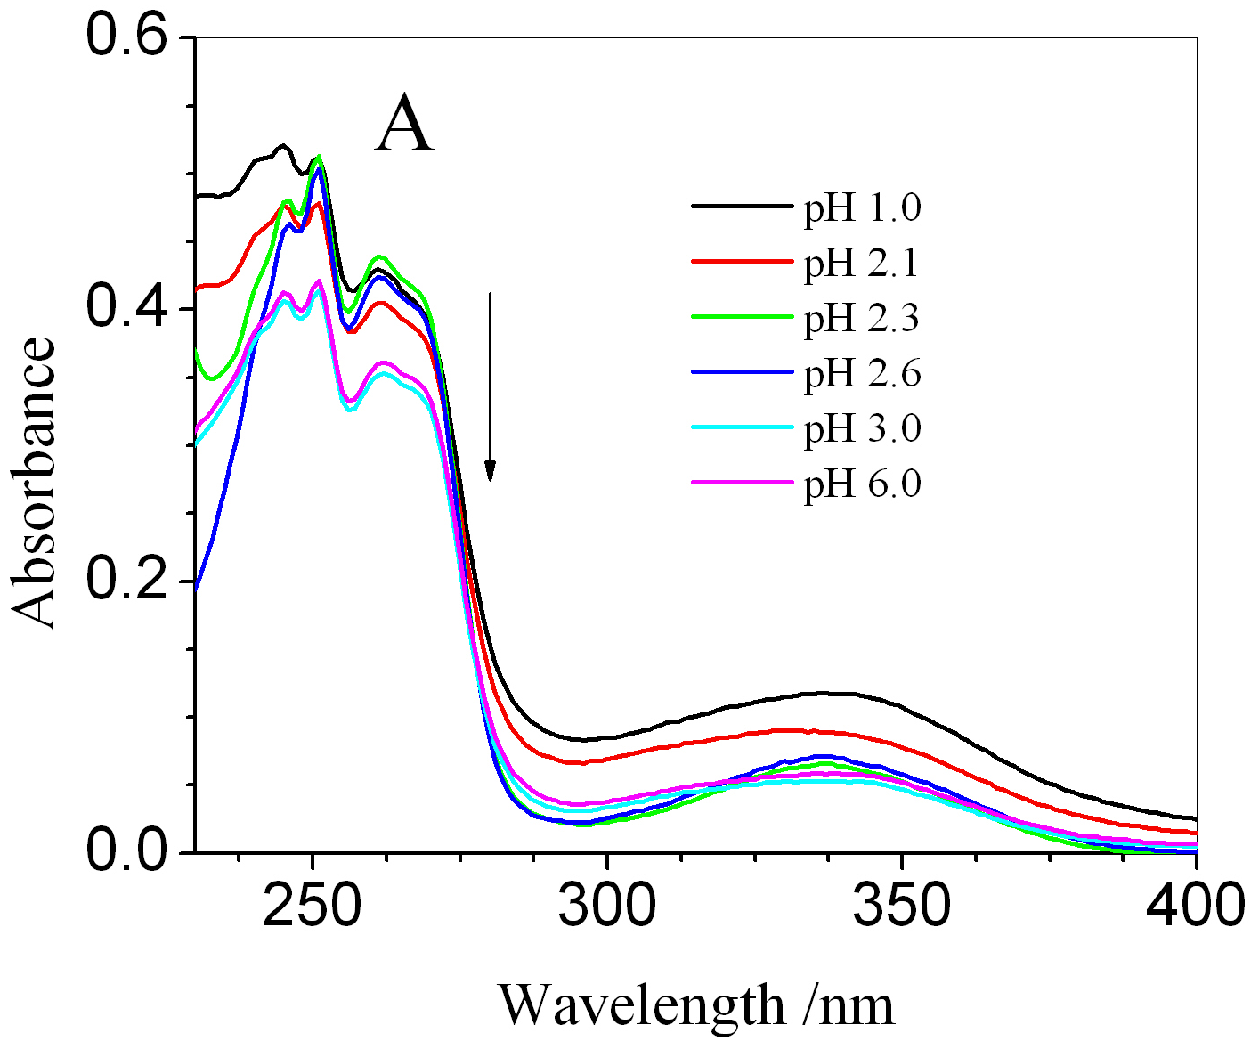
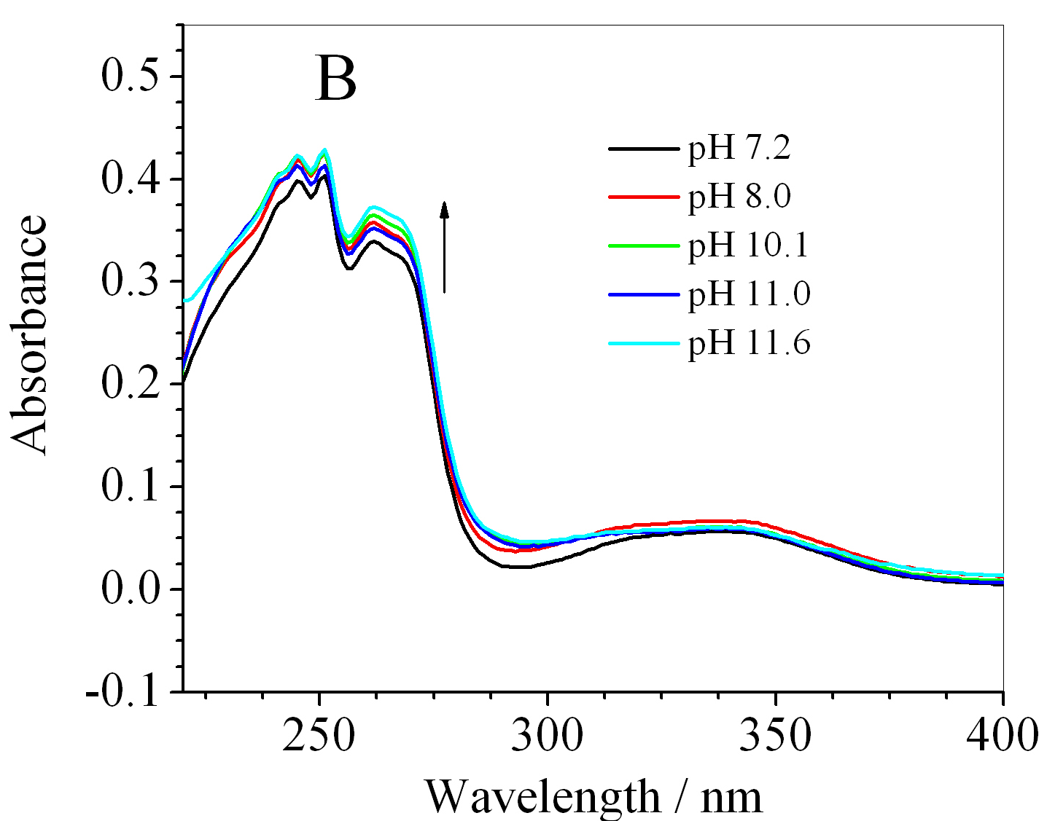
Fig. S-5. (A) Absorption spectra of HND obtained in different pH ranging from 1.0-6.0 and (B) 7.2-11.6.

