Supporting Information

Seven-membered Pd(II) complexes containing symmetric phosphorus ylides: synthesis, characterization and high catalytic activity toward Suzuki cross-coupling reactions

Fig. S1.A representation of crystal srycturepacking of 5 showing the intermolecular interactions. O2∙∙∙H44 (1.988 A˚), O1∙∙∙H43 (2.023 A˚), O1∙∙∙C43 (3.004 A˚), C2∙∙∙H43 (2.852 A˚), C18∙∙∙H30b (2.884 A˚), Cll0∙∙∙H17 (2.892 A˚), C17∙∙∙H26 (2.757 A˚), C29∙∙∙Cl5 (3.278 A˚), C42∙∙∙H5 (2.827 A˚), Cl4∙∙∙H7 (2.929 A˚), O2∙∙∙C44 (2.979 A˚), Cl1∙∙∙C13 (3.497 A˚) and C19∙∙∙H13 (2.916 A˚).

Table s1. Fractional Atomic Coordinates (×10⁴) and Equivalent Isotropic Displacement Parameters (Å²×10³) for exp_2031g. U_{eq} is defined as 1/3 of of the trace of the orthogonalised U_{IJ} tensor.
Atom | x | y | z | U(eq)
Cl1 | 6946.5(7) | 7918.7(5) | 9068.9(4) | 39.70(16)
Cl2 | 8000.0(7) | 6798.4(5) | 6022.3(5) | 40.99(16)
P1 | 4580.6(5) | 10419.8(4) | 8736.5(4) | 17.72(11)
O1 | 4353.5(15) | 8351.0(11) | 8061.7(11) | 25.6(3)
C1 | 5574(2) | 9956.6(15) | 8290.8(14) | 20.9(4)
C2 | 5288(2) | 8939.9(15) | 8003.9(14) | 20.7(4)
C3 | 6095(2) | 8491.0(15) | 7577.1(14) | 20.5(4)
C4 | 6785(2) | 7947.5(16) | 7961.1(15) | 24.7(4)
C5 | 7388(2) | 7435.8(17) | 7498.2(16) | 29.6(5)
C6 | 7306(2) | 7482.1(16) | 6635.4(16) | 26.8(5)
C7 | 6689(2) | 8050.0(16) | 6249.6(16) | 27.2(5)
C8 | 6091(2) | 8551.6(16) | 6728.5(15) | 25.1(4)
C9 | 4362.4(19) | 10017.0(15) | 9655.9(14) | 19.3(4)
C10 | 2900(2) | 10048.0(14) | 7824.7(14) | 20.6(4)
C11 | 2585(2) | 9604.9(17) | 6853.6(16) | 28.6(5)
C12 | 1303(2) | 9332.9(19) | 6156.2(17) | 37.4(6)
C13 | 326(2) | 9490.2(19) | 6417.4(18) | 38.2(6)
C14 | 628(2) | 9933.0(19) | 7387.1(18) | 36.0(5)
C15 | 1913(2) | 10222.7(17) | 8091.8(16) | 27.4(5)
C16 | 5287.2(19) | 11763.5(14) | 9211.6(14) | 19.5(4)
C17 | 5435(2) | 12193.9(16) | 8572.6(16) | 26.0(4)
C18 | 5891(2) | 13215.3(17) | 8867.3(18) | 31.9(5)
C19 | 6217(2) | 13821.0(17) | 9806.0(18) | 33.5(5)
C20 | 6099(2) | 13397.6(17) | 10447.9(17) | 33.8(5)
C21 | 5635(2) | 12371.8(16) | 10158.8(16) | 26.8(5)
Cl3 | 11863.2(7) | 2846.0(5) | 9042.1(4) | 41.47(16)
Cl4 | 12942.8(6) | 1786.7(4) | 6014.8(4) | 33.44(14)
P2 | 9383.6(5) | 5275.3(4) | 8653.2(4) | 17.89(11)
O2 | 9109.2(15) | 3148.0(11) | 8074.1(10) | 24.7(3)
C22 | 10218(2) | 4698.7(15) | 8113.8(14) | 21.7(4)
C23 | 9957(2) | 3694.1(15) | 7912.0(14) | 20.3(4)
C24 | 10720(2) | 3222.5(14) | 7451.0(14) | 20.2(4)
C25 | 11571(2) | 2798.6(16) | 7888.4(15) | 24.8(4)
C26 | 12252(2) | 2356.0(16) | 7454.8(16) | 27.0(5)
C27 | 12078(2) | 2339.3(15) | 6558.7(15) | 23.5(4)
C28 | 11252(2) | 2752.2(16) | 6092.1(15) | 24.7(4)
C29 | 10580(2) | 3190.7(15) | 6545.6(15) | 22.9(4)
C30 | 9325.5(19) | 4972.8(15) | 9658.6(14) | 19.7(4)
C31 | 7648(2) | 4954.8(15) | 7863.1(14) | 20.3(4)
C32 | 6873(2) | 5371.6(16) | 8220.3(16) | 26.9(5)
C33 | 5552(2) | 5140.0(18) | 7619.8(18) | 33.0(5)
C34 | 4992(2) | 4491(2) | 6662.2(19) | 39.0(6)
C35 | 5759(3) | 4076(2) | 6311.9(18) | 45.5(7)
C36 | 7079(2) | 4300.4(18) | 6904.7(17) | 34.5(5)
C37 | 10170(2) | 6599.6(15) | 9041.5(15) | 20.5(4)
C38 | 10451(2) | 7274.9(15) | 9948.0(16) | 25.6(4)
C39 | 10930(2) | 8287.8(17) | 10170.0(18) | 32.5(5)
C40 | 11147(2) | 8638.1(17) | 9505.4(19) | 34.5(5)
C41 | 10903(2) | 7969.3(17) | 8610.6(18) | 32.4(5)
C42 | 10412(2) | 6952.4(16) | 8377.2(16) | 26.0(4)
Cl5 | 2104.8(7) | 5413.3(5) | 6694.8(5) | 44.61(16)
Cl6 | 1036.3(9) | 6737.8(7) | 5984.1(7) | 70.2(3)
Cl7 | 2950.9(11) | 6113.5(6) | 5444.0(7) | 70.5(3)
C43 | 2440(2) | 6427.9(17) | 6357.8(17) | 32.5(5)
Cl8 | 6939.4(7) | 1893.2(5) | 5345.9(4) | 39.74(15)
Cl9 | 7814.4(7) | 500.3(5) | 6055.4(6) | 50.45(18)
Cl10 | 5547.9(7) | 897.4(5) | 6217.8(5) | 43.19(16)
C44 | 7113(2) | 1412.0(16) | 6241.9(16) | 28.5(5)

Table S2. Anisotropic Displacement Parameters (Å²×10³) for exp_2031g. The Anisotropic displacement factor exponent takes the form: -2π²[h²a*²U₁₁+...+2hka×b×U₁₂]
Atom | U₁₁ | U₂₂ | U₃₃ | U₂₃ | U₁₃ | U₁₂
Cl1 | 62.8(4) | 62.5(4) | 28.9(3) | 32.8(3) | 30.3(3) | 48.0(4)
Cl2 | 59.1(4) | 54.8(4) | 37.5(3) | 24.8(3) | 34.7(3) | 39.9(3)
P1 | 20.0(3) | 20.9(2) | 15.4(2) | 10.14(19) | 7.5(2) | 10.0(2)
O1 | 27.9(8) | 27.1(8) | 23.8(8) | 11.0(6) | 13.5(7) | 9.9(6)
C1 | 23.2(10) | 24.8(10) | 20.3(10) | 12.5(8) | 11.4(9) | 11.3(8)
C2 | 23.2(10) | 27.5(10) | 13.7(9) | 9.8(8) | 7.2(8) | 12.6(8)
C3 | 22.8(10) | 21.8(10) | 17.6(9) | 8.9(8) | 8.1(8) | 9.5(8)
C4 | 33.9(12) | 32.4(11) | 20.1(10) | 16.3(9) | 15.8(9) | 19.7(10)
C5 | 40.1(13) | 36.9(12) | 27.8(12) | 20(1) | 18.7(11) | 26.1(11)
C6 | 32.8(12) | 32.6(11) | 23.9(11) | 11.7(9) | 17.7(10) | 18.3(10)
C7 | 35.4(12) | 35.2(12) | 20.9(10) | 16.8(9) | 15.7(10) | 17.9(10)
C8 | 30.1(11) | 30.5(11) | 23.3(10) | 17.1(9) | 12.9(9) | 15.9(9)
C9 | 20.8(10) | 23.9(10) | 18.7(10) | 12.8(8) | 9.6(8) | 11.0(8)
C10 | 21.9(10) | 21.1(10) | 18.8(10) | 11.8(8) | 5.3(8) | 9.1(8)
C11 | 29.0(12) | 34.1(12) | 21.6(11) | 10.6(9) | 8.3(9) | 15.1(10)
C12 | 36.4(14) | 41.8(14) | 20.5(11) | 6.7(10) | 2.3(10) | 15.1(11)
C13 | 24.5(12) | 41.1(14) | 33.6(13) | 12.0(11) | -2.1(10) | 13.4(11)
C14 | 27.7(12) | 47.0(15) | 36.7(14) | 19.7(11) | 11.6(11) | 20.1(11)
C15 | 28.2(11) | 35.7(12) | 24.2(11) | 16.3(9) | 11.2(9) | 17.4(10)
C16 | 19.1(10) | 21.8(10) | 19.9(10) | 11.2(8) | 7.7(8) | 9.5(8)
C17 | 28.9(11) | 28.5(11) | 23.5(11) | 14.2(9) | 11.3(9) | 11.3(9)
C18 | 32.3(13) | 29.9(12) | 37.1(13) | 20.9(10) | 14.5(11) | 9.7(10)
C19 | 33.6(13) | 21.9(11) | 41.7(14) | 12.5(10) | 15.9(11) | 6.4(10)
C20 | 40.0(14) | 27.3(12) | 27.8(12) | 4.7(9) | 15.7(11) | 8.9(10)
C21 | 29.3(12) | 28.2(11) | 22.7(11) | 10.8(9) | 12.0(9) | 9.1(9)
Cl3 | 59.1(4) | 71.6(4) | 24.2(3) | 31.0(3) | 25.7(3) | 48.8(4)
Cl4 | 44.6(3) | 46.3(3) | 30.0(3) | 20.7(3) | 25.1(3) | 31.1(3)
P2 | 20.2(3) | 21.9(3) | 15.6(2) | 10.40(19) | 8.1(2) | 10.5(2)
O2 | 26.9(8) | 26.2(8) | 21.4(7) | 9.6(6) | 11.9(6) | 8.6(6)
C22 | 25.4(11) | 27(1) | 19.9(10) | 12.7(8) | 12.6(9) | 13.5(9)
C23 | 20.2(10) | 27.6(10) | 13.1(9) | 8.7(8) | 5.4(8) | 11.3(8)
C24 | 23.9(10) | 20.0(9) | 18.3(10) | 8.9(8) | 9.4(8) | 9.3(8)
C25 | 32.9(12) | 31.1(11) | 17.4(10) | 14.3(8) | 12.0(9) | 16.6(10)
C26 | 33.6(12) | 34.3(12) | 23.4(11) | 16.6(9) | 14.1(10) | 21.4(10)
C27 | 28.3(11) | 25.7(10) | 23.4(10) | 9.8(8) | 15.7(9) | 14.7(9)
C28 | 32.9(12) | 29.0(11) | 18.6(10) | 13.1(8) | 13.8(9) | 14.2(9)
C29 | 26.8(11) | 28.2(11) | 18.6(10) | 13.5(8) | 9.2(9) | 14.2(9)
C30 | 20.1(10) | 25.1(10) | 18.6(10) | 12.6(8) | 8.8(8) | 10.9(8)
C31 | 19.8(10) | 22.5(10) | 17.7(9) | 10.8(8) | 5.0(8) | 8.4(8)
C32 | 26.7(11) | 31.7(11) | 22.1(11) | 10.9(9) | 8.4(9) | 14.2(9)
C33 | 24.7(12) | 40.3(13) | 35.8(13) | 16.2(11) | 11.6(10) | 16.5(10)
C34 | 22.4(12) | 50.9(15) | 33.9(13) | 16.1(12) | 3(1) | 12.8(11)
C35 | 34.7(14) | 57.7(17) | 22.6(12) | 2.5(11) | 2.7(11) | 13.6(13)
C36 | 30.1(12) | 43.4(14) | 23.5(11) | 6.8(10) | 9.1(10) | 15.4(11)
C37 | 19.6(10) | 22.9(10) | 21.3(10) | 12.3(8) | 7.5(8) | 9.9(8)
C38 | 25.6(11) | 26.0(11) | 24.7(11) | 10.3(9) | 11.3(9) | 8.4(9)
C39 | 30.8(12) | 26.1(11) | 33.2(13) | 6.6(9) | 13.1(10) | 6.7(10)
C40 | 32.1(13) | 23.9(11) | 45.3(15) | 14.3(10) | 16.9(12) | 6.9(10)
C41 | 33.4(13) | 31.0(12) | 36.9(13) | 21.1(10) | 15.6(11) | 9.8(10)
C42 | 28.0(11) | 28.0(11) | 23.9(11) | 14.0(9) | 10.4(9) | 11.1(9)
Cl5 | 54.2(4) | 44.2(4) | 45.5(4) | 29.2(3) | 25.7(3) | 15.9(3)
Cl6 | 68.8(6) | 81.6(6) | 63.9(5) | 35.2(5) | 14.4(5) | 49.1(5)
Cl7 | 116.6(8) | 62.2(5) | 65.7(5) | 33.5(4) | 70.0(6) | 33.1(5)
C43 | 40.4(14) | 28.6(12) | 28.2(12) | 12.9(9) | 15.4(11) | 10.6(10)
Cl8 | 48.7(4) | 39.6(3) | 29.8(3) | 19.2(3) | 12.3(3) | 16.0(3)
Cl9 | 50.2(4) | 48.7(4) | 65.8(5) | 29.1(4) | 25.1(4) | 33.5(3)
Cl10 | 40.7(4) | 49.7(4) | 38.5(3) | 11.5(3) | 23.1(3) | 14.7(3)
C44 | 30.5(12) | 28.5(11) | 22.7(11) | 9.8(9) | 7.6(9) | 11.9(9)

Table S3. Bond Lengths for exp_2031g.
Atom | Atom | Length/Å |  | Atom | Atom | Length/Å
Cl1 | C4 | 1.737(2) |  | P2 | C30 | 1.814(2)
Cl2 | C6 | 1.7395(19) |  | P2 | C31 | 1.807(2)
P1 | C1 | 1.7218(19) |  | P2 | C37 | 1.794(2)
P1 | C9 | 1.815(2) |  | O2 | C23 | 1.266(2)
P1 | C10 | 1.803(2) |  | C22 | C23 | 1.384(3)
P1 | C16 | 1.800(2) |  | C23 | C24 | 1.507(3)
O1 | C2 | 1.267(2) |  | C24 | C25 | 1.389(3)
C1 | C2 | 1.384(3) |  | C24 | C29 | 1.391(3)
C2 | C3 | 1.505(3) |  | C25 | C26 | 1.381(3)
C3 | C4 | 1.390(3) |  | C26 | C27 | 1.374(3)
C3 | C8 | 1.389(3) |  | C27 | C28 | 1.378(3)
C4 | C5 | 1.384(3) |  | C28 | C29 | 1.387(3)
C5 | C6 | 1.378(3) |  | C30 | C30² | 1.525(4)
C6 | C7 | 1.378(3) |  | C31 | C32 | 1.389(3)
C7 | C8 | 1.385(3) |  | C31 | C36 | 1.381(3)
C9 | C9¹ | 1.522(4) |  | C32 | C33 | 1.379(3)
C10 | C11 | 1.384(3) |  | C33 | C34 | 1.379(3)
C10 | C15 | 1.399(3) |  | C34 | C35 | 1.376(3)
C11 | C12 | 1.379(3) |  | C35 | C36 | 1.377(3)
C12 | C13 | 1.375(3) |  | C37 | C38 | 1.393(3)
C13 | C14 | 1.386(3) |  | C37 | C42 | 1.396(3)
C14 | C15 | 1.381(3) |  | C38 | C39 | 1.380(3)
C16 | C17 | 1.393(3) |  | C39 | C40 | 1.384(3)
C16 | C21 | 1.390(3) |  | C40 | C41 | 1.389(3)
C17 | C18 | 1.375(3) |  | C41 | C42 | 1.383(3)
C18 | C19 | 1.384(3) |  | Cl5 | C43 | 1.759(2)
C19 | C20 | 1.382(3) |  | Cl6 | C43 | 1.740(3)
C20 | C21 | 1.382(3) |  | Cl7 | C43 | 1.749(2)
Cl3 | C25 | 1.741(2) |  | Cl8 | C44 | 1.757(2)
Cl4 | C27 | 1.7404(19) |  | Cl9 | C44 | 1.755(2)
P2 | C22 | 1.7233(19) |  | Cl10 | C44 | 1.762(2)
¹1-X,2-Y,2-Z; ²2-X,1-Y,2-Z

Table S4. Bond Angles for exp_2031g.
Atom | Atom | Atom | Angle/˚ |  | Atom | Atom | Atom | Angle/˚
C1 | P1 | C9 | 114.08(9) |  | C31 | P2 | C30 | 103.74(9)
C1 | P1 | C10 | 113.44(10) |  | C37 | P2 | C30 | 110.56(10)
C1 | P1 | C16 | 108.55(9) |  | C37 | P2 | C31 | 105.70(9)
C10 | P1 | C9 | 104.32(9) |  | C23 | C22 | P2 | 119.01(15)
C16 | P1 | C9 | 110.02(9) |  | O2 | C23 | C22 | 124.40(18)
C16 | P1 | C10 | 106.09(9) |  | O2 | C23 | C24 | 118.32(17)
C2 | C1 | P1 | 117.06(15) |  | C22 | C23 | C24 | 117.26(17)
O1 | C2 | C1 | 123.41(17) |  | C25 | C24 | C23 | 122.78(18)
O1 | C2 | C3 | 117.37(17) |  | C25 | C24 | C29 | 117.14(17)
C1 | C2 | C3 | 119.20(18) |  | C29 | C24 | C23 | 120.07(18)
C4 | C3 | C2 | 122.49(18) |  | C24 | C25 | Cl3 | 120.51(15)
C8 | C3 | C2 | 119.92(18) |  | C26 | C25 | Cl3 | 117.08(16)
C8 | C3 | C4 | 117.43(18) |  | C26 | C25 | C24 | 122.38(19)
C3 | C4 | Cl1 | 120.12(15) |  | C27 | C26 | C25 | 118.4(2)
C5 | C4 | Cl1 | 117.83(16) |  | C26 | C27 | Cl4 | 118.37(16)
C5 | C4 | C3 | 122.03(19) |  | C26 | C27 | C28 | 121.81(18)
C6 | C5 | C4 | 118.3(2) |  | C28 | C27 | Cl4 | 119.82(16)
C5 | C6 | Cl2 | 118.65(17) |  | C27 | C28 | C29 | 118.48(19)
C7 | C6 | Cl2 | 119.61(16) |  | C28 | C29 | C24 | 121.81(19)
C7 | C6 | C5 | 121.74(18) |  | C30² | C30 | P2 | 112.57(17)
C6 | C7 | C8 | 118.53(19) |  | C32 | C31 | P2 | 119.81(16)
C7 | C8 | C3 | 121.8(2) |  | C36 | C31 | P2 | 120.76(16)
C9¹ | C9 | P1 | 112.57(17) |  | C36 | C31 | C32 | 119.4(2)
C11 | C10 | P1 | 120.15(15) |  | C33 | C32 | C31 | 120.2(2)
C11 | C10 | C15 | 119.5(2) |  | C32 | C33 | C34 | 120.2(2)
C15 | C10 | P1 | 120.32(16) |  | C35 | C34 | C33 | 119.5(2)
C12 | C11 | C10 | 120.1(2) |  | C34 | C35 | C36 | 120.9(2)
C13 | C12 | C11 | 120.5(2) |  | C35 | C36 | C31 | 119.8(2)
C12 | C13 | C14 | 120.0(2) |  | C38 | C37 | P2 | 122.12(16)
C15 | C14 | C13 | 120.1(2) |  | C38 | C37 | C42 | 119.81(19)
C14 | C15 | C10 | 119.8(2) |  | C42 | C37 | P2 | 117.91(16)
C17 | C16 | P1 | 117.07(15) |  | C39 | C38 | C37 | 119.6(2)
C21 | C16 | P1 | 123.15(16) |  | C38 | C39 | C40 | 120.7(2)
C21 | C16 | C17 | 119.74(19) |  | C39 | C40 | C41 | 120.0(2)
C18 | C17 | C16 | 120.3(2) |  | C42 | C41 | C40 | 119.8(2)
C17 | C18 | C19 | 119.9(2) |  | C41 | C42 | C37 | 120.1(2)
C20 | C19 | C18 | 119.9(2) |  | Cl6 | C43 | Cl5 | 110.35(13)
C21 | C20 | C19 | 120.7(2) |  | Cl6 | C43 | Cl7 | 111.58(14)
C20 | C21 | C16 | 119.3(2) |  | Cl7 | C43 | Cl5 | 108.81(12)
C22 | P2 | C30 | 113.58(9) |  | Cl8 | C44 | Cl10 | 110.28(13)
C22 | P2 | C31 | 114.72(10) |  | Cl9 | C44 | Cl8 | 109.68(12)
C22 | P2 | C37 | 108.22(10) |  | Cl9 | C44 | Cl10 | 110.32(12)
¹1-X,2-Y,2-Z; ²2-X,1-Y,2-Z

Table S5. Torsion Angles for exp_2031g.
A | B | C | D | Angle/˚
Cl1 | C4 | C5 | C6 | -177.79(18)
Cl2 | C6 | C7 | C8 | 177.12(18)
P1 | C1 | C2 | O1 | -0.6(3)
P1 | C1 | C2 | C3 | 177.91(15)
P1 | C10 | C11 | C12 | -179.14(18)
P1 | C10 | C15 | C14 | -179.88(18)
P1 | C16 | C17 | C18 | 175.99(17)
P1 | C16 | C21 | C20 | -176.25(17)
O1 | C2 | C3 | C4 | -58.0(3)
O1 | C2 | C3 | C8 | 117.4(2)
C1 | P1 | C9 | C9¹ | 39.0(2)
C1 | P1 | C10 | C11 | -11.8(2)
C1 | P1 | C10 | C15 | 169.49(17)
C1 | P1 | C16 | C17 | 58.65(19)
C1 | P1 | C16 | C21 | -123.77(18)
C1 | C2 | C3 | C4 | 123.5(2)
C1 | C2 | C3 | C8 | -61.2(3)
C2 | C3 | C4 | Cl1 | -9.6(3)
C2 | C3 | C4 | C5 | 172.0(2)
C2 | C3 | C8 | C7 | -172.3(2)
C3 | C4 | C5 | C6 | 0.7(4)
C4 | C3 | C8 | C7 | 3.3(3)
C4 | C5 | C6 | Cl2 | -177.30(18)
C4 | C5 | C6 | C7 | 2.5(4)
C5 | C6 | C7 | C8 | -2.6(3)
C6 | C7 | C8 | C3 | -0.4(3)
C8 | C3 | C4 | Cl1 | 174.94(17)
C8 | C3 | C4 | C5 | -3.5(3)
C9 | P1 | C1 | C2 | 49.0(2)
C9 | P1 | C10 | C11 | -136.52(18)
C9 | P1 | C10 | C15 | 44.76(19)
C9 | P1 | C16 | C17 | -175.87(15)
C9 | P1 | C16 | C21 | 1.7(2)
C10 | P1 | C1 | C2 | -70.23(19)
C10 | P1 | C9 | C9¹ | 163.29(18)
C10 | P1 | C16 | C17 | -63.59(18)
C10 | P1 | C16 | C21 | 113.99(18)
C10 | C11 | C12 | C13 | -0.6(4)
C11 | C10 | C15 | C14 | 1.4(3)
C11 | C12 | C13 | C14 | 0.6(4)
C12 | C13 | C14 | C15 | 0.4(4)
C13 | C14 | C15 | C10 | -1.4(4)
C15 | C10 | C11 | C12 | -0.4(3)
C16 | P1 | C1 | C2 | 172.11(16)
C16 | P1 | C9 | C9¹ | -83.3(2)
C16 | P1 | C10 | C11 | 107.29(18)
C16 | P1 | C10 | C15 | -71.43(18)
C16 | C17 | C18 | C19 | 0.7(3)
C17 | C16 | C21 | C20 | 1.3(3)
C17 | C18 | C19 | C20 | 0.7(4)
C18 | C19 | C20 | C21 | -1.1(4)
C19 | C20 | C21 | C16 | 0.1(4)
C21 | C16 | C17 | C18 | -1.7(3)
Cl3 | C25 | C26 | C27 | -177.73(17)
Cl4 | C27 | C28 | C29 | -179.76(16)
P2 | C22 | C23 | O2 | 1.9(3)
P2 | C22 | C23 | C24 | -179.29(15)
P2 | C31 | C32 | C33 | 179.27(18)
P2 | C31 | C36 | C35 | -179.2(2)
P2 | C37 | C38 | C39 | -173.31(17)
P2 | C37 | C42 | C41 | 174.08(17)
O2 | C23 | C24 | C25 | -62.2(3)
O2 | C23 | C24 | C29 | 117.2(2)
C22 | P2 | C30 | C30² | 45.5(2)
C22 | P2 | C31 | C32 | 179.73(16)
C22 | P2 | C31 | C36 | -0.4(2)
C22 | P2 | C37 | C38 | -135.70(18)
C22 | P2 | C37 | C42 | 48.99(19)
C22 | C23 | C24 | C25 | 118.9(2)
C22 | C23 | C24 | C29 | -61.7(3)
C23 | C24 | C25 | Cl3 | -3.1(3)
C23 | C24 | C25 | C26 | 179.1(2)
C23 | C24 | C29 | C28 | -179.18(19)
C24 | C25 | C26 | C27 | 0.1(3)
C25 | C24 | C29 | C28 | 0.3(3)
C25 | C26 | C27 | Cl4 | 179.69(17)
C25 | C26 | C27 | C28 | 0.2(3)
C26 | C27 | C28 | C29 | -0.3(3)
C27 | C28 | C29 | C24 | 0.0(3)
C29 | C24 | C25 | Cl3 | 177.43(16)
C29 | C24 | C25 | C26 | -0.3(3)
C30 | P2 | C22 | C23 | 45.2(2)
C30 | P2 | C31 | C32 | 55.26(19)
C30 | P2 | C31 | C36 | -124.90(19)
C30 | P2 | C37 | C38 | -10.7(2)
C30 | P2 | C37 | C42 | 173.97(16)
C31 | P2 | C22 | C23 | -73.89(19)
C31 | P2 | C30 | C30² | 170.67(19)
C31 | P2 | C37 | C38 | 100.94(18)
C31 | P2 | C37 | C42 | -74.37(18)
C31 | C32 | C33 | C34 | 0.2(4)
C32 | C31 | C36 | C35 | 0.7(4)
C32 | C33 | C34 | C35 | 0.1(4)
C33 | C34 | C35 | C36 | -0.1(4)
C34 | C35 | C36 | C31 | -0.3(4)
C36 | C31 | C32 | C33 | -0.6(3)
C37 | P2 | C22 | C23 | 168.38(16)
C37 | P2 | C30 | C30² | -76.4(2)
C37 | P2 | C31 | C32 | -61.13(19)
C37 | P2 | C31 | C36 | 118.72(19)
C37 | C38 | C39 | C40 | -0.7(3)
C38 | C37 | C42 | C41 | -1.3(3)
C38 | C39 | C40 | C41 | -1.0(4)
C39 | C40 | C41 | C42 | 1.6(4)
C40 | C41 | C42 | C37 | -0.4(3)
C42 | C37 | C38 | C39 | 1.9(3)
¹1-X,2-Y,2-Z; ²2-X,1-Y,2-Z

Table S6. Hydrogen Atom Coordinates (Å×10⁴) and Isotropic Displacement Parameters (Å²×10³) for exp_2031g.
Atom | x | y | z | U(eq)
H1 | 6287 | 10380 | 8244 | 25
H5 | 7848 | 7062 | 7768 | 36
H7 | 6673 | 8096 | 5668 | 33
H8 | 5667 | 8948 | 6470 | 30
H9A | 4070 | 10481 | 10033 | 23
H9B | 3648 | 9344 | 9336 | 23
H11 | 3252 | 9488 | 6667 | 34
H12 | 1094 | 9035 | 5491 | 45
H13 | -556 | 9295 | 5933 | 46
H14 | -49 | 10037 | 7567 | 43
H15 | 2125 | 10540 | 8756 | 33
H17 | 5220 | 11779 | 7930 | 31
H18 | 5981 | 13505 | 8427 | 38
H19 | 6522 | 14527 | 10009 | 40
H20 | 6340 | 13816 | 11095 | 41
H21 | 5554 | 12085 | 10603 | 32
H22 | 10847 | 5065 | 7957 | 26
H26 | 12827 | 2070 | 7768 | 32
H28 | 11145 | 2737 | 5474 | 30
H29 | 10008 | 3477 | 6229 | 28
H30A | 9032 | 5443 | 10027 | 24
H30B | 8656 | 4290 | 9402 | 24
H32 | 7255 | 5818 | 8880 | 32
H33 | 5027 | 5428 | 7866 | 40
H34 | 4082 | 4332 | 6247 | 47
H35 | 5373 | 3628 | 5652 | 55
H36 | 7597 | 4006 | 6655 | 41
H38 | 10314 | 7040 | 10411 | 31
H39 | 11112 | 8749 | 10785 | 39
H40 | 11462 | 9336 | 9661 | 41
H41 | 11074 | 8209 | 8160 | 39
H42 | 10240 | 6493 | 7764 | 31
H43 | 3187 | 7017 | 6932 | 39
H44 | 7725 | 1968 | 6890 | 34

¹H NMR of compound 1

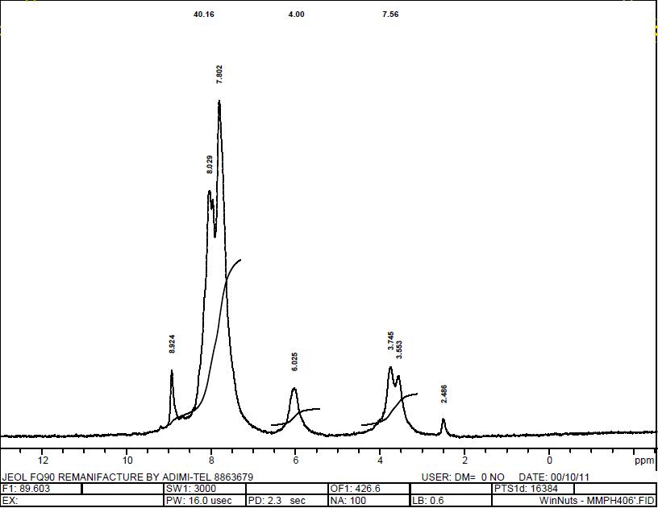

³¹P NMR of compound 6
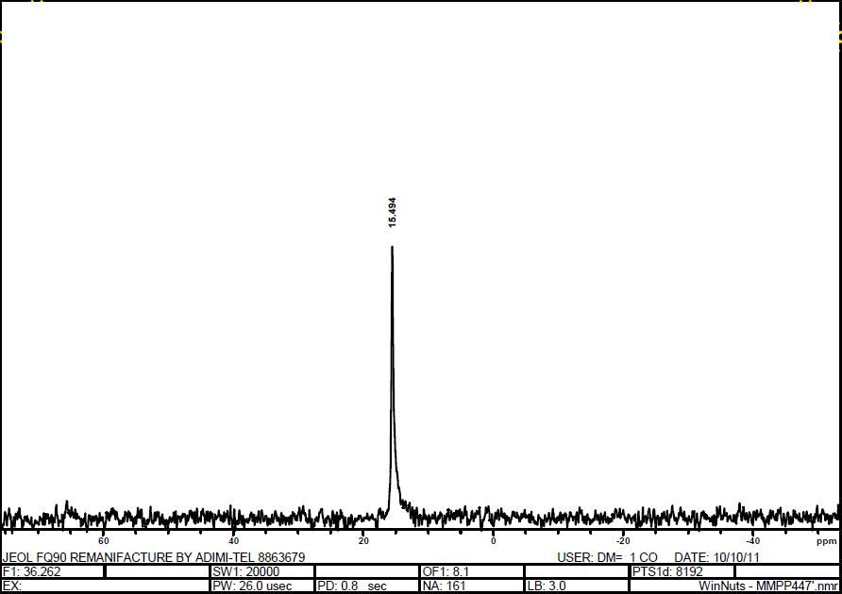

¹H NMR of compound 6

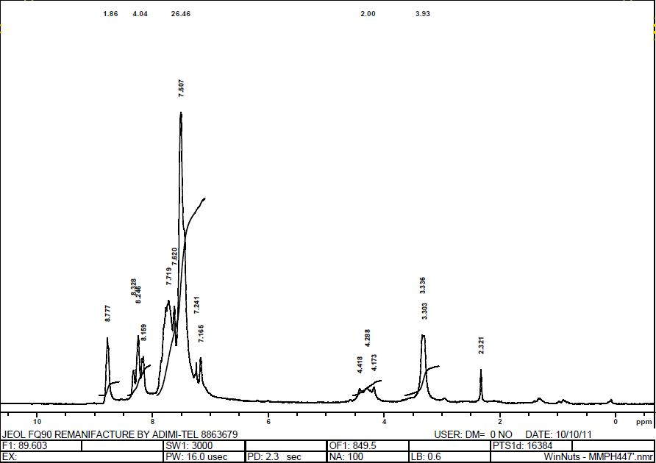

¹³C NMR of compound 6

³¹P NMR of complex 7

³¹P NMR of complex 8

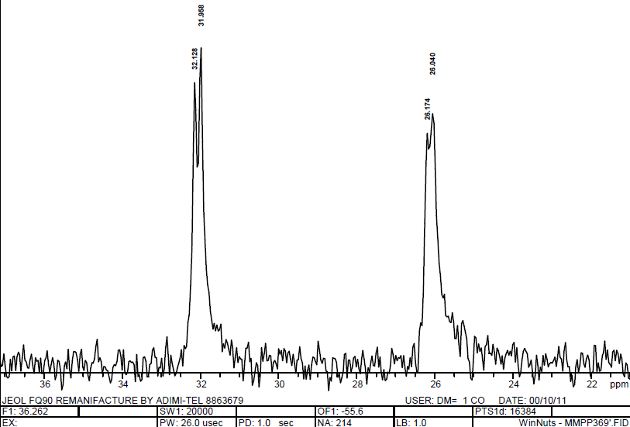

IR spectrum of complex 9

