An one-pot synthesis of 5,5-disubstituted hydantoin derivatives using magnetic Fe₃O₄ nanoparticles as a reusable heterogenous catalyst
Javad Safari*, Leila javadian
Laboratory of Organic Compound Research, Department of Organic Chemistry, College of Chemistry, University of Kashan, P.O. Box: 87317-51167 Kashan, Islamic Republic of Iran.

4. Experimental section
Spectral data:

¹H NMR 4a:
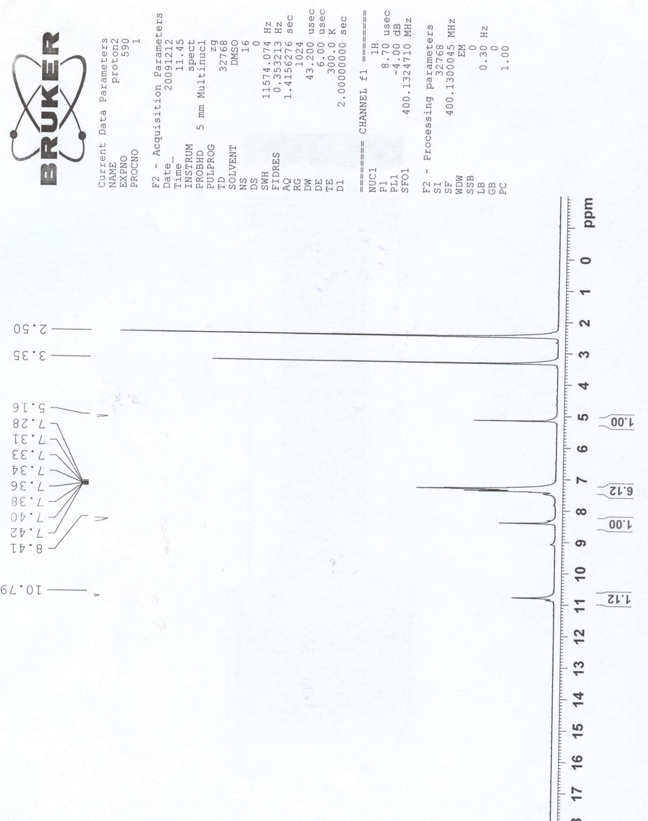

¹H NMR 4b:

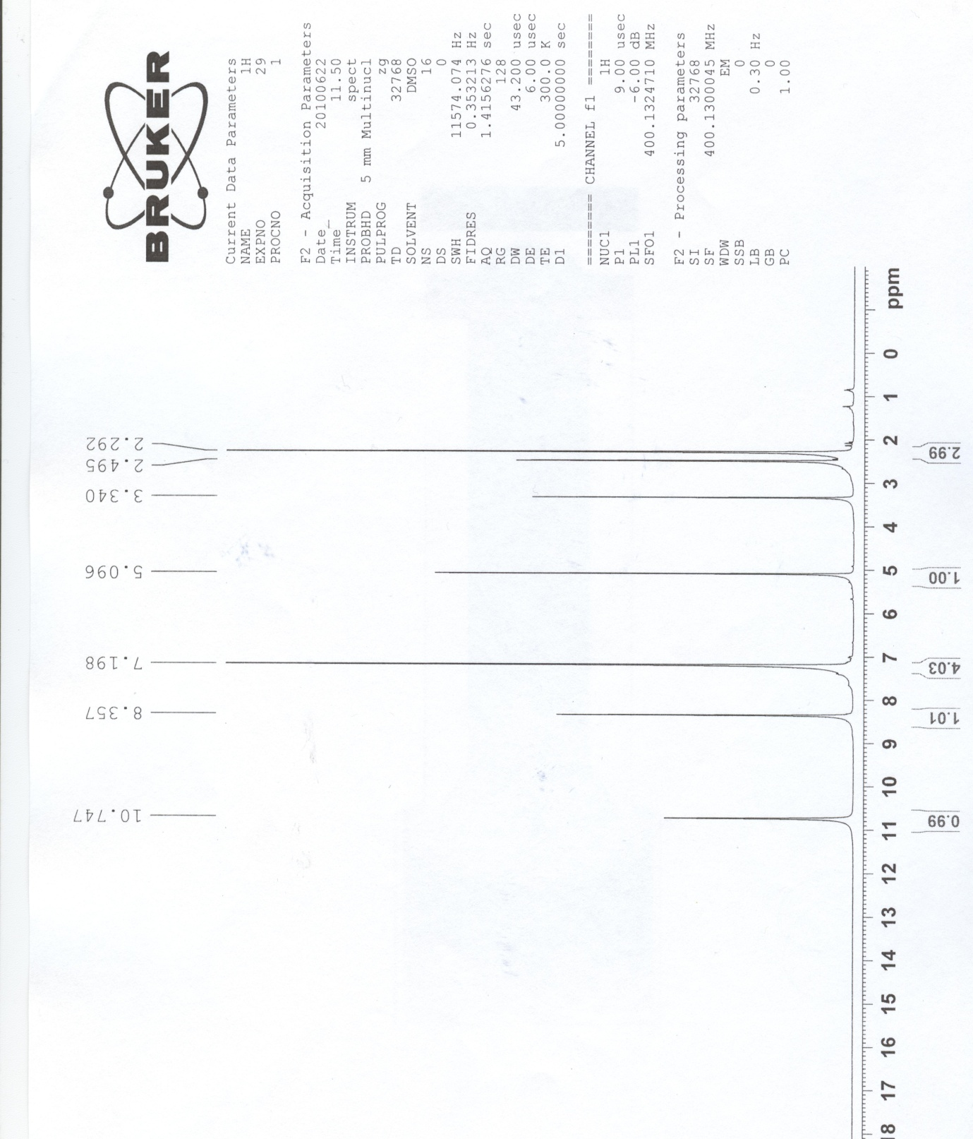

¹³C NMR 4b:

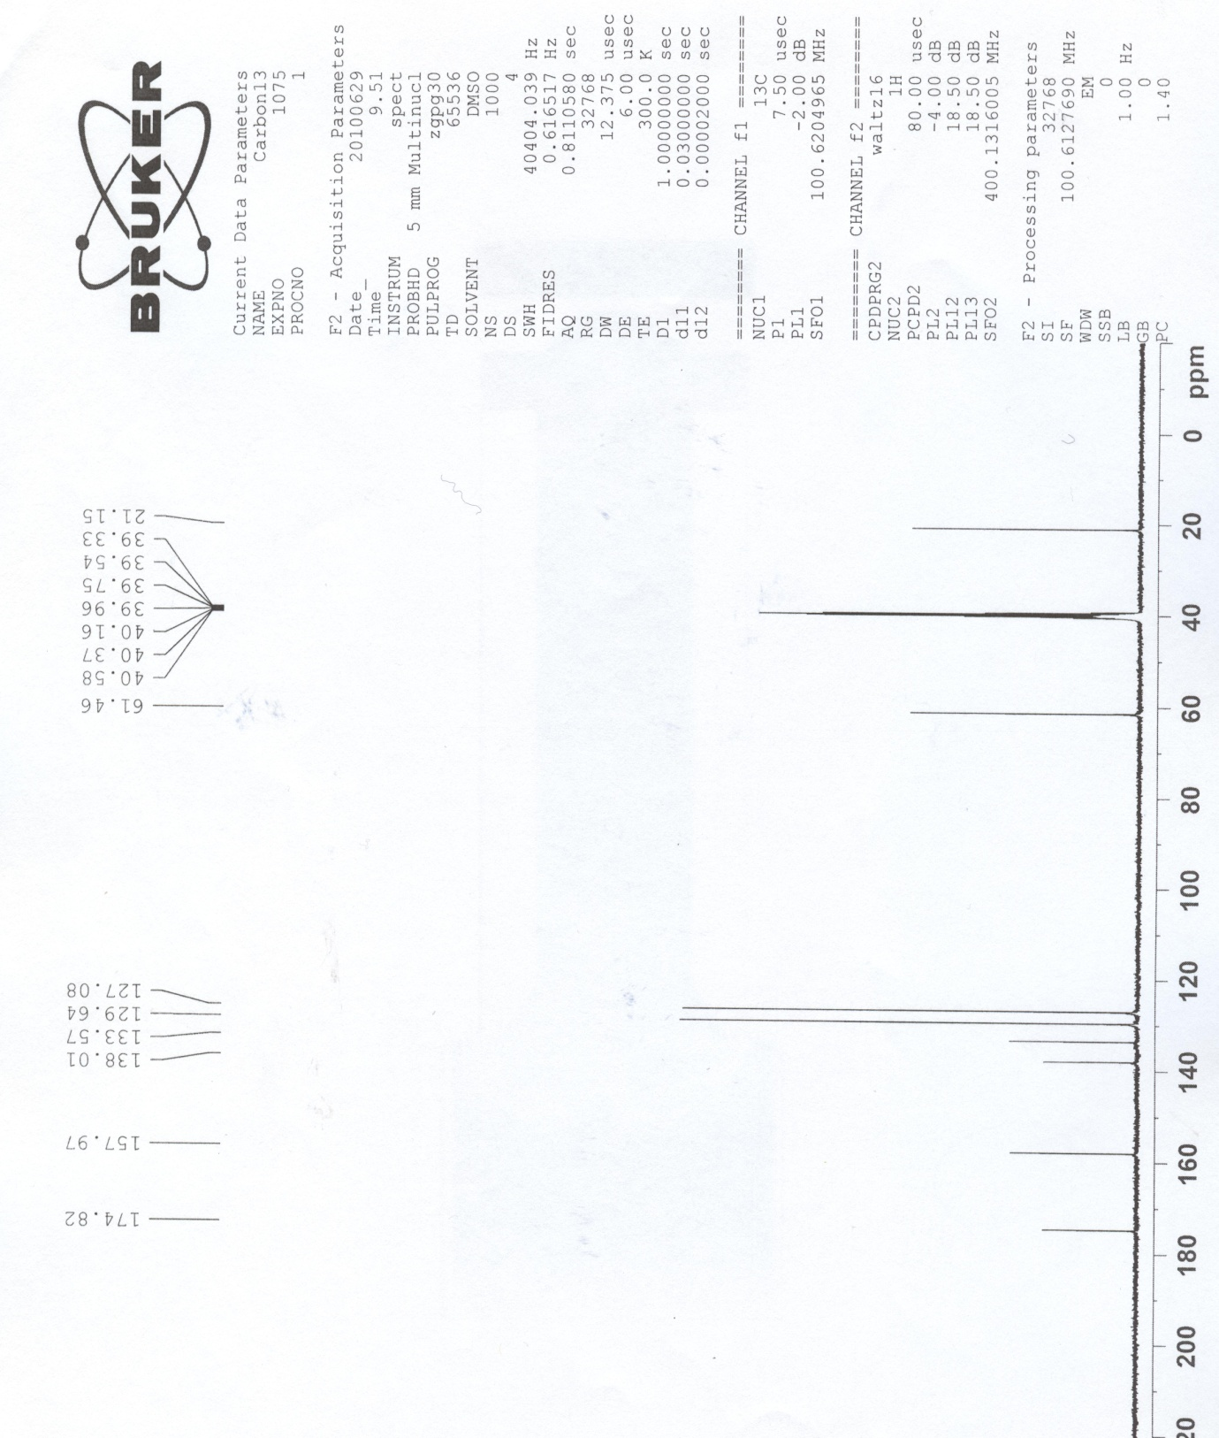

¹H NMR 4c:
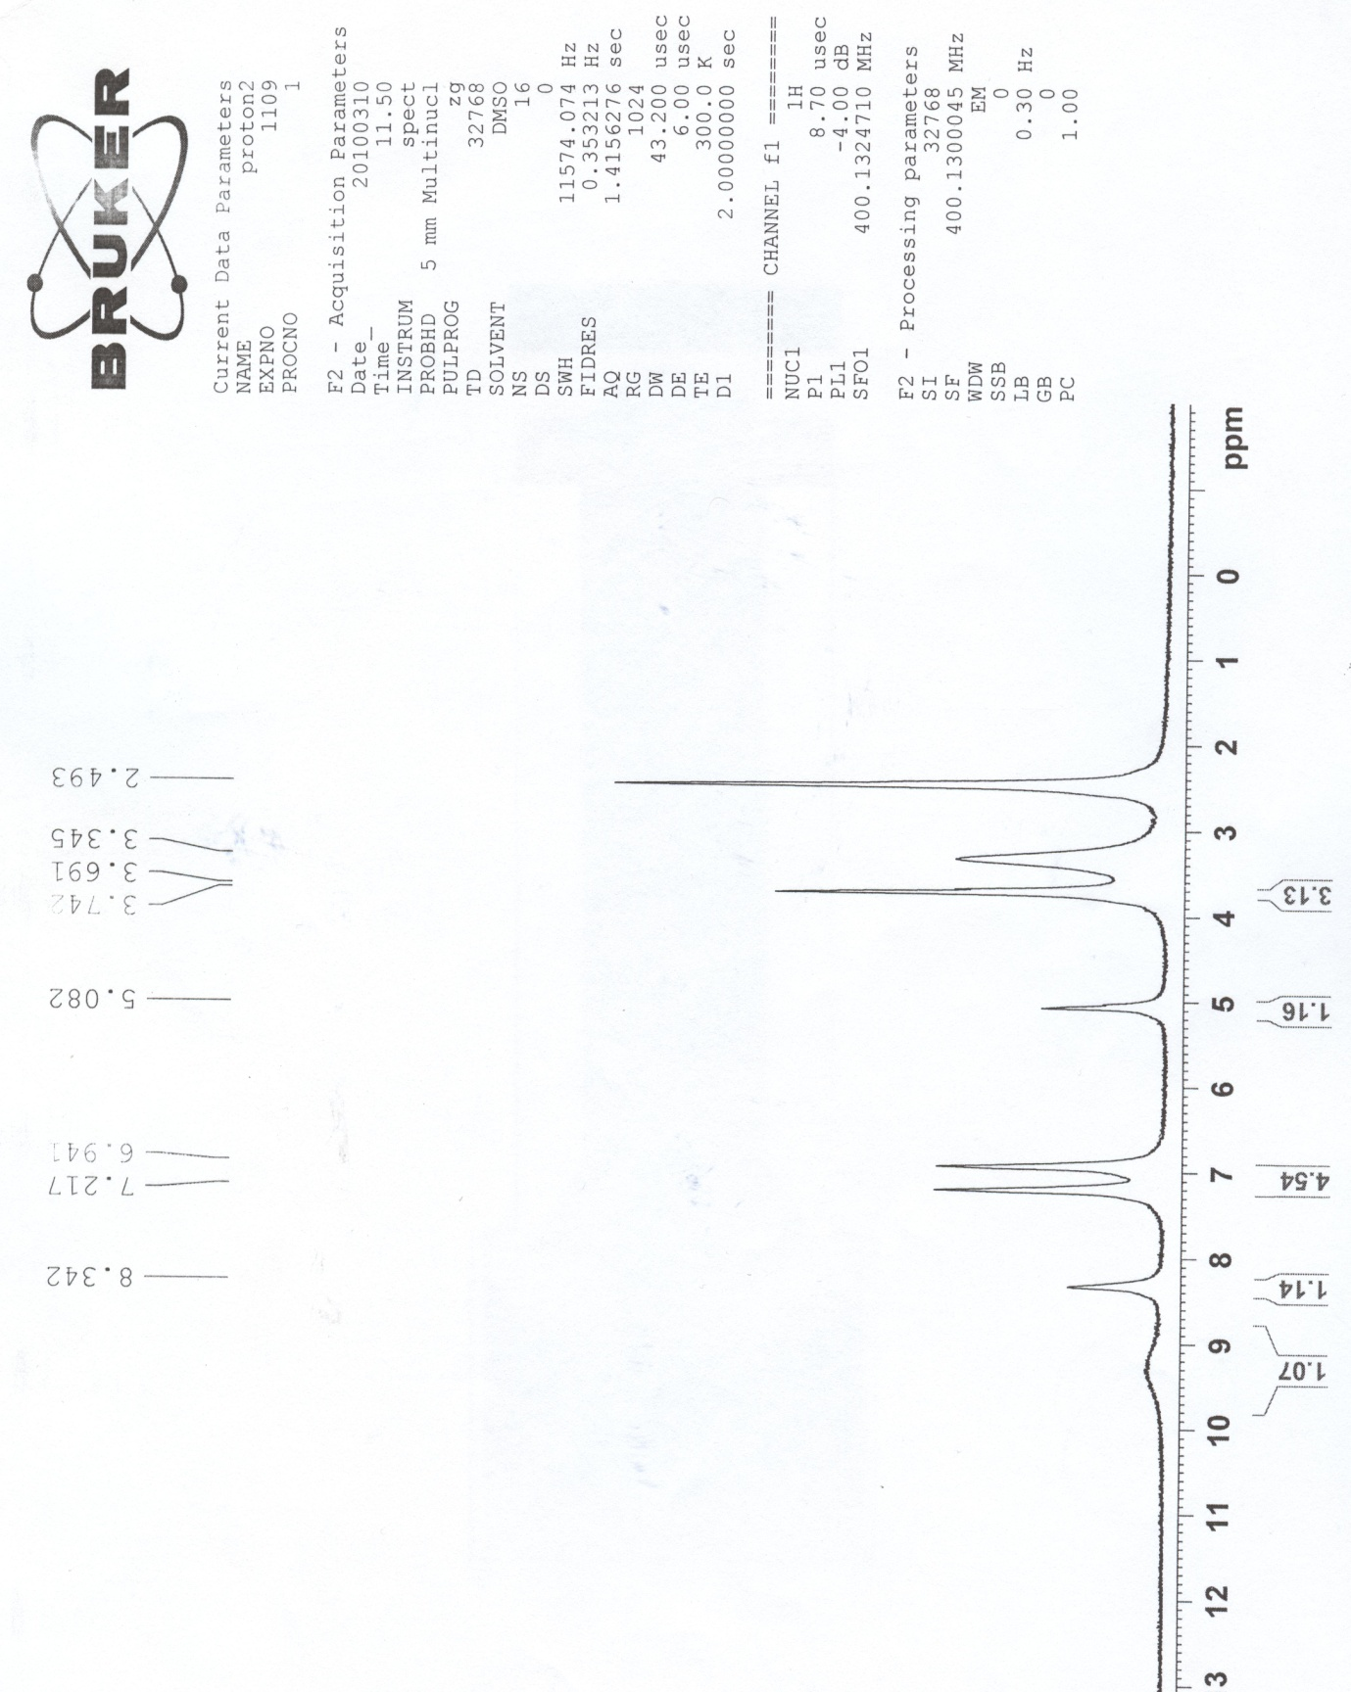

¹³C NMR 4c:
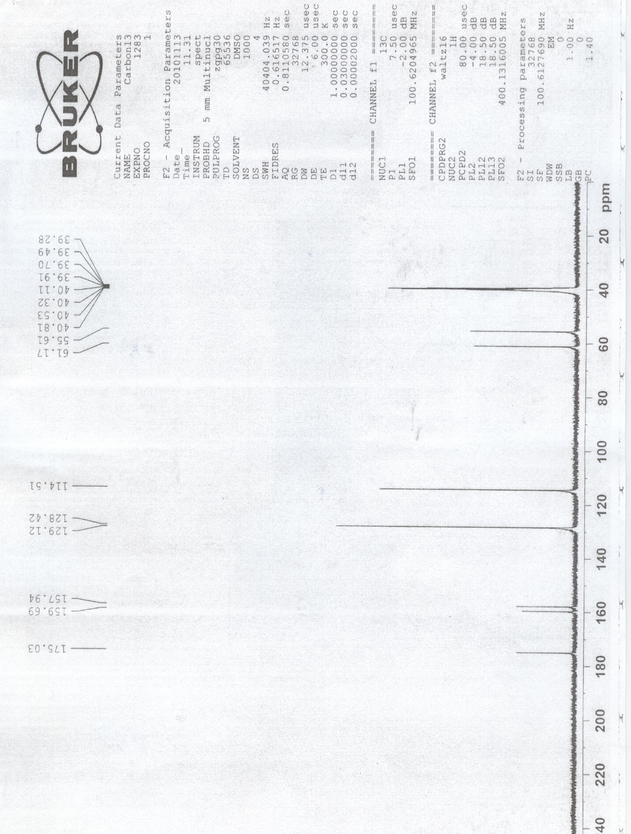

IR 4c:
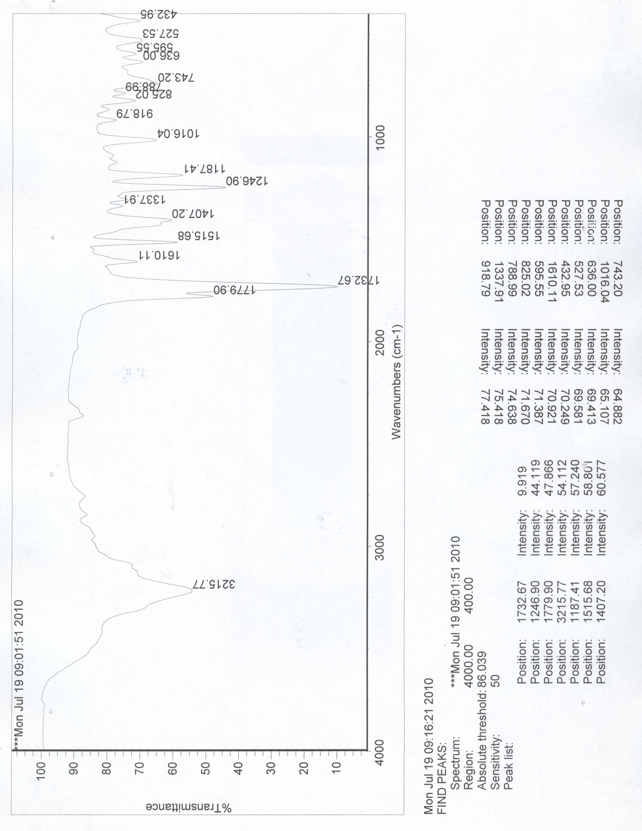

¹H NMR 4f:
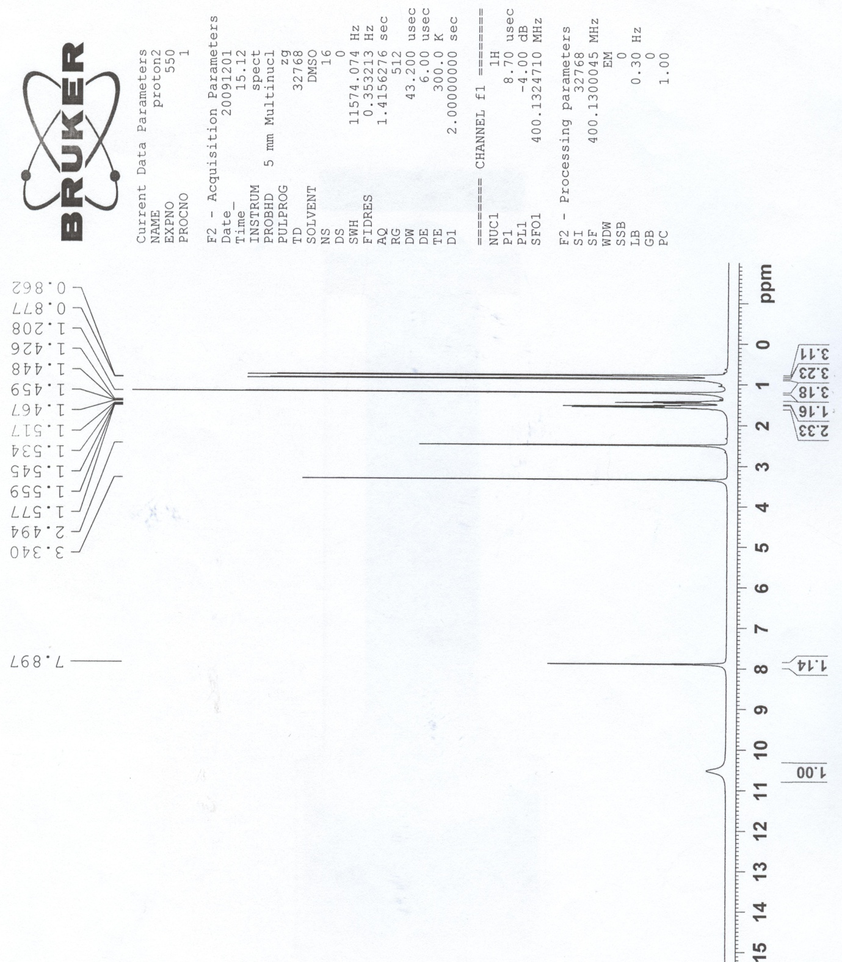

¹H NMR 4g:
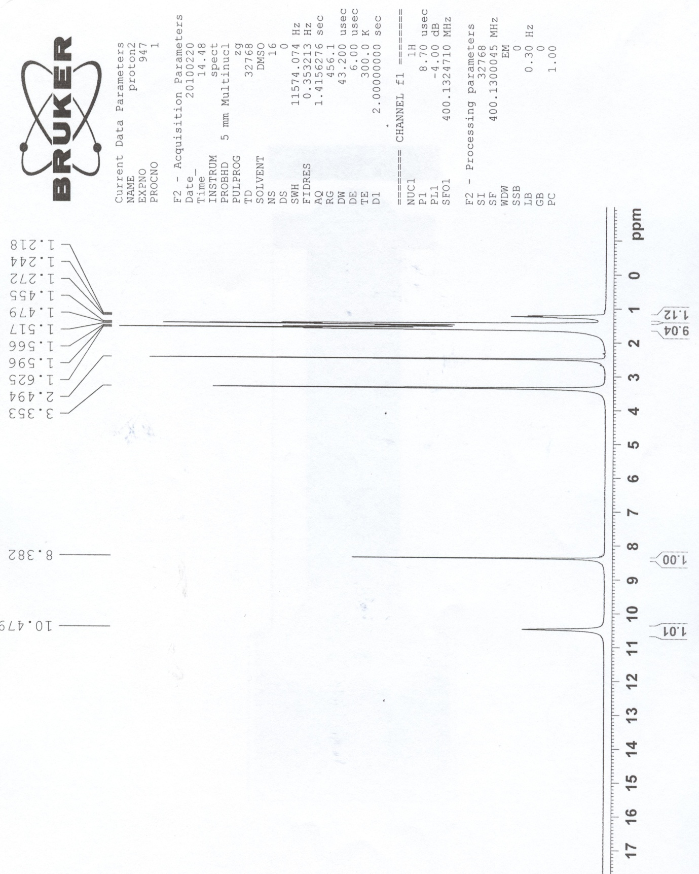

IR 4g:
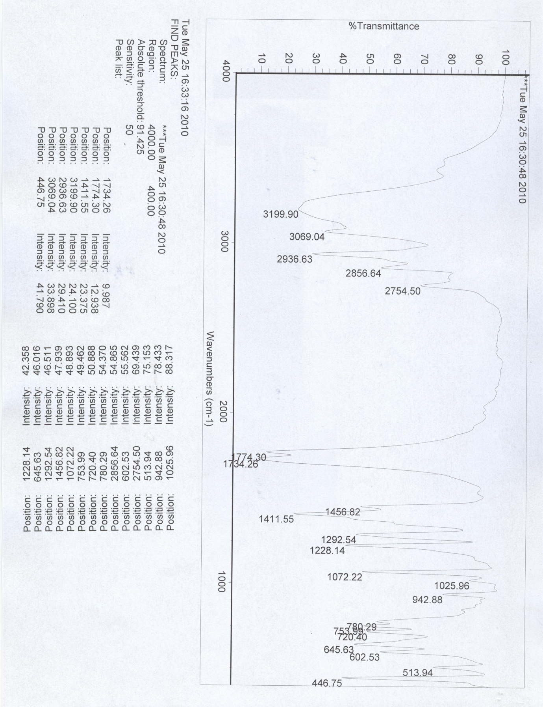

1H NMR 4h:
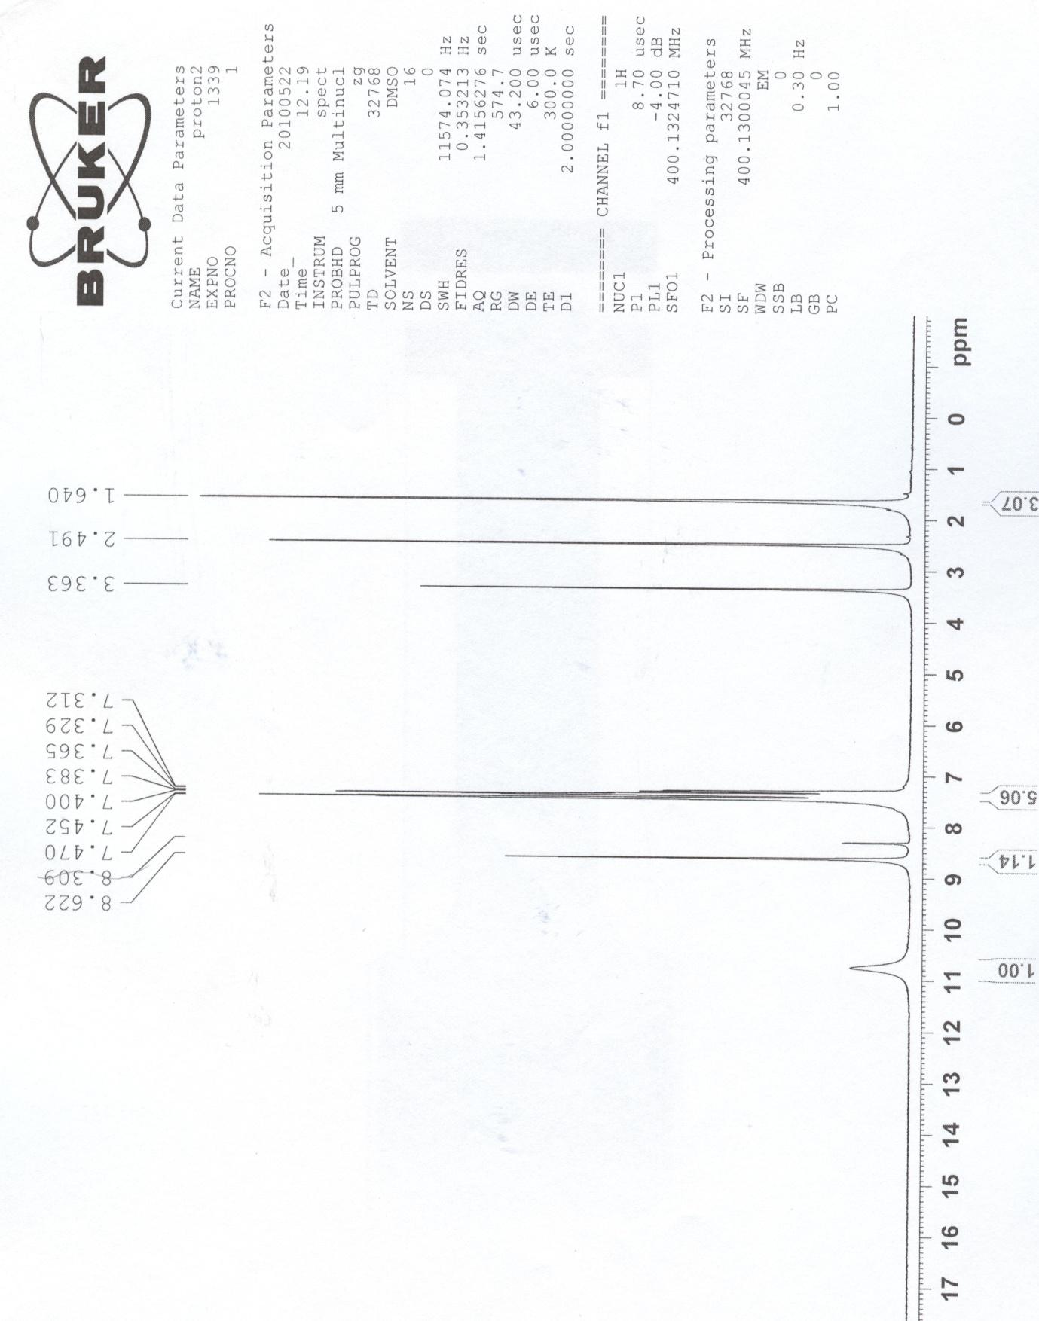

1H NMR 4i:
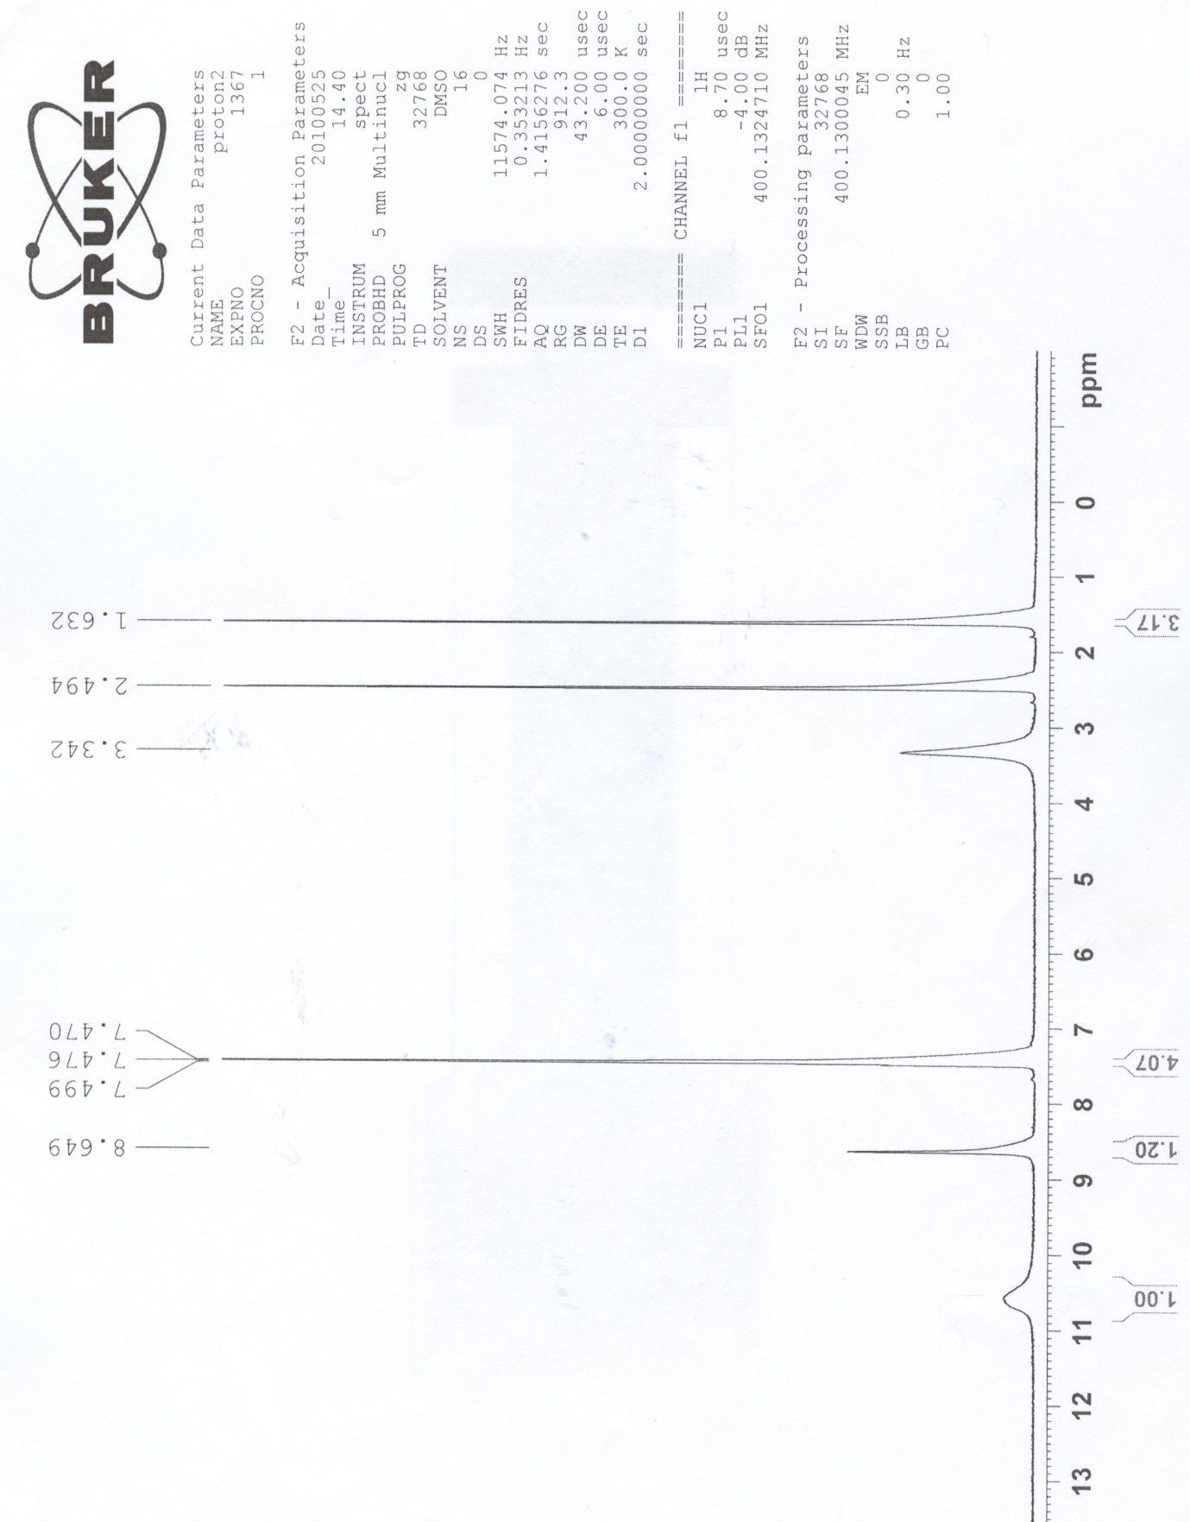

13C NMR 4i:
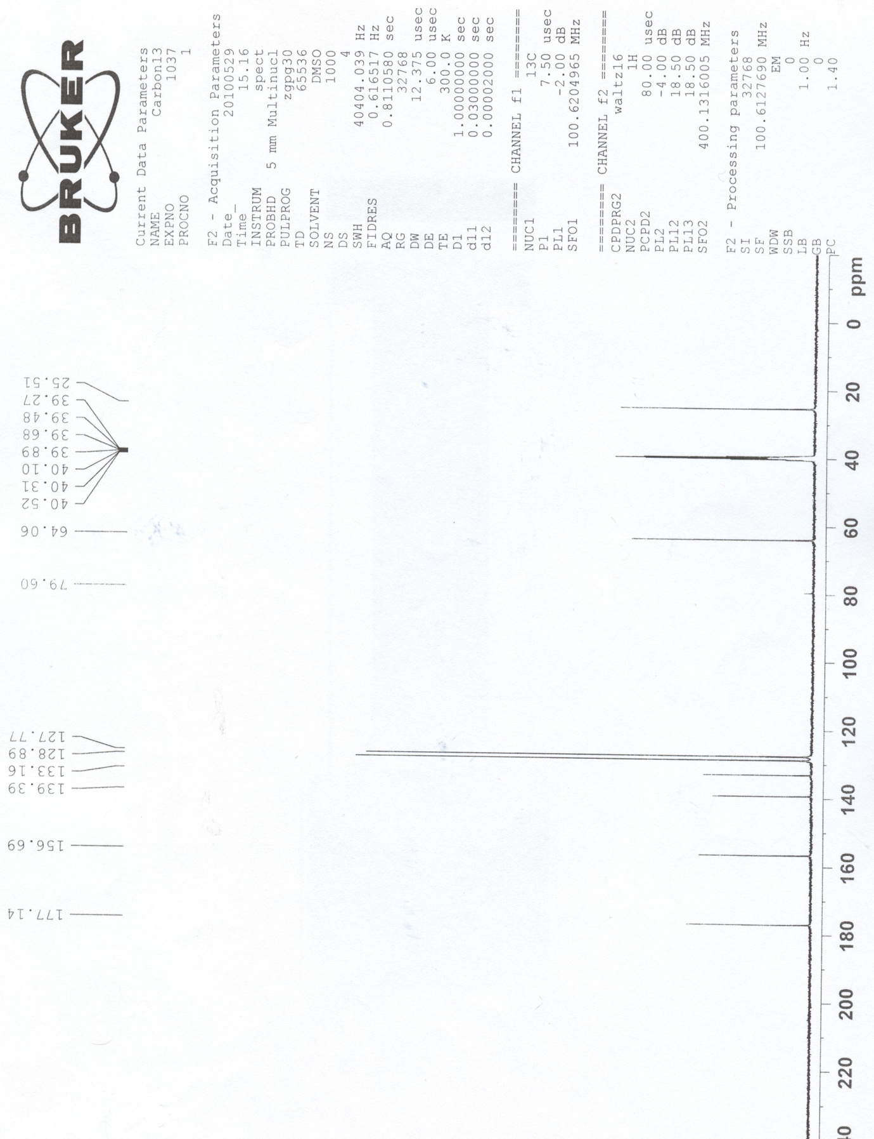

IR 4i:
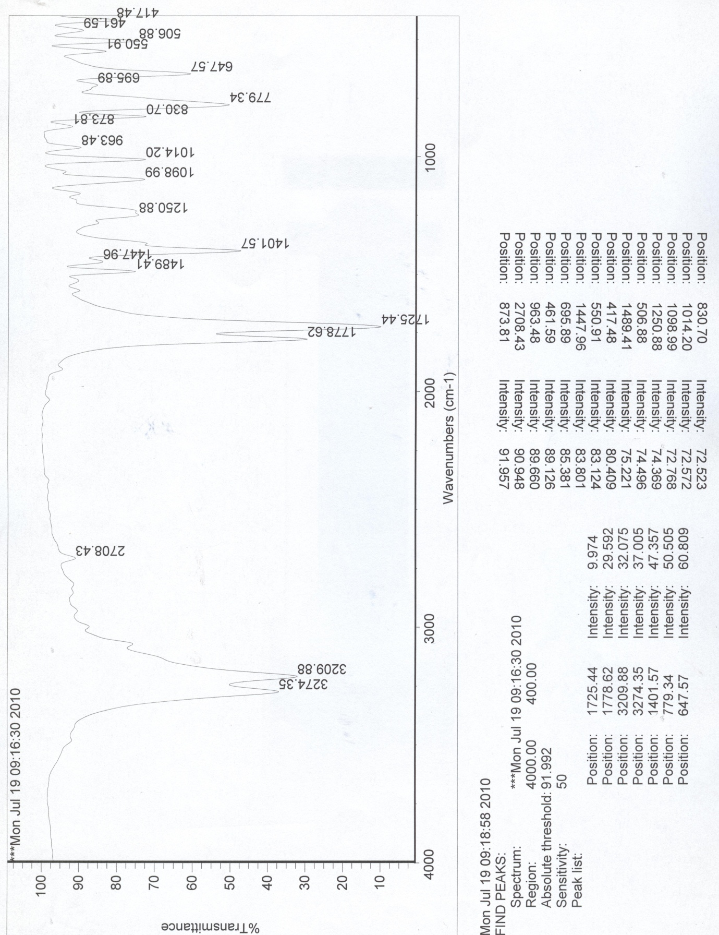

1H NMR 4j:
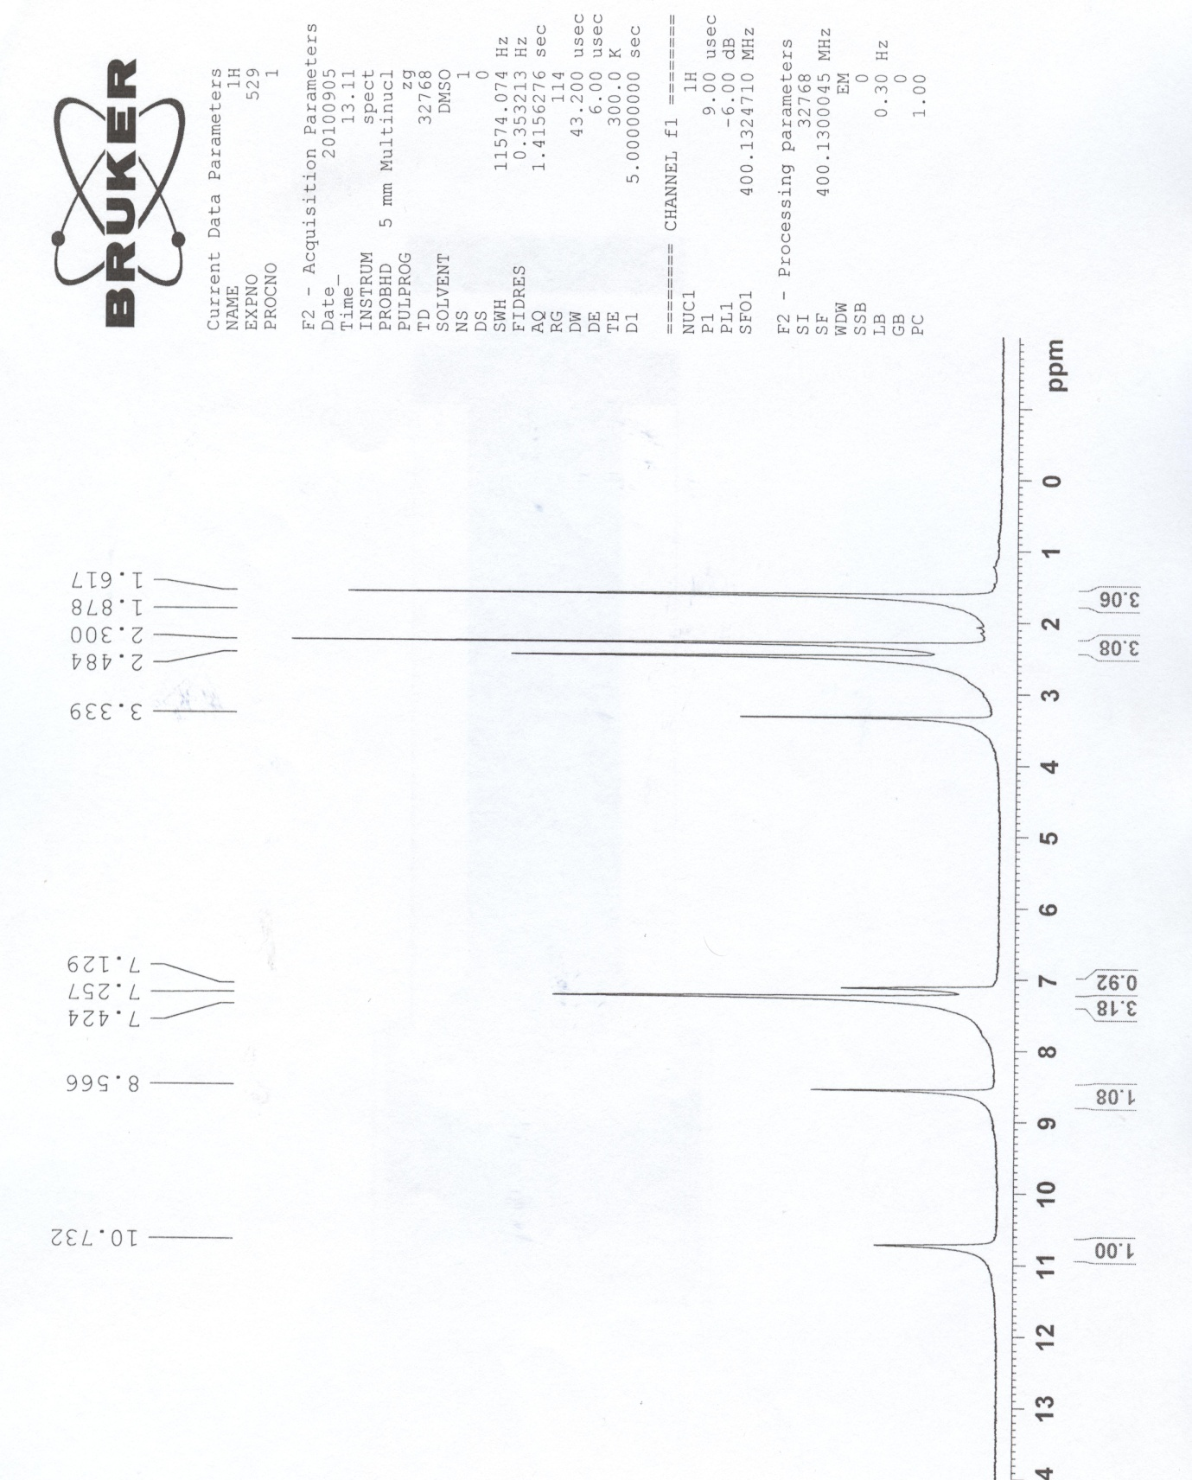

1H NMR 4l:
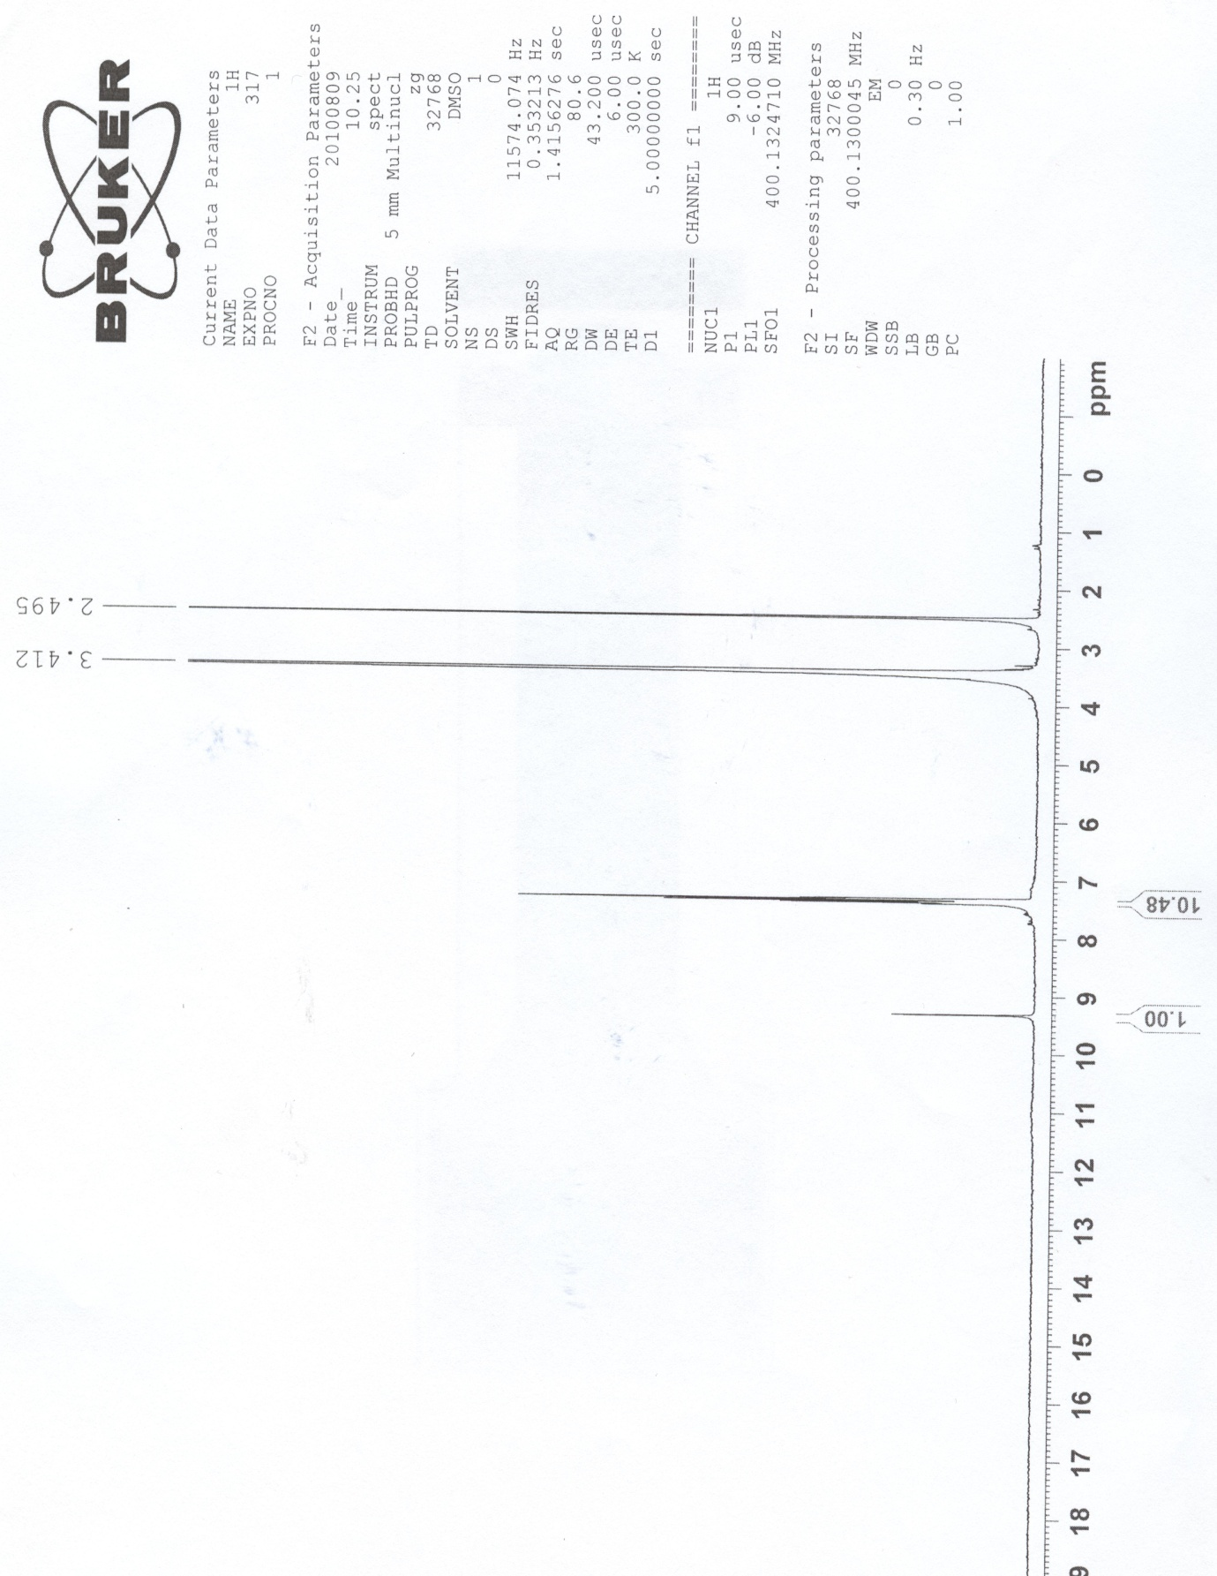

1H NMR 4l(expanded):

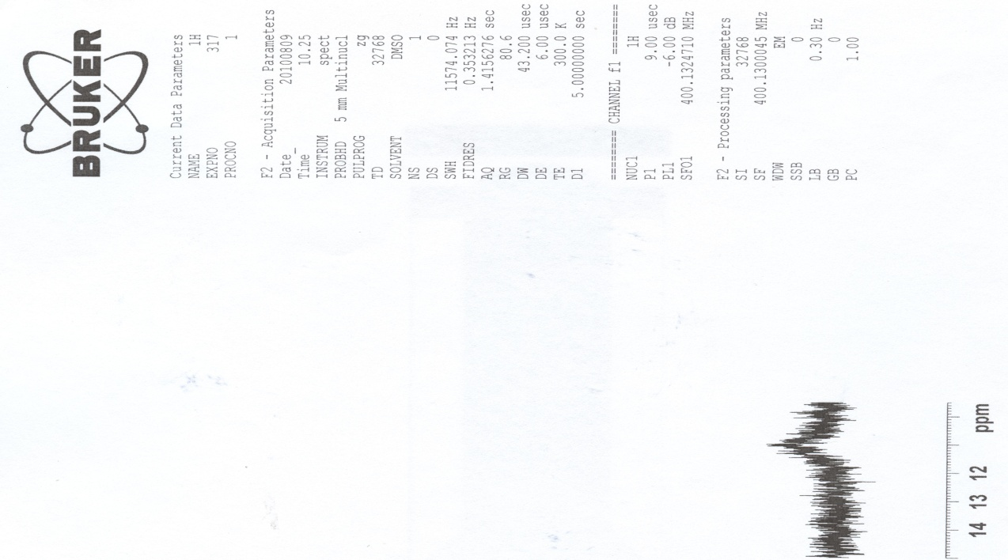

13C NMR 4l:
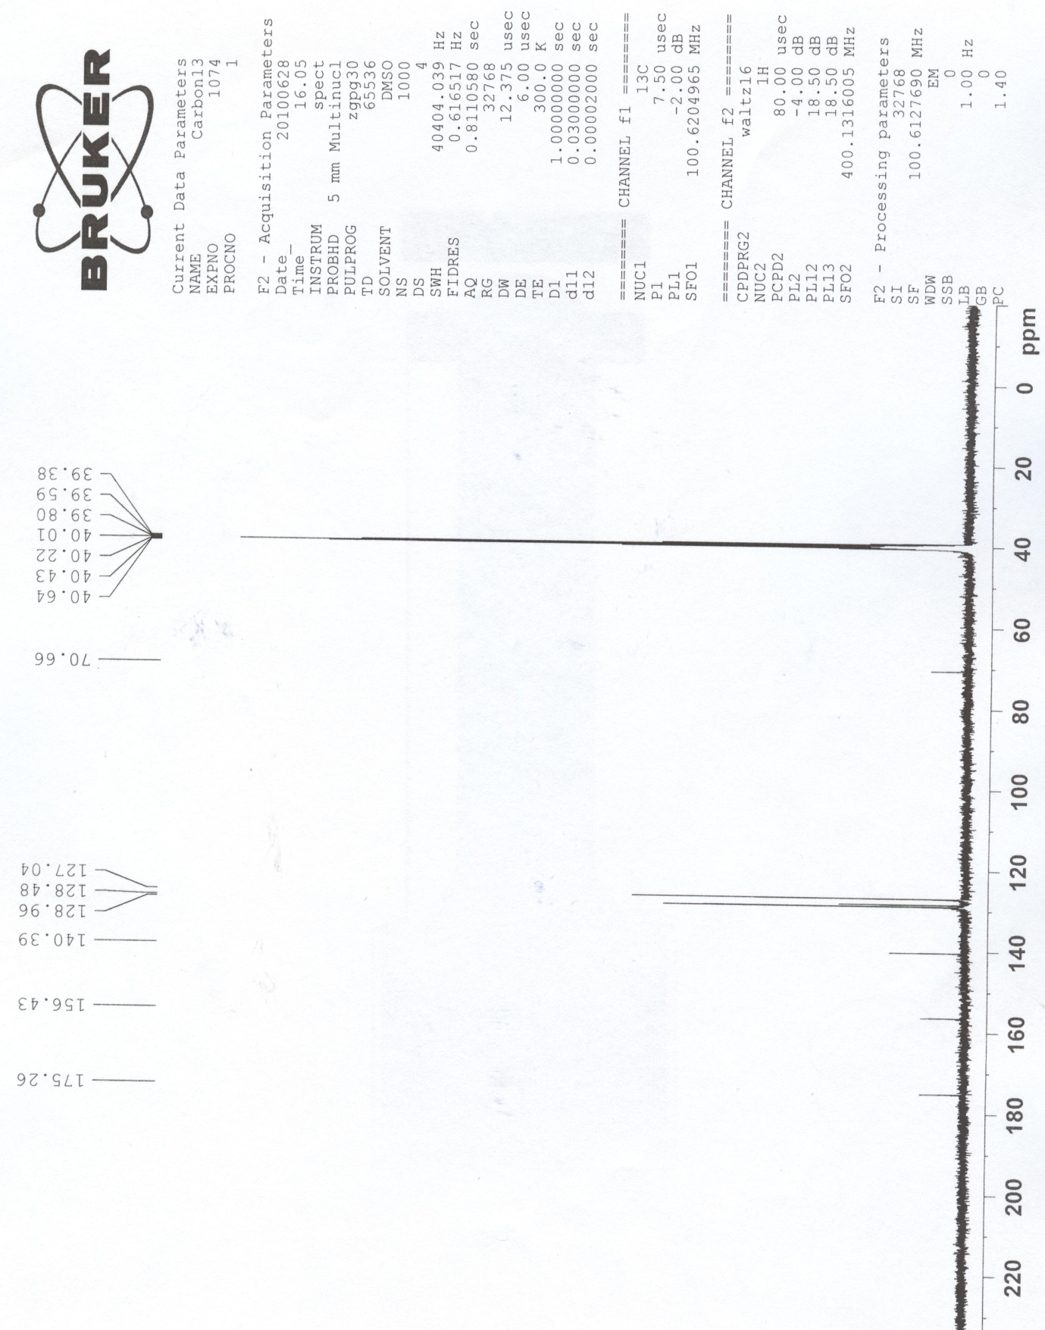

1H NMR 4m:
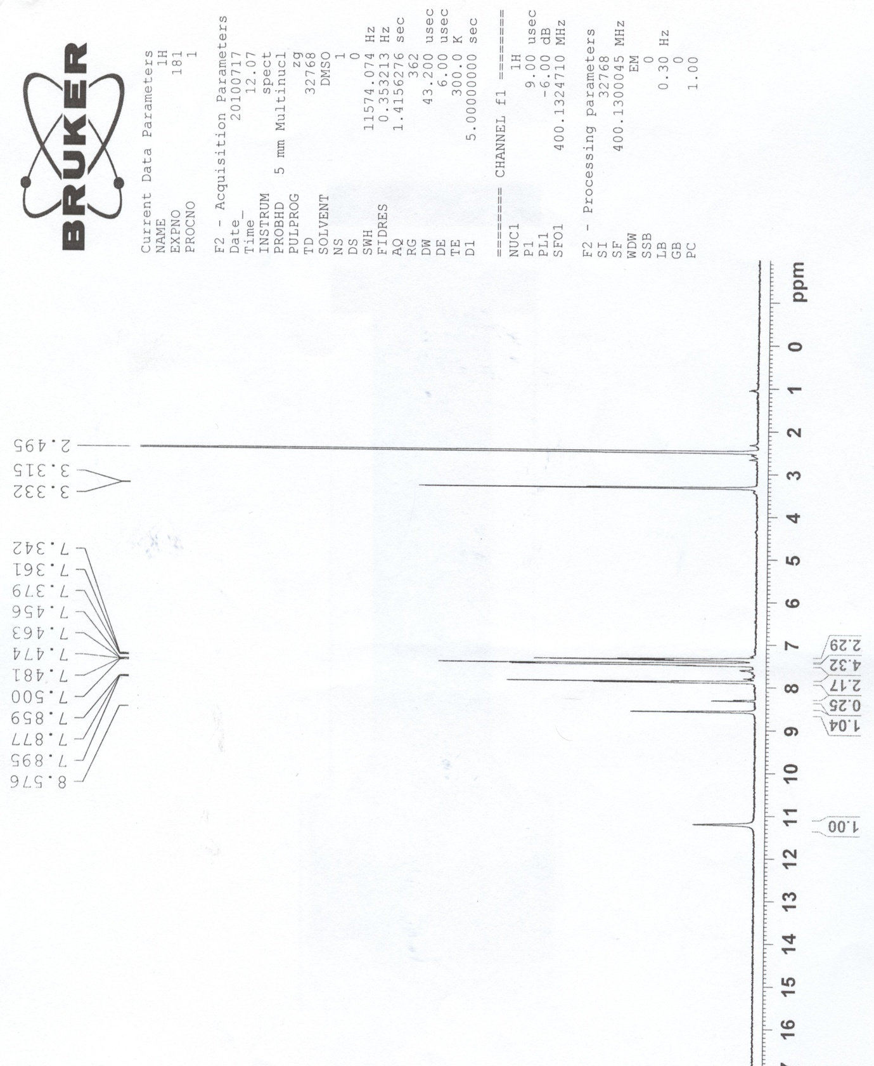

1H NMR 4m(expanded):
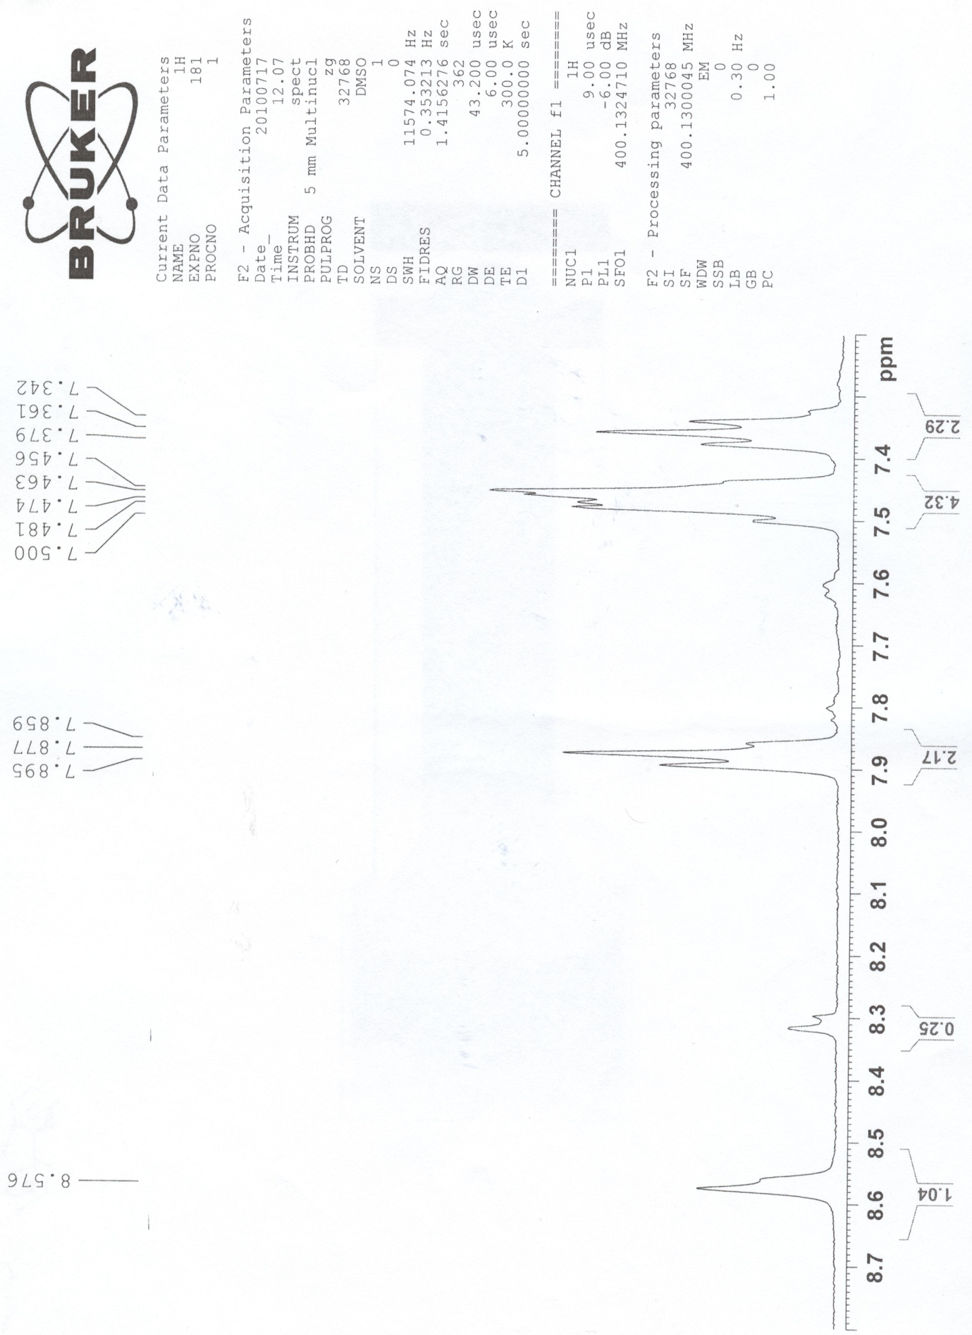

13C NMR 4m:
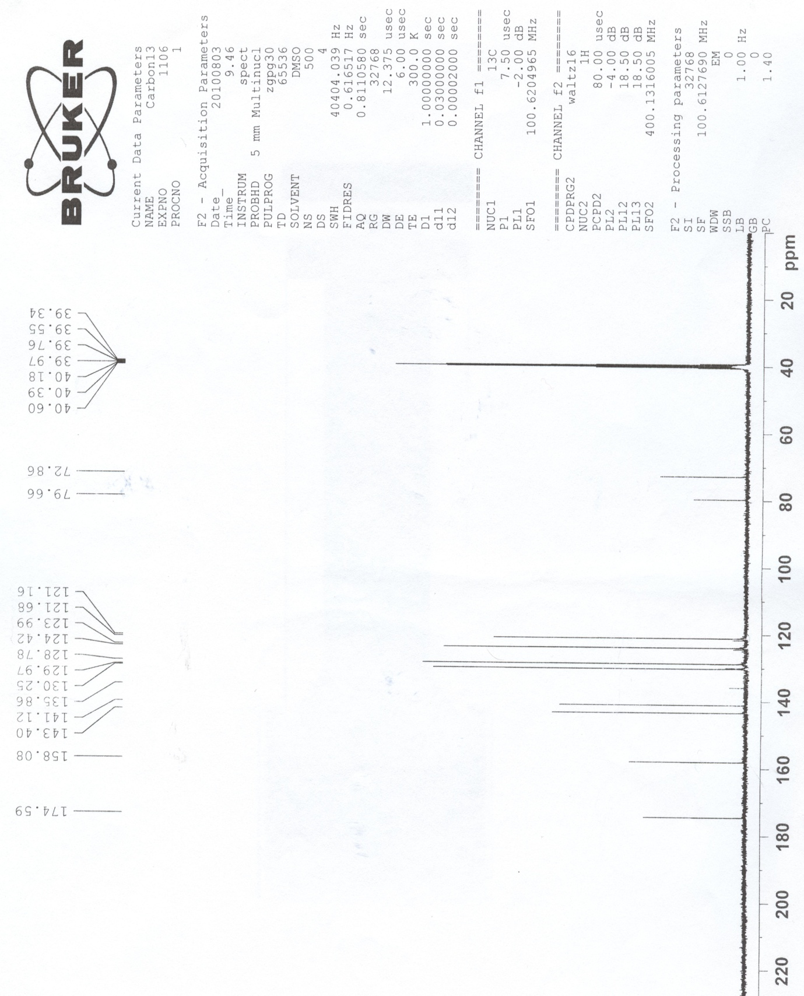

IR 4m:
