***Supporting Information***

**One-pot synthesis of** **2-amino-3-cyanopyridine derivatives under solvent-free conditions**

Ramin Ghorbani-Vaghei, a* Zahra Toghraei-Semiromi, a RahmanKarimi-Nami b

aDepartment of Organic Chemistry, Faculty of Chemistry, Bu-Ali Sina University 65174, Hamedan, Iran

Fax/Tel +98(811)8257407; E-mail: rgvaghei@yahoo.com

b School of Chemistry, University College of Science, University of Tehran, PO Box 14155-6455, Tehran, Iran

Table of Contents:

1H and 13C NMR Spectra of compound 5a…………………………………………………..……….….3

Mass and Anal. Calcd of compound 5a ………………………..………………………………….……...4

1H and 13C NMR Spectra of compound 5b …………………………………………………..……...….5

1H NMR Spectra of compound 5b with one drop D2O ……………………………..……....…...6

Mass and Anal. Calcd of compound 5b …………………………….………………………… ………...7

1H and 13C NMR Spectra of compound 5c …………………………………………………..………….8

Mass and Anal. Calcd of compound 5c ………………………………………………...………………....9

1H and 13C NMR Spectra of compound 5d…………………………………….....………..…………...10

Mass and Anal. Calcd of compound 5d ………………………………….…………….……..………….11

1H and 13C NMR Spectra of compound 5e .……………………………………………………….…...12

Mass of compound 6a and Anal. Calcd of compound 5e …………………………………….……13

1H and 13C NMR Spectra of compound 5f ……………………………….…………………….…….…14

Mass and Anal. Calcd of compound 5f …………………………..……………………….………………15

1H and 13C NMR Spectra of compound 5g …………………………………………………..……….…16

Mass and Anal. Calcd of compound 5g ………………………………………………..…..………..…...17

1H and 13C NMR Spectra of compound 5h ……………………………………………….………………18

Mass and Anal. Calcd of compound 5h ……………………………………..……….…………..…….…19

1H and 13C NMR Spectra of compound 5i ….………………………………….…………………..…..20

Mass and Anal. Calcd of compound 5i …………………………….……………….……..……..…….…21

1H and 13C NMR Spectra of compound 5j ……………………………………………….………………22

Mass and Anal. Calcd of compound 5j ……………………………………..……….…………..…….…23

1H and 13C NMR Spectra of compound 5k ……………………………………………….………………24

Mass and Anal. Calcd of compound 5k ……………………………………..……….…………..…….…25

1H NMR Spectra of compound 5a

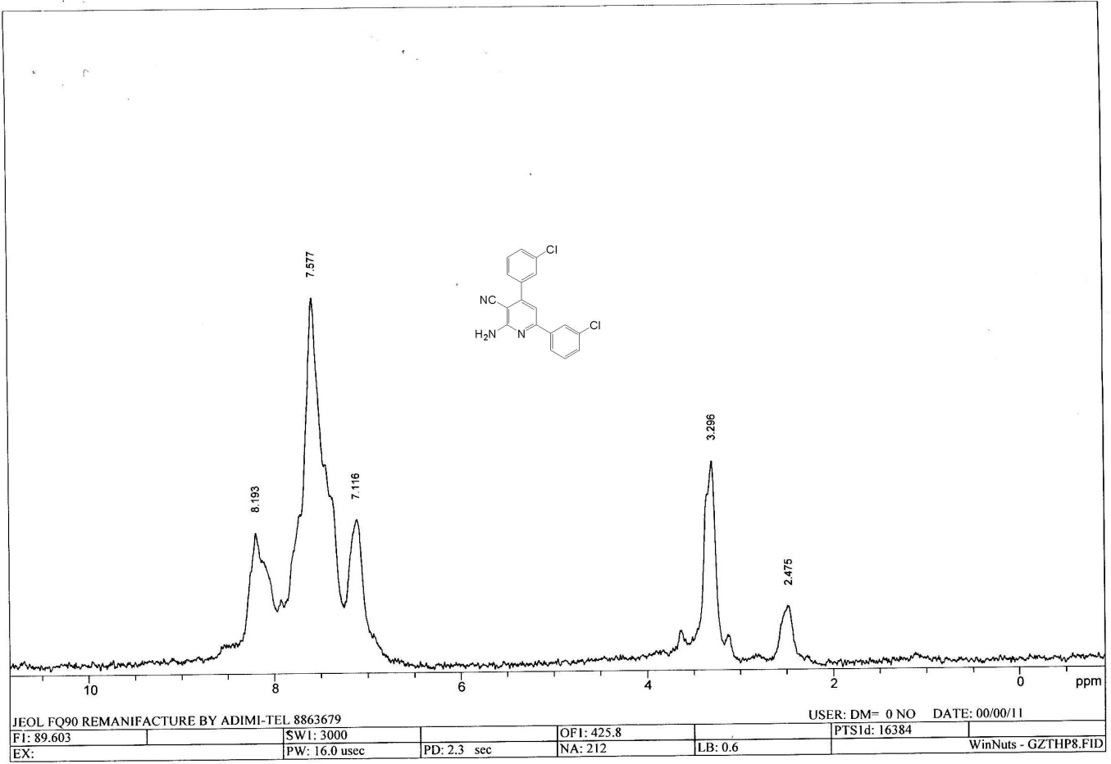13C NMR Spectra of compound 5a

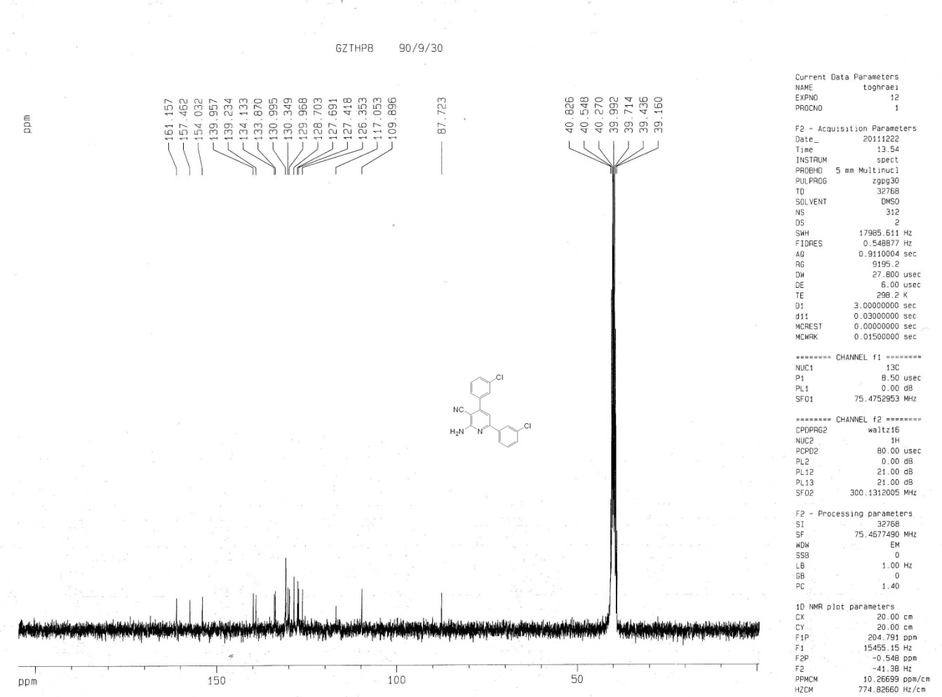

Mass of compound 5a

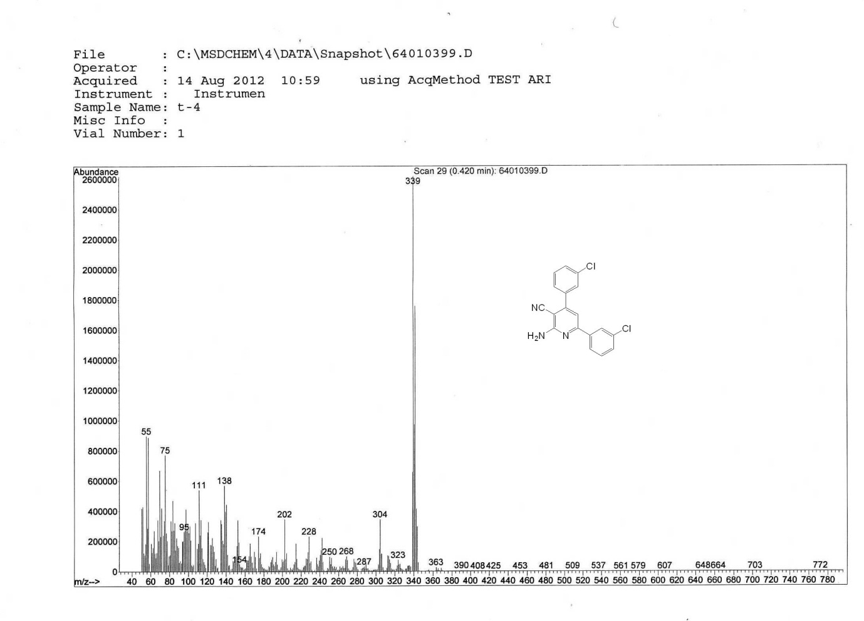

Anal. Calcd of compound 5a

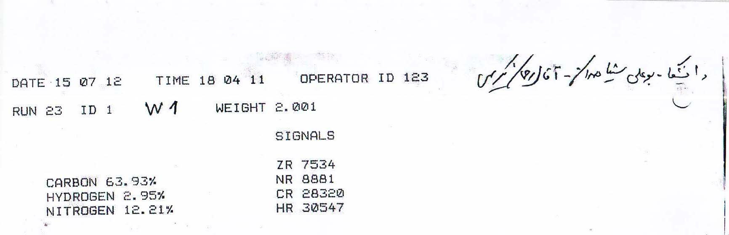

1H NMR Spectra of compound 5b

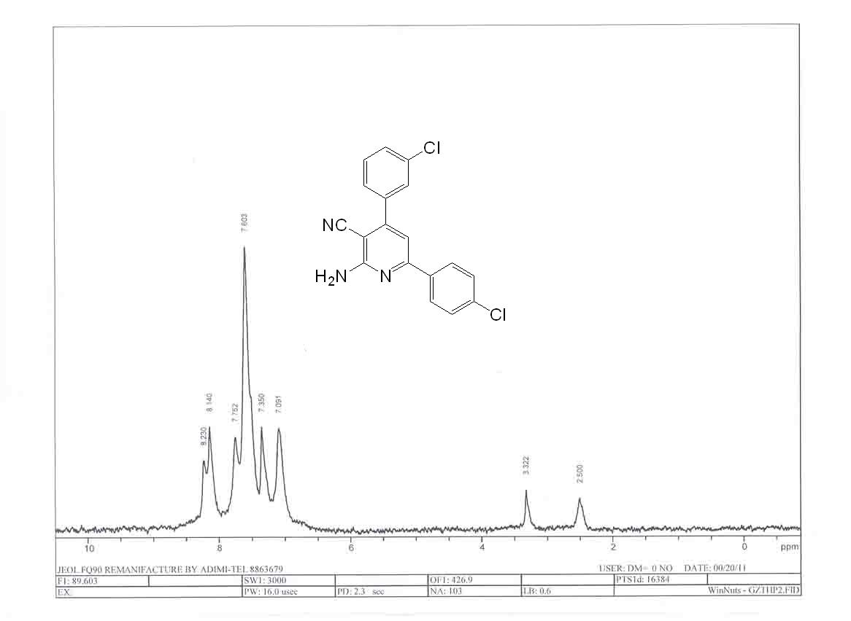

13C NMR Spectra of compound 5b

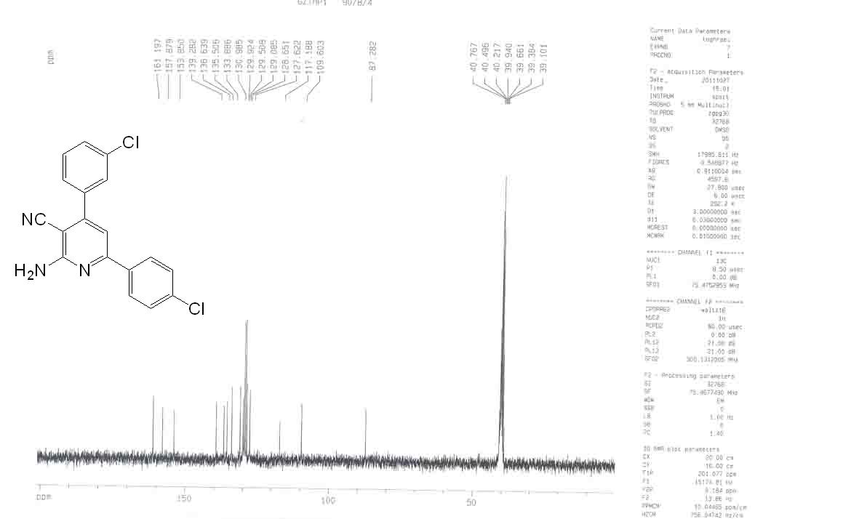

1H NMR Spectra of compound 5b with one drop D2O

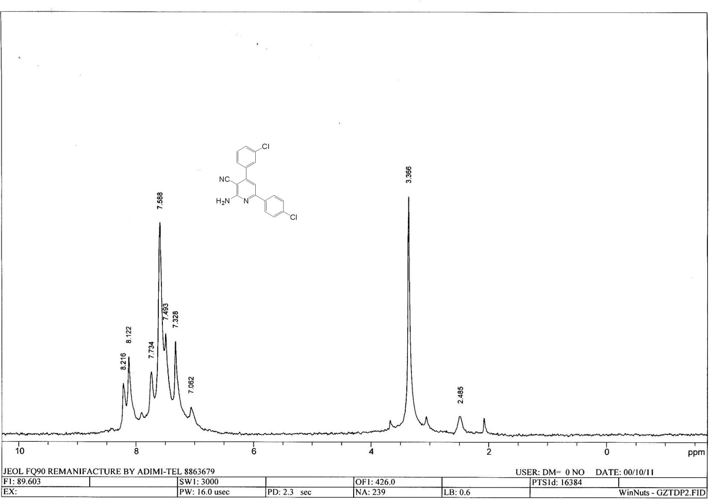

Mass of compound 5b

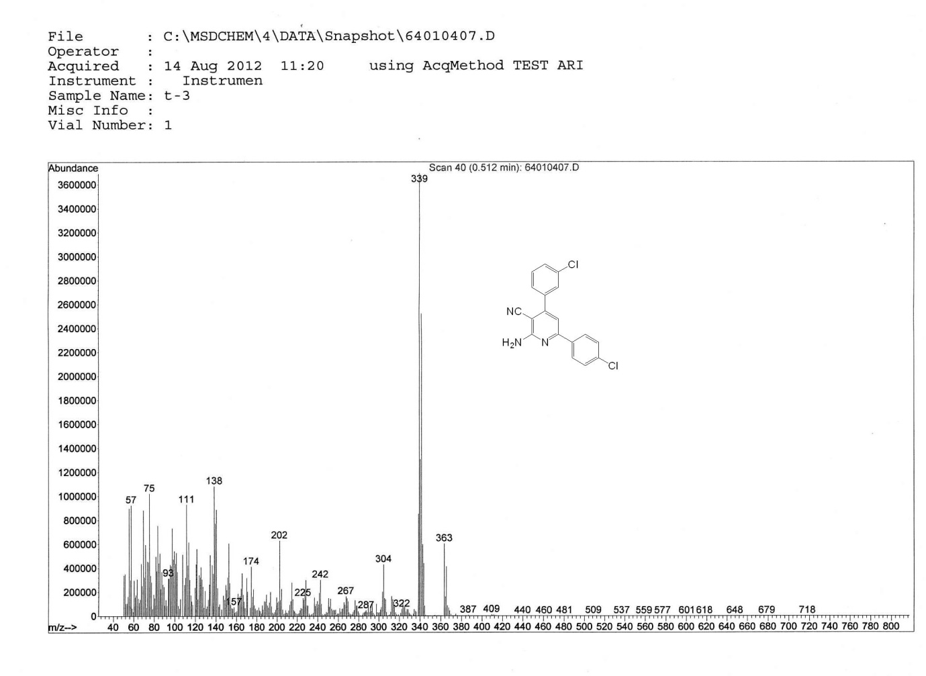

Anal. Calcd of compound 5b

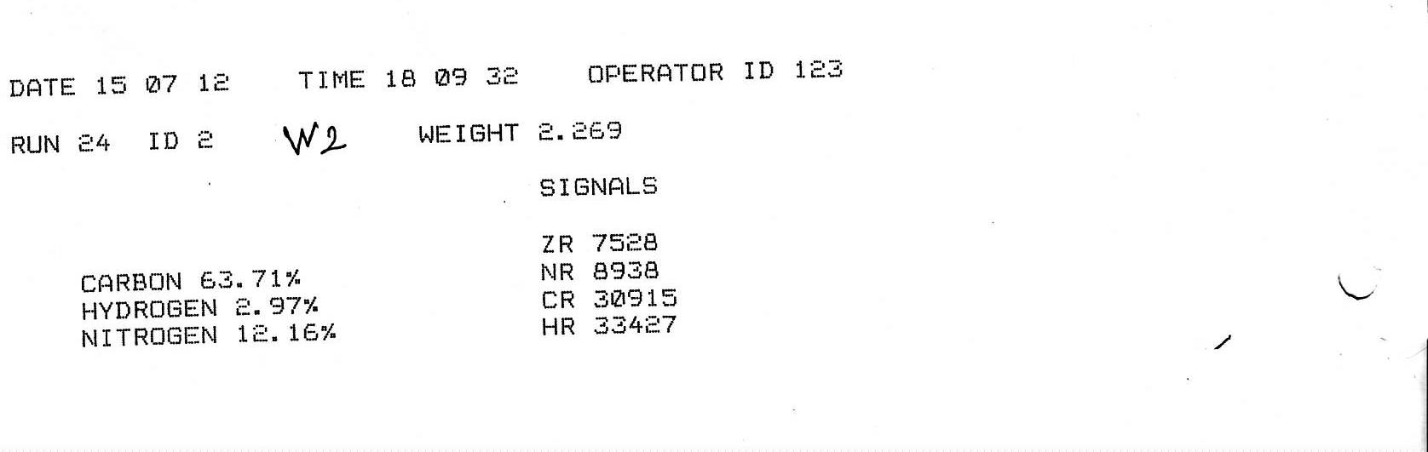

1H NMR Spectra of compound 5c

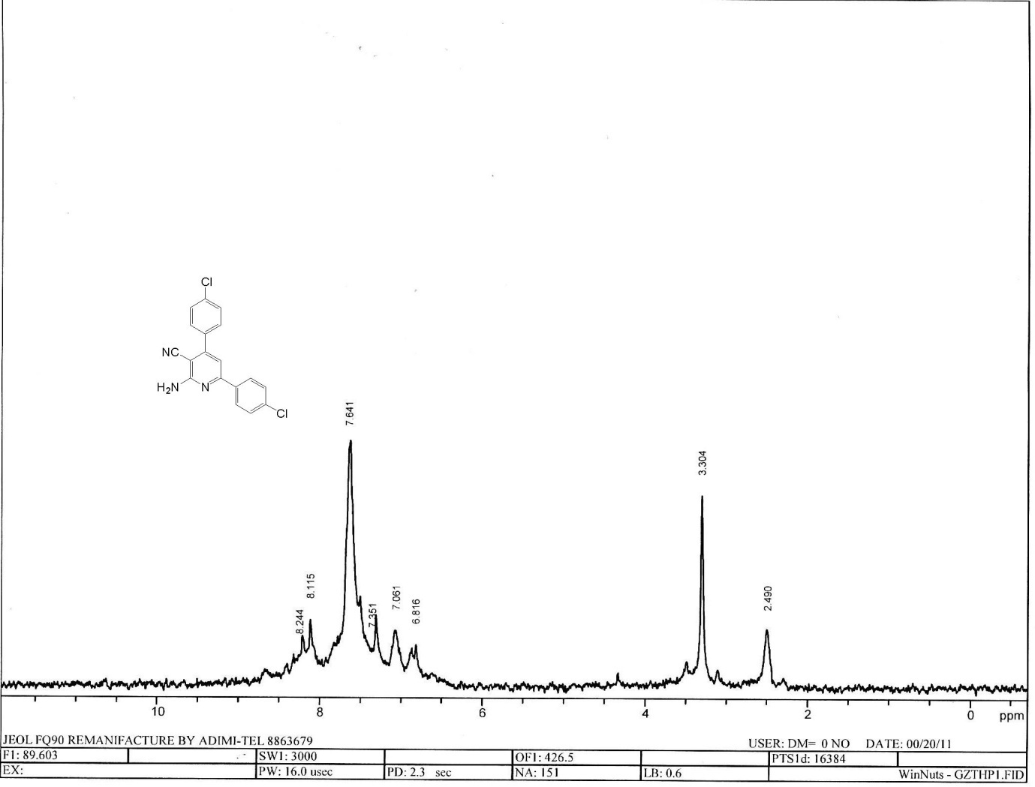

13C NMR Spectra of compound 5c

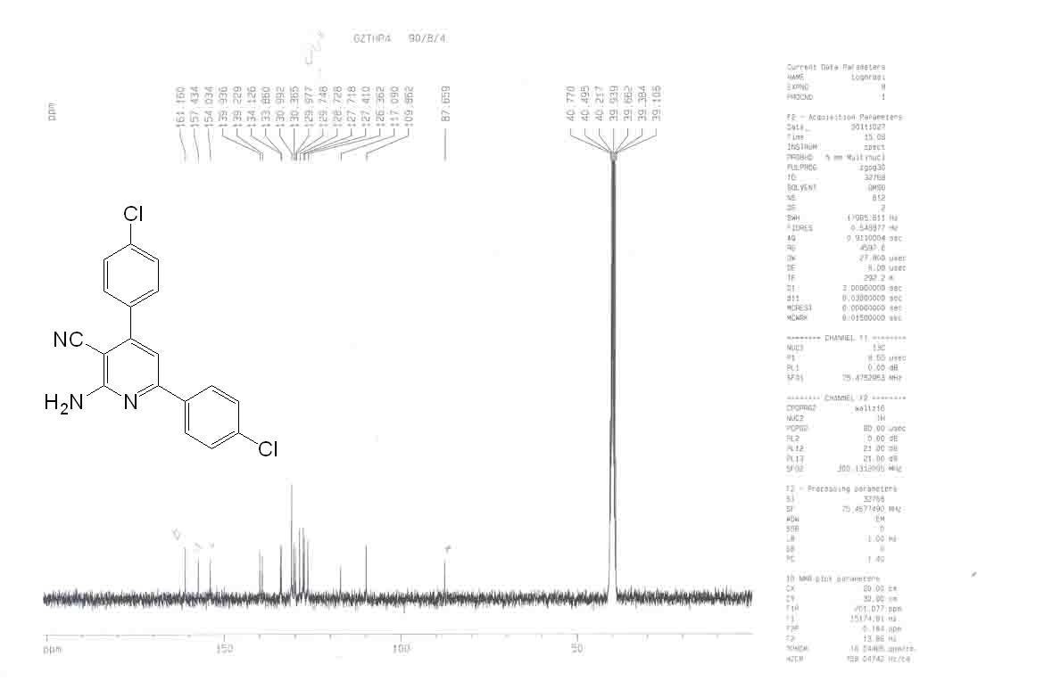

Mass of compound 5c

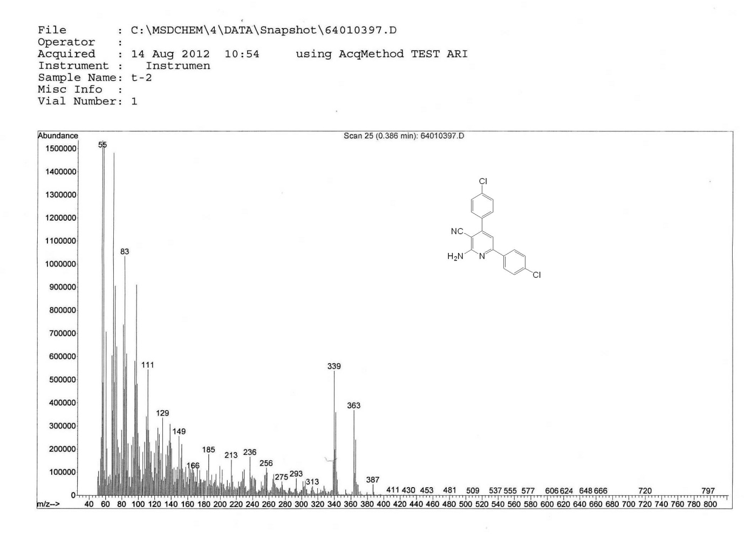

Anal. Calcd of compound 5c

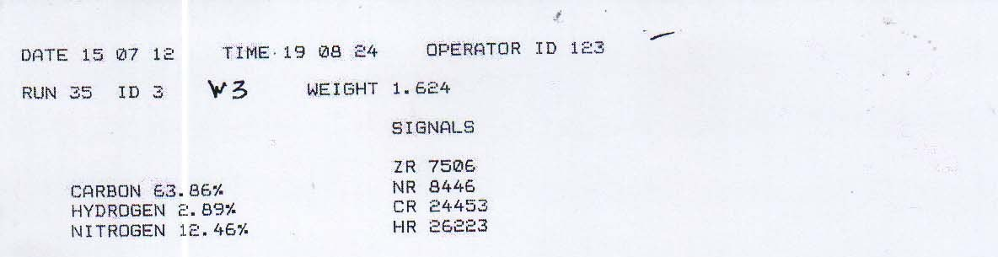

1H NMR Spectra of compound 5d

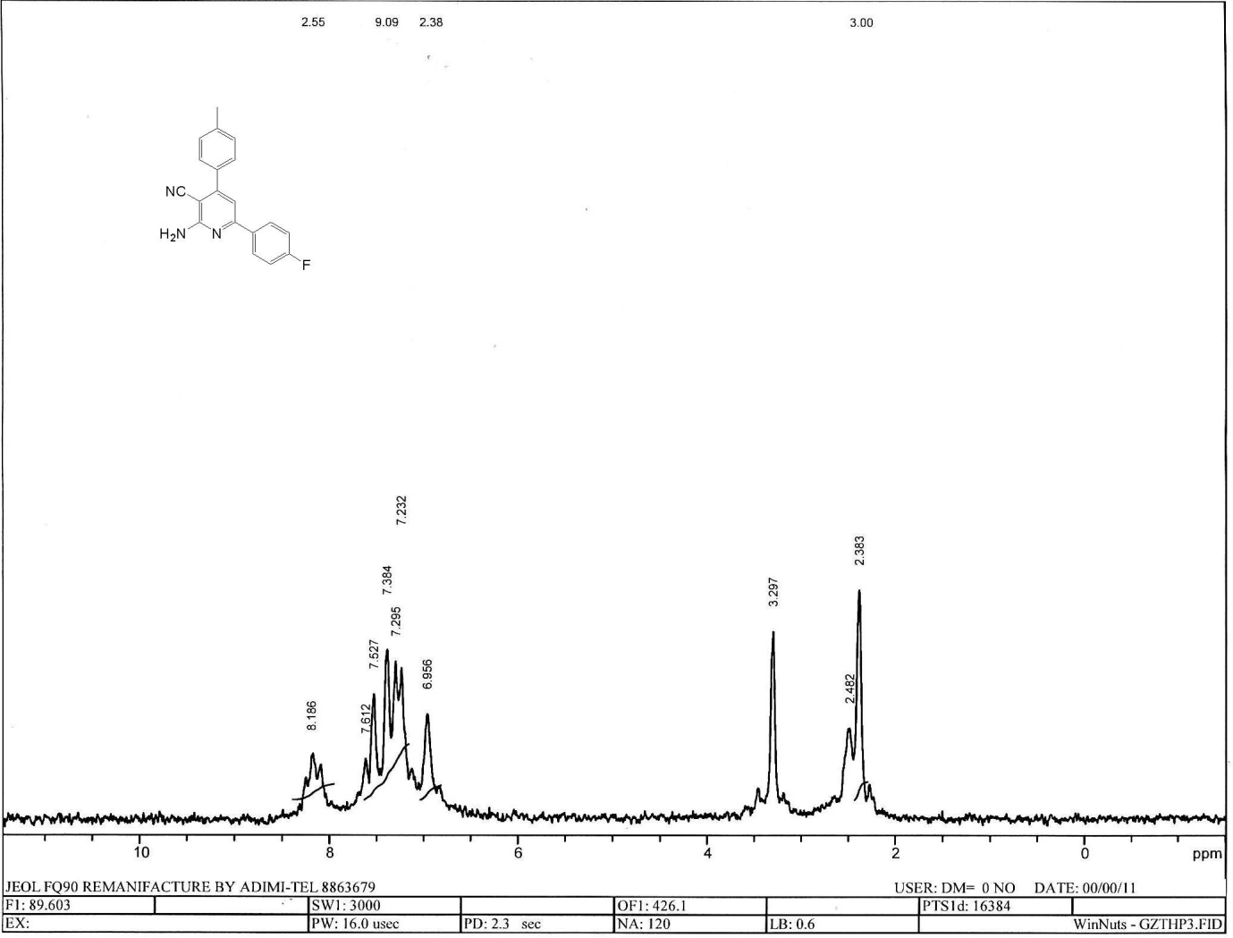

13C NMR Spectra of compound 5d

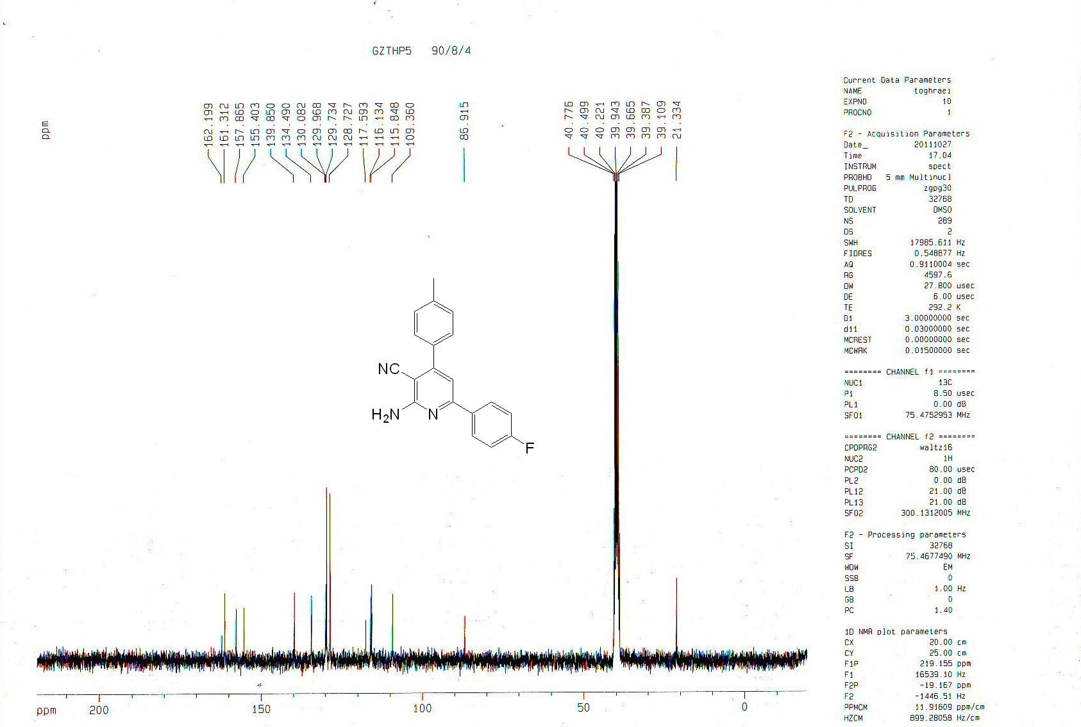

Mass of compound 5d

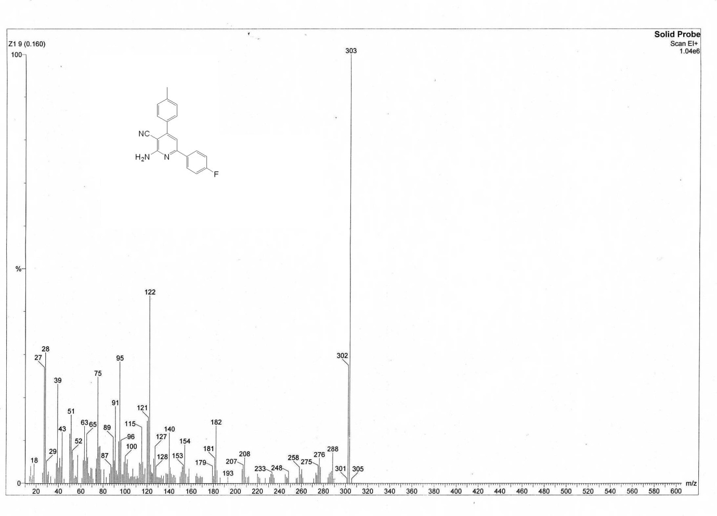

Anal. Calcd of compound 5d

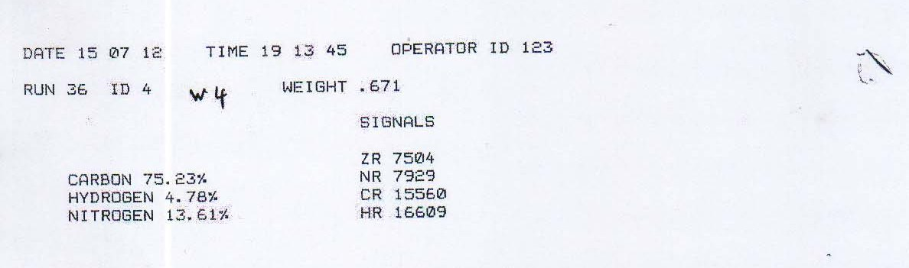

1H NMR Spectra of compound 5e

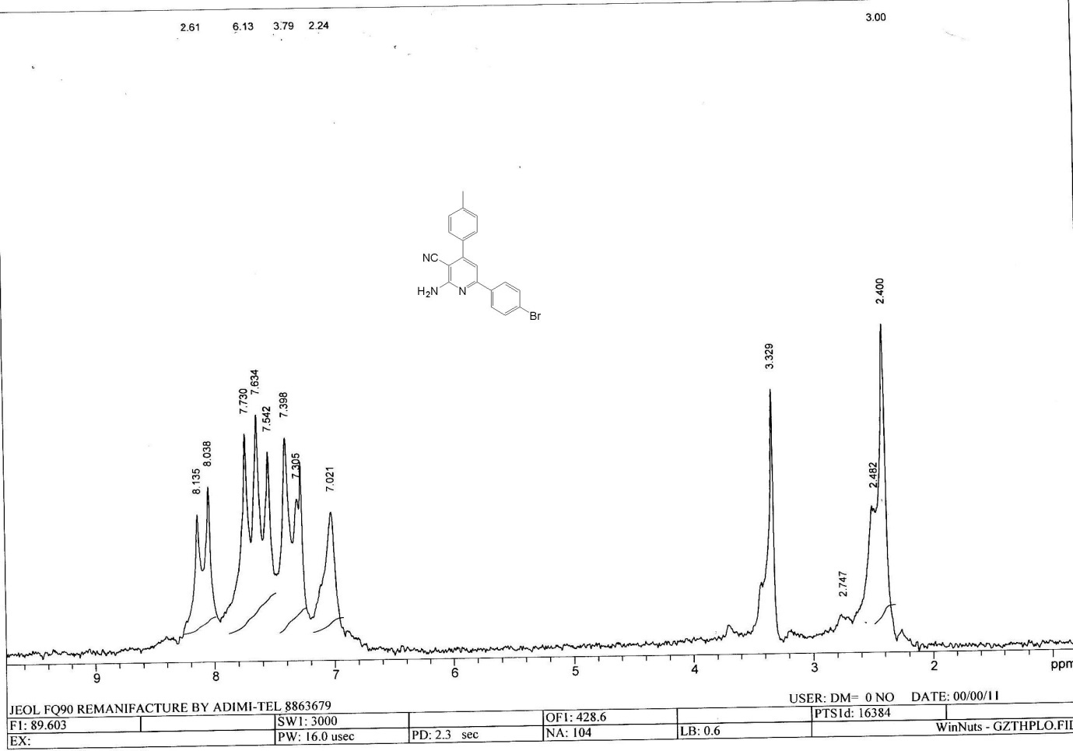

13C NMR Spectra of compound 5e

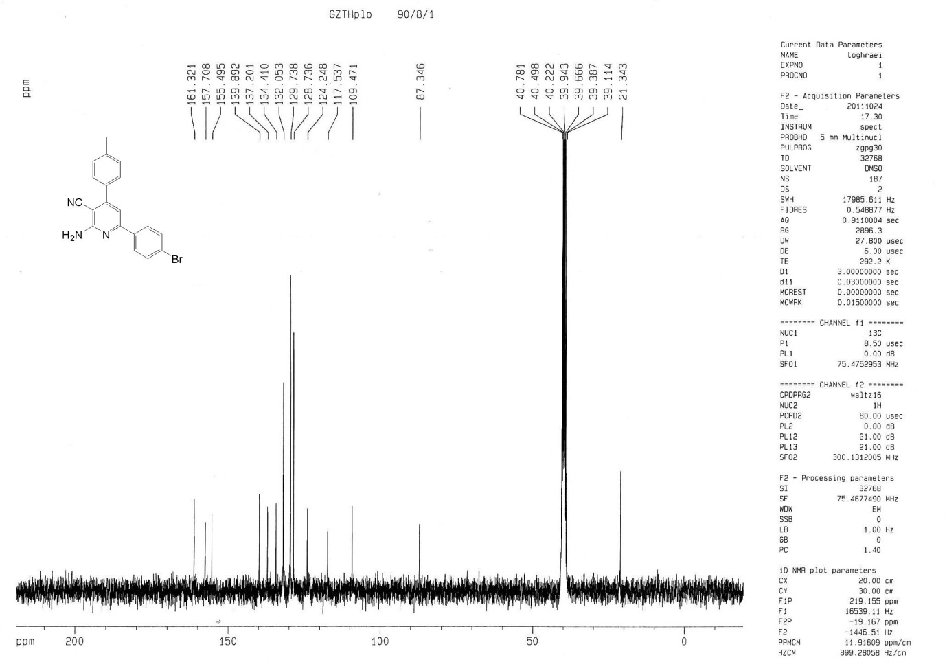

Mass of compound 5e

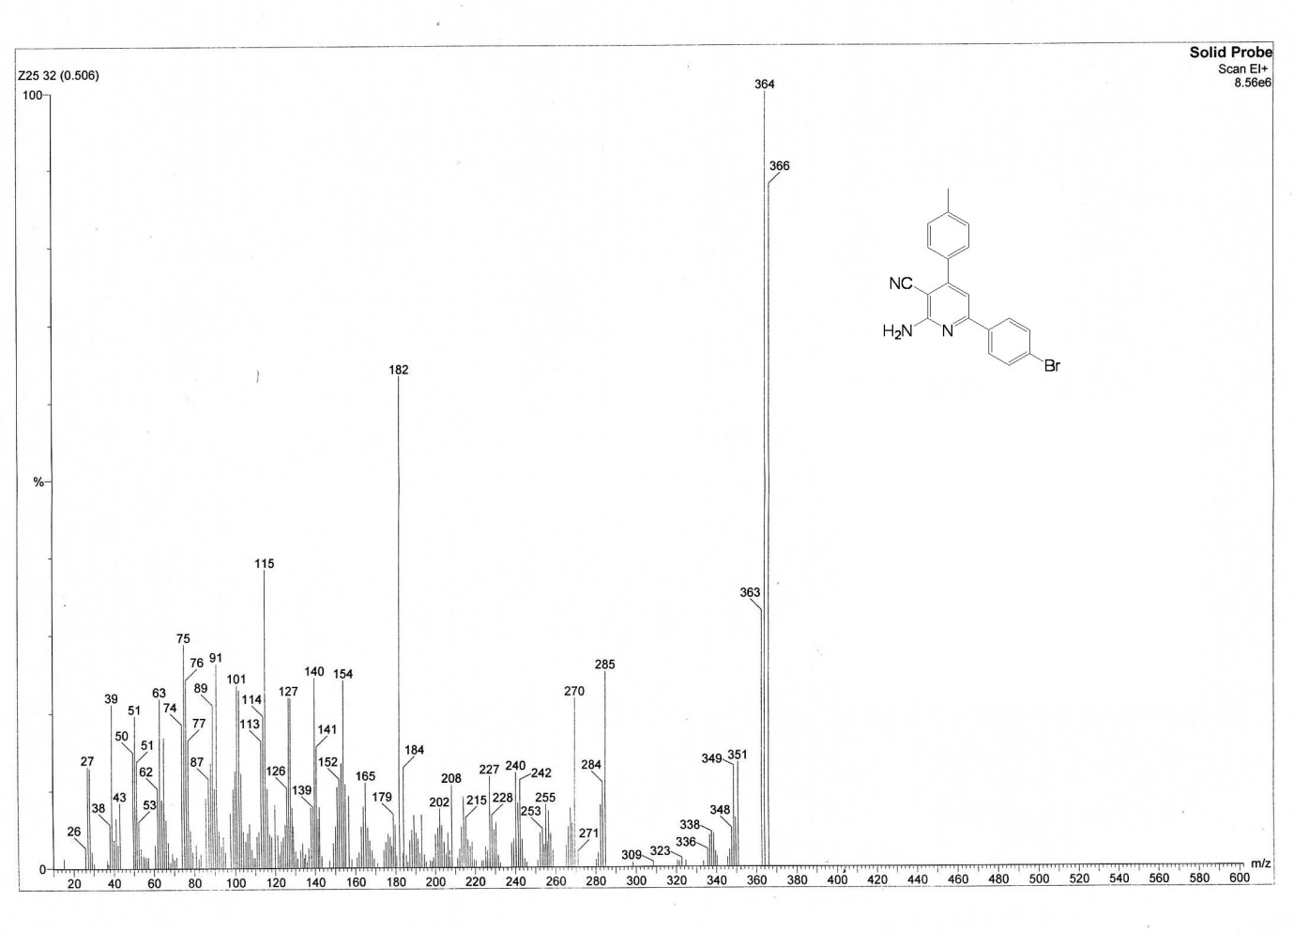

Anal. Calcd of compound 5e

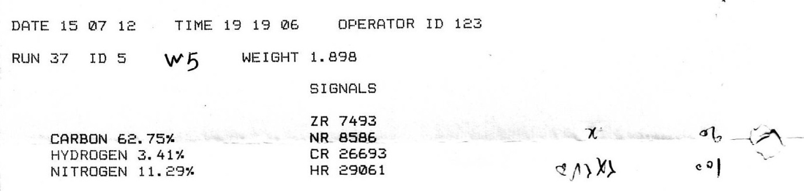

1H NMR Spectra of compound 5f

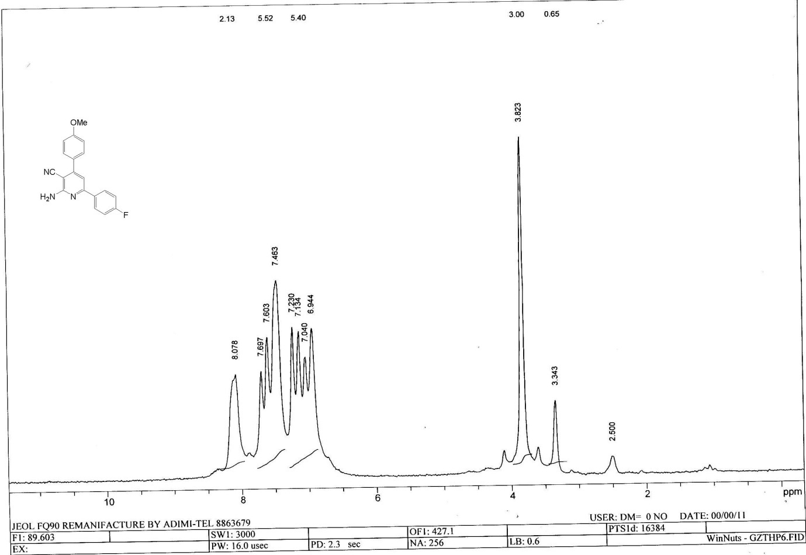

13C NMR Spectra of compound 5f

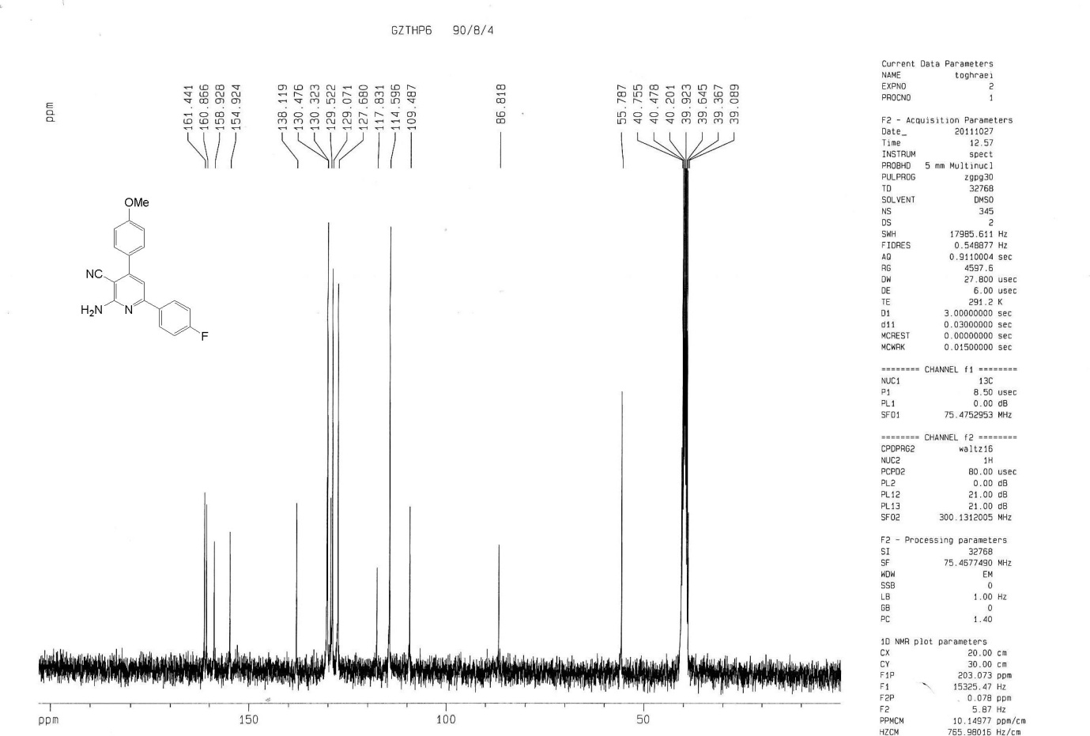

Mass of compound 5f

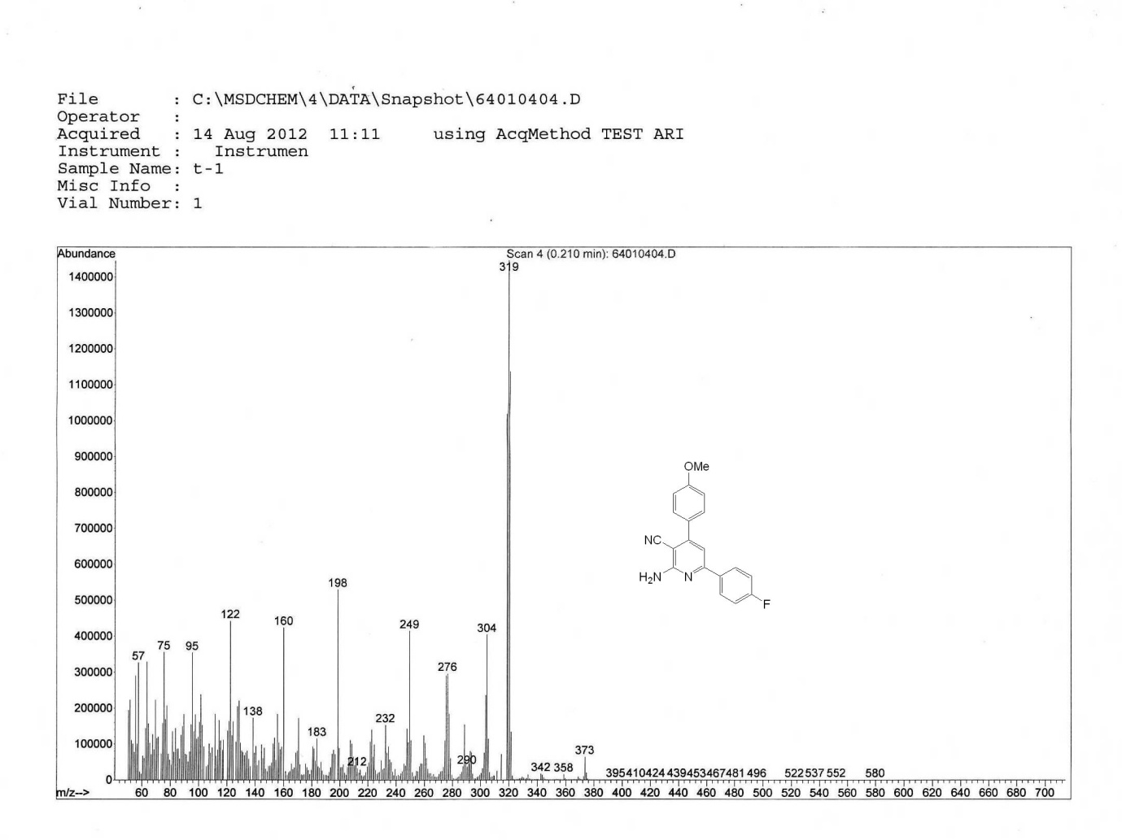

Anal. Calcd of compound 5f

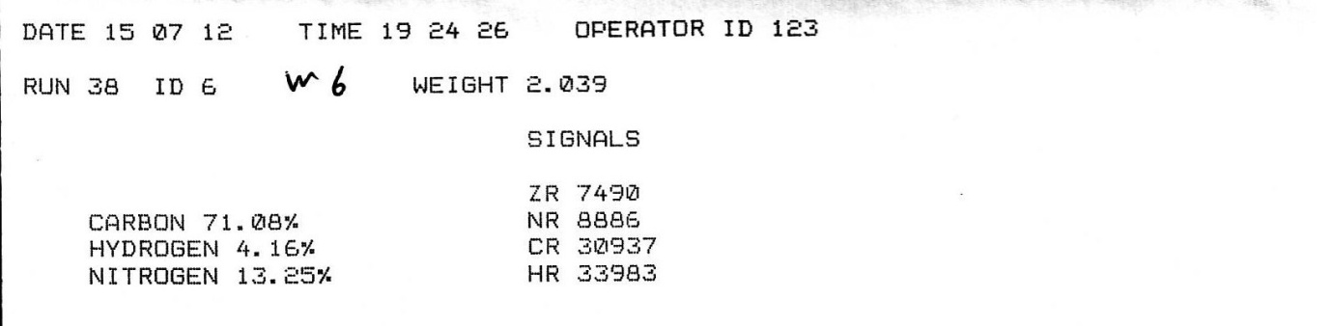

1H NMR Spectra of compound 5g

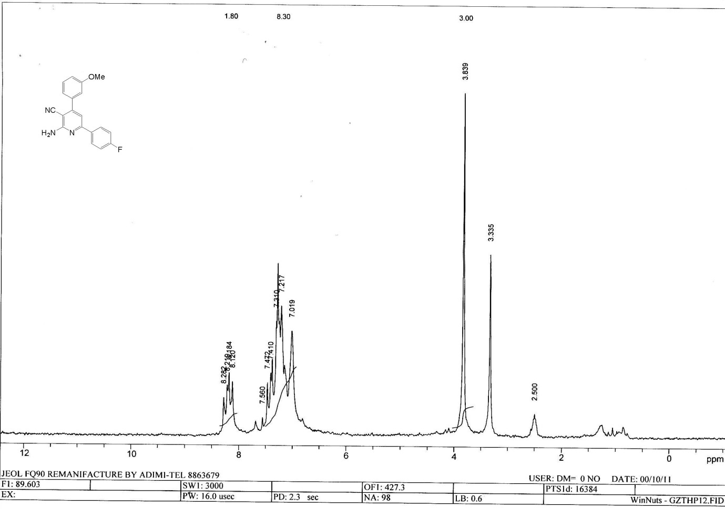

13C NMR Spectra of compound 5g

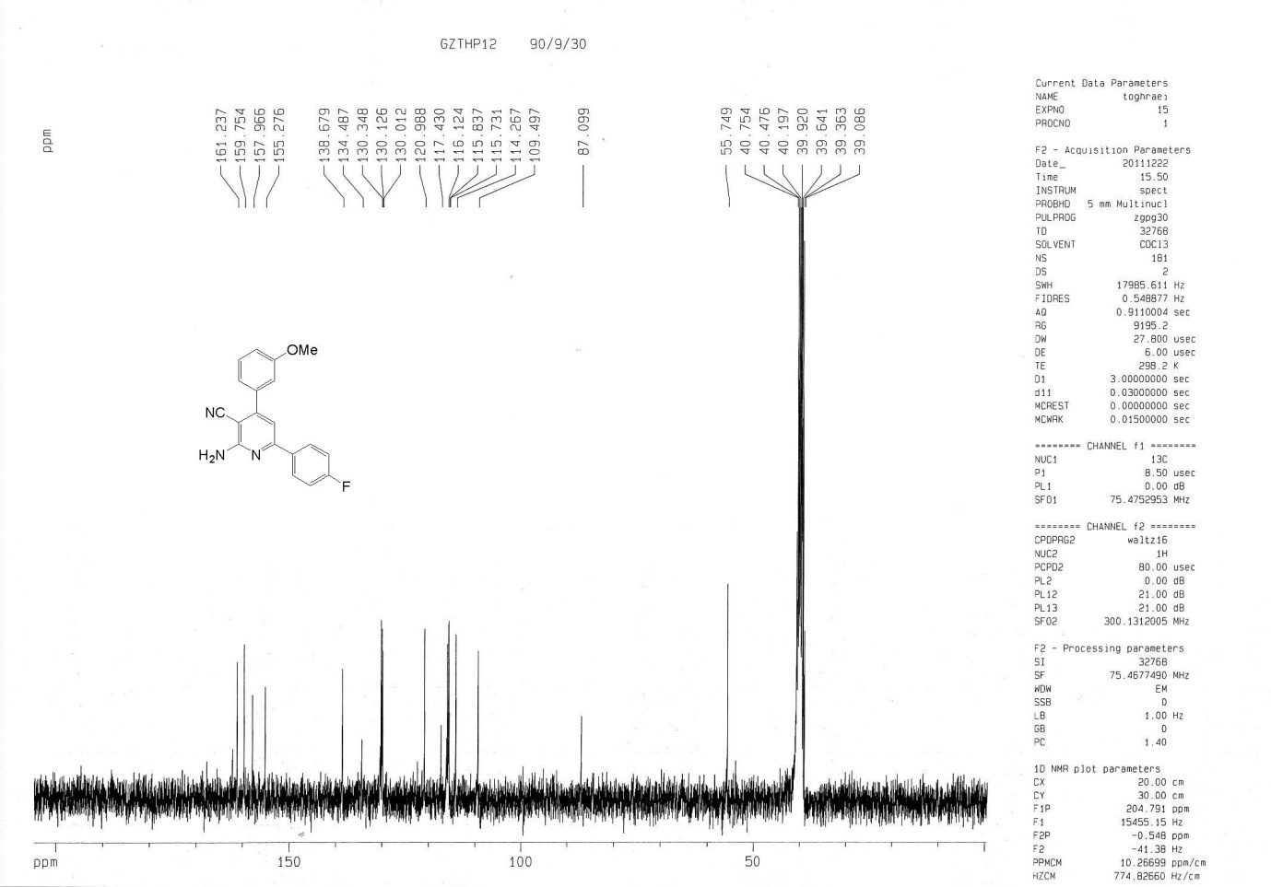

Mass of compound 5g

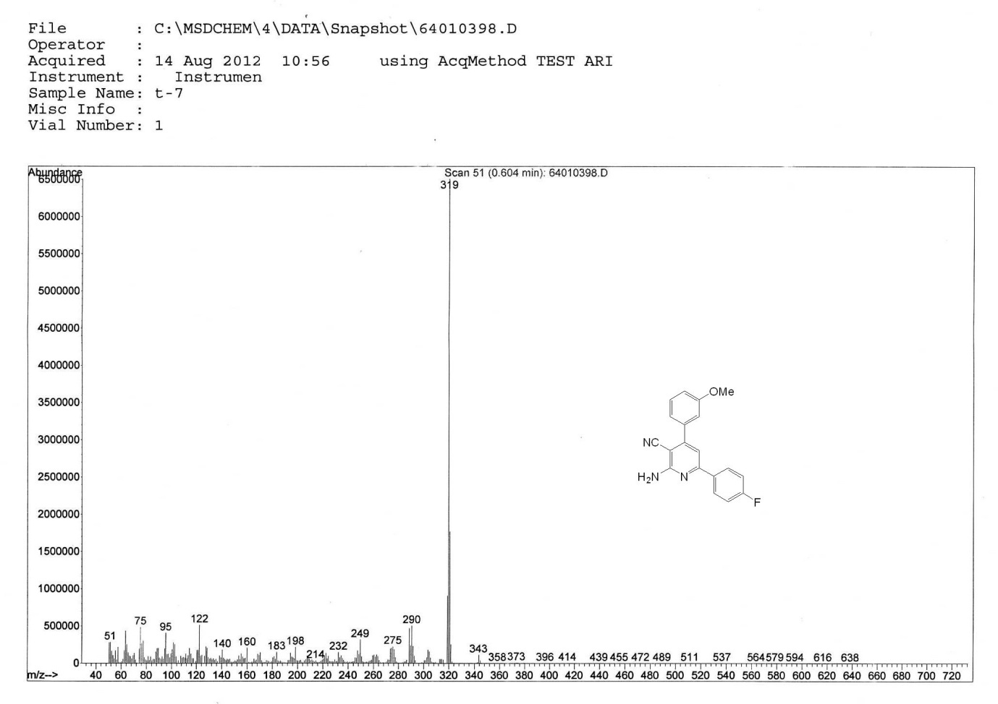

Anal. Calcd of compound 5g

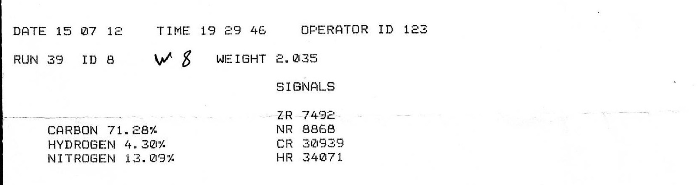

1H NMR Spectra of compound 5h

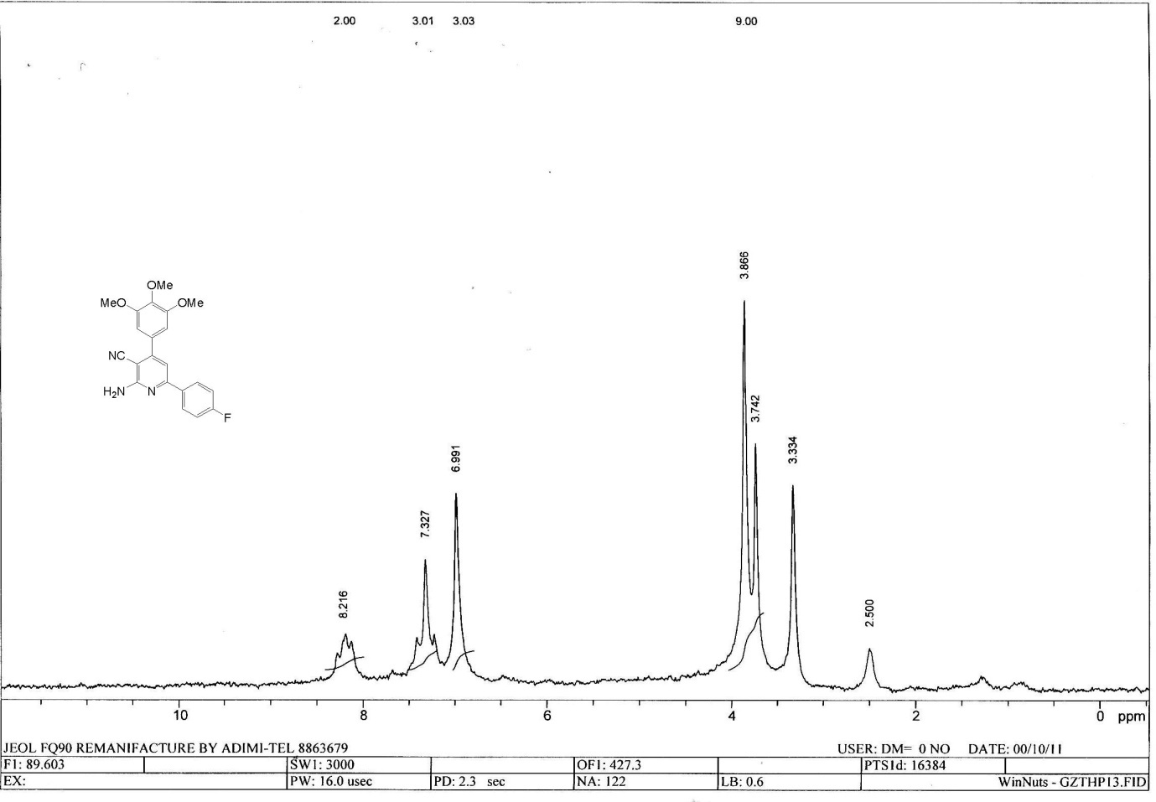

13C NMR Spectra of compound 5h

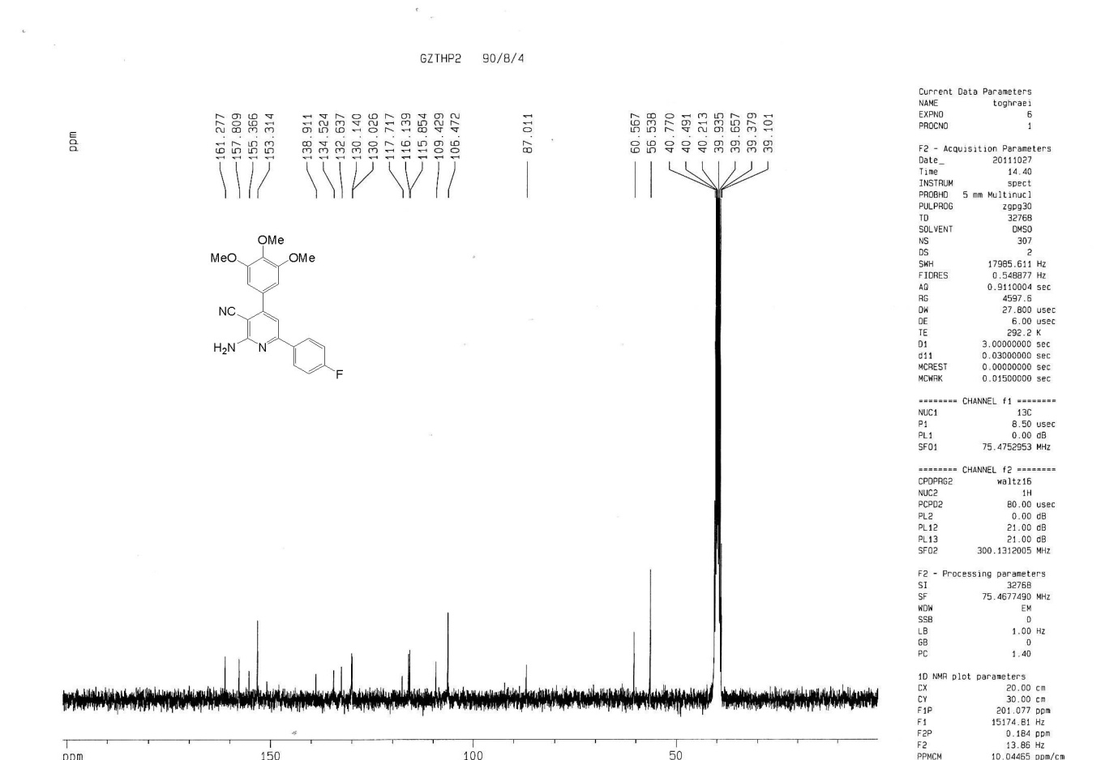

Mass of compound 5h

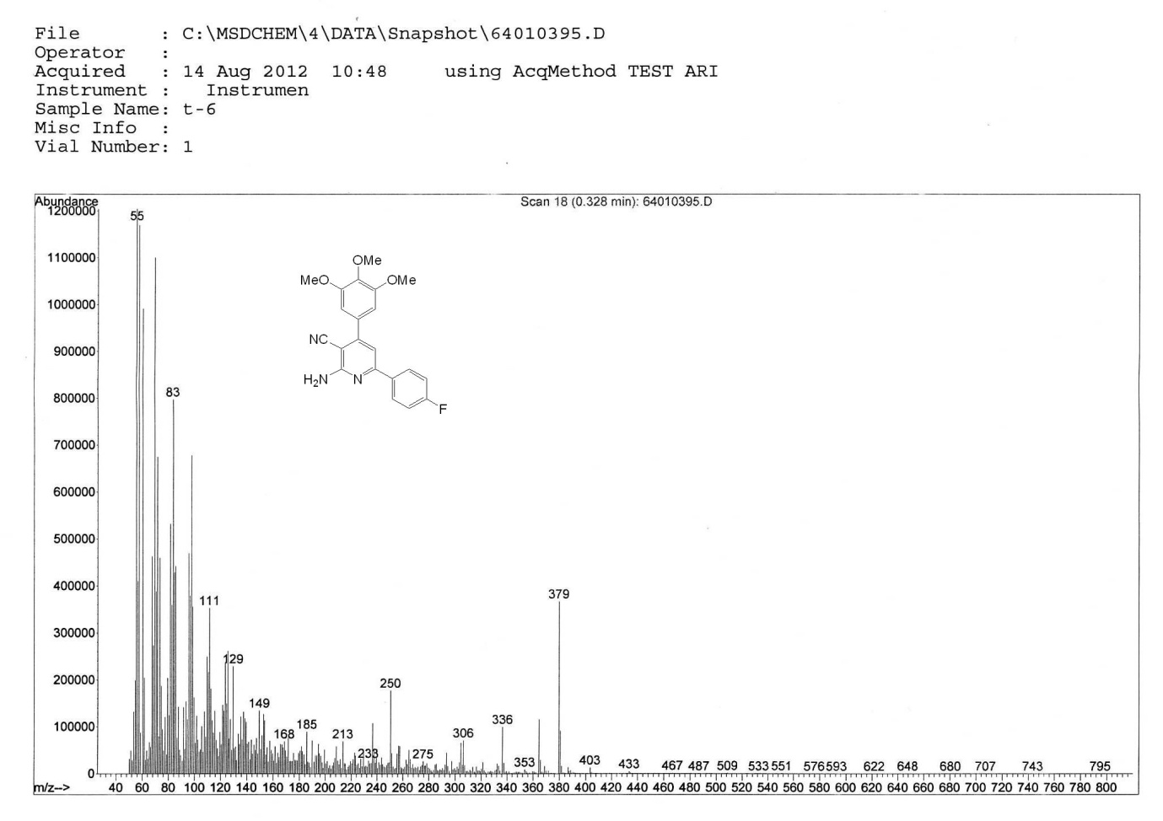

Anal. Calcd of compound 5h

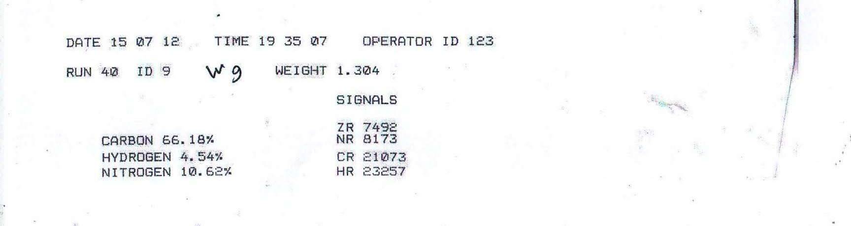

1H NMR Spectra of compound 5i

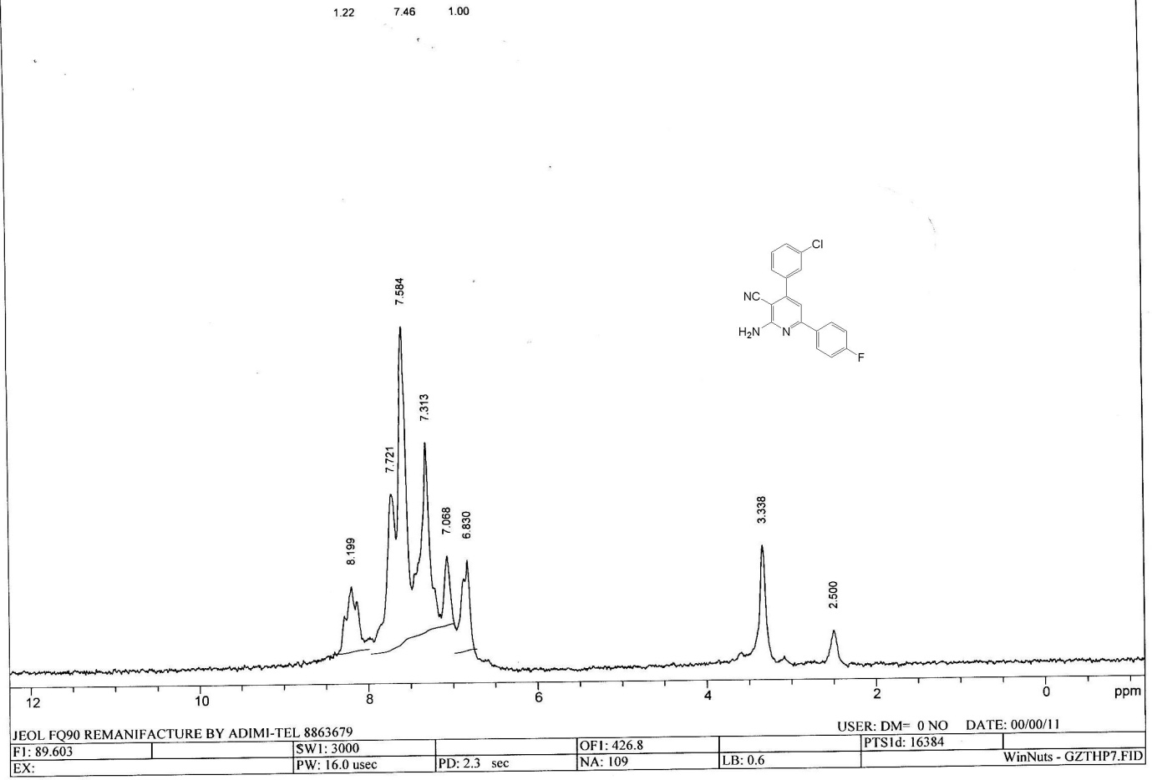

13C NMR Spectra of compound 5i

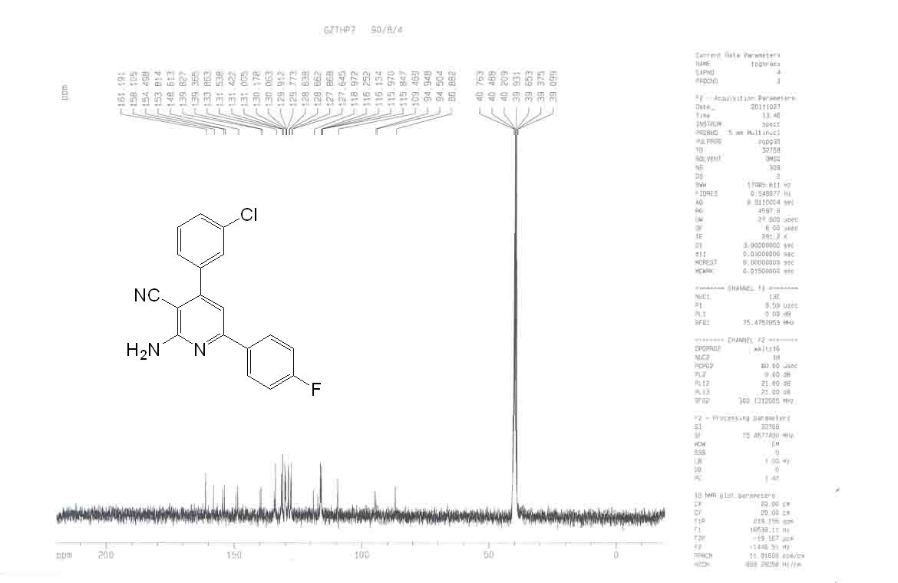

Mass of compound 5i

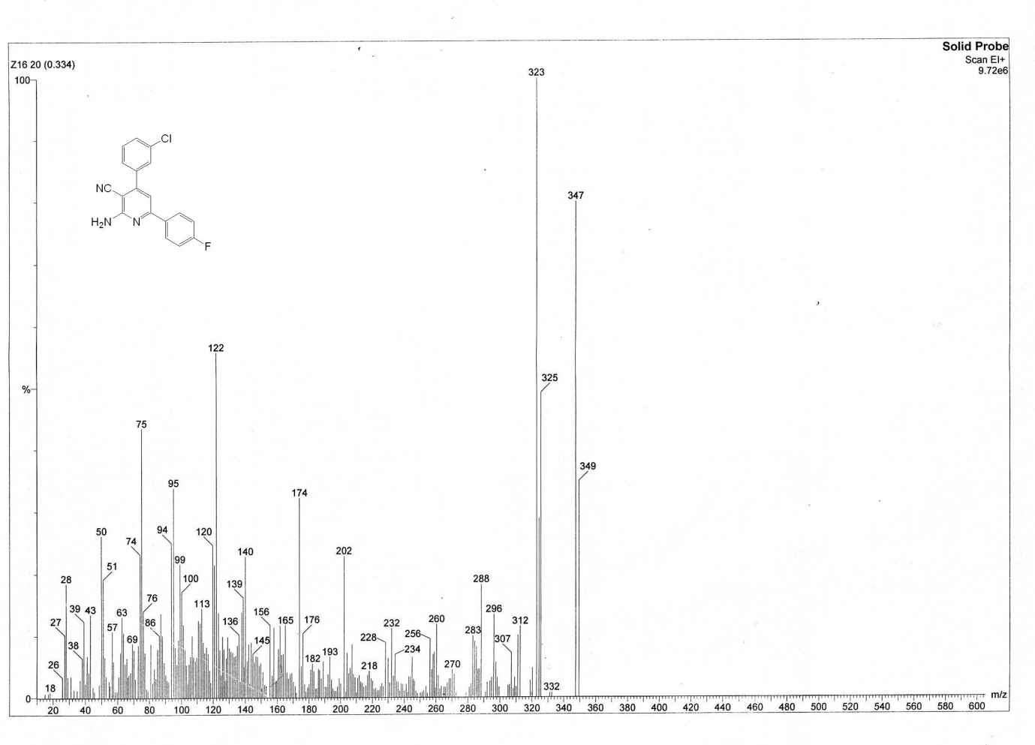

Anal. Calcd of compound 5i

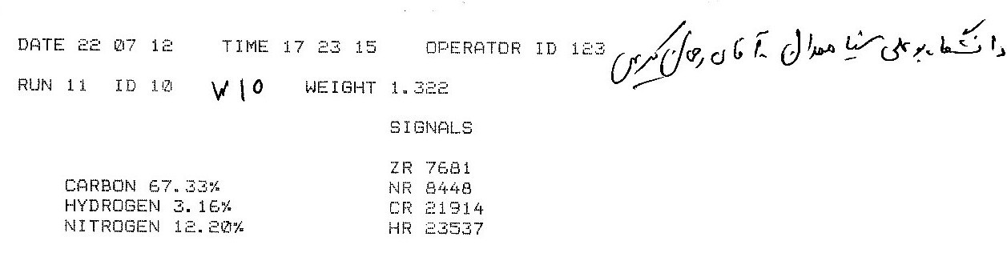

1H NMR Spectra of compound 5j

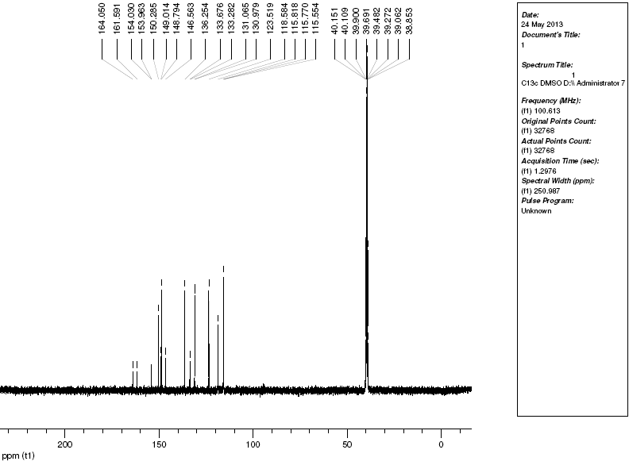

13C NMR Spectra of compound 5j

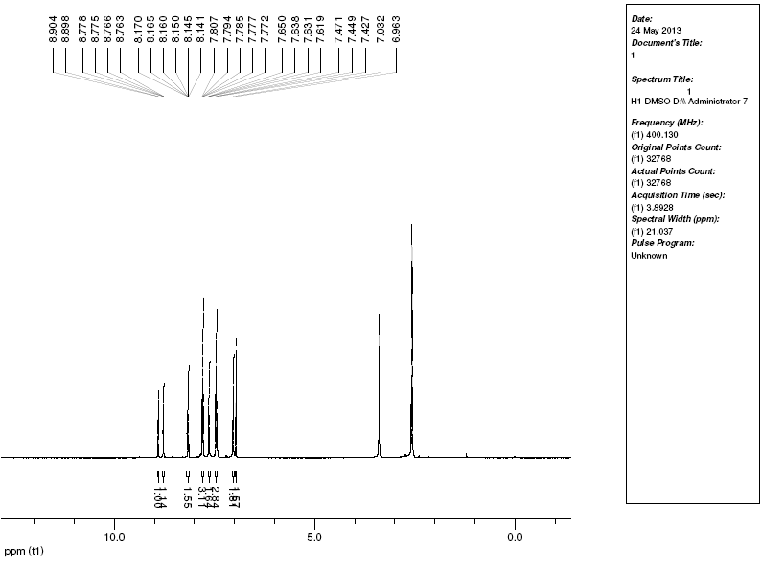

Mass of compound 5j

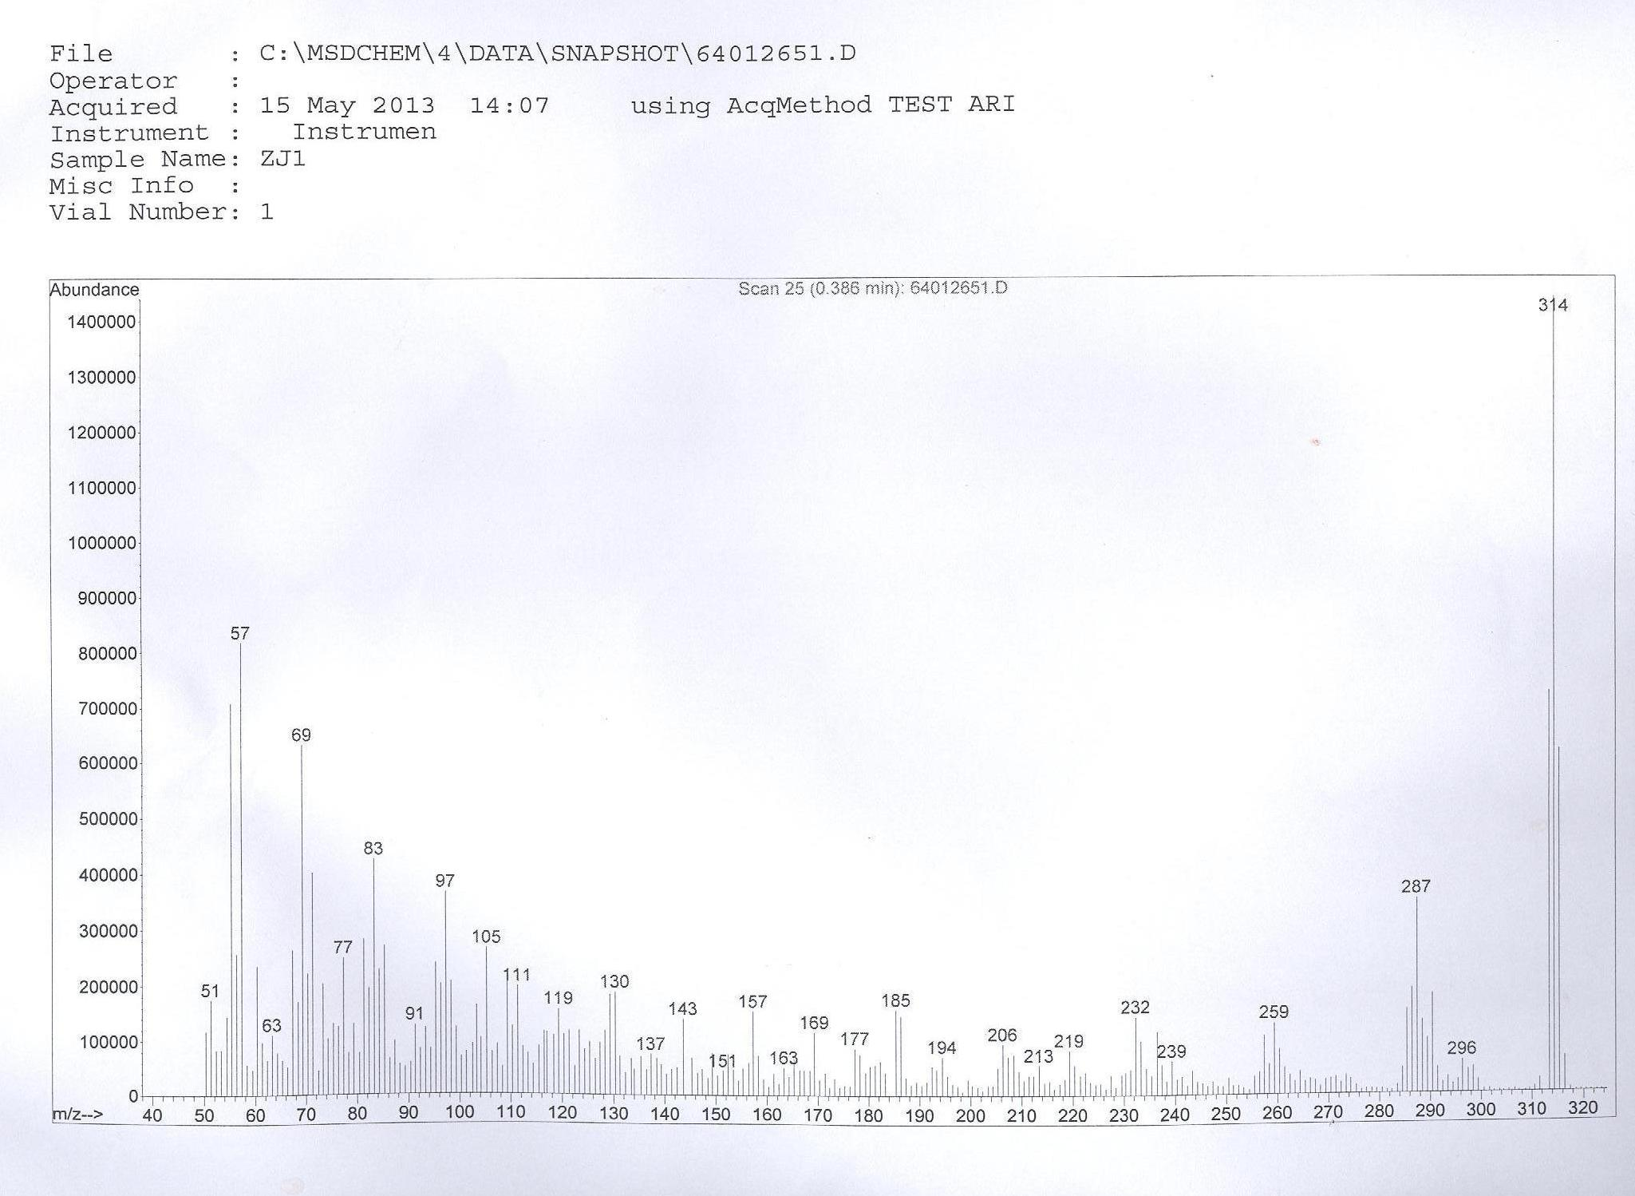

Anal. Calcd of compound 5i

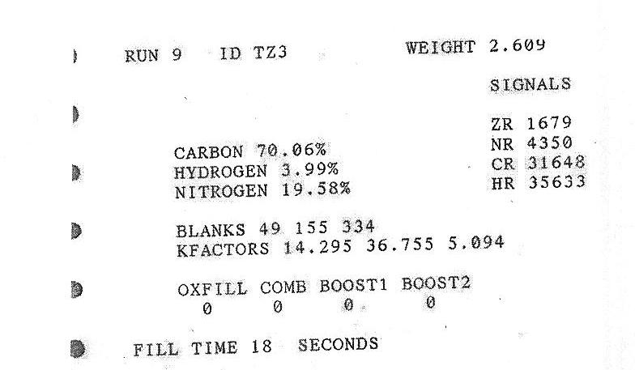

1H NMR Spectra of compound 5k

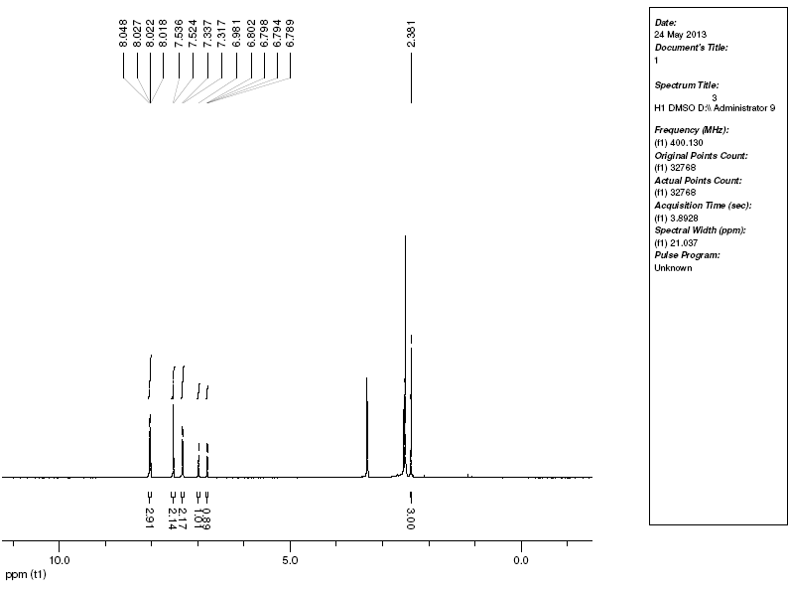

13C NMR Spectra of compound 5k

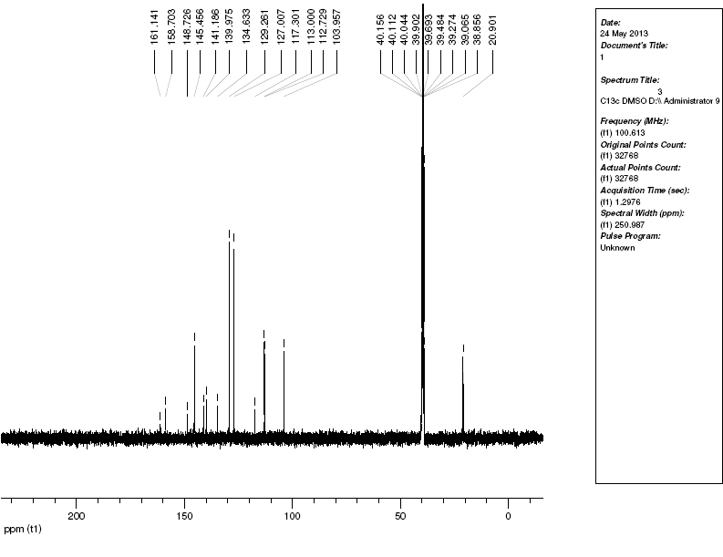

Mass of compound 5k

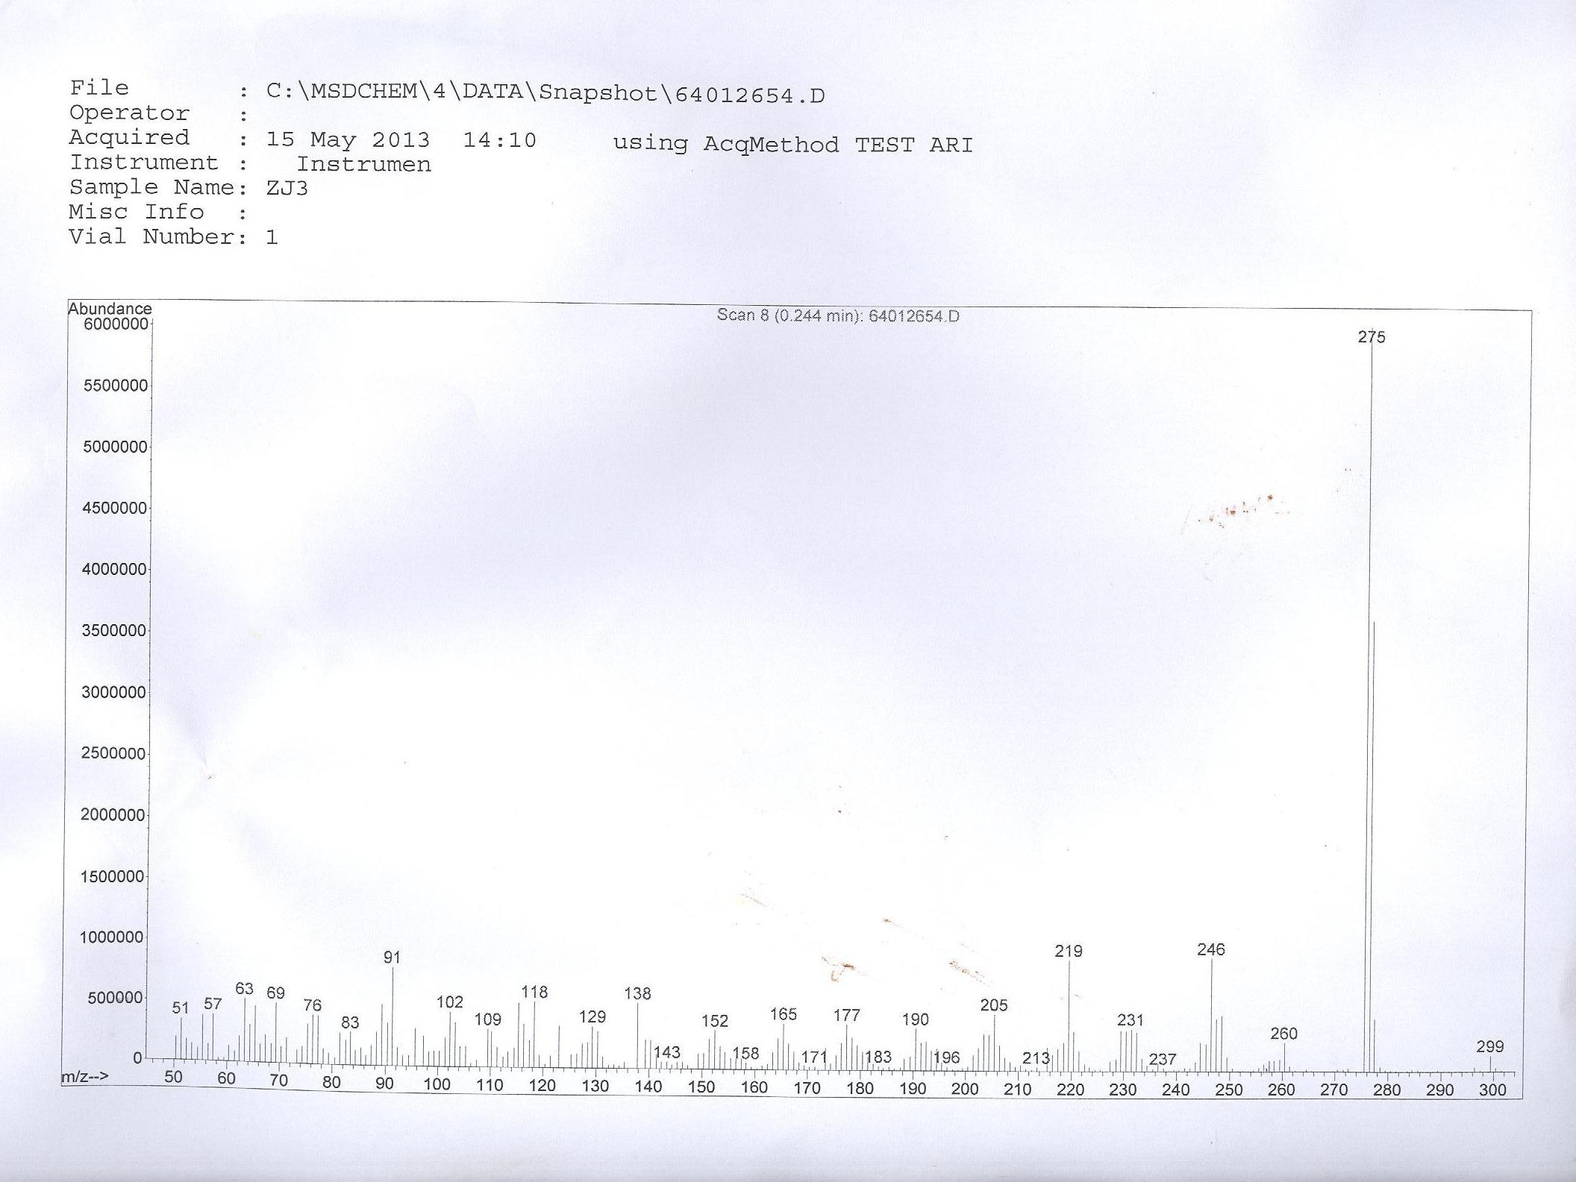

Anal. Calcd of compound 5k

