Supporting Information 1

An efficient one-pot synthesis of novel isatin-based 2-amino thiazol-4-one conjugates using MgO nanoparticles in aqueous media

Robabeh Baharfar* and Narges Shariati

Faculty of chemistry, university of Mazandaran, Babolsar, Iran

¹H NMR of compound 4a

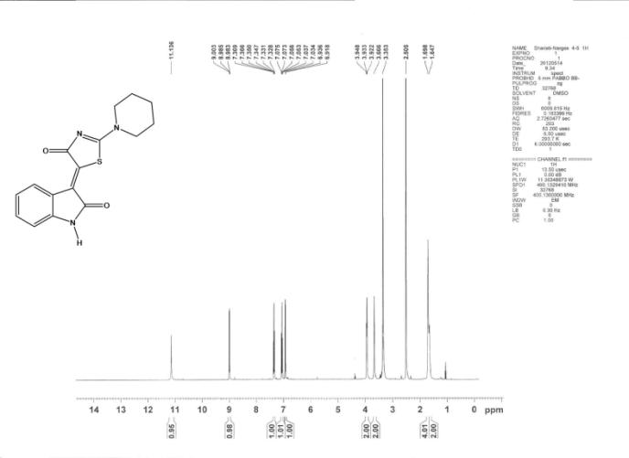

¹³C NMR of compound 4a

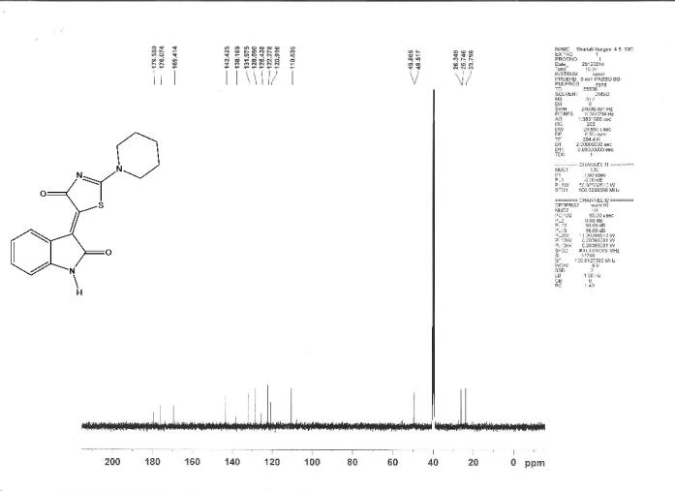

¹H NMR of compound 4b
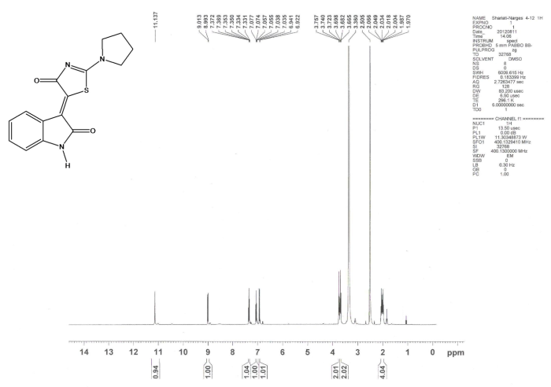

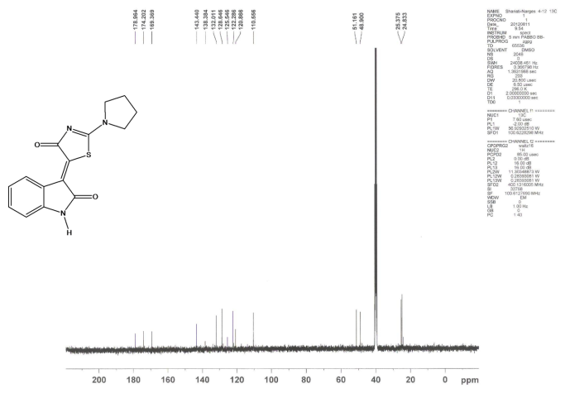

¹³C NMR of compound 4b

¹H NMR of compound 4c
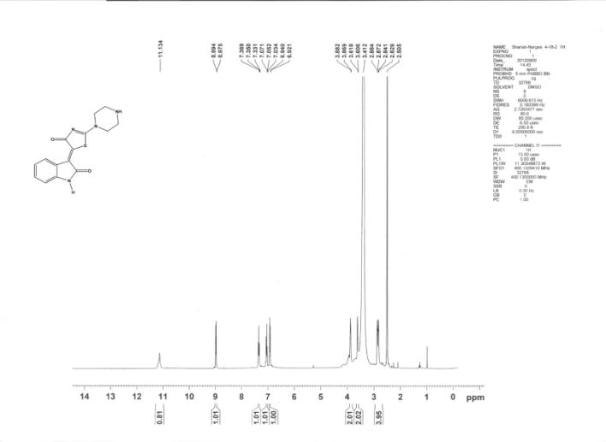

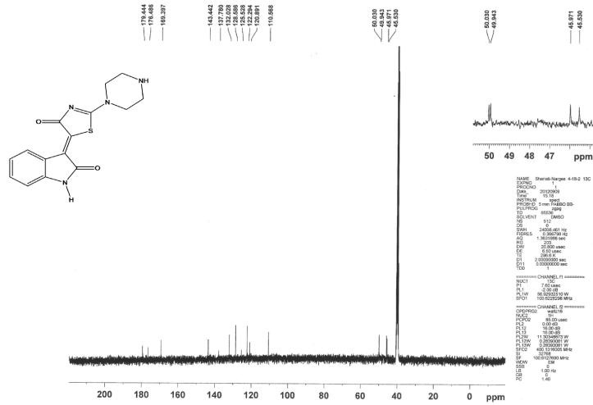
¹³C NMR of compound 4c

¹H NMR of compound 4d
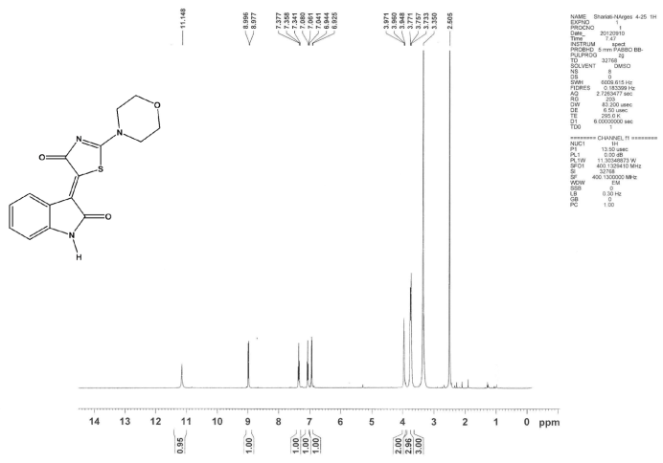

¹³C NMR of compound 4d
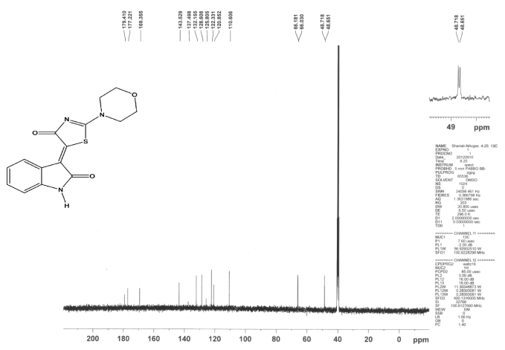

¹H NMR of compound 4e

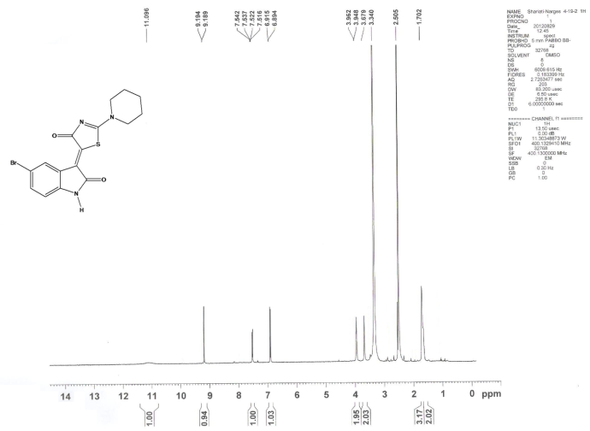

¹³C NMR of compound 4e

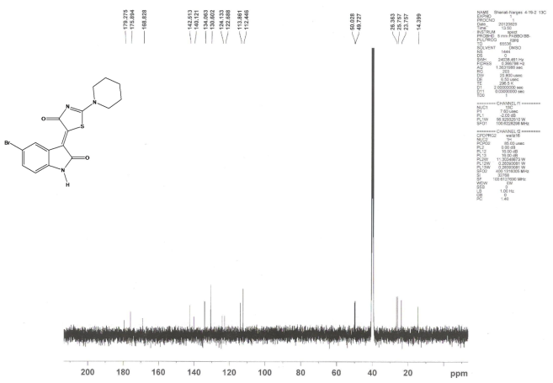

¹H NMR of compound 4f

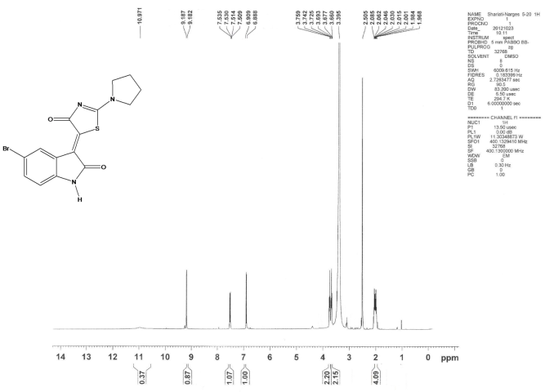

¹³C NMR of compound 4f

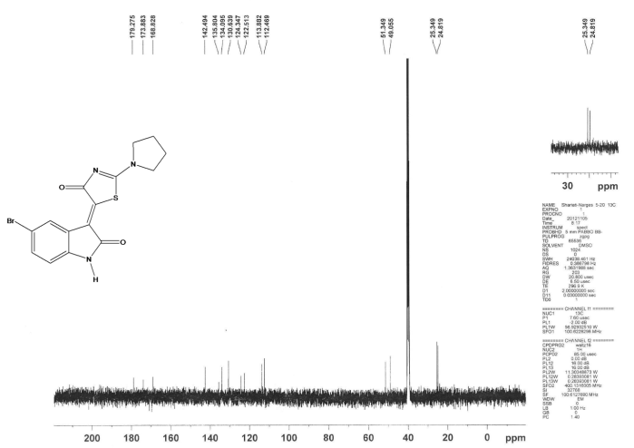

¹H NMR of compound 4g

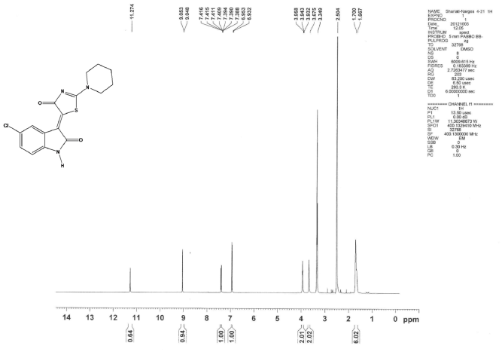

¹³C NMR of compound 4g

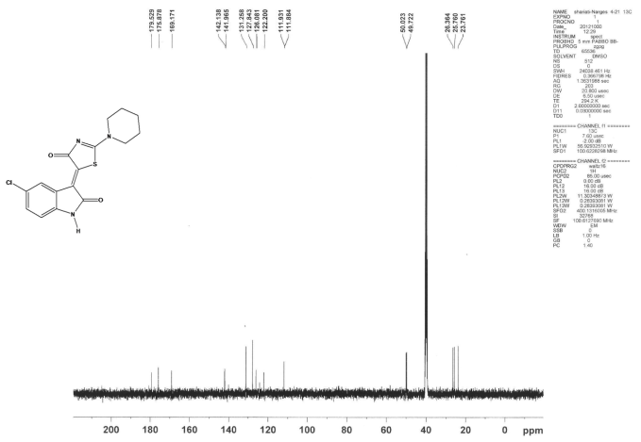

¹H NMR of compound 4h

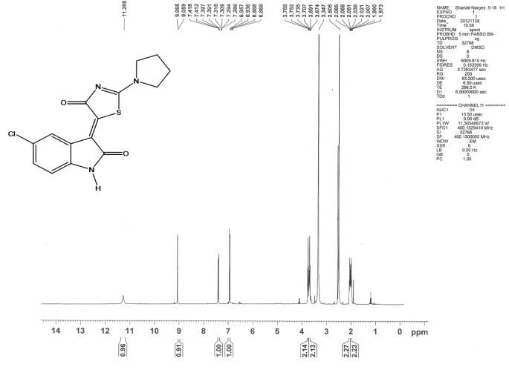

¹³C NMR of compound 4h

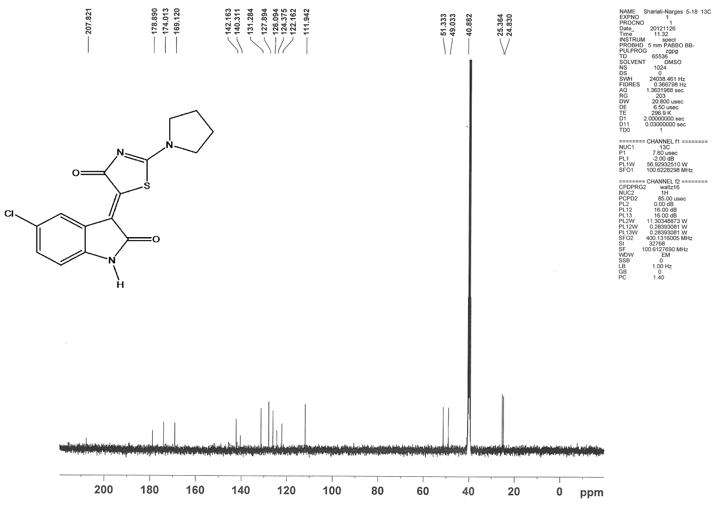

¹H NMR of compound 4i

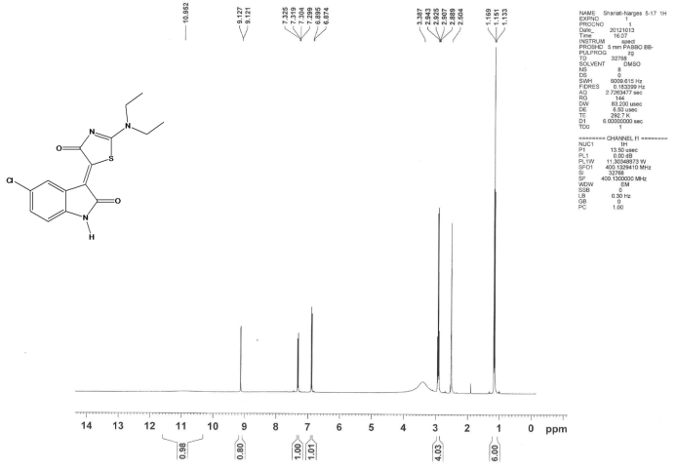

¹³C NMR of compound 4i

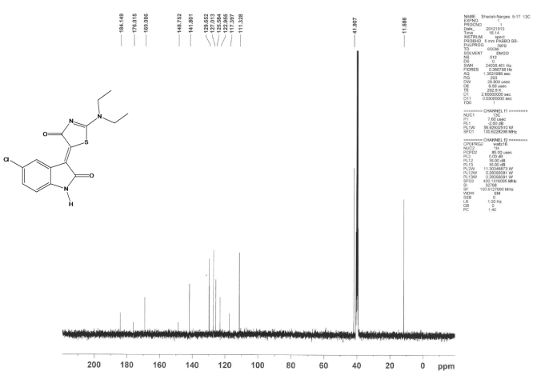

¹H NMR of compound 4j

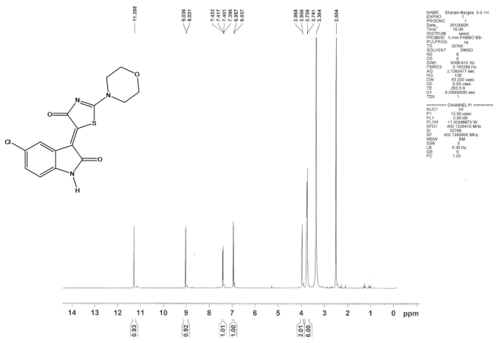

¹³C NMR of compound 4j

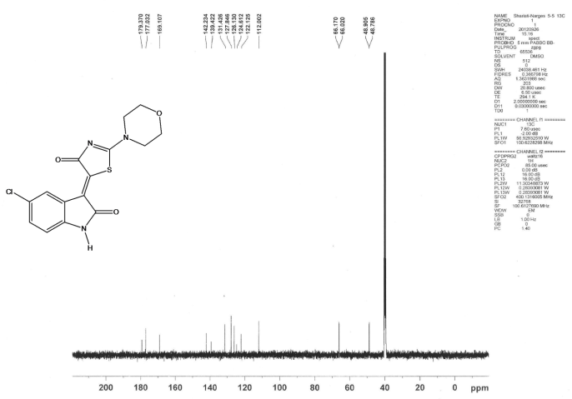

¹H NMR of compound 4k

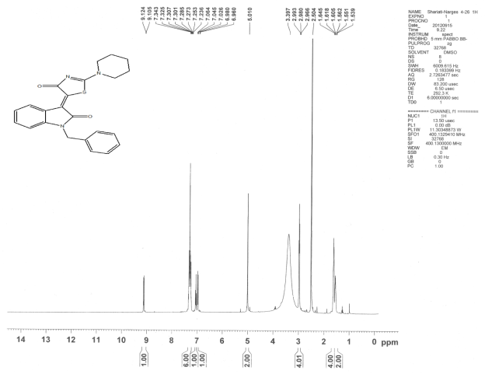

¹³C NMR of compound 4k

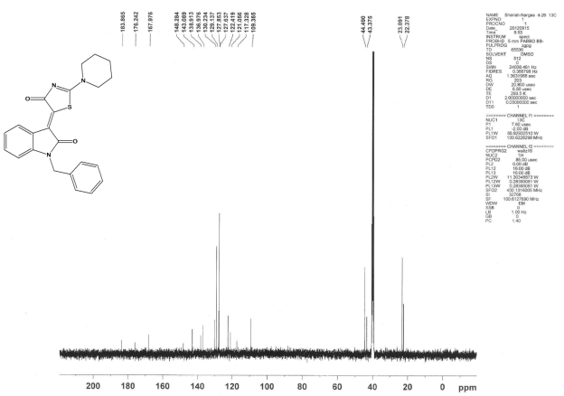

¹H NMR of compound 4l
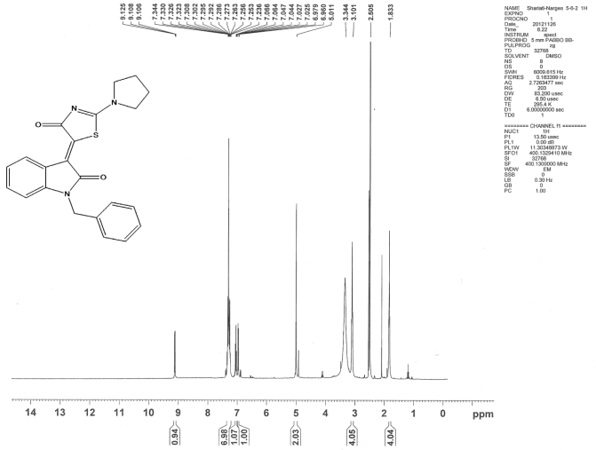

¹³C NMR of compound 4l

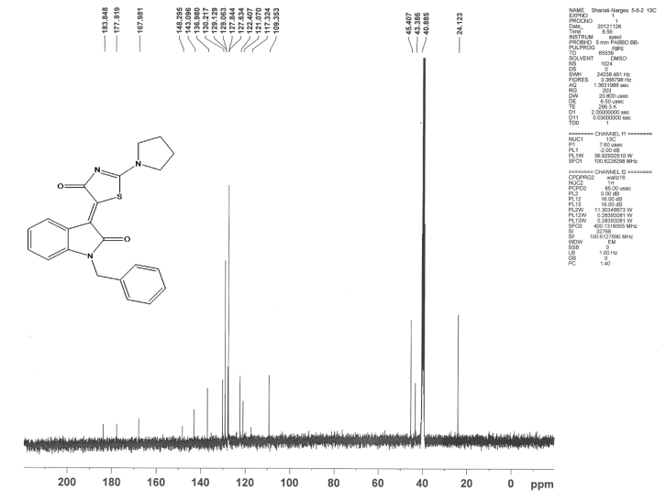

¹H NMR of compound 4m

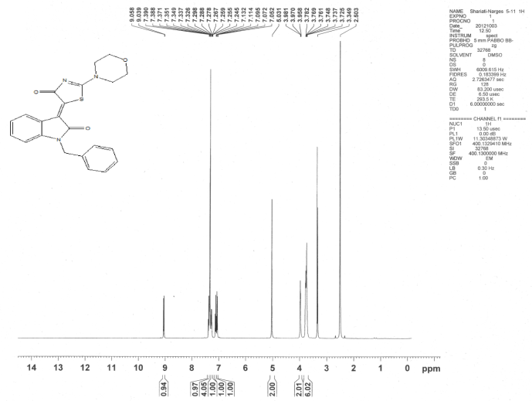

¹³C NMR of compound 4m

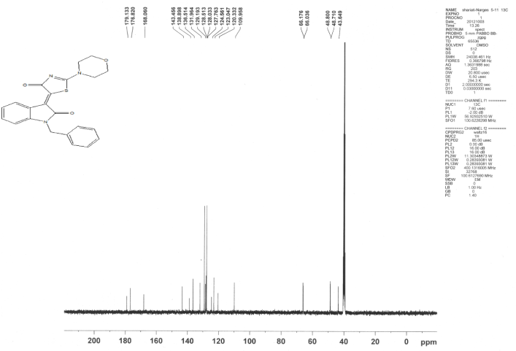

¹H NMR of compound 4n

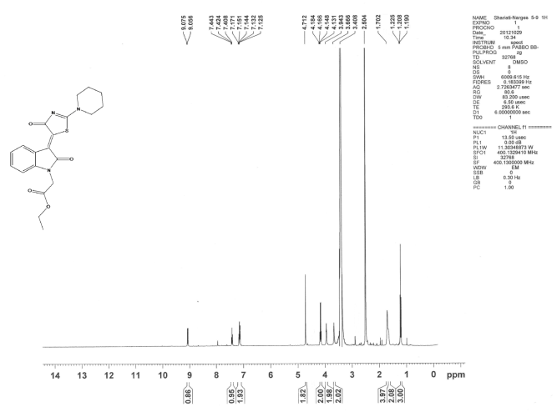

¹³C NMR of compound 4n

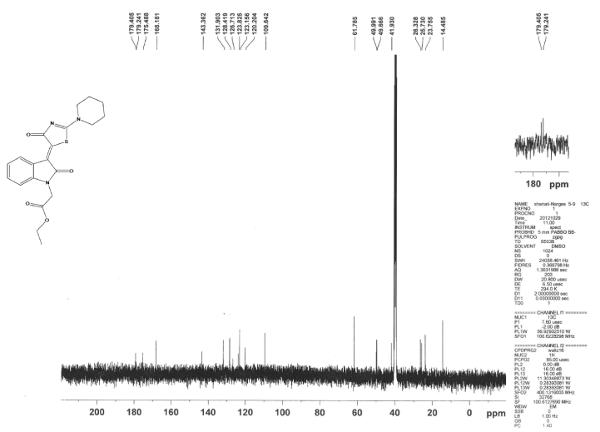

¹H NMR of compound 4o

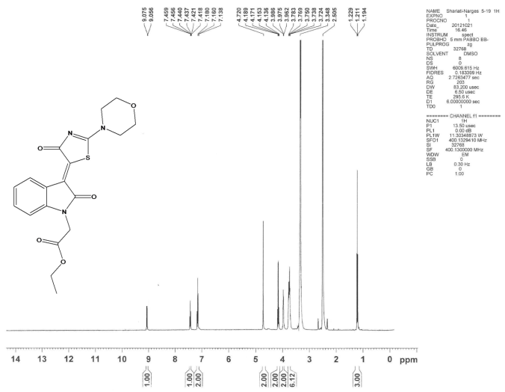

¹³C NMR of compound 4o

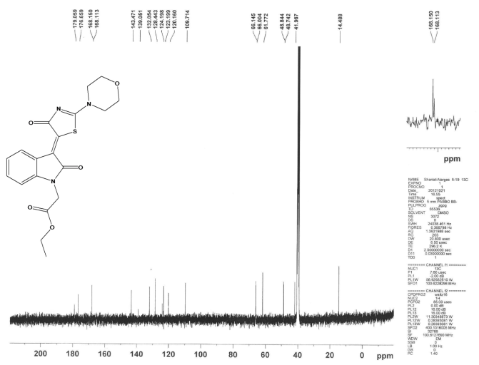

¹H NMR of compound 4p

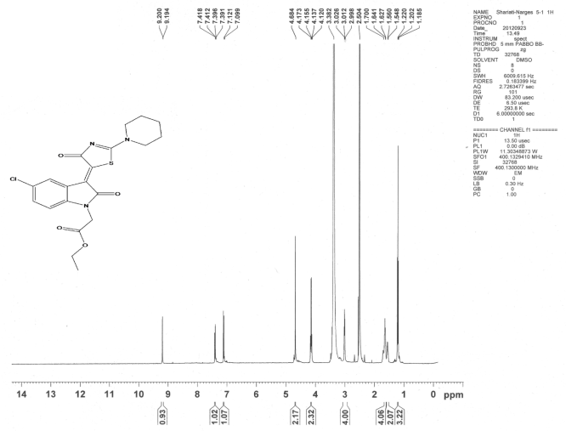

¹³C NMR of compound 4p

