Supplementary Figures
No. S-Fig. | Comment | page
1. | FT-IR spectrum of [Hbpq] | b
2. | FT-IR spectrum of [Cu(bpq)NCS] | c
3. | FT-IR spectrum of [Cu(bpq)N₃] | c
4. | FT-IR spectrum of [Ni^{II}(bpq)(SCN)] | d
5. | FT-IR spectrum of [Ni^{II}(bpq)N₃] | d
6. | UV-Vis spectrum of Hbpq in CH₂Cl₂ | e
7. | UV-Vis spectrum of [Cu(bpq)NCS]in CH₂Cl₂ solution | e
8. | UV-Vis spectrum of [Cu(bpq)N₃]in CH₂Cl₂ solution | f
9. | UV-Vis spectrum of [Ni^{II}(bpq)(SCN)] in CH₂Cl₂ solution | f
10. | UV-Vis spectrum of [Ni^{II}(bpq)N₃] in CH₂Cl₂ solution | g
11. | ¹H-NMR spectrum of [Hbpq] | h
 | ¹H-NMR spectrum of [Hbpq] | i

Supplementary Figures

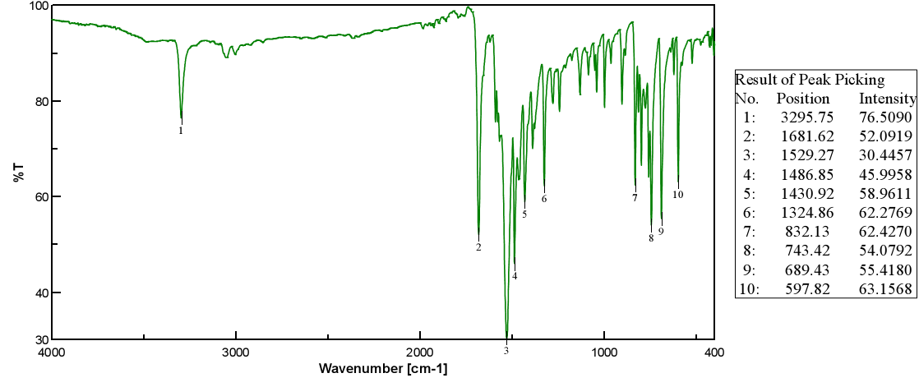

S-Fig.1. FT-IR spectrum of [Hbpq].
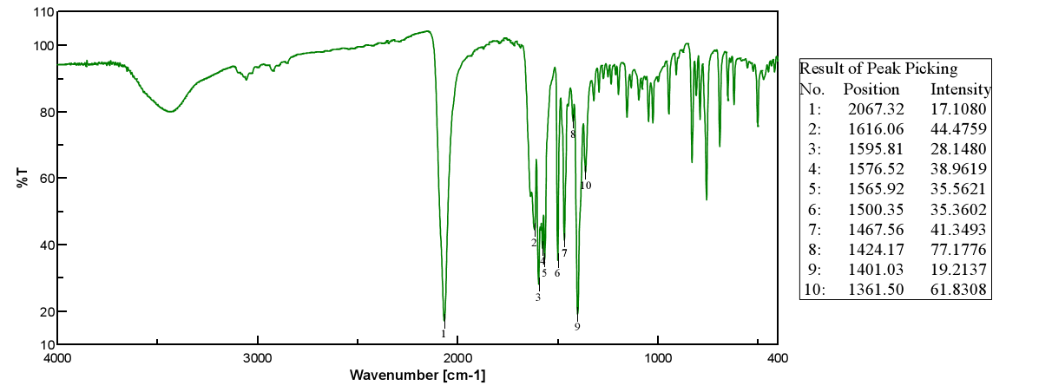
S-Fig.2. FT-IR spectrum of [Cu(bpq)NCS]
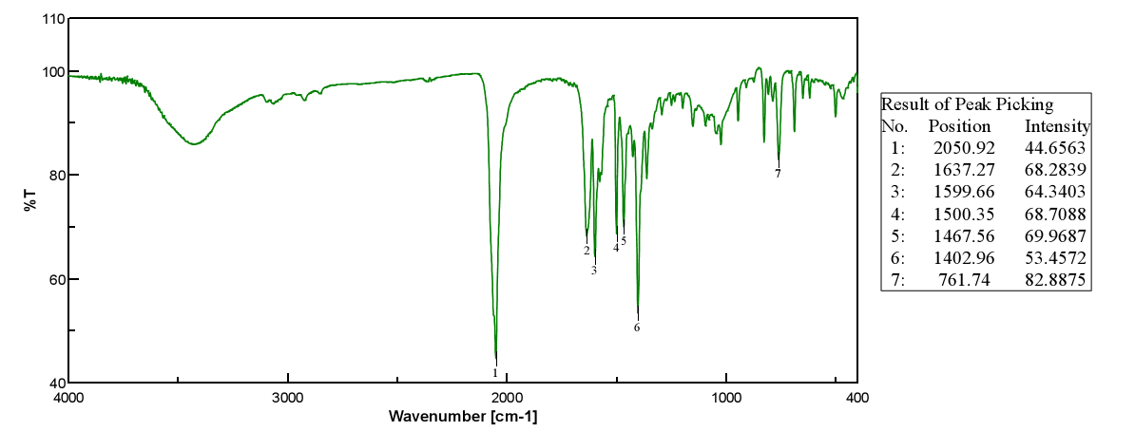

S-Fig.3. FT-IR spectrum of [Cu(bpq)N₃].

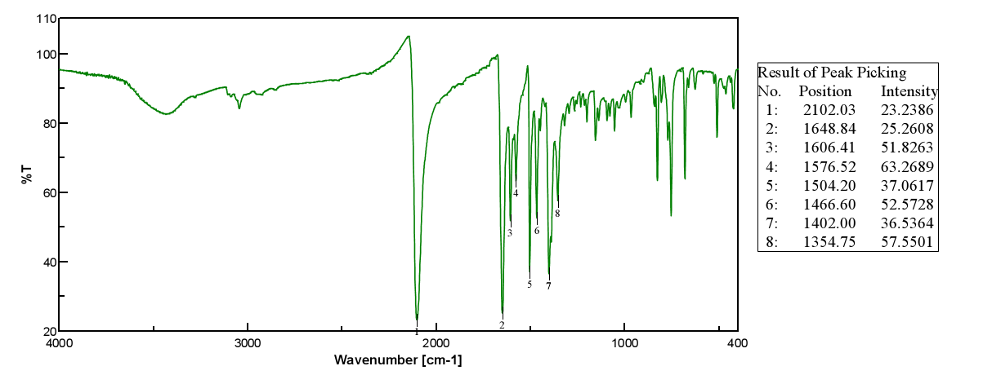
S-Fig.4. FT-IR spectrum of [Ni^{II}(bpq)(SCN)].
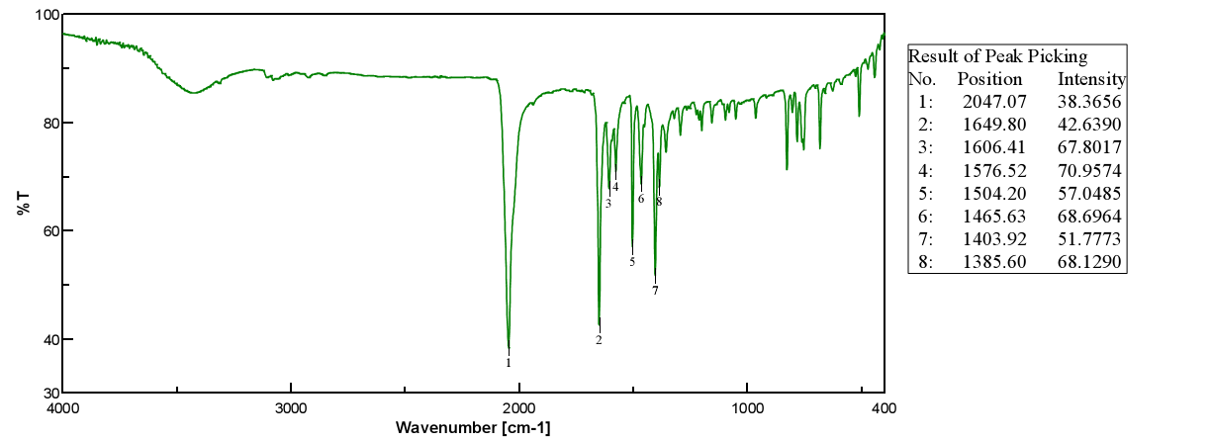
S-Fig.5. FT-IR spectrum of [Ni^{II}(bpq)N₃].

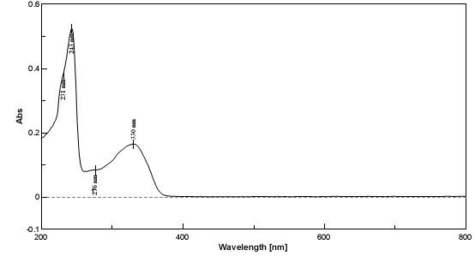

S-Fig.6. UV-Vis spectrum of Hbpq in CH₂Cl₂.

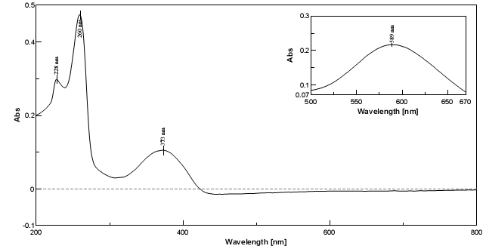
S-Fig.7. UV-Vis spectrum of [Cu(bpq)NCS] in CH₂Cl₂.
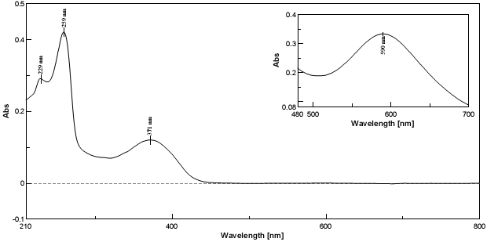

S-Fig.8. UV-Vis spectrum of [Cu(bpq)N₃]in CH₂Cl₂.

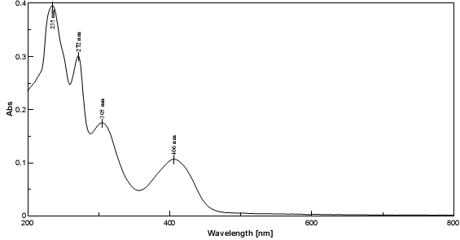

S-Fig.9. UV-Vis spectrum of [Ni^{II}(bpq)(SCN)] in CH₂Cl₂.
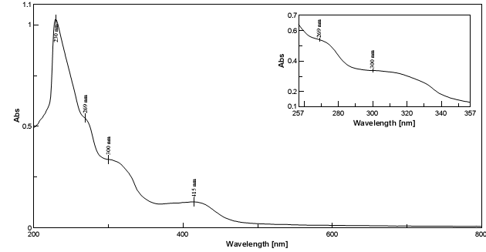

S-Fig.10. UV-Vis spectrum of [Ni^{II}(bpq)N₃] in CH₂Cl₂.

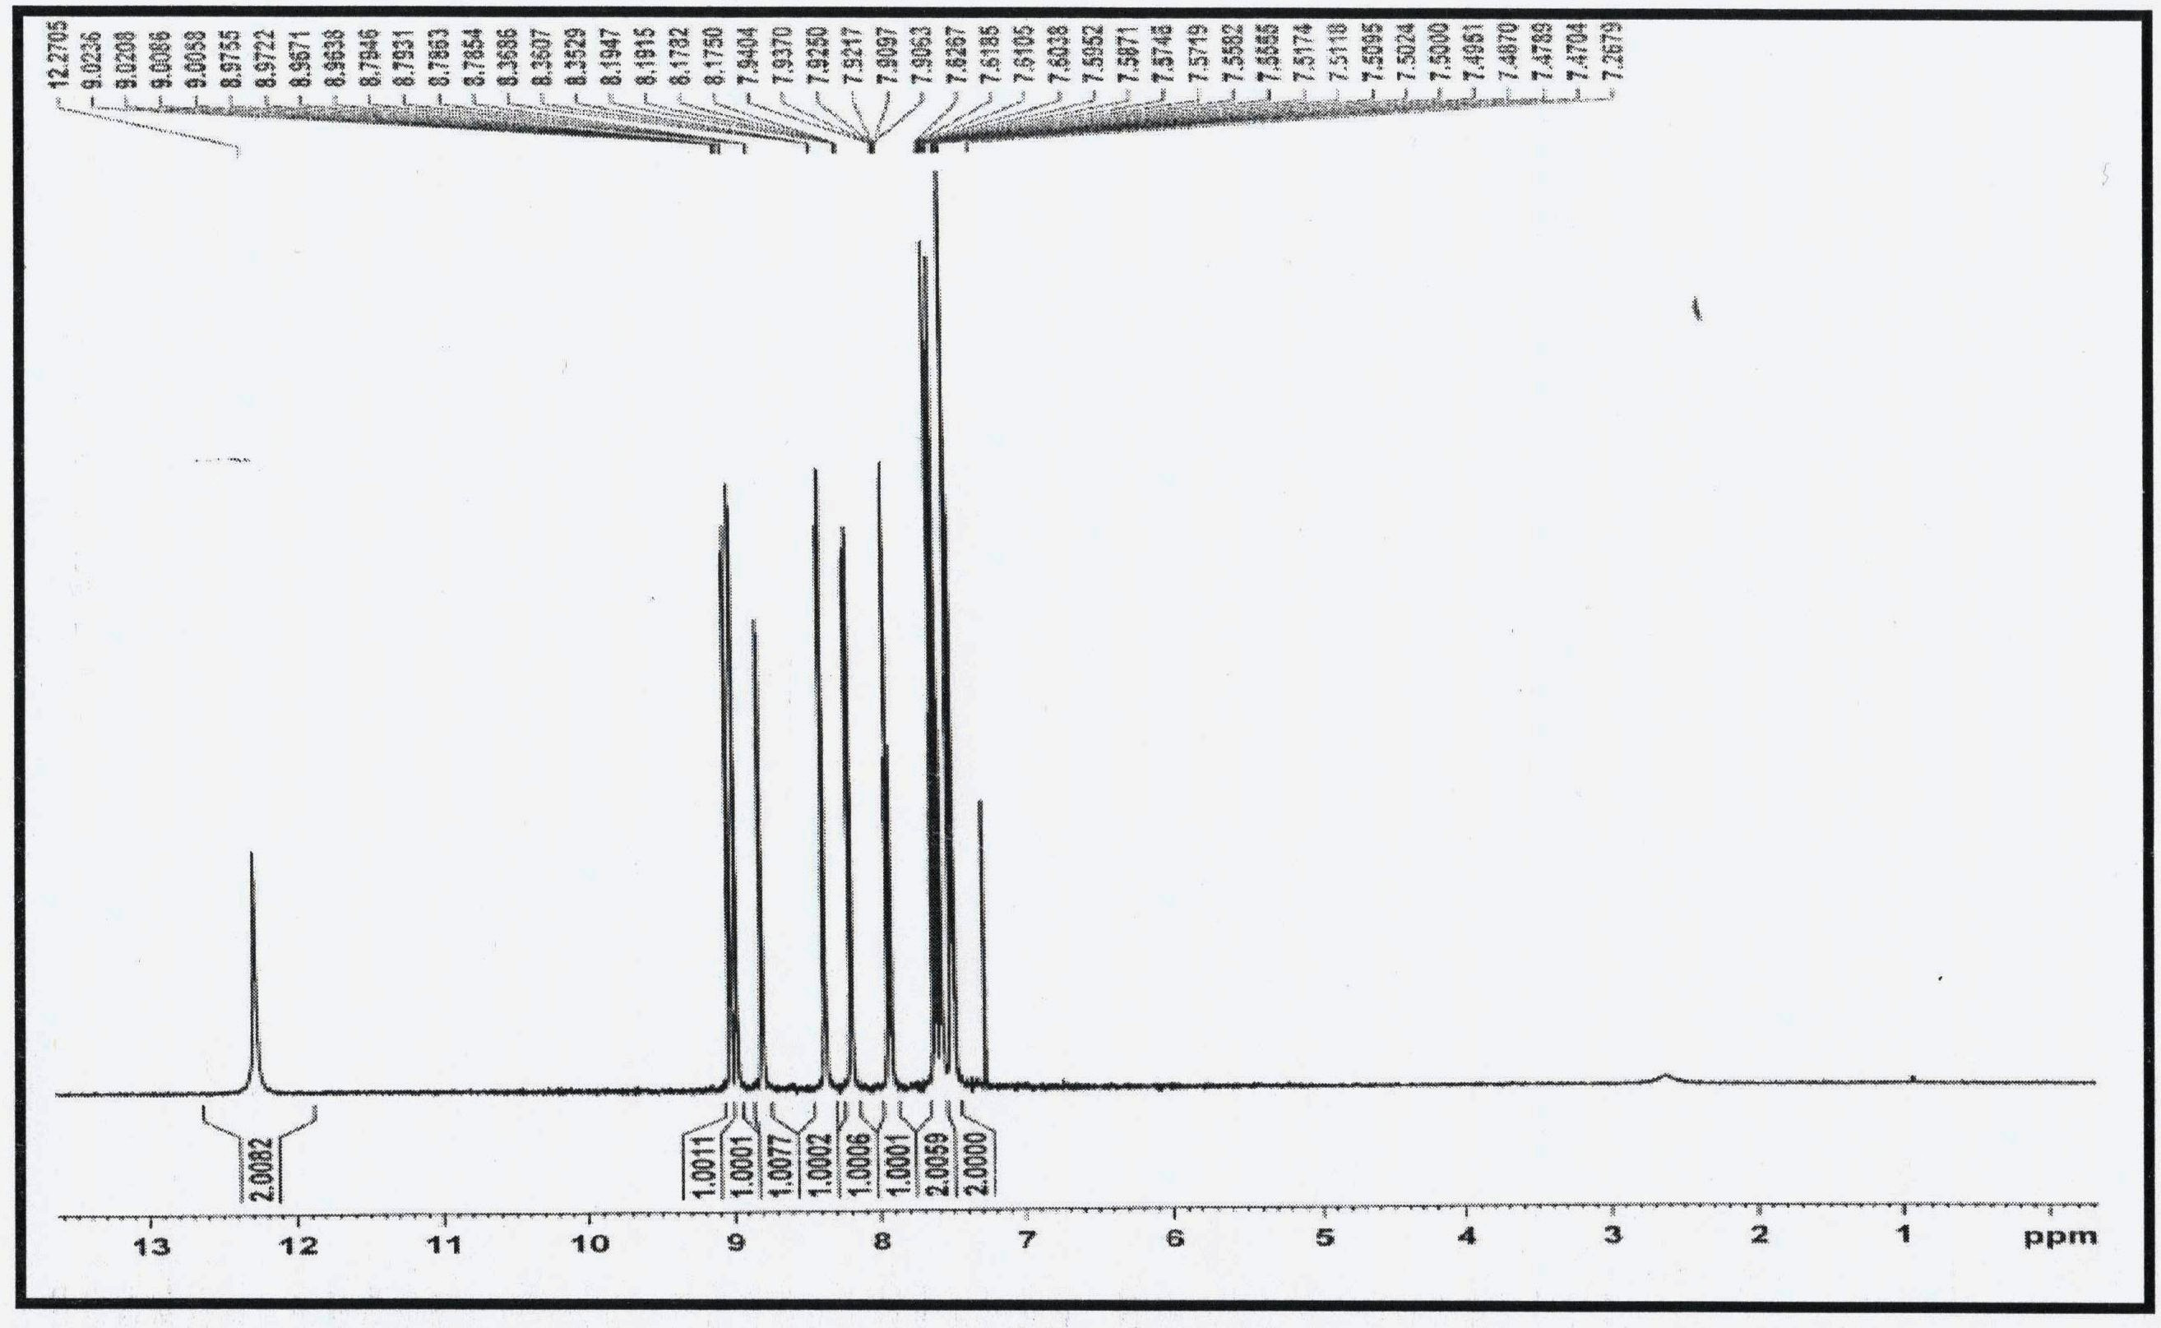
S-Fig. 11.¹H-NMR spectrum of Hbpq in CDCl₃.

