Additionally, DSC examinations were conducted to determine the oxygen induction time (OIT), expressed by the OIT index. It appears that the OIT of the ENR/PCL biocomposite cross-linked with dodecane acid began at a temperature of 410oC and amounted to 0.32 min (Fig. 1). The energy of this process amounted to 935 J g-1, which is similar to the energy value obtained by the oxygen induction process of the ENR/PCL composite cross-linked with quercetin. The OIT index of this composite was 3.35 min. However, the vulcanisate of ENR rubber had an OIT index equal to 1.36 min, and the energy of his process amounted to 2721 J g-1 ( Fig. 2). It should be emphasised that the oxidation of this sample began at 210oC. ENR/PCL biocomposites are characterised by a low oxidation energy, although their oxidation energy was comparable in the case of cross-linking with quercetin and lower in the case of the remaining samples. However, increasing the quercetin content did not significantly influence the oxygen induction time: at a content of 0.75 phr, the oxidation was more energetic than that of samples with higher quercetin contents (Fig.3).

Fig. 1. OIT index of ENR/ PCL composite measurement by using DSC method.

Fig. 2. OIT index of ENR vulcanizate measurement by using DSC method.

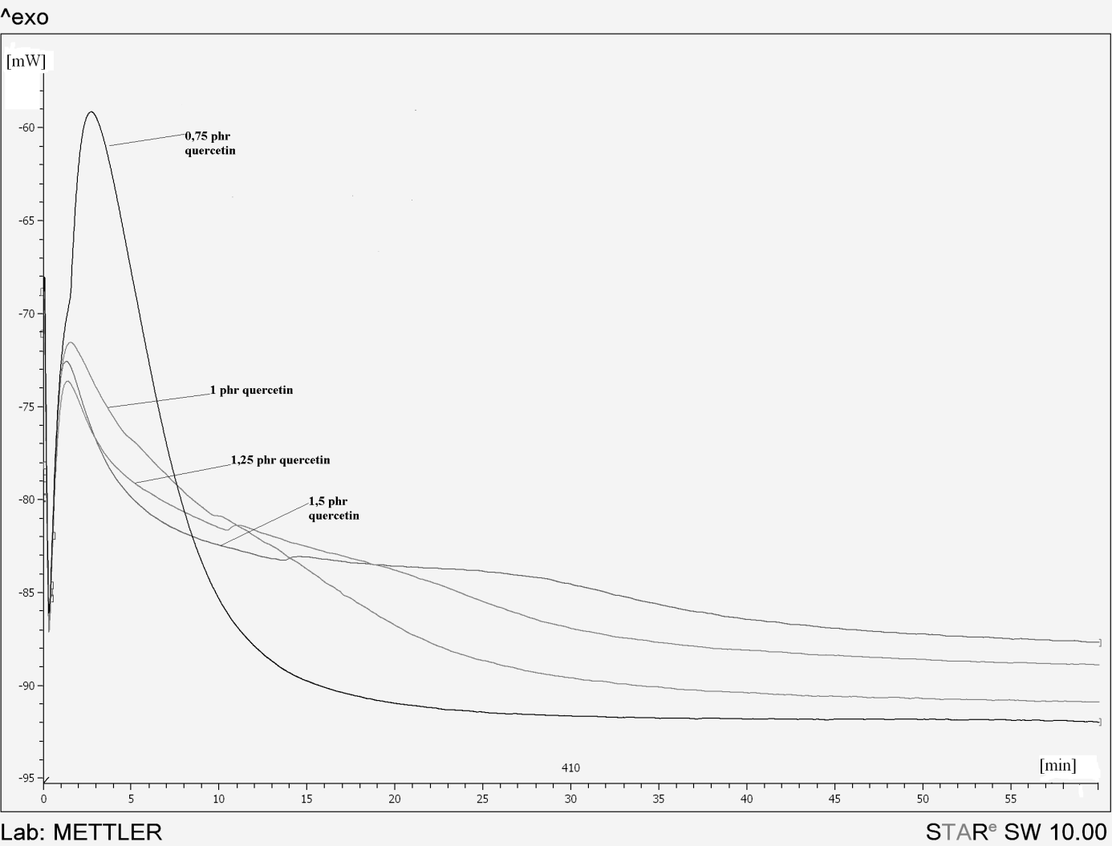

Fig. 3. OIT index of ENR/PCL composites containing quercetin.