Supplementary data
Friedel-Crafts alkylation of 4-hydroxycoumarin catalyzed by sulfonic acid functionalized pyridinium chloride as new ionic liquid
Mohammad Ali Zolfigol*^{,a}, Ahmad Reza Moosavi-Zare*^{,b} and Mahmoud Zareiª
ªFaculty of Chemistry, Bu-Ali Sina University, Hamedan, 6517838683, Iran.
^{b}Department of Chemistry, University of Sayyed Jamaleddin Asadabadi,

Table of Contents
Data of compounds………………………………………..………………………………...……….............2
NMR spectra of compounds………………………………………………….……………………...............5

Selected Data of Compounds:
3,3'-((4-chlorophenyl)methylene)bis(4-hydroxy-2H-chromen-2-one) (2)
White powder; Mp 259-261 ºC; IR (KBr) (υ_{max}, cm⁻¹): 3367, 1608, 1552, 1346, 1240, 762; ¹H NMR (400 MHz, DMSO-d₆): δ= 6.04 (s,1H), 7.26-7.42 (m, 6H), 7.55-7.69 (m, 2H), 7.87 (d, J = 1.2 Hz, 2H), 8.08 (d, J = 8.8 Hz, 2H), 12.67 (s, 2H, OH); ¹³C NMR (100 MHz, DMSO-d₆): 37.1, 103.6, 116.2, 119.2, 123.6, 123.8, 124.5, 128.4, 132.1, 145.9, 150.8, 152.8, 164.8, 167.1.
4-(bis(4-hydroxy-2-oxo-2H-chromen-3-yl)methyl)benzonitrile (3)
White powder; Mp: 260-262 ºC; IR (KBr) (υ_{max}, cm⁻¹): 3369, 2298, 1691.3, 1606.4, 1286.3;
¹H NMR (400 MHz, DMSO-d₆): δ (ppm) 5.60 (s, 1H), 7.32-7.33 (m, 4H), 7.52-7.47 (m, 2H), 7.66-7.59 (m, 2H), 7.83-7.80 (m, 2H) 7.95-7.95, (m, 2H), 12.65 (s, 2H, OH); ¹³C NMR (100 MHz, DMSO-d₆): δ (ppm) 37.0, 91.4, 116.2, 116.8, 123.6, 124.3, 129.0, 129.7, 131.1, 133.1, 133.3, 153.9, 162.3, 166.1, 167.7.

3,3'-(pyridin-4-ylmethylene)bis(4-hydroxy-2H-chromen-2-one) (6)
White powder; Mp: 270-274 ˚C; ¹H NMR (400 MHz, DMSO-d₆/D₂O): δ= 6.38 (s, 1H), 7.19-7.26 (m, 4H), 7.45-7.51 (m, 2H), 7.73-7.75 (m, 4H), 8.6-8.58 (d, J= 8 Hz, 2H); ¹³C NMR (100 MHz, DMSO-d₆/D₂O): 37.7, 101.3, 115.7, 119.3, 123.1, 124.1, 125.1, 131.5, 140.9, 162.6, 164.0, 164.7, 168.0.

3,3'-(thiophen-2-ylmethylene)bis(4-hydroxy-2H-chromen-2-one) (7)
White powder; Mp: 197-201˚C; ¹H NMR (400 MHz, DMSO-d₆/D₂O): 6.43 (s, 1H), 6.63 (d, J= 0.8 Hz, 1H), 6.81 (t, J= 4 Hz, 1H), 7.18 (d, J= 4.8 Hz, 1H), 7.25-7.30 (m, 4H), 7.54 (t, J= 7.2 Hz, 2H), 7.86 (d, J= 6.8 Hz, 2H); ¹³C NMR (100 MHz, DMSO-d₆/D₂O): δ (ppm) 33.2, 104.3, 116.1, 119.6, 123.4, 123.71, 123.79, 124.6, 126.7, 131.9, 147.5, 152.8, 164.6, 167.5.

3,3',3'',3'''-(1,4-phenylenebis(methanetriyl))tetrakis(4-hydroxy-2H-chromen-2-one) (10)

White powder; Mp: 312-314 ˚C; ¹H NMR (400 MHz, DMSO-d₆/D₂O): δ (ppm) 6.01 (s, 2H), 6.83 (s, 4H), 7.16-7.21 (m, 8H), 7.47-7.43 (m, 4H), 7.78 (d, J= 7.6 Hz, 4H); ¹³C NMR (100 MHz, DMSO-d₆/D₂O): δ (ppm) 39.1, 103.6, 104.3, 113.3, 116.1, 119.2, 120.1, 123.7, 124.4, 125.7, 127.9, 129.9, 131.8, 138.0, 148.9, 152.7, 165.1, 166.6, 168.1, 185.5, 193.2.

3,3'-((4-chlorophenyl)methylene)bis(4-hydroxy-2H-chromen-2-one) (2)
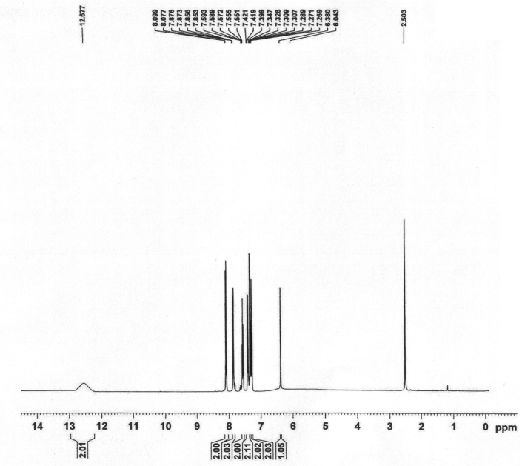

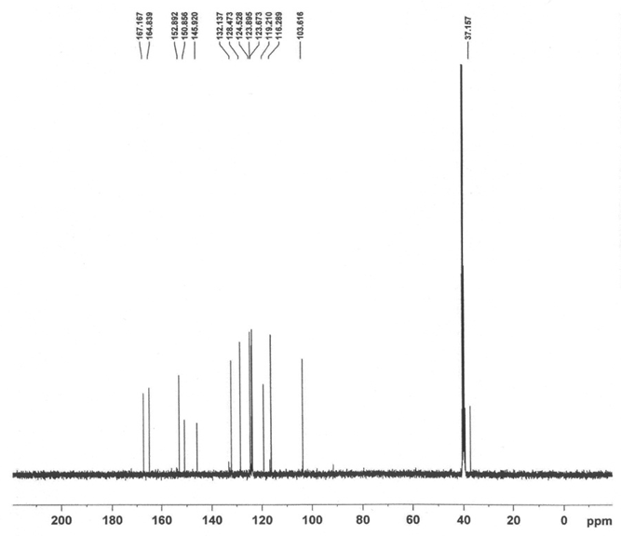
4-(bis(4-hydroxy-2-oxo-2H-chromen-3-yl)methyl)benzonitrile (3)
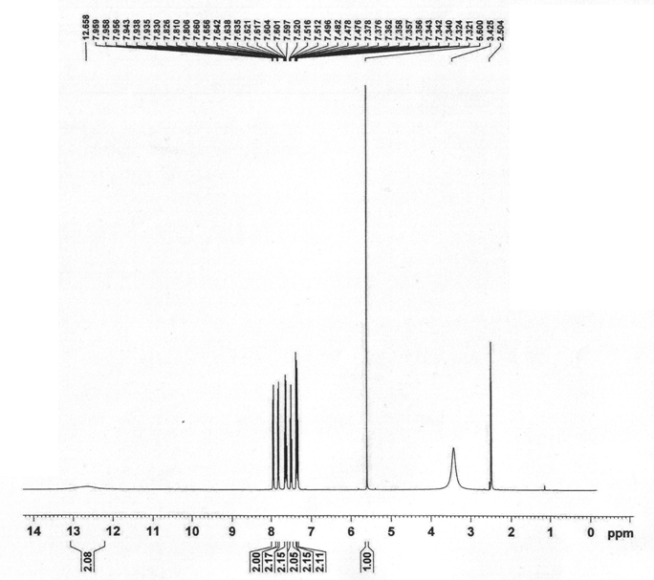
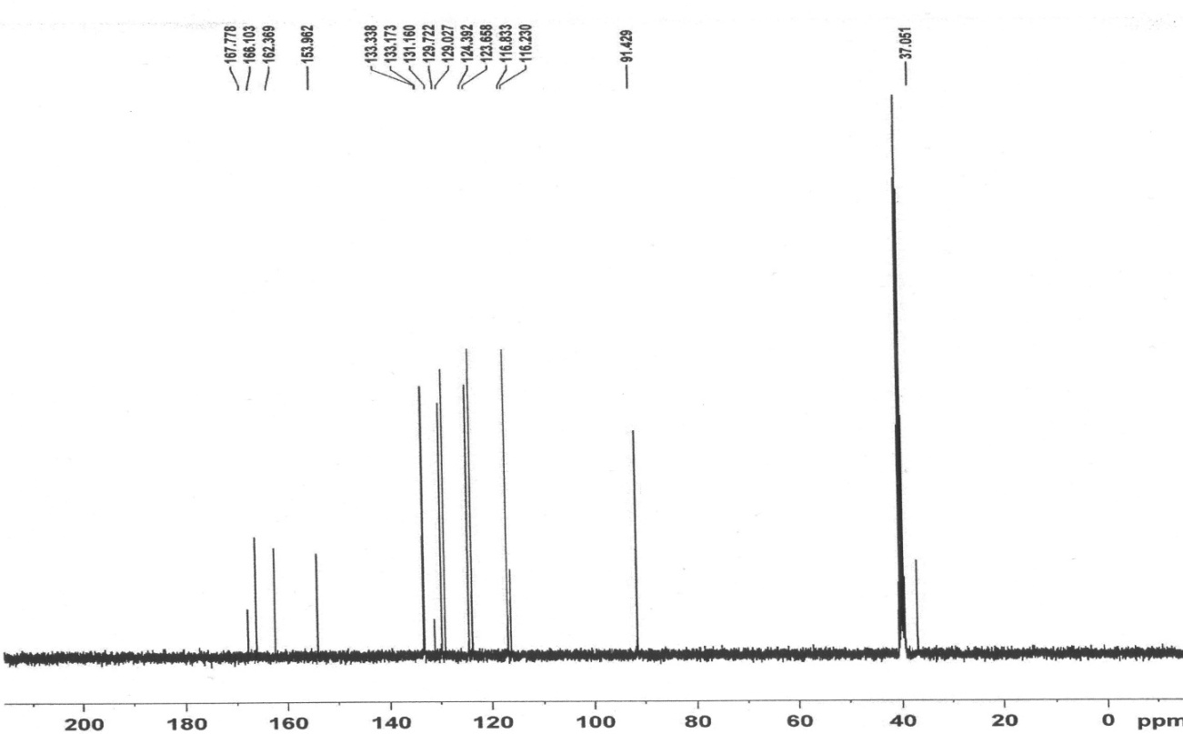
3,3'-(pyridin-4-ylmethylene)bis(4-hydroxy-2H-chromen-2-one) (6)
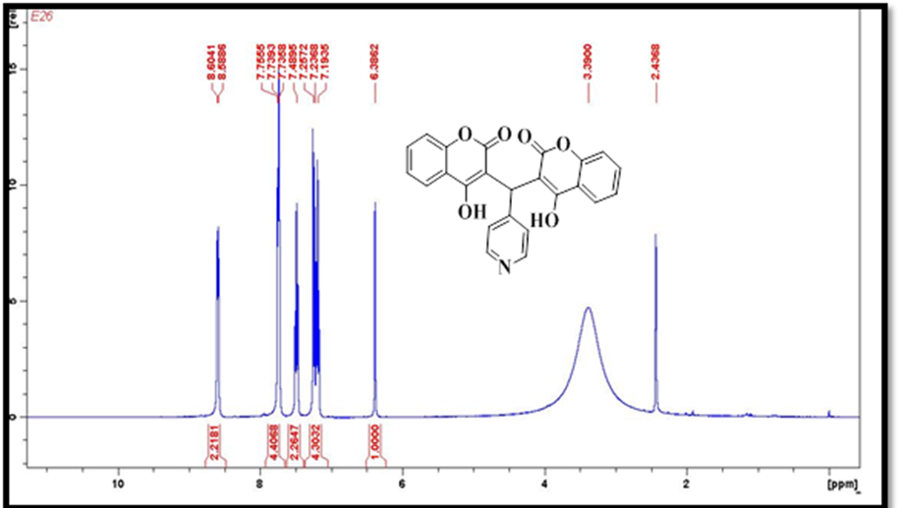

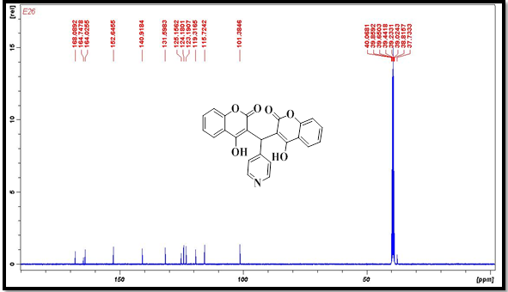

3,3'-(thiophen-2-ylmethylene)bis(4-hydroxy-2H-chromen-2-one) (7)
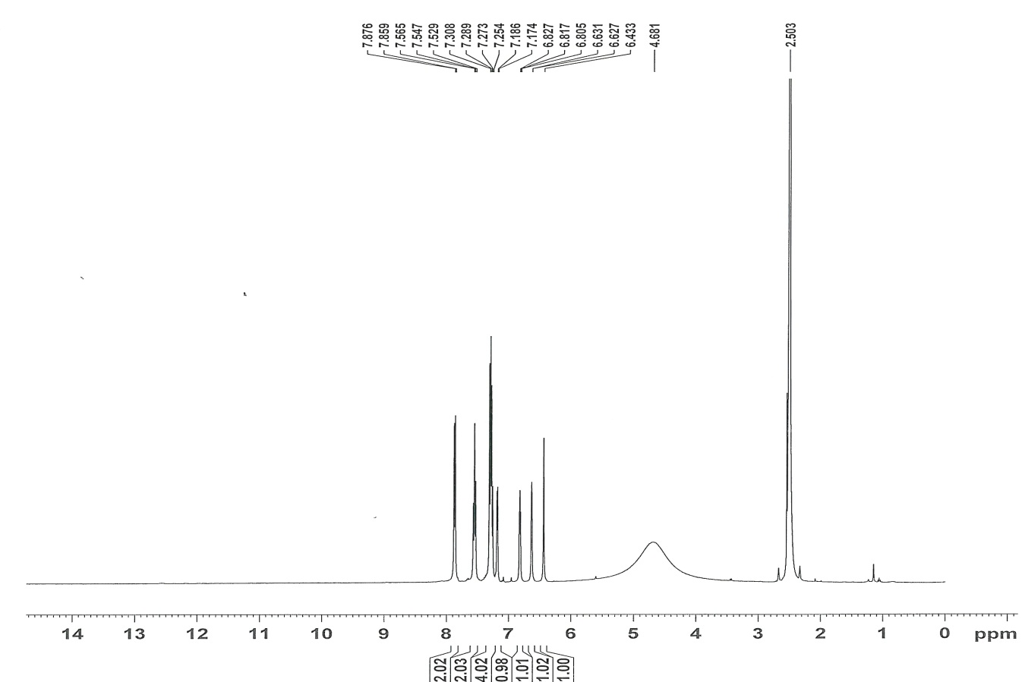

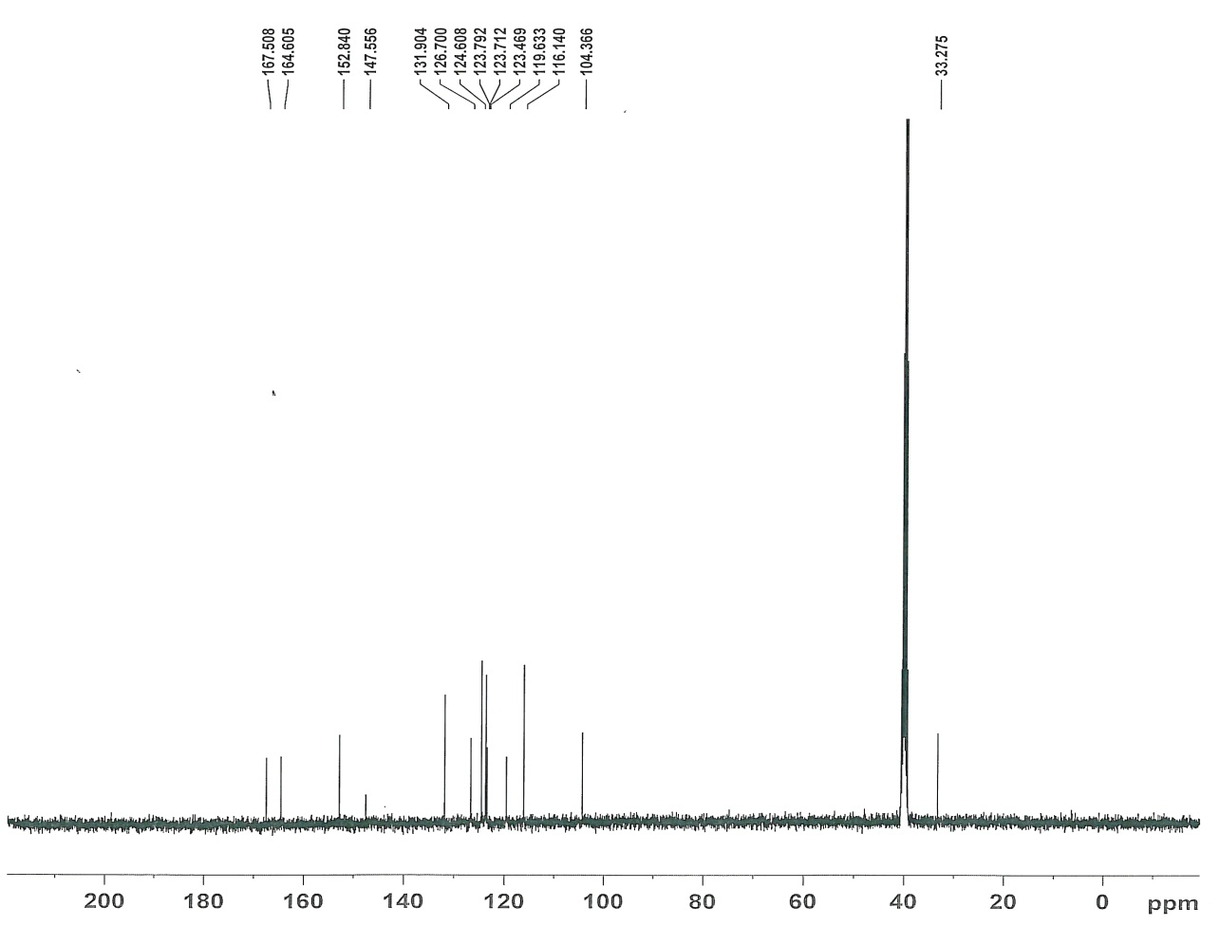
3,3',3'',3'''-(1,4-phenylenebis(methanetriyl))tetrakis(4-hydroxy-2H-chromen-2-one) (10)
