Supplementary Material

**Title**:A Proton Transfer and a Cobalt(II) Compound Including 2,6-pyridinedicarboxylate and o-PhenylenediamineIons: Synthesis, Characterization, Crystal Structure and Solution Study

**Author(s):** Khaled Ghasemi, Ali Reza Rezvani,* Ardeshir Shokrollahi, Abolghasem Moghimi, Sara Gavahi, Santiago García-Granda,*and Rafael Mendoza-Meroño

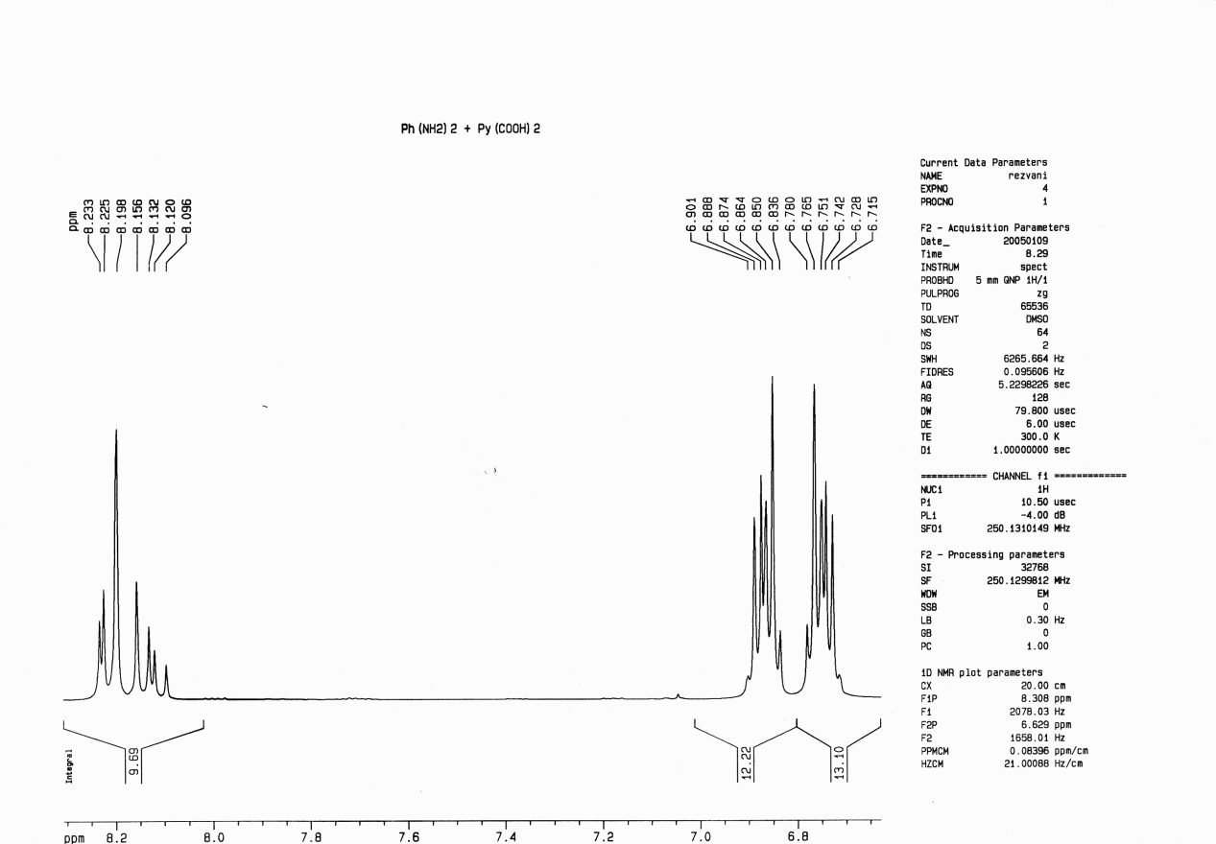

**Fig. S1.** 1HNMR spectrum of proton transfer compound (OPDH)2(dipic) in DMSO-*d*6

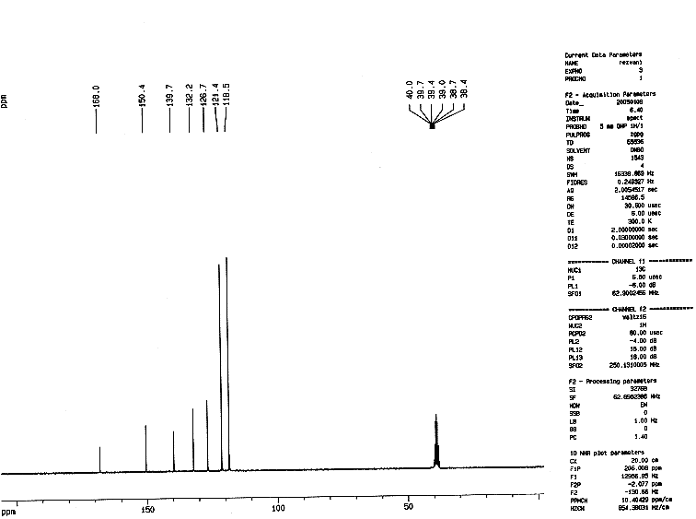

**Fig. S2.** 13C NMR spectrum of proton transfer compound (OPDH)2(dipic) in DMSO-*d*6