# Compound 1



H4

H9

H1

H5

H8

OCH2O

N-CH3

2xOCH3

solvent

H2O

H12

# 1H NMR

# HMBC

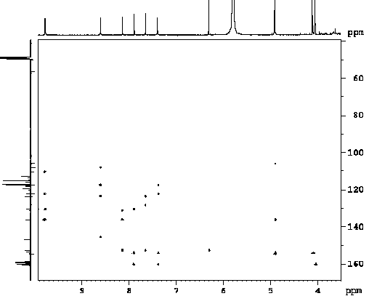

8/12a

8/9

8/8a

8/14

H5/C6

1/14

5/14a

5/13

5/4

N-CH3/14

12/13

4/14a

N-CH3/8

1,4/2,3

4/5

12/ 8a

OCH2/2,3

OCH3/10

9,12/10,11

OCH3/11

9/12a

1/4a

# Compound 2

# 1H NMR

8-OCH3



H4

N-CH3

OCH2O

H2O

H8

H12

H9

H1

H5

10,11-OCH3

CD2HOH

# Compound 3

H7

H8



N-CH3



H1

H9

H4

H12

H11

H2

H10

HSQC



H1-C1

H9-C9

H4-C4

H12-C12

H2-C2

H10-C10

H11-C11

COSY



H1/H2

H2/H4

H9/H10

H10/H11

H11/H12

H1

H9

H4

H12

H11

H2

H10

HMBC

N-CH3/C13b

H7/C5



H1/C3,C5

H4/C3,C5

H2/C3

H7, N-CH3/C13b

H7/C8a

N-CH3/C14a

H8/C13a

H8/C8a

H8/C9a

H1/C4a

H11,H10/C12a

H1,H4,H2/C14a

H9/C11,C8a



N-CH3/H1

N-CH3



H7

H1

H9

H8/H9

H7/H8

NOESY

# Compound 4

# HSQC



H10-C10

H4-C4

H9-C9

H11-C11

H2-C2

H1-C1

H12-C12

# COSY



H1

H2

H4

H9

H10

H11

H12

H1/ H2

H2/ H4

H9/H10

H10/H11

H11 /H12

# HMBC



H7/C 8a

H8/C 8a

N-CH3 /C13b

H7/C=O

N-CH3/C14a

H8/C9a

H8/C13a

H7/C13b



H9/C12a

H11/C12a

H1/C5

H1/C3

H4/C5

H2/C3

H2/C4

H11/C12/H10

H1/C4

H9/C12

H9/C9a

H9/C11

H1/C4a

H12/C9a

H11/C9

H4/C14a

H10/C9a

H2/C4a