Supporting Information

Effects of N-heteroaromatic ligands on highly luminescent mononuclear copper(I)-halide complexes

Hiroki Ohara, ª Atsushi Kobayashi ^{a, b} and Masako Kato* ª

ªDepartment of Chemistry, Faculty of Science, Hokkaid-o University, North-10 West-8, Kita-ku, Sapporo, Hokkaido 060-0810, Japan
^{b}Precursory Research for Embryonic Science and Technology (PRESTO), Japan Science and Technology Agency (JST), Honcho 4-1-8, Kawaguchi-shi, Saitama 332-0012, Japan

Contents
Table S1. Energy, oscillator strength and major contribution of calculated transition for1-Cl ……………….…..... 2
Figure S1. Schematic molecular orbital diagrams and orbital shapes related to calculated transition of 1-Cl. ......... 3
Table S2. Energy, oscillator strength and major contribution of calculated transition for 1-Br ……………….…..... 4
Figure S2. Schematic molecular orbital diagrams and orbital shapes related to calculated transition of 1-Br…… 5
Table S3. Energy, oscillator strength and major contribution of calculated transition for 2-Cl ……………….…..... 6
Figure S3. Schematic molecular orbital diagrams and orbital shapes related to calculated transition of 2-Cl.…… 7
Table S4. Energy, oscillator strength and major contribution of calculated transition for 2-Br ……………….…..... 8
Figure S4. Schematic molecular orbital diagrams and orbital shapes related to calculated transition of 2-Br........ 9
Table S5. Energy, oscillator strength and major contribution of calculated transition for 2-I-β ……………….…..... 10
Figure S5. Schematic molecular orbital diagrams and orbital shapes related to calculated transition of 2-I-β…… 11
Table S6. Energy, oscillator strength and major contribution of calculated transition for 3-Cl ……………….…..... 12
Figure S6. Schematic molecular orbital diagrams and orbital shapes related to calculated transition of 3-Cl…… 13
Table S7. Energy, oscillator strength and major contribution of calculated transition for 3-Br ……………….…..... 14
Figure S7. Schematic molecular orbital diagrams and orbital shapes related to calculated transition of 3-Br........ 15
Figure S8. Schematic molecular orbital diagrams of 1-I, 2-I, and 3-I ………………………......... 16
Table S1. Energy, oscillator strength and major contribution of calculated transition for 1-Cl
Excited state | Energy / eV (nm) | Oscillator strength | Major contribution (%)
1 | 2.9464 (420.81) | 0.0022 | HOMO->LUMO (70)  HOMO-1->LUMO (30)
2 | 2.9884 (414.89) | 0.0164 | HOMO-1->LUMO (71)  HOMO->LUMO (29)
3 | 3.0961 (400.46) | 0.0010 | HOMO-2->LUMO (100)
4 | 3.4721 (357.09 | 0.0034 | HOMO->LUMO+1 (89)  HOMO->LUMO+2 (8)  HOMO-1->LUMO+1 (3)
5 | 3.5031 (353.93) | 0.0028 | HOMO-1->LUMO+1 (90)  HOMO-1->LUMO+2 (7)  HOMO->LUMO+1 (3)
6 | 3.6227 (342.24) | 0.0012 | HOMO->LUMO+2 (92)  HOMO->LUMO+1 (8)
7 | 3.6379 (340.81) | 0.0008 | HOMO-2->LUMO+1 (77)  HOMO-2->LUMO+2 (17)  HOMO-1->LUMO+2 (3)  HOMO->LUMO+2 (3)
8 | 3.6687 (337.96) | 0.0081 | HOMO-1->LUMO+2 (85)  HOMO-1->LUMO+1 (5)  HOMO->LUMO+3 (4)  HOMO-2->LUMO+1 (4)  HOMO->LUMO+4 (2)
9 | 3.6954 (335.51) | 0.0088 | HOMO->LUMO+3 (90)  HOMO-1->LUMO+2 (4)  HOMO->LUMO+4 (2)  HOMO-3->LUMO (2)
10 | 3.7182 (333.46) | 0.0022 | HOMO-3->LUMO (86)  HOMO-4->LUMO (8)  HOMO->LUMO+3 (3)  HOMO-2->LUMO (3)

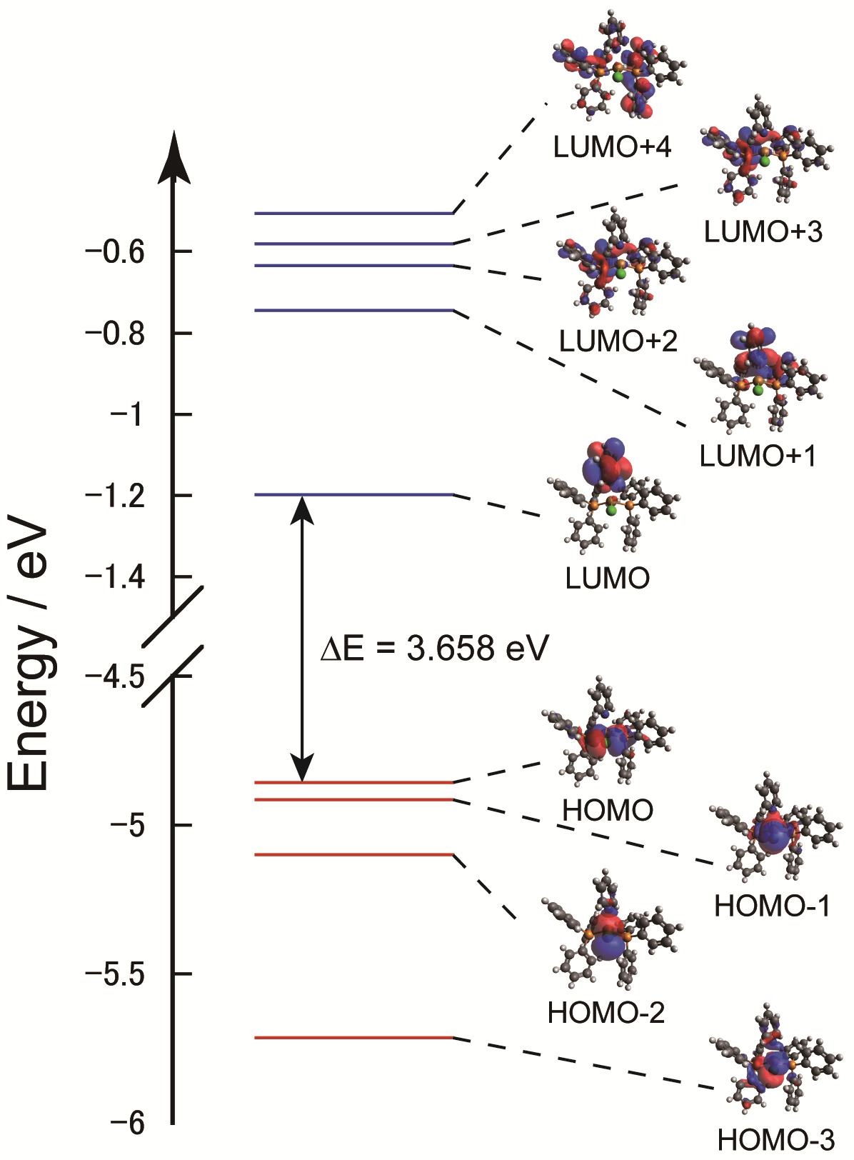

Figure S1. Schematic molecular orbital diagrams and orbital shapes related to calculated transition of 1-Cl. Molecular structure determined by X-ray crystallographic analysis was used for the calculation.

Table S2. Energy, oscillator strength and major contribution of calculated transition for 1-Br
Excited state | Energy / eV (nm) | Oscillator strength | Major contribution (%)
1 | 2.9035 (427.02) | 0.0042 | HOMO->LUMO (100)
2 | 2.9992 (413.39) | 0.0061 | HOMO-1->LUMO (96)  HOMO-2->LUMO (4)
3 | 3.1100 (398.66) | 0.0043 | HOMO-2->LUMO (96)  HOMO-1->LUMO (4)
4 | 3.4584 (358.50) | 0.0086 | HOMO->LUMO+1 (96)  HOMO->LUMO+2 (4)
5 | 3.5715 (347.15) | 0.0042 | HOMO->LUMO+1 (91)  HOMO->LUMO+2 (9)
6 | 3.5878 (345.57) | 0.0050 | HOMO->LUMO+2 (88)  HOMO->LUMO+3 (5)  HOMO->LUMO+1 (4)  HOMO->LUMO+5 (3)
7 | 3.6602 (338.73) | 0.0061 | HOMO->LUMO+3 (82)  HOMO->LUMO+4 (15)  HOMO->LUMO+2 (3)
8 | 3.6863 (336.34) | 0.0114 | HOMO->LUMO+5 (34)  HOMO-1->LUMO+2 (24)  HOMO-2->LUMO+1 (22)  HOMO-1->LUMO+3 (6)  HOMO->LUMO+2 (4)  HOMO-2->LUMO+2 (3)  HOMO->LUMO+3 (3)  HOMO-1->LUMO+1 (2)  HOMO-1->LUMO+4 (2)
9 | 3.6941 (335.62) | 0.0050 | HOMO->LUMO+5 (47)  HOMO-2->LUMO+1 (22)  HOMO->LUMO+4 (18)  HOMO-1->LUMO+2 (11)  HOMO-2->LUMO+2 (2)
10 | 3.7139 (333.84) | 0.0022 | HOMO-4->LUMO (4)  HOMO-2->LUMO+1 (41)  HOMO-2->LUMO+2 (6)  HOMO-1->LUMO+1 (8)  HOMO-1->LUMO+2 (39)  HOMO-1->LUMO+3 (2)

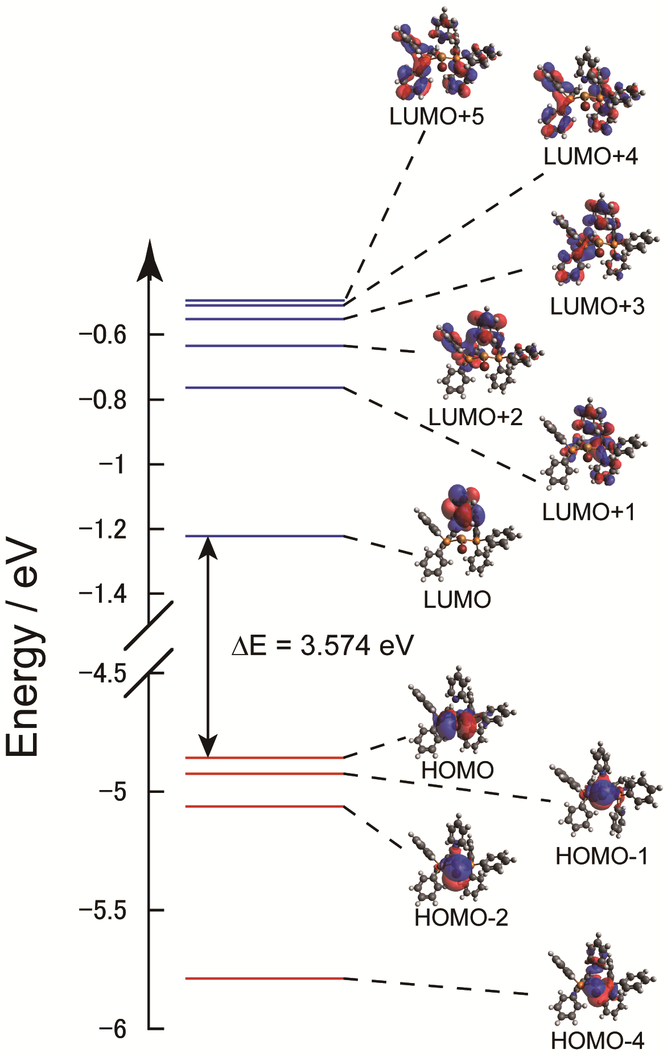

Figure S2. Schematic molecular orbital diagrams and orbital shapes related to calculated transition of 1-Br. Molecular structure determined by X-ray crystallographic analysis is used for the calculation.

Table S3. Energy, oscillator strength and major contribution of calculated transition for 2-Cl
Excited state | Energy / eV (nm) | Oscillator strength | Major contribution (%)
1 | 2.5760 (481.30) | 0.0171 | HOMO->LUMO (86)  HOMO-1->LUMO (14)
2 | 2.6594 (466.21) | 0.0087 | HOMO-1->LUMO (87)  HOMO->LUMO (13)
3 | 2.7324 (453.75) | 0.0005 | HOMO-2->LUMO (100)
4 | 3.3044 (375.21) | 0.0063 | HOMO-2->LUMO+1 (100)
5 | 3.3246 (372.93) | 0.0021 | HOMO-4->LUMO (54)  HOMO-3->LUMO (46)
6 | 3.3869 (366.07) | 0.0012 | HOMO-1->LUMO+1 (100)
7 | 3.4218 (362.34) | 0.0336 | HOMO-3 ->LUMO (54)  HOMO-4->LUMO (46)
8 | 3.4874 (355.52) | 0.0021 | HOMO-2->LUMO+1 (100)
9 | 3.6433 (340.31) | 0.0110 | HOMO->LUMO+2 (100)
10 | 3.7222 (333.09) | 0.0044 | HOMO-1->LUMO+3 (100)

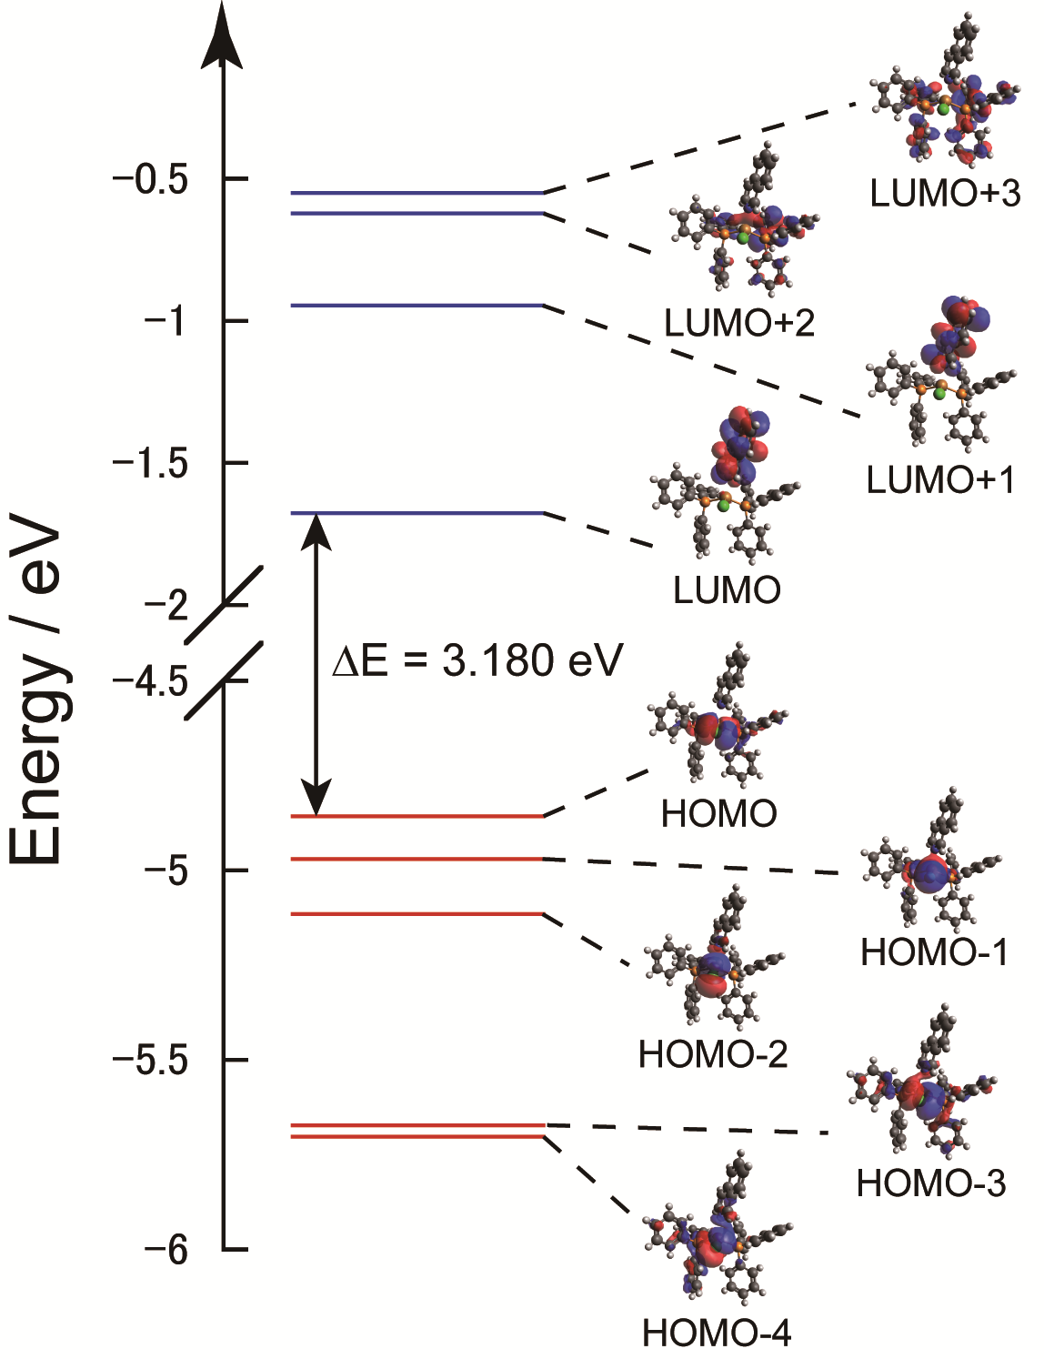

Figure S3. Schematic molecular orbital diagrams and orbital shapes related to calculated transition of 2-Cl. Molecular structure is determined by X-ray crystallographic analysis.

Table S4. Energy, oscillator strength and major contribution of calculated transition for 2-Br
Excited state | Energy / eV (nm) | Oscillator strength | Major contribution (%)
1 | 2.4003 (516.53) | 0.0015 | HOMO->LUMO (100)
2 | 2.4684 (502.30) | 0.0006 | HOMO-1->LUMO (100)
3 | 2.6196 (473.30) | 0.0065 | HOMO-2->LUMO (100)
4 | 3.1632 (391.96) | 0.0039 | HOMO-2->LUMO+1 (100)
5 | 3.2023 (387.17) | 0.0019 | HOMO-3->LUMO (53)  HOMO-4->LUMO (25)  HOMO-1->LUMO+1 (22)
6 | 3.2434 (382.27) | 0.0012 | HOMO-1->LUMO+1 (64)  HOMO-4->LUMO (19)  HOMO-3->LUMO (18)
7 | 3.3502 (370.08) | 0.0241 | HOMO-4->LUMO (56)  HOMO-3->LUMO (29)  HOMO-2->LUMO+1 (15)
8 | 3.3873 (366.03) | 0.0042 | HOMO-2->LUMO+1 (83)  HOMO-4->LUMO (17)
9 | 3.4813 (356.15) | 0.0202 | HOMO->LUMO+2 (100)
10 | 3.5567 (348.59) | 0.0031 | HOMO->LUMO+3 (82)  HOMO-1->LUMO+2 (18)

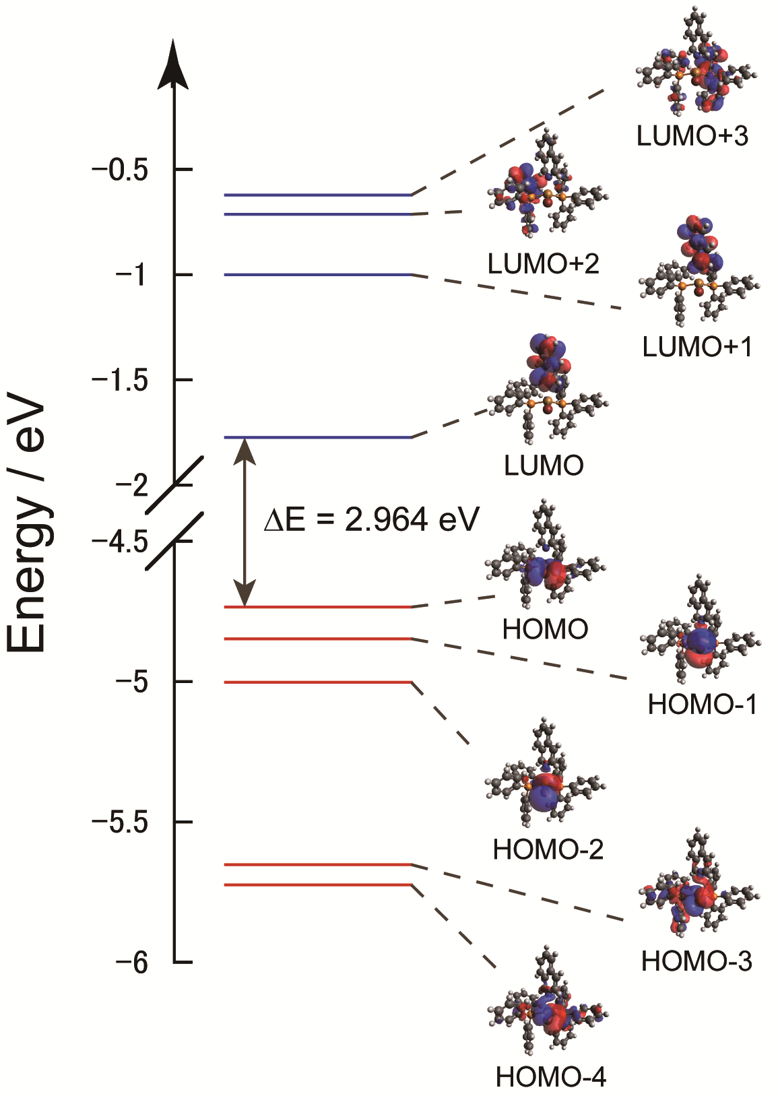

Figure S4. Schematic molecular orbital diagrams and orbital shapes related to calculated transition of 2-Br. Molecular structure is determined by X-ray crystallographic analysis.
Table S5. Energy, oscillator strength and major contribution of calculated transition for 2-I-
Excited state | Energy / eV (nm) | Oscillator strength | Major contribution (%)
1 | 2.2159 (559.53) | 0.0005 | HOMO->LUMO (100)
2 | 2.3137 (535.87) | 0.0009 | HOMO-1->LUMO (100)
3 | 2.4864 (498.65) | 0.0086 | HOMO-2->LUMO (100)
4 | 3.0340 (408.65) | 0.0031 | HOMO->LUMO+1 (100)
5 | 3.1257 (396.66) | 0.0018 | HOMO-1->LUMO+1 (56)  HOMO-3->LUMO (28)  HOMO-4->LUMO (16)
6 | 3.1589 (392.50) | 0.0017 | HOMO-1->LUMO+1 (56)  HOMO-3->LUMO (28)  HOMO-4->LUMO (16)
7 | 3.2740 (378.69) | 0.0184 | HOMO-4->LUMO (43)  HOMO-3->LUMO (31)  HOMO->LUMO+2 (26)
8 | 3.2944 (376.35) | 0.0183 | HOMO-3->LUMO (48)  HOMO-4->LUMO (25)  HOMO-2->LUMO+1 (15)  HOMO->LUMO+2 (12)
9 | 3.3075 (374.86) | 0.0090 | HOMO-2->LUMO+1 (55)  HOMO->LUMO+2 (21)  HOMO-4->LUMO (14)  HOMO-3->LUMO (10)
10 | 3.3713 (367.77) | 0.0025 | HOMO->LUMO+3 (100)

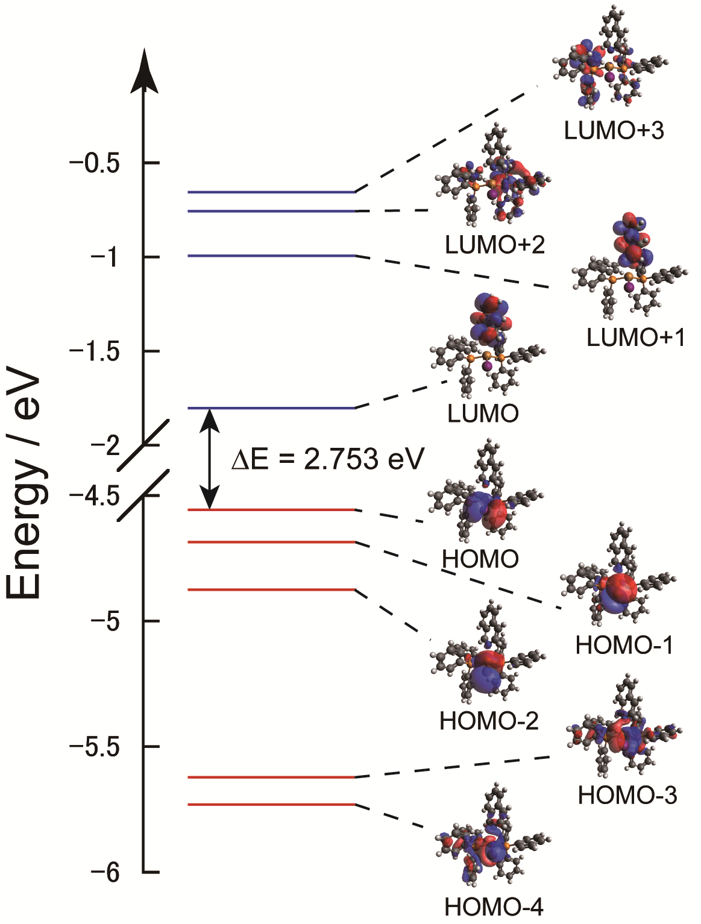

Figure S5. Schematic molecular orbital diagrams and orbital shapes related to calculated transition of 2-I-β. Molecular structure is determined by X-ray crystallographic analysis.
Table S6. Energy, oscillator strength and major contribution of calculated transition for 3-Cl
Excited state | Energy / eV (nm) | Oscillator strength | Major contribution (%)
1 | 2.1883 (566.57) | 0.0045 | HOMO->LUMO (100)
2 | 2.2480 (551.52) | 0.0027 | HOMO-1->LUMO (100)
3 | 2.4011 (516.36) | 0.0046 | HOMO-2->LUMO (100)
4 | 3.0060 (412.46) | 0.0013 | HOMO-3->LUMO (74)  HOMO-4->LUMO (26)
5 | 3.1047 (399.34) | 0.0038 | HOMO-1->LUMO+1 (100)
6 | 3.1270 (396.49) | 0.0143 | HOMO-4->LUMO (58)  HOMO-1->LUMO (22)  HOMO-3->LUMO+1 (20)
7 | 3.1875 (388.97) | 0.0162 | HOMO-1 ->LUMO+1 (59)  HOMO-4->LUMO (19)  HOMO-3->LUMO (11)  HOMO-2->LUMO+1 (11)
8 | 3.3228 (373.14) | 0.0017 | HOMO-2->LUMO+1 (85)  HOMO-1->LUMO+1 (15)
9 | 3.5897 (345.39) | 0.0248 | HOMO->LUMO+2 (83)  HOMO-1->LUMO+2 (17)
10 | 3.6775 (337.14) | 0.0006 | HOMO-1->LUMO+2 (57)  HOMO->LUMO+3 (30)  HOMO->LUMO+2 (13)

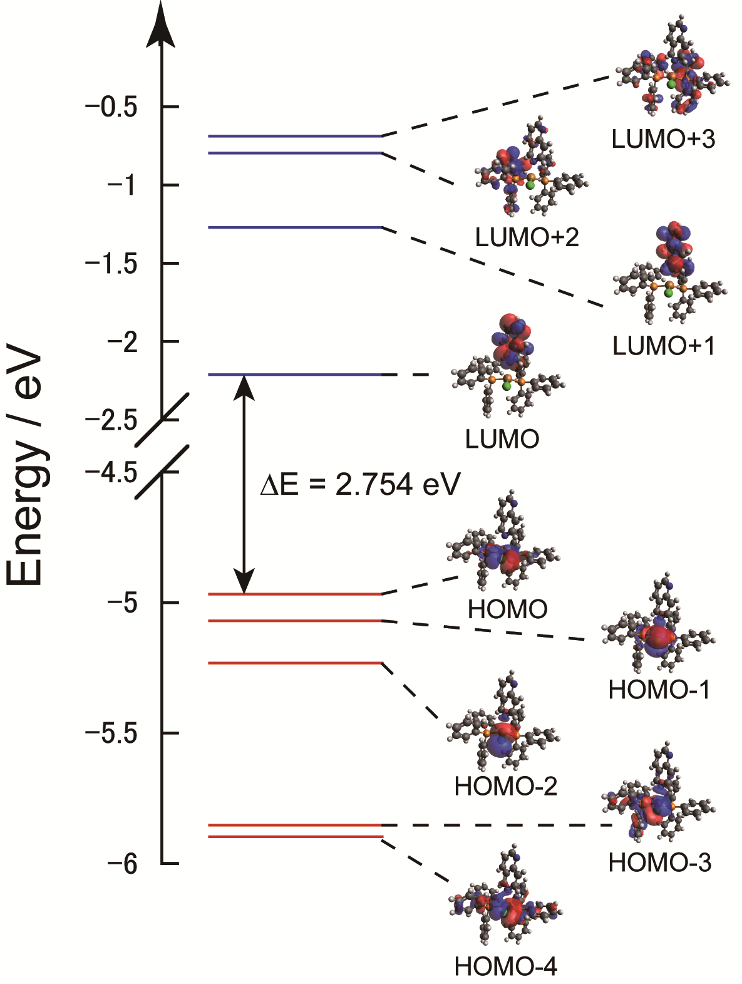

Figure S6. Schematic molecular orbital diagrams and orbital shapes related to calculated transition of 3-Cl. Molecular structure is determined by X-ray crystallographic analysis.

Table S7. Energy, oscillator strength and major contribution of calculated transition for 3-Br
Excited state | Energy / eV (nm) | Oscillator strength | Major contribution (%)
1 | 2.0325 (610.00) | 0.0016 | HOMO->LUMO (100)
2 | 2.1136 (586.60) | 0.0005 | HOMO-1->LUMO (100)
3 | 2.2736 (545.33) | 0.0055 | HOMO-2->LUMO (100)
4 | 2.8848 (429.79) | 0.0008 | HOMO-3->LUMO (57)  HOMO-4->LUMO (43)
5 | 2.9467 (420.75) | 0.0037 | HOMO->LUMO+1 (100)
6 | 2.9941 (414.10) | 0.0165 | HOMO-4->LUMO (47)  HOMO-3->LUMO (34)  HOMO-1->LUMO+1 (19)
7 | 3.0436 (407.36) | 0.0143 | HOMO-1->LUMO+1 (68)  HOMO-3->LUMO (19)  HOMO-4->LUMO (13)
8 | 3.1858 (389.18) | 0.0018 | HOMO-2->LUMO+1 (100)
9 | 3.4596 (358.38) | 0.0198 | HOMO->LUMO+2 (100)
10 | 3.5567 (348.59) | 0.0031 | HOMO-1->LUMO+2 (55)  HOMO->LUMO+3 (35)  HOMO->LUMO+2 (10)

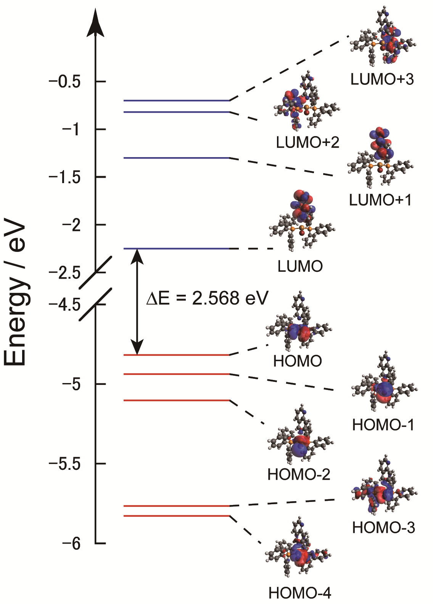

Figure S7. Schematic molecular orbital diagrams and orbital shapes related to calculated transition of 3-Br. Molecular structure is determined by X-ray crystallographic analysis.
TD-DFT Calculations
The electron density in the highest and second highest occupied molecular orbitals (HOMO and HOMO-1) is distributed over the Cu and halogen atoms, while that in the lowest unoccupied molecular orbitals (LUMO) are localized on the L ligand. For complexes 1-Br, 1-I, 2-Br, 2-I, 3-Cl, 3-Br, and 3-I, the HOMO-LUMO transition contributes to the lowest excited state by 100%. For complexes 1-Cl and 2-Cl, the HOMO-LUMO and HOMO-1 to LUMO transitions contribute to the lowest excited state by 61% asnd 39% for 1-Cl, and 86% and 14% for 2-Cl, respectively. Thus, the lowest excited states of complexes 1-X, 2-X, and 3-X are a combination of MLCT and halide-to-ligand charge transfer (XLCT) states ((M+X)LCT). As shown in Figure S8, the HOMO energies of 1-I, 2-I, and 3-I are almost the same, and independent of the L ligands. However, the LUMO energies of 1-I, 2-I, and 3-I are strongly dependent on the π* energy level of the L ligands, which suggests the energy of the (M+X)LCT state is controlled by the L ligands.

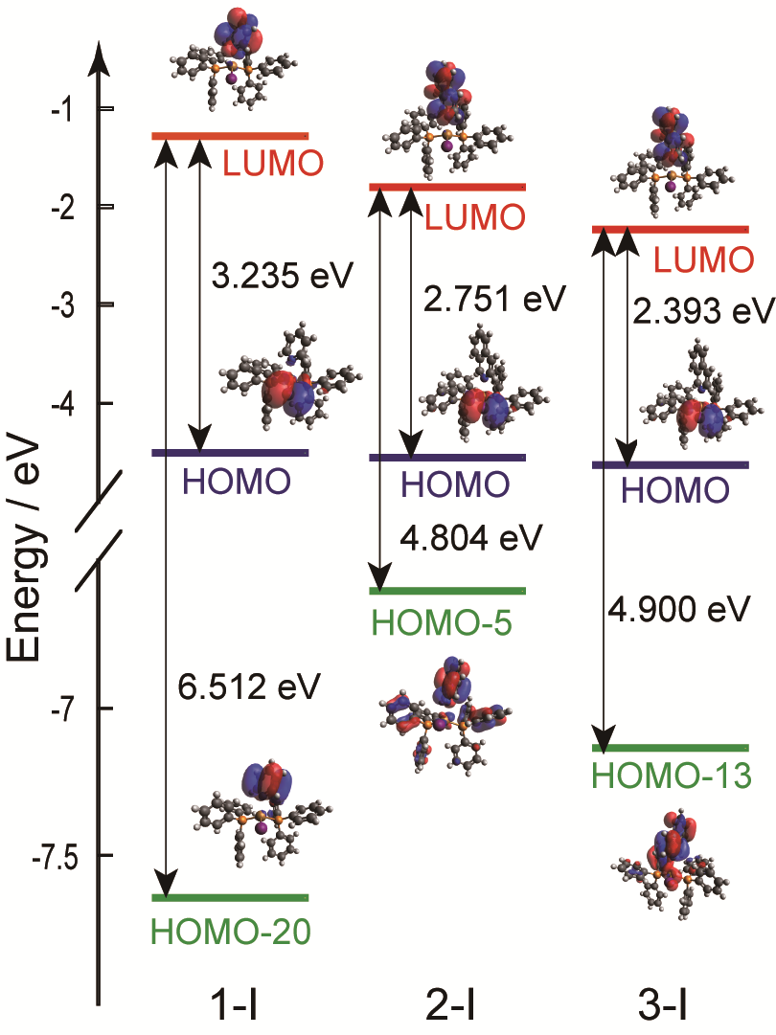

Figure S8. Schematic molecular orbital diagrams of 1-I, 2-I, and 3-I.

