Synthesis of organosilyl compounds-containing 1,2,4,5-tetraaryl imidazoles sonocatalyzed by M/SAPO-34 (M: Fe, Co, Mn, and Cu) nanostructures
Kazem D. Safa^{a,}*, Maryam Allahvirdinesbatª, Hassan Namazi^{b}, Parvaneh Nakhostin Panahi^{c}
ªOrganosilicon Research Laboratory, Faculty of Chemistry, University of Tabriz, Tabriz, 5166614766, Iran
^{b}Laboratory of Dendrimers and Nano-Biopolymers, Faculty of Chemistry, University of Tabriz, Tabriz, 5166614766, Iran
^{c}Department of Chemistry, Faculty of Science, University of Zanjan, Iran
Tel: +98 (0)41 33393124 Fax: +98 (0)41 3334 0191
Corresponding author, e-mail: dsafa@tabrizu.ac.ir

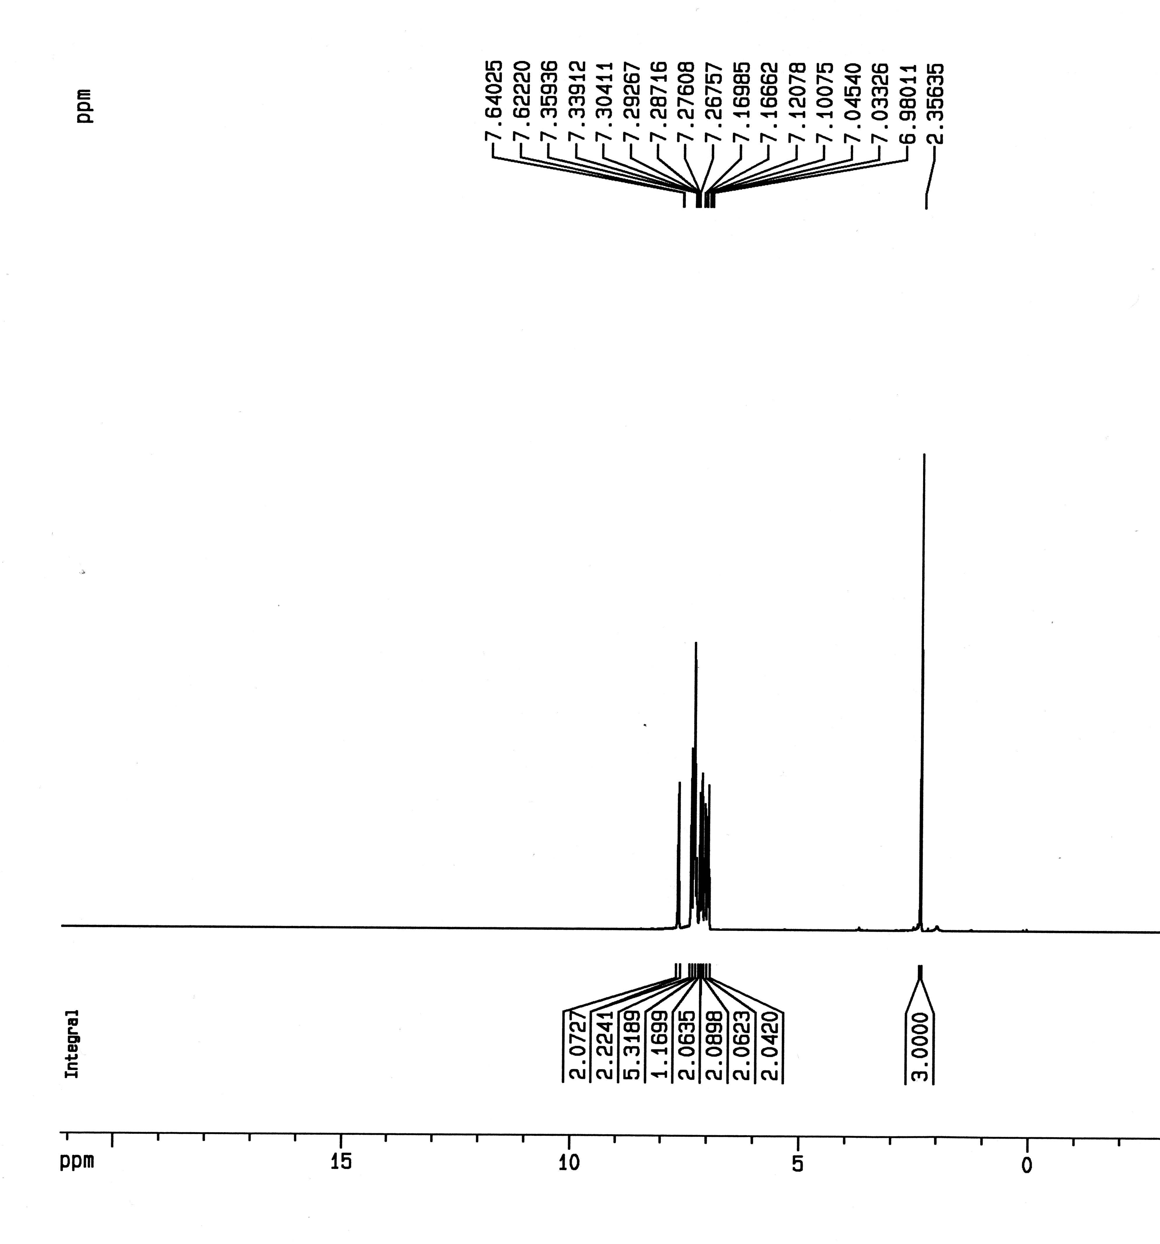
Fig. S1. ¹H NMR spectrum of 1-(4-fluorophenyl)-4,5-diphenyl-2-p-tolyl-1H-imidazole (1d) in CDCl₃
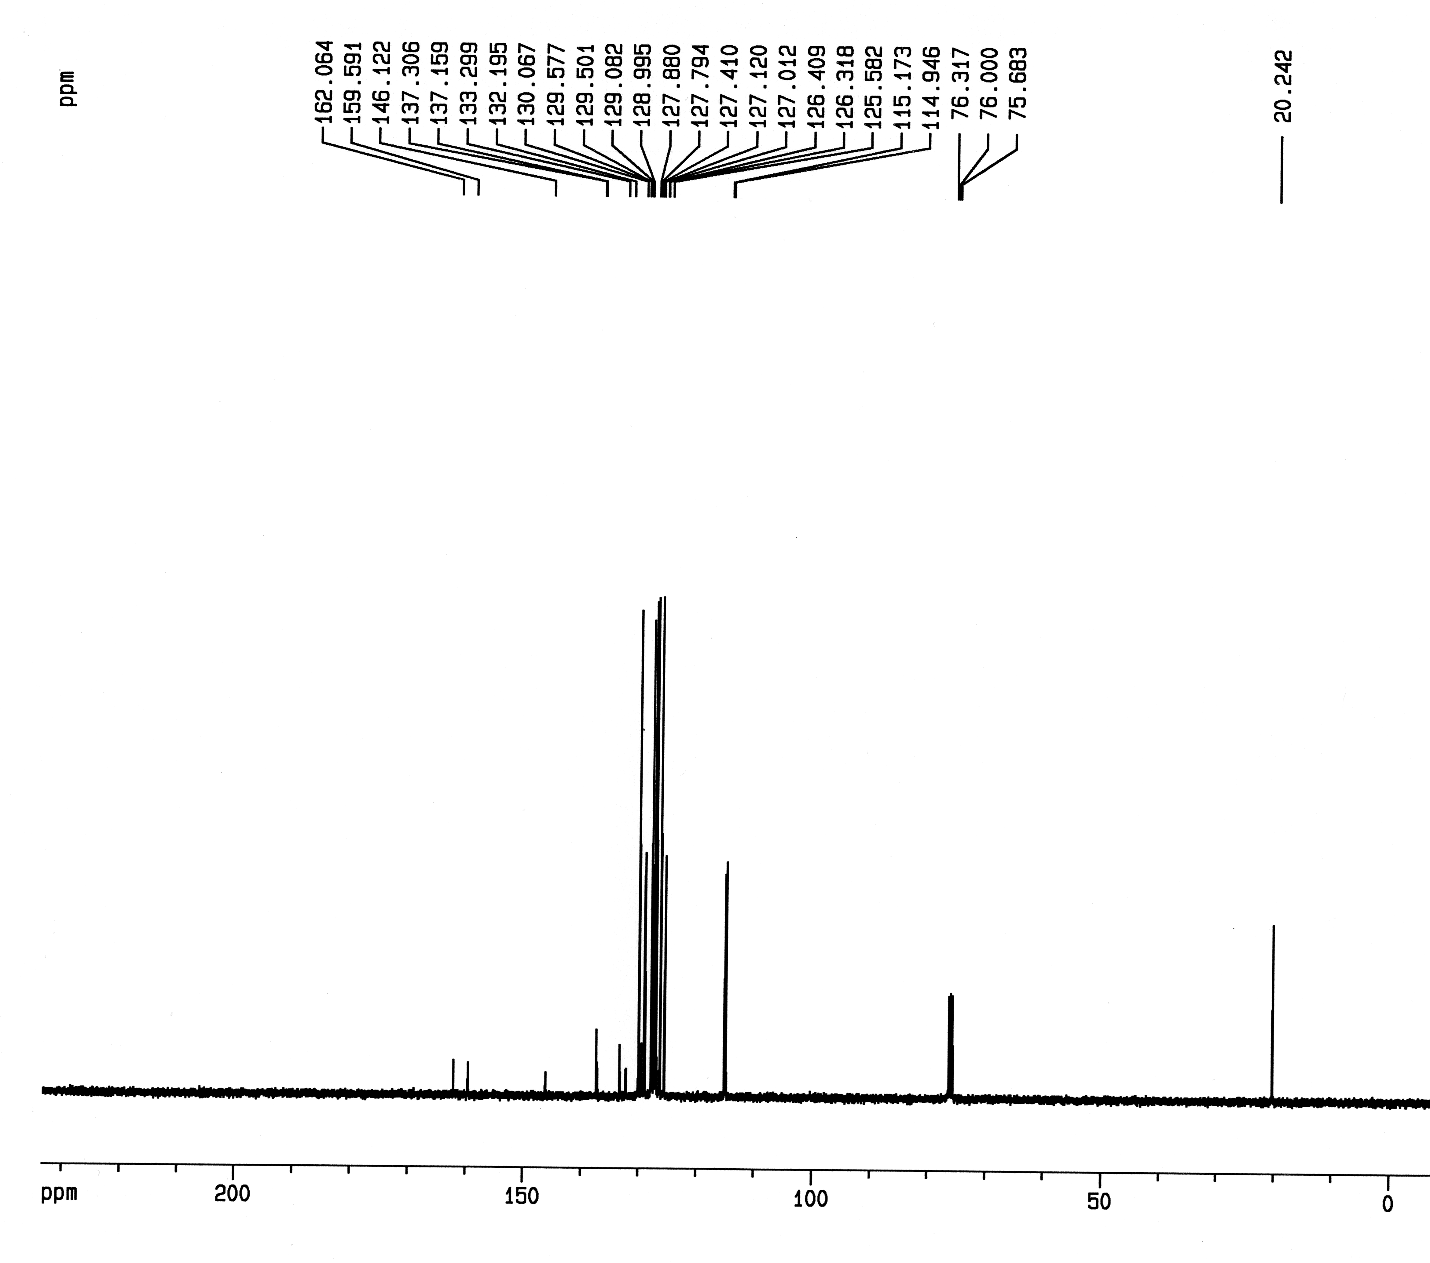
Fig. S2. ¹³C NMR spectrum of 1-(4-fluorophenyl)-4,5-diphenyl-2-p-tolyl-1H-imidazole (1d) in CDCl₃

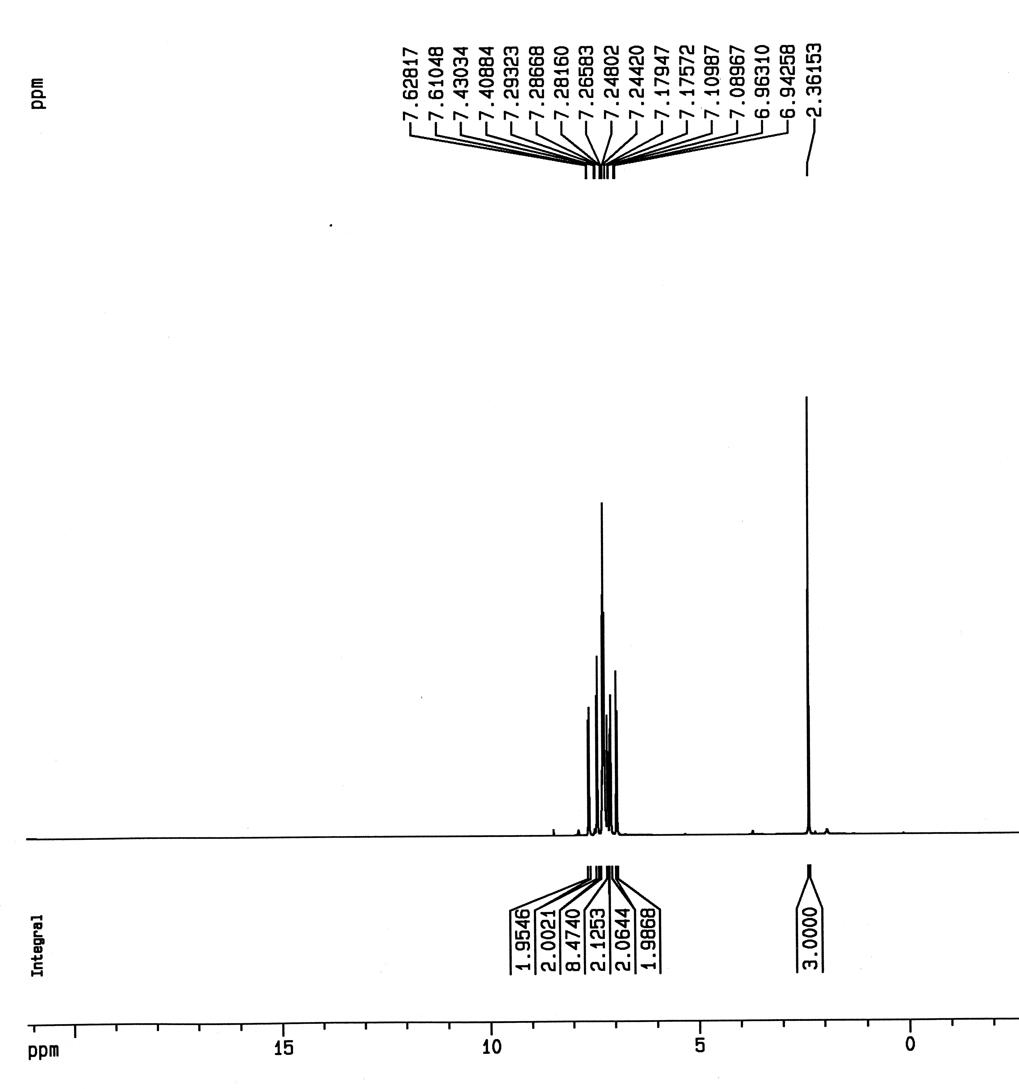
Fig. S3. ¹H NMR spectrum of 2-(4-Chlorophenyl)-4,5-diphenyl-1-p-tolyl-1H-imidazole (1e) in CDCl₃
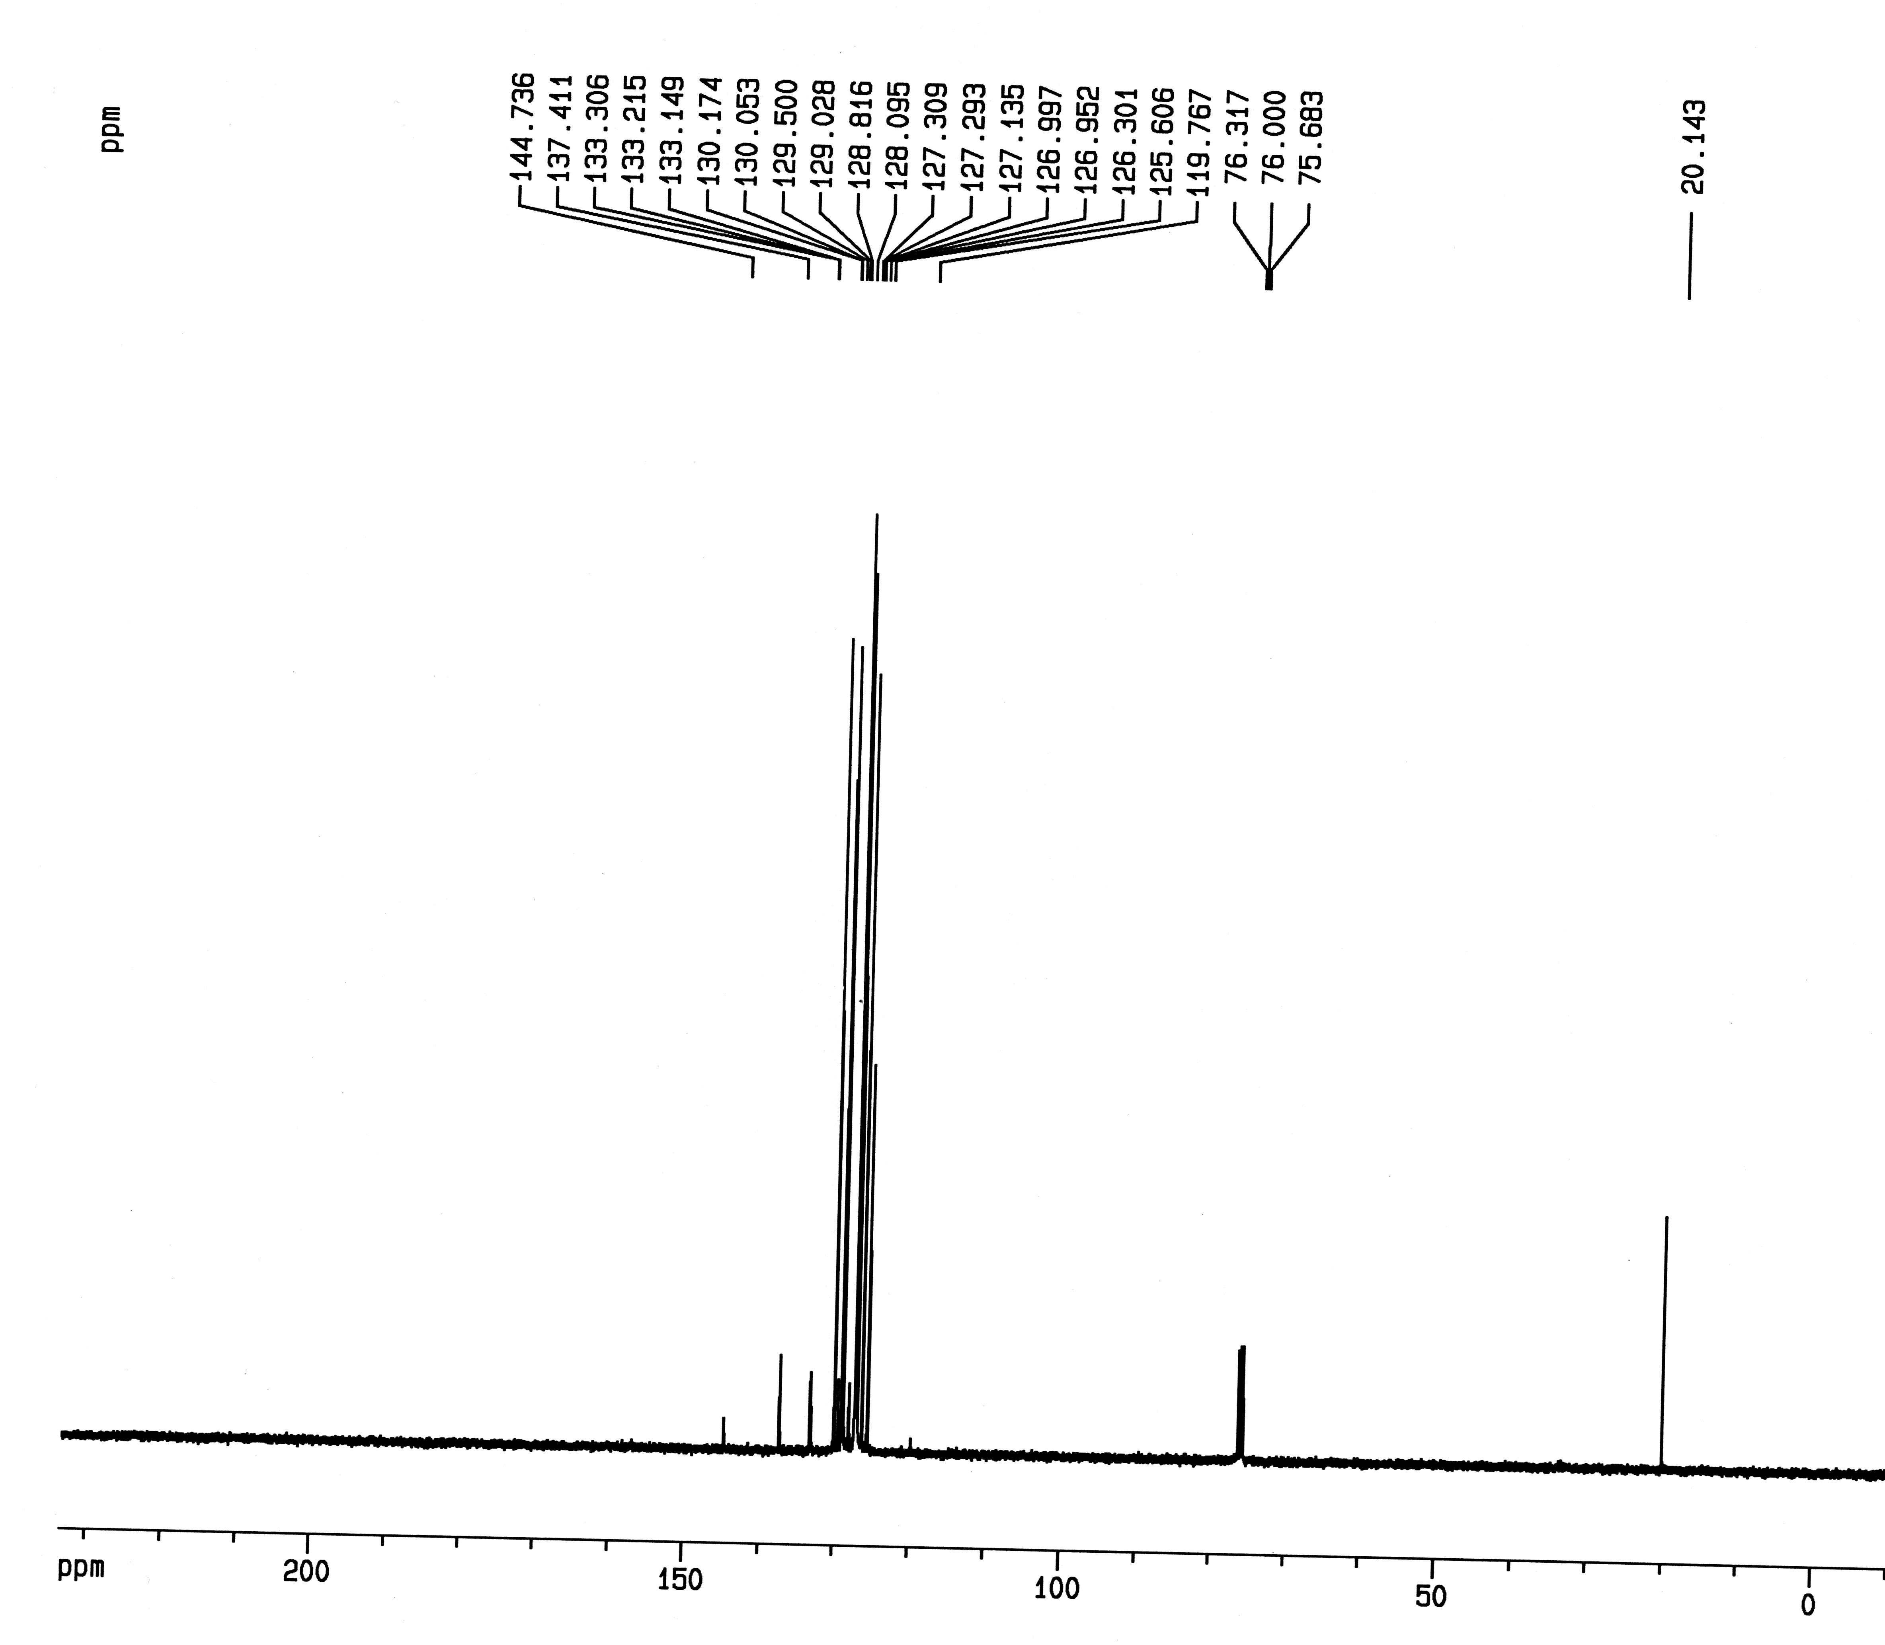
Fig. S4. ¹³C NMR spectrum of 2-(4-Chlorophenyl)-4,5-diphenyl-1-p-tolyl-1H-imidazole (1e) in CDCl₃

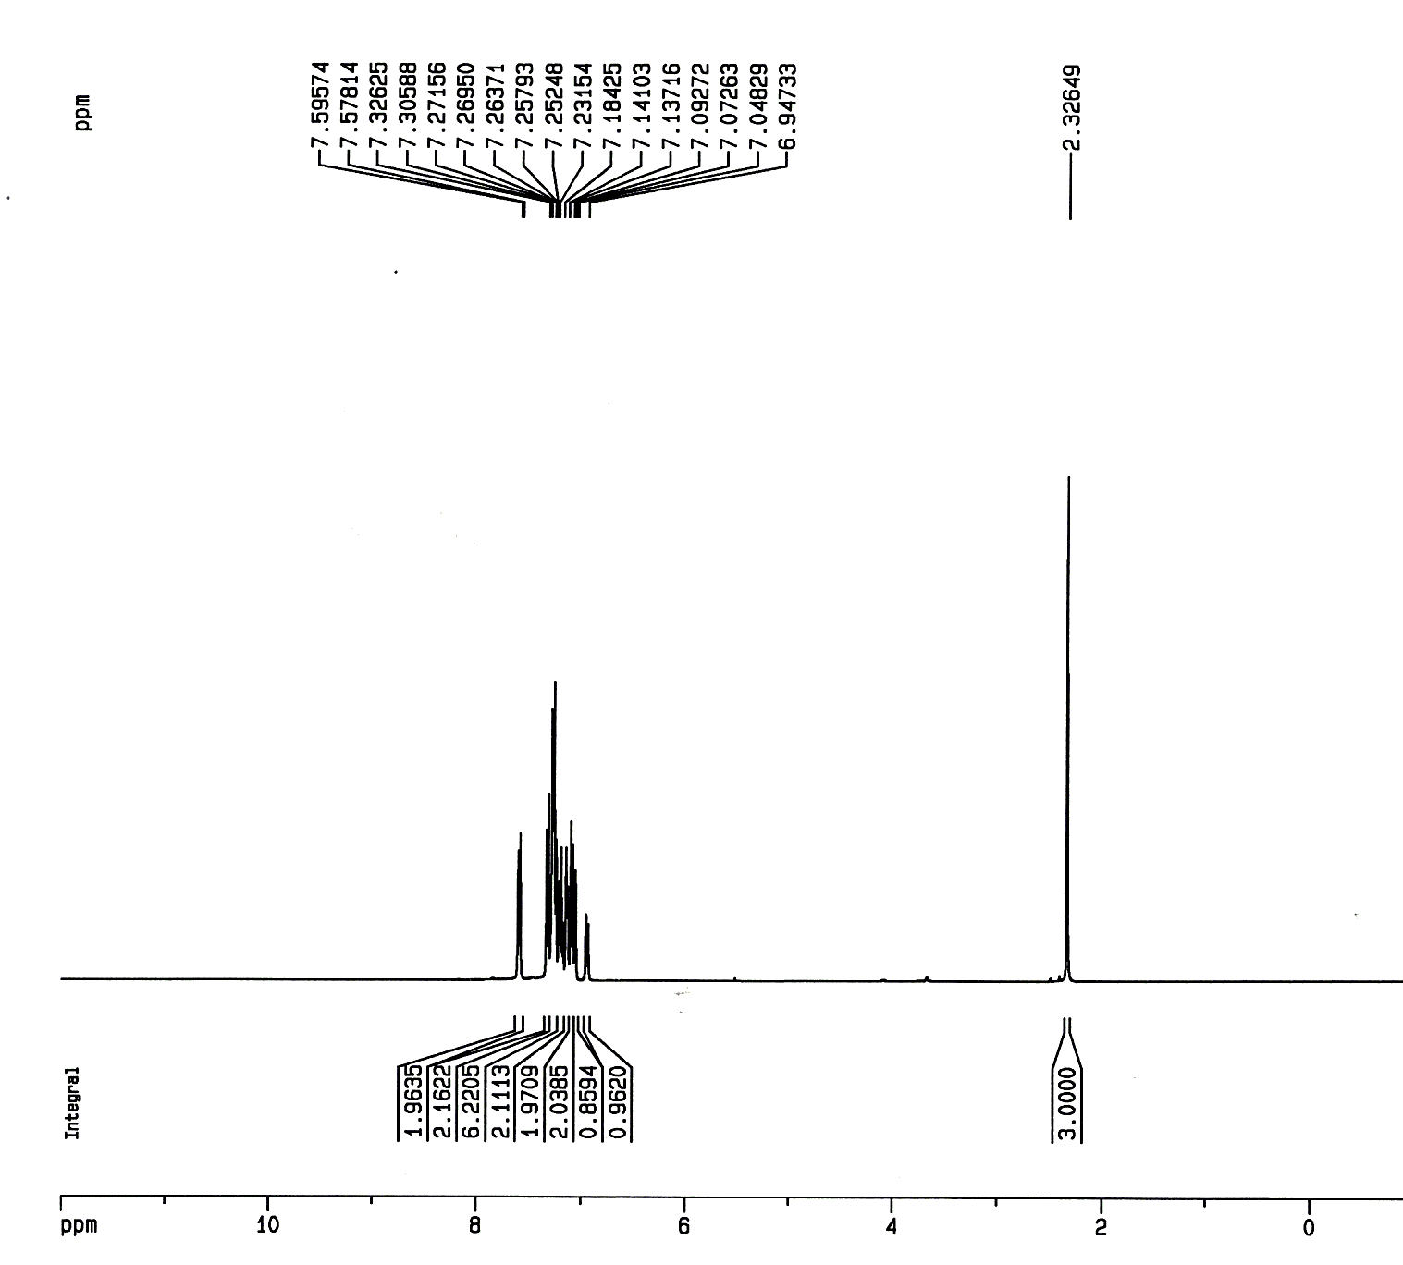
Fig. S5. ¹H NMR spectrum of 1-(3-chlorophenyl)-4,5-diphenyl-2-p-tolyl-1H-imidazole (1d) in CDCl₃
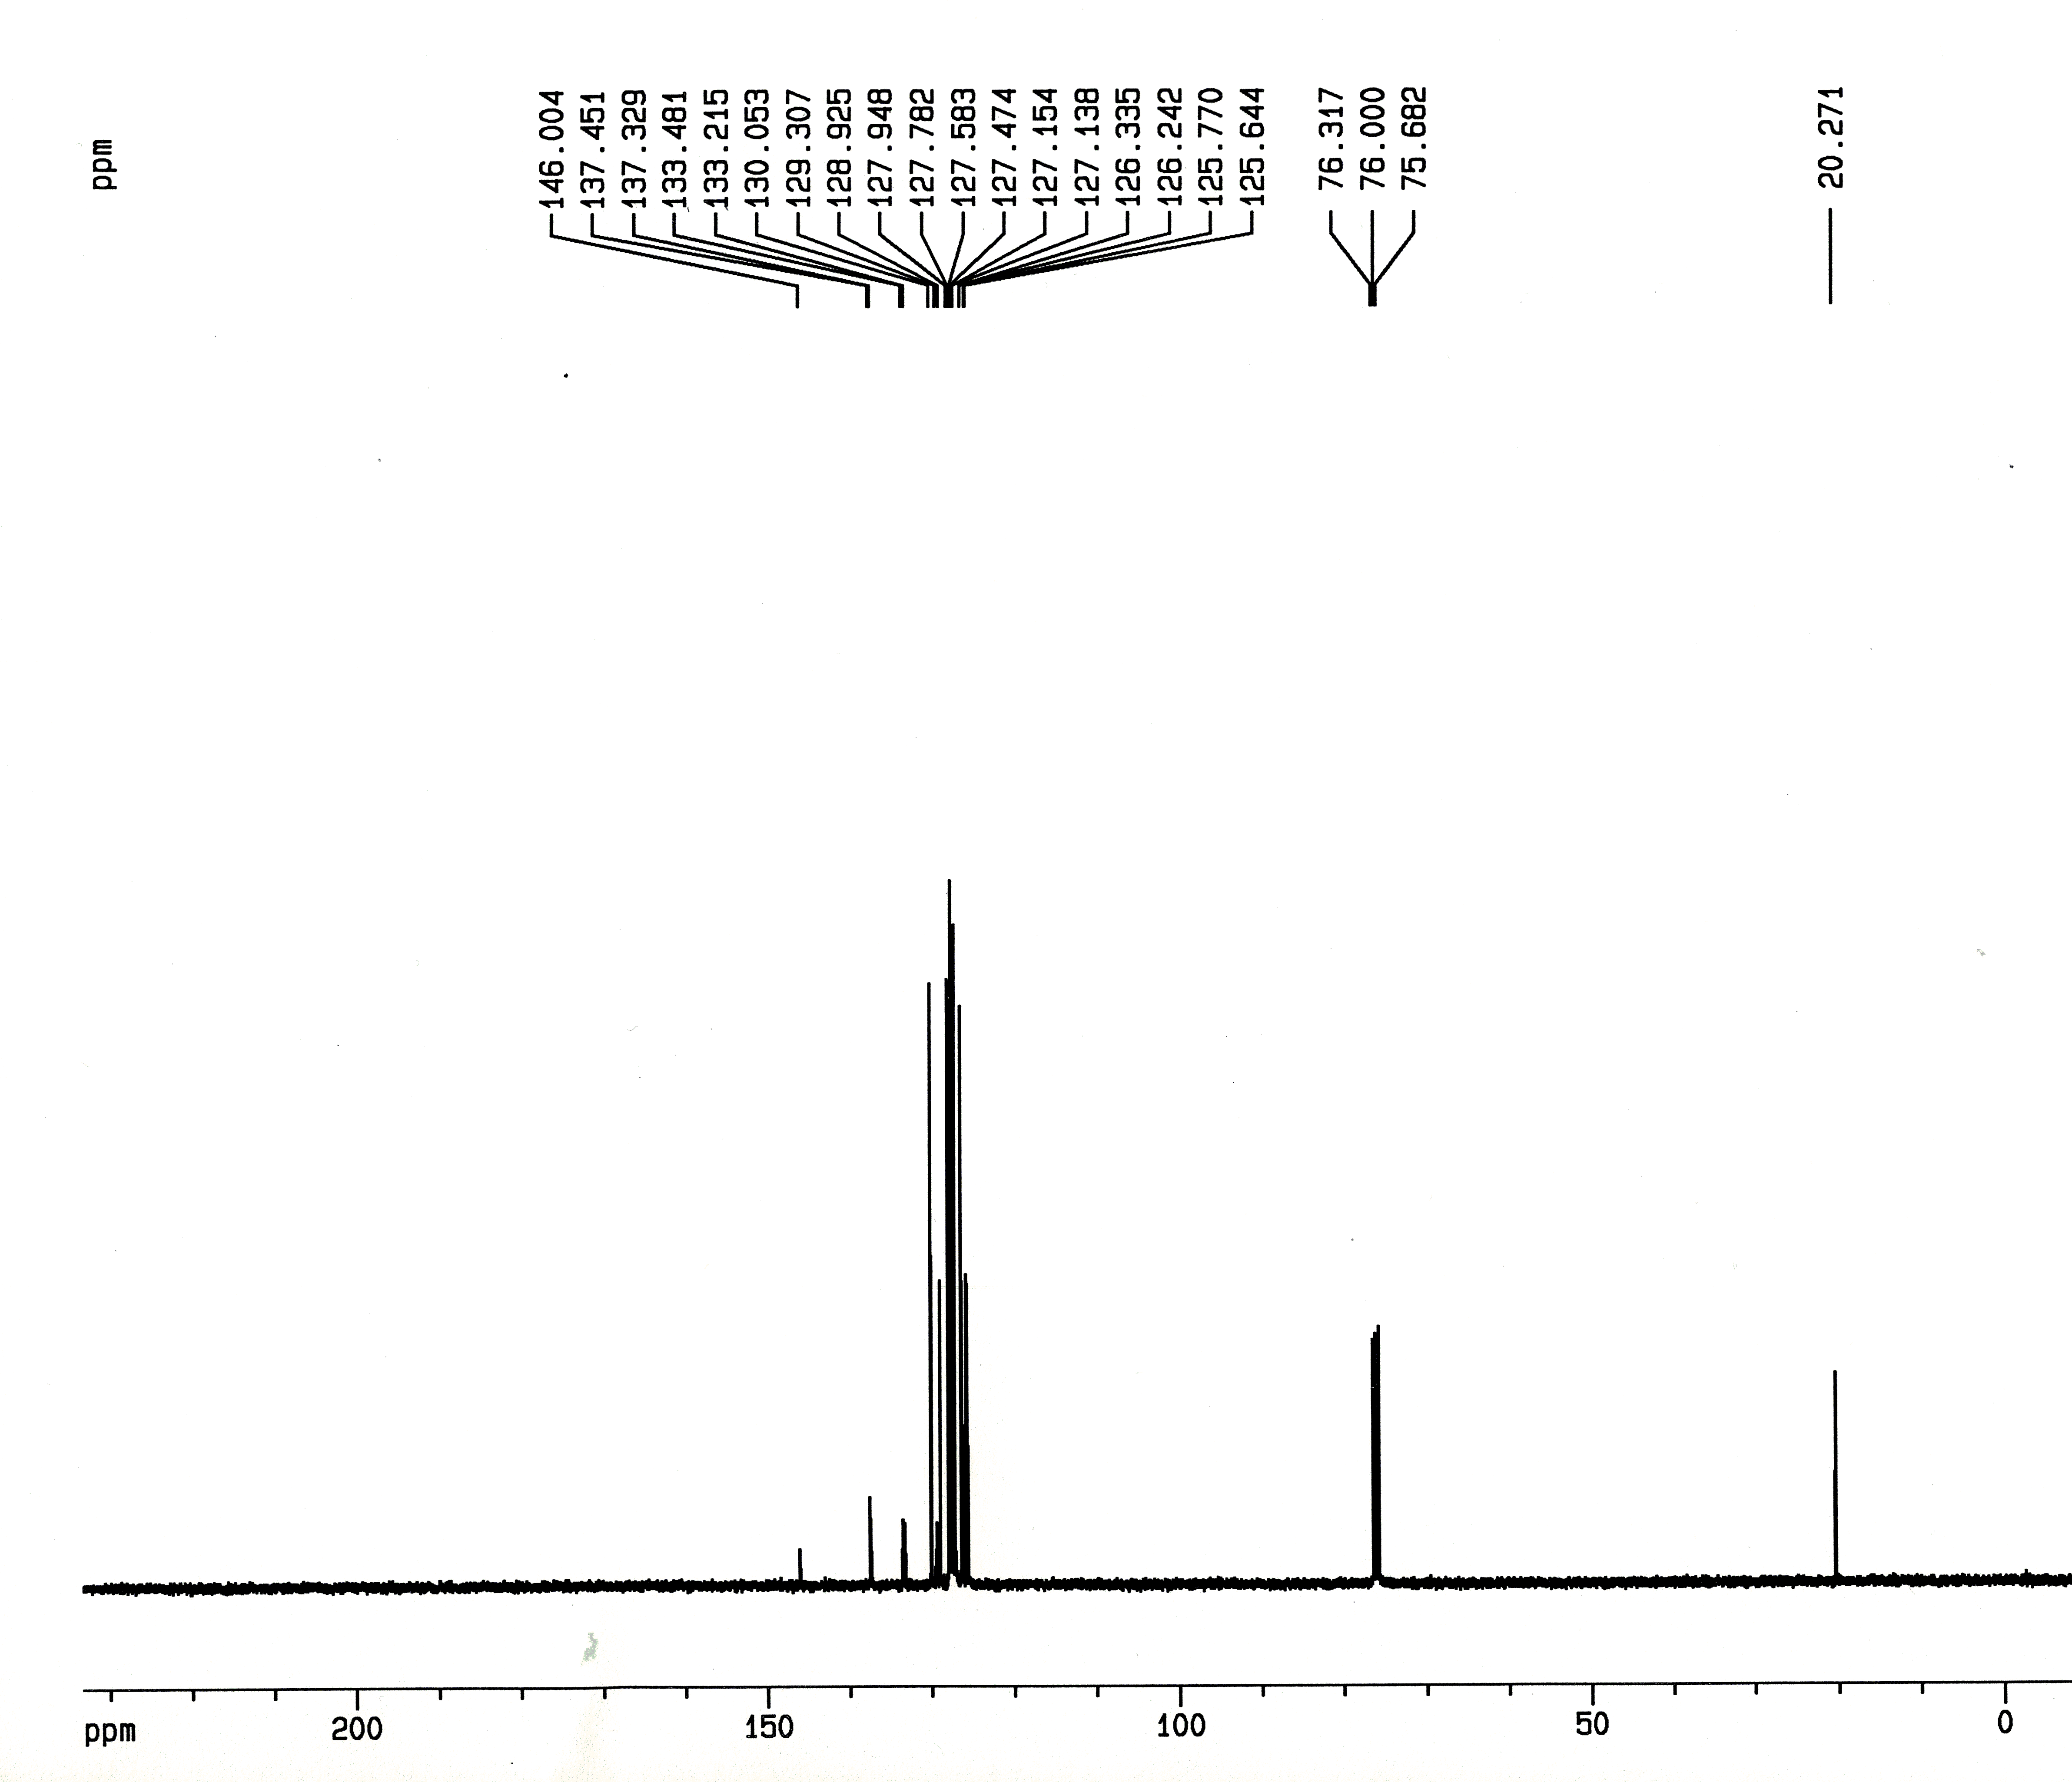
Fig. S6. ¹³C NMR spectrum of 1-(3-chlorophenyl)-4,5-diphenyl-2-p-tolyl-1H-imidazole (1g) in CDCl₃

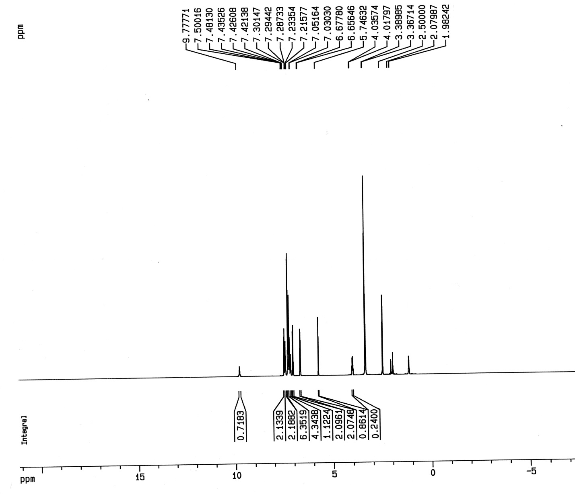
Fig. S7. ¹H NMR spectrum of 4-(2,4,5-triphenyl-1H-imidazol-1-yl)phenol (1h) in DMSO-d₆
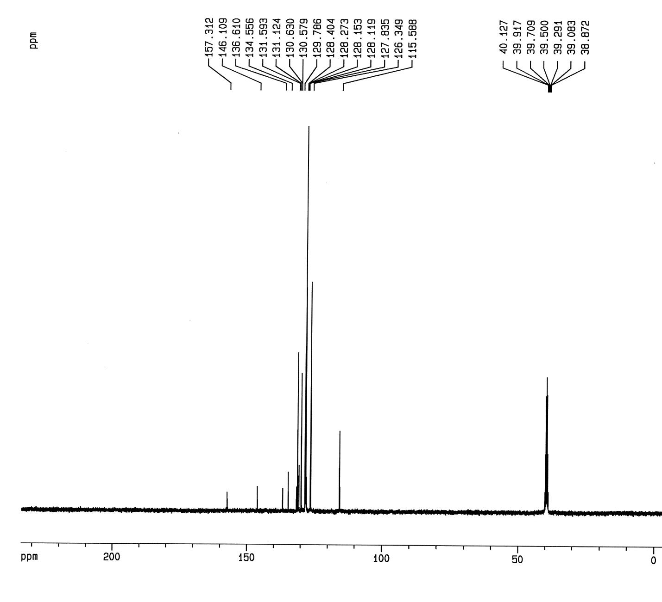
Fig. S8. ¹³C NMR spectrum of 4-(2,4,5-triphenyl-1H-imidazol-1-yl)phenol (1h) in DMSO-d₆

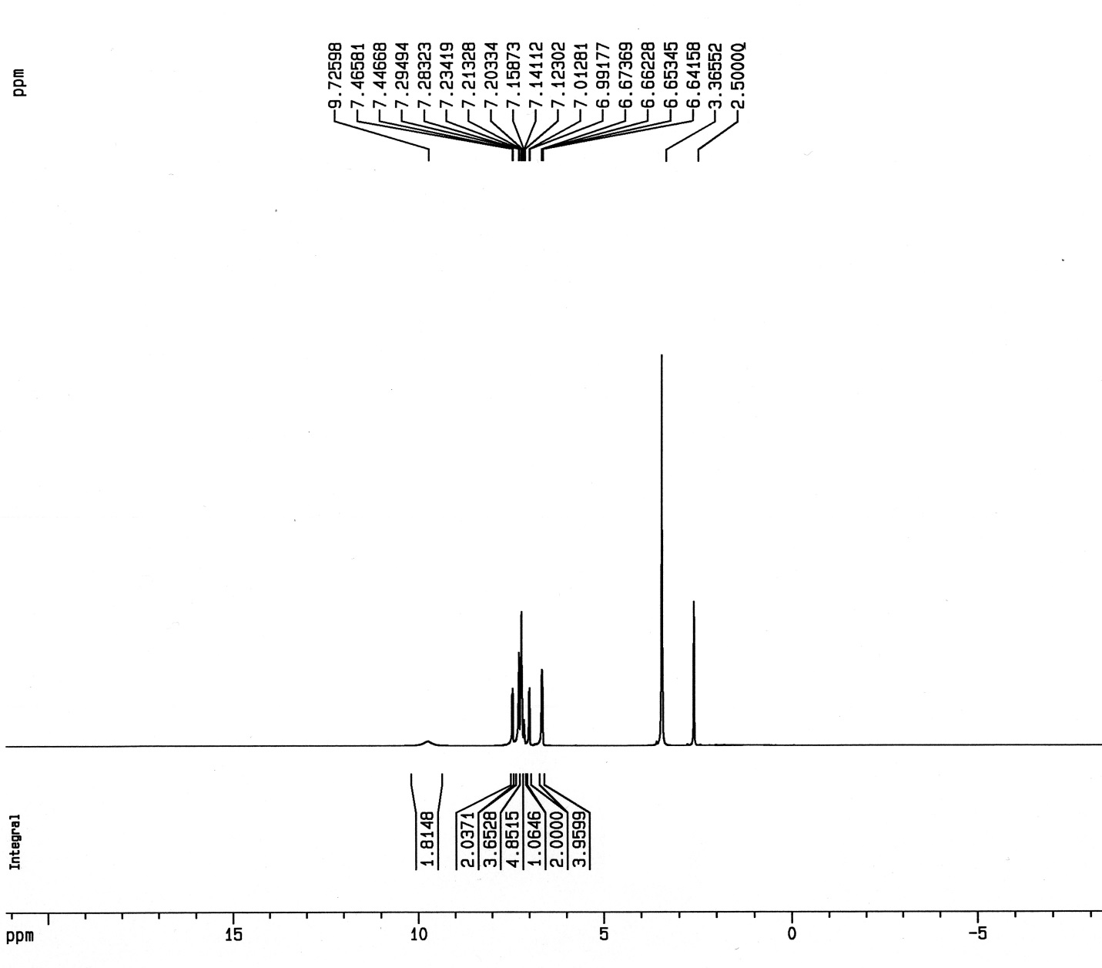
Fig. S9. ¹H NMR spectrum of 4,4'-(4,5-diphenyl-1H-imidazole-1,2-diyl)diphenol (1i) in DMSO-d₆
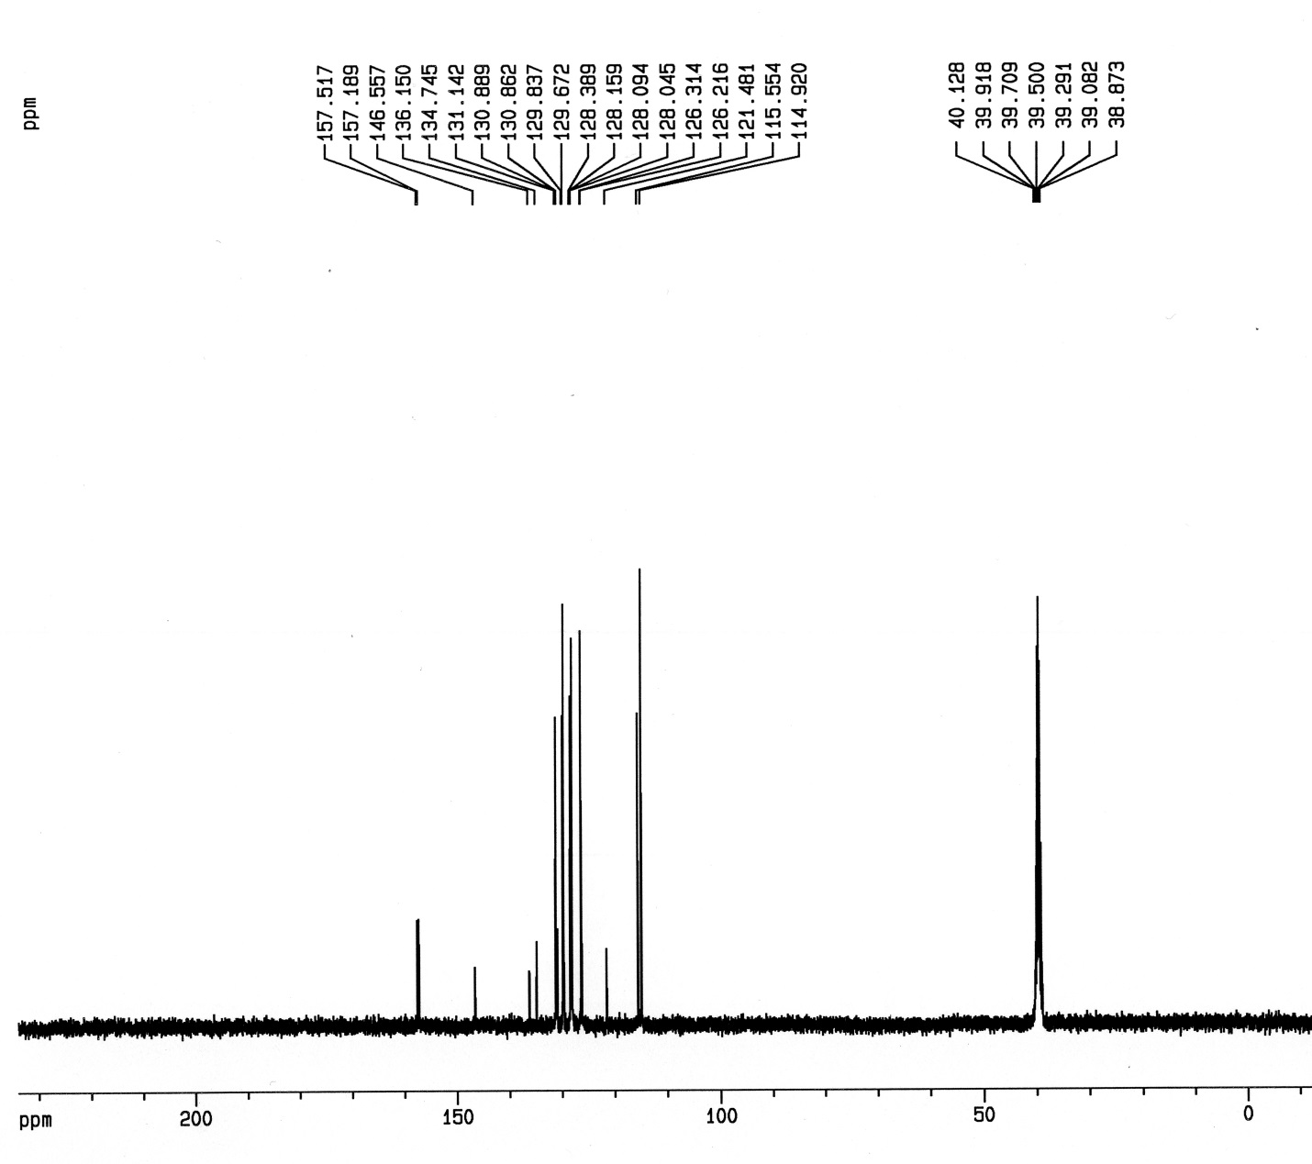
Fig. S10. ¹³C NMR spectrum of 4,4'-(4,5-diphenyl-1H-imidazole-1,2-diyl)diphenol (1i) in DMSO-d₆

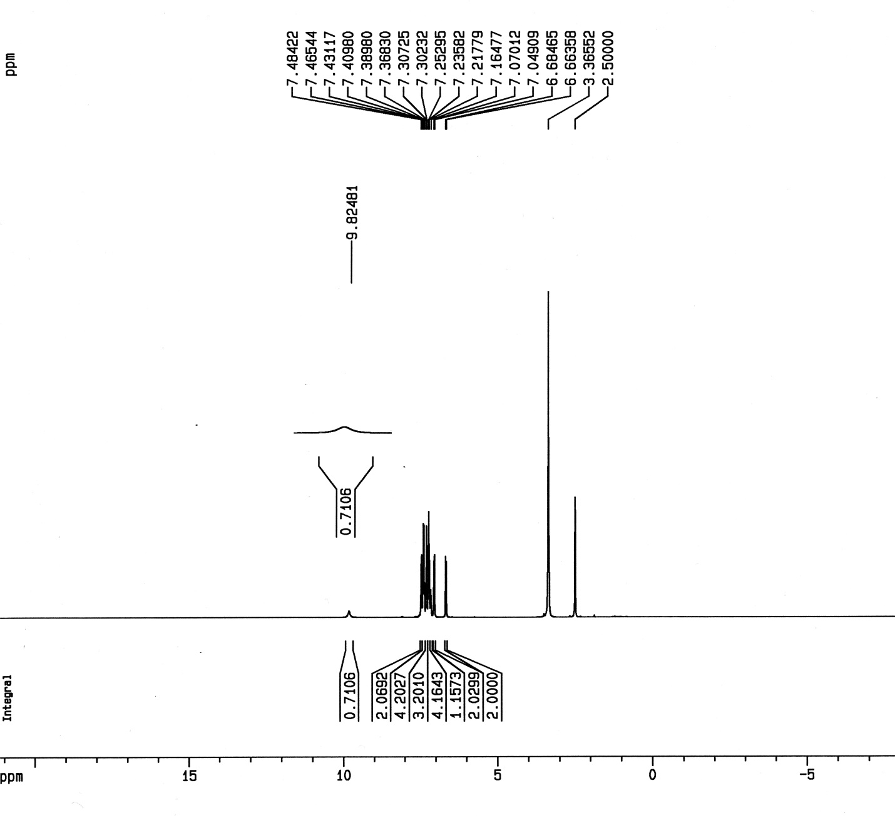
Fig. S11. ¹H NMR spectrum of 4-(2-(4-chlorophenyl)-4,5-diphenyl-1H-imidazol-1-yl)phenol (1j) in DMSO-d₆

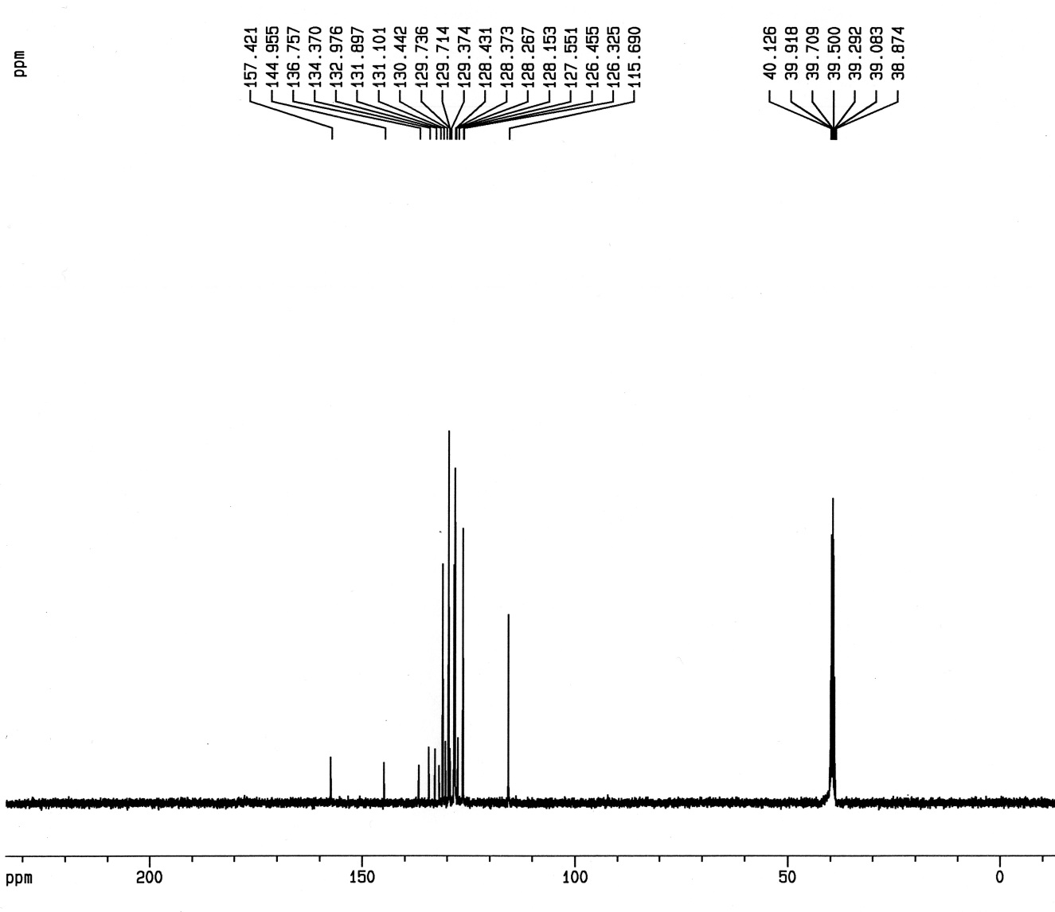
Fig. S12. ¹³C NMR spectrum of 4-(2-(4-chlorophenyl)-4,5-diphenyl-1H-imidazol-1-yl)phenol (1j) in DMSO-d₆

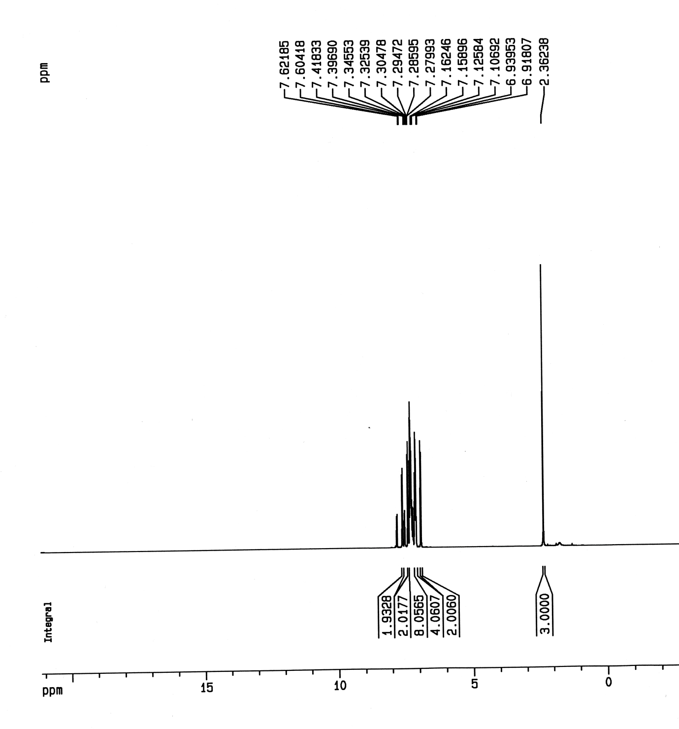
Fig. S13. ¹H NMR spectrum of 1-(4-bromophenyl)-4,5-diphenyl-2-p-tolyl-1H-imidazole (1l) in CDCl₃
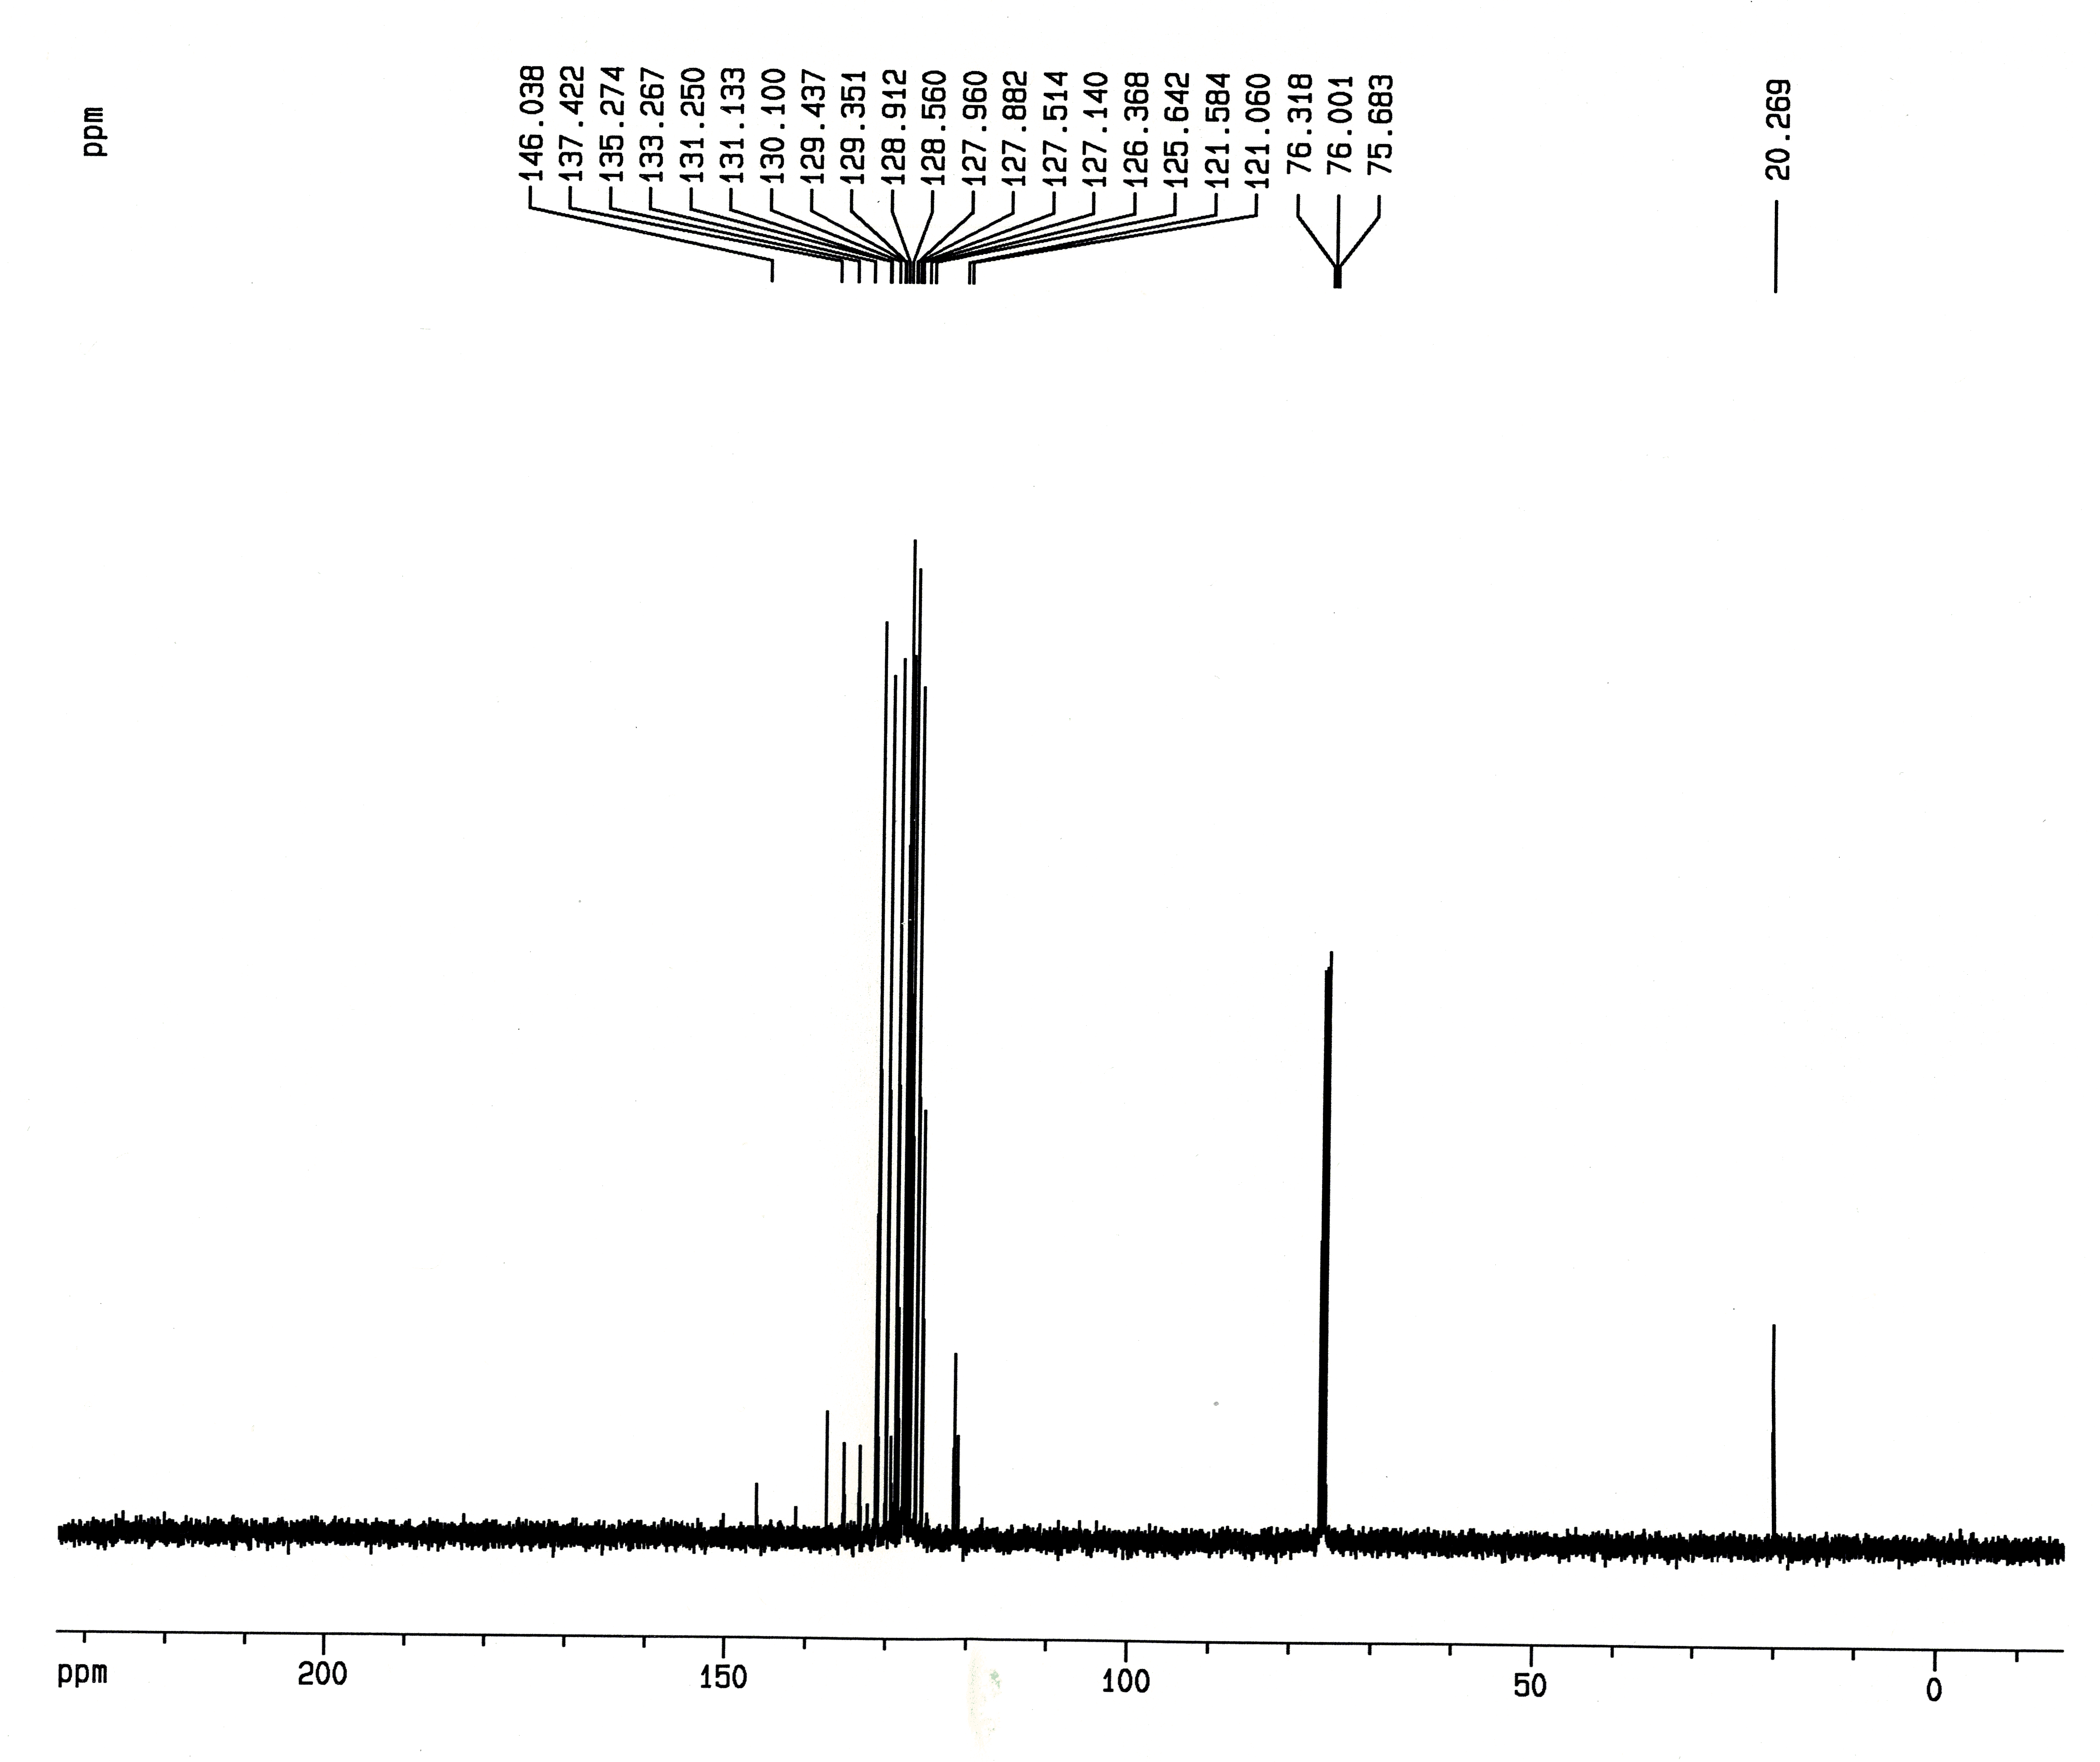
Fig. S14. ¹³C NMR spectrum of 1-(4-bromophenyl)-4,5-diphenyl-2-p-tolyl-1H-imidazole (1l) in CDCl₃

Fig. S15. ¹H NMR spectrum of 4,5-diphenyl-2-(thiophen-2-yl)-1-p-tolyl-1H-imidazole (1o) in CDCl₃

Fig. S16. ¹³C NMR spectrum of 4,5-diphenyl-2-(thiophen-2-yl)-1-p-tolyl-1H-imidazole (1o) in CDCl₃

Fig. S17. ¹H NMR spectrum of 1-benzyl-4,5-diphenyl-2-p-tolyl-1H-imidazole (1p) in CDCl₃

Fig. S18. ¹³C NMR spectrum of 1-benzyl-4,5-diphenyl-2-p-tolyl-1H-imidazole (1p) in CDCl₃
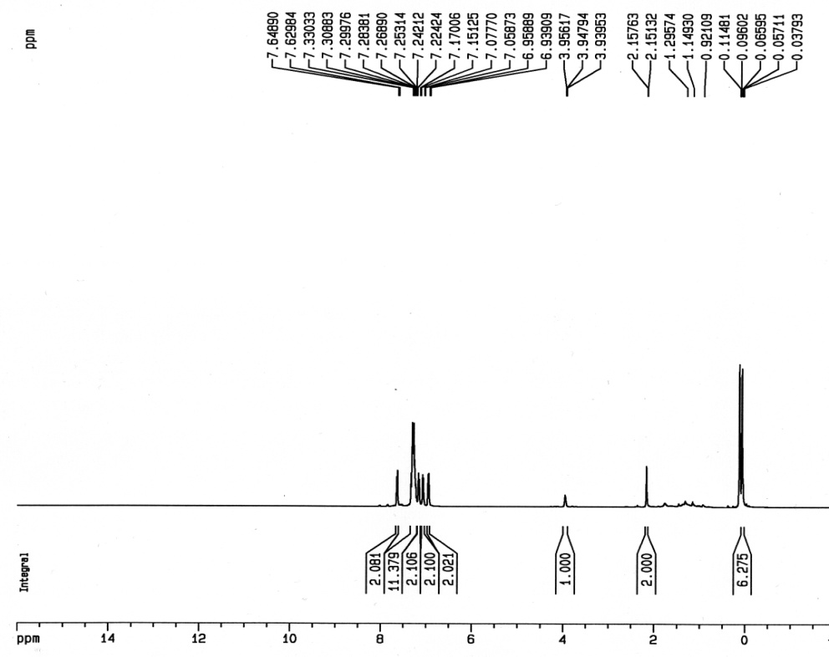
Fig. S19. ¹H NMR spectrum of 2-(4-((dimethylsilyl)methyl)phenyl)-1,4,5-triphenyl-1H-imidazole (2b) in CDCl₃
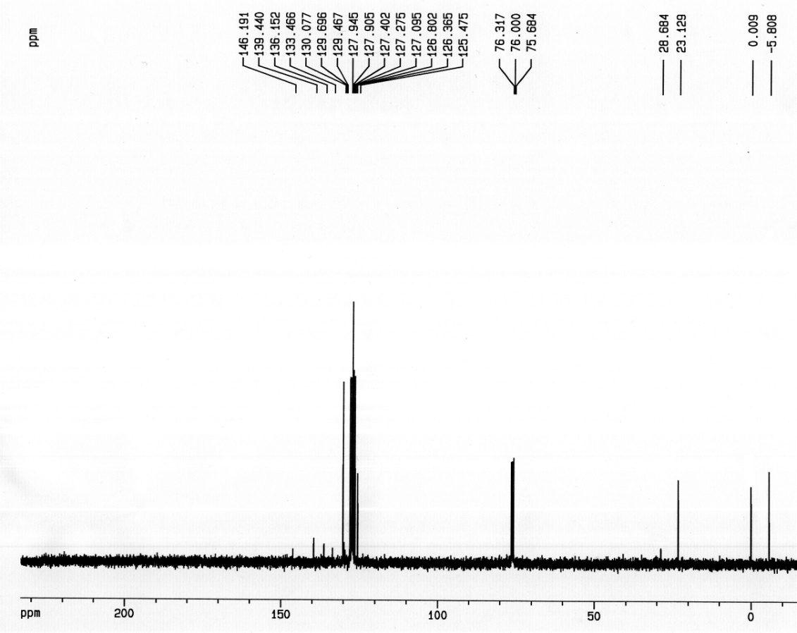

Fig. S20. ¹³C NMR spectrum of 2-(4-((dimethylsilyl)methyl)phenyl)-1,4,5-triphenyl-1H-imidazole (2b) in CDCl₃

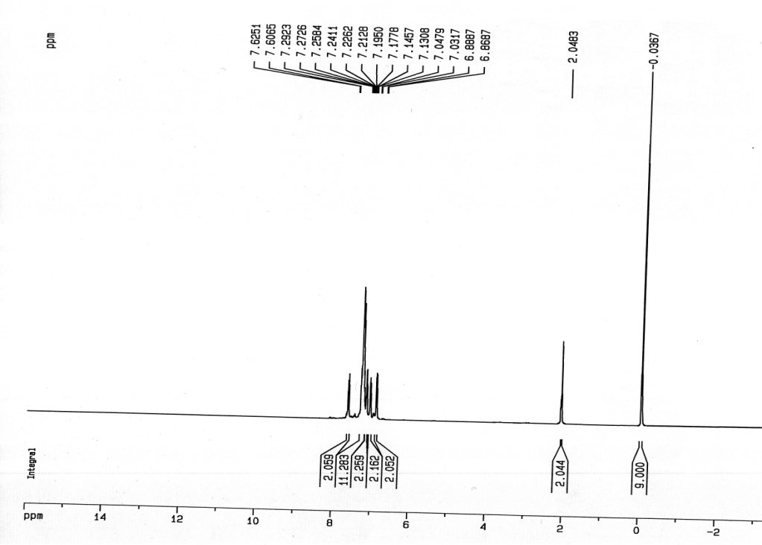
Fig. S21. ¹H NMR spectrum of 2-(4-((trimethylsilyl)methyl)phenyl)-1,4,5-triphenyl-1H-imidazole (3b) in CDCl₃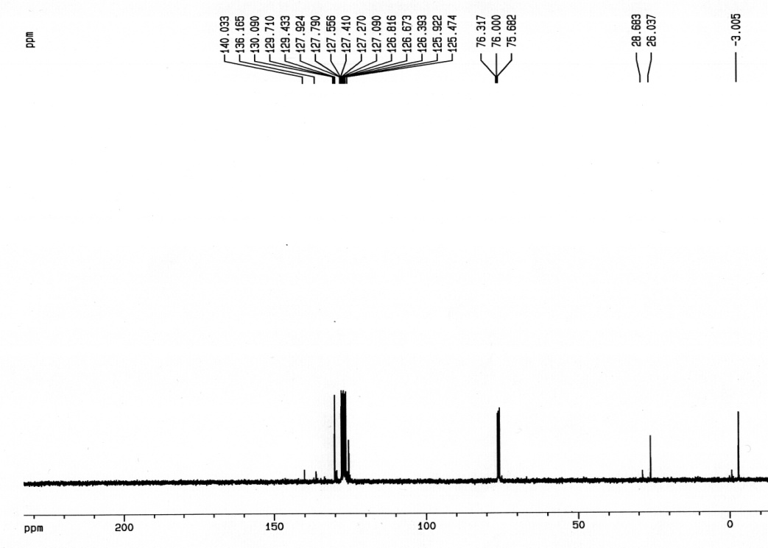

Fig. S22. ¹³C NMR spectrum of 2-(4-((trimethylsilyl)methyl)phenyl)-1,4,5-triphenyl-1H-imidazole (3b) in CDCl₃

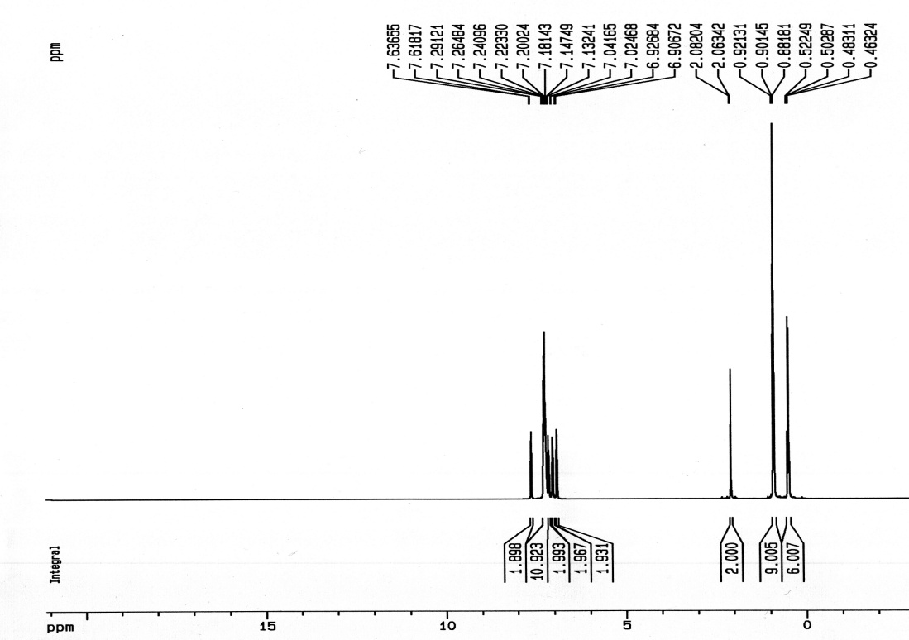
Fig. S23. ¹H NMR spectrum of 2-(4-((triethylsilyl)methyl)phenyl)-1,4,5-triphenyl-1H-imidazole (4b) in CDCl₃

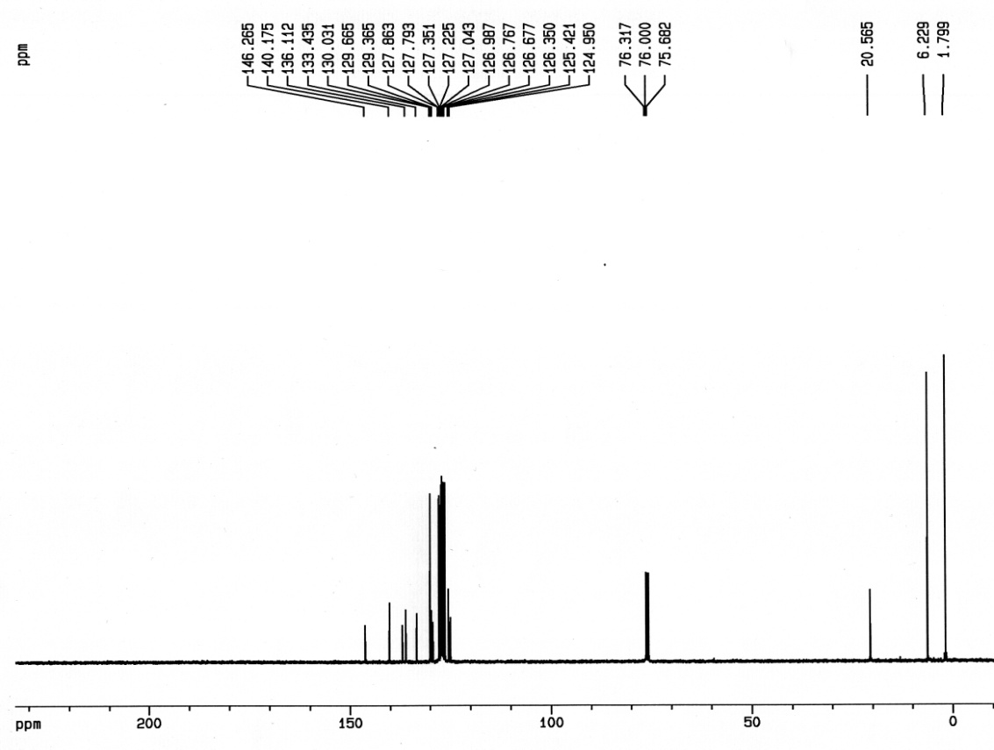
Fig. S24. ¹³C NMR spectrum of 2-(4-((triethylsilyl)methyl)phenyl)-1,4,5-triphenyl-1H-imidazole (4b) in CDCl₃

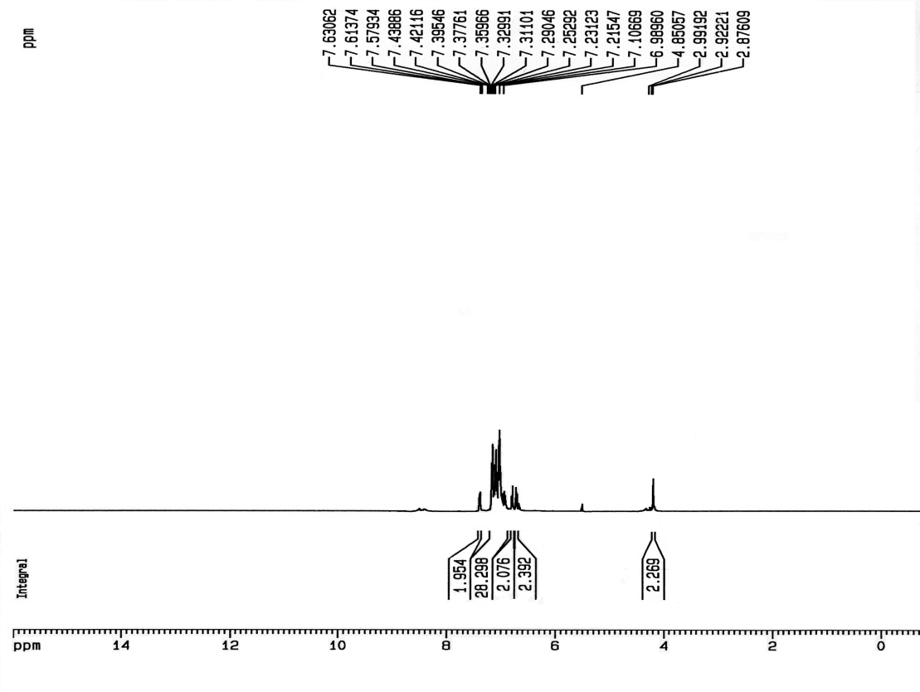
Fig. S25. ¹H NMR spectrum of 2-(4-((triphenylsilyl)methyl)phenyl)-1,4,5-triphenyl-1H-imidazole (5b) in CDCl₃

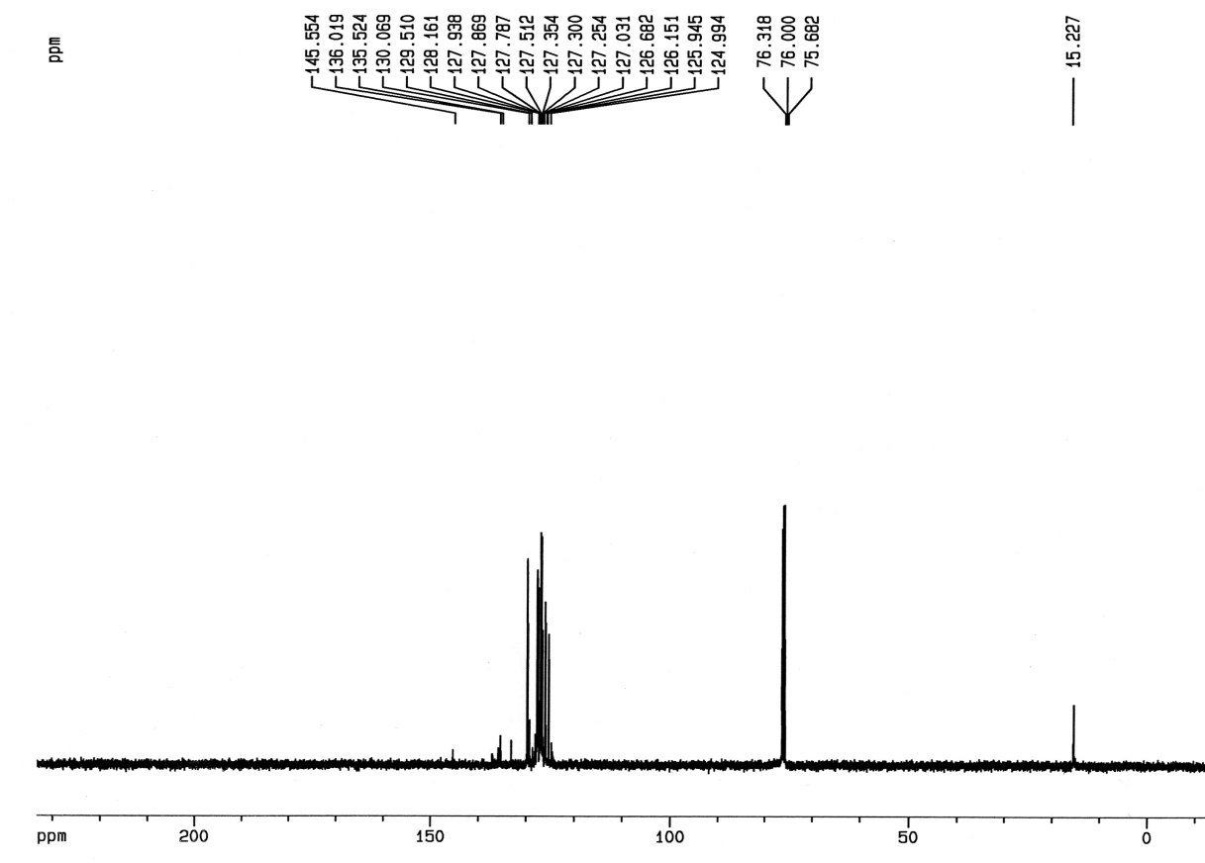
Fig. S26. ¹³C NMR spectrum of 2-(4-((triphenylsilyl)methyl)phenyl)-1,4,5-triphenyl-1H-imidazole (5b) in CDCl₃

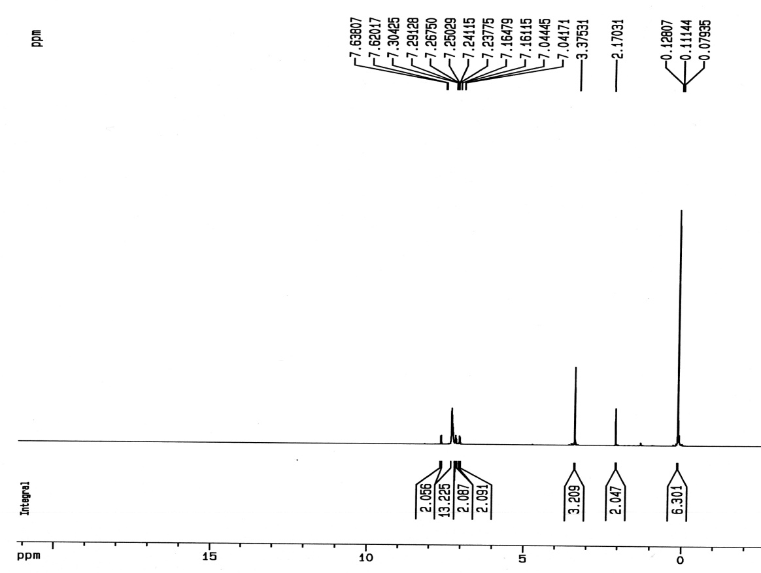
Fig. S27. ¹H NMR spectrum of 2-(4-((methoxydimethylsilyl)methyl)phenyl)-1,4,5-triphenyl-1H-imidazole (6b) in CDCl₃

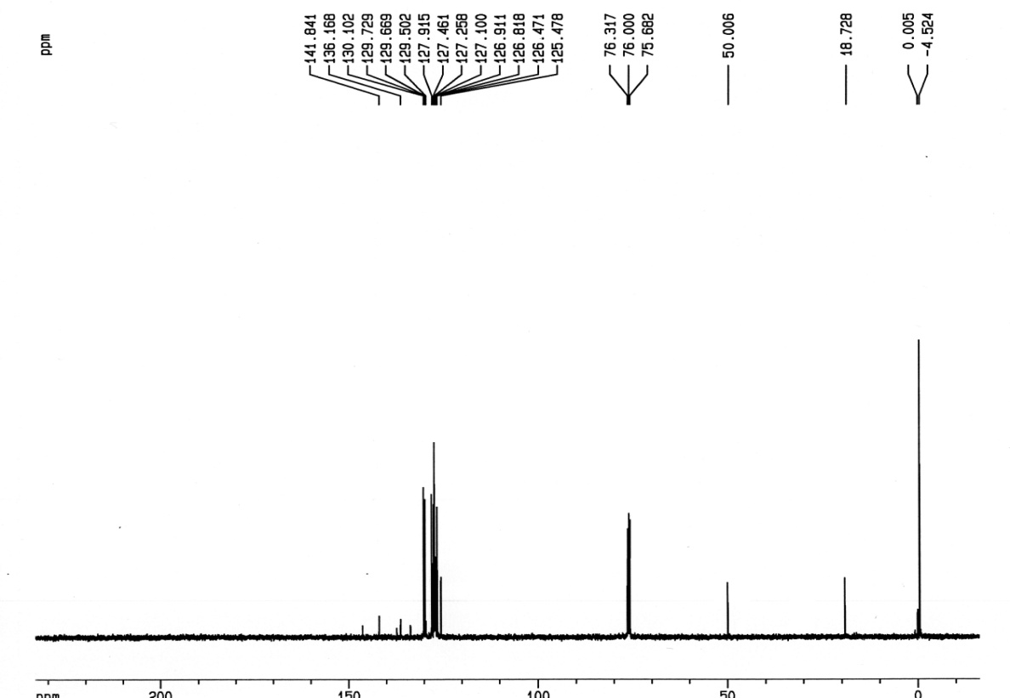
Fig. S28. ¹³C NMR spectrum of 2-(4-((methoxydimethylsilyl)methyl)phenyl)-1,4,5-triphenyl-1H-imidazole (6b) in CDCl₃

Fig. S29. The XRD patterns of Cu-SAPO-34 (5%)

Fig. S30. TEM image of H-SAPO-34

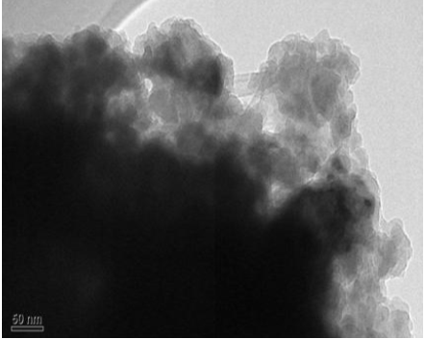
Fig. S31. TEM image of H-SAPO-34

Fig. S32. TEM image of Cu-SAPO-34 (5%)

