**Supporting Information to be published electronically**

Hierarchical Porous Silica Monoliths: a Novel Class of Microreactors for Process Intensification in Catalysis and Adsorption

Anne Galarneau*1, Alexander Sachse1, Bilel Said1, Carl-Hugo Pelisson1, Paolo Boscaro1, Nicolas Brun1, Laurence Courtheoux1, Nathalie Olivi-Tran2, Benoit Coasne1, Francois Fajula1

1 Institut Charles Gerhart Montpellier, UMR 5253 CNRS-UM2-ENSC-UM1, ENSCM, 8 rue de l’Ecole Normale, 34296 Montpellier Cedex 5, France.

2 Laboratoire Charles Coulomb, Université Montpellier 2, Place Eugène Bataillon, 34000 Montpellier, France.

**Abstract**

Silica monoliths with hierarchical porosity (macro-/mesoporous), prepared by a combination of phase separation (spinodal decomposition) and sol-gel process, have demonstrated remarkable potential as supports for catalysts and adsorbents with improved efficiency and productivity of a number of applications. This is due to perfect homogeneous interconnected porous networks enabling an exceptional mass transfer and a fine control of contact times. Silica monoliths have been functionalized by an important variety of moities and techniques, such as grafting with versatile species (acidic, basic), by alumina coating, immobilization of ionic liquids, in-situ synthesis of nanoparticles of Pd, MOF, NiMoS2, pseudomorphic transformation of the skeleton into MCM-41 or zeolites (SOD, LTA). These functional materials reveal great opportunities for process intensification.



**Figure S1.** Plot of the polynomial function f() of the Renkin equation as a function of the reduced pore diameter (1/).

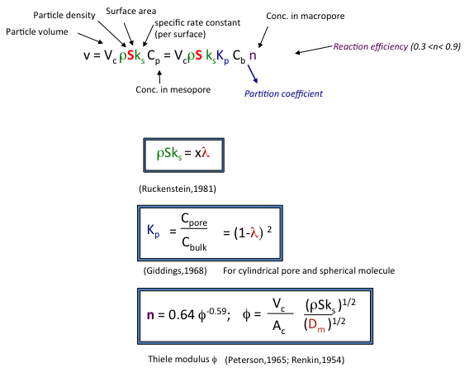

**Figure S2**. Description of the Ruchenstein equation.

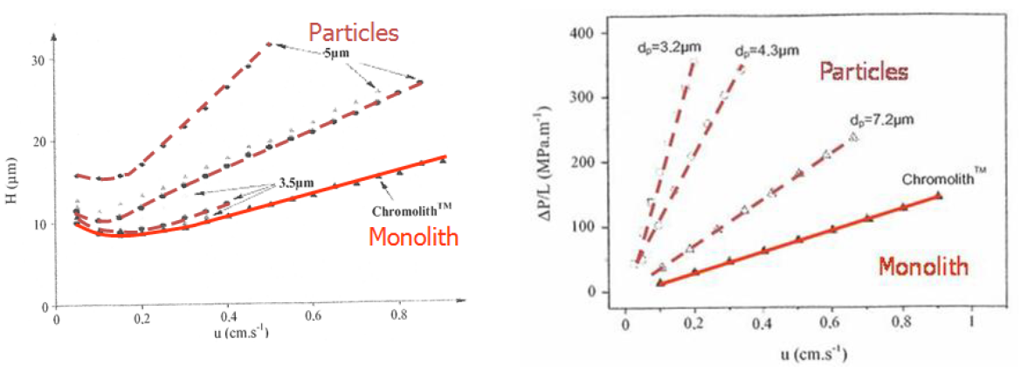

**Figure S3.** Van Deemter curves and pressure drops of chromatographic analysis performed with the monolith of Merck (named ChromolithTM) and packed-bed made of spherical particles of 3, 4 and 7 microns (adapted from ref. 37)

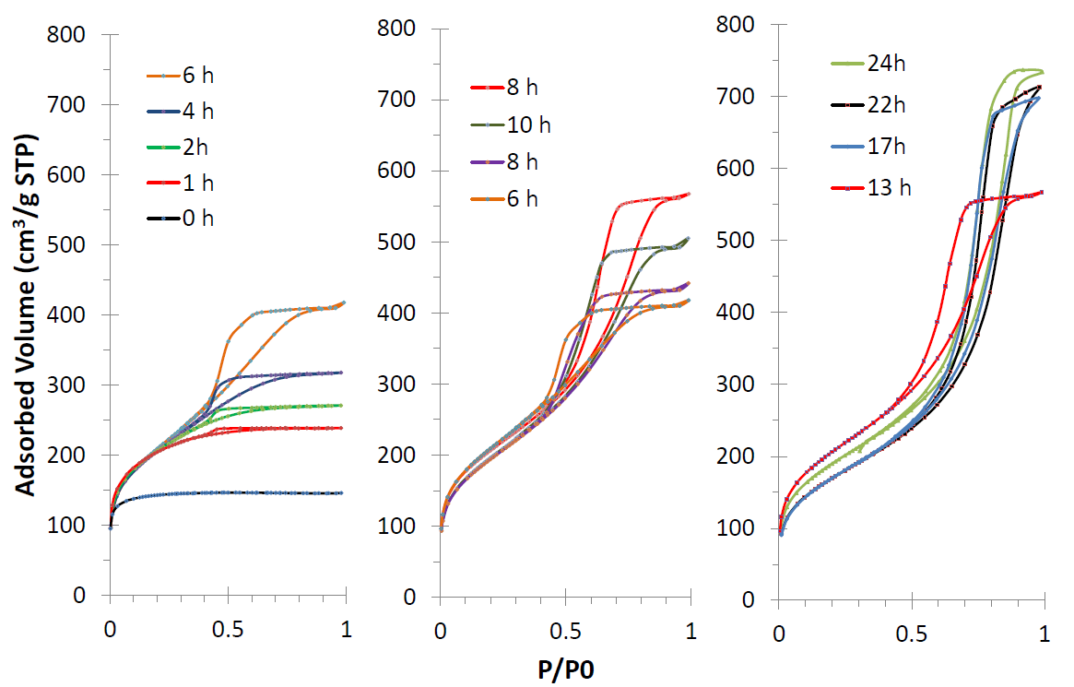

**Figure S4.** Nitrogen sorption isotherms at 77 K of silica monoliths issue from the same first step in acidic media and obtained after different duration (from 1 to 24 h) in ammoniac bath at 40 °C. Monoliths have been calcined at 550 °C.

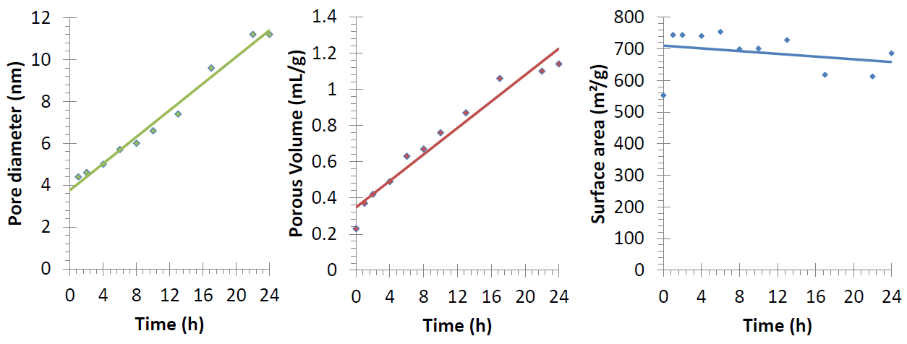

**Figure S5.** Evolution of mesopore diameter, mesoporous volume and BET surface area of silica monoliths issue from the same first step in acidic media and obtained after different duration (from 1 to 24 h) in ammoniac bath at 40 °C. Monoliths have been calcined at 550 °C.

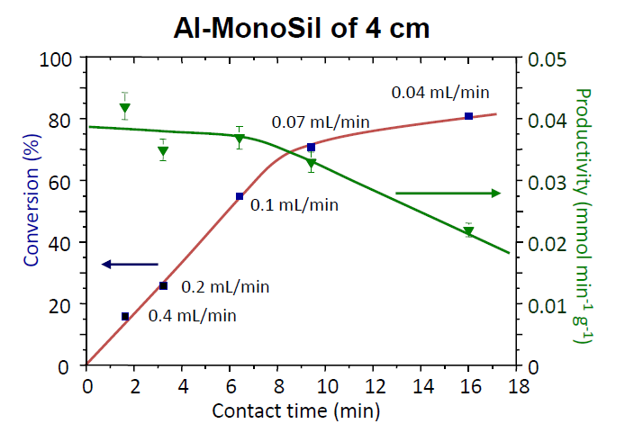

**Figure S6**. Conversion and productivity of the Diels-Alder reaction with Al203-grafted on silica monolith (Al-MonoSil) as a function of contact time – corresponding flow rates are indicated (adapted from ref. 14).

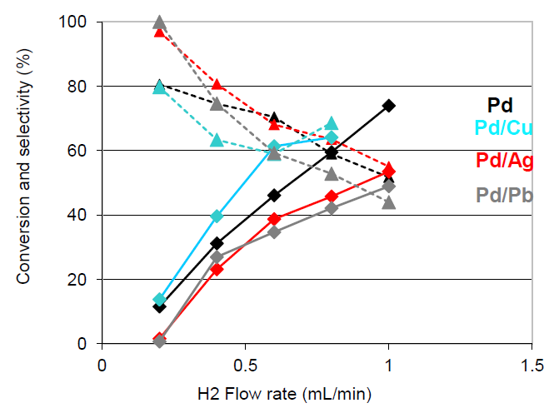

**Figure S7.** Conversion (plain lines) and selectivity in 3-hexenol (dashed lines) of 3-hexyn-1-ol as a function of hydrogen flow rate for silica monolith (3 cm length) containing Pd nanoparticles (1.3 wt%) (black) and Pd nanoparticles and promotors M (M/Pd = 1/3): M = Cu (cyan), Ag (red) and Pb (grey). Conditions: T = 40 °C, liquid flow 0.2 mL min-1, concentration hexynol 0.2 M in MeOH.

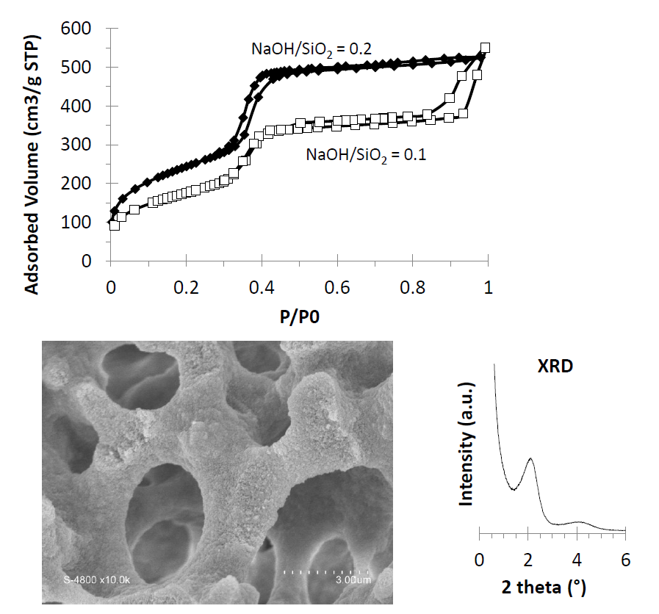

**Figure S8.** Nitrogen sorption isotherms at 77K of calcined MCM-41 monoliths with one or two porosity prepared with NaOH/SiO2 ratio of 0.2 and 0.1, respectively. SEM image and XRD diffractogram of the MCM-41-monolith synthesized with NaOH/SiO2 ratio of 0.1.



**Figure S9.** UV-Vis spectra of the solution of Orange-G: starting solution (green) and after 5 h in contact with a titania-monolith (1 cm length) in static in dark (blue), under UV lamp (red), under sunlight (purple).