Electronic supplementary information

Generation of a substituted 1,2,4-thiadiazole ring via the [3+2] cycloaddition reaction of benzonitrile sulfide toward trichloroacetonitrile. A DFT study of the regioselectivity and of the molecular mechanism

Saeedreza Emamian*
Chemistry Department, Shahrood Branch, Islamic Azad University, Shahrood, Iran.

Index

S2. Details of the ELF topological analysis of 32CA reaction between BNS1 and TCAN2.
S3. MPWB1K/6-311G(d) Cartesian coordinates of the optimized structures in the presence of toluene including thermochemical data for the species involved in the 32CA reaction between BNS1 and TCAN2.

S2

ELF topological analysis of 32CA reaction between BNS1 and TCAN2.
The electron density, ρ(r), of a molecular system can represent all information hidden in the wave-function of such system. Thus, a successive detection of the electron density changes along a chemical reaction in which a continuous redistribution of ρ(r) proceeds with the reaction can provide valuable information about bonds forming/breaking patterns. In this way, from the molecular mechanistic point of view, our questions can greatly be addressed [1]. One of the most popular function, introduce by Becke and Edgecombe [2], is electron localization function, ELF, by which essential information about the electron density shared between neighboring atoms can be extracted [1].
A great deal of work has confirmed that the ELF topological analysis of the bonding changes along a reaction path is a powerful tool to establish the molecular mechanism of a reaction [3-5]. After an analysis of the electron density, ELF provides basins which are the domains in which the probability of finding an electron pair is maximal. The basins are classified as core and valence basins. The latter are characterized by the synaptic order; i.e. the number of atomic valence shells in which they participate [6]. Thus, there are monosynaptic, disynaptic, trisynaptic basins and so on. Monosynaptic basins, labelled as V(A), correspond to lone pairs or non-bonding regions, while disynaptic basins, labelled as V(A,B), connect the core of two nuclei A and B and, thus, correspond to a bonding region between A and B. This description recovers the Lewis bonding model, providing a very suggestive graphical representation of the molecular system.
The ELF topological analysis of significant organic reactions involving the formation of new C–C single bonds has shown that it begins in the short C–C distance range of 1.9–2.0 Å by merging two monosynaptic basins, V(Cx) and V(Cy), into a new disynaptic basin V(Cx,Cy) associated with the formation of the new Cx–Cy single bond [39]. The Cx and Cy carbons characterized by the presence of the monosynaptic basins, V(Cx) and V(Cy), are called pseudoradical centers [7].
In order to understand the molecular mechanism of the 32CA reaction between BNS1 and TCAN2, an ELF topological analysis of the MPWB1K/6-311G(d) wave functions of some relevant points, P1 through P5, was performed along the IRC profile associated with the more favorable TS1. The IRC profile of TS1 including the attractor positions associated with points P1-P5 is given in Fig. S1. As shown in Fig. S2, the most relevant basins in separate BNS1 and TCAN2 are those corresponding to the interacting systems; i.e. the C1–N2, N2–S3, and C4–N5 bonds. In BNS1, while the C1–N2 bonding region is characterized with the presence of V(C1,N2) and V^{ʹ}(C1,N2) disynaptic basins integrating 2.83 and 2.64e, respectively, the N2–S3 bonding region is characterized with the presence of V(N2,S3) disynaptic basin integrating 2.67e. Moreover, lone pairs of S3 are described with the presence of two V(S3) and V^{ʹ}(S3) monosynaptic basins integrating 2.75 and 2.89e, respectively. Consequently, based on the ELF valence basins population, while N2–S3 bond presents a singlet character, the sum of V(C1,N2) and V^{ʹ}(C1,N2) disynaptic basins population, 5.47e, is close to 6e indicating a triple character for C1–N2 bond. On the other hand, the sum of V(S3) and V^{ʹ}(S3) monosynaptic basins populations is 5.64e which is very close to 6e demonstrating that S3 sulfur atom bears a negative charge. The ELF valence shapes for BNS1 are in agreement with the corresponding Lewis structure presented in Scheme 3. Additionally, the C4–N5 bonding region in TCAN2 is identified with the existence of V(C4,N5), V^{ʹ}(C4,N5), and V^{ʹʹ}(C4,N5) disynaptic basins integrating 1.54, 1.53, and 1.54e, respectively. The sum of mentioned disynaptic basins population is 4.61e indicating a noticeable difference of 6e which is expected for C4–N5 triple bond. It is worth noting that the presence of a highly electron withdrawing CCl₃ substitution on the TCAN2 leads to the polarization of C4–N5 σ bonding electrons toward C4 resulting a significant decrease in C4–N5 bonding population. The lone pair of N5 nitrogen atom is also characterized with the presence of a V(N5) monosynaptic basin integrating 3.09e. This value which is different from the expected value of 2e indicates that the more electronegative N5 nitrogen atom exhibits a higher propensity than C4 carbon atom to attract electron density of C4–N5 bonding region to itself.
As two reagents approach each other along the reaction channel, At P1, d(C1–N5) = 2.382Å and d(S3–C4) = 2.573Å, a new V(N2) monosynaptic basin with an initial population of 0.33e emerges over N2 nitrogen atom. The electronic density of this basin comes mainly from the V(C1,N2) and V^{ʹ}(C1,N2) disynaptic basins, which are depopulated to 2.39 and 2.59e, respectively. At P2 where d(C1–N5) = 2.212Å and d(S3–C4) = 2.411Å, which is associated with the favorable TS1 a new V(C4) monosynaptic basin integrating 0.31e appears over C4 carbon atom as a result of depopulation V(C4,N5) disynaptic basins from a sum of 4.61e into a sum of 4.21e. Emerging V(C4) monosynaptic basin in a very early point P2, compared with point P5 located at the almost end of the IRC profile in which S3–C4 single bond beings to form, can be related to the presence of CCl₃ substitution on C4. In other words, a highly electron withdrawing CCl₃ group leads the pseudoradical C4 center to be stabilized and is allowed to form. At P3 in which d(C1–N5) and d(S3–C4) are 2.027 and 2.264Å, respectively, while a re-depopulation of V(C1,N2) disynaptic basins leads to the formation of a new V(C1) monosynaptic basin integrating 0.15e over C1 carbon atom, a new V^{ʹʹ}(S3) monosynaptic basin integrating 0.22e is allowed to be emerged over S3 sulfur atom. It should be noted that at P3 while V(N2,S3) disynaptic basin is depopulated to 1.80e, the sum of V(S3) and V^{ʹ}(S3) monosynaptic basins population is reduced to 5.11e. Consequently, the electronic density of V^{ʹʹ}(S3) monosynaptic basin comes from depopulation of both V(N2,S3) disynaptic and, V(S3) and V^{ʹ}(S3) monosynaptic basins. Therefore, at P3 the two pseudoradical centers required for the subsequent S3–C4 single-bond formation have already been formed. At P4, d(C1–N5) = 1.813Å and d(S3–C4) = 2.116Å, the C1–N5 single bond beings to form characterized with the presence of a new V(C1,N5) disynaptic basin with an initial population of 1.13e. Finally, at P5 for which d(C1–N5) and d(S3–C4) are, respectively, 1.649 and 2.008Å, the S3–C4 single bond starts to form by merging two V^{ʹʹ}(S3) and V(C4) monosynaptic basins into a new V(S3,C4) disynaptic basin integrating 1.63e. It is noteworthy that when S3–C4 single bond beings to form, the V(C1,N5) disynaptic basin reaches to a population of 1.52e. If this value is compared with the corresponding value in cycloadduct CA1, 1.82e, one can easily be concluded that when formation of S3–C4 single bond beings, formation of C1–N5 single bond, started at P4, is almost completed by more than of 83% in clear agreement with the two-stage one-step molecular mechanism.

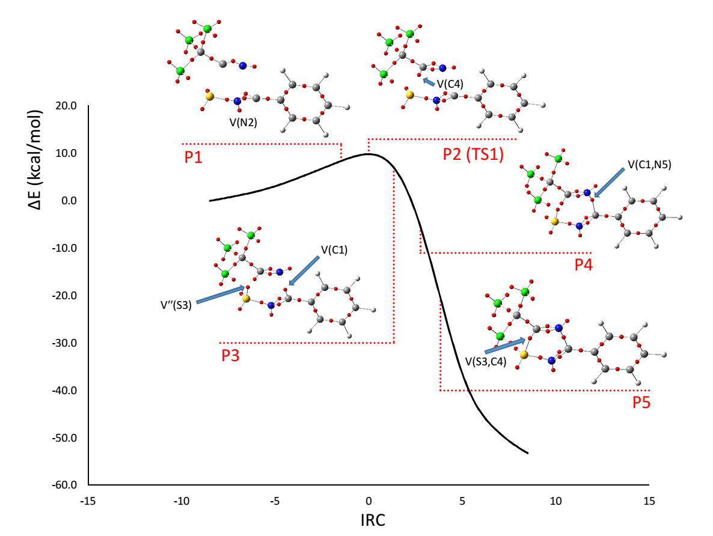

Fig. S1. MPWB1K/6-311G(d) IRC profile associated with the more favorable TS1 of the studied 32CA reaction between BNS1 and TCAN2 including attractor positions of considered points P1-P5 in the ELF topological analysis.
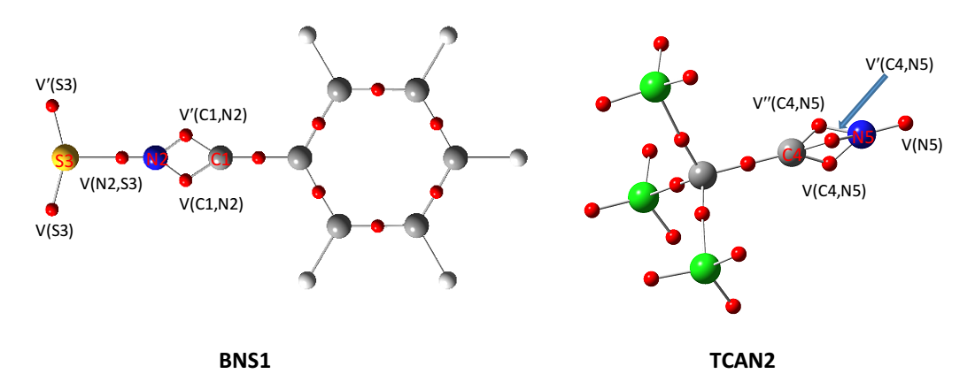

Fig. S2. Attractor positions for separate BNS1 and TCAN2.

References

[1] J. Andrés, S. Berski, L. R. Domingo, P. González–Navarrete, J. Comput. Chem. 33 (2012) 748.
[2] A. D. Becke, K. E. Edgecombe, J. Chem. Phys. 92 (1990) 5397.
[3] V. Polo, J. Andrés, S. Berski, L. R. Domingo, B. Silvi, J. Phys. Chem. A 112 (2008) 7128.
[4] J. Andrés, S. Berski, L. R. Domingo, V. Polo, B. Silvi, Curr. Org. Chem. 15 (2011) 3566.
[5] J. Andrés, S. Berski, L. R. Domingo, P. González–Navarrete, J. Comput. Chem. 33 (2012) 748.
[6] B. Silvi, J. Mol. Struct. 614 (2002) 3.
[7] L. R. Domingo, E. Chamorro, P. Pérez, Lett. Org. Chem. 7 (2010) 432.

S3

MPWB1K/6-311G(d) Cartesian coordinates of the optimized structures in the presence of toluene including thermochemical data for the species involved in the 32CA reaction between BNS1 and TCAN2.

BNS1
C –2.55630200 –1.19928000 0.00000800
C –1.17942600 –1.20812300 0.00000900
C –0.48788500 –0.00007300 0.00000600
C –1.17925900 1.20807300 0.00000900
C –2.55613700 1.19942100 0.00000800
C –3.24426300 0.00011800 0.00000600
H –3.09474300 –2.13248100 0.00000900
H –0.63503800 –2.13739600 0.00001100
H –0.63474300 2.13727100 0.00001100
H –3.09444900 2.13269700 0.00000900
H –4.32204200 0.00019300 0.00000700
C 0.92315400 –0.00017800 0.00001600
N 2.07265300 –0.00024600 0.00003500
S 3.68457200 0.00010500 –0.00004200

Zero-point correction= 0.104218 (Hartree/Particle)
Thermal correction to energy= 0.111622
Thermal correction to enthalpy= 0.112566
Thermal correction to Gibbs free energy= 0.070836
Sum of electronic and zero-point energies= –722.506005
Sum of electronic and thermal energies= –722.498601
Sum of electronic and thermal enthalpies= –722.497656
Sum of electronic and thermal free energies= –722.539386
Entropy= 87.827 cal/mol·K

TCAN2
C –0.02570100 –0.00010800 0.00020000
C –1.47578700 0.00007100 0.00385800
N –2.61596000 –0.00028900 0.00714400
Cl 0.53173000 –0.90555200 –1.40261500
Cl 0.54004800 –0.76066900 1.48334200
Cl 0.53532000 1.66635200 –0.08510100

Zero-point correction = 0.018250 (Hartree/Particle)
Thermal correction to energy = 0.024394
Thermal correction to enthalpy= 0.025338
Thermal correction to Gibbs free energy= –0.013137
Sum of electronic and zero-point energies= –1511.672188
Sum of electronic and thermal energies= –1511.666044
Sum of electronic and thermal enthalpies= –1511.665100
Sum of electronic and thermal free energies= –1511.703575
Entropy= 80.978 cal/mol·K

TS1
C –4.28193200 1.75837900 0.00002100
C –3.01688900 1.21186100 0.00002300
C –2.87552700 –0.16875300 –0.00000500
C –3.99610800 –0.99748200 –0.00003400
C –5.25173500 –0.43424200 –0.00003500
C –5.39643500 0.94153600 –0.00000700
H –4.39690400 2.82966900 0.00004300
H –2.13755000 1.82928700 0.00004400
H –3.87255000 –2.06759600 –0.00005500
H –6.12041200 –1.07181700 –0.00005700
H –6.38262400 1.37660800 –0.00000800
C –1.59448200 –0.78254900 –0.00000400
N –0.84684500 –1.68247500 –0.00000600
S 0.68550800 –2.14762800 –0.00000800
C 2.46957200 0.40297400 0.00000600
C 1.00240600 0.22179600 0.00000300
N –0.02485000 0.77768600 0.00000400
Cl 3.16441900 –0.33428400 1.44164100
Cl 2.82942000 2.13200700 0.00000200
Cl 3.16442900 –0.33429300 –1.44162000

Zero-point correction = 0.123494 (Hartree/Particle)
Thermal correction to energy= 0.137643
Thermal correction to enthalpy= 0.138587
Thermal correction to Gibbs free energy= 0.078169
Sum of electronic and zero-point energies= –2234.162019
Sum of electronic and thermal energies= –2234.147871
Sum of electronic and thermal enthalpies= –2234.146927
Sum of electronic and thermal free energies= –2234.207344
Entropy = 127.160 cal/mol·K

TS2
C –3.49677400 –0.57043500 1.19805500
C –2.32747600 0.15861700 1.20399700
C –1.74382900 0.52989000 0.00001700
C –2.32748500 0.15861600 –1.20395900
C –3.49678300 –0.57043500 –1.19800800
C –4.08124200 –0.93635400 0.00002600
H –3.95284400 –0.85383200 2.13238500
H –1.86422300 0.44448100 2.13368600
H –1.86423800 0.44448000 –2.13365200
H –3.95286000 –0.85383200 –2.13233400
H –4.99422500 –1.50940000 0.00002900
C –0.54824900 1.33293100 0.00001400
N –0.18232500 2.46793500 0.00001800
S 1.02484500 3.45077500 0.00001200
C 1.48331700 –0.93431400 –0.00001700
C 1.52010900 0.53887300 –0.00001300
N 2.31614900 1.40280200 –0.00001600
Cl 0.65293400 –1.50697600 1.44689700
Cl 3.12970900 –1.58746000 –0.00002700
Cl 0.65292100 –1.50696300 –1.44692800

Zero-point correction= 0.123884 (Hartree/Particle)
Thermal correction to energy= 0.137604
Thermal correction to enthalpy= 0.138548
Thermal correction to Gibbs free energy = 0.081629
Sum of electronic and zero-point energies = –2234.137195
Sum of electronic and thermal energies = –2234.123475
Sum of electronic and thermal enthalpies = –2234.122531
Sum of electronic and thermal free energies = –2234.179450
Entropy= 119.797

CA1
C –4.14903900 –1.68684600 0.00001200
C –2.83823300 –1.25531900 –0.00000300
C –2.55647200 0.10235000 –0.00001300
C –3.59588100 1.02134800 –0.00000900
C –4.90251200 0.58553000 0.00000300
C –5.18208900 –0.76952800 0.00001400
H –4.36357900 –2.74336600 0.00002200
H –2.02613600 –1.96297200 –0.00000300
H –3.36682100 2.07418500 –0.00001700
H –5.70697100 1.30316100 0.00000500
H –6.20532200 –1.10970300 0.00002500
C –1.17117600 0.56995900 –0.00002700
N –0.88039300 1.84111900 –0.00002300
S 0.73845000 2.01824700 –0.00002500
C 2.29837100 –0.35706200 0.00001200
C 0.96788000 0.33052300 –0.00000600
N –0.14159100 –0.31682900 –0.00001000
Cl 2.43536500 –1.36042600 –1.44053000
Cl 2.43533700 –1.36043400 1.44055100
Cl 3.58708700 0.85209400 0.00002100

Zero-point correction = 0.127861 (Hartree/Particle)
Thermal correction to energy = 0.140786
Thermal correction to enthalpy = 0.141731
Thermal correction to Gibbs free energy = 0.085421
Sum of electronic and zero-point energies = –2234.266938
Sum of electronic and thermal energies = –2234.254013
Sum of electronic and thermal enthalpies = –2234.253068
Sum of electronic and thermal free energies = –2234.309378
Entropy= 118.514 cal/mol·K

CA2
C –3.18613500 –1.33534700 0.80007000
C –1.94277300 –0.73967900 0.84932100
C –1.67987500 0.38728100 0.08766200
C –2.68360400 0.91745300 –0.70982400
C –3.92214700 0.31497400 –0.76488400
C –4.17600500 –0.81464900 –0.01048200
H –3.38107700 –2.20896600 1.40077800
H –1.18293200 –1.14982900 1.49151400
H –2.48068800 1.80338300 –1.28885800
H –4.69170800 0.72930200 –1.39590600
H –5.14477700 –1.28619500 –0.05047000
C –0.39409700 1.09826400 0.13327100
N –0.42261300 2.40092900 0.23444000
S 1.09244000 2.96344700 0.23336100
C 1.42982700 –0.80948300 –0.11325800
C 0.95534100 0.61085900 0.03367500
N 1.85036000 1.54863500 0.08843100
Cl 1.43072000 –1.59191200 1.48461700
Cl 3.07063500 –0.86115100 –0.74363100
Cl 0.38127500 –1.70739700 –1.21064700

Zero-point correction = 0.127809 (Hartree/Particle)
Thermal correction to energy = 0.140562
Thermal correction to enthalpy = 0.141506
Thermal correction to Gibbs free energy = 0.086719
Sum of electronic and zero-point energies = –2234.247920
Sum of electronic and thermal energies = –2234.235167
Sum of electronic and thermal enthalpies = –2234.234223
Sum of electronic and thermal free energies = –2234.289010
Entropy = 115.308 cal/mol·K

* Corresponding author. Tel.: +98 9121735085; Fax: +98 2332390537. E-mail address: s_emamian@iau-shahrood.ac.ir & saeedreza_em@yahoo.com

