**Supporting Information**

**1,3-Dipolar Cycloaddition of Diaryldiazomethanes Across *N*-Ethoxy-Carbonyl-*N*-(2,2,2-Trichloroethylidene)amine and Reactivity of the Resulting 2-Azabutadienes Towards Thiolates And Cyclic Amides**

Rodolphe Kinghat,Gérard Schmitt, Kabula Ciamala, Abderrahim Khatyr*,Michael Knorr*, Sandrine Jacquot,Yoann Rousselin,and Marek M. Kubicki*

|  |
| --- |
| **Content** |
| **Fig. S1.** Mass spectrum of [(MeS)2C=C(H)-N=C(C6H4Cl)(C6H4SMe)] | | |
| **Fig. S2** 1H RMN (CDCl3) spectrum of compound **8** | |
| **Fig. S3** Projection of the molecular structure of **13** down direction perpendicular to the central phenyl rings in the molecular macrocycle; intramolecular  stacking | |
|  |

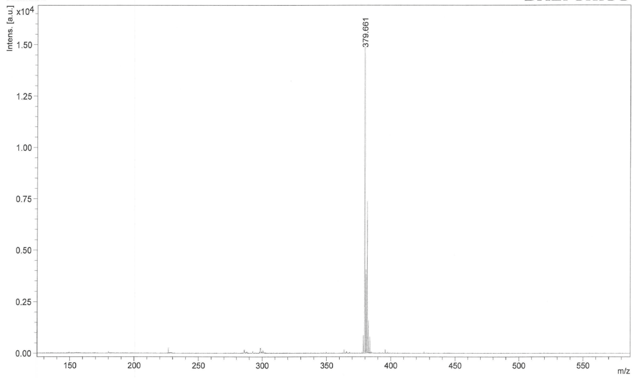

**Fig. S1.** Mass spectrum of [(MeS)2C=C(H)-N=C(C6H4Cl)(C6H4SMe)]

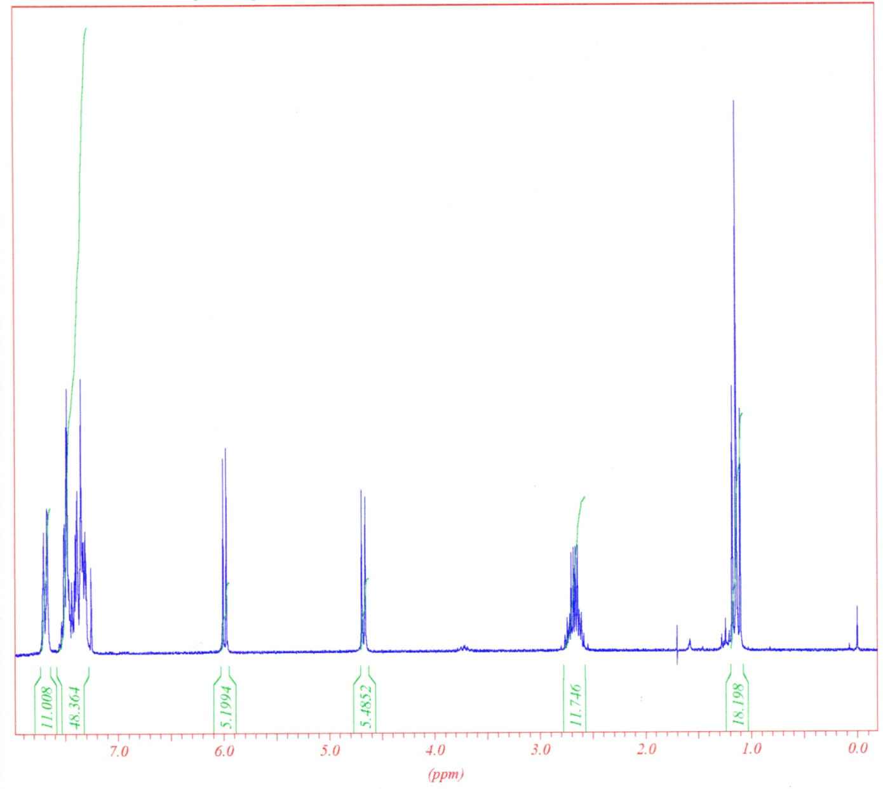

**Fig. S2** 1H RMN (CDCl3) spectrum of compound **8**.

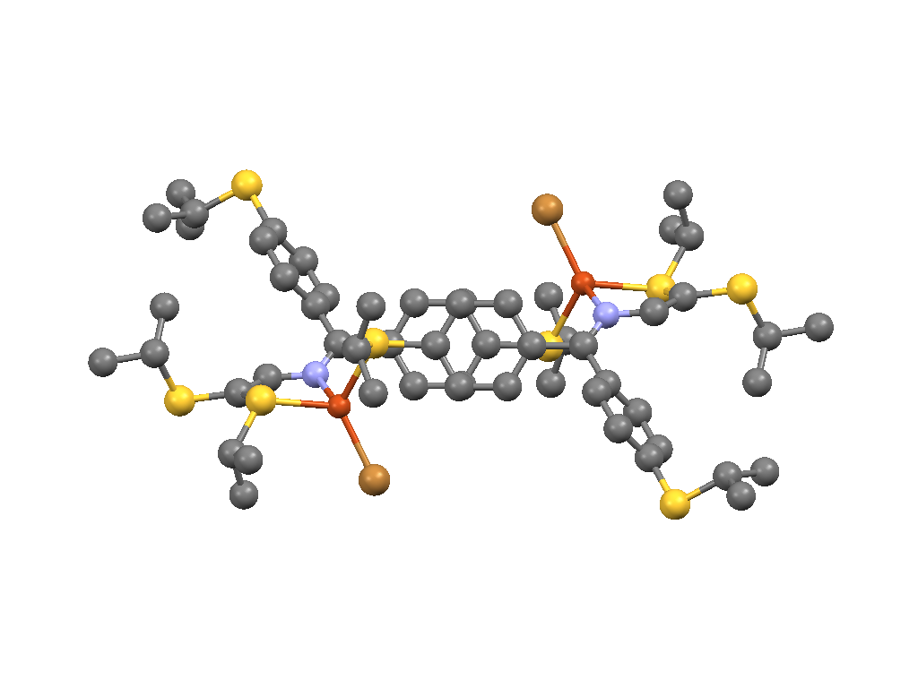

**Fig. S3** Projection of the molecular structure of **11** down direction perpendicular to the central phenyl rings in the molecular macrocycle; showing the intramolecular  stacking.