**Synthesis of  EMT/FAU-type zeolite nanocrystal aggregates with high yield and crystalline state**

Synthèse d’agrégats de nanocristaux de zéolithe de type EMT/FAU avec un rendement et un état cristallin important

Laetitia Bullota,b, T. Jean Daoua,*, Angélique Simon-Masserona, Gérald Chaplaisa, Joël Patarina,*

*a Université de Strasbourg (UDS), Université de Haute Alsace (UHA), Equipe Matériaux à Porosité Contrôlée (MPC), Institut de Science des Matériaux de Mulhouse (IS2M), UMR CNRS 7361, Université de Haute Alsace, ENSCMu, 3B rue Alfred Werner, 68093 Mulhouse Cedex, France*

*laetitia.bullot@uha.fr, Telephone number: +33 3 89 33 67 27;*

*jean.daou@uha.fr, Telephone number: +33 3 89 33 67 39;*

*angelique.simon-masseron@uha.fr, Telephone number: +33 3 89 33 67 75;*

*gerald.chaplais@uha.fr, Telephone number: +33 3 89 33 68 87;*

*joel.patarin@uha.fr, Telephone number: +33 3 89 33 68 80*

*b French Environment and Energy Management Agency, 20 avenue du Grésillé, BP 90406 49004 Angers Cedex 01, France*

**Supporting Information**

* To whom correspondence should be addressed. Email: jean.daou@uha.fr Telephone number: +33 3 89 33 67 39 Email: joel.patarin@uha.fr Telephone number: +33 3 89 33 68 80

**Fig. S1** XRD pattern of the as-synthesized zeolite sample synthesized in the presence of 5 equivalents of TEA additive (S1;5;7;0) after 7 days of thermal treatment at 30 °C

Stars correspond to the peaks that can be attributed to EMT-type zeolite and full circles correspond to the peaks that can be attributed to FAU-type zeolite

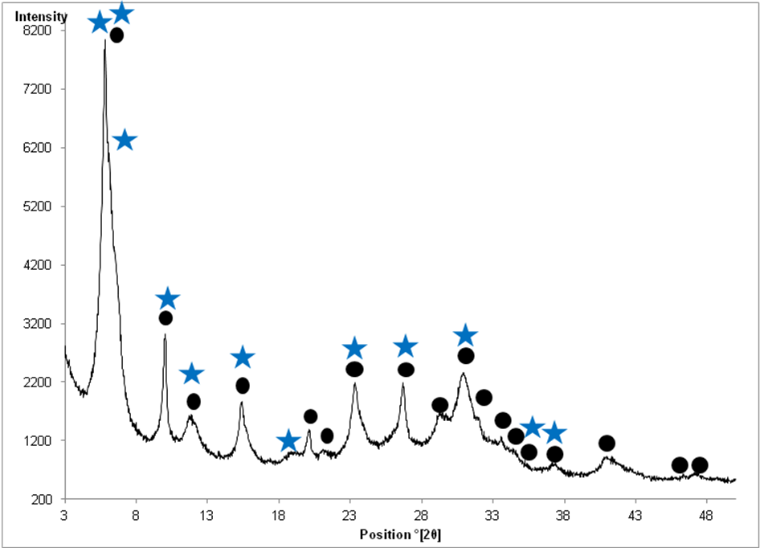

**2θ ° (CuKα)**

**Table S1** Atomic absorption spectroscopy results for the samples synthesized in the absence of TEA additive: x = 0 (Reference, without TEA) and in the presence of 5 equivalents of TEA additive with 1 equivalent of Al2O3 (S1;5;7;0), with 1.5 equivalents of Al2O3 (S1.5;5;7;0) and with 2 equivalents of Al2O3 (S2;5;7;0) after 7 days of thermal treatment at 30 °C

|  |  |  |  |  |
| --- | --- | --- | --- | --- |
| **Sample** | **Reference, without TEA** | **S1;5;7;0** | **S1.5;5;7;0** | **S2;5;7;0** |
| wt.% of remaining silica in mother liquor | 1.3 | 1.5 | 0.8 | 0.6 |