**Supplementary Information**

**Upgrading of Palm Biodiesel Fuel over Supported Palladium Catalysts**

Shih-Yuan Chena\*, Lalita Attanathob, Takehisa Mochizukia, Yohko Abea, Makoto Tobaa, Yuji Yoshimuraa, Chiraphat Kumpidetb, Phunthinee Somwonhsac, Supranee Lao-ubolc

**Scheme S1.** A continuous up-flow fixed-bed reaction system for partial hydrogenation of palm BDF into Palm H-FAME over supported Pd catalysts……………………………...2

**Table S1.** FAME composition and fuel property of different Palm BDFs in Thailand……3

**Table S2.** The specification of the EAS-ERIA BDF standard…………………………..4

**Fig. S1.** Optic photos of (a) 0.5wt%Pd/SBA-15, (b) 0.5wt%Pd/Zr-SBA-15……...……...5

**Fig. S2.** The polyunsaturated FAME conversion and *cis*-monounsaturated FAME selectivity vs TOS over (●, ○) 0.5wt%Pd/SBA-15 and (□, ■) commercial 0.5wt%Pd/γ-Al2O3 catalysts using different space velocities.........................................................…….6

**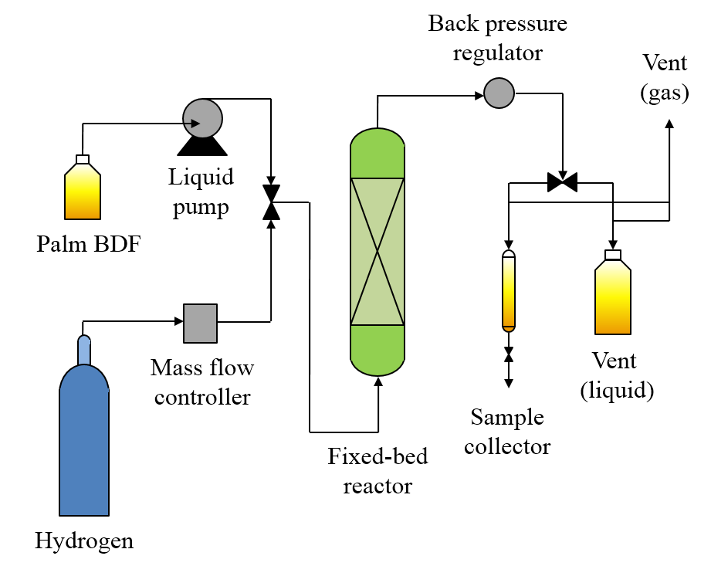**

**Scheme S1.** A continuous up-flow fixed-bed reaction system for partial hydrogenation of palm BDF into Palm H-FAME over supported Pd catalysts.

**Table S1.** FAME composition and fuel property of different Palm BDFs in Thailand.

|  |  |  |  |
| --- | --- | --- | --- |
| FAME composition and fuel property | Company A | Company B | Company C |
| Saturated FAME (wt%) | 49.07 | 50.94 | 52.81 |
| Monounsaturated FAME (wt%) | 41.01 | 38.03 | 36.58 |
| Polyunsaturated FAME (wt%) | 9.54 | 10.51 | 10.01 |
| Oxidation stability (h) | 19.4 | 19.1 | 13.6 |
| Cloud point (oC) | 12.0 | 13.0 | 13.0 |
| Pour point (oC) | 12.0 | 13.0 | 13.0 |
| Moisture content (ppm) | 343 | 355 | 455 |
| Density (g cm-3) | 0.859 | 0.854 | 0.863 |

**Table S2.** The specification of the EAS-ERIA BDF standard.

|  |  |  |
| --- | --- | --- |
| Specifications | Unit | EAS-ERIA |
| EEBS:2008 |
| Ester content | mass% | 96.5 min. |
| Density | kg m-3 | 860-900 |
| Viscosity | mm2 s-1 | 2.00-5.00 |
| Sulfur content | mass% | 0.001 max. |
| Flashpoint | oC | 100 min. |
| Carbon residue (100%) | mass% | 0.05 max. |
| Cetane number |  | 51.0 min. |
| Sulfated ash | mass% | 0.02 max. |
| Total contamination | mg kg-1 | 24 max. |
| Copper corrosion |  | Class-1 |
| Oxidation stability | hrs. | 10.0 min. |
| Iodine value |  | N.D. |
| Methyl linolenate | mass% | 12.0 max. |
| Polyunsaturated FAME  (with 4+ double bonds) | mass% | N.D. |
| Monoglyceride content | mass% | 0.80 max. |
| Diglyceride content | mass% | 0.20 max. |
| Triglyceride content | mass% | 0.20 max. |
| Total glycerol content | mass% | 0.25 max. |
| Phosphorus content | mg kg-1 | 10.0 max. |
| Cloud point | oC | Grade a as EB590 diesel fuel or EN14214:2013\* |
| Pour point | oC | Grade a as EB590 diesel fuel or EN14214:2013\* |

\* Depended on the climate condition.

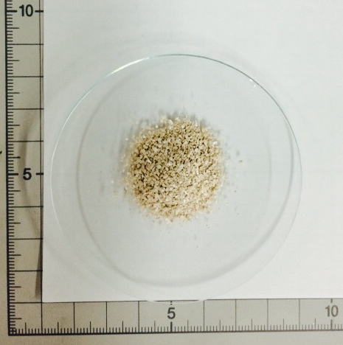

**(a)**

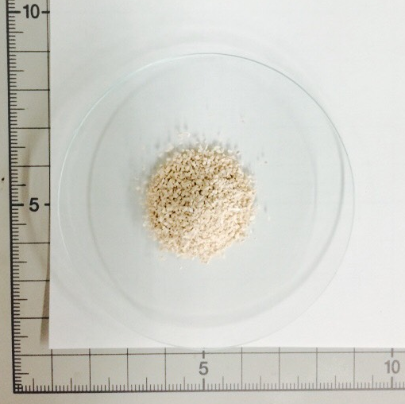

**(b)**

**Fig. S1.** Optic photos of (a) 0.5wt%Pd/SBA-15 and (b) 0.5wt%Pd/Zr-SBA-15 catalysts.

C:\Users\Shih-Yuan Chen\Desktop\AIST_Research\Papers\2015_1009_Pd Catalysts with Lalita\CR Chimie\Revised Manuscript\TOS vs conversion and select-1.TIF

C:\Users\Shih-Yuan Chen\Desktop\AIST_Research\Papers\2015_1009_Pd Catalysts with Lalita\CR Chimie\Revised Manuscript\TOS vs conversion and select-2.TIF

**Fig. S2.** The polyunsaturated FAME conversion and cis-monounsaturated FAME selectivity vs TOS over (●, ○) 0.5wt%Pd/SBA-15 and (□, ■) commercial 0.5wt%Pd/γ-Al2O3 catalysts using different space velocities.