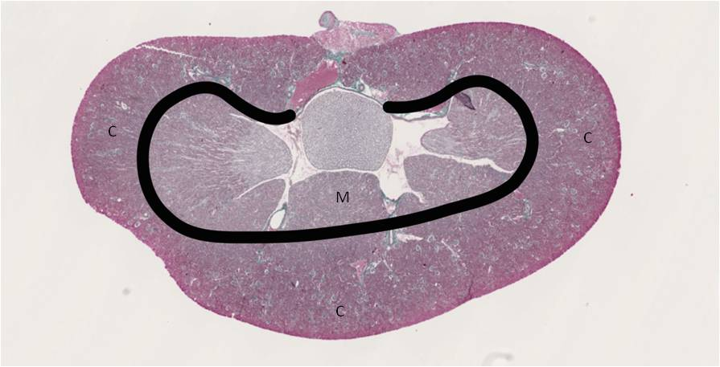
Supplementary Data 1. Histological view of a whole kidney section colored with Masson’s trichrome. The corticomedullary junction is shown by the black line. C: Cortex, M: Medulla.

