The effect of Migrating Group Structure on Enantioselectivity in Lipases-Catalyzed Kinetic Resolution of 1-Phenylethanol

**Effet de la structure du groupe partant sur l'énantiosélectivité des lipases lors de la résolution cinétique du 1-Phenyl éthanol.**

**Nedjma MELAIS[1], Louisa ARIBI-ZOUIOUECHE*[1], Olivier RIANT*[2]**

Additional Supporting Information may be found in the online version of this article.

* Corresponding author:

Prof. Louisa ARIBI-ZOUIOUECHE.

[1] Ecocompatible Asymmetric Catalysis Laboratory (LCAE). Badji Mokhtar Annaba-University.B.P 12, 23000, ANNABA, ALGERIA. Tel: +213 (0)774037059 Fax: +213 (0)38871712 (L.A.Z.)

E-mail address : [louisa.zouioueche@univ-annaba.dz](mailto:louisa.zouioueche@univ-annaba.dz)

1-Laboratoire Catalyse Asymétrique Eco compatible (LCAE). Université Badji Mokhtar. B.P 12, 23000 Annaba, Algeria. Courriel: [louisa.zouioueche@univ-annaba.dz](mailto:louisa.zouioueche@univ-annaba.dz)

2- Institute of Condensed Matter and Nanosciences Molecules, Solids and Reactivity (MOST). Université Catholique de Louvain. Bât. Lavoisier Pl. Louis Pasteur, 1, bte 3. 1348 Louvain La Neuve, Belgium.

**Table of contents**

|  |  |
| --- | --- |
| **Contents** | **Page** |
| 1. General Information | 1 |
| 1. NMR and mass spectra of compounds | 3 |
| 1. Chromatographic data for the racemic compounds | 10 |

1. **General Information:**

NMR spectra were recorded on Brucker spectrometers (300 MHz for 1H, 75 MHz for 13C). Chemical shifts are reported in *δ* ppm from tetramethylsilane with the solvent resonance as the internal standard for 1H NMR and chloroform-*d* (*δ* 77.0 ppm) for 13C NMR. Coupling constants (*J)* are given in hertz. Following abbreviations classify the multiplicity: s = singulet, d = doublet, t = triplet, q = quartet, m = multiplet, br = broad signal. The mass spectra were obtained from the mass-service at Catholic University of Louvain (FINNIGAN-MAT TSQ 7000 and FINNIGAN-MAT LQC spectrometers).

The enantiomeric excesses were measured by gas chromatography (ThermoFinnigan

Trace GC) equipped with an automatic autosampler and using a CHIRALSIL-DEX CB column (25 m; 0.25 mm; 0.25 μm), or by a chiral stationary phase HPLC. HPLC analyses were performed on a Thermo Separation Product Pompe P100 with a UV detector and a chiral stationary-phase column Chiralcel OD-H. Retention times are reported in minutes. Optical rotations were determined using a Perkin–Elmer 241 Polarimeter at room temperature using a cell of 1 dm length at 589 nm. All of the crude products were purified by preparative thin layer chromatography on Silica Gel 60 PF254 (petroleum ether/ethyl acetate, 9:1).

1. **NMR spectra of all compounds**

**2-1. (*R,S*)-1-Phenylethyl acetate 3a**

**1H RMN** (CDCl3): δ (ppm) = 1.52 – 1.54 (d, *J=6,63 Hz*, 3H, CH3-CH-) ; 2.05 (s, 3H, -O-CH3) ; 5.8 - 6 (q, *J=6,61Hz,* 1H, -*CH-C=O) ; 7.3-7.5 (m, 5H).

**13C RMN** (CDCl3): δ (ppm) = 21.3, 22.2, 72.3, 126.1, 127.9, 128.5, 141.7, 170.3.

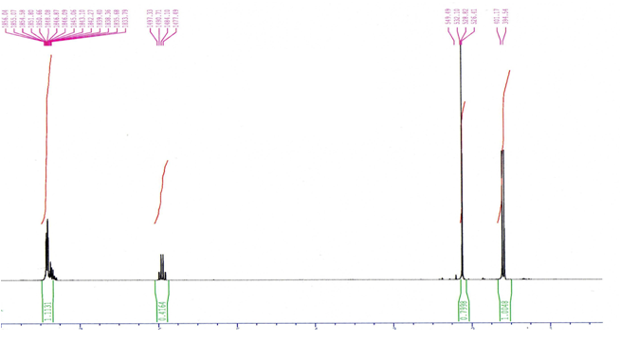

**2-2. (*R,S*)-1-Phenylethyl pivaloate 3d**

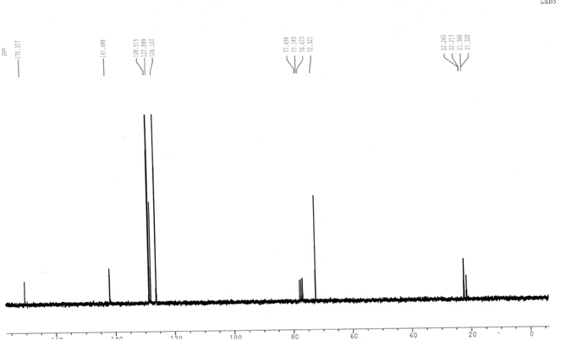



**1H NMR** (CDCl3, 300 MHz): 1.24 (s, 9H), 1.54 (d, J = 6.6 Hz, 3H), 5.86 (q, J = 6.6 Hz, 1H), 7.28–7.37 (m, 5H).

**13C NMR** (CDCl3, 75 MHz): 22.4, 27.1, 38.7, 71.9, 125.7, 127.6, 142.1, 170.6.

**MS** (EI ; m/z):57,1 ([3CH3] +, 43%); 77,2 ([Ph]+, 15%); 105,1 (([Ph]C=O+, 100%); 206,3 ([M]+, 10%).

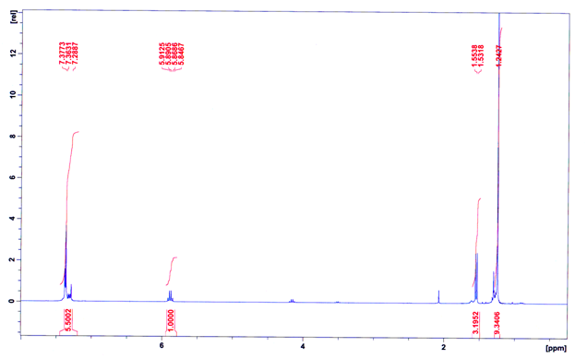



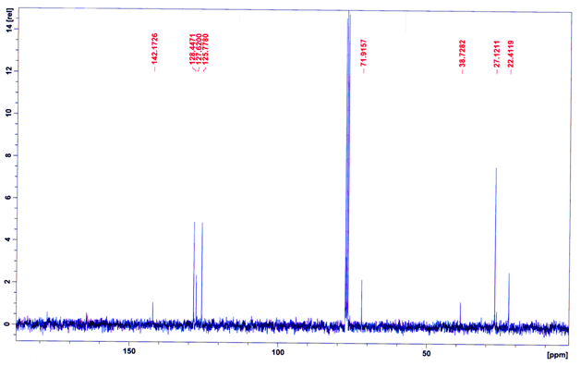

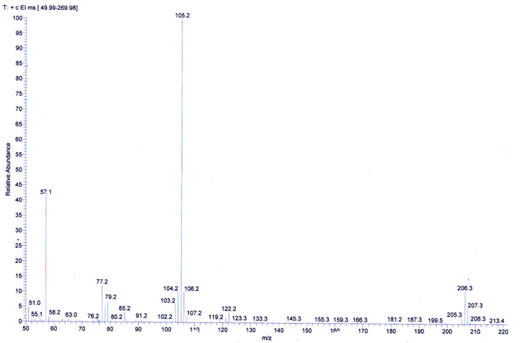

**2-3. (*R,S*)-1-Phenylethyl benzoate 3c**

**1H NMR** (CDCl3, 300 MHz): 1.69 (d, J = 6.5 Hz, 3H), 6.17 (q, J = 6.6 Hz, 1H), 7.29–7.59 (m, 8H), 8.10 (d, J = 7.8 Hz, 2H).

**13C NMR** (CDCl3, 75 MHz): 22.4, 72.9, 126.3, 128.1, 128.6, 128.8, 129.9, 130.7, 141.1, 165.8.

**MS** (EI ; m/z): 77,1 ([Ph]+, 35%); 105,1 (([Ph]C=O+, 100%); 226,2 ([M]+, 10%).

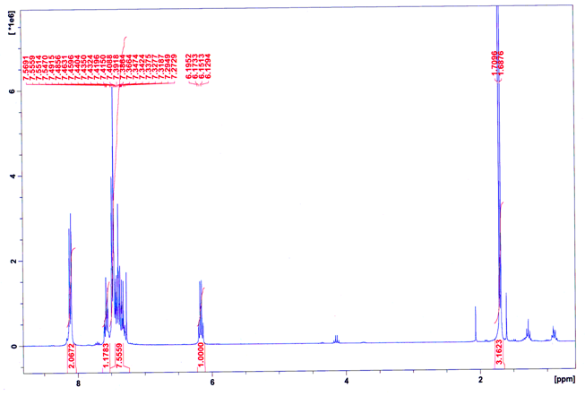



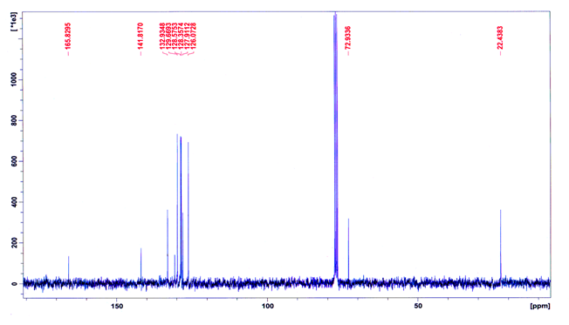

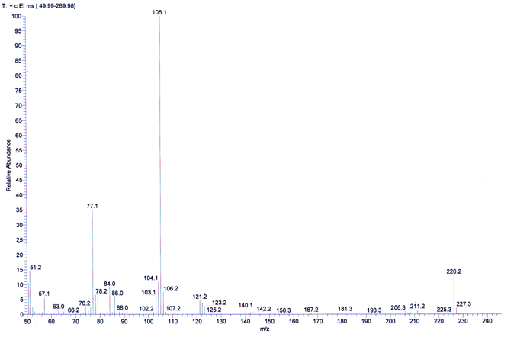

**2-4. (*R,S*)-1-Phenylethyl decanoate 3e**

**1H NMR** (CDCl3, 300 MHz): 0.87-0.92 (t, 3H), 1.27 (m, 12H), 1.55 (d, 3H), 1.64 (m, 2H), 2.34 (t, 2H), 5.9 (q, 1H), 7.27-7.37 (m, 5H).

**13C NMR** (CDCl3, 75 MHz): 22.4, 27.1, 38.7, 71.9, 125.7, 127.6, 142.1, 170.6.

**MS** (EI ; m/z): 77,1 ([Ph]+, 25%); 276 ([M]+, 5%).

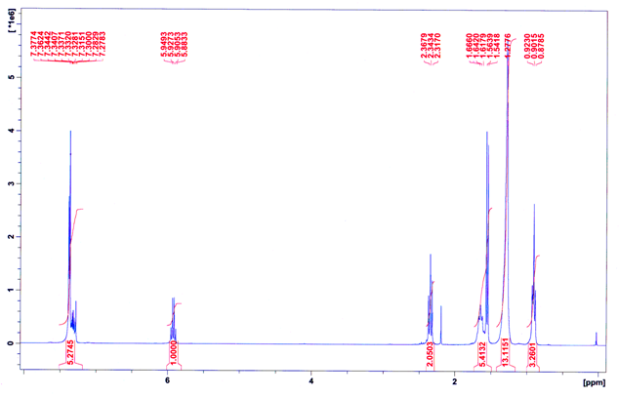



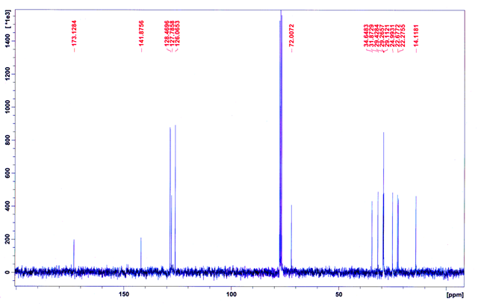

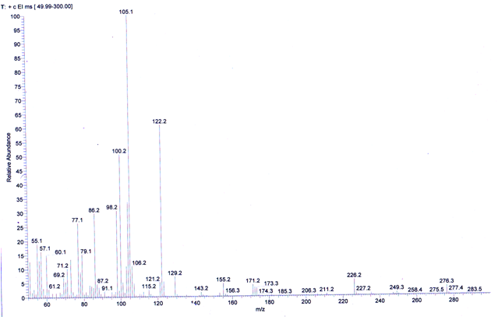

**2-5. (*R,S*)-1-Phenylethyl laurate 3f**

**1H NMR** (CDCl3, 300 MHz): 0.87-0.92 (t, 3H), 1.27 (m, 16H), 1.53-1.66 (m, 5H), 2.34 (t, 2H), 5.9 (q, 1H), 7.27-7.37 (m, 5H);

**13C NMR** (CDCl3, 75 MHz): 22.4, 27.1, 38.7, 71.9, 125.7, 127.6, 142.1, 170.6.

**MS (EI ; m/z):** 77,1 ([Ph]+, 25%); 304 ([M]+, 5%).

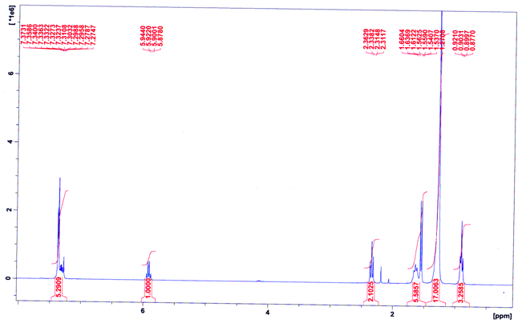



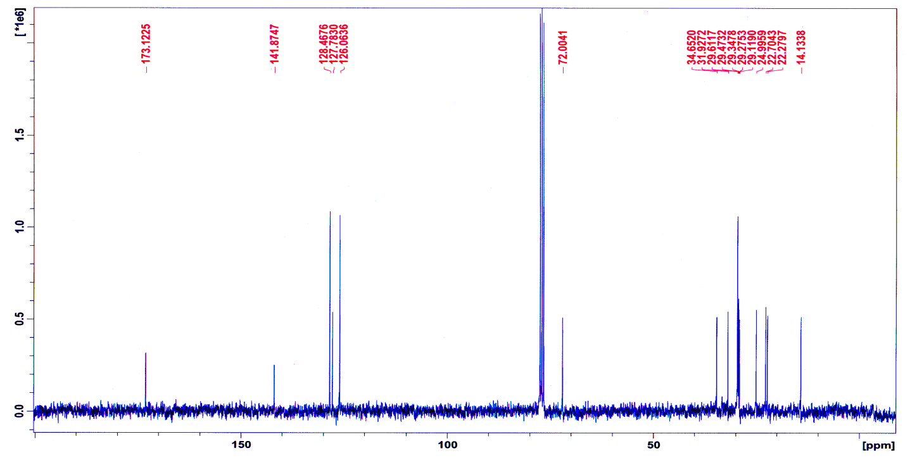

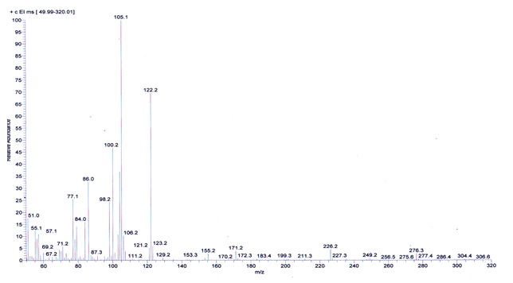

1. **Chromatographic data for racemic compounds**

|  |  |  |  |
| --- | --- | --- | --- |
| **Table1. Lipase-catalyzed transesterification of 1-phenylethanol with vinyl esters 2 a-f.** | | | |
| **Entry** | **Compound** | **Chromatographic conditions** | **Specter** |
| **1** | ***rac*-1** | GC (Chiralsil-Dex CB,): (Tcolumn = 140 °C, flow 1.2 mL/min).  t*(R)* = 3.9 min, t*(S)* = 4.1 min |  |
| ***rac*-3a** | GC (Chiralsil-Dex CB): (Tcolumn = 140 °C, flow 1.2 mL/min).  t(*S)* = 2.9 min, t(*R)* = 3.2 min |  |
| **by IA**  **and**  ***CAL-B*** | GC (Chiralsil-Dex CB,): (Tcolumn = 140 °C, flow 1.2 mL/min).  (*S*)-1: t*(S)* = 4.1 min  GC (Chiralsil-Dex CB), (Tcolumn = 140 °C, flow 1.2 mL/min).  (*R*)-3a : t(*R)* = 3.2 min |  |
| **2** | ***rac-* 3e**  . | HPLC (Chiralcel AD-H, isohexane/iPrOH: 98/2, flow 1.0 mL/min):  t*(S)* =4.2 min, t*(R)* =5.0 min |  |
| **by VD**  **and**  ***CAL-B*** | GC (Chiralsil-Dex CB,): (Tcolumn = 140 °C, flow 1.2 mL/min).  (*S*)-1 t*(S)* = 4.3 min  HPLC (Chiralcel AD-H, isohexane/iPrOH: 98/2, flow 1.0 mL/min):  t*(S)* =4.7 min, t *(R)* =5.3 min |  |
| **3** | ***rac*-3f** | HPLC (Chiralcel AD-H, isohexane/iPrOH: 98/2, flow 1.0 mL/min):  t(*S)* =3.9 min, t (*R)* =4.5 min. |  |
| **3** | **by VL**  **and**  ***CAL-B*** | GC (Chiralsil-Dex CB), (Tcolumn = 140 °C, flow 1.2 mL/min).  (*S*)-1, t*(S)* = 4.3 min  HPLC (Chiralcel AD-H, isohexane/iPrOH: 98/2, flow 1.0 mL/min):  t (*S)* =4.0 min, t (*R)* =4.3 min. |  |
| **4** | **By VD**  **and**  ***PCL*** | GC (Chiralsil-Dex CB,): (Tcolumn = 140 °C, flow 1.2 mL/min).  (*S*)-1, t*(S)* = 4.0 min  HPLC (Chiralcel AD-H, isohexane/iPrOH: 98/2, flow 1.0 mL/min):  (*R)*-3e, t *(R)* =4.3 min |  |

|  |  |  |  |
| --- | --- | --- | --- |
| **Table 2: lipase-catalyzed hydrolysis of racemic esters 3 a-f.** | | | |
| **Entry** | **Compound** | **Chromatographic conditions** | **Specter** |
| **1** | ***rac-*3a + *CAL-B*** | GC (Chiralsil-Dex CB,): (Tcolumn = 140 °C, flow 1.2 mL/min).  (*R*)-1 : t*(S)* = 3.9 min  GC (Chiralsil-Dex CB) (Tcolumn = 140 °C, flow 1.2 mL/min).  1a : t(*S)* = 3.0 min, t(*R)* = 3.6 min |  |
| **2** | ***rac-*3e + *CAL-B*** | GC (Chiralsil-Dex CB,): (Tcolumn = 140 °C, flow 1.2 mL/min).  1: t*(R)* = 3.9 min, t*(S)* = 4.1 min  HPLC (Chiralcel AD-H, isohexane/iPrOH: 98/2, flow 1.0 mL/min):  3e: t(S) =4.1 min, t (R) =4.8 min |  |
| **3** | ***rac-*3f + *CAL-B*** | GC (Chiralsil-Dex CB,): (Tcolumn = 140 °C, flow 1.2 mL/min).  1: t*(R)* = 3.8 min, t*(S)* = 4.0 min  HPLC (Chiralcel AD-H, isohexane/iPrOH: 98/2, flow 1.0 mL/min):  *(S)-*3f : t(*R)* = 4.3 min |  |