**SUPPORTING INFORMATION**

Aqueous microwave assisted DMAP catalyzed synthesis of β-phosphonomalonates and 2-amino-4*H*-chromen-4-ylphosphonates via domino Knoevenagel-phospha-Michael reaction.

**Parteek Kour, Anil Kumar,* Vijai K. Rai**

Synthetic Organic Chemistry Lab, Faculty of Sciences, Shri Mata Vaishno Devi University, Katra, 182 320, Jammu & Kashmir, India

[**anilsharmachemistry@gmail.com**](mailto:anilsharmachemistry@gmail.com)

**Table of contents**

General Data S2

General procedure domino Knoevenagel-phospha-Michael reactionS2

Analytical data of Knoevenagel-phospha-Michael reaction productsS3

References S5

NMR spectra S6

**General Data**

Column chromatography was performed using 60-120 mesh silica gel. Melting points were determined on analab melting point apparatus. 1H , 13C NMR and 31P spectra were recorded on a Bruker 400, 100 and 162 MHz Spectrometer, respectively in CDCl3 solvent.

**General procedure for the synthesis of β-phosphonomalonates** **4a-h**:To a mixture of aromatic aldehyde (1 mmol), malononitrile/ethyl cyanoacetate (1 mmol), phosphite ester (1 mmol) in H2O (1 mL), 20 mol% DMAP was added. The contents of reaction mixture were subjected to reflux for appropriate time as mentioned in Table 4. The progress of reaction was monitored by TLC. After completion, the reaction mixture was diluted with water (10 mL), extracted with ethyl acetate (3×10 mL) and dried over Na2SO4. The solvent was removed under reduced pressure using a rotary evaporator andthe crude reaction mixture was further purified by column chromatography using ethyl acetate and *n*-hexane (8:2 to 6:4). Under microwave condition, the reaction mixture of same composition as mentioned was irradiated at 100 oC in microwave reactor (Biotage, Model: Initiator EXP EU 355301, 012180) in sealed vial till the completion of reaction. Work-up and purification was done as mentioned above to provide the desired product. The structure of the product, **4a-h** was confirmed by spectral data which is consistent with that reported in the literature.

**General procedure for the synthesis of 2-amino-4H-chromen-4-ylphosphonates** **6a-h**:A sealed vial was charged with 1 mmol of each of substituted salicylaldehyde, malononitrile/ethyl cyanoacetate, phosphite ester, H2O (1 mL) and 20 mol% of DMAP. The reaction mixture was then irradiated at 100 oC in microwave reactor (Biotage, Model: Initiator EXP EU 355301, 012180). After the completion of reaction as indicated by TLC, the reaction mixture was extracted with ethyl acetate (3×10 mL) and organic layers were dried over Na2SO4. The solvent was removed under reduced pressure using a rotary evaporator and the crude reaction mixture was purified by column chromatography using ethyl acetate and *n*-hexane (8:2 to 6:4). The structure of the product, **6a-h** was confirmed by spectral data which is consistent with that reported in the literature.

S-2

**Analytical data of Knoevenagel-phospha-Michael reaction products**

**Diethyl (2,2-dicyano-1-phenylethyl)phosphonate (4a).1** Yellow solid. Yield 92%. mp 55-56 °C. 1H NMR (400 MHz, CDCl3, *δ* in ppm): 7.43 (m, 5H, -**ArH**), 4.55 (dd, 1H, -**CH**(CN)2), 4.22 – 4.12 (m, 2H, -O**CH2**CH3), 4.02 – 3.72 (m, 2H, -O**CH2**CH3), 3.60 (dd, 1H, -P**CH**), 1.38 – 1.30 (t, 3H, -OCH2**CH3**), 1.11 (t, 3H, -OCH2**CH3**). 13C NMR (100 MHz, CDCl3, *δ* in ppm): 130.42, 130.36, 129.74, 129.62, 129.60, 129.41, 111.52, 111.23, 64.64, 63.56, 44.12, 25.69, 16.39, 16.19. 31P NMR (162 MHz, CDCl3, *δ* in ppm): 19.60.

**Diethyl (2,2-dicyano-1-(4-methoxyphenyl)ethyl)phosphonate (4b).1** White solid. Yield 95%. mp 59-60 °C. 1H NMR (400 MHz, CDCl3, *δ* in ppm): 7.44 – 7.39 (m, 2H, -**ArH**), 6.97 – 6.93 (m, 2H, -**ArH**), 4.52 (dd, 1H, -**CH**(CN)2), 4.23 – 4.11 (m, 2H, -O**CH2**CH3), 4.06 – 3.97 (m, 1H, -O**CH2**CH3), 3.82 (s, 3H, -O**CH3**), 3.81 – 3.75 (m, 1H, -O**CH2**CH3), 3.56 (dd, 1H, -P**CH**), 1.35 (t, 3H, -OCH2**CH3**), 1.15 (t, 3H, -OCH2**CH3**). 13C NMR (100 MHz, CDCl3, *δ* in ppm): 160.50, 130.74, 130.67, 122.04, 114.90, 114.89, 111.64, 111.32, 64.43, 63.34, 55.40, 44.66, 25.94, 16.35, 16.22. 31P NMR (162 MHz, CDCl3, *δ* in ppm): 19.55.

**Diethyl (2,2-dicyano-1-(4-nitrophenyl)ethyl)phosphonate (4c).1** Yellow solid. Yield 78%. mp 106 °C. 1H NMR (400 MHz, CDCl3, *δ* in ppm): 8.22 (d, 2H, -**ArH**), 7.69 (d, 2H, -**ArH**), 4.86 – 4.81 (m, 1H, -**CH**(CN)2), 4.15 – 4.01 (m, 4H, -O**CH2**CH3), 3.90 (dd, 1H, -P**CH**), 1.28 (t, 3H, -OCH2**CH3**), 1.13 (t, 3H, -OCH2**CH3**). 13C NMR (100 MHz, CDCl3, *δ* in ppm): 148.24, 137.93, 130.63, 130.56, 124.20, 124.19, 111.25, 111.06, 64.54, 63.89, 42.89, 24.95, 16.09, 16.03. 31P NMR (162 MHz, CDCl3, *δ* in ppm): 17.88.

**Diethyl (1-(2-chlorophenyl)-2,2-dicyanoethyl)phosphonate (4d).1** Yellow solid. Yield 80%. mp 76 °C. 1H NMR (400 MHz, CDCl3, *δ* in ppm): 7.80 – 7.75 (m, 1H, -**ArH**), 7.51 (dd, 1H, -**ArH**), 7.41 – 7.34 (m, 2H, -**ArH**), 4.63 – 4.57 (m, 1H, -**CH**(CN)2), 4.52 – 3.95 (m, 4H, -O**CH2**CH3), 3.82 (dd, 1H, -P**CH**), 1.38 (t, 3H, -OCH2**CH3**), 1.13 (t, 3H, -OCH2**CH3**). 13C NMR (100 MHz, CDCl3, *δ* in ppm): 135.30, 130.80, 130.55, 129.70, 128.73, 127.93, 111.17, 111.00, 64.48, 63.78, 38.88, 25.06, 16.36, 16.18. 31P NMR (162 MHz, CDCl3, *δ* in ppm): 19.55.

**Diethyl (1-(4-chlorophenyl)-2,2-dicyanoethyl)phosphonate (4e).1** Yellow solid. Yield 91%. mp 94 °C. 1H NMR (400 MHz, CDCl3, *δ* in ppm): 7.57 – 7.51 (m, 4H, -**ArH**), 4.66 (dd, 1H, -**CH**(CN)2), 4.34 – 4.23 (m, 2H, -O**CH2**CH3), 4.19 – 3.91 (m, 2H, -O**CH2**CH3), 3.74 – 3.65 (m, 1H, -P**CH**), 1.46 (t, 3H, -OCH2**CH3**), 1.28 (t, 3H, -OCH2**CH3**). 13C NMR (100 MHz, CDCl3, *δ* in ppm): 135.95, 135.92, 130.87, 130.80, 129.81, 128.93, 111.37, 111.06, 64.63, 63.67, 44.82, 25.62, 16.33, 16.31.  31P NMR (162 MHz, CDCl3, *δ* in ppm): 18.92.

**Diethyl (2,2-dicyano-1-(p-tolyl)ethyl)phosphonate (4f).1** Yellow solid. Yield 90%. mp 94 °C. 1H NMR (400 MHz, CDCl3, *δ* in ppm): 7.36 (dd, 2H, -**ArH**), 7.23 (d, 2H, -**ArH**), 4.57 (dd, 1H, -**CH**(CN)2), 4.22 – 4.11 (m, 2H, -O**CH2**CH3), 4.04 – 3.73 (m, 2H, -O**CH2**CH3), 3.58 (dd, 1H, -P**CH**), 2.36 (s, 3H, -**CH3**), 1.35 (t, 3H, -OCH2**CH3**), 1.13 (t, 3H, -OCH2**CH3**). 13C NMR (100 MHz, CDCl3, *δ* in ppm): 139.56, 130.15, 129.25, 129.18, 127.27, 127.21, 111.63, 111.34, 64.38, 63.31, 43.55, 25.71, 21.24, 16.30, 16.12. 31P NMR (162 MHz, CDCl3, *δ* in ppm): 19.59.

S-3

**Dimethyl (1-(2-chlorophenyl)-2,2-dicyanoethyl)phosphonate (4g).2** yellow solid. Yield 84%. mp 72 °C. 1H NMR (400 MHz, CDCl3, *δ* in ppm): 7.42 (d, 4H, -**ArH**), 4.51 (dd, 1H, -**CH**(CN)2), 3.81 (dd, 3H, -**OCH3**), 3.68 – 3.59 (m, 4H, -P**CH**, -**OCH3**). 13C NMR (100 MHz, CDCl3, *δ* in ppm): 135.03, 134.93, 130.46, 130.00, 129.96, 127.99, 127.40, 114.76, 53.97, 53.10, 43.22, 24.77. 31P NMR (162 MHz, CDCl3, *δ* in ppm): 20.24.

**Ethyl 3-(4-chlorophenyl)-2-cyano-3-(diethoxyphosphoryl)propanoate (4h).3** oil. Yield 79%. 1H NMR (400 MHz, CDCl3, *δ* in ppm): 7.39 – 7.25 (m, 2H, -**ArH**), 7.22 (m, 2H, -**ArH**), 4.23 (d, 1H, -**CH**CN), 4.10 – 3.91 (m, 6H, -COO**CH2**CH3, -O**CH2**CH3), 3.77 – 3.70 (m, 1H, -P**CH**), 1.18 (t, 3H, -OCH2**CH3**), 1.08 (t, 3H, -OCH2**CH3**), 0.99 (t, 3H, -COOCH2**CH3**). 13C NMR (100 MHz, CDCl3, *δ* in ppm): 163.62, 134.00, 133.81, 130.79, 130.30, 129.82, 128.40, 114.22, 63.11, 62.76, 61.21, 42.97, 38.68, 15.66, 15.61, 13.23. 31P NMR (162 MHz, CDCl3, *δ* in ppm): 20.98.

**Diethyl (2-amino-3-cyano-4H-chromen-4-yl)phosphonate (6a).4** White solid. Yield 95%. mp 139-141 °C. 1H NMR (400 MHz, CDCl3, *δ* in ppm): 7.34 (d, 1H, -**ArH**), 7.29 – 7.23 (m, 1H, -**ArH**), 7.14 (d, 1H, -**ArH**), 6.98 (d, 1H, -**ArH**), 5.17 (s, 2H, -**NH2**), 4.17 – 4.08 (m, 2H, -O**CH2**CH3), 4.00 (m, 2H, -O**CH2**CH3), 3.90 (d, 1H, -P**CH**), 1.35 (t, 3H, -OCH2**CH3**), 1.21 (t, 3H, -OCH2**CH3**). 13C NMR (100 MHz, CDCl3, *δ* in ppm): 162.17, 150.01, 129.67, 129.17, 125.06, 119.74, 116.61, 116.58, 63.50, 63.43, 63.14, 63.07, 51.36, 34.79, 16.57, 16.54, 16.52, 16.49. 31P NMR (162 MHz, CDCl3, *δ* in ppm): 21.81.

**Dimethyl (2-amino-3-cyano-4H-chromen-4-yl)phosphonate (6b).4** Pale yellow solid. Yield 89%. mp 151 °C. 1H NMR (400 MHz, CDCl3, *δ* in ppm): 7.35 – 7.27 (m, 2H, -**ArH**), 7.16 (d, 1H, -**ArH**), 7.00 (d, 1H, -**ArH**), 5.34 (s, 2H, -**NH2**), 3.98 – 3.92 (m, 1H, -P**CH**), 3.77 (m, 3H, -O**CH3**), 3.70 (m, 3H, -O**CH3**). 13C NMR (100 MHz, CDCl3, *δ* in ppm): 162.39, 149.94, 129.53, 129.26, 125.18, 119.70, 116.74, 116.25, 54.03, 53.63, 50.55, 34.40. 31P NMR (162 MHz, CDCl3 *δ* in ppm): 24.62.

**Diethyl (2-amino-6-chloro-3-cyano-4H-chromen-4-yl)phosphonate (6c).4** White solid. Yield 90%. mp 150-151 °C. 1H NMR (400 MHz, CDCl3, *δ* in ppm): 7.31 (d, 1H, -**ArH**), 7.22 (d, 1H, -**ArH**), 6.93 (d, 1H, -**ArH**), 5.29 (s, 2H, -**NH2**), 4.17 – 4.05 (m, 4H, -O**CH2**CH3), 3.84 (d, 1H, -P**CH**), 1.34 (t, 3H, -OCH2**CH3**), 1.27 (t, 3H, -OCH2**CH3**). 13C NMR (100 MHz, CDCl3, *δ* in ppm): 162.11, 148.58, 130.00, 129.34, 129.18, 119.42, 118.55, 117.96, 63.64, 63.31, 50.61, 36.18, 16.53, 16.47. 31P NMR (162 MHz, CDCl3, *δ* in ppm): 20.98.

**Dimethyl (2-amino-6-chloro-3-cyano-4H-chromen-4-yl)phosphonate (6d).4** White solid. Yield 87%. mp 167-169 °C. 1H NMR (400 MHz, CDCl3, *δ* in ppm): 7.29 (d, 1H, -**ArH**), 7.21 (d, 1H, -**ArH**), 6.92 (d, 1H, -**ArH**), 5.24 (s, 2H, -**NH2**), 4.15 – 4.04 (m, 1H, -P**CH**), 3.91 – 3.70 (m, 6H, -O**CH3**). 13C NMR (100 MHz, CDCl3, *δ* in ppm): 162.14, 148.58, 130.29, 129.38, 129.21, 129.17, 119.28, 118.12, 54.16, 50.50, 50.42, 34.37. 31P NMR (162 MHz, CDCl3, *δ* in ppm): 23.20.

S-4

**Diethyl (2-amino-6-bromo-3-cyano-4H-chromen-4yl)phosphonate (6e).4** White Solid. Yield

90%. mp 177-178 °C. 1H NMR (400 MHz, CDCl3, *δ* in ppm): 7.46 (d, 1H, -**ArH**), 7.37 (d, 1H, -

**ArH**), 6.87 (d, 1H, -**ArH**), 5.17 (s, 2H, -**NH2**), 4.31 – 3.97 (m, 4H, -O**CH2**CH3), 3.84 (d, 1H, -

P**CH**), 1.41 – 1.30 (m, 3H, -OCH2**CH3**), 1.27 (t, 3H, -OCH2**CH3**). 13C NMR (100 MHz, CDCl3, *δ* in ppm): 161.97, 149.12, 132.32, 132.15, 119.32, 118.99, 118.36, 117.48, 63.65, 63.37, 51.01, 36.09, 16.56, 16.51. 31P NMR (162 MHz, CDCl3, *δ* in ppm): 20.98.

**Dimethyl (2-amino-6-bromo-3-cyano-4H-chromen-4-yl)phosphonate (6f).4** Yellow solid. Yield 88%. mp 159-161 °C. 1H NMR (400 MHz, CDCl3, *δ* in ppm): 7.44 (d, 1H, -**ArH**), 7.36 (d, 1H, -**ArH**), 6.87 (d, 1H, -**ArH**), 5.18 (s, 2H, -**NH2**), 4.14 – 4.04 (m, 1H, -P**CH**), 4.00 – 3.55 (m, 6H, -O**CH3**). 13C NMR (100 MHz, CDCl3, *δ* in ppm): 162.04, 149.11, 132.30, 132.14, 119.22, 118.50, 117.71, 117.68, 54.15, 50.70, 50.62, 34.27. 31P NMR (162 MHz, CDCl3, *δ* in ppm): 24.00.

**Ethyl 2-amino-4-(diethoxyphosphoryl)-4H-chromen-3-carboxylate (6g).5** oil. Yield 84%. 1H NMR (400 MHz, CDCl3, *δ* in ppm): 7.24 (d, 1H, -**ArH**), 7.12 – 7.06 (m, 1H, -**ArH**), 6.98 (d, 1H, -**ArH**), 6.85 (d, 1H, -**ArH**), 4.50 – 3.46 (m, 9H, -**NH2**, -COO**CH2**CH3, -O**CH2**CH3 and -P**CH**), 1.22 (t, 3H, -OCH2**CH3**), 1.14 (t, 3H, -OCH2**CH3**), 1.02 (t, 3H, -COOCH2**CH3**). 13C NMR (100 MHz, CDCl3, *δ* in ppm): 172.70, 168.18, 161.87, 150.43, 144.53, 127.93, 123.92, 119.33, 115.53, 69.31, 62.39, 62.13, 59.20, 35.36, 15.97, 15.96, 14.19. 31P NMR (162 MHz, CDCl3, *δ* in ppm): 24.00.

**Ethyl 2-amino-4- (dimethoxyphosphoryl)-4H-chromene-3-carboxylate (6h).5** oil. Yield 85%. 1H NMR (400 MHz, CDCl3, *δ* in ppm): 7.15 (d, 1H, -**ArH**), 7.03 (d, 1H, -**ArH**), 6.91 (d, 1H, -**ArH**), 6.78 (d, 1H, -**ArH**), 4.26 (dd, 1H, -P**CH**), 4.04 (s, 2H, -**NH2**), 3.96 – 3.60 (m, 2H, -COO**CH2**CH3), 3.59 – 3.28 (m, 6H, -O**CH3**), 1.18 – 1.10 (m, 3H, -COOCH2**CH3**). 13C NMR (100 MHz, CDCl3, *δ* in ppm): 168.05, 162.10, 150.40, 129.05, 128.13, 124.10, 119.01, 115.68, 62.64, 59.29, 53.16, 52.96, 33.55, 14.25. 31P NMR (162 MHz, CDCl3, *δ* in ppm): 26.52.

**References**

1. Sharghi, H.; Ebrahimpourmoghaddam, S.; Doroodmand, M. M. *Tetrahedron,* **2013,** 69, 4708-4724.
2. Fahmy, A. A.; Ismail, N. A.; Hafez, T. S. *Phosphorus, Sulfur Silicon Relat. Elem*. **1992**, 66, 201-205.
3. Yu, Y.-Q.; Xu, D.-Z. *RSC Adv.* **2015,** 5, 28857-28863.
4. Kalla, R. M. N.; Byeon, S. J.; Heo, M. S.; Kim, I. *Tetrahedron,* **2013,** 69, 10544-10551.
5. Rajasekhar, M.; Rao, K. U. M; Sundar, C. S.; Reddy, N. B.; Nayak, S. K.; Reddy, C. S. *Chem. Pharm. Bull.* **2012,** 60, 854-858.

S-5

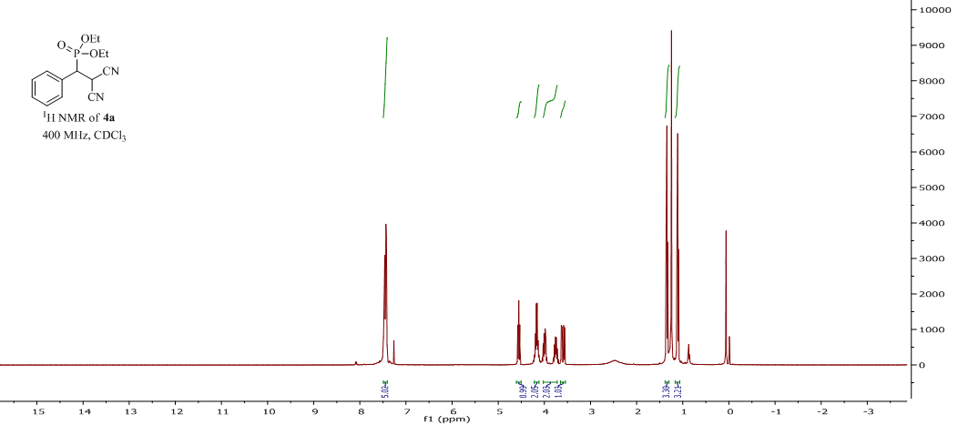

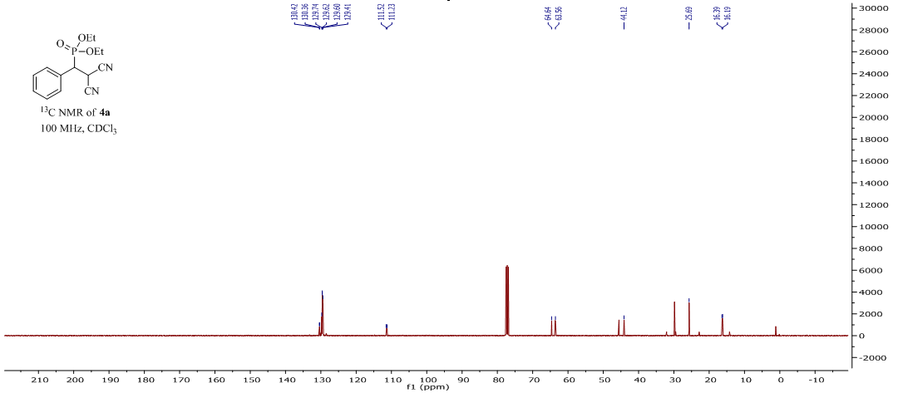

S-6

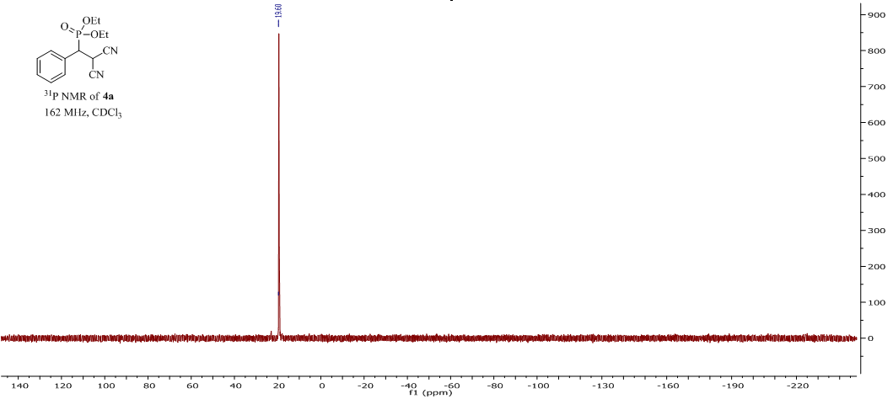

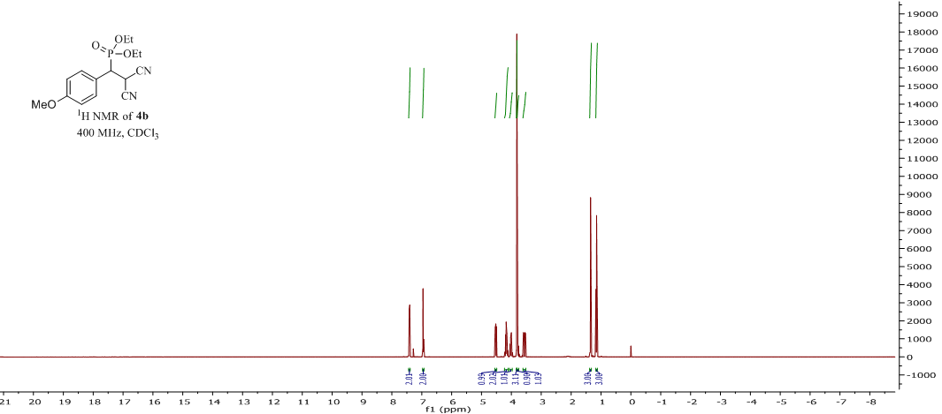

S-7

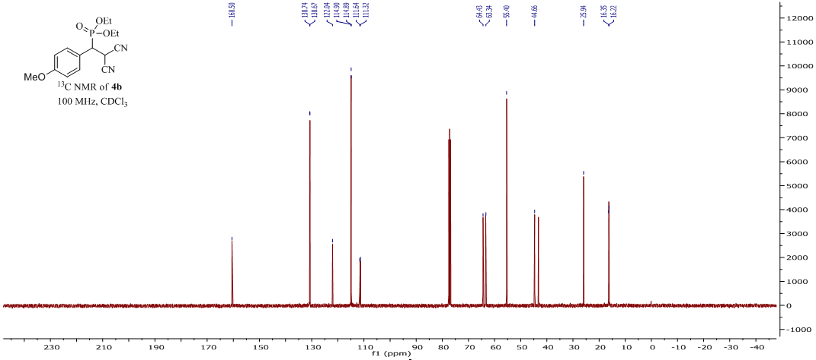

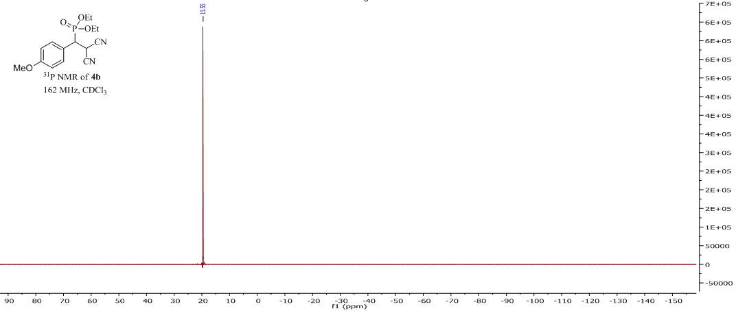

S-8

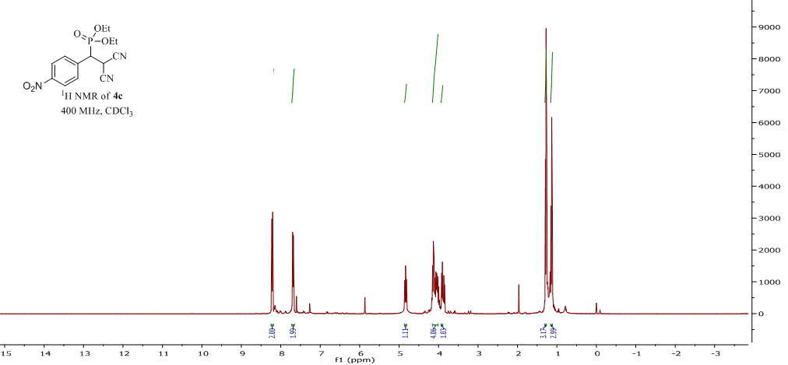

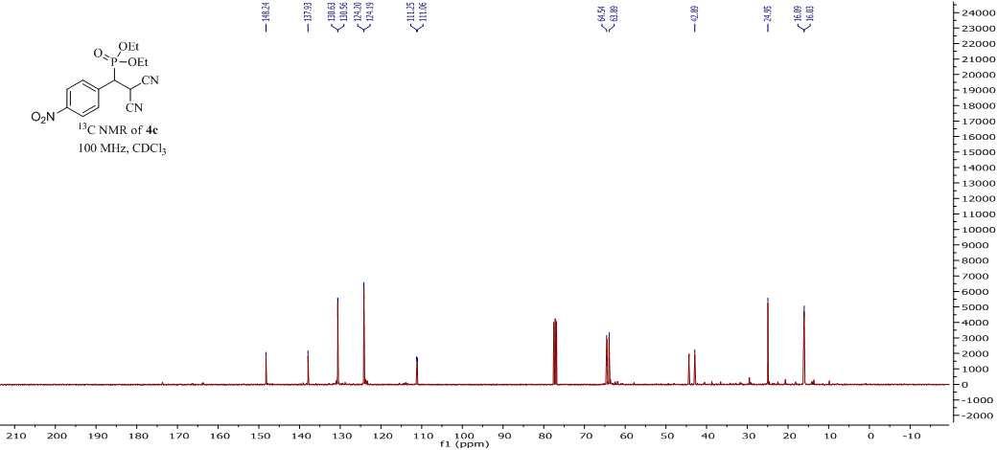

S-9

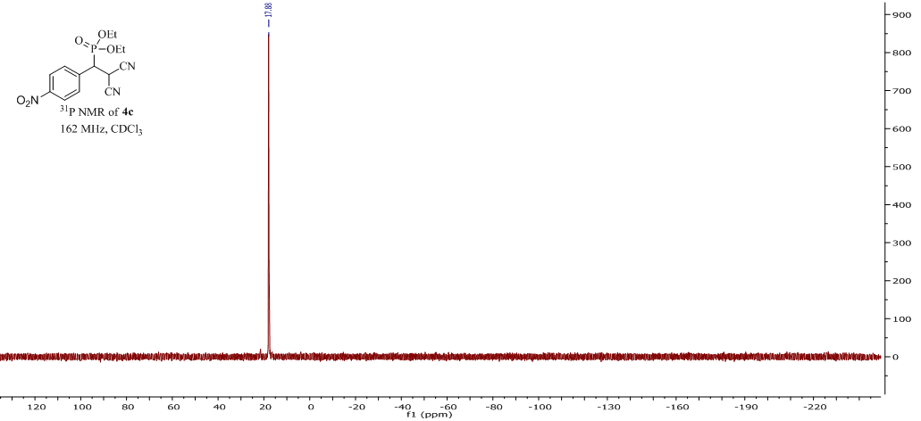

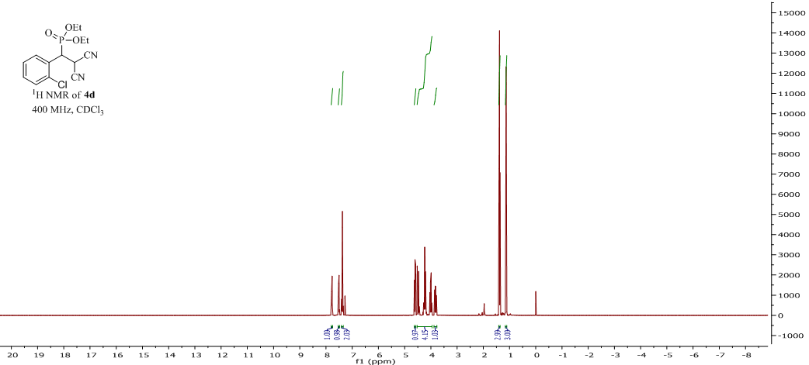

S-10

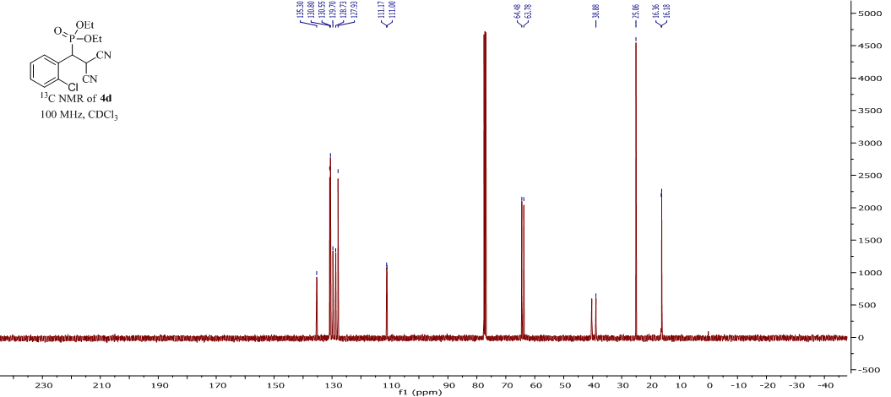

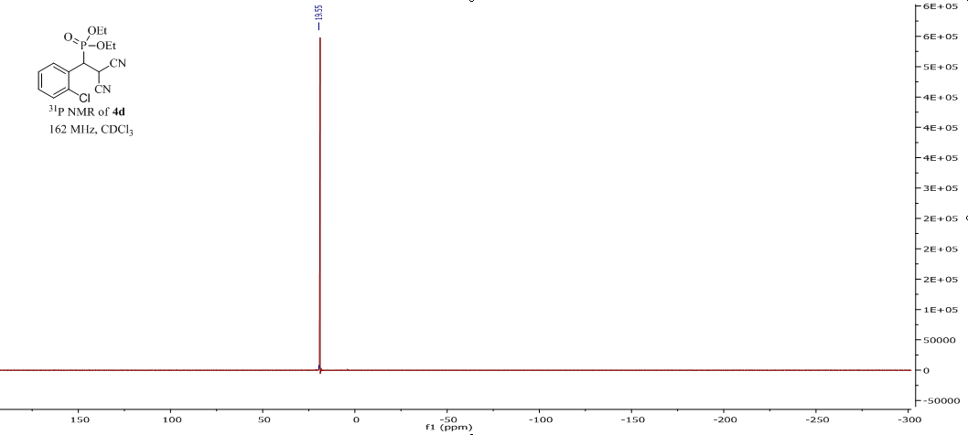

S-11

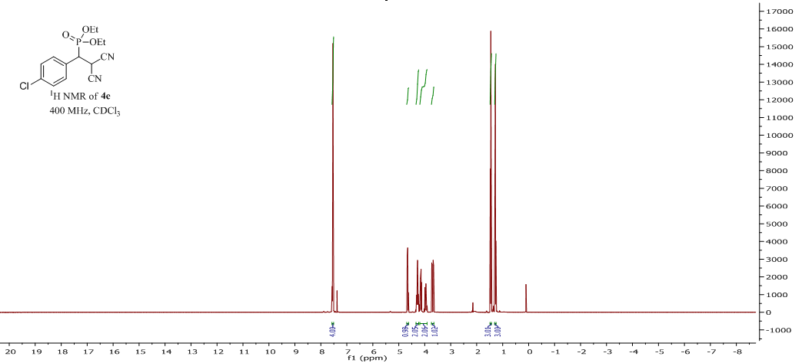

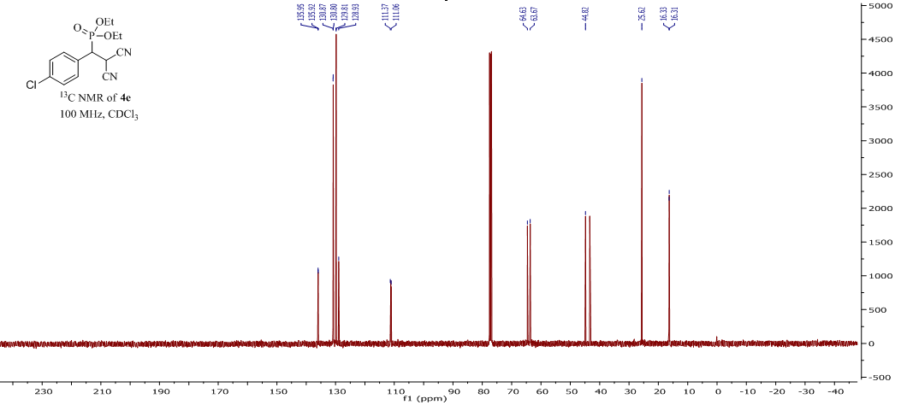

S-12

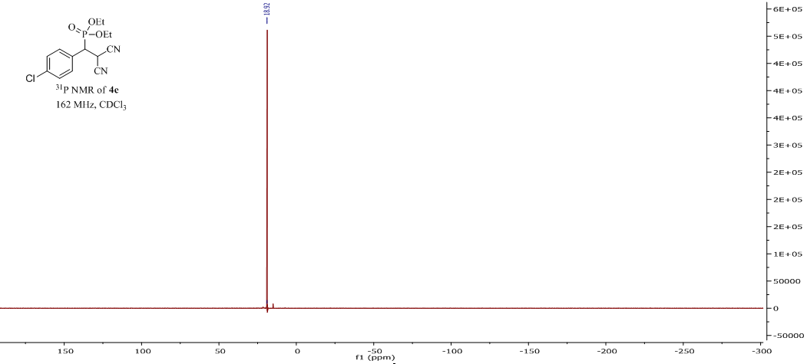

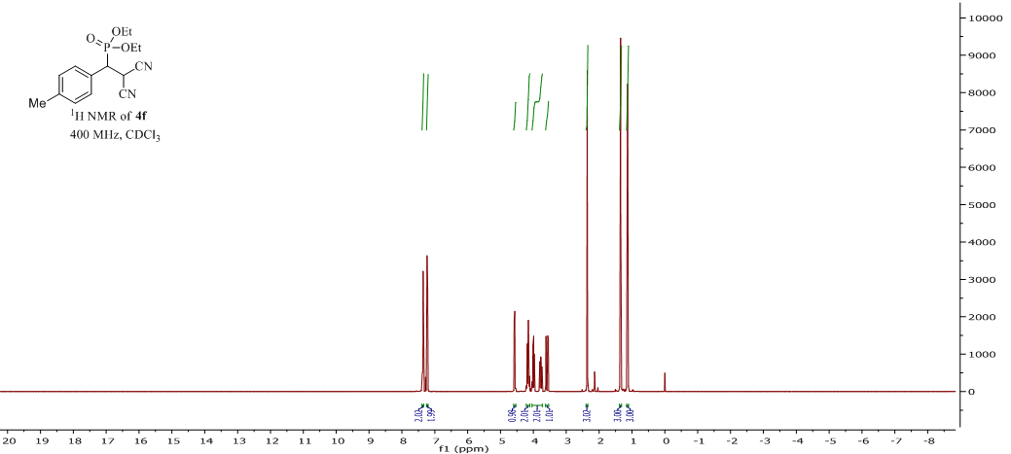

S-13

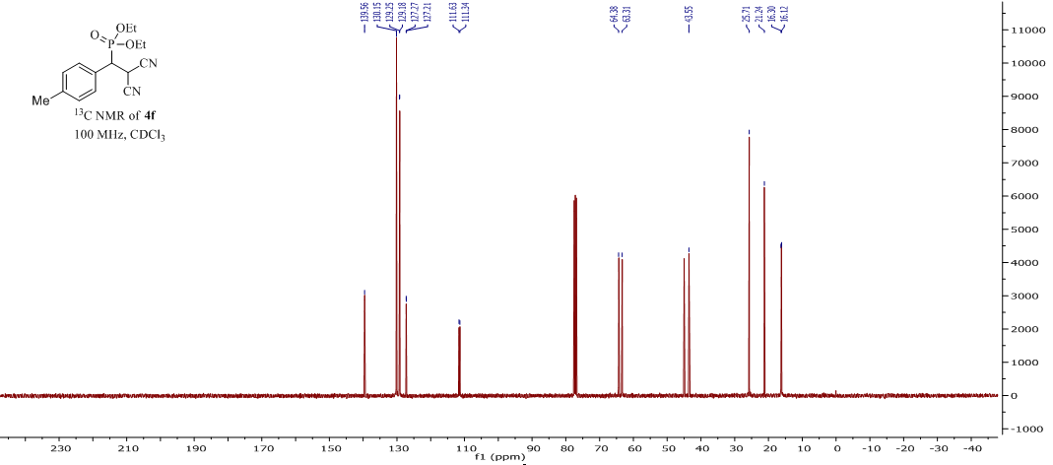

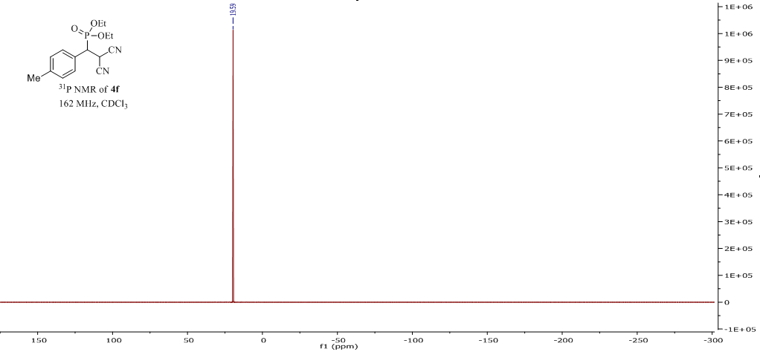

S-14

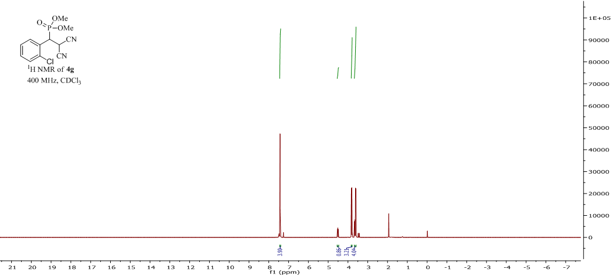

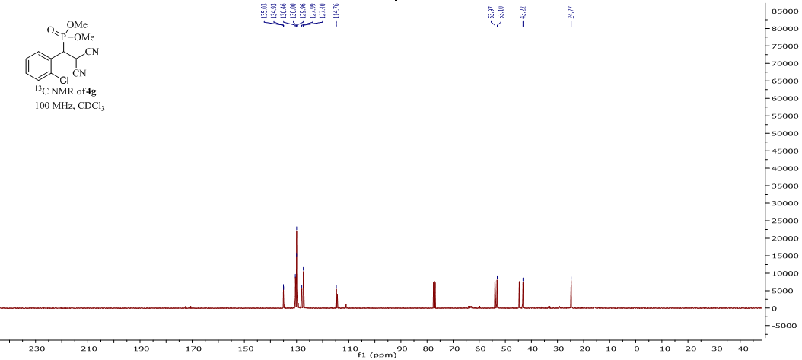

S-15

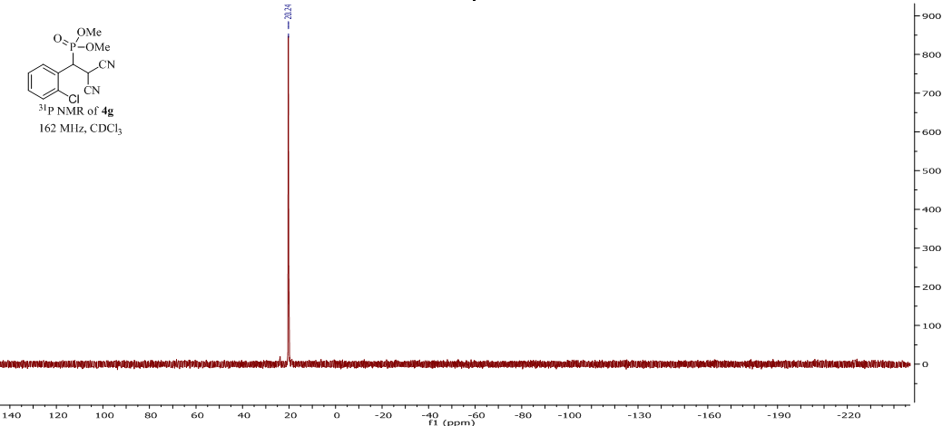

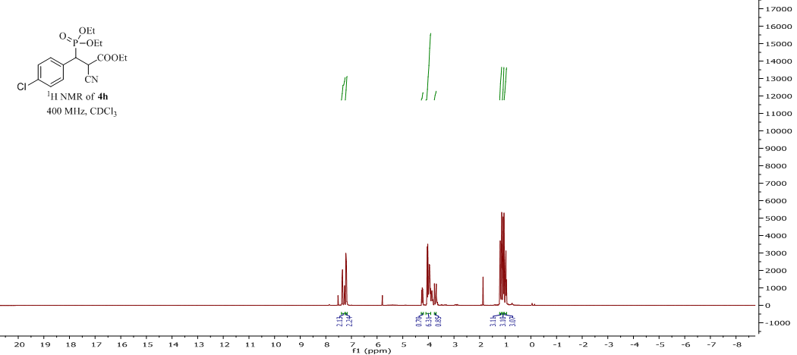

S-16

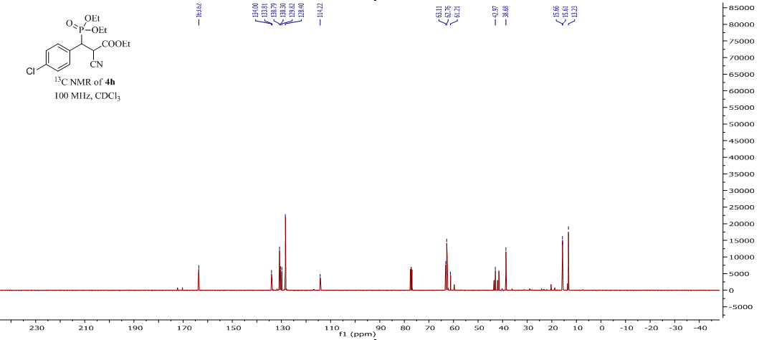

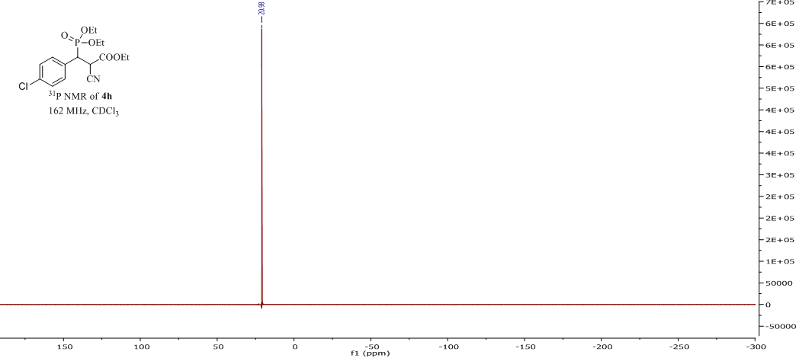

S-17

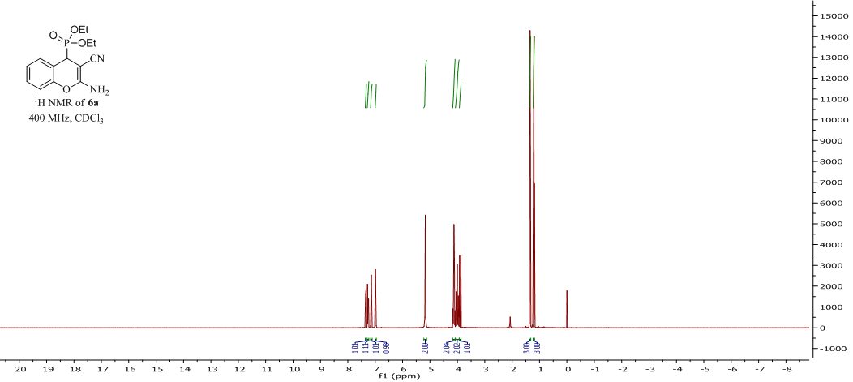

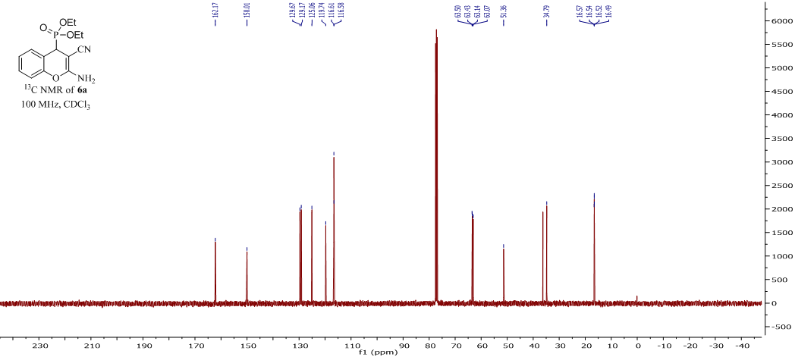

S-18

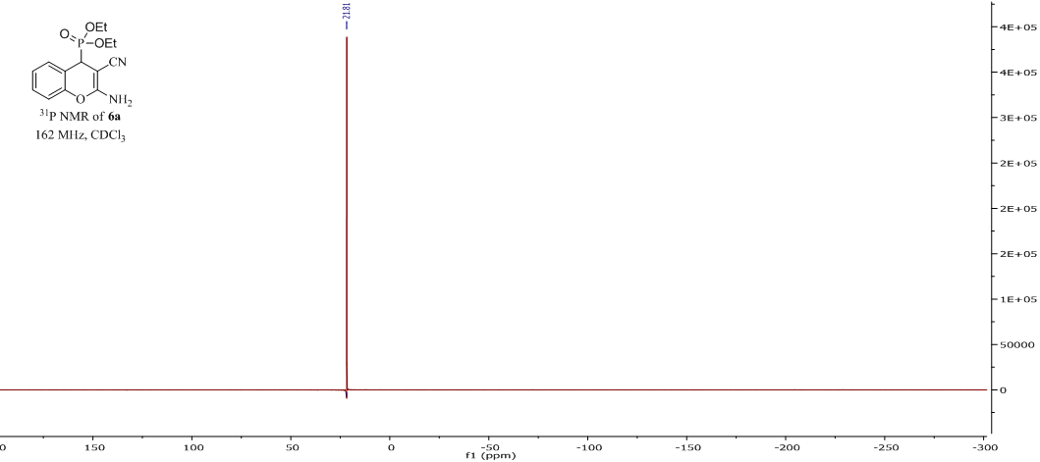

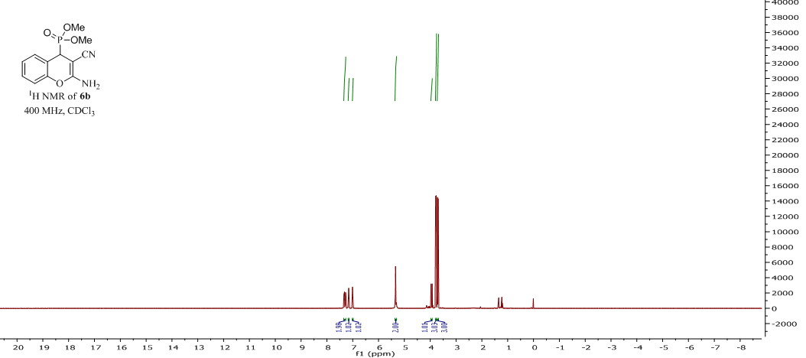

S-19

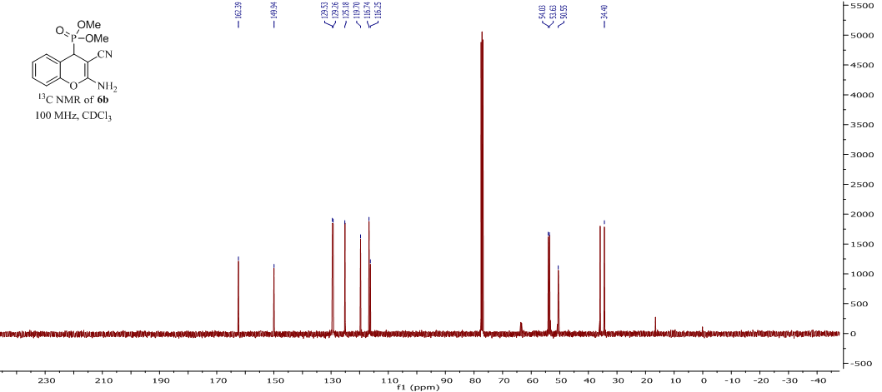

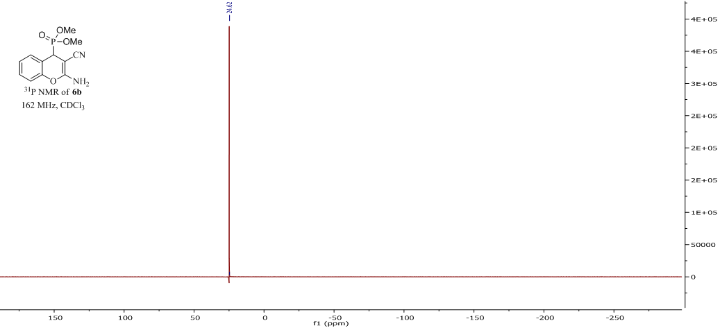

S-20

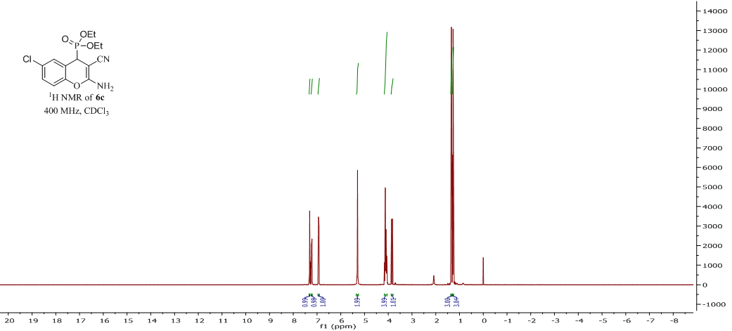

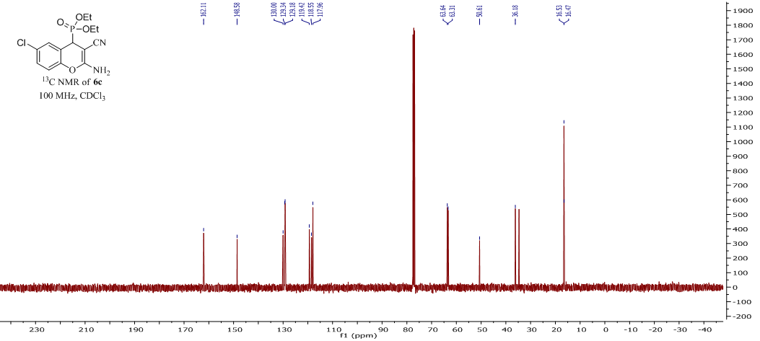

S-21

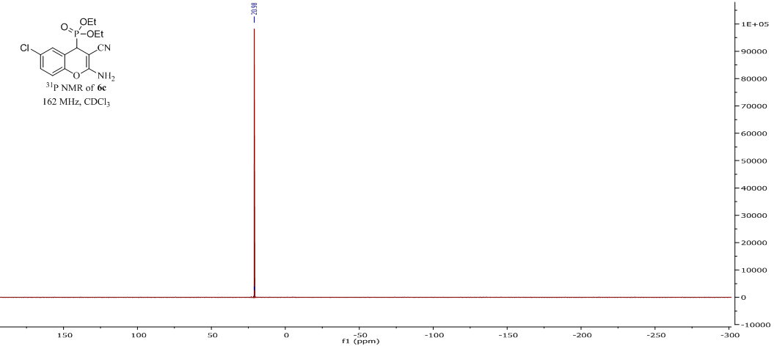

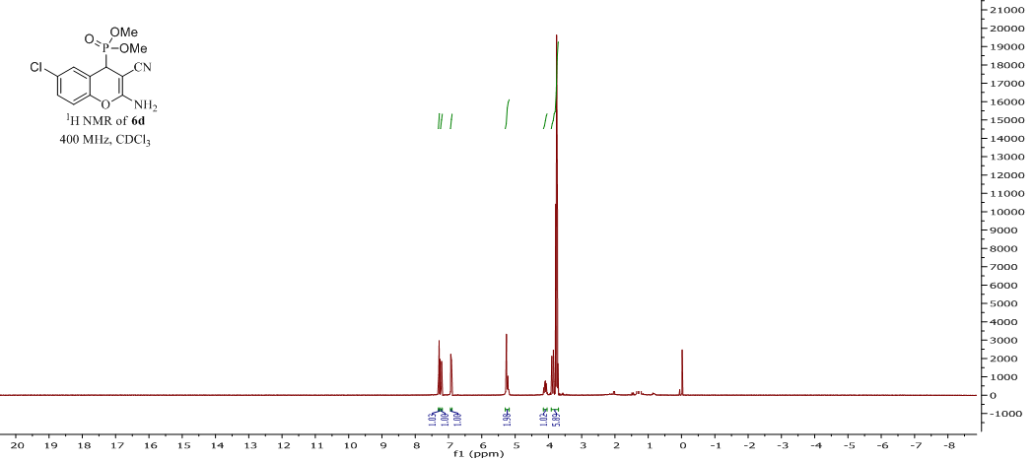

S-22

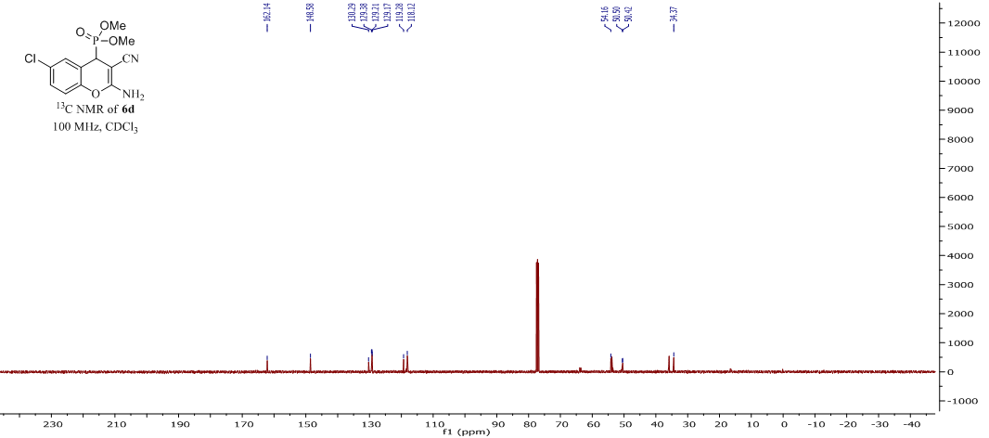

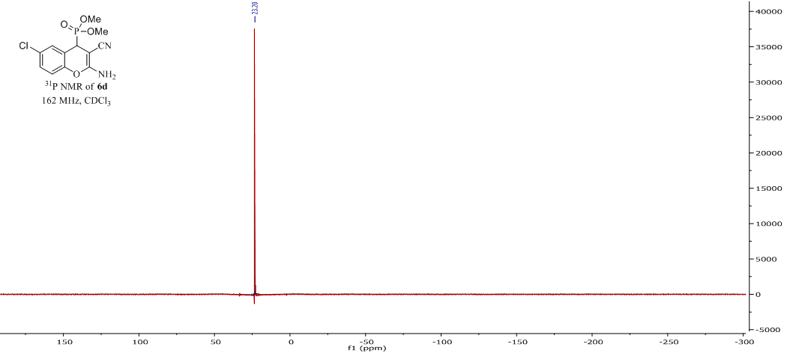

S-23

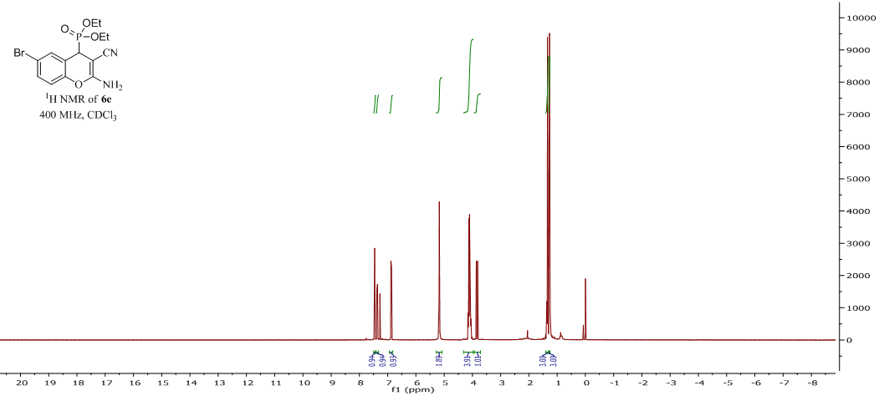

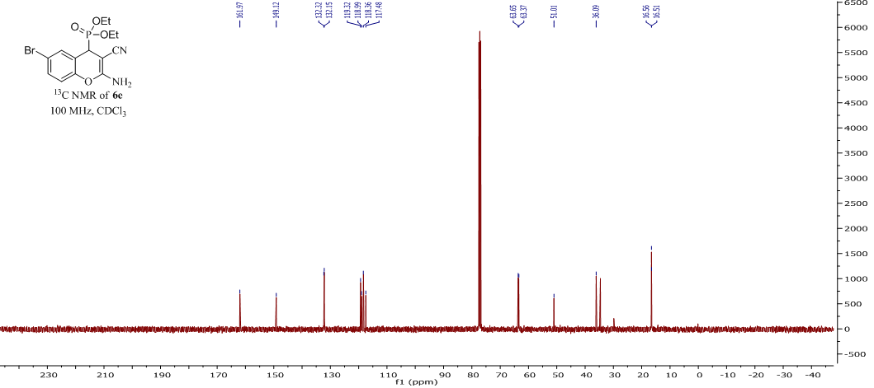

S-24

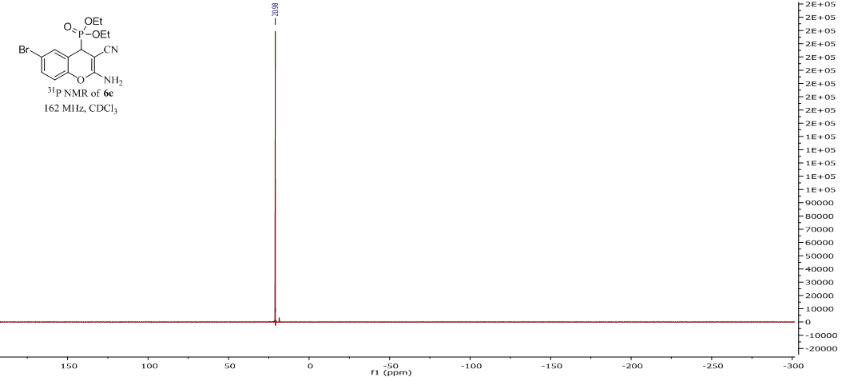

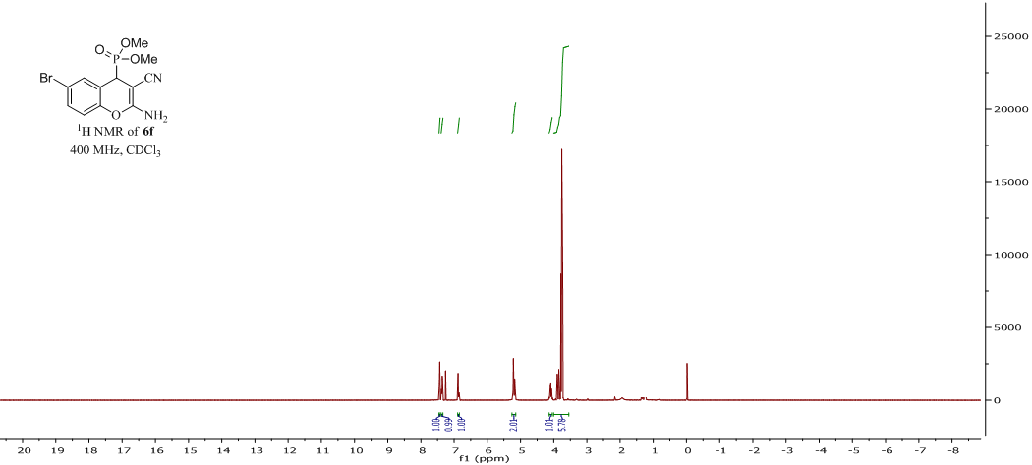

S-25

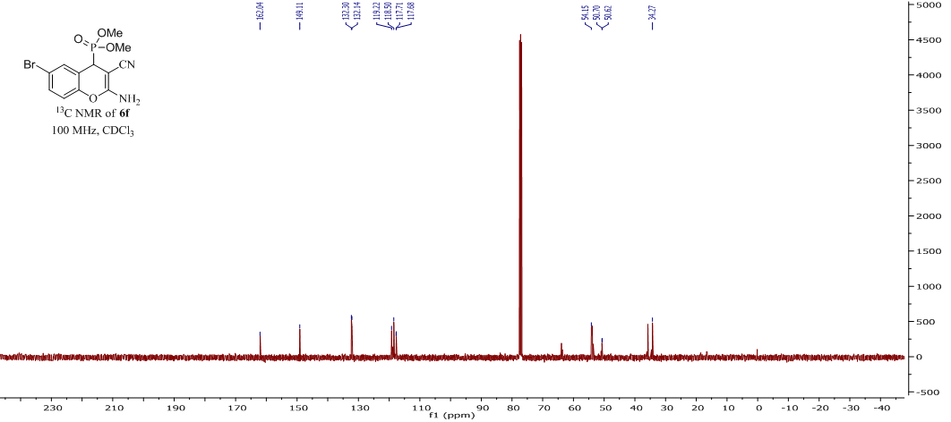

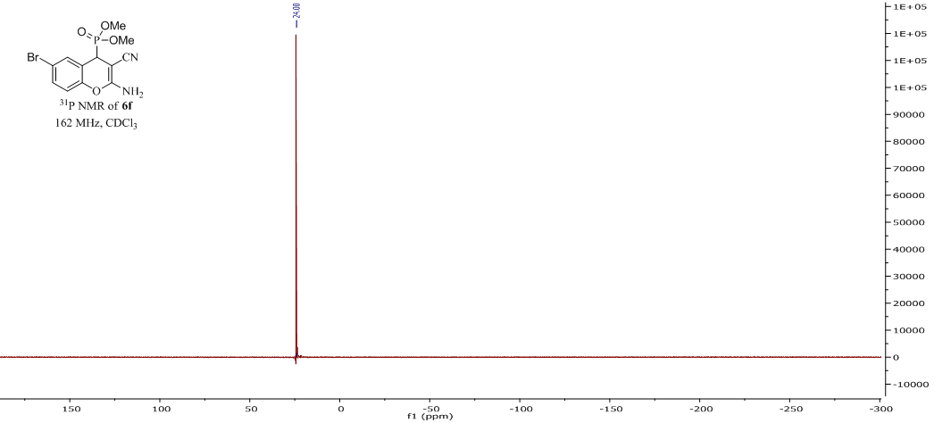

S-26

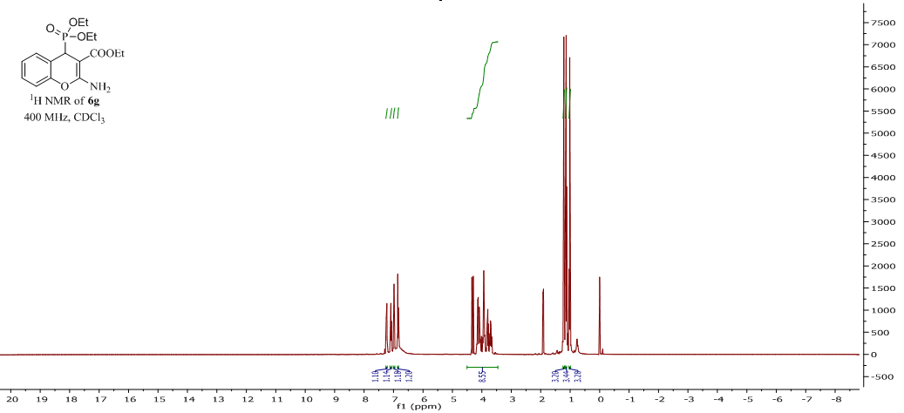

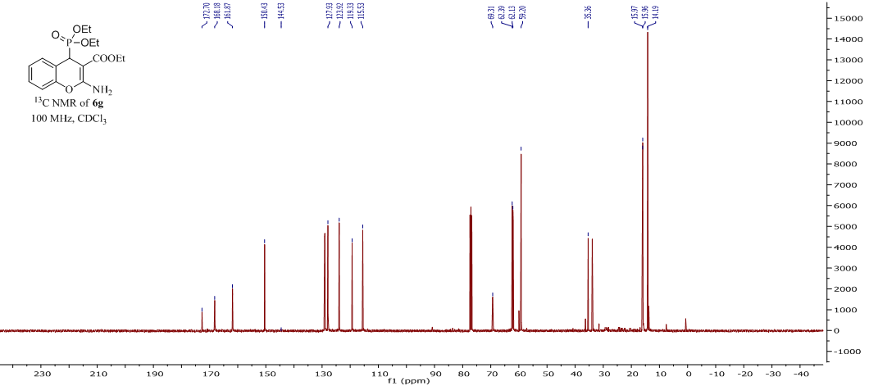

S-27

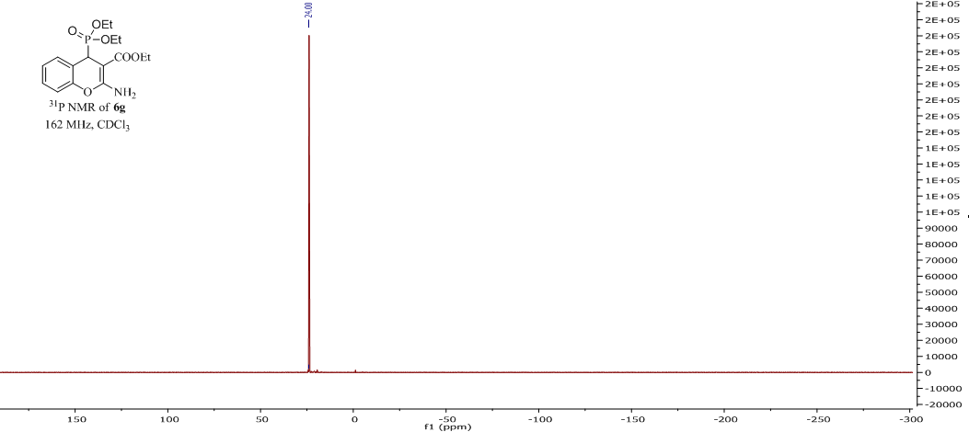

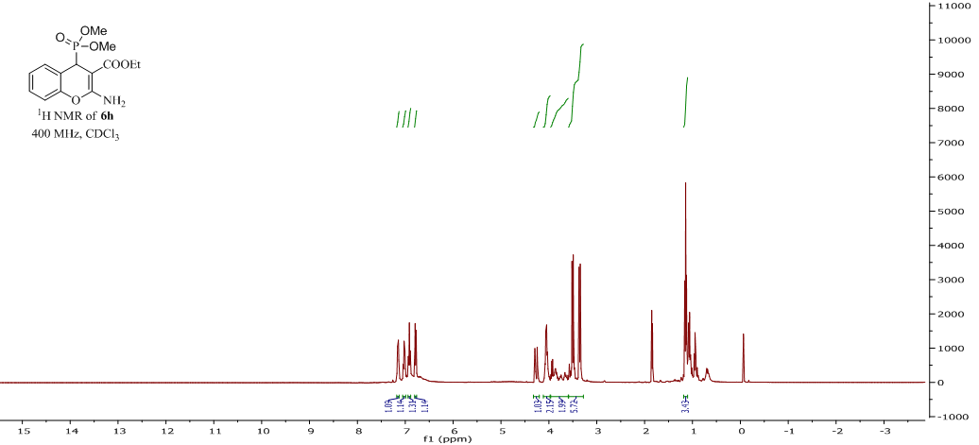

S-28

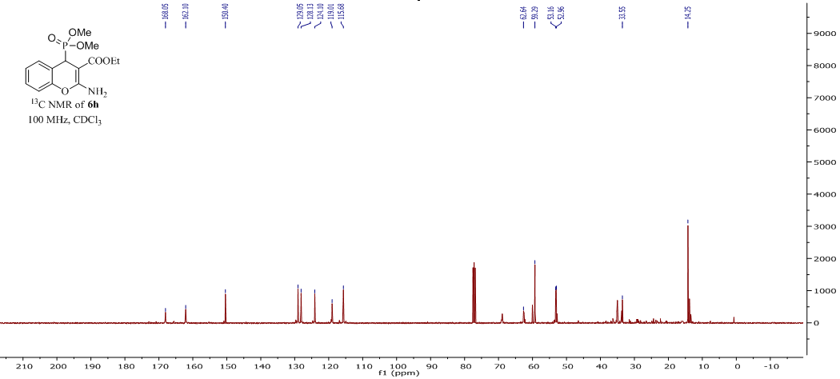

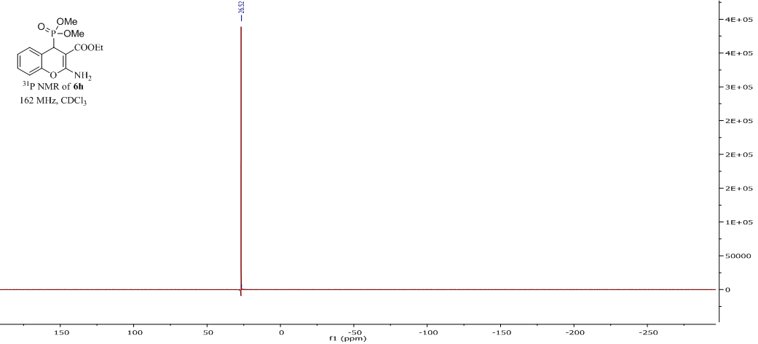

S-29