Supporting information

Three component synthesis of novel spirooxindole-furan derivatives using pyridinium salts

Robabeh Baharfar*, Sakineh Asghari, Farya Zaheri, Narges Shariati

Department of Chemistry, University of Mazandaran, P. O. Box 47415, Babolsar, Iran
*Corresponding author. Email: baharfar@umz.ac.ir

¹H NMR spectra of compound 4a
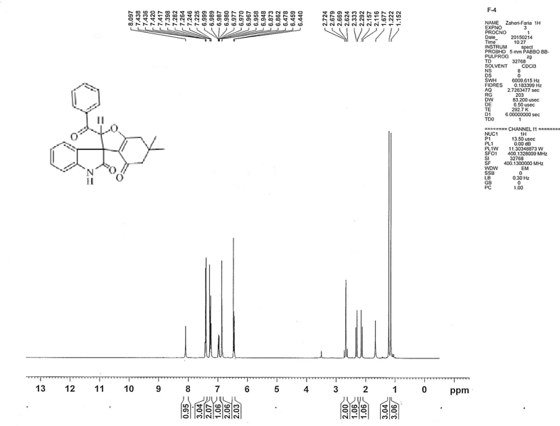

¹³C NMR spectra of compound 4a

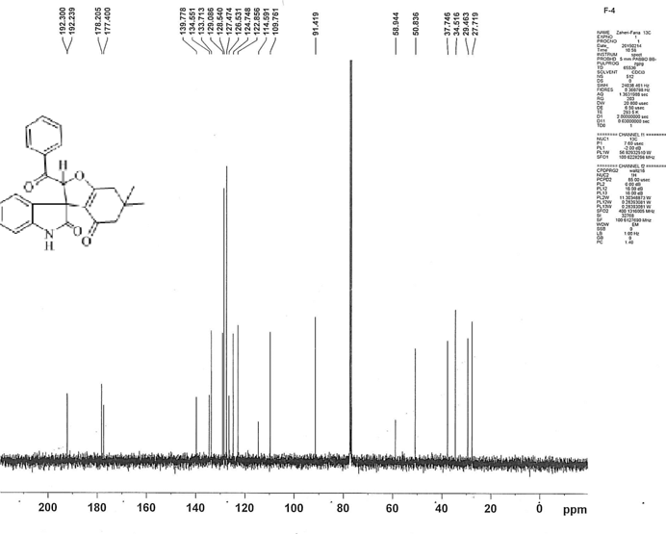

IR spectra of compound 4a
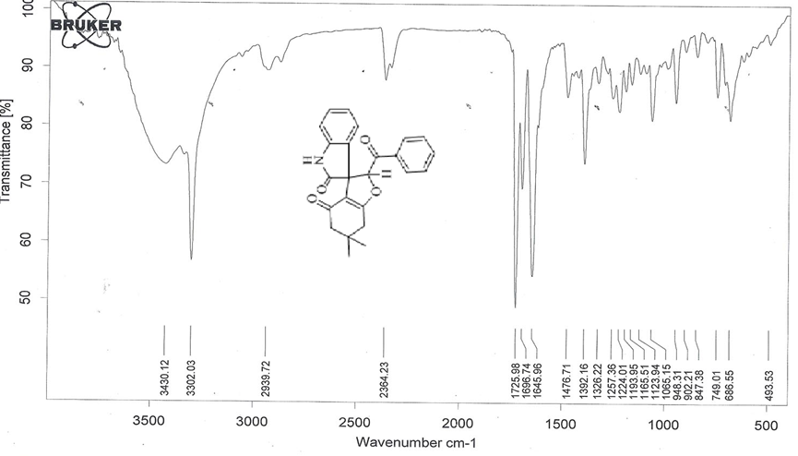

Mass spectra of compound 4a
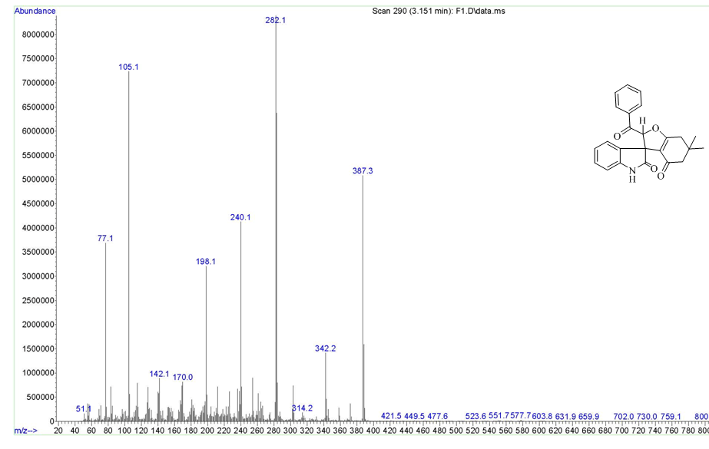

¹H NMR spectra of compound 4b
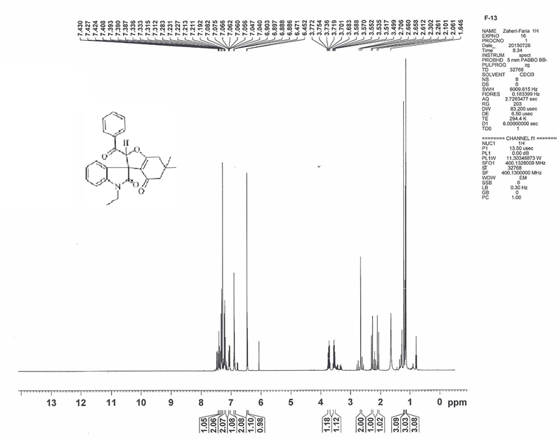

¹³C NMR spectra of compound 4b
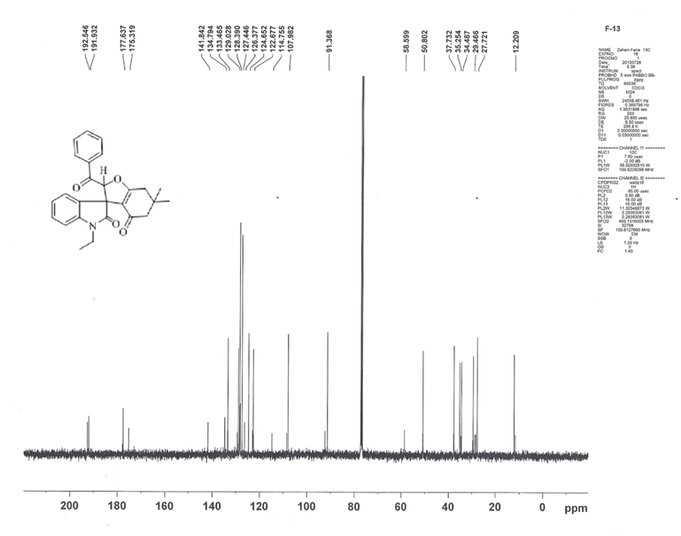

IR spectra of compound 4b
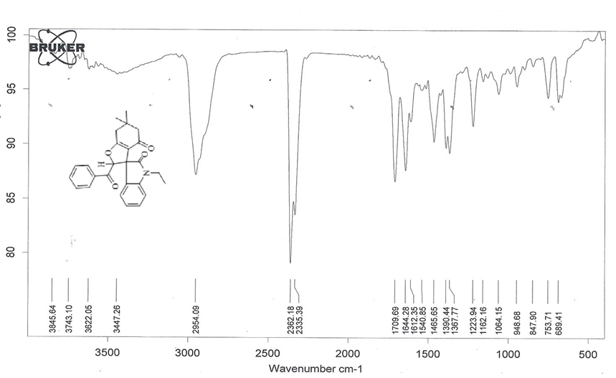

¹H NMR spectra of compound 4c
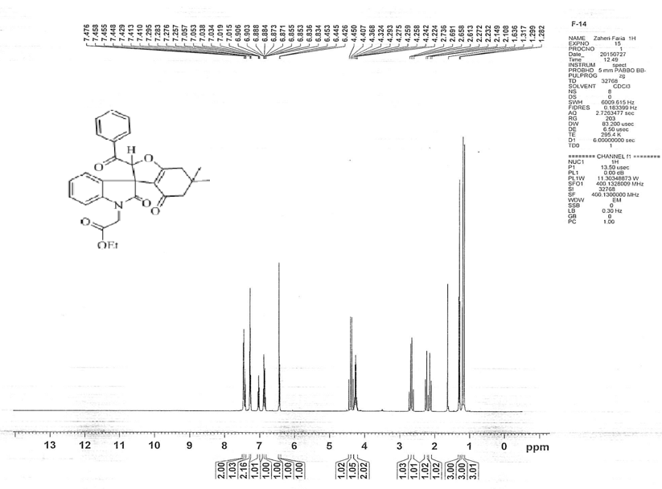

¹³C NMR spectra of compound 4c
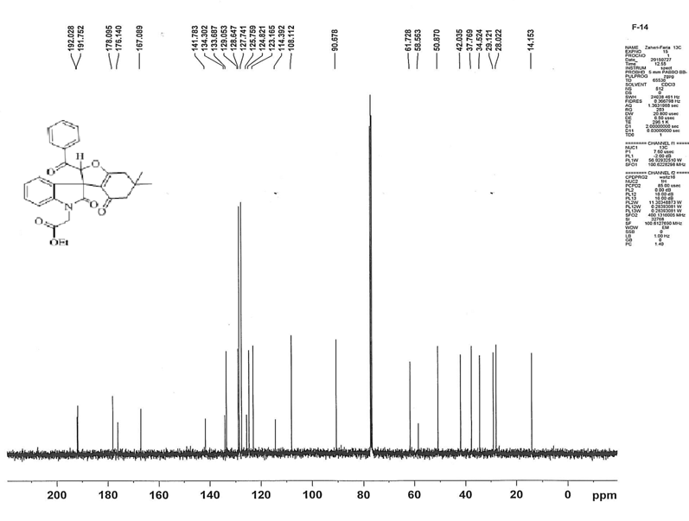

IR spectra of compound 4c
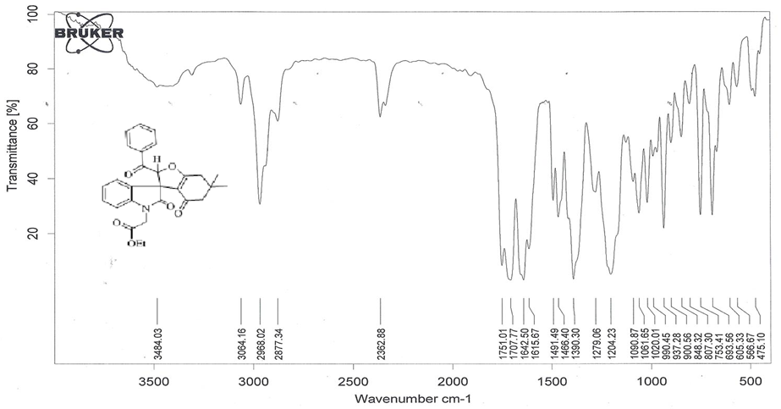
Mass spectra of compound 4c
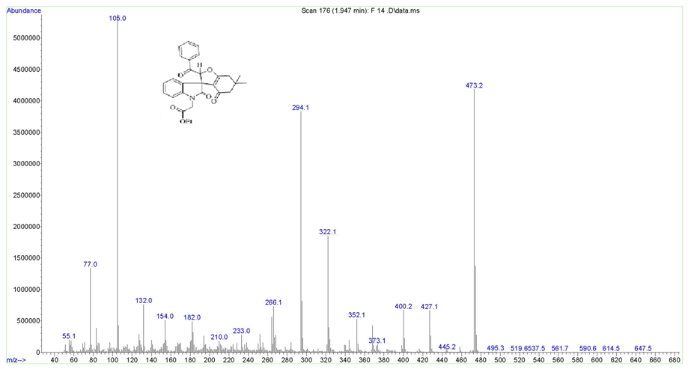

¹H NMR spectra of compound 4d
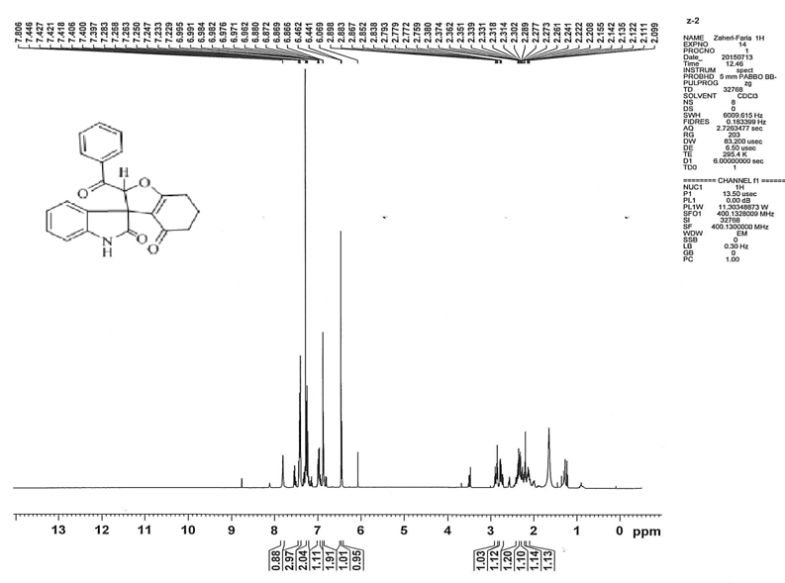

¹³C NMR spectra of compound 4d
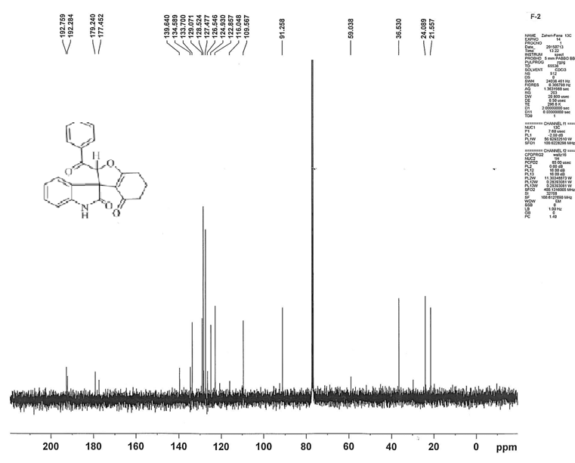

IR spectra of compound 4d
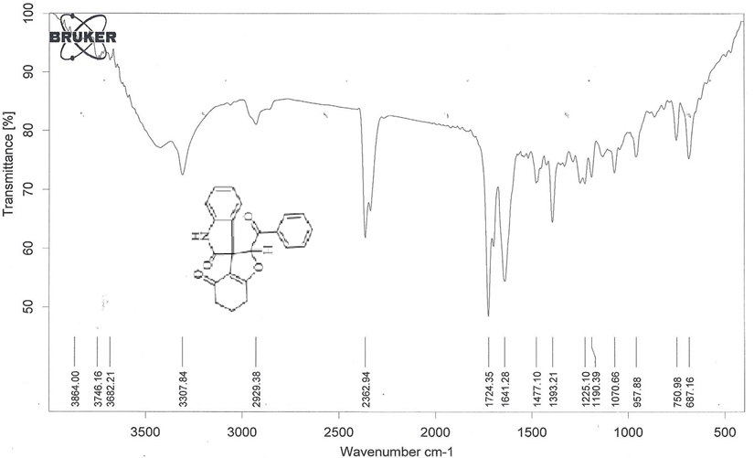
Mass spectra of compound 4d
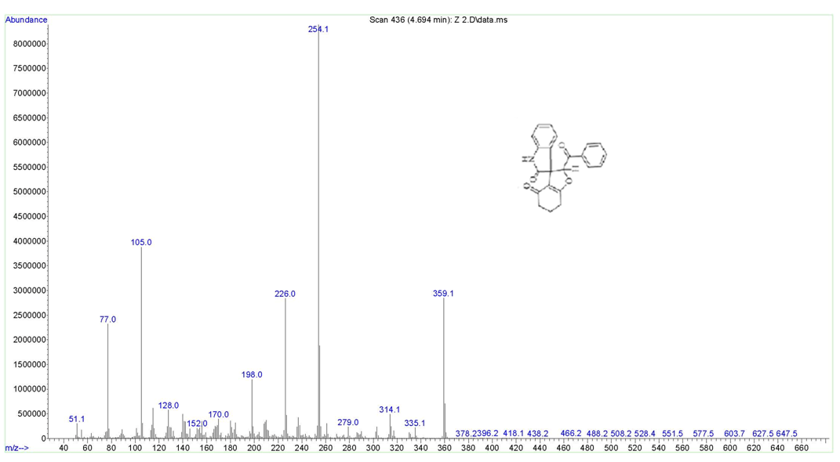

¹H NMR spectra of compound 4e
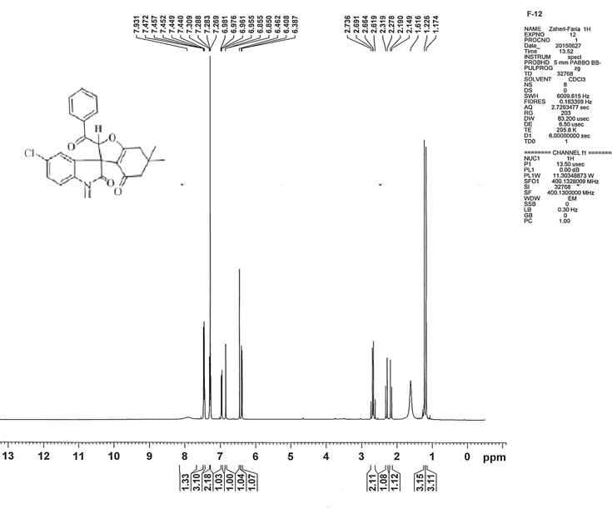

¹³C NMR spectra of compound 4e
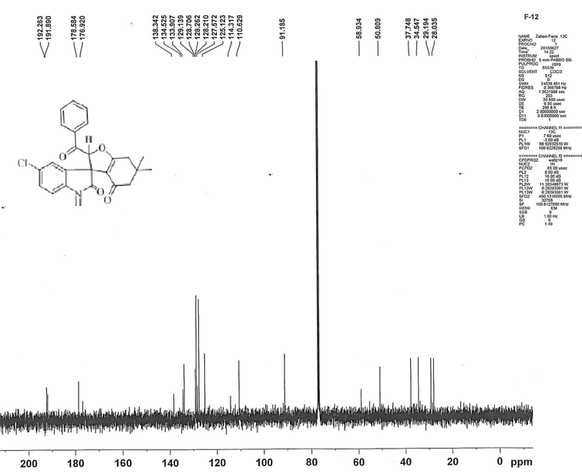

IR spectra of compound 4e
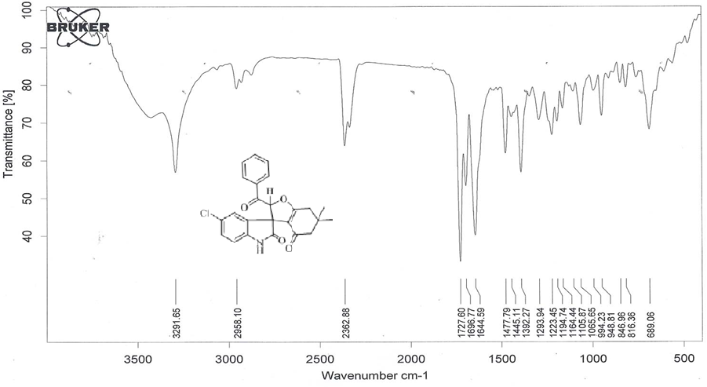
Mass spectra of compound 4e
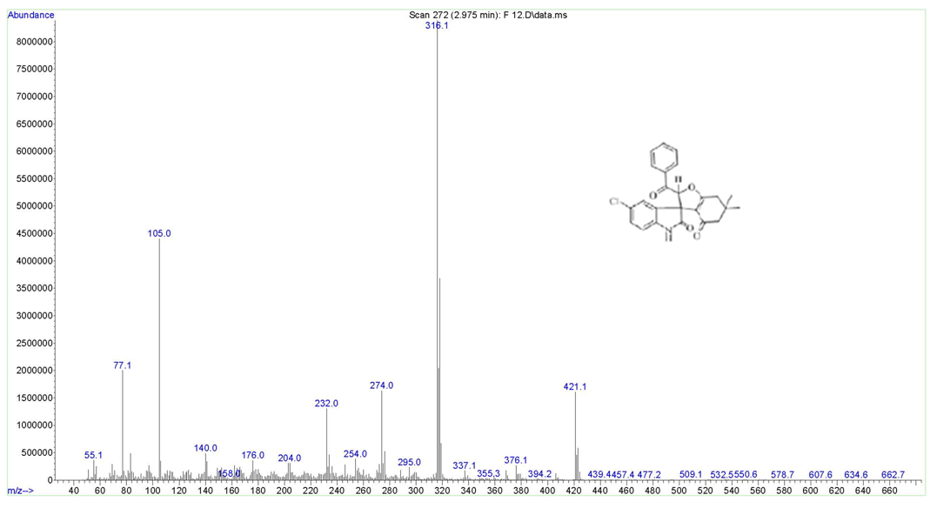

¹H NMR spectra of compound 4f
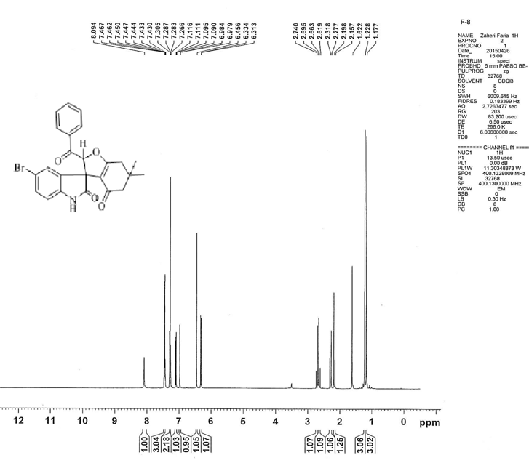

¹³C NMR spectra of compound 4f
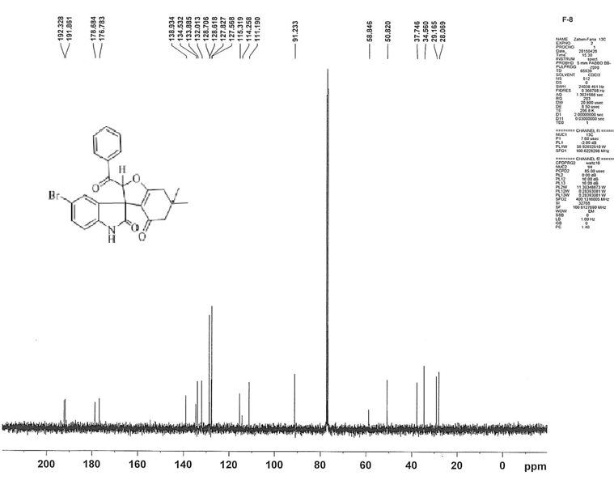

IR spectra of compound 4f
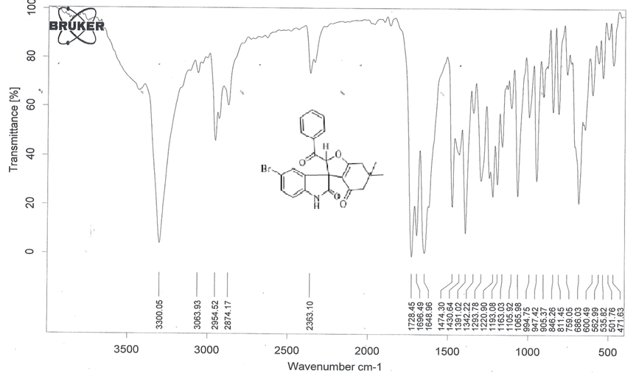
Mass spectra of compound 4f
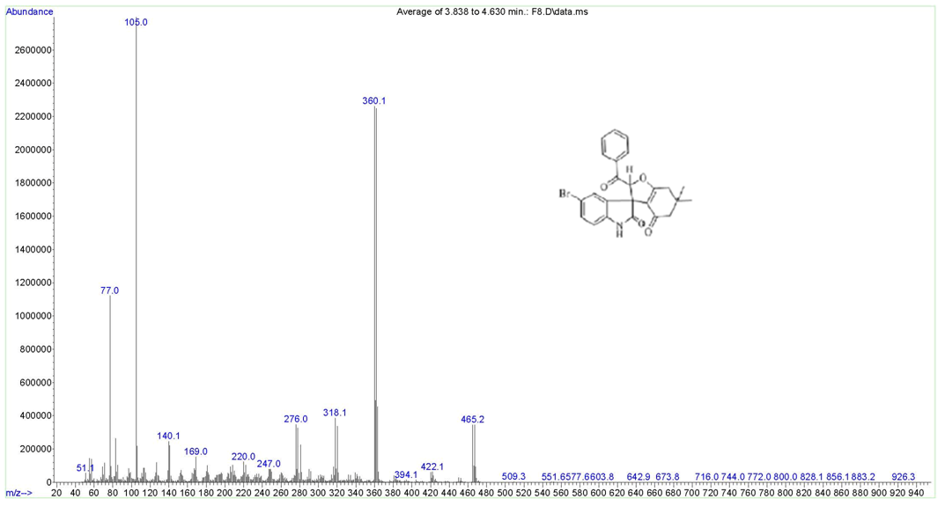

¹H NMR spectra of compound 4g
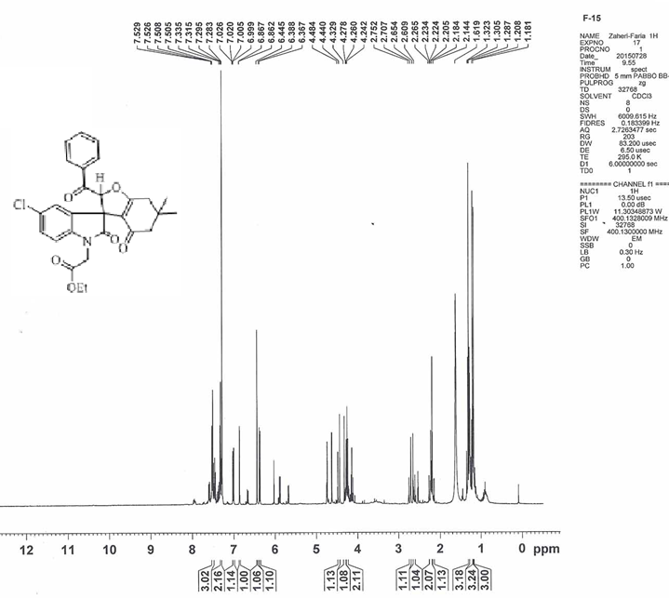

¹³C NMR spectra of compound 4g
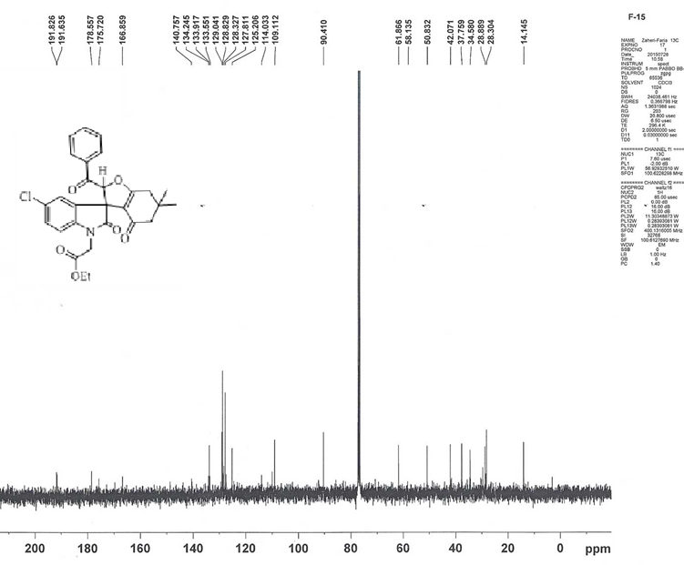

IR spectra of compound 4g
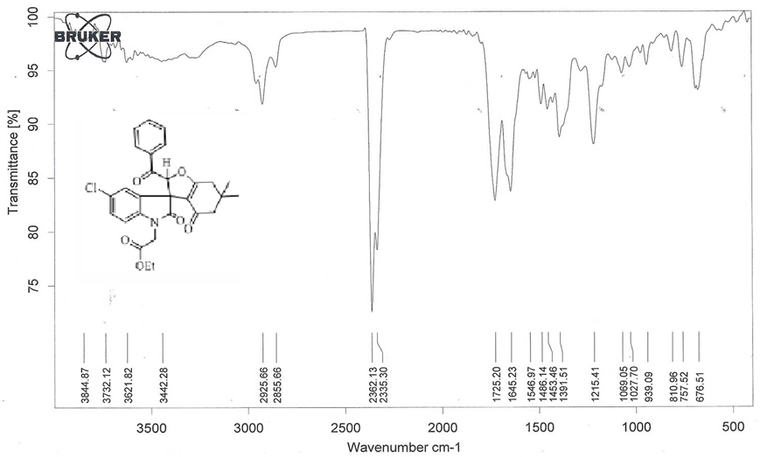

Mass spectra of compound 4g
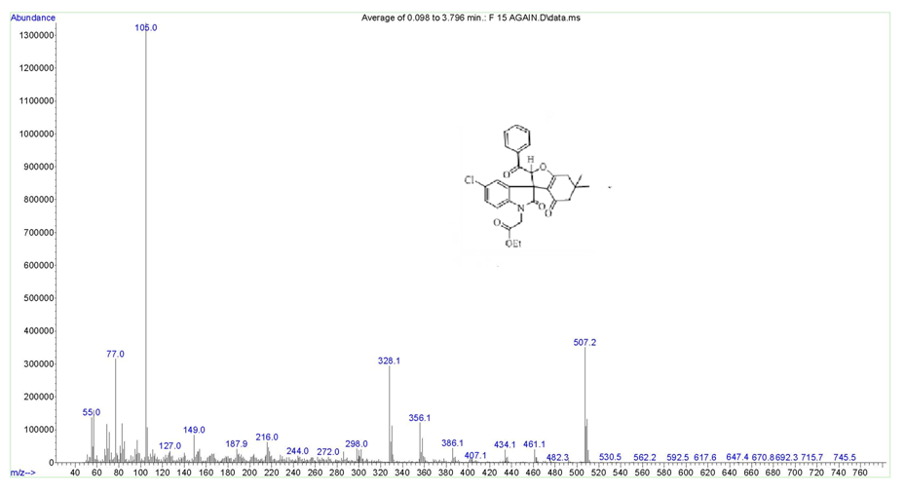

¹H NMR spectra of compound 4h
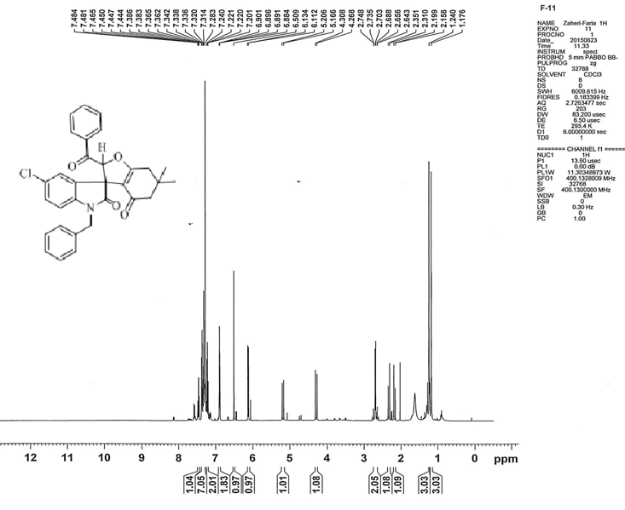

¹³C NMR spectra of compound 4h
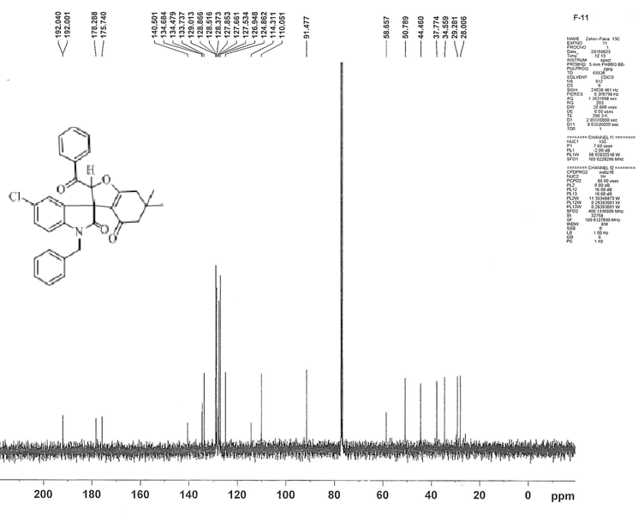

IR spectra of compound 4h
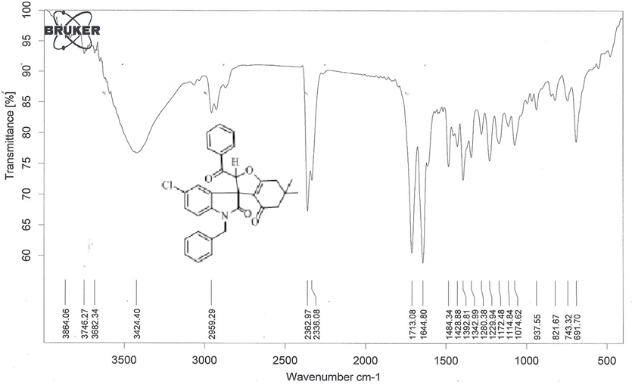
Mass spectra of compound 4h
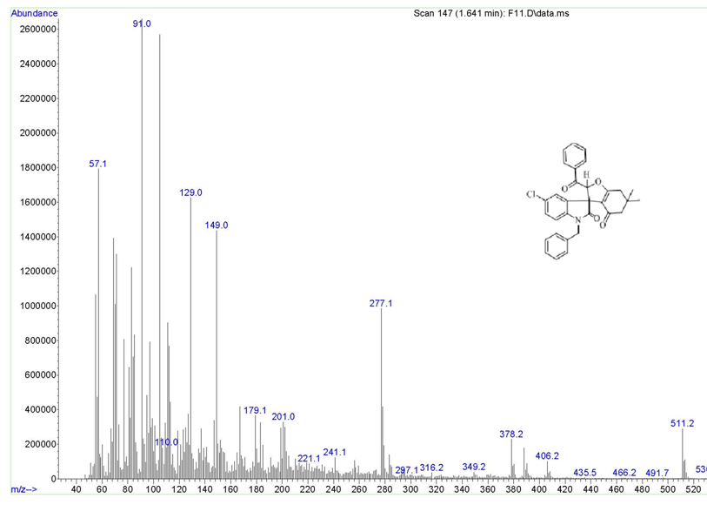

¹H NMR spectra of compound 4i
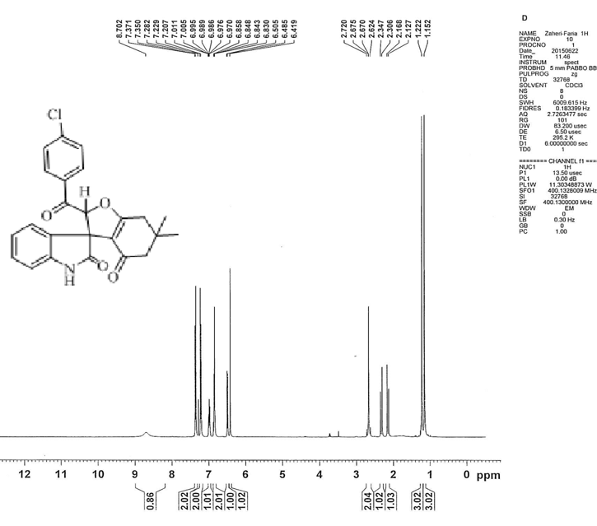

¹³C NMR spectra of compound 4i
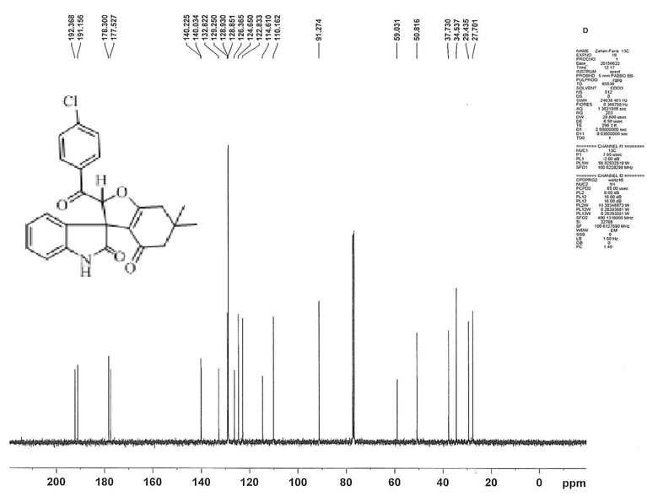

IR spectra of compound 4i
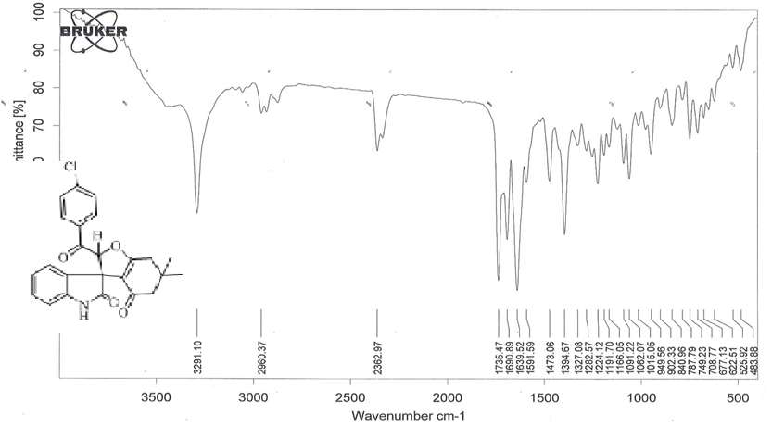

Mass spectra of compound 4i
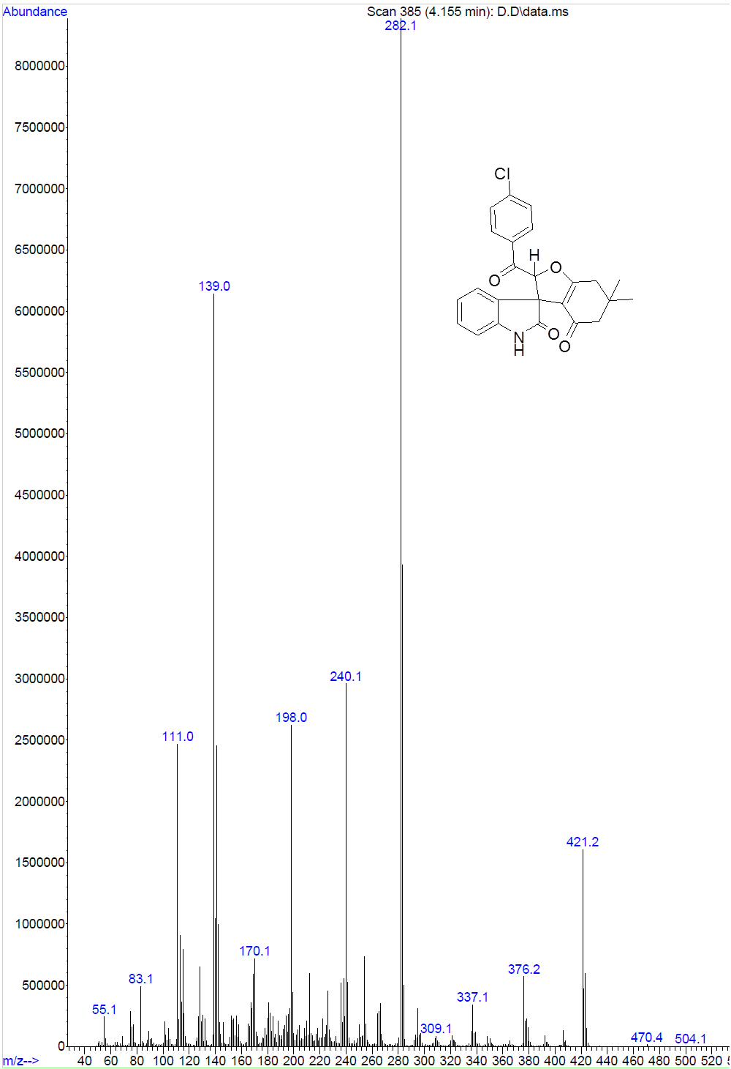
¹H NMR spectra of compound 4j
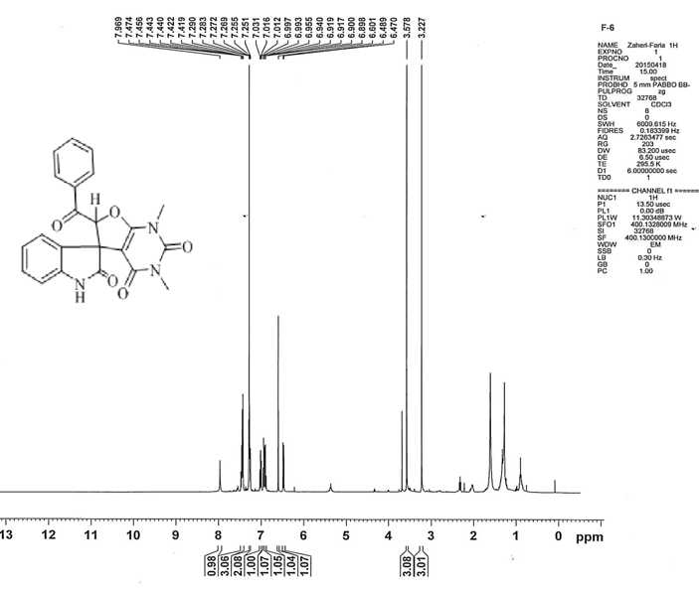

¹³C NMR spectra of compound 4j
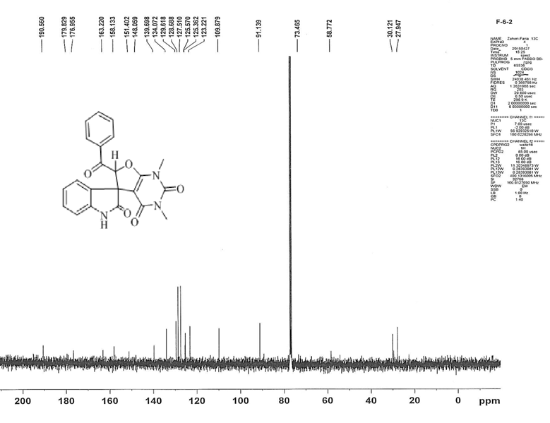

IR spectra of compound 4j
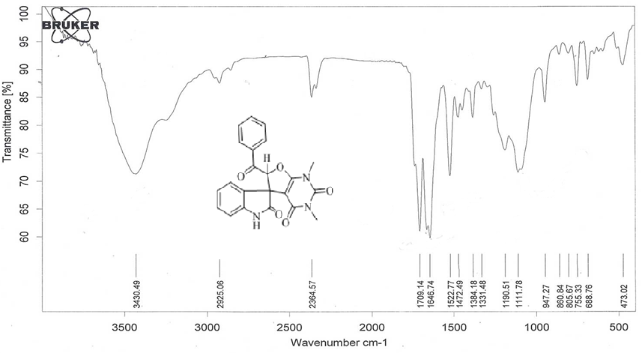
Mass spectra of compound 4j
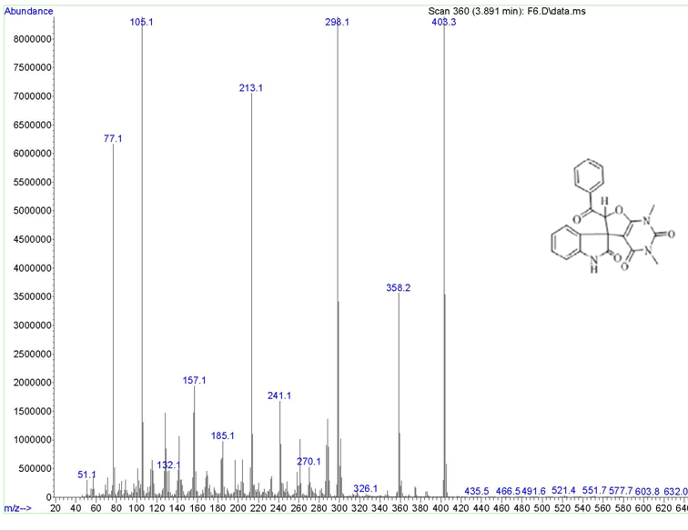

¹H NMR spectra of compound 4k
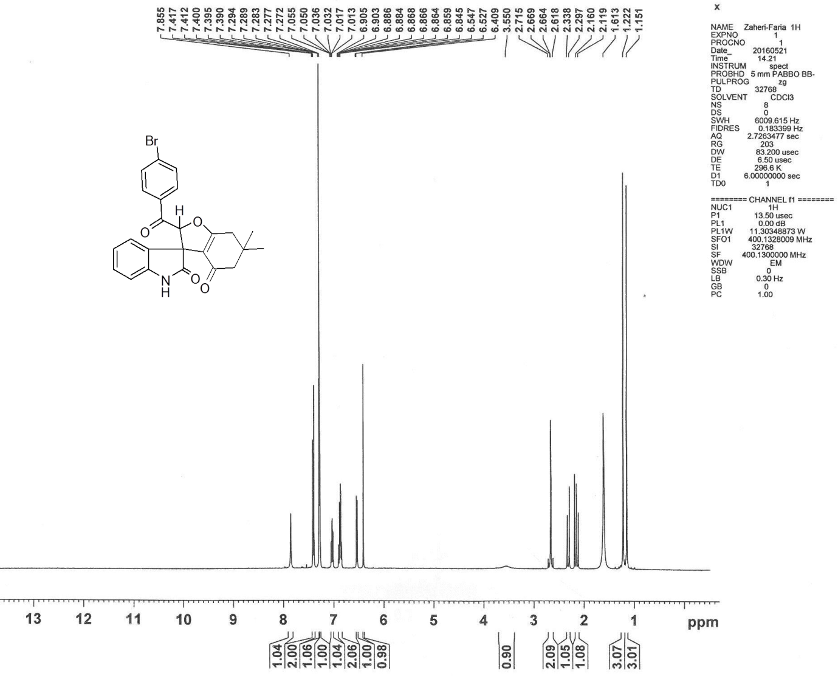

¹³C NMR spectra of compound 4k
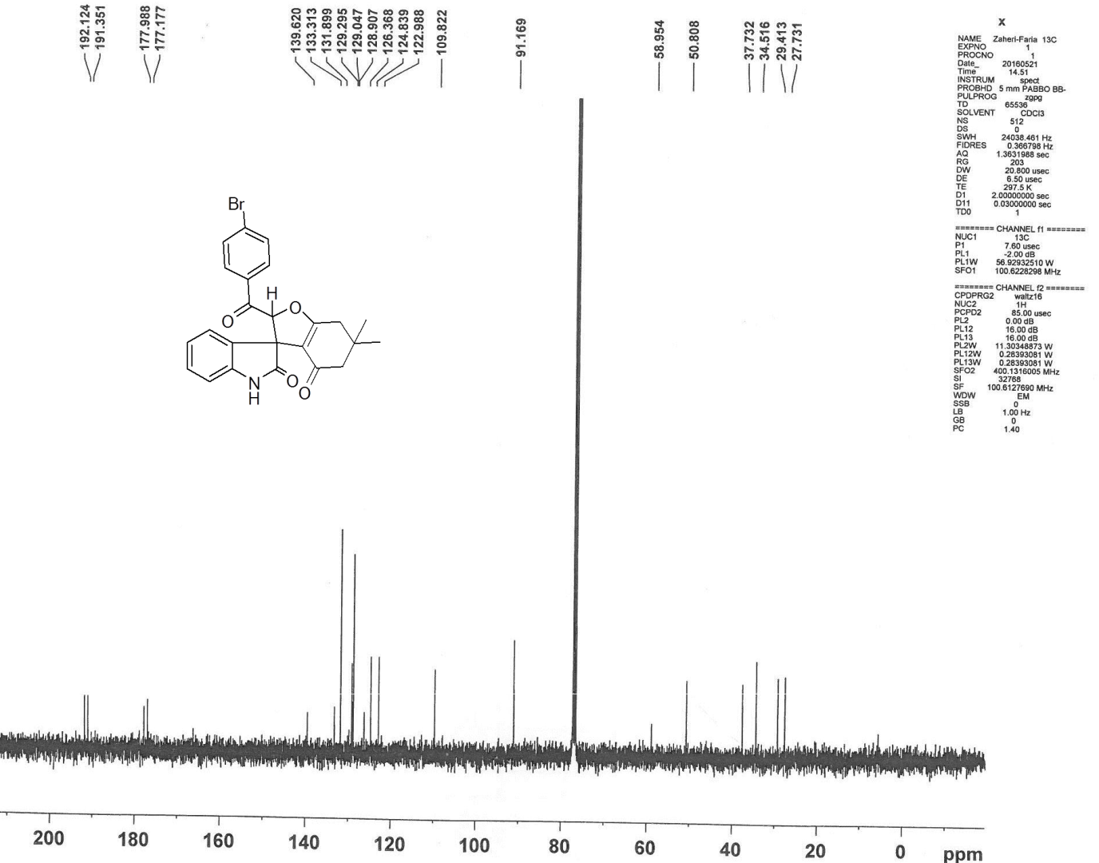

IR spectra of compound 4k
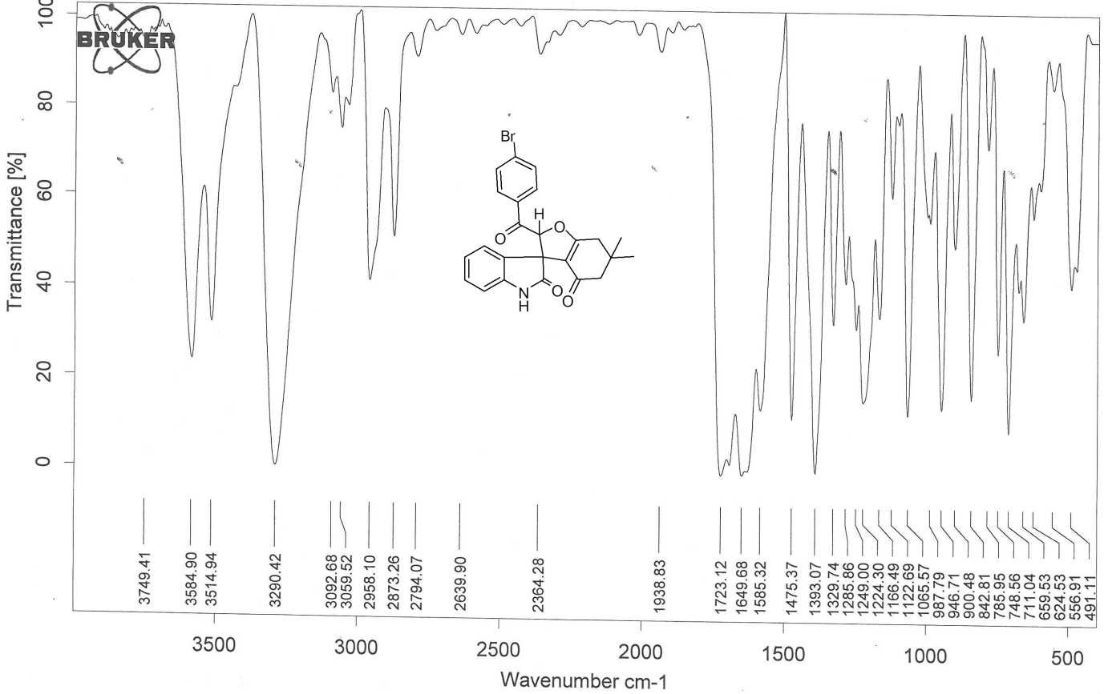
Mass spectra of compound 4k
