Acetic acid functionalized ionic liquids systems: An efficient an recyclable catalyst for the regioselective ring opening of epoxides with NaN₃
Sobhan Rezayati^{*,1}, Elaheh Salehi², Rahimeh Hajinasiri³, Saeid Afshari Sharif Abad³
¹Young Researchers and Elite Club, Ilam Branch, Islamic Azad University, Ilam, Islamic Republic of Iran
²Department of Chemistry, Iran University of Science and Technology, Tehran 16846-13114, Islamic
Republic of Iran
² Chemistry Department, Islamic Azad University, Qaemshahr Branch, P.O. Box 163, Qaemshahr, Iran
E-mail: sobhan.rezayati@yahoo.com
Tel: +98 (84) 3333 9303, Fax: +98 (84) 3333 1371; Mobile: +98 918 3433771

1-Azido-3-phenoxy-2-propanol: IR νmax/cm⁻¹: 2103 (N₃); ¹H NMR (CDCl₃, 400 MHz): δ = 3.45-3.54 (2H, m), 3.89 (1H, m), 3.97-4.03 (2H, m), 4.18 (1H, s), 6.95-7.00 (m, 2H), 7.02-7.06 (m, 1H), 7.27-7.36 (m, 2H); ¹³C NMR (CDCl₃, 100 MHz): δ = 53.5, 69.2, 69.3, 114.3, 121.1, 129.4, 158.3.
2-Azido-2-phenyl-1-ethanol: IR νmax/cm⁻¹: 2102 (N₃); ¹H NMR (CDCl₃, 400 MHz): δ = 3.37 (1H, s), 3.74 (2H, m), 4.65-4.69 (1H, m), 7.34-7.44 (5H, m); ¹³C NMR (CDCl₃, 100 MHz): δ = 66.3, 68.0, 127.4, 128.4, 128.6, 136.4
1-Azido-3-butoxy-2-propanol: IR νmax/cm⁻¹: 2102 (N₃); ¹H NMR (CDCl₃, 400 MHz): δ = 0.87 (3H, t), 1.31-1.35 (2H, m), 1.50-1.53 (2H, m), 3.14 (1H, s), 3.30-3.32 (2H, m), 3.39-3.44 (4H, m), 3.87 (1H, m); ¹³C NMR (CDCl₃, 100 MHz): δ = 13.78, 19.16, 30.74, 53.52, 69.74, 70.59, 70.71.

IR spectrum of 1-Azido-3-butoxy-2-propanol (Table 3, Entry 11)
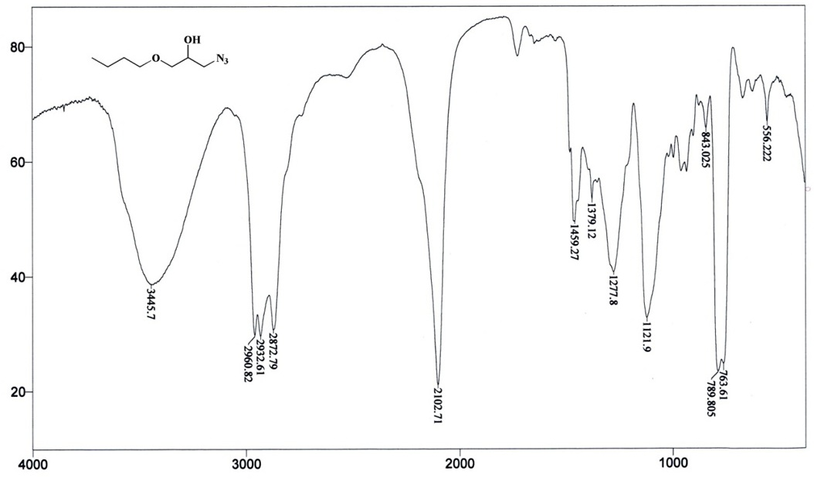

¹H-NMR spectrum of 1-Azido-3-butoxy-2-propanol (Table 3, Entry 11)

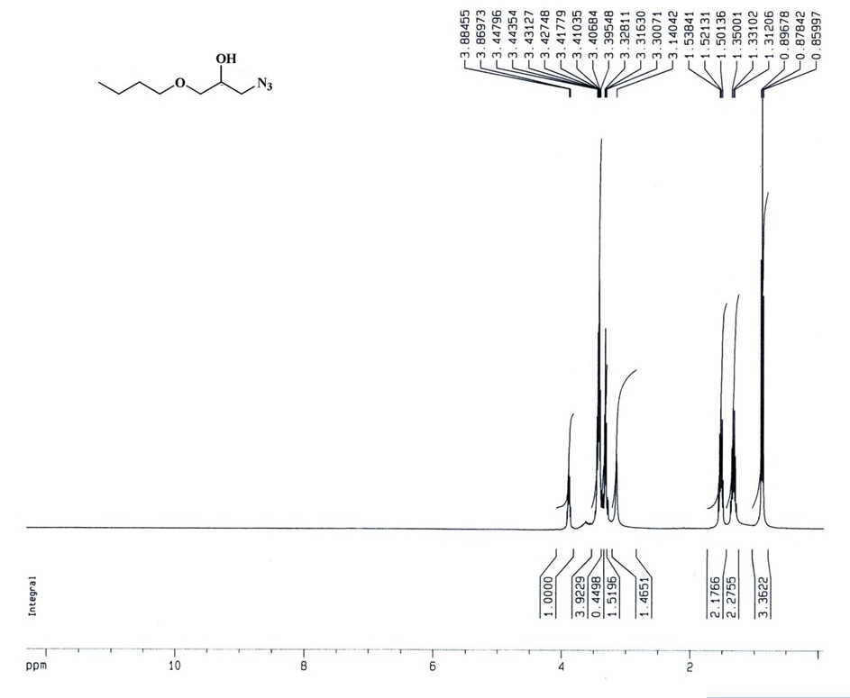

¹³C-NMR spectrum of 1-Azido-3-butoxy-2-propanol (Table 3, Entry 11
