**Supporting Information**

Efficient and green oxidation of alcohols with *tert-*butyl hydrogen peroxide catalyzed by recyclable magnetic core-shell nanoparticle-supported oxo-vanadium ephedrine complex

**Amin Rostami*, Omid Pourshiani, Neda Darvishi and Bahareh Atashkar**

**1. Preparation of Catalyst**

**1-1. Preparation of large-scale the magnetic Fe3O4 nanoparticles (MNPs)**

FeCl3·6H2O (4.865 g, 0.018 mol) and FeCl2·4H2O (1.789 g, 0.0089 mol) were added to 100 mL deionized water and sonicated until the salts dissolved completely. Then, 10 mL of 25% aqueous ammonia was added quickly into the reaction mixture in one portion under N2 atmosphere at room temperature followed by stirring about 30 min with mechanical stirrer. The black precipitate was washed with doubly distilled water (five times). The product stored in a refrigerator to use.

**1-2. Preparation of Fe3O4@SiO2 core-shell (SMNPs)**

The synthesized MNPs Fe3O4 (1gr) suspended in 2-propanol (200 mL) and sonicated for 20 min. PEG (5.36 g), water (20 mL), ammonia solution (28 wt.%,10 mL) and tetraethyl orthosilicate (1.2 mL) were respectively added into the suspension, and continuously reacted for 24h under stirring at room temperature. The iron oxide nanoparticles with a thin layer of silica (Fe3O4@SiO2) were separated by an external magnet, washed three times with ethanol and water and dried under vacuum.

**1-3. Preparation of the *N*-(3-trimethoxysilane) propyl ephedrine (TMSP-ephedrine) ligand**

Ephedrine hydrochloride (0.403 g, 0.002 mol) was dissolved in 25 mL of H2O/ethanol (1:1). Then 0.380 mL (0.002 mol) of (3-chloropropyl) trimethoxysilane (CPTMS), and sodium bicarbonate (0.168 g, 0.004 mol) were added and the mixture was refluxed for 24 h. After this time, the yellow-orange solution was obtained. The concentrated product stored in a refrigerator to use.

**1-4. Preparation of the VO(TMSP-ephedrine) complex**

To the solution of the TMSP-ephedrine ligand (0.002 mol) in 25 mL of H2O/ethanol (1:1), vanadyl acetylacetonate (0.265 g, 0.001 mol) was added and the mixture was refluxed for 24h. The dark-green solution was obtained. The concentrated product stored in a refrigerator to use.

**1-5. Preparation of the VO(ephedrine)2@MNPs**

Fe3O4@SiO2 (1 g) was added to the solution of VO(TMSP-ephedrine) complex (0.001 mol) in 25 mL of H2O/ethanol (1:1) and then the mixture was reflux for 24h. The final sample was separated by magnetic decantation and washed two times with dry CH2Cl2, EtOH and CH2Cl2 respectively to remove the unattached complex. The product stored in a refrigerator to use.

**2. Characterizations of catalyst**

**2-1. FTIR Spectrum of VO(ephedrine)2@MNPs**

The IR spectrum of VO(ephedrine)2@MNPs shows peaks that are characteristic of ephedrine-functionalized Fe3O4 magnetic nanoparticles (Fig. S1)

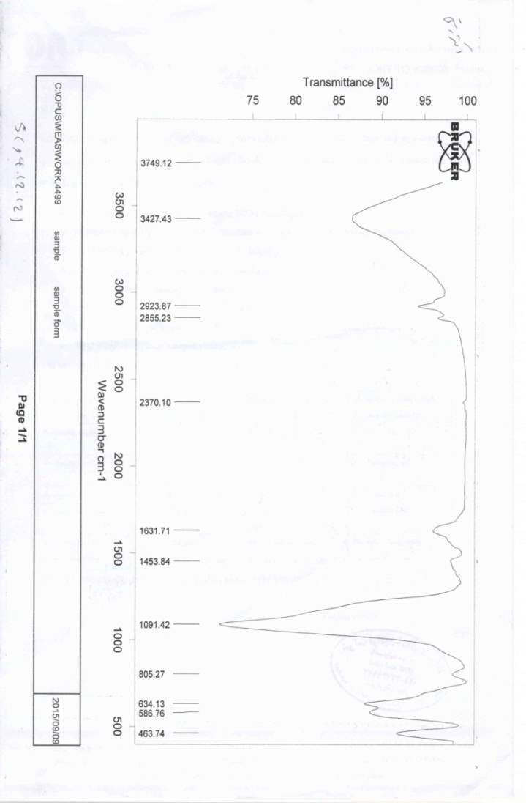

**Fig. S1.** FTIR Spectrum of VO(ephedrine)2@MNPs

**2-2. SEM image of VO(ephedrine)2@MNPs**

Fig. S2 shows the SEM image of the VO(ephedrine)2@MNPs. It was confirmed that the catalyst was made up of uniform nanometer-sized particles 10-15 nm.

C:\Users\koob\AppData\Local\Temp\Rar$DIa0.194\5.tif

**Fig. S2.** SEM image of VO(ephedrine)2@MNPs

**2-3. The TGA curve of the VO(ephedrine)2@MNPs**

One indication of bond formation between MNPs and the VO(ephedrine)2 complex can be inferred from TGA. The TGA curve of the VO(ephedrine)2@MNPs show the mass loss of the organic functional group as it decompose upon heating (Fig. S3).

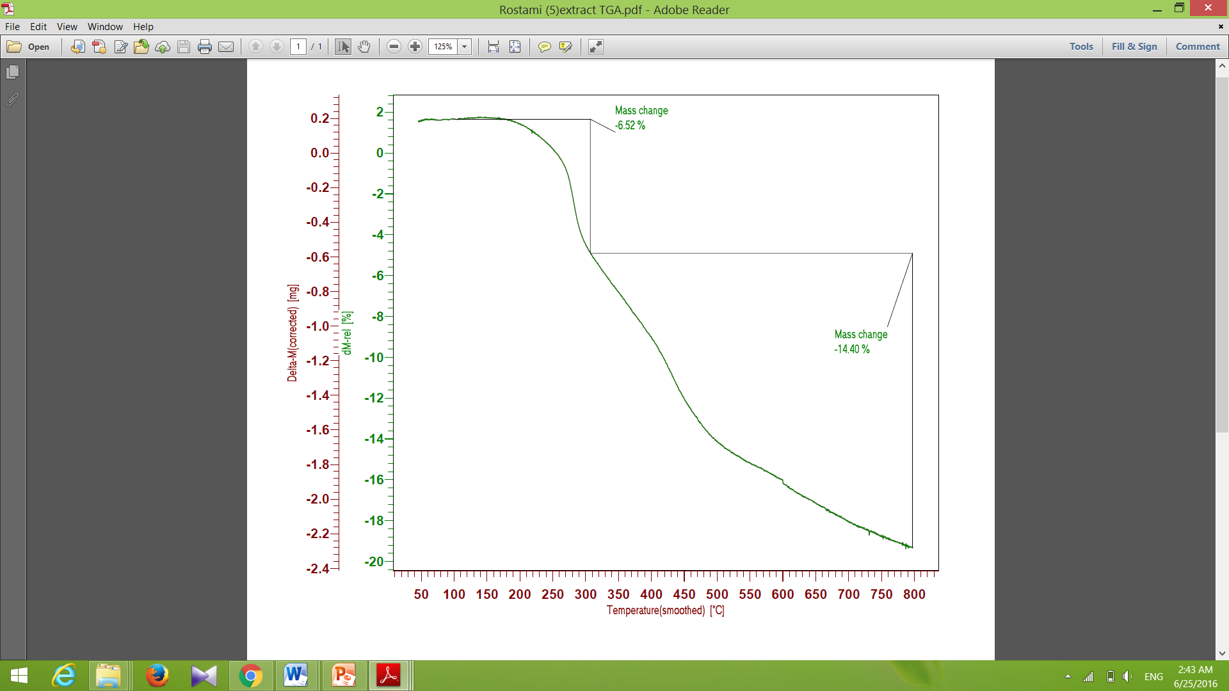

**Fig. S3.** TGA profile of the VO(ephedrine)2@MNPs

**2-4. The EDX spectrum of the VO(ephedrine)2@MNPs**

The EDX spectrum shows the elemental composition (V, Fe, Si and N) of the VO(ephedrine)2@MNPs (Fig. S4).

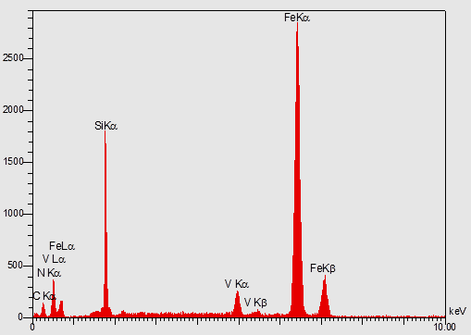

**Fig. S4.** EDX spectrum of the VO(ephedrine)2@MNPs