**Electronic Supporting Information:**

Bis(tetraethylthiophosphoramidoyl)methylamine as an electrochemical ligand for simultaneous detection of iron and copper bivalent cations

Bis(tétraéthylthiophosphoramidoyl)méthylamine comme ligand électrochimique pour la détection simultanée des cations bivalents du fer et du cuivre

Alma Mejri* and Khaled Alouani

Laboratoire de Chimie Analytique et Electrochimie, Département de Chimie, Faculté des Sciences de Tunis, Université de Tunis El Manar, Campus universitaire de Tunis El Manar, 2092 Tunis El Manar, Tunisia.

**\*** Corresponding author: almaa.mejri@gmail.com

Tel: +21671872600, Fax: +21671883424

**Abstract :** A new thiophosphoramide-based electrochemical ligand was synthesized and used as a bivalent metallic cation sensor. The electrochemical studies reveal a sensitive detection process toward various cations such as Fe2+, Co2+, Ni2+, Cd2+, Cu2+ and Ca2+. The chelation process was accompanied by dramatic changes in the redox properties of free ligand. Interestingly, the ligand shows a simultaneous sensing behavior towards iron and copper cations. The oxidation peak potentials of the two complexes can be well separated allowing the sensitive detection. Furthermore, UV-Visible spectra showed red-shifts of absorbance bands of free ligand in the presence of cations due to the coordination of the thiophosphoryl groups. Electrochemical and UV-Visible studies confirmed that the metal-ligand complexes have 1:2 stoichiometry.

**Résumé** : Dans ce travail, un nouveau ligand électrochimique à base de thiophosphoramide a été synthétisé pour la détection des cations métalliques bivalents. Les études électrochimiques ont montré que la présence des différents cations métalliques tels que Fe2+, Co2+, Ni2+, Cd2+, Cu2+ et Ca2+ provoque un changement considérable au niveau des propriétés électrochimiques du ligand libre. Par ailleurs, le ligand a montré la possibilité de détecter d’une manière simultanée les ions Fe2+ et Cu2+. En outre, les investigations UV-Visible montrent un déplacement considérable des bandes d’absorption du ligand vers les longueurs d’onde infrarouge. Ceci est dû à la coordination des groupements thiophosphoryles présents dans la structure du ligand. Les études électrochimiques et par UV-Visible confirment que les complexes formés ont une steochiométrie 1 :2.

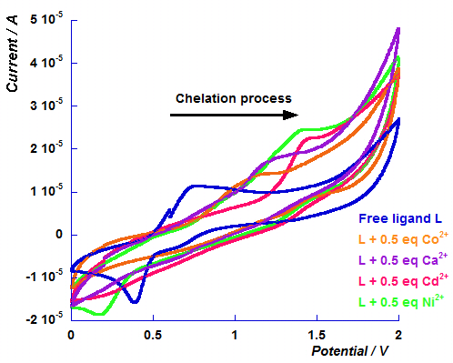

**Figure.S.1.** Cyclic voltammograms of 1.0 mM solution of free ligand **L** and in presence of 0.5 equivalent of cobalt perchlorate, calcium perchlorate, cadmium perchlorate and nickel perchlorate cations in 0.1M TBAClO4 acetonitrile solution. Scan rate: 0.1 Vs-1.

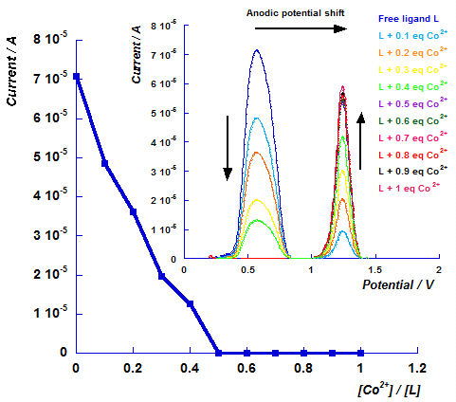

**Figure.S.2.** Variation of peak current Ipa of free ligand **L** depending on relative Co2+ concentration. Inset: Differential pulse voltammograms of the successive addition of the cobalt perchlorate cation (from 0.1 to 1 equivalent) to the free ligand **L** solution (1 mM).

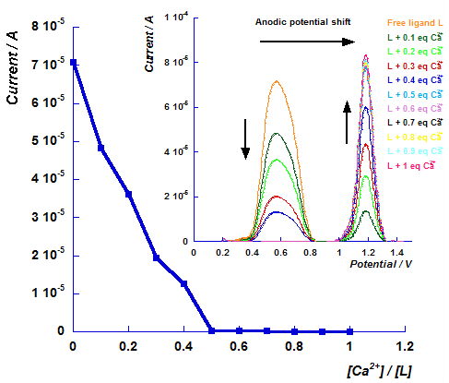

**Figure.S.3.** Variation of peak current Ipa of free ligand **L** depending on relative Ca2+ concentration. Inset: Differential pulse voltammograms of the successive addition of the calcium perchlorate cation (from 0.1 to 1 equivalent) to the free ligand **L** solution (1 mM).

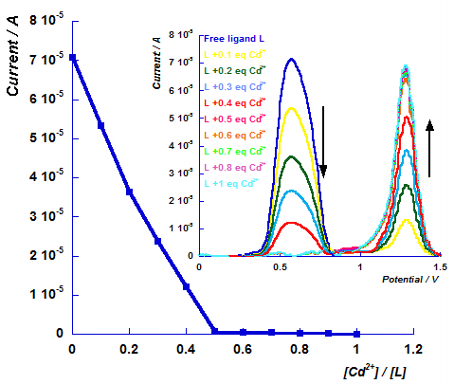

**Figure.S.4.** Variation of peak current Ipa of free ligand **L** depending on relative Cd2+ concentration. Inset: Differential pulse voltammograms of the successive addition of the cadmium perchlorate cation (from 0.1 to 1 equivalent) to the free ligand **L** solution (1 mM).

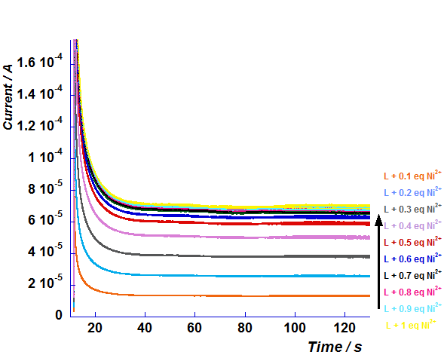

**Figure.S.5.** Chronoamperograms of the successive additions of the nickel perchlorate cation equivalents on the **L** solution (1 mM) performed on the potential of the oxidation of the nickel complex.

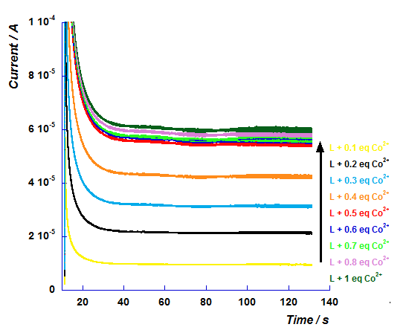

**Figure.S.6.**Chronoamperograms of the successive additions of the cobalt perchlorate cation equivalents on the L solution (1 mM) performed on the potential of the oxidation of the cobalt complex.

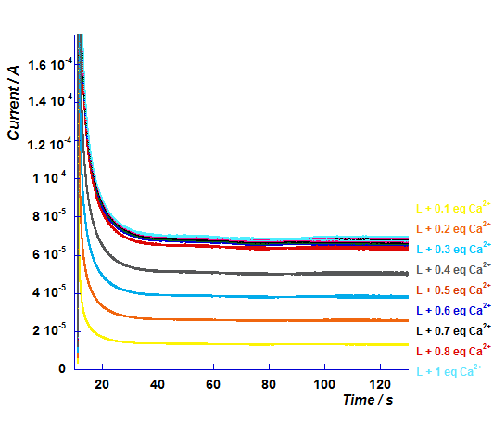

**Figure.S.7.** Chronoamperograms of the successive additions of the calcium perchlorate cation equivalents on the **L** solution (1 mM) performed on the potential of the oxidation of the calcium complex.

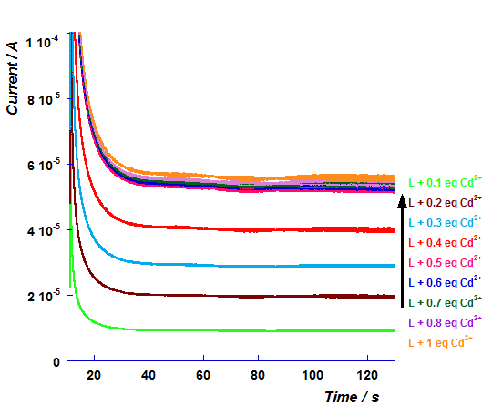

**Figure.S.8.** Chronoamperograms of the successive additions of the cadmium perchlorate cation equivalents on the **L** solution (1 mM) performed on the potential of the oxidation of the cadmium complex.

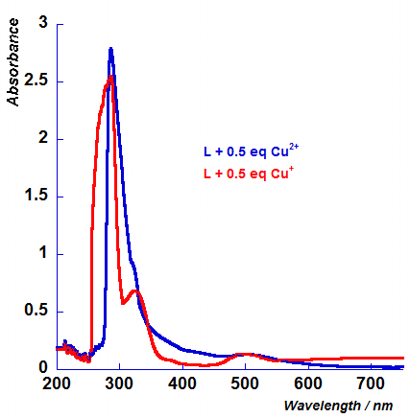

**Figure S.9.** UV-Visible absorption spectra after addition of 0.5 equivalent of Cu[ClO4]2.6H2O (blue curve) and Cu[MeCN]4.BF4 (red curve) to an acetonitrile solution of **L** .

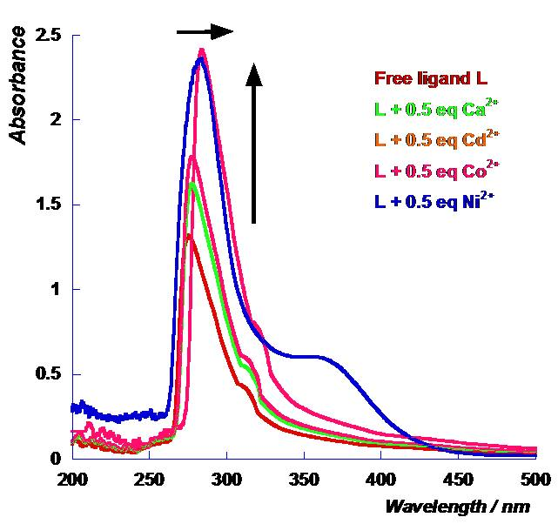

**Figure S.10.** UV-Visible absorption spectra before and after addition of 0.5 equivalent of Ca2+, Cd2+, Ni2+and Co2+ to an acetonitrile solution of **L** .