***Electronic Supporting Information***

**Synthesis, characterization, and x-ray crystal structures of copper(I) halide and pseudohalide complexes with 2-(2-quinolyl)benzothiazole. Diverse coordination geometries and electrochemical properties.**

**SoraiaMeghdadia, MehdiAmirnasr*a, ElaheYavaria,KurtMereiterb, Maryam Bagheria**

*aDepartment of Chemistry, Isfahan University of Technology, Isfahan 84156-83111, Iran*

*bFaculty of Chemistry, Vienna University of Technology, Getreidemarkt 9/164SC, A-1060 Vienna, Austria*

1. **Supplementary data of qbtz ligand**

***S. 1.1*.** FT-IR spectrum of qbtz 3

***S. 1.2.***UV-Vis spectrum of qbtz in DMF 3

**2. Supplementary data of [Cu2(µ-I)2(qbtz)2]**

***S. 2.1***. FT-IR spectrum of [Cu2(µ-I)2(qbtz)2] 4

***S. 2.2.*** UV-Vis spectrum of [Cu2(µ-I)2(qbtz)2] in DMF 4

**3. Supplementary data of [Cu3(µ-CN)3(qbtz)2]**

***S. 3.1***. FT-IR spectrum of [Cu3(µ-CN)3(qbtz)2] 5

***S. 3.2.*** UV-Vis spectrum of [Cu3(µ-CN)3(qbtz)2] in DMF 5

**4. Supplementary data of *[Cu(qbtz)(µ-SCN)]n***

***S. 4.1.*** FT-IR spectrum of [Cu(qbtz)(µ-SCN)]n 6

***S. 4.2.*** UV-Vis spectrum of [Cu(qbtz)(µ-SCN)]n in DMF 6

**5. Remarks Regarding the CN-Orientation between Linear and Tetrahedral Copper** 7-8

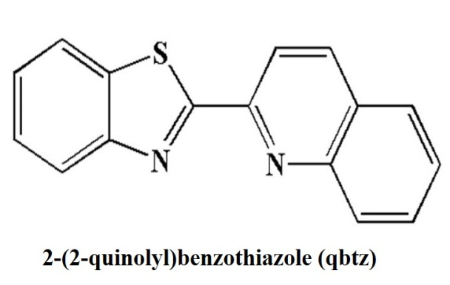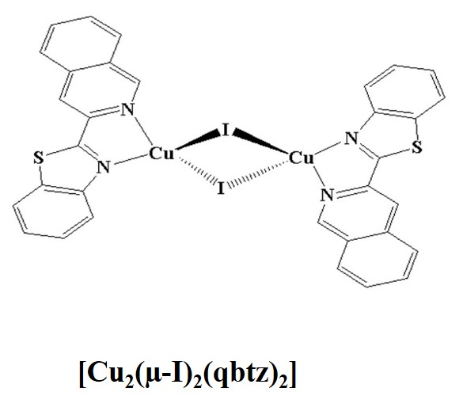

**[Cu2(µ-I)2(qbtz)2] (1)**

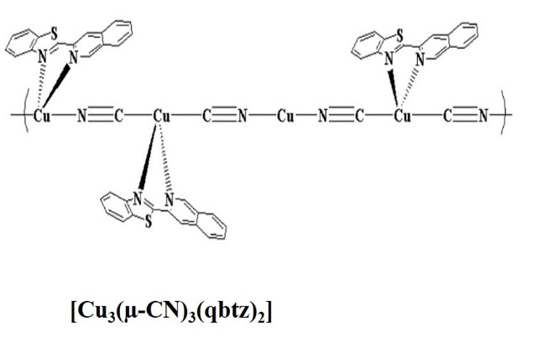

**[Cu3(µ-CN)3(qbtz)2] (2)**

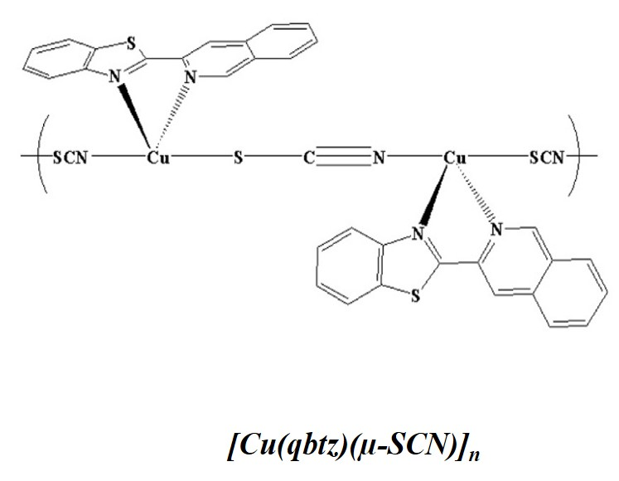

**[[Cu(qbtz)](*μ*-SCN)]n (3)**

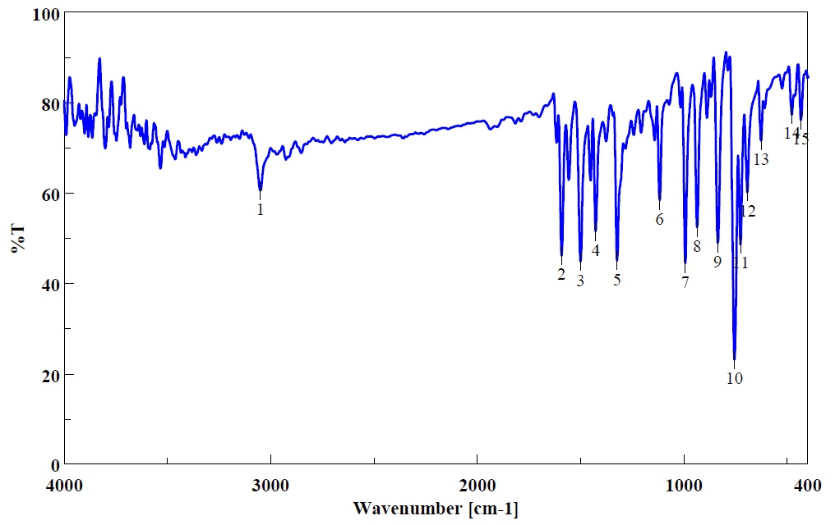

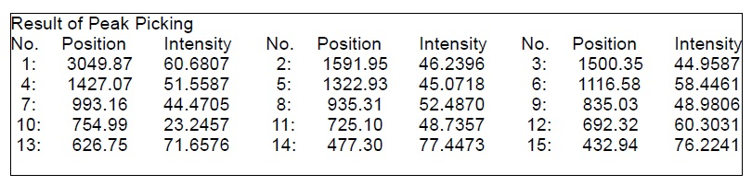

***S. 1.1.*** FT-IR spectrum of qbtz ligand (KBr pellet)

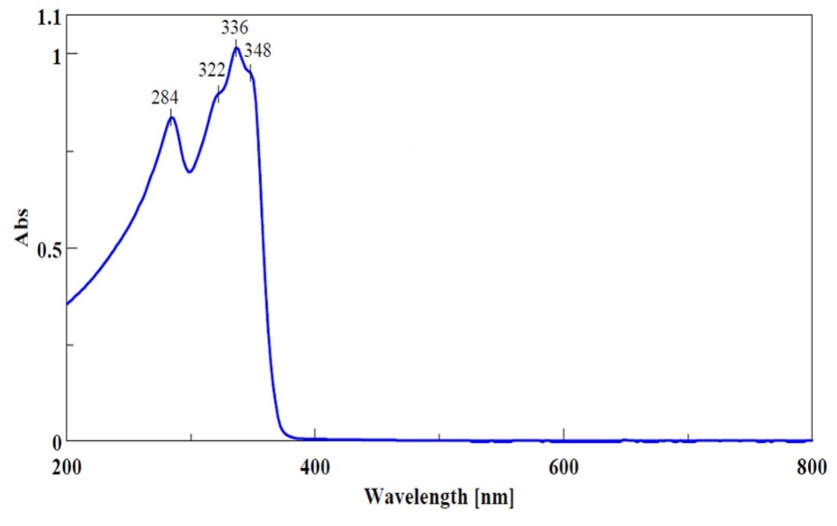

***S.1.2.*** UV-Vis spectrum of qbtz ligand in DMF at room temperature, c = 5×10-5 M

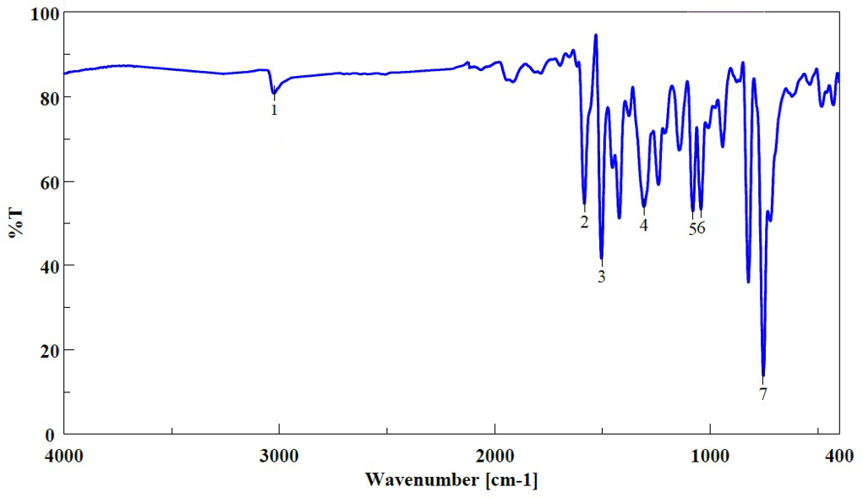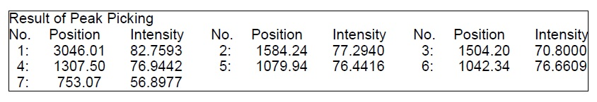

***S. 2.1.*** FT-IR spectrum of **[Cu2(µ-I)2(qbtz)2]** (KBr pellet)

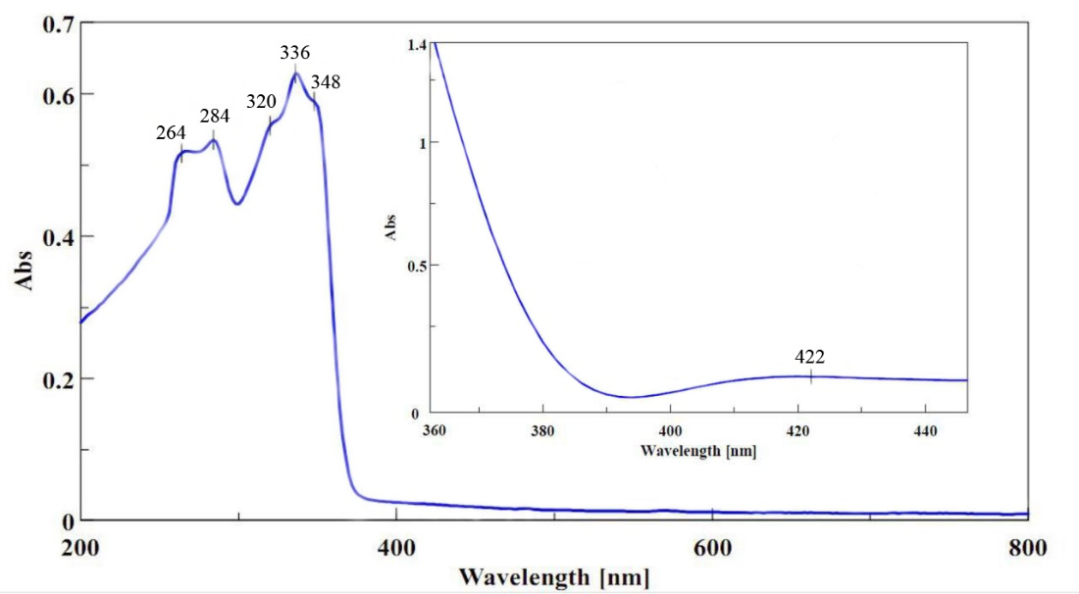

***S. 2.2.*** UV-Vis spectrum of **[Cu2(µ-I)2(qbtz)2]** in DMF at room temperature, c = 1.25×10-5 M (inset: c = 1.25×10-4 M).

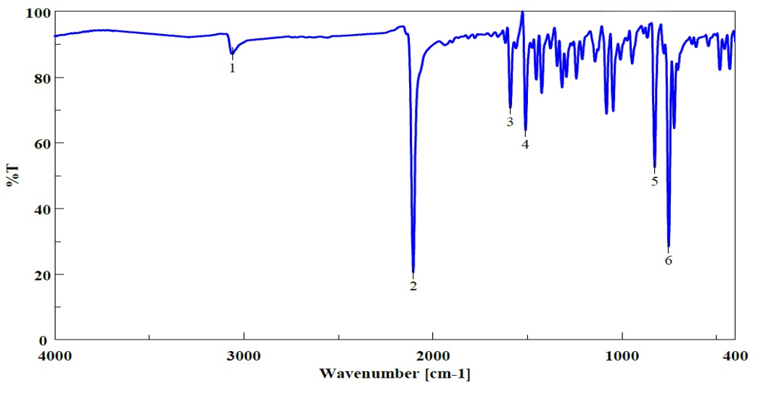

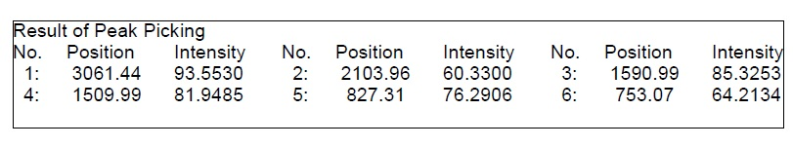

***S. 3.1.*** FT-IR spectrum of **[Cu3(µ-CN)3(qbtz)2]** (KBr pellet)

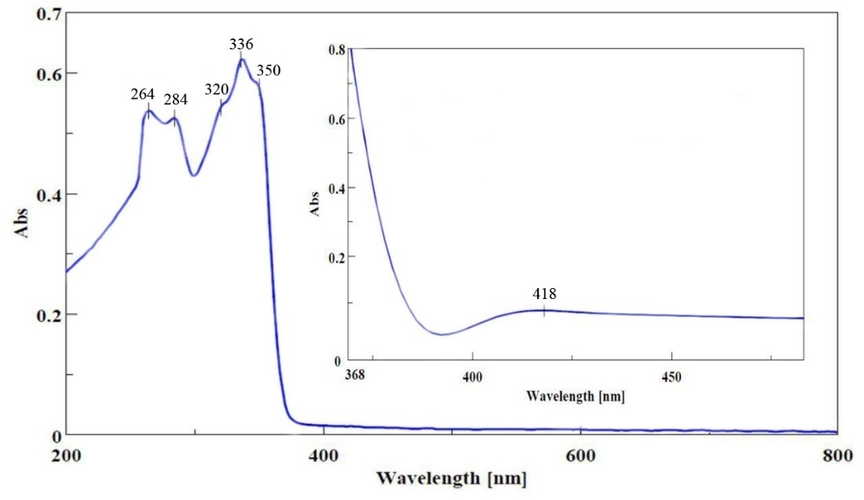

***S. 3.2.*** UV-Vis spectrum of **[Cu3(µ-CN)3(qbtz)2]** in DMF at room temperature, c = 1.25×10-5 M (inset: c = 1.25×10-4 M).

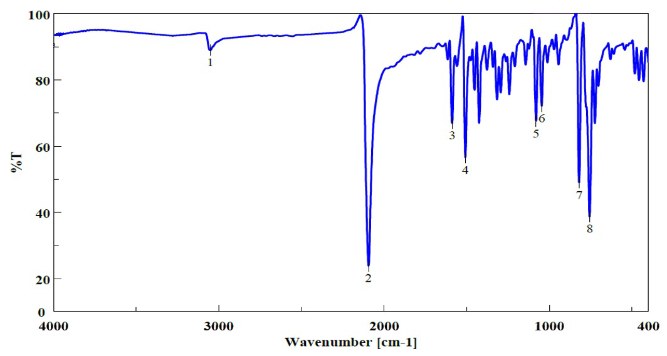

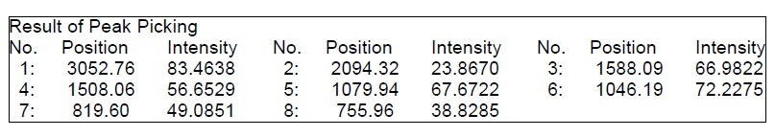

***S. 4.1.*** FT-IR spectrum of ***[Cu(qbtz)(µ-SCN)]n*** (KBr pellet)

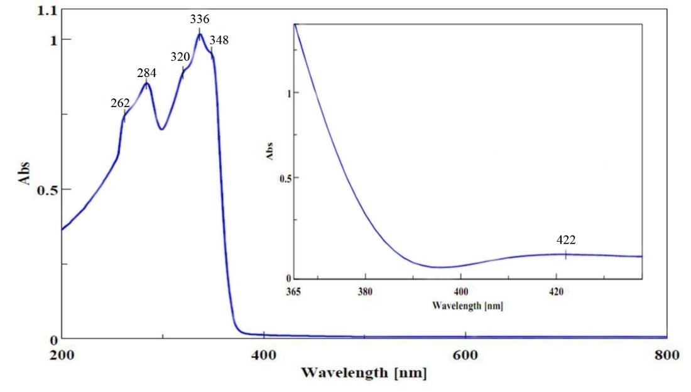

***S. 4.2.*** UV-Vis spectrum of ***[Cu(qbtz)(µ-SCN)]n*** in DMF at room temperature, c = 1.25×10-5 M (inset: c = 1.25×10-4 M).

**Remarks Regarding the CN-Orientation between Linear and Tetrahedral Copper**

There seems to exist a certain ambiguity or myth regarding the orientation of cyanido group between a tetrahedral and a linear copper Cu(I) complex.

In order to clarify the ambiguity regarding the orientation of the cyanido group between a tetrahedral and a linear copper Cu(I) complex, we came to the following suggestion after studying the literature and performing structure-refinements with ours as well as the literature data:

**1)** We maintain the disorder model for the CN groups, *but refine the CN occupancies*, *i.e.* an order/disorder (OD) parameter for each of the three CN groups. The result of this refinement is a practically statistically disordered CN between tetrahedral Cu1 and Cu2 (OD 0.48(5); 0.5 would mean ideal disorder), but the CN groups bonded to “linear” Cu3 are mainly N-bonded (!) to Cu3, and not C-bonded as kindly suggested, the OD parameters being 0.88(5) and 0.85(5) meaning ca. 86% of the CN are N-bonded and ca. 16% are C-bonded to Cu3. The structure model with exclusively C-bonded CN to Cu3 is clearly disfavoured by R-values.   
 Interestingly, our result is confirmed by the CCDC refcode **MODLOH:**   
Shi-Hong Lin, Ying-Yi Yang, [S.W.Ng](http://s.w.ng/), *Acta Crystallogr., Sect. E: Struct. Rep. Online* (2008), *64*, m1076.   
This is a *catena*-[tris(m2-Cyano)-bis(4,4'-dimethyl-2,2'-bipyridine-k2N,N')-tri-copper(i)] with a Cu-CN chain of exactly the same kind as our qbtz-Cu-CN complex. The authors presented (= assumed) their structure with all CN groups as fully disordered (one of them disordered by symmetry requirement, the other two bonded to a linear Cu(I) ASSUMED to adopt 50/50% orientational disorder). For this structure, which has good R-values (R1 = 0.037) and no disorder other than CN orientation, the original diffraction data are available and we could carry out with them a test refinement in which we optimized the CN orientation. The result was 74(2)% of the CN bonded to “linear” Cu are N-bonded, hence supporting our result on compound **2**.

**2)** We did not find any literature citation requiring that cyanido groups within a continuous Cu(I)-CN chain of 2- and 4-coordinated Cu(I) must be C-bonded to the 2-coordinated Cu(I). Subsequently, we use CC, XX, and NN for C-, disordered (0.5/0.5) N+C-, and N-bonded linear Cu(I).

**3)** There exist seven crystal structures (see attaced CIF exluding **UTOBUB** and **UTOBUB01**) of 4 different compounds with the same chain type like our compound 2, i.e. -(CN)-Cu[4]-(CN)-Cu[4]-(CN)-Cu[2]- where [4] and [2] represent the coordination numbers and [4] means that in addition to the two CN groups there are two additional nitrogen ligands, all heteroaromatic N. These structures are the CCDC refcodes:   
**ANETAP**,  
and the three structure determination pairs on the same compounds:   
**DAMZEW** and **DAMZEW01**,   
**MODLOH** and **MODLOH01**,   
**SUYFEX** and **SUYFEX01**.   
The seven structures were reported with configuration CC (see §2 above for the definition) for **ANETAP**, NN and XX for **DAMZEW/DAMZEW01**, XX and XX for **MODLOH/MODLOH01**, and XX and NN for **SUYFEX/SUFEX01**. In summary, we have 1 CC, 2 NN, and 4 XX structures.   
There are two contradicting structure determination pairs, **DAMZEW/DAMZEW01** and **SUYFEX/SUFEX01**. In case of **DAMZEW** the R-values of both structures are good. Based on the available, rather limited information on the **DAMZEW** structures, it is not possible to judge which one is more credible (it appears that NN and XX were inferred *by believe*). The **SUYFEX** structures are notably poorer in R-values: here also no judgment seems to be possible which model is more credible (we guess that XX and NN configurations were inferred *by believe*). The best structure pair in terms of R-values and available data is **MODLOH/MODLOH01**, both published with XX configuration without giving information that they have tested the CN orientations by refinement. However, as we have demonstrated above, the **MODLOH** diffraction data support a mix of XX and NN configuration, *but not a CC* model.