Figure S1.

a) 2μm, 4 μm 20 μm
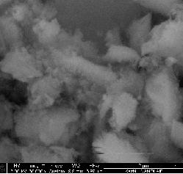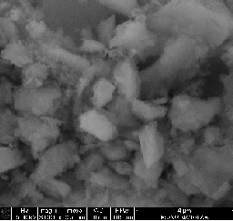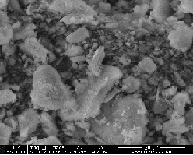

- 2 μm 4 μm 20 μm
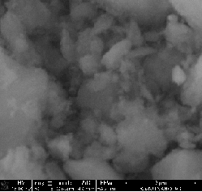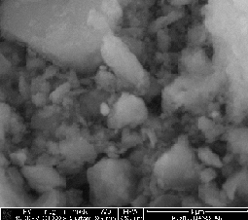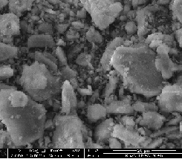
- 10 μm, 20 μm 50 μm

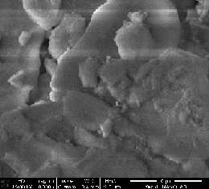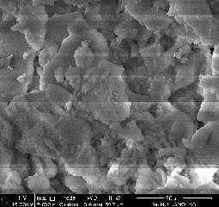

- 10 μm, 20 μm 50 μm
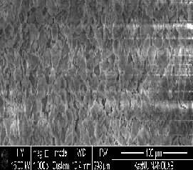
Fig S1. SEM images of a) catalyst V, b) VI, c) VIII and d) VIII. Notation: V: 3 wt% CuO+2 wt% ZnO/γ-Al₂O_{3,} VI: 3 wt% CuO+2 wt% Cr₂O₃/γ-Al₂O₃, VII: 3 wt% CuO+2 wt% ZnO/γ-Al₂O₃ (sc), and VIII: 3 wt% CuO+2 wt% Cr₂O₃ /γ-Al₂O₃(sc).

