**A mild and convenient protocol for conversion of toxic acid red-37 into pharmacological (antibiotic and anticancer) nominees: Organopalladium architectures.**

Reda F. M. Elshaarawya,b,*, Tahany. M. Sayedc, Haniya. M. Khalifac, Emtithal.A.El-Sawic*

a Institut für Anorganische Chemie und Strukturchemie, Heinrich-Heine Universität Düsseldorf, 40204 Düsseldorf, Germany

bChemistry Department, Faculty of Science, Suez University, 43518 Suez, Egypt.

c Department of Chemistry, Faculty of Women for Arts, Science and Education, Ain Shams University, Heliopolis, Cairo, Egypt

**\***Corresponding authors: [reel-001@uni-duesseldorf.de](mailto:reel-001@uni-duesseldorf.de)

[reda_elshaarawi@science.suez.edu.eg](mailto:reda_elshaarawi@science.suez.edu.eg),

[elsawi_e@yahoo.com](mailto:elsawi_e@yahoo.com)

**Figures captions**

**Fig S1:** 1H NMR spectrum of **ARSB1** (300 MHz, DMSO-*d*6)

**Fig S2:** 1H NMR spectrum of **ARSB2** (300 MHz, DMSO-*d*6)

**Fig S3:** 1H NMR spectrum of **ARSB3** (300 MHz, DMSO-*d*6)

**Fig S4:** 1H NMR spectrum of **ARSB4** (300 MHz, DMSO-*d*6)

**Fig S5:** 1H NMR spectrum of **ARSB5** (300 MHz, DMSO-*d*6)

**Fig S6:** 1H NMR spectrum of **ARSB6** (300 MHz, DMSO-*d*6)



**Fig S1:** 1H NMR spectrum of **ARSB1** (300 MHz, DMSO-*d*6)

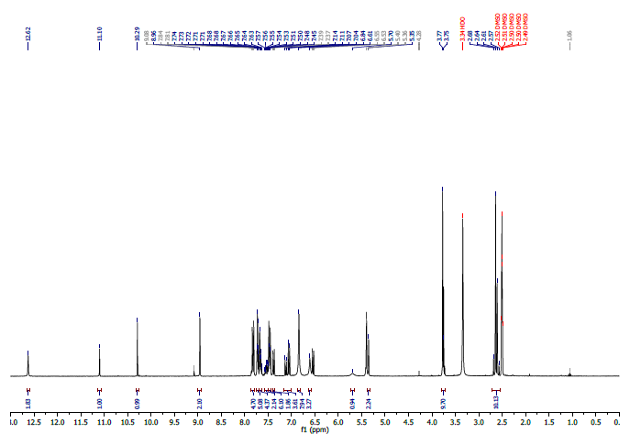

**Fig S2:** 1H NMR spectrum of **ARSB2** (300 MHz, DMSO-*d*6)



**Fig S3:** 1H NMR spectrum of **ARSB3** (300 MHz, DMSO-*d*6)



**Fig S4:** 1H NMR spectrum of **ARSB4** (300 MHz, DMSO-*d*6)



**Fig S5:** 1H NMR spectrum of **ARSB5** (300 MHz, DMSO-*d*6)



**Fig S6:** 1H NMR spectrum of **ARSB6** (300 MHz, DMSO-*d*6)