Supporting Information

Ring-Closing-Metathesis of fluoroalkenes towards the synthesis of fluorinated heterocycles containing an oxaza bond.

David Guérin,a Annie-Claude Gaumont,a Isabelle Dez, a Xavier Pannecouckeb andSamuel Couve-Bonnaireb*

a Normandie Université, ENSICAEN, Unicaen, CNRS, LCMT, 14000 Caen, France

b Normandie Université, INSA Rouen, UNIROUEN, CNRS, COBRA, 76000 Rouen, France

E-mail : Samuel.couve-bonnaire@insa-rouen.fr

**Table of Contents**

|  |  |
| --- | --- |
| 1. 1H, 19F and 13C Spectra for compounds **2a-b**, **6a-d**, **7**, **8** |  |

**2a:** Tert-butyl allyloxy(2-fluoroallyl)carbamate

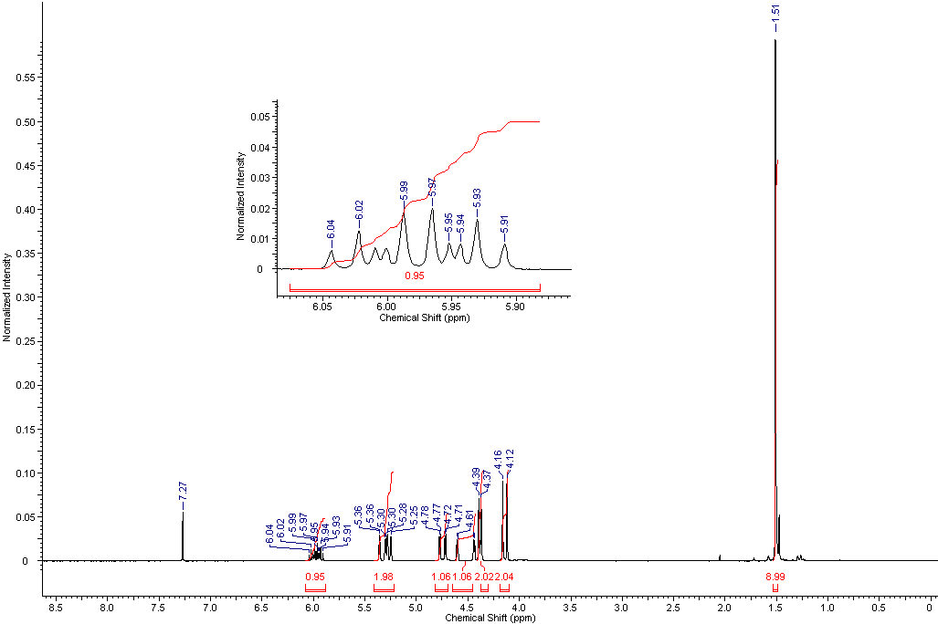

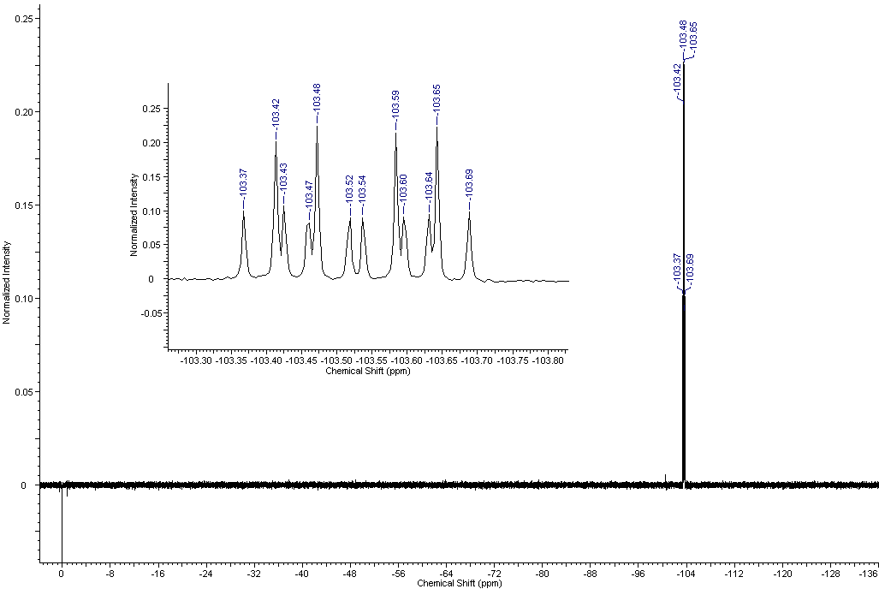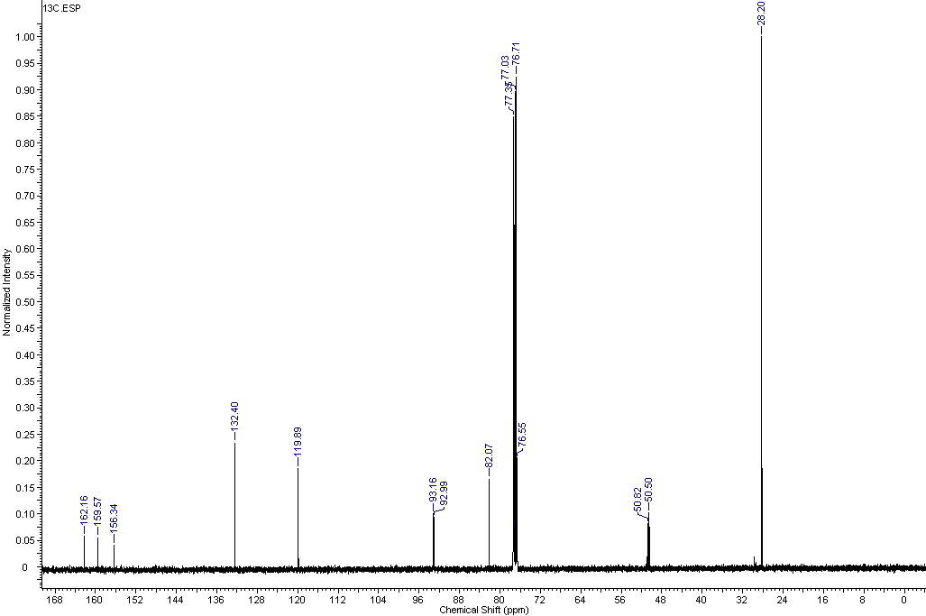

**2b:** Tert-butyl but-3-en-1-yloxy(2-fluoroallyl)carbamate

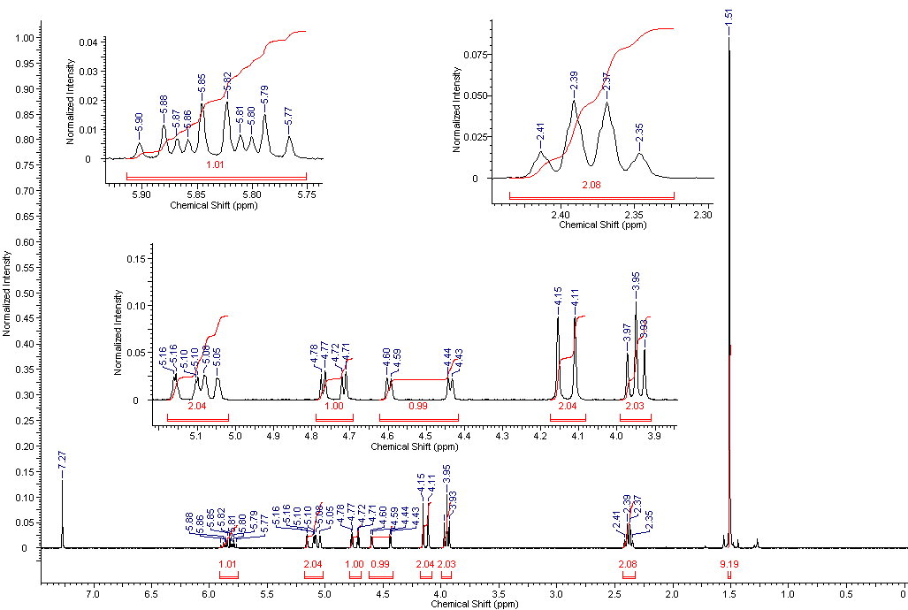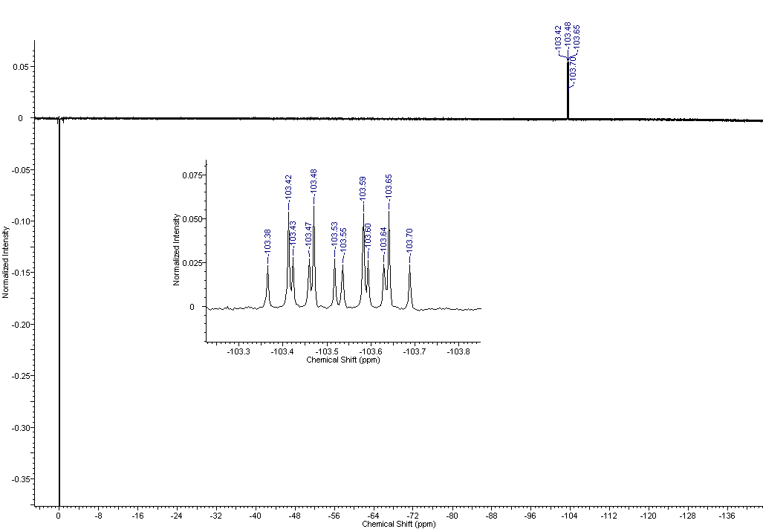

**6a:** (Z)-tert-butyl allyloxy(2-fluoro-3-phenylallyl)carbamate

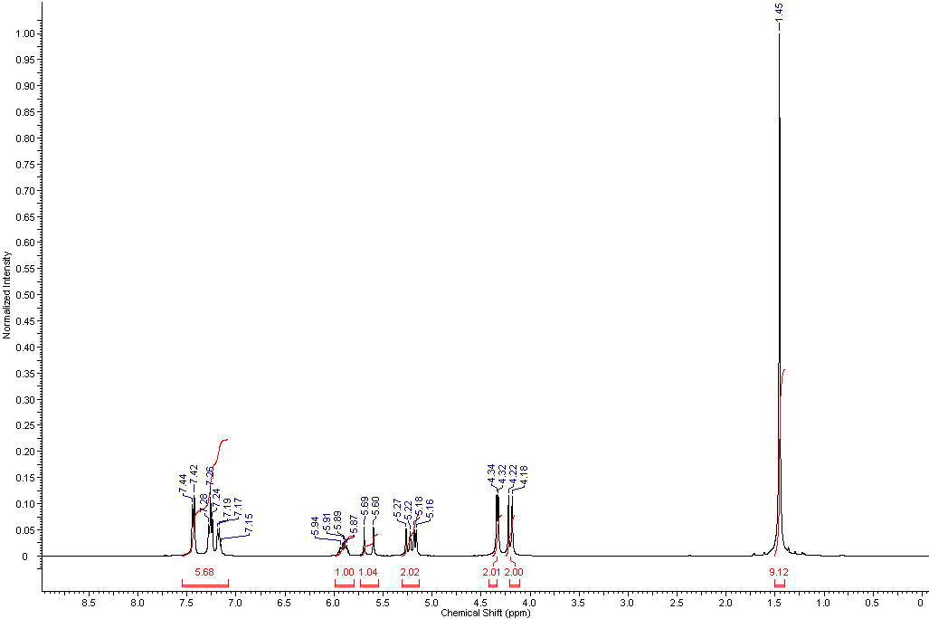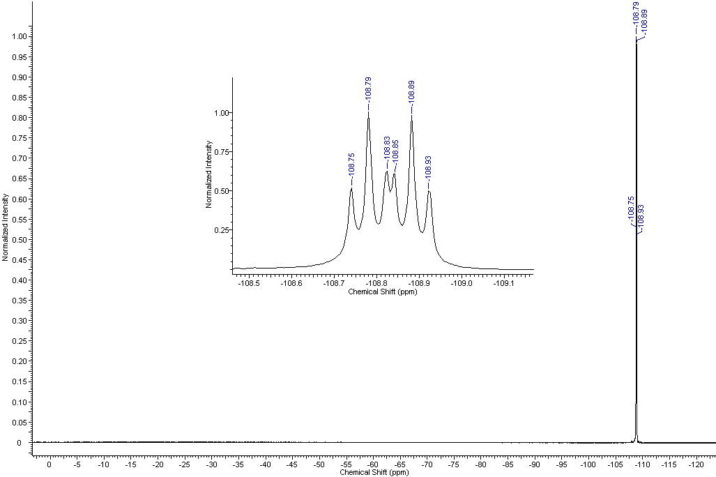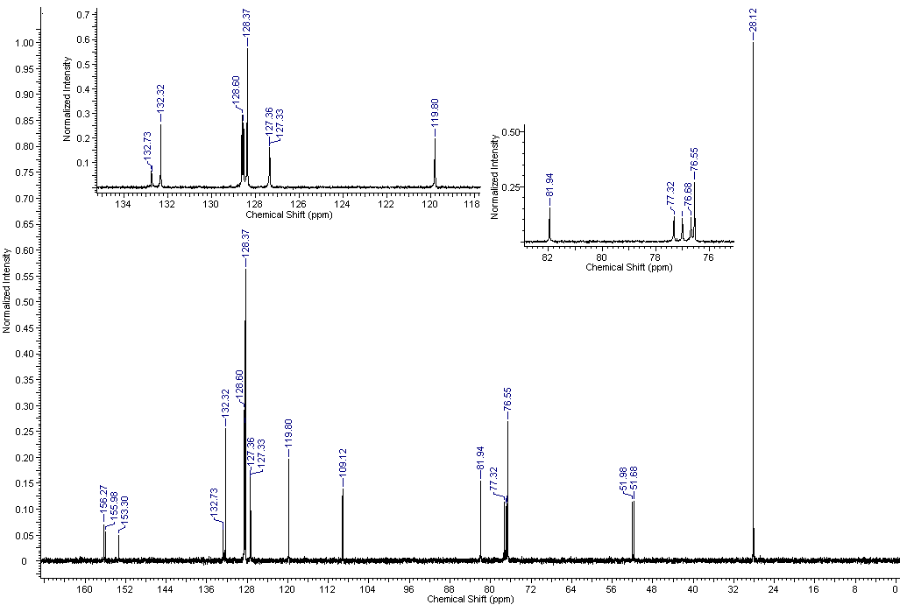

**6b:** (Z)-tert-butyl but-3-en-1-yloxy(2-fluoro-3-phenylallyl)carbamate

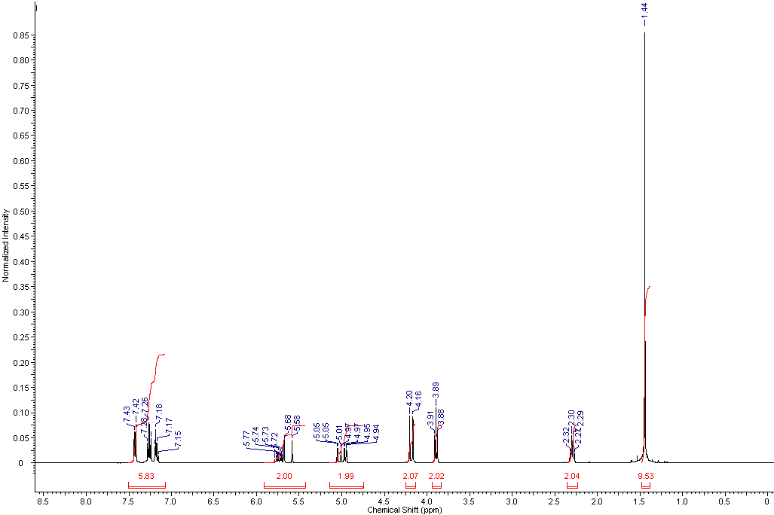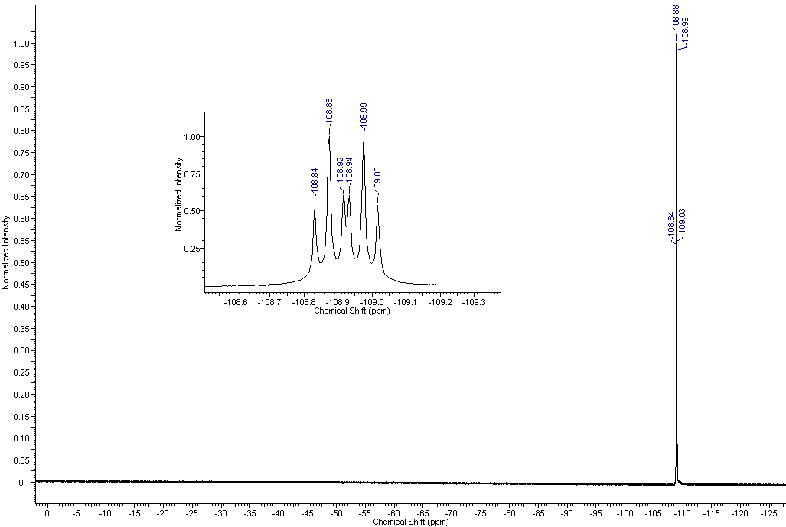

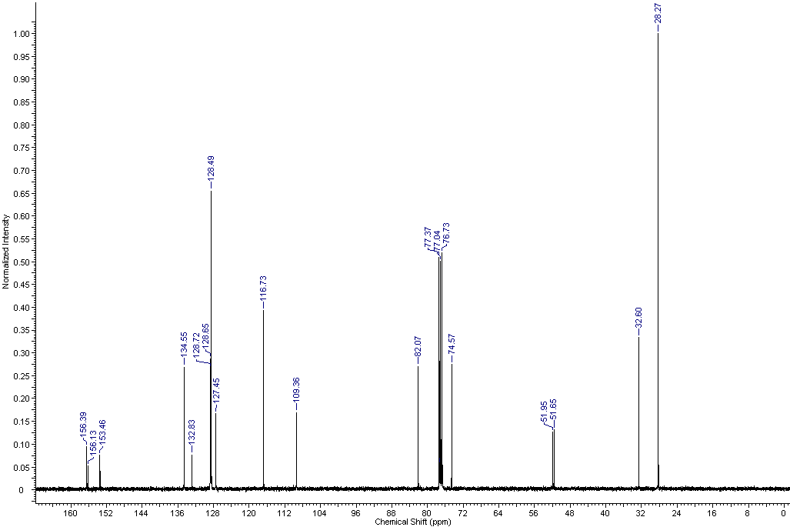

**6c:** (Z)-tert-butyl (2-fluoro-3-phenylallyl)(pent-4-en-1-yloxy)carbamate

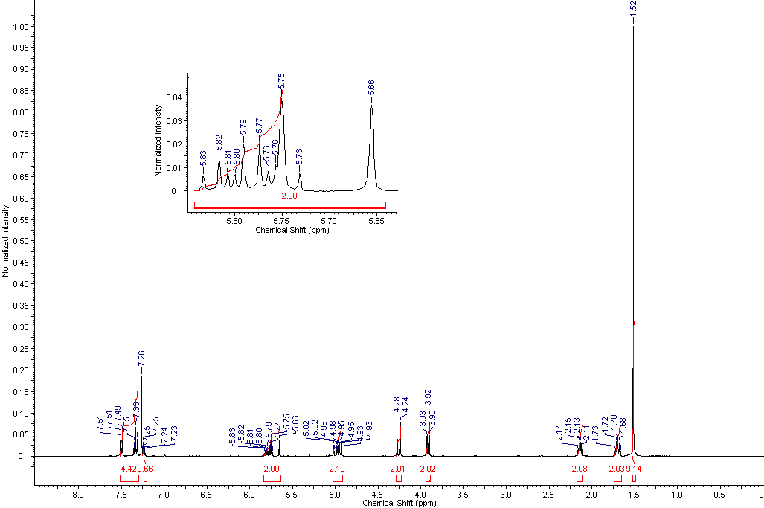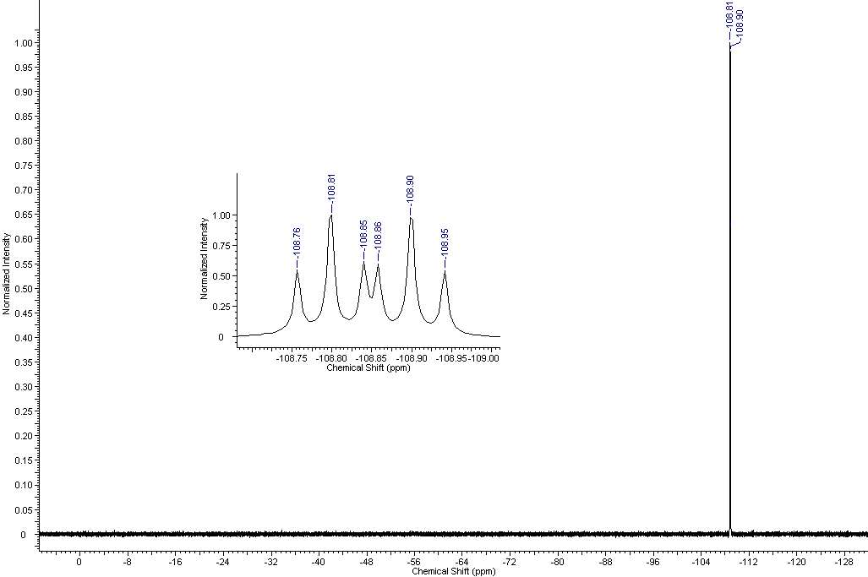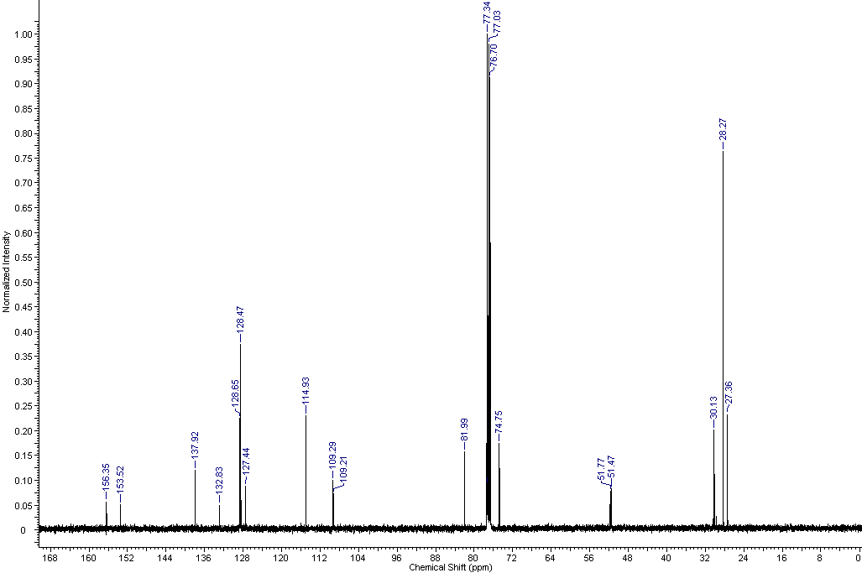

**6d:** (Z)-tert-butyl (2-fluoro-3-phenylallyl)(hex-5-en-1-yloxy)carbamate

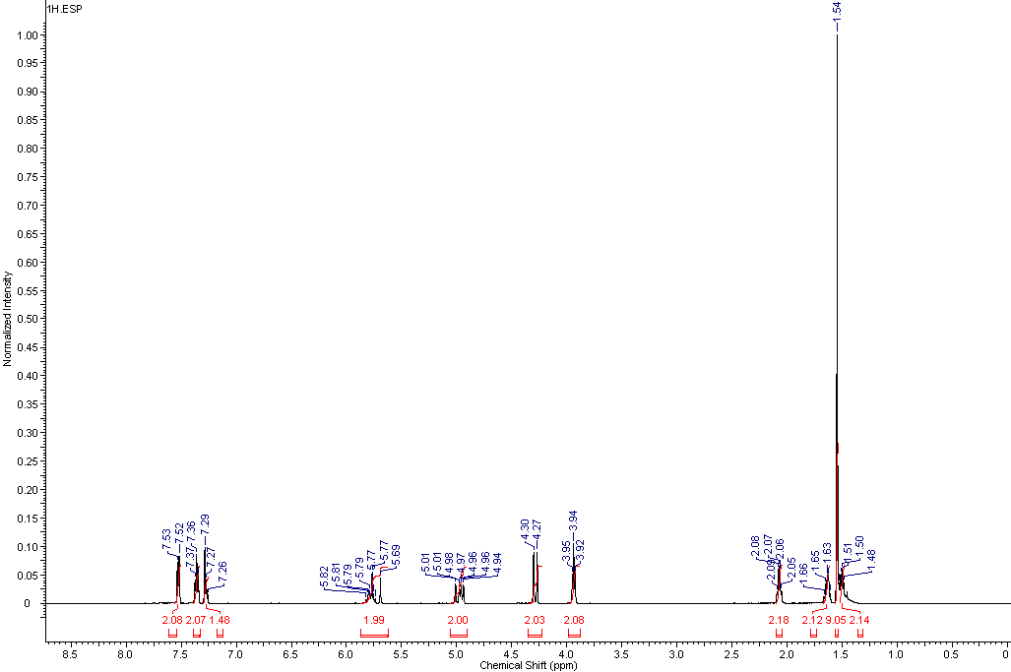

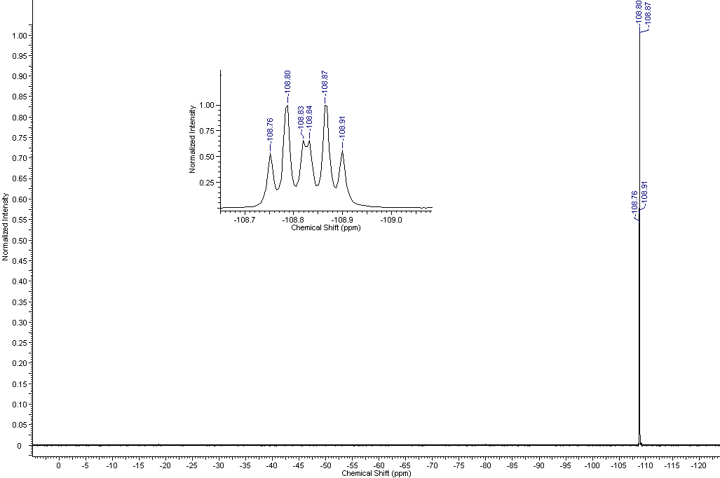

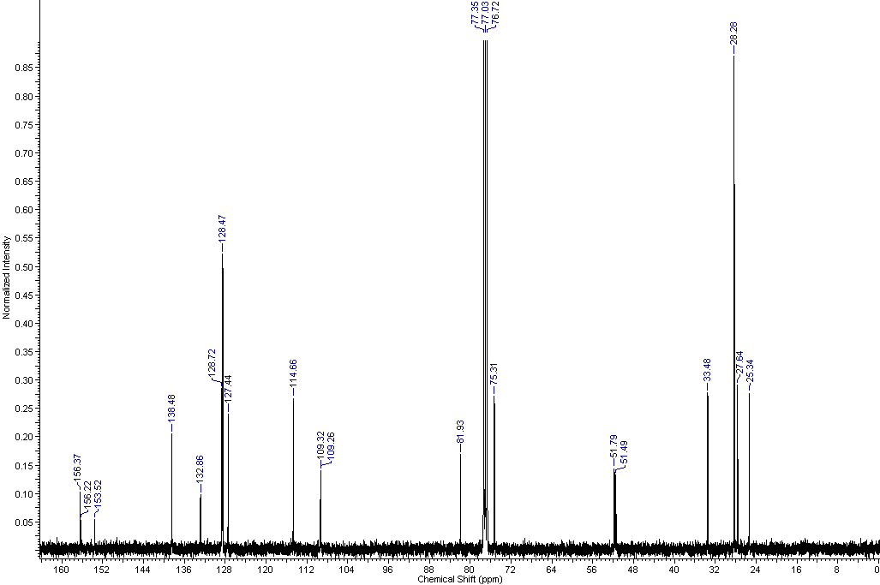

**7:** Tert-butyl 4-fluoro-3,6-dihydro-2H-1,2-oxazine-2-carboxylate

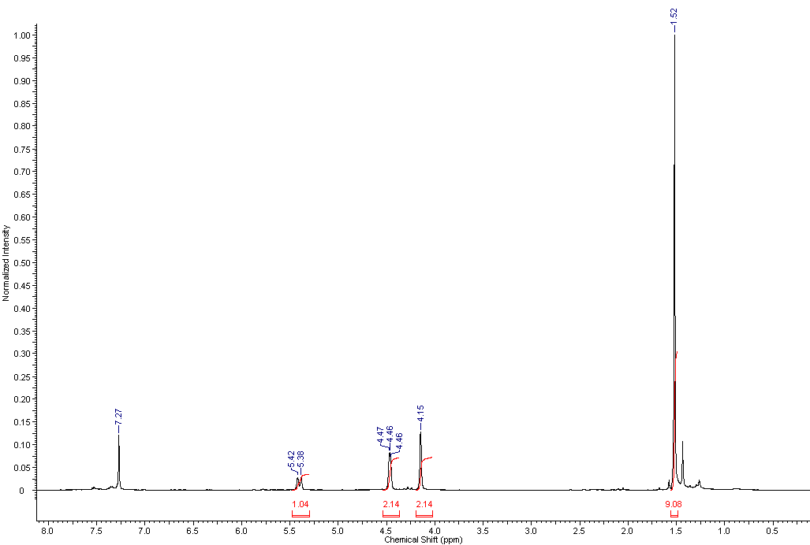

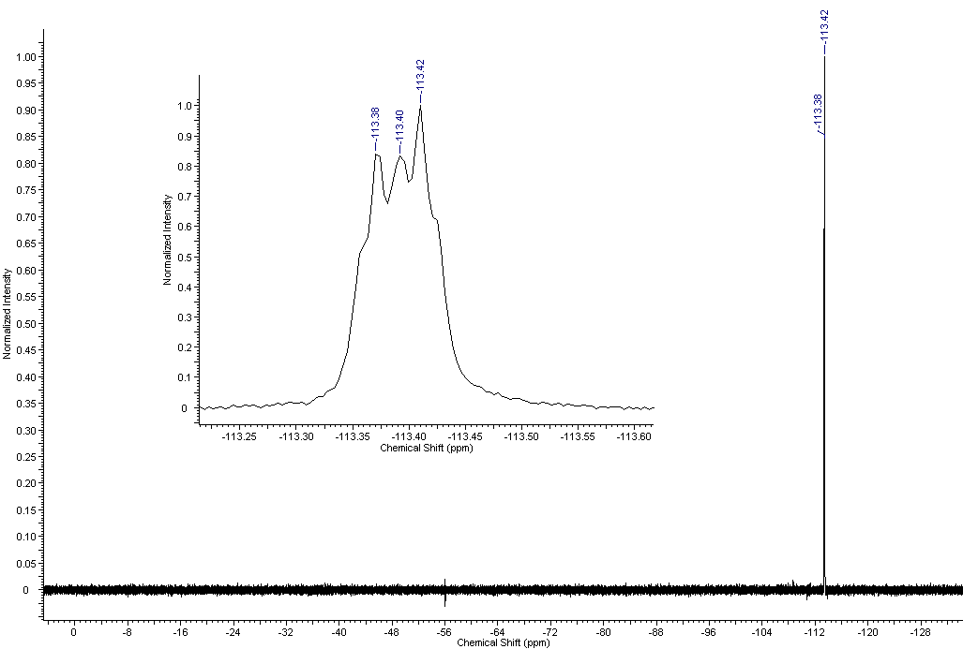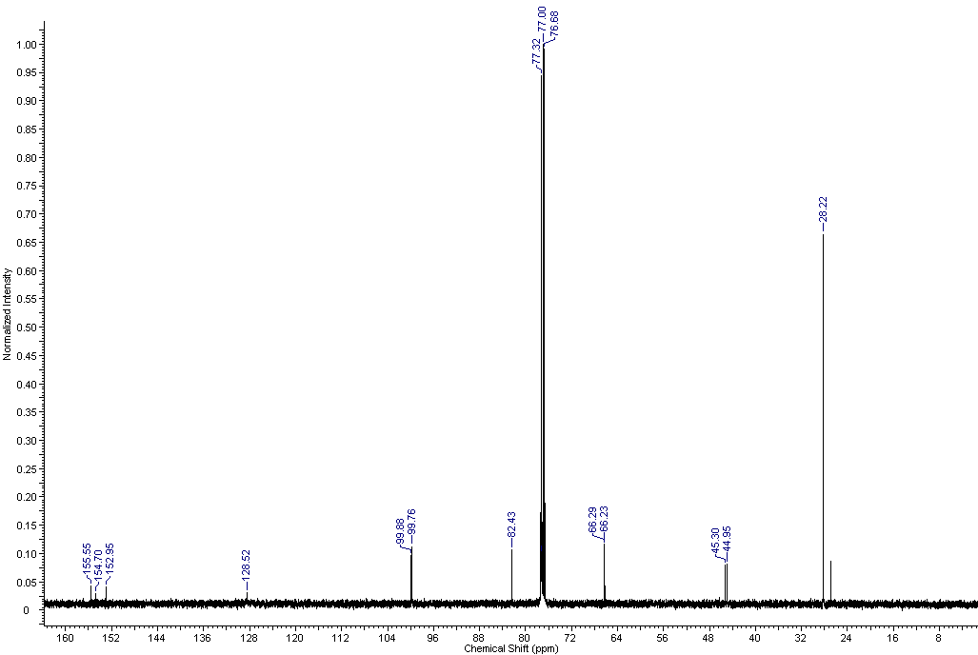

**8:** Tert-butyl 4-fluoro-3,6,7-trihydro-3H-1,2-oxazepine-2-carboxylate

