**Supporting Information**

**Electrosynthesis of cinnamic acid by electrocatalytic carboxylation of phenylacetylene in the presence of [NiII(Me4-NO2Bzo[15]tetraeneN4)] complex: An EC'CCC'C mechanism**

**Kobra Ghobadi, Hamid R. Zare*, Hossein Khoshro, Alireza Gorji, Abbas A. Jafari**

*Department of Chemistry, Yazd University, Yazd, 89195-741, Iran*

*Fax number: +98 3538210991 Telephone number: +98 35 38122669*

*E-mail address:* [hrzare@yazd.ac.ir](mailto:hrzare@yazd.ac.ir) hrzare@yahoo.com

**Spectral characteristics of electrosynthesized cinnamic acid:**

1H NMR (DMSO, 400 MHz): 6.54 (d, 1H, j=16), δ 7.62 (d, 1H, j=16), δ 7.38−7.40 (multi, 3H), δ 7.66 (d, 2H, j=3.9), δ 12.44 (s, 1H, CO2H) ppm, 13C NMR (DMSO, 100.6 MHz): δ 119.09, 128.12, 128.84, 130.16, 134.17, 143.95, 167.51 ppm, FTIR: 1681 (C=O), 1628 (C=C aliphatic), 1095 (C−O), 3445 (O−H).

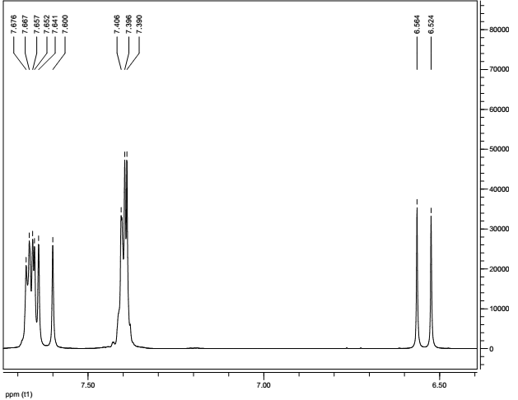

**Fig. S1.** 1H NMR of electrosynthesized cinnamic acid.

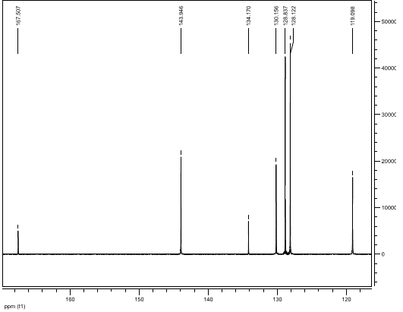

**Fig. S2.** 13C NMR of electrosynthesized cinnamic acid.

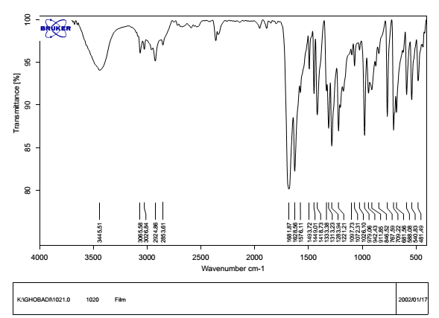

**Fig. S3.** FTIR spectra of electrosynthesized cinnamic acid.

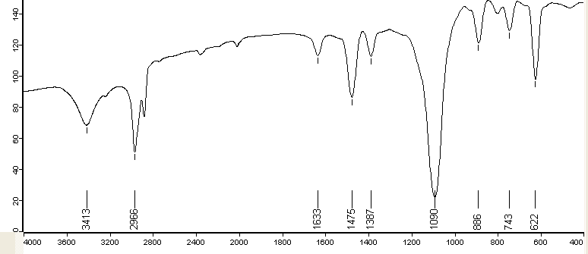

**Fig S4.** FTIR spectra of prepared magnesium perchlorate.