**S1 :** Major light products obtained from pine wood liquefaction in SC ethanol and analysed by GC-MS

|  |  |  |  |
| --- | --- | --- | --- |
| GC retention time (min) | Identified compounds | Yields ( %) | proposed origin |
| 1.9 | Diethyl ether - C4H10O | 0.29 | solvent |
| 2.0 | Ethyl vinyl ether - C4H8O | 0.03 | solvent |
| 2.1 | Acetaldehyde - C2H4O | 0.97 | carbohydrate/lignin |
| 2.9 | Ethyl formate - HCOOC2H5 | 0.03 | carbohydrate/lignin |
| 3.4 | 2-Methylfuran - C5H6O | 0.02 | carbohydrate |
| 3.6 | Ethyl Acetate - C4H8O2 | 3.31 | hemicellulose/lignin |
| 6.0 | Ethyl acrylate - CH2=CHCOOC2H5 | 0.03 | cellulose |
| 7.2 | 2-Ethoxytetrahydrofuran - C6H12O2 | 0.17 | carbohydrate |
| 12.9 | Ethyl orthoformate - C7H16O3 | 0.01 | carbohydrate |
| 13.3 | 2,5-Diethoxytetrahydrofuran - C8H16O3 | 0.05 | cellulose |
| 14.8 | Acetol - CH3C(O)CH2OH | 0.01 | cellulose |
| 15.2 | Ethyl-lactate - C5H10O3 | 0.86 | cellulose |
| 16.2 | 1-Hydroxy-2-butanone – C4H8O2 | 0.08 | carbohydrates |
| 17.1 | Butanoic acid, 2-hydroxy-, ethyl ester - C6H12O3 | 0.36 | carbohydrate |
| 17.7 | Ethyl glycolate - C4H8O3 | 1.86 | cellulose |
| 18.8 | 1-Hydroxy-2-pentanone - C5H10O2 | 0.19 | hemicelluloses |
| 19.2 | Furfural - C5H4O2 | 0.07 | hemicelluloses |
| 21.7 | Tetrahydrofurfuryl alcool - C8H14O3 | 0.09 | hemicelluloses |
| 23.7 | 2-Hydroxy-3-methylsuccinic acid - C5H8O5 | 0.07 | cellulose |
| 25.2 | Diethyl methylsuccinate - C9H16O4 | 0.04 | carbohydrate |
| 26.0 | 2-Furanmethanol - C5H6O2 | 0.28 | cellulose |
| 26.8 | Succinic acid, diethyl ester - C8H14O4 | 0.06 | carbohydrate |
| 30.7 | 2-Propanol, 1-(2-methoxy-1-methylethoxy)- - C7H16O3 | 0.07 |  |
| 31.2 | Ethyl hydrogen glutarate - C7H12O4 | 0.04 |  |
| 33.0 | 2-Cyclopenten-1-one, 2-hydroxy-3-methyl- C6H8O2 | 0.10 |  |
| 33.8 | o-Guaiacol - C7H8O2 | 0.11 | lignin |
| 35.3 | 2-Cyclopenten-1-one, 3-ethyl-2-hydroxy- - C7H10O2 | 0.05 |  |
| 37.9 | p-Methylguaiacol - C8H10O2 | 0.05 | lignin |
| 41.5 | p-Ethylguaiacol - C9H12O2 | 0.07 | lignin |
| 43.2 | p-Propylguaiacol - C10H14O2 | 0.06 | lignin |
| 44.1 | 3-Allyl-2-methoxyphenol - C10H12O2 | 0.12 | lignin |
| 44.6 | p-Vinylguaiacol - C9H10O2 | 0.15 | lignin |
| 45.8 | Ethyl 5-oxotetrahydro-2-furancarboxylate - C7H10O4 | 0.20 | cellulose |
| 46.1 | Isoeugenol - C10H12O2 | 0.11 | lignin |
| 46.8 | Furfuryl alcohol, tetrahydro- C5H10O2 | 1.16 | carbohydrate |
| 48.0 | Isoeugenol - C10H12O2 | 0.82 | lignin |

**S2:** 13C MAS-NMR- Solid residues recovered from pine wood liquefaction in dense ethanol at 280°C, 250°C and 220°C

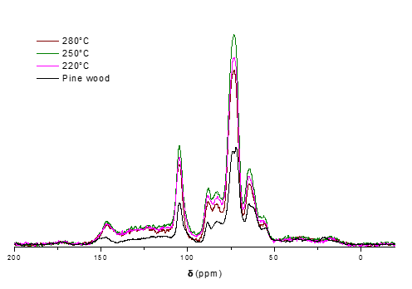

**S3:** FTIR spectra- Solid residues recovered from pine wood liquefaction in SC ethanol at 280°C for increasing holding time.



**S4:** 13C MAS-NMR- Solid residues recovered from pine wood liquefaction in SC ethanol at 280°C for increasing holding time



**S5.** Pine wood liquefaction in SC ethanol at 250°C, influence of the fluid density on the residual fractions (wt%), unconverted lignin, cellulose or hemicellulose in wt %

**S6:** 13C MAS-NMR Solid residues recovered from pine wood liquefaction in SC ethanol at 250°C of different densities

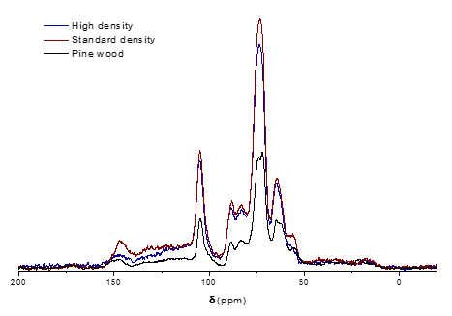

**S7:** FTIR spectra- Solid residues recovered from pine wood liquefaction in SC ethanol at 250°C of different densities.

