**supporting information**

**Challenges in Chemical Synthesis at the Border of Solution-Based and Solid State Chemistry - Synthesis and Structure of [CH3CH2Ge9{Si(SiMe3)3}]2−**

Sabine Frischhut, Wilhelm Klein, and Thomas F. Fässler[a]*

# Characterization of the anion 1a

## NMR spectroscopic characterization of 1a

Figure S1. 1H, b) 29Si, c) 13C, d) 1H 1H COSY, e) 1H 13C HSQC NMR and f) 1H 13C HMBC NMR spectrum of reaction solution of 1 recorded at r.t. in acetone-*d6*. Signals marked with # are assigned to toluene which is present in small amounts in the educt K2[Ge9{Si(SiMe3)3}2]. Signals marked with * could not be assigned.

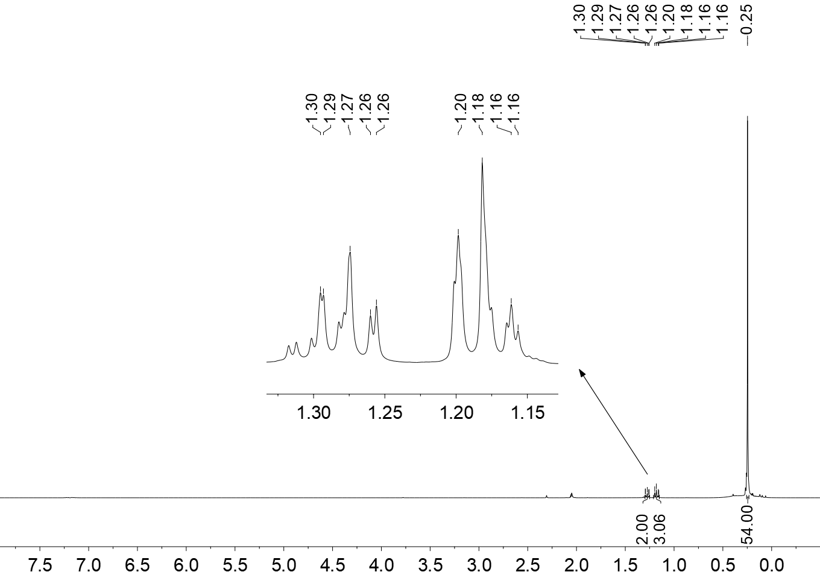

 / ppm



1a

1a

1a

acetone

 / ppm

#

a)

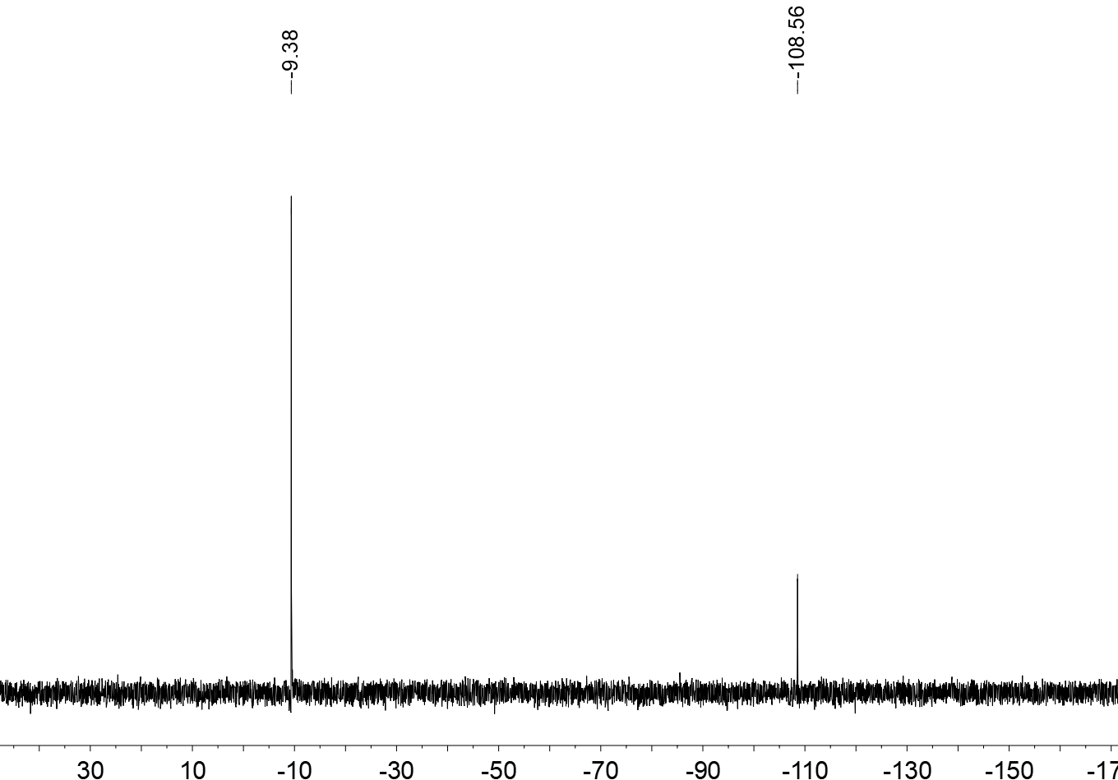

 / ppm

*Si*(CH3)3

*Si*{Si(CH3)3}3

b)

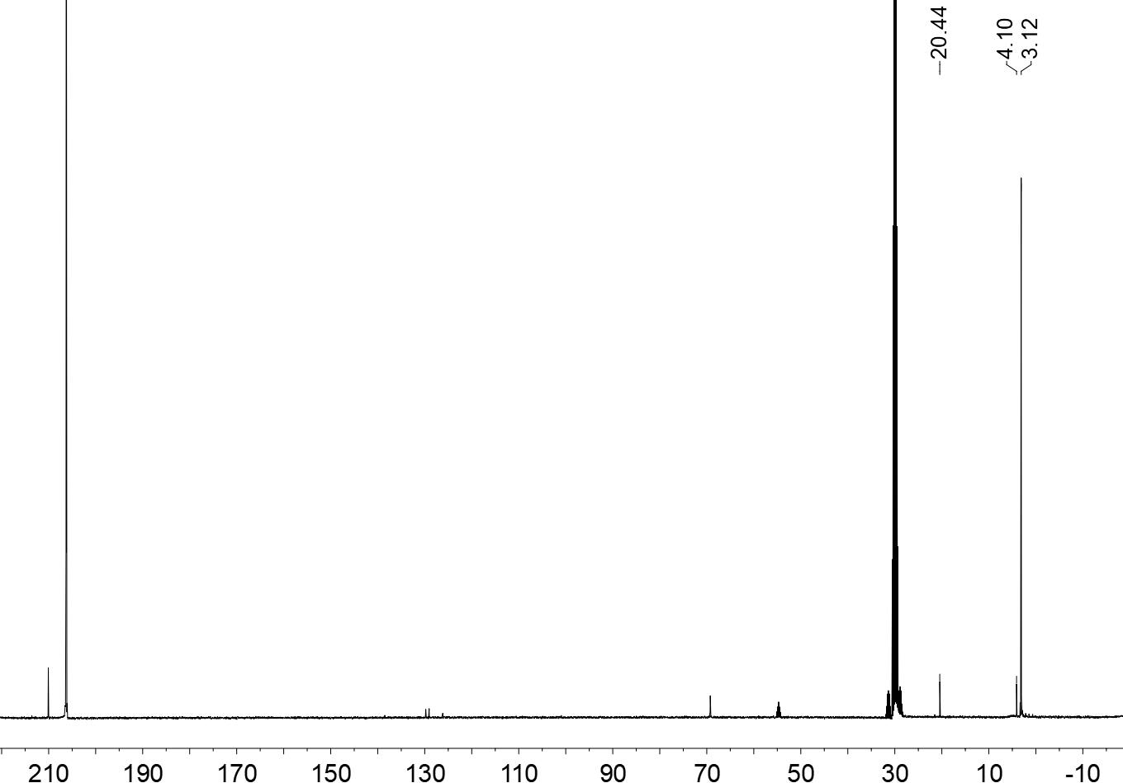

 / ppm

acetone

acetone

1a

1a

1a

*

*

*

*

c)

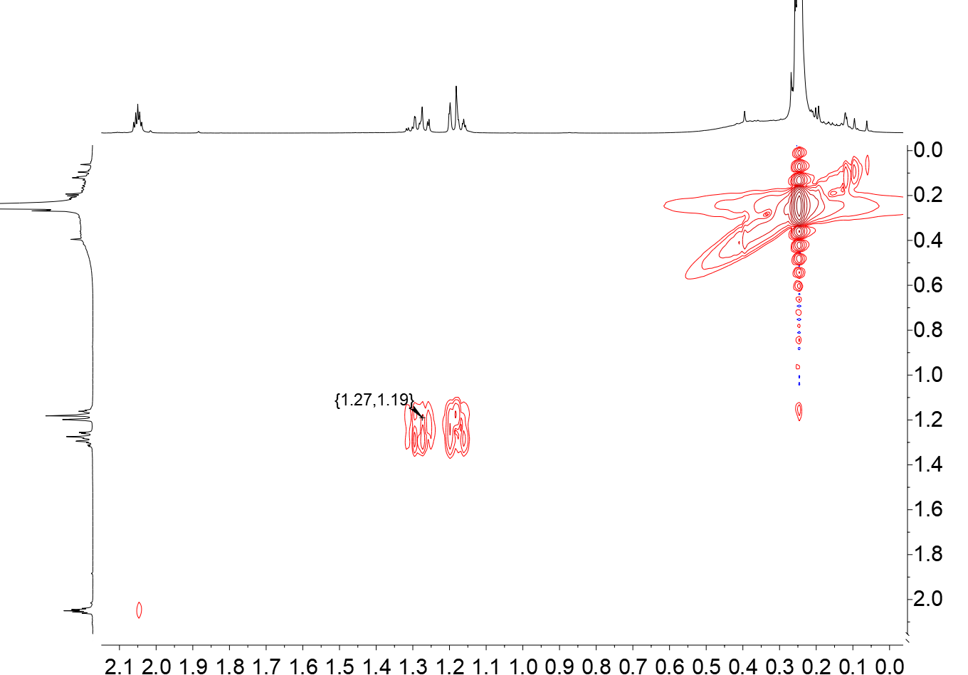

 / ppm

 / ppm

acetone

1a

1a

1a

*

*

*

*

*

1a

1a

1a

d)

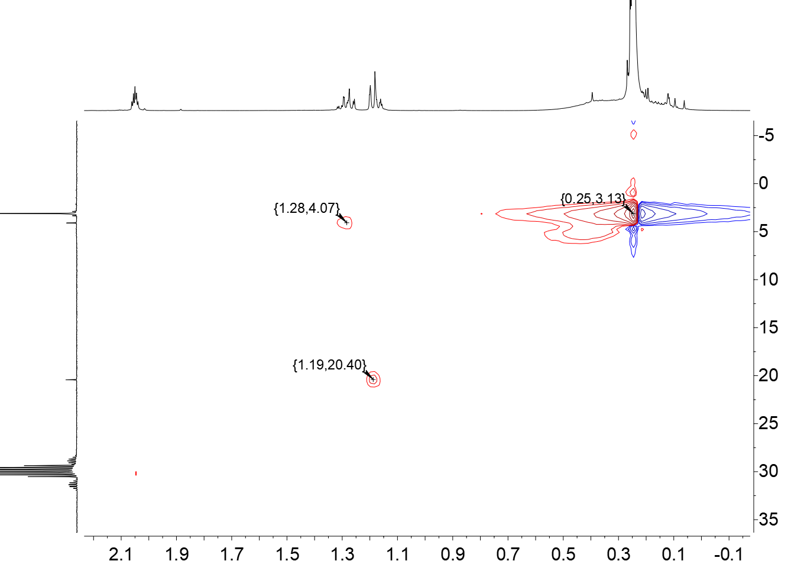

 / ppm

 / ppm

acetone

1a

1a

1a

*

*

*

*

1a

1a

1a

*

e)

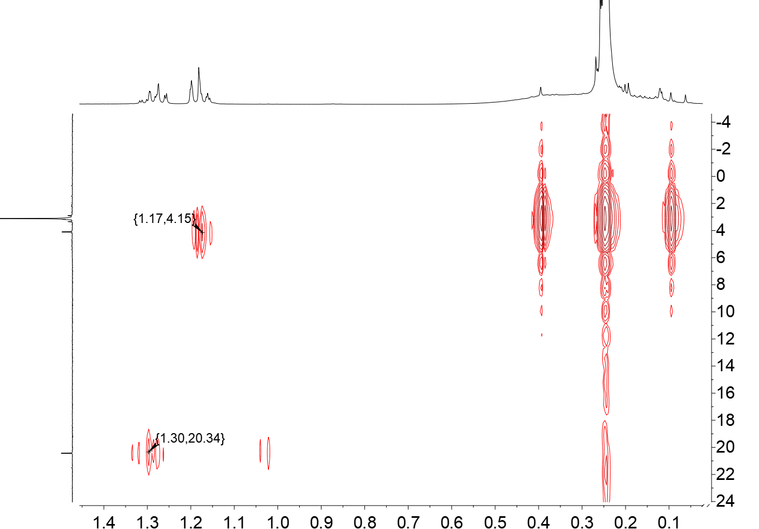

 / ppm

 / ppm

1a

1a

1a

*

*

*

*

1a

1a

1a

*

f)

## ESI mass spectrum of 1a

Figure S2. Relevant section of the measured ESI-MS spectrum of 1 in a thf solution (black) and the simulated spectra of 1a and [Ge9{Si(SiMe3)3}3]− shown as bar graphs below in red and blue, respectively. The shown signals are the only signals of relevant intensity observed in the ESI-MS spectrum. 1a partly reacts to [Ge9{Si(SiMe3)3}3]− in the gas-phase.



# Characterization of compound 2

## 1H NMR spectra of 2a

Figure S3. 1H NMR spectrum of the raw product of **2a** recorded in acetone-*d6* at r.t..

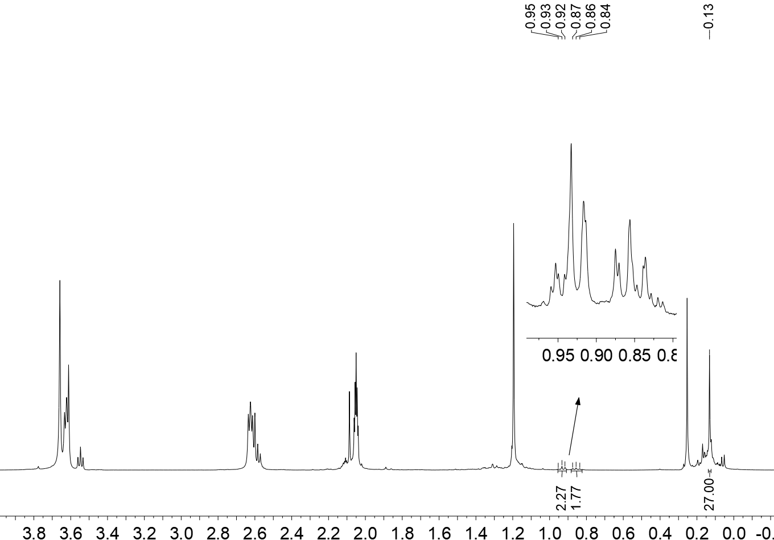

 / ppm

 / ppm

2a

*

*

2a

2,2,2-crypt

2,2,2-crypt

acetone



2a

Figure S4. a) 1H and b) 1H 1H COSY NMR spectrum of crystals of 2 dissolved in acetonitrile-*d3* recorded at r.t..

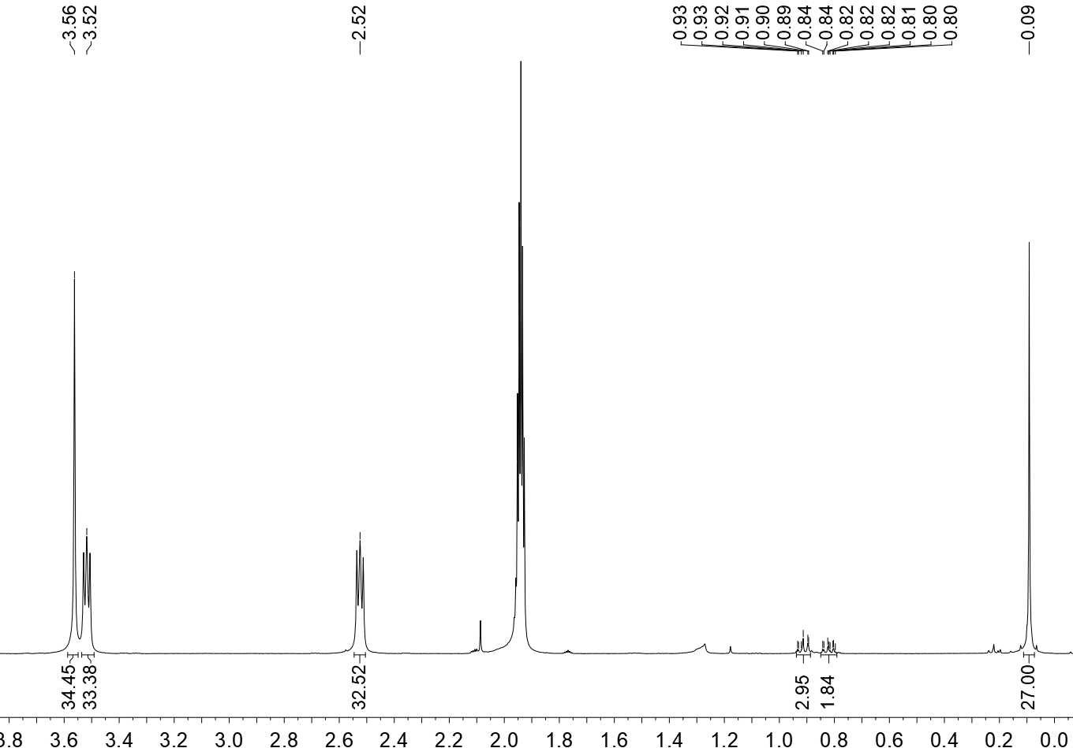

 / ppm

2a

CH3CN

2,2,2-crypt

2,2,2-crypt

2,2,2-crypt

hexane

acetone

a)

2a

2a

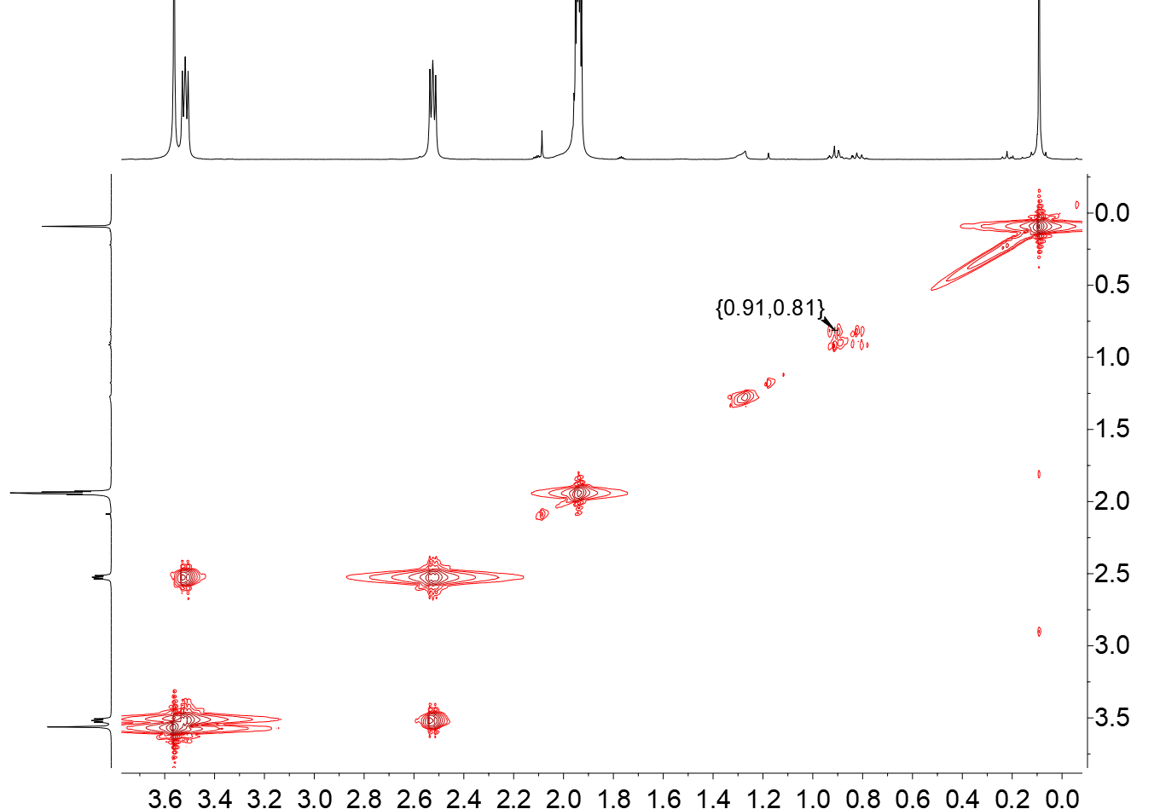

 / ppm

 / ppm

CH3CN

2,2,2-crypt

2,2,2-crypt

2,2,2-crypt

b)

2a

2a

2a

## Crystallographic details on 2



Figure S5. Unit cell of compound 2. The Ge9 clusters are shown as grey polyhedra. The organic moieties are shown schematically. All hydrogen atoms are omitted for clarity.

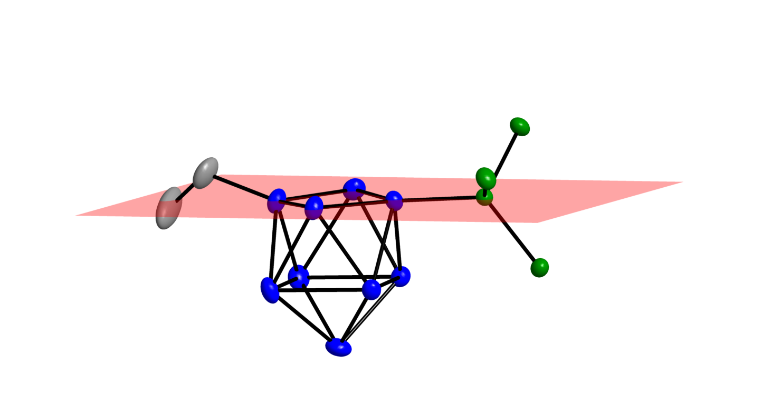

Ge1

Ge3

Si1

Ge4

Ge2

C1

**2a**

Figure S6. Depiction of 2a with plane in red which runs through the atoms Ge1, Ge2, Ge3, Ge4 and Si1. All hydrogen atoms as well as the methyl-groups on the hypersilyl ligand are omitted for clarity. All atoms are shown as ellipsoids at a probability level of 50%.

Table S1. Selected bond lengths [Å] in the crystal structure of 2.

|  |  |  |  |
| --- | --- | --- | --- |
| Ge1−Ge2 | 2.565(1) | Ge4−Ge5 | 2.620(2) |
| Ge1−Ge4 | 2.571(1) | Ge4−Ge8 | 2.679(2) |
| Ge1−Ge5 | 2.607(1) | Ge5−Ge6 | 2.939(2) |
| Ge1−Ge6 | 2.627(1) | Ge5−Ge8 | 2.717(1) |
| Ge1−Si1 | 2.423(3) | Ge5−Ge9 | 2.587(2) |
| Ge2−Ge3 | 2.519(2) | Ge6−Ge7 | 2.711(2) |
| Ge2−Ge6 | 2.623(1) | Ge6−Ge9 | 2.588(2) |
| Ge2−Ge7 | 2.693(2) | Ge7−Ge8 | 2.873(2) |
| Ge3−Ge4 | 2.532(1) | Ge7−Ge9 | 2.589(2) |
| Ge3−Ge7 | 2.596(2) | Ge8−Ge9 | 2.580(2) |
| Ge3−Ge8 | 2.600(2) | C1−C2 | 1.43(2) |
| Ge3−C1 | 2.02(1) |  |  |

# Investigation of a potential desilylation of 1a with 18-crown-6

Figure S7. 1H NMR spectrum of a reaction solution of 1 upon addition of 18-crown-6 recorded in acetone-*d6* at r.t.. K2[Ge9{Si(SiMe3)3}2] (30 mg, 0.024 mmol) was treated with a solution of bromoethane (1.8 **L, 0.024 mmol) in 0.6 mL acetone-*d6*. The reaction solution was stirred for 15.5 h. 18-crown-6 (13 mg, 0.048 mmol) was added to the reaction solution. After 3 h the 1H NMR spectrum was recorded. The 1H NMR spectrum shows that 1a did not undergo a desilylation.

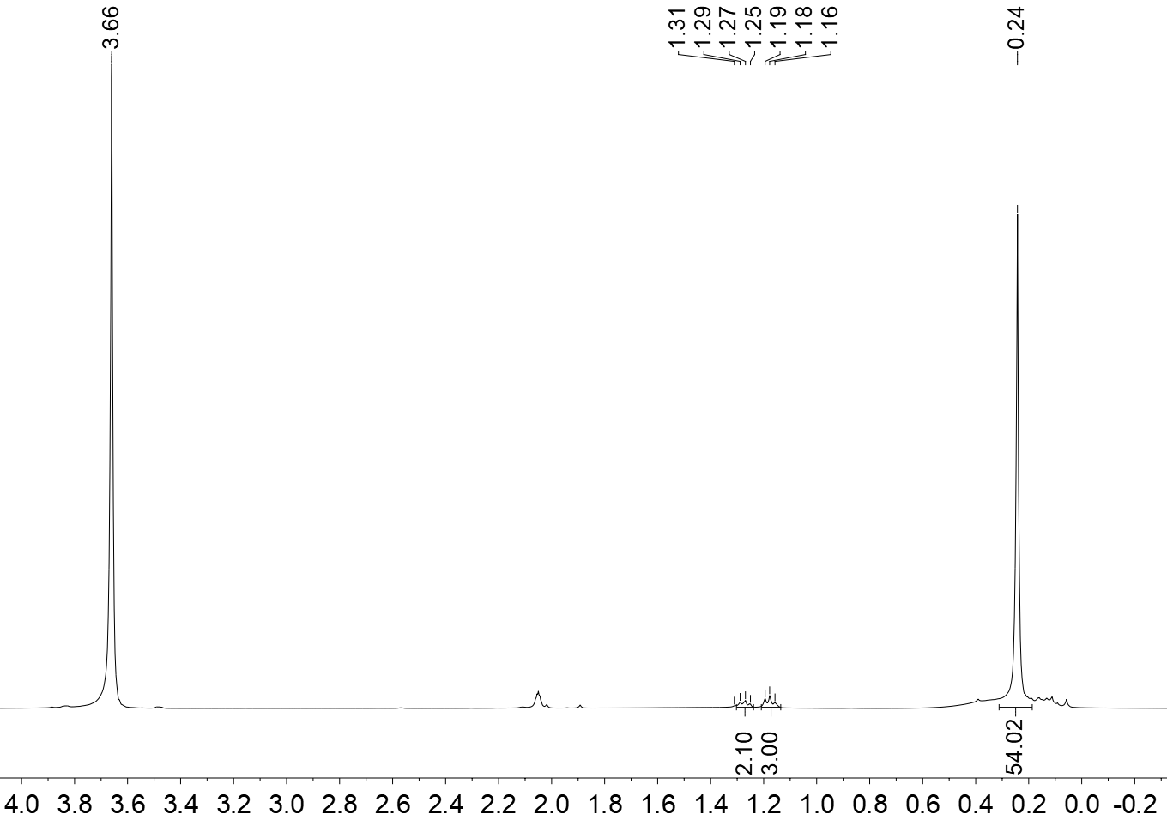

18-crown-6

acetone

1a

 / ppm

1a

1a