**Bulky alkylaminophenol chelates with high potential for functionalization**

Monika Olesiejuk, Karolina Bakalorz, Tomasz Krawczyk, Nikodem Kuźnik*

Faculty of Chemistry, Silesian University of Technology, B. Krzywoustego 4, 44-100 Gliwice

* nikodem.kuznik@polsl.pl, tel. +48 694220077

**Supplementary data**

1. **General**

Melting points were measured using a Stuart SMP3 melting point apparatus. The 1H and 13C NMR spectra were recorded at 25 °C on an Agilent 400-NMR spectrometer in CDCl3 solutions using TMS as the internal standard. HRMS spectra were registered with a Waters ACQUITY UPLC/Xevo G2QT instrument. Thin-layer chromatography was performed on silica gel 60 F254 (Merck). X-ray single crystal measurement**:** measurements of the diffraction intensities were performed on a KUMA KM4 four-circle diffractometer, MoKα radiation, ω/2Θ scan mode. Crystallographic data for 1a and 2a were deposited with the Cambridge Crystallographic Data Centre as supplementary publications number: CCDC 1823197 and 1823198 respectively. A complete listing of the atomic coordinates of x, y, and z can be obtained free of charge, on request, from the Director, Cambridge Crystallographic Data Centre, 12 Union Road, Cambridge CB2 1EZ, UK [fax: (+int) 44-1223 336 033; e-mail: deposit@ccdc.cam.ac.uk], upon quoting the depository numbers, names of the authors and the journal citation.

1. **General Procedure for the Preparation of *N*,*N*-bis(3,5-dialkyl-2-hydroxybenzyl)-3-aminopropan-1-oles** (**1a,b**)

The appropriate 2,4-R-disubstituted phenol derivative (R= methyl, R= *tert*-butyl) (50.00 mmol), 35% formaldehyde solution (3.76 mL, 50.00 mmol), and 3-aminopropan-1-ol (1.90 mL, 25.00 mmol) in ethanol (30 mL) were kept under reflux in an oil bath (130 °C) for 38 h (TLC). After cooling, the mixture was concentrated on a rotary evaporator, then treated with hexane (20 mL) and shaken to dissolve. The solution was then placed into the freezer for four days. The solid precipitate was filtered off, washed with chilled petroleum ether, and air-dried yielding the appropriate *N*,*N*-bis(3,5-dialkyl-2-hydroxybenzyl)-3-aminopropan-1-oles **1a**,**b**.

***N*,*N*-bis(2-hydroxy-3,5-dimethylbenzyl)-3-aminopropan-1-ol** (**1a**).White solid, yield: 24%; mp 124-126 °C; 1H NMR (400 MHz, CDCl3): δ 1.89 (q, 2H, *J* 6.0 Hz, -CH2-CH2-CH2-), 2.21 (s, 12H, CAr-CH3), 2.66 (t, 2H, *J* 6.0 Hz, N-CH2-CH2), 3.67 (s, 4H, CAr-CH2-N), 3.76 (t, 2H, *J* 6.0 Hz, CH2-CH2-OH), 6.71 (s, 2H, CAr‑H), 6.86 (s, 2H, CAr‑H); 13C NMR (100 MHz, CDCl3): δ 15.9; 20.4, 28.4, 51.8, 56.5, 61.4, 121.1, 124.8, 128.1, 128.5, 131.2, 151.8; HRMS Calcd for (C21H29NO3+H+): 344.2220; found: 344.2226. Crystal data:The crystal chosen for X-ray analysis, obtained from recrystallization from chloroform, was a clear colorless plate with the approximate dimensions of 0.8×0.6×0.2 mm. C21H29NO3 (343.45 g mol‑1) crystallizes in the triclinic system, space group P-1 with *a*= 9.2774(19), *b*= 10.995(2), *c*= 11.014(2) Å, α = 78.66(3)º, *β*= 65.19(3)º, γ = 76.08(3)º, V= 984.0(3) Å3, Z=2, μ(MoKα)= 0.077 mm-1, and *D*calcd= 1.159 cm-3. A total of 3624 reflections were collected to 2Θmax= 50.11° (*h*: -10→10 *k*: 0→13, *l*: -12→12), of which 3427 were unique. In refinements, weights were used according to the scheme *w*=1/[σ2(*F*o2)+(0.0866*P*)2+0.30*P*], where *P*=(*F*o2+2*F*c2)/3. The refinement of 343 parameters converged to the final agreement factors *R*=0.0428 for 2249 reflections with Fo > 4σ (Fo) and *R*w=0.1329, and *S*=1.011 for all observed reflections. The electron density of the largest difference peak was found to be 0.16 e Å-3, while that of the largest difference hole was 0.19 e Å-3.

***N*,*N*-bis[2-hydroxy-3,5-di(*tert*-butyl)benzyl]-3-aminopropan-1-ol** (**1b**). White solid, yield: 66%; mp 78-80 °C; 1H NMR (400 MHz, CDCl3): δ 1.22 (s, 18H, CAr-*t*-Bu), 1.36 (s, 18H, CAr-*t*-Bu), 1.70 (m, 2H, -CH2-CH2-CH2-), 2.65 (m, 2H, N-CH2-CH2-), 3.40 (m, 2H, -CH2-CH2-OH), 3.70 (s, 4H, CAr-CH2-N), 6.80 (d, 2H, *J*  2.1 Hz, CAr‑H), 7.17 (d, 2H, *J* 2.1 Hz, CAr-H); 13C NMR (100 MHz, CDCl3): δ 29.5, 31.5, 34.0, 34.7, 45.3, 50.5, 58.1, 63.9, 68.6, 79.9, 73.1, 80.4, 120.0, 123.0, 123.5, 135.6, 140.6, 154.0; HRMS Calcd for (C33H53NO3+H+): 512.4098; found: 512.4103.

1. **General Procedure for the Preparation of *N*,*N*-bis(3,5-dialkyl-2-hydroxybenzyl)-3-chloropropan-1-amines** (**2a,b**)

Freshly distilled thionyl chloride (2.50 mL, 31.10 mmol)was slowly added to a stirred, nitrogen-purged solution of received *N*,*N*-bis(3,5-dialkyl-2-hydroxybenzyl)-3-aminopropan-1-oles **1a,b** (5.00 mmol) in dried CH2Cl2 (55 mL). Stirring was continued for two days at room temperature, then the mixture was concentrated on a rotary evaporator. The residue was neutralized with the use of saturated sodium hydrogen carbonate and stirred for another two days. The mixture was extracted with CH2Cl2 (3 x 20 mL), the organic layer was dried over MgSO4 and then concentrated under reduced pressure. The crude products of *N*,*N*-bis(3,5-dialkyl-2-hydroxybenzyl)-3-chloropropan-1-amines **2a,b** did not require further purification.

***N*,*N*-bis(2-hydroxy-3,5-dimethylbenzyl)-3-chloropropan-1-amine** (**2a**).Bright yellow crystals, yield: 92%; mp 105-109 °C; 1H NMR (400 MHz, CDCl3): δ 1.92 (q, 2H, *J* 6.8 Hz, -CH2-CH2-CH2-), 1.99 (s, 6H, CAr-CH3), 2.09 (s, 6H, CAr-CH3), 2.53 (t, 2H, *J* 6.8 Hz, N-CH2-CH2-), 3.40 (t, 2H, *J* 6.8 Hz, -CH2-CH2-OH), 3.55 (s, 4H, CAr-CH2-N), 6.60 (s, 2H, CAr‑H), 6.71 (s, 2H, CAr‑H); 13C NMR (100 MHz, CDCl3): δ 15.7, 20.3, 29.1, 42.7, 50.5, 56.0, 121.5, 124.2, 128.3, 128.4, 131.0, 151.8; HRMS Calcd for (C21H28NO2Cl+H+): 362.1881; found: 362.1887. Crystal data:The crystal chosen for X-ray analysis, obtained from recrystallization from ethanol, was a clear colorless plate with the approximate dimensions of 0.8×0.4×0.2 mm. C21H28ClNO2 (361.89 g mol‑1) crystallizes in the triclinic system, space group P-1 with *a*= 8.7114(17), *b*= 9.5001(19), *c*= 13.313(3) Å, α = 72.05(3)º, *β*= 75.38(3)º, γ = 74.97(3)º, V= 994.3(3)Å3, Z=2, μ(MoKα)= 0.205 mm-1, and *D*calcd= 1.209 cm-3. A total of 3735 reflections were collected to 2Θmax= 39,99° (*h*: -8→8 *k*: 0→9, *l*: -12→12), of which 1842 were unique. In refinements, weights were used according to the scheme *w*=1/[σ2(*F*o2)+(0.1380*P*)2+0.06*P*], where *P*=(*F*o2+2*F*c2)/3. The refinement of 338 parameters converged to the final agreement factors *R*=0.0541 for 1438 reflections with Fo > 4σ (Fo) and *R*w=0.1641, and *S*=1.030 for all observed reflections. The electron density of the largest difference peak was found to be 0.39 e Å-3, while that of the largest difference hole was 0.26 e Å-3.

***N*,*N*-bis[2-hydroxy-3,5-di(*tert*-butyl)benzyl]-3-chloropropan-1-amine** (**2b**). Brown oil, yield: 91%; 1H NMR (400 MHz, CDCl3): δ 1.31 (s, 18H, CAr-*t*-Bu), 1.44 (s, 18H, CAr-*t*-Bu), 2.06 (quintet, 2H, *J* 6.9 Hz, -CH2-CH2-CH2-), 2.75 (t, 2H, *J* 6.9 Hz, N-CH2-CH2-), 3.52 (t, 2H, *J* 6.9 Hz, -CH2-CH2-Cl), 3.74 (s, 4H, CAr-CH2-N), 6.97 (d, 2H, *J* 2.4 Hz *CAr*-H), 7.27 (d, 2H, *J* 2.4 Hz CAr-H); 13C NMR (100 MHz, CDCl3): δ 29.6, 31.5, 34.1, 34.6, 42.6, 51.0, 57.1, 121.5, 123.5, 125.0, 135.8, 141.6, 152.2; HRMS Calcd for (C33H52NO2Cl+H+): 530.3759; found: 530.3765.

1. **General Procedure for the Preparation of *N,N*-bis(3,5-dialkyl-2-hydroxybenzyl)-*N’*-(2-pyridylmethyl)-propane-1,3-diamines** (**3a,b**)

2-Picolylamine (3.06 mL, 30.00 mmol)was added to a nitrogen-purged solution of received *N*,*N*-bis(3,5-dialkyl-2-hydroxybenzyl)-3-chloropropan-1-amines **2a,b** (3.00 mmol) in ethanol (30 mL). The mixture was refluxed until substrate **2** was fully consumed (TLC; 1.5 h). After cooling, the solvent was evaporated and the crude brown product *N,N*-bis(3,5-dialkyl-2-hydroxybenzyl)-*N’*-(2-pyridylmethyl)-propane-1,3-diamines(**3a,b**) were purified by means of column chromatography (SiO2, CHCl3/MeOH, 9:1 v/v for compound **3a** or Al2O3, hexane/ethyl acetate, 5:1 v/v for compound **3b**).

***N*,*N*-bis(2-hydroxy-3,5-dimethylbenzyl)-*N*’-(2-pyridylmethyl)-propane-1,3-diamine** (**3a**). Brown oil, yield: 56%; 1H NMR (400 MHz, CDCl3): δ 1.74 (q, 2H, *J* 8.0 Hz, -CH2-CH2-CH2-), 2.07 (s, 6H, CAr-CH3), 2.12 (s, 6H, CAr-CH3), 2.48 (t, 2H, *J* 8.0 Hz, N-CH2-CH2-), 2.62 (t, 2H, *J* 8.0 Hz, -CH2-CH2-NH), 3.54 (s, 4H, CAr-CH2-N), 3.87 (s, 2H, NH-CH2-CAr), 6.61 (s, 2H, CAr-H), 6.75 (s, 2H, CAr-H), 7.11 (dd, 1H, *J* 10.0 and 6.4 Hz, CAr-H), 7.24 (d, 1H, *J* 10.0 Hz, CAr-H), 7.57 (td, 1H, *J* 10.0 Hz and 2.4 Hz, CAr-H), 8.47 (d, 1H, *J* 6.4 Hz, CAr-H); 13C NMR (100 MHz, CDCl3 ): δ 16.0, 20.4, 25.7, 47.6, 52.6, 54.6, 56.3, 122.0, 122.2, 123.1, 125.0, 127.9, 128.6, 130.8, 136.6, 149.1, 152.3, 158.3; HRMS Calcd for (C27H35N3O2+H+): 434.2802; found: 434.2808.

***N,N*-bis[2-hydroxy-3,5-di(*tert*-butyl)benzyl]-*N*’-(2-pyridylmethyl)-propane-1,3-diamine** (**3b**). Yellow oil, yield: 38%; 1H NMR (400 MHz, CDCl3): δ 1.24 (s, 18H, CAr-*t*-Bu), 1.33 (s, 18H, CAr-*t*-Bu), 2.26 (m, 2H, -CH2-CH2-CH2-), 2.61 (t, 2H, *J* 5.6 Hz, N-CH2-CH2-), 3.13 (t, 2H, *J* 7.0 Hz, -CH2-CH2-NH), 3.65 (s, 4H, CAr-CH2-N ), 4.28 (s, 2H, NH-CH2-CAr), 6.87 (d, 2H, *J*  2.4 Hz, CAr-H), 7.16 (d, 2H, *J* 2.0 Hz, CAr-H), 7.27 (dd, 1H, *J* 4.4 and 7.4 Hz, CAr-H), 7.43 (d, 1H, *J* 7.4 Hz, CAr-H), 7.72 (td, 1H, *J* 7.4 Hz and 1.6 Hz, CAr-H), 8.52 (d, 1H, *J* 4.4 Hz, CAr-H); 13C NMR (100 MHz, CDCl3 ): δ 29.7, 31.5, 34.0, 34.6, 46.6, 51.2, 56.7, 122.9, 123.3, 123.4, 123.7, 125.3, 136.6, 137.5, 141.6, 149.3, 152.0; HRMS Calcd for (C39H59N3O2+H+): 602.4680; found: 602.4686.

1. **Procedure for the Preparation of ­­*N*,*N*-bis[2-hydroxy-3,5-di(*tert*-butyl)benzyl]-1,3-diazinane** (**4**)

2,4‑Di(*tert-*butyl)phenol (10.30 g, 50.00 mmol), 35% formaldehyde solution (3.76 mL, 50.00 mmol) and 1,3-propanediamine (1.90 mL, 25.00 mmol) in ethanol (30 mL) were kept under reflux in an oil bath (130 °C) for 38 h (TLC). After cooling, the mixture was concentrated on a rotary evaporator, then treated with hexane (20 mL) and heated to dissolve. The solution was then placed into the freezer for four days. The solid precipitate was filtered off, washed with chilled petroleum ether, and air-dried yielding the pure ­­*N*,*N*-bis[2-hydroxy-3,5-di(*tert*-butyl)benzyl]-1,3-diazinane (**4**).

**­­*N*,*N*-bis[2-hydroxy-3,5-di(*tert*-butyl)benzyl]-1,3-diazinane** (**4**). White solid, yield: 28%; mp 180-182 °C;1H NMR (400 MHz, CDCl3): δ 1.33 (s, 18H, CAr-*t*-Bu), 1.47 (s, 18H, CAr-*t*-Bu), 1.81 (m, 2H, -CH2-CH2-CH2-), 2.76 (m, 4H, N-CH2-CH2-CH2-N), 3.52 (m, 2H, N-CH2-N), 3.81 (s, 4H, CAr-CH2-N), 6.91 (m, 2H, CAr‑H), 7.28 (m, 2H, CAr‑H); 13C NMR (100 Mhz, CDCl3): δ: 29.72, 31.78, 34.23, 34.97, 50.78, 58.37, 73.26, 120.26, 123.27, 123.71, 135.88, 140.81, 154.25; HRMS Calcd for (C34H54N2O2+H+): 523.4258; found: 523.4263

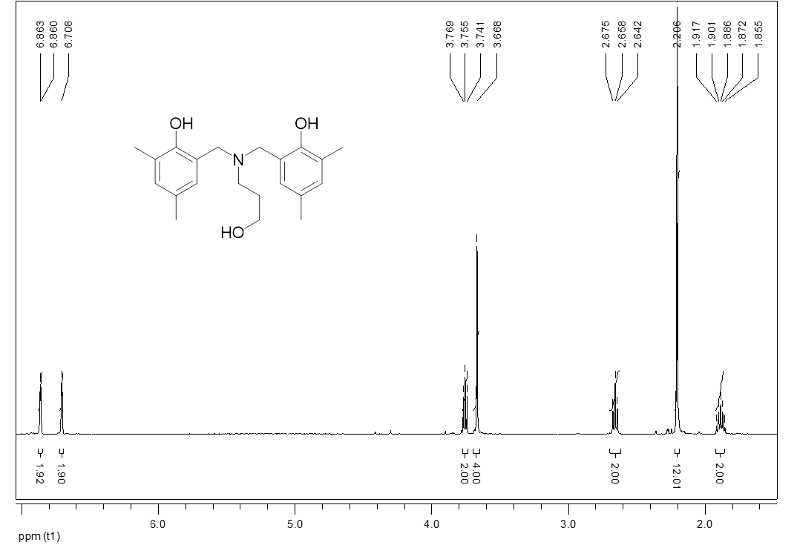

1H NMR spectrum of **1a**

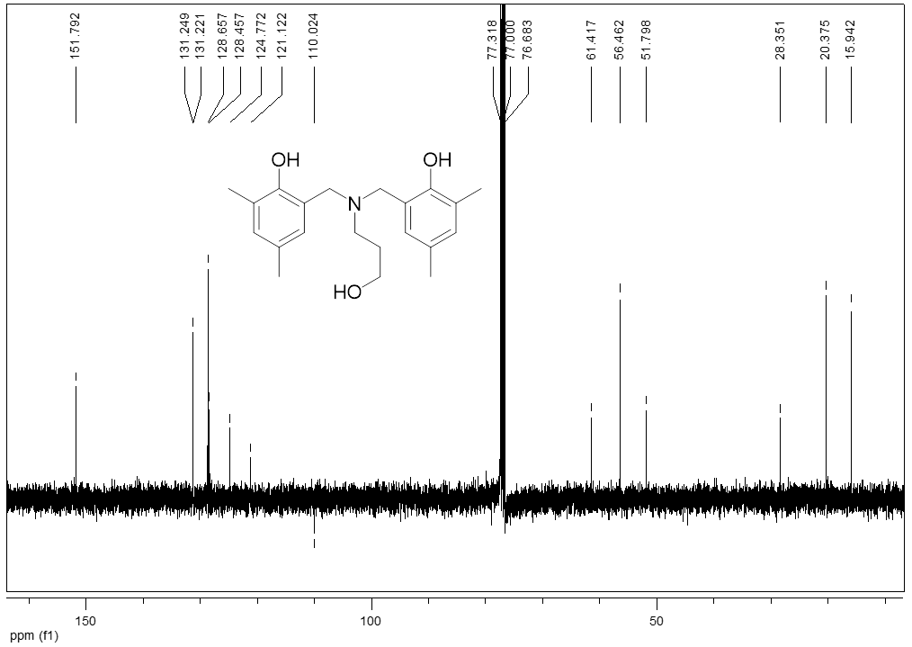

13C NMR spectrum of **1a**

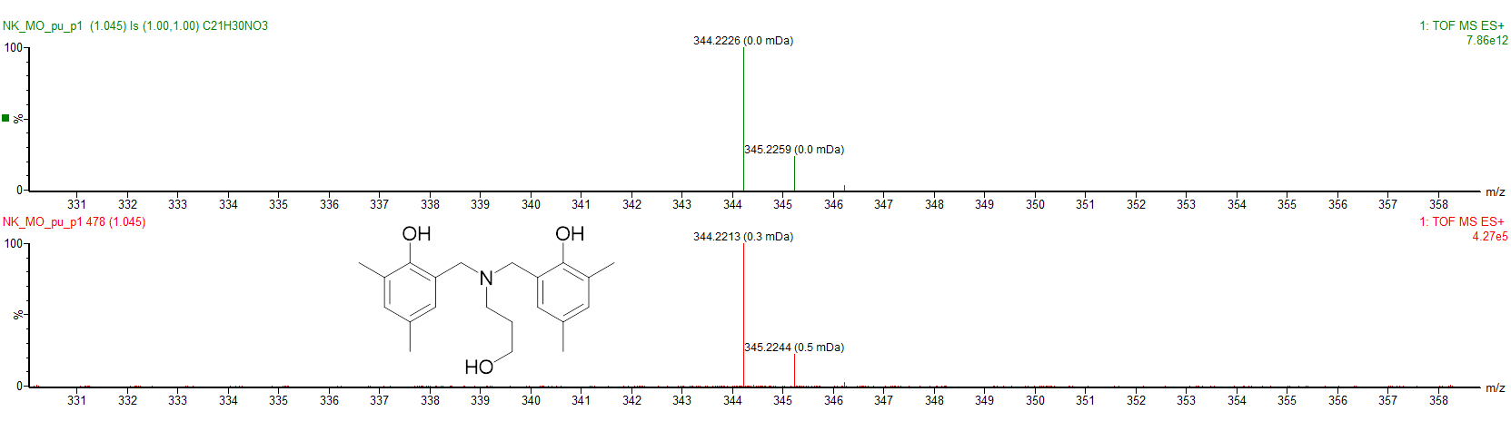

HRMS (ESI) of **1a**



X-ray structure of**1a**

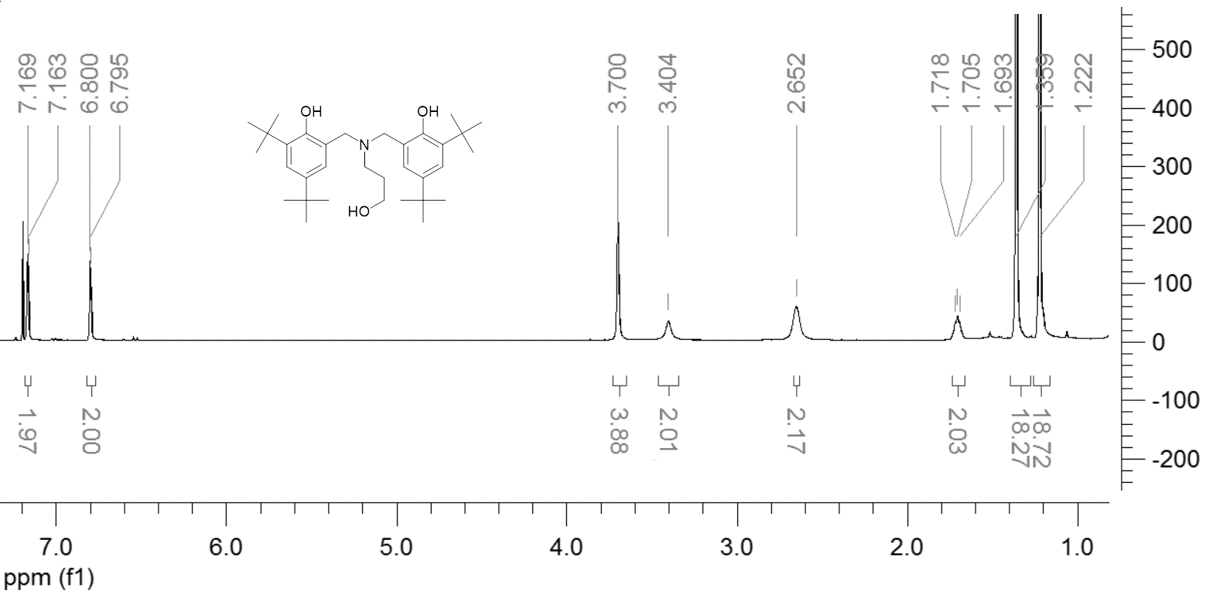

1H NMR spectrum of **1b**

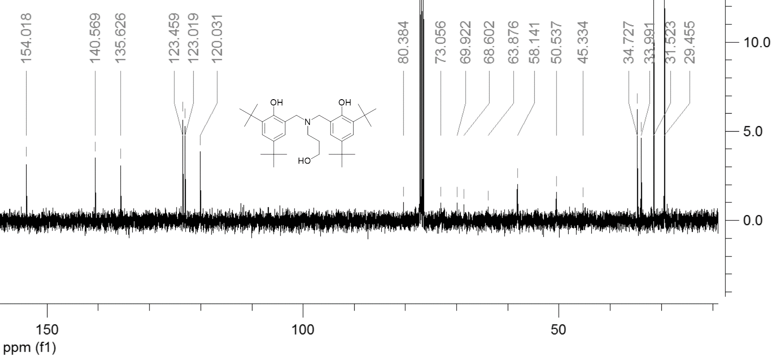13C NMR spectrum of **1b**

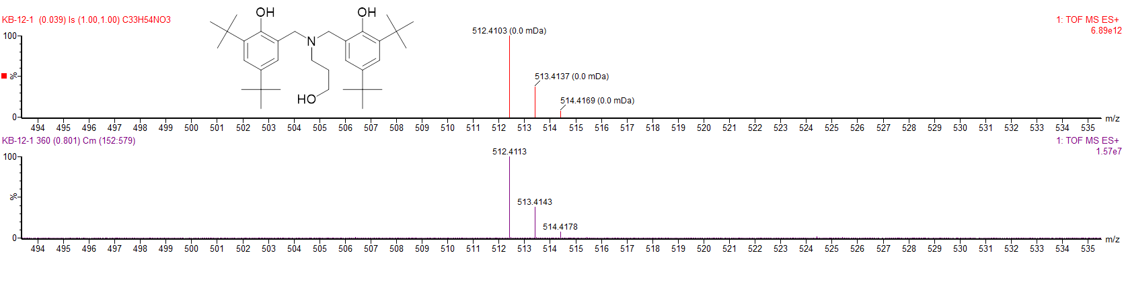HRMS (ESI) of **1b**

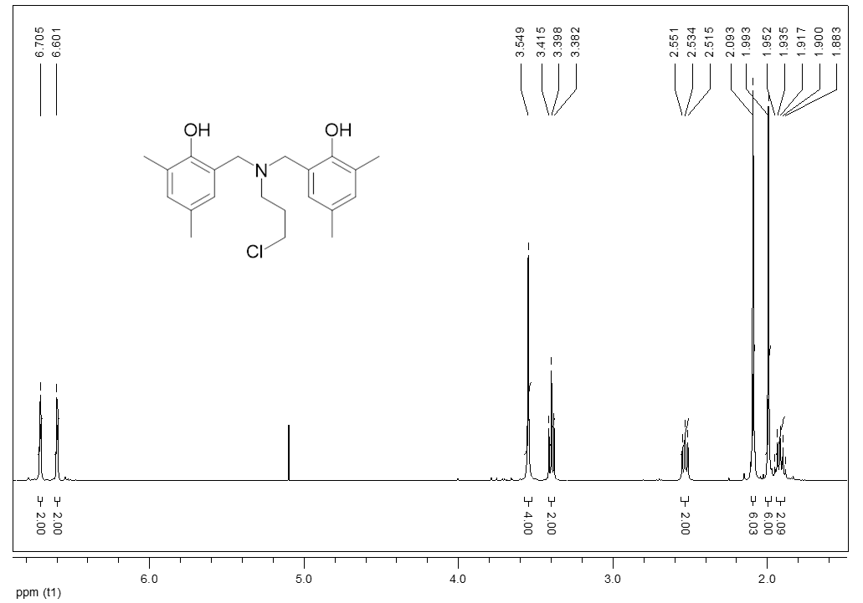

1H NMR spectrum of **2a**

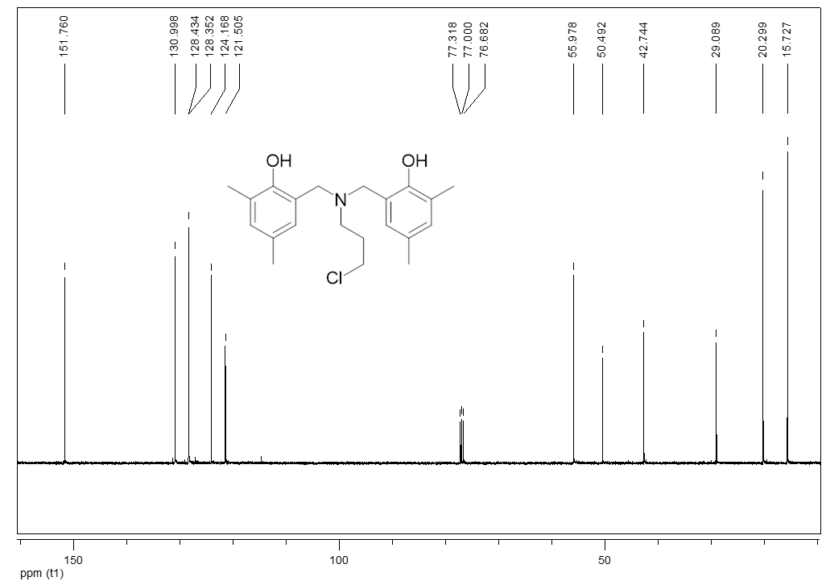

13C NMR spectrum of **2a**

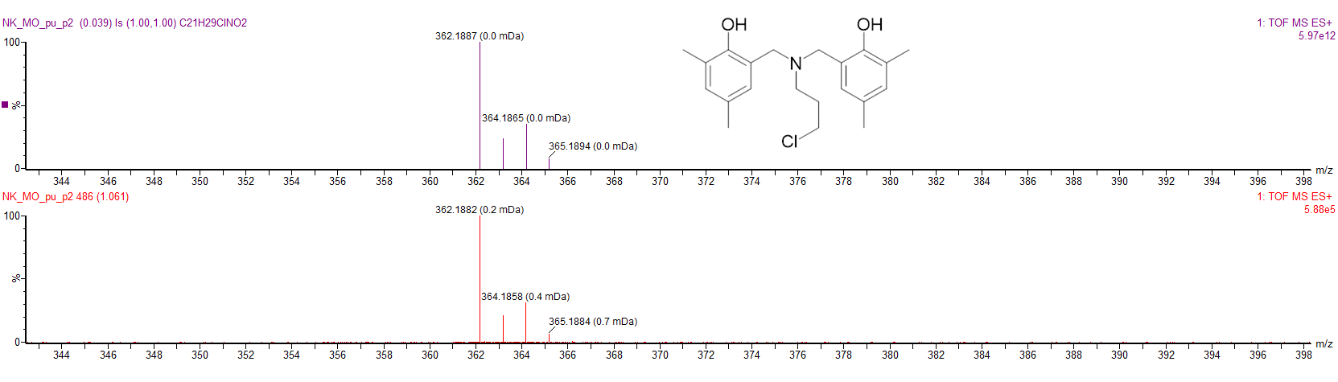

HRMS (ESI) of **2a**

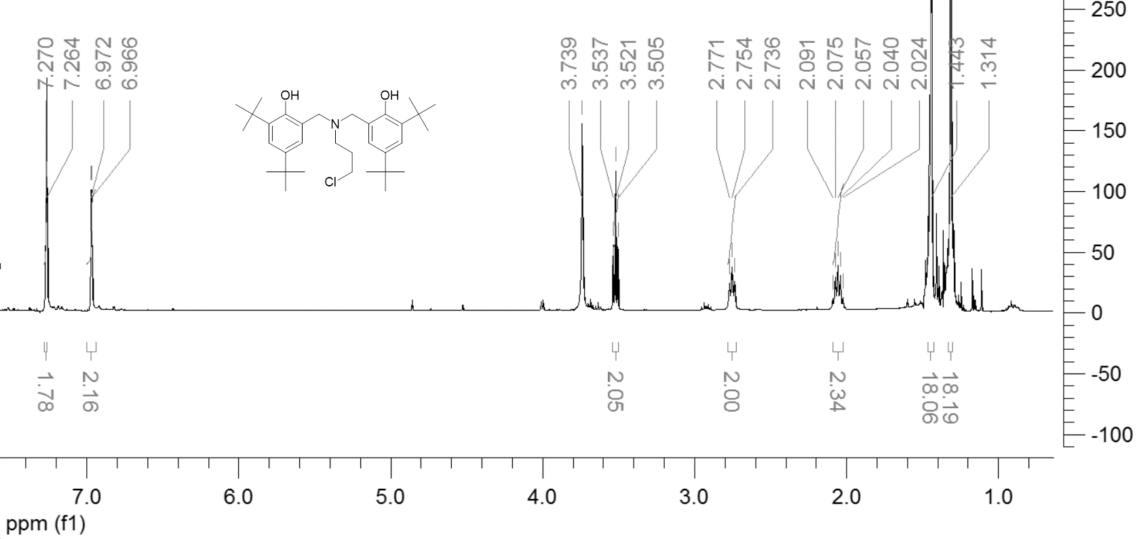

­1 H NMR spectrum of **2b**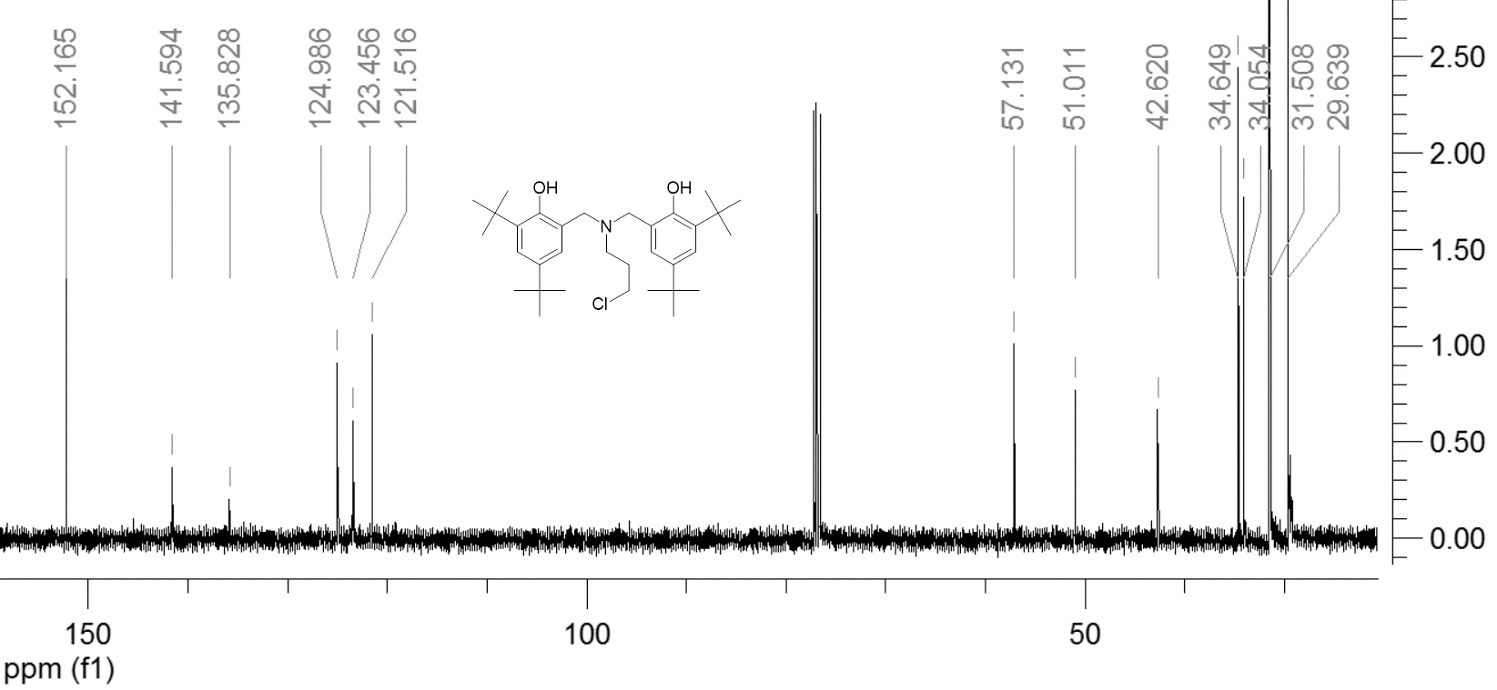

13C NMR spectrum of **2b**

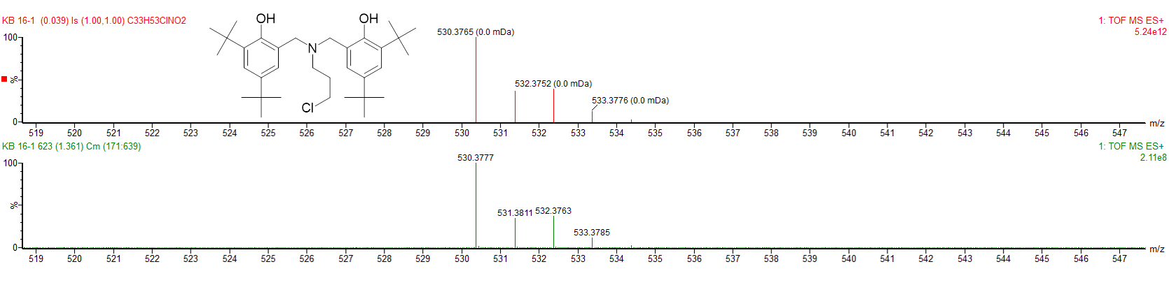

HRMS (ESI) of **2b**

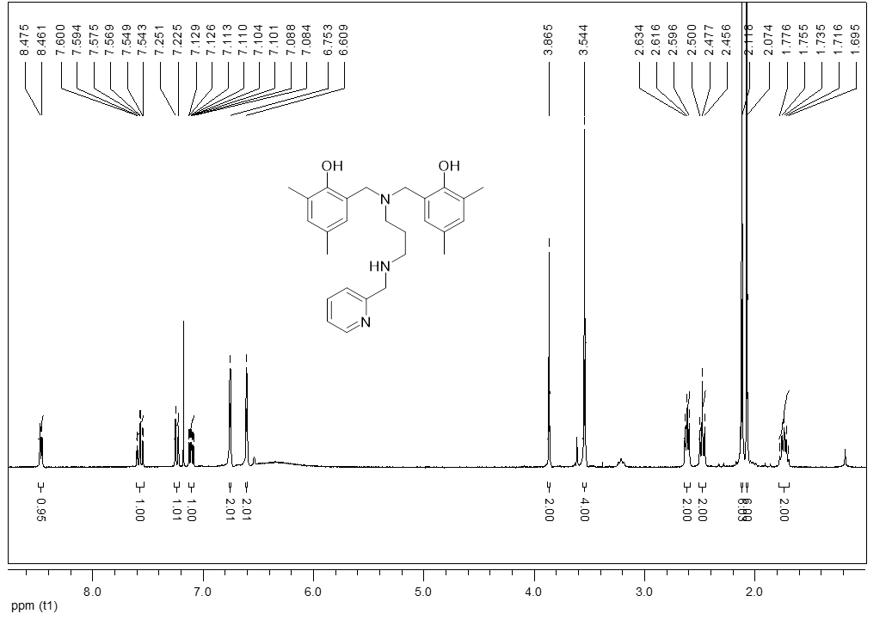

1H NMR spectrum of **3a**

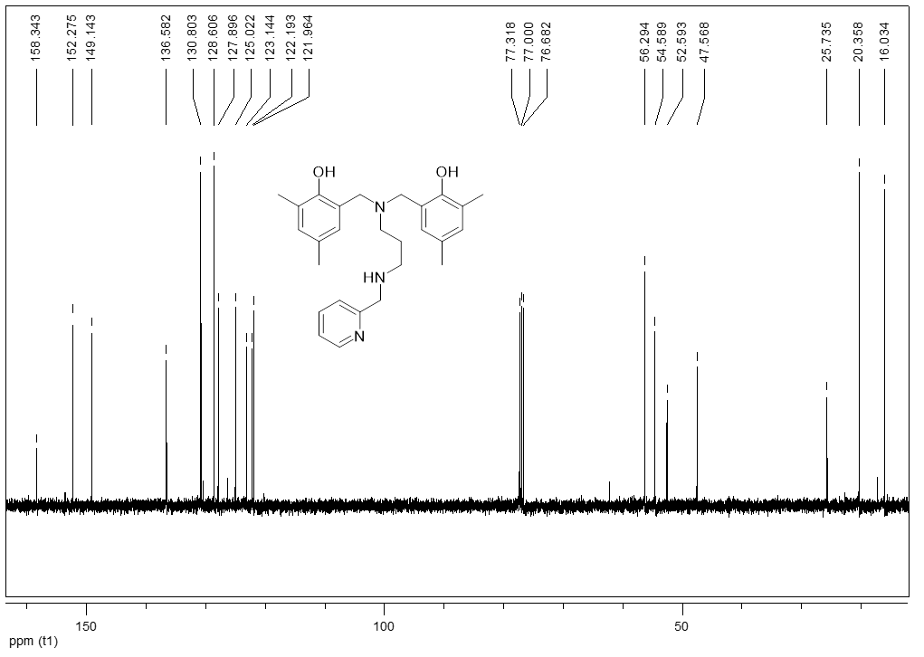

13C NMR spectrum of **3a**

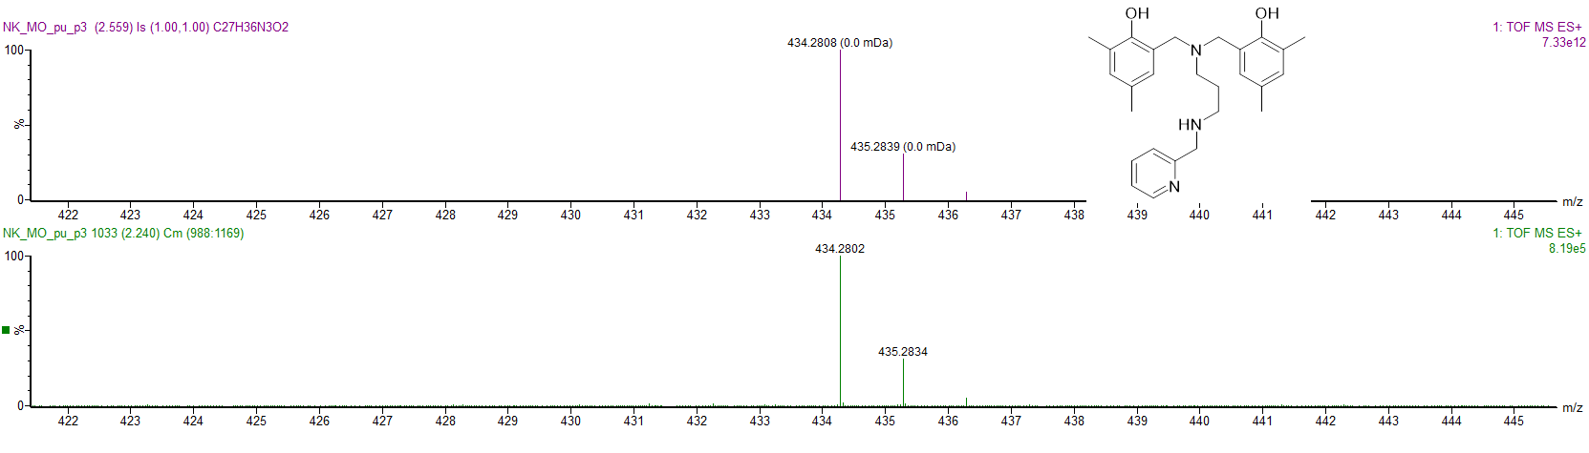

HRMS (ESI) of **3a**

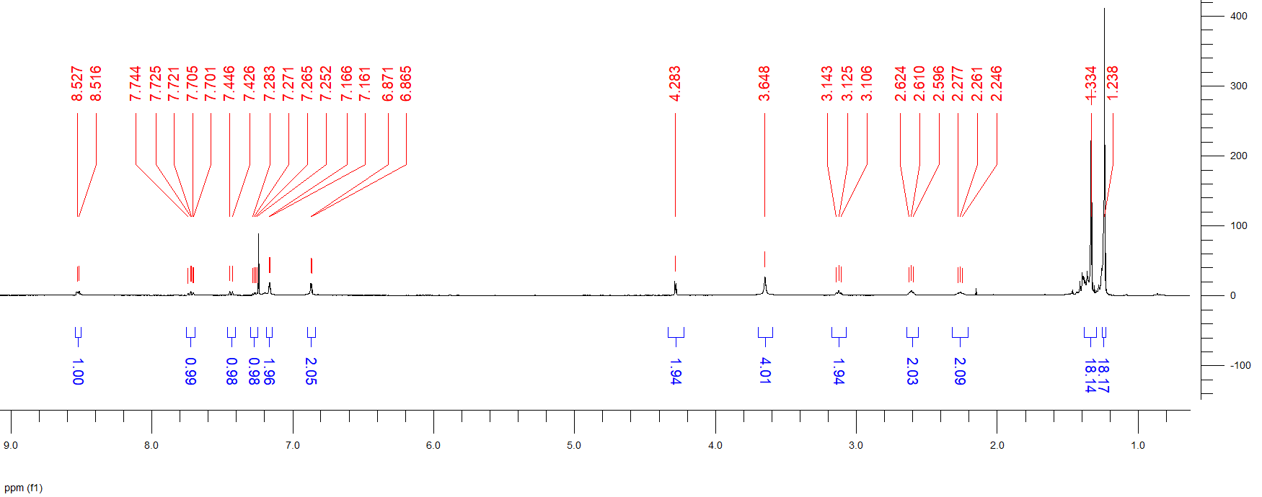

1H NMR spectrum of **3b**

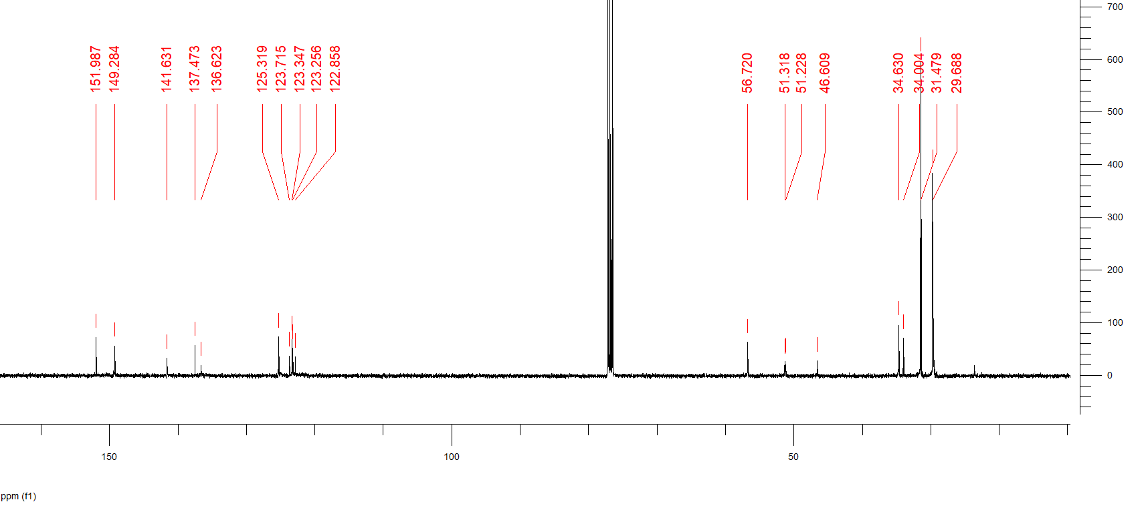

13C NMR spectrum of **3b**

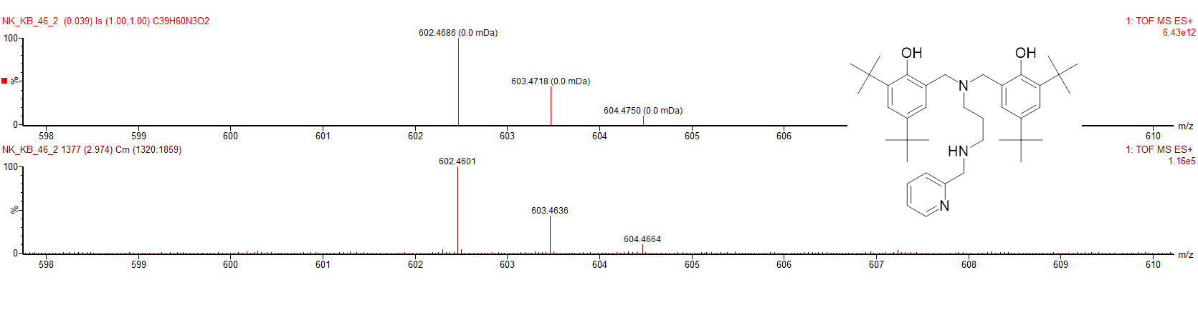

HRMS (ESI) of **3b**

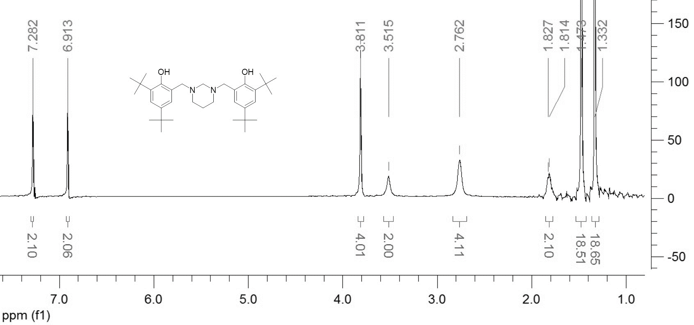

1H NMR spectrum of **4**

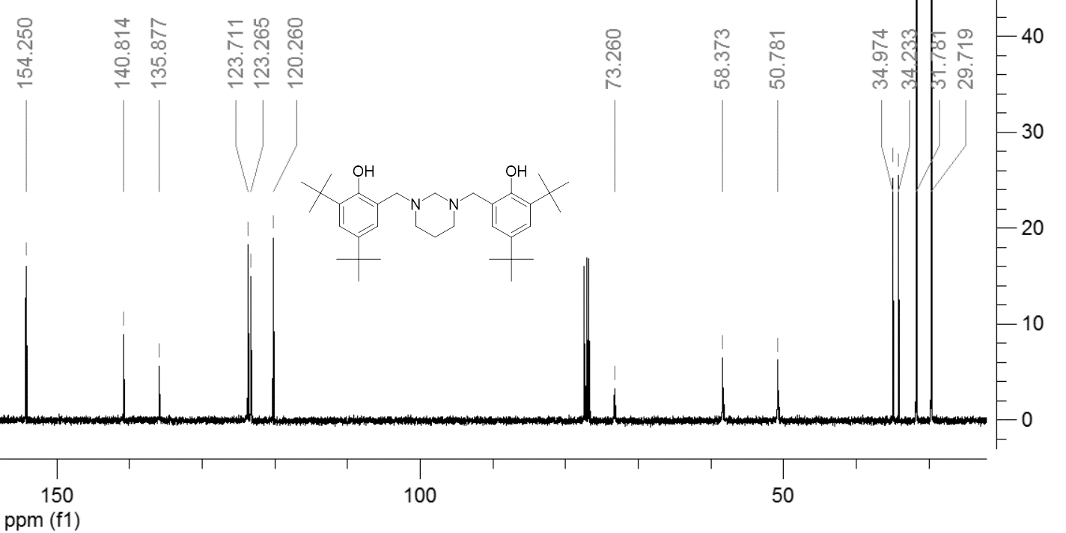

13 C NMR spectrum of **4**

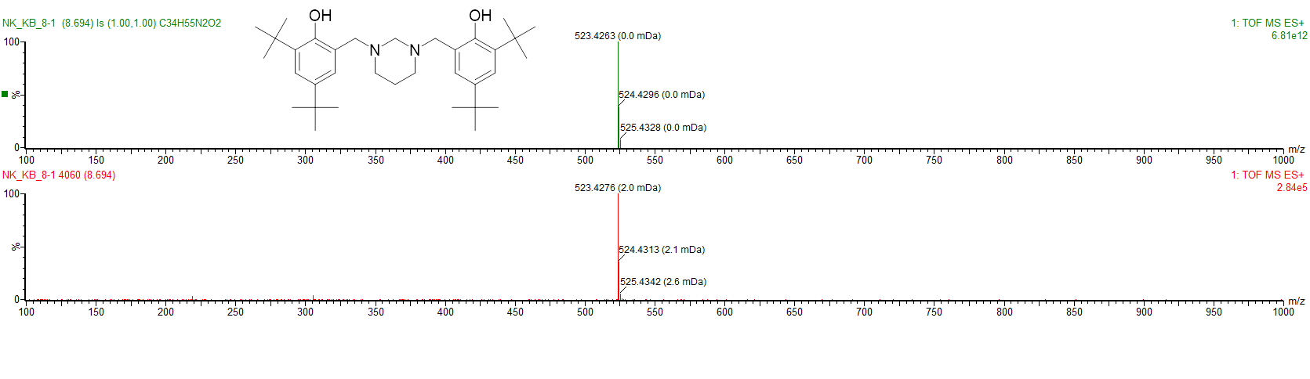HRMS (ESI) of **4**