Cover Page for Supplementary Information
Manuscript title: Novel magnetic biosorbent prepared by oak shell waste material as an efficient adsorbent for consecutive removal of Pb²⁺, Ag⁺, Ba²⁺, Sr²⁺ and chromate from aqueous solutions
Author list: Maryam Adibmehr. Hossein Faghihian*
Department of Chemistry, Shahreza Branch, Islamic Azad University, Shahreza, Iran P.O. Box 311-86145, Shahreza, Iran
Total number of pages (including the cover page): 8 pages
This Supplementary Information contains:
Figure S1. EDAX analysis of AC-Fe₃O₄-DTZ sample.
Figure S2. Adsorption capacity of Pb-ads-4(a), Ag-ads-4(b),Ba-ads-4(c), Sr-ads-4(d) adsorbents.
Figure S3. Pseudo-first-order kinetics equation.
Figure S4. Pseudo-second-order kinetics equation.
Figure S5. Equilibrium distribution of Cr (VI) species in aqueous medium.
Figure S6. Langmuir, Freundlich, Redlich-Peterson,Sips isotherm of Pb-ads-4 (a), Ag-ads-4 (b),Ba-ads-4 (c), Sr-ads-4 (d) adsorbents.
Figure S7. Van‘t Hoff plot of ln K_{d} versus 1/T.

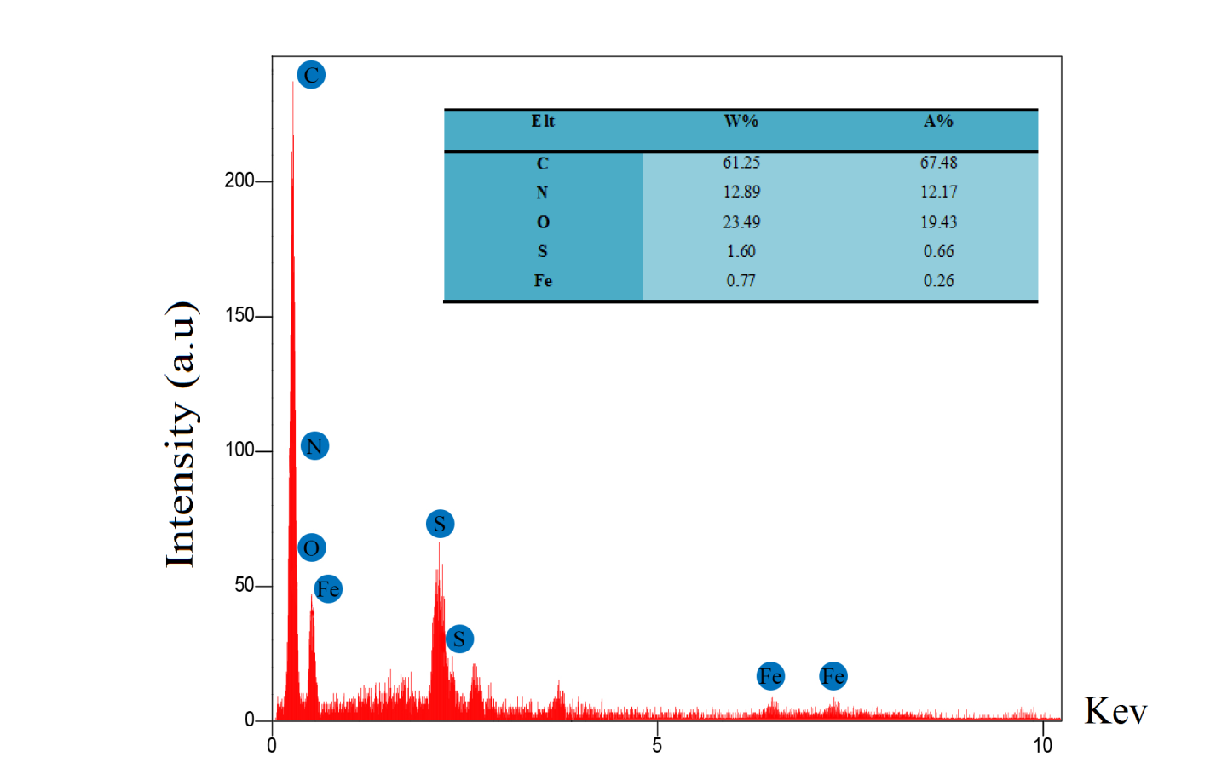
Fig. S1. EDAX analysis of AC-Fe₃O₄-DTZ sample.

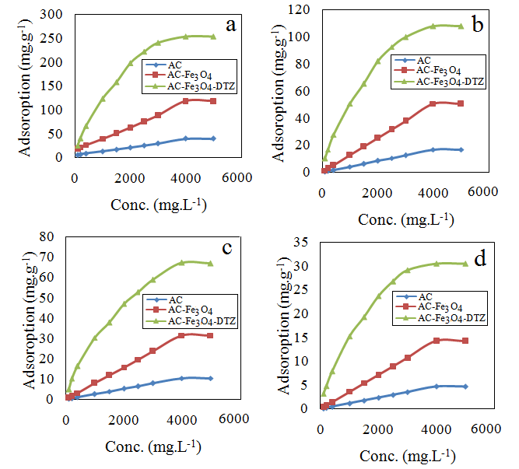
Fig. S2.Adsorption capacity of Pb-ads-4(a) ,Ag-ads-4(b),Ba-ads-4(c), Sr-ads-4(d) adsorbents.

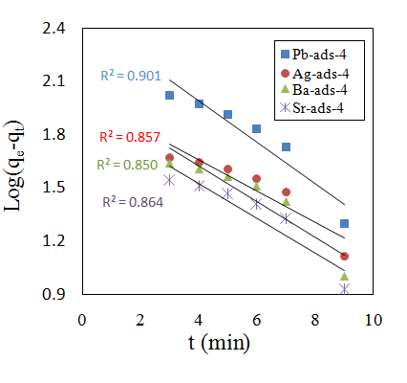
Fig. S3. Pseudo-first-order kinetics equation.

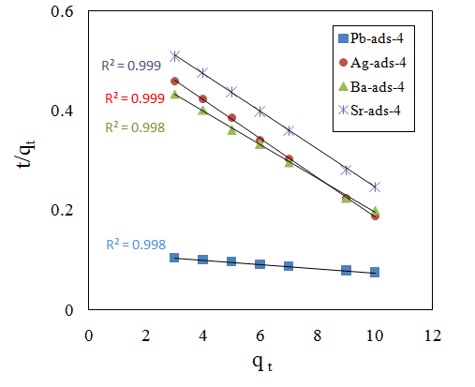
Fig. S4. Pseudo-second-order kinetics equation.

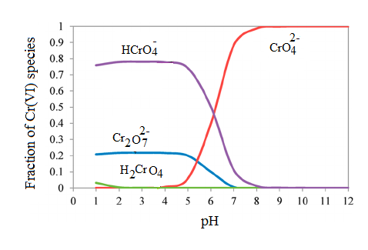
Fig. S5. Equilibrium distribution of Cr(VI) species in aqueous medium.

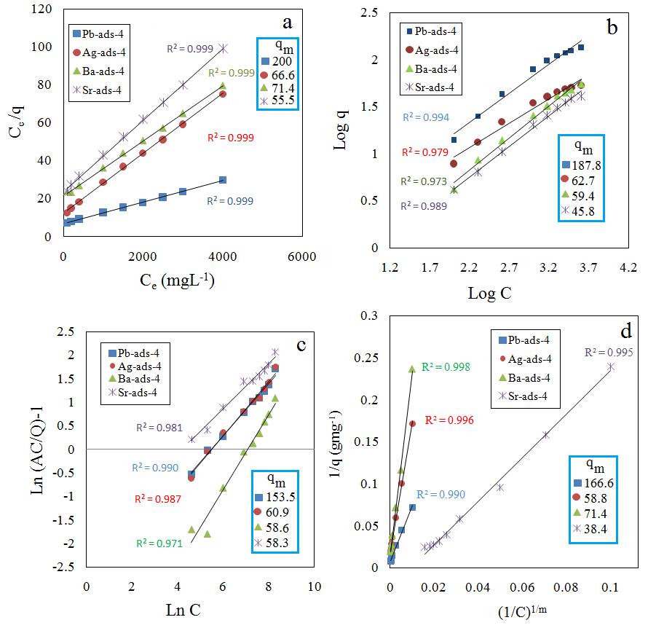
Fig. S6. Langmuir, Freundlich, Redlich-Peterson, Sips isotherm of Pb-ads-4 (a),Ag-ads-4 (b), Ba-ads-4(c), Sr-ads-4(d) adsorbents.

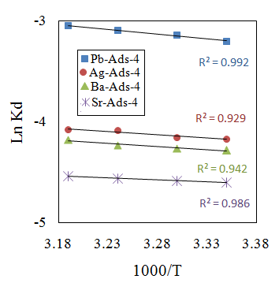
Fig. S7. Van‘t Hoff plot of ln K_{d} versus 1/T.

