Supporting information

Novel 4-Azaandrostenes as Prostate Cancer Cell Growth Inhibitors: Synthesis, Antiproliferative Effects and Molecular Docking Studies

Vanessa Brito,¹ Adriana O. Santos,¹ Paulo Almeida,¹ Samuel Silvestre ^{1,2}*

¹CICS-UBI- Centro de Investigação em Ciências da Saúde, Universidade da Beira Interior, Av. Infante D. Henrique, 6200-506 Covilhã, Portugal
²CNC - Center for Neuroscience and Cell Biology, Universidade de Coimbra, Coimbra, Portugal.
*Corresponding author. Tel. +351 275329002; E-mail: samuel@fcsaude.ubi.pt

Table of Contents
Microscopic cell morphology observations
MTT assay: concentration-response curves
Contour plots in the flow cytometry assay
Molecular Docking Results

Microscopic cell morphology observations
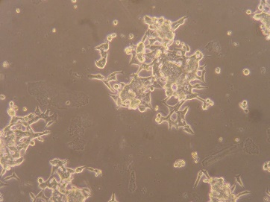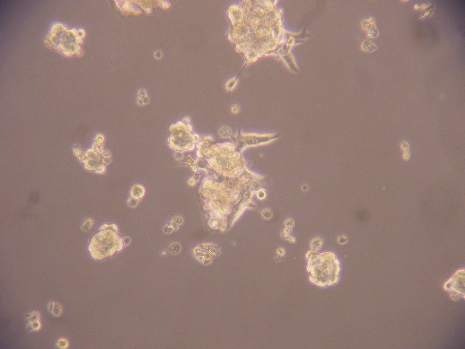
d
D
Figure S1. Photographs taken after incubation of LNCaP cells with the compounds (24 and 72 h, zoom: 100$×$). (A) control after 24 h, (a) control after 72 h; (B) cells after 24 h of incubation with finasteride, (b) cells after 72 h of incubation with finasteride; (C) cells after 24 h of incubation with compound 4b, (c) cells after 72 h of incubation with compound 4b; (D) cells after 24 h of incubation with 5-FU, (d) cells after 72 h of incubation with 5-FU.

MTT assay: concentration-response curves
Figure S2. Concentration-response curves of compounds 4a, 4b, 4c, Finasteride and 5-FU in LNCaP cells and of 4a, 4b and 5-FU in PC-3 cells.
Figure S3. Concentration-response curves of compound 4g in T47-D cells and 5-FU in T47-D and NHDF cells.

Contour plots in the flow cytometry assay
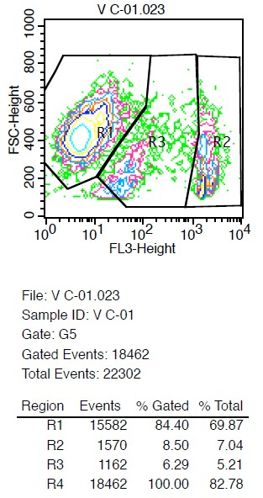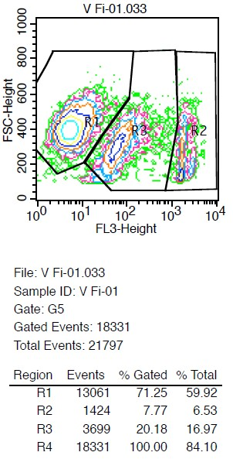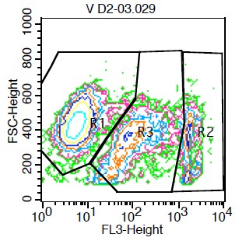
Control 24 h
Finasteride 1 24 h
4b 24 h
Figure S4. Examples of contour plots in the flow cytometry assay with PI staining showing the different plotted regions, R1, R2 and R3.

Molecular Docking Results

Table S1. Molecular docking results for simulations between 5BR and the compounds synthesized.
 |  |  |  |  | Energy (kcal.mol⁻¹)
Compound |  | Number of clusters |  |  | Lowest energy | Average energy
4a |  | 1 |  |  | -9.47 | -9.47
4b |  | 1 |  |  | -9.99 | -9.86
4c |  | 5 |  |  | -10.08 | -9.94
4d |  | 1 |  |  | -9.81 | -9.81
4e |  | 1 |  |  | -10.00 | -9.99
4f |  | 1 |  |  | -9.97 | -9.97
4g |  | 2 |  |  | -9.87 | -9.85

Table S2. Molecular docking results for simulations between ERα and the compounds synthesized.
 |  |  |  |  | Energy (kcal.mol⁻¹)
Compound |  | Number of clusters |  |  | Lowest energy | Average energy
4a |  | 1 |  |  | -8.97 | -8.96
4b |  | 3 |  |  | -7.94 | -7.81
4c |  | 3 |  |  | -7.9 | -7.55
4d |  | 2 |  |  | -9.15 | -9.13
4e |  | 2 |  |  | -8.81 | -8.79
4f |  | 1 |  |  | -8.8 | -8.79
4g |  | 1 |  |  | -9.09 | -9.08

Table S3. Molecular docking results for simulations between AR and the compounds synthesized.
 |  |  |  |  | Energy (kcal.mol⁻¹)
Compound |  | Number of clusters |  |  | Lowest energy | Average energy
4a |  | 1 |  |  | -9.62 | -9.6
4b |  | 1 |  |  | -6.76 | -6.74
4c |  | 4 |  |  | -2.61 | -2.51
4d |  | 1 |  |  | -11.78 | -11.77
4e |  | 2 |  |  | -10.36 | -10.3
4f |  | 1 |  |  | -10.16 | -10.16
4g |  | 2 |  |  | -10.77 | -10.52

Table S4. Molecular docking results for simulations between CYP17A1 and the compounds synthesized.
 |  |  |  |  | Energy (kcal.mol⁻¹)
Compound |  | Number of clusters |  |  | Lowest energy | Average energy
4a |  | 1 |  |  | -11.31 | -11.31
4b |  | 1 |  |  | -11.37 | -11.36
4c |  | 2 |  |  | -11.13 | -11.1
4d |  | 1 |  |  | -11.01 | -11.01
4e |  | 1 |  |  | -10.96 | -10.95
4f |  | 1 |  |  | -11.18 | -11.18
4g |  | 1 |  |  | -11.46 | -11.46

Table S5. Molecular docking results for simulations between aromatase and the compounds synthesized.
 |  |  |  |  | Energy (kcal.mol⁻¹)
Compound |  | Number of clusters |  |  | Lowest energy | Average energy
4a |  | 2 |  |  | 0.70 | 2.61
4b |  | 1 |  |  | 3.58 | 3.64
4c |  | 1 |  |  | 5.45 | 5.73
4d |  | 1 |  |  | -6.43 | -6.25
4e |  | 1 |  |  | -4.83 | -4.80
4f |  | 1 |  |  | -6.72 | -6.31
4g |  | 1 |  |  | -6.73 | -6.64

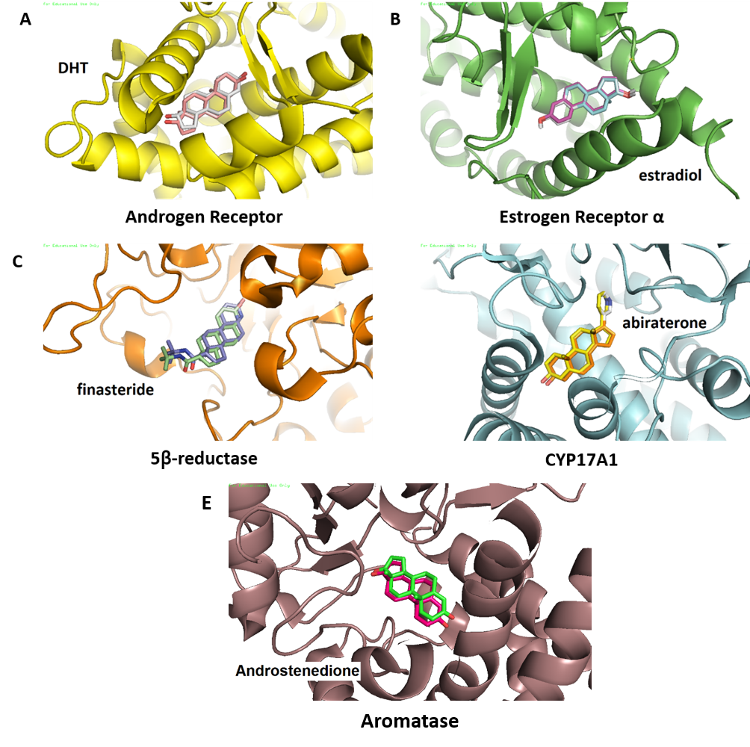
D

Figure S5. Autodock re-docking of ligands present in the X-ray crystal structures of protein targets used in molecular docking simulations. (A) DHT in complex with androgen receptor (AR); (B) β-estradiol in complex with estrogen receptor-α (ERα); (C) finasteride in complex with 5β-reductase (5BR); (D) abiraterone in complex with CYP17A1 and (E) androstenedione in complex with aromatase. The RMSD between re-docked ligands and the corresponding X-ray crystal structure coordinates was ≤ 1 for all cases.

Figure S6. Analysis of predicted AR binding orientations for the best ranked compound, 4d (binding energy higher than re-docking energies). (A) 3D molecular and (B) 2D docking result, showing the principal interactions with the residues Arg 752 and Gln 711 (common interactions with the binding between DHT and AR).

Figure S7. Overlap of compound 4d (in turquoise) and DHT (in soft pink) in the binding pocket of AR. The lactam group of 4d is aligned with the hydroxyl group of DHT.

Figure S8. Analysis of predicted 5BR binding orientations for the best ranked compounds 4b, 4c, 4e, 4f – (A) 3D and (B) 2D docking results showing the principal interactions with cofactor (polar interaction), Glu 120, Tyr 132, Tyr 58 as well as of finasteride and cofactor, Tyr 132 and Tyr 58 (common interactions with the binding between finasteride and 5BR).

Figure S9. Overlap of 4b (in violet) and finasteride (in green) in the binding pocket of 5BR. The orientation of the two compounds is identical and both lactam groups are aligned and interacting through hydrogen bound with the cofactor NADP.

Figure S10. Analysis of predicted CYP17A1 binding orientations for the two best ranked compounds 4b and 4g – (A) 3D and (B) 2D docking results showing the principal interactions with Asn 202, Ile 205, Ala 302, Val 483 and Thr 306 (common interactions with the binding between abiraterone and CYP17A1).

