Supplementary Information

**Insight into surface and structural changes of Montmorillonite and Organo-montmorillonites loaded with Ag.**

*Alejandra M. Fernández Solarteab, Jhonny Villarroel-Rochac, César Fernández Morantesad, Maria L. Montese, Karim Sapagc, Gustavo Curutchetd and Rosa M. Torres Sáncheza(*)*

aCETMIC-CCT La Plata-CIC, Camino Centenario y 506, (1897) M. B. Gonnet, La Plata, Argentina. bpresent address. Research group on Mechanical Desing and Material (GIDMyM), Univ. ECCI. Calle 51#19-12, Bogota DC, Colombia. cLaboratorio de Sólidos Porosos, INFAP-CONICET, Univ. Nacional de San Luis, Chacabuco 917, CP 5700, San Luis, Argentina. dLaboratorio de Análisis Ambiental, Instituto de Investigación e Ingeniería Ambiental. Univ. Nacional de San Martín, Av. 25 de Mayo y Francia, San Martin (1650), Buenos Aires, Argentina. eIFLP, Instituto de Física La Plata. CONICET-CCT-La Plata, Departamento de Física, Facultad de Ciencias Exactas, Universidad Nacional de La Plata, La Plata, Argentina.

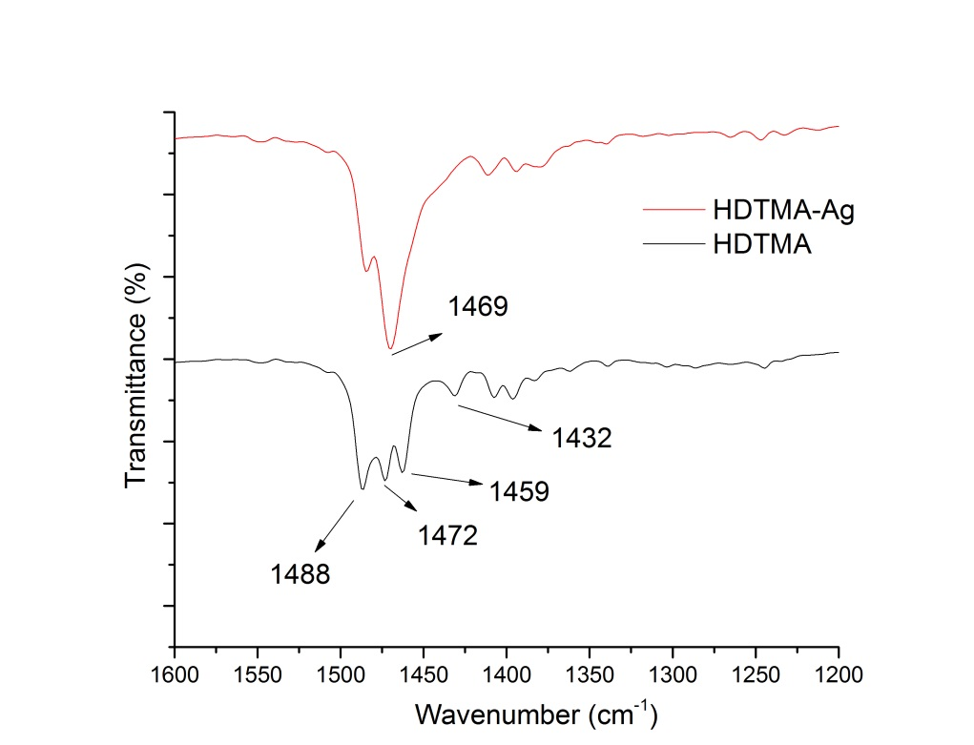

**Figure S1.** FTIR of HDTMA and HDTMA-Ag complex in solution

 {

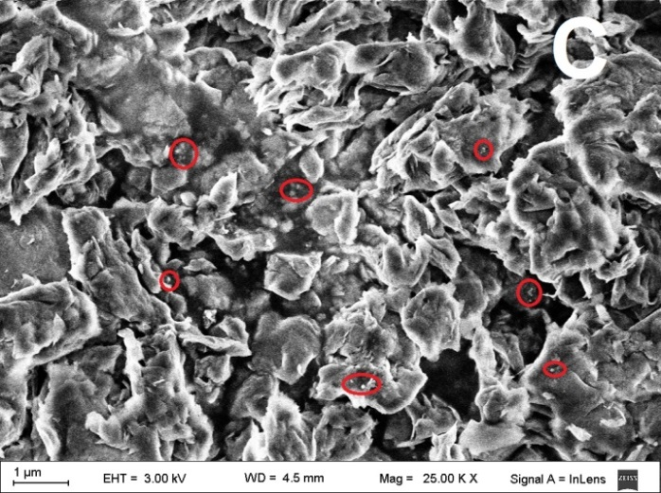 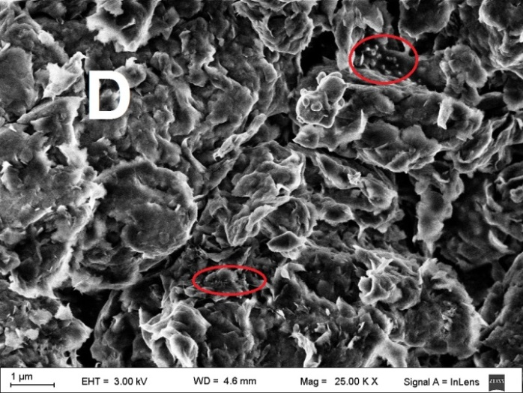

**Figure S2.** SEM images: (A) MMT-Ag, (B) MH.5-Ag, (D) MH1-Ag and (D) MH2-Ag samples. Red circles evidence Ag aggregates.

|  |  |  |
| --- | --- | --- |
| Element | Weight% | Atomic% |
| O K | 49.94 | 63.85 |
| Mg K | 2.00 | 1.68 |
| Al K | 13.82 | 10.48 |
| Si K | 31.82 | 23.18 |
| Fe K | 1.99 | 0.73 |
| Ag L | 0.43 | 0.08 |
|  |  |  |
| Totals | 100.00 |  |

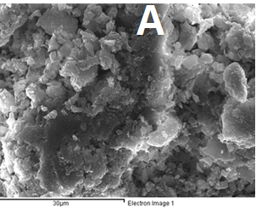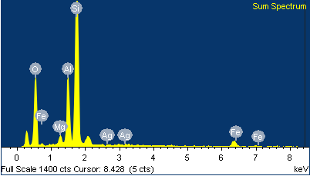

|  |  |  |
| --- | --- | --- |
| Element | Weight% | Atomic% |
| O K | 51.384 | 65.18 |
| Mg K | 1.85 | 1.54 |
| Al K | 12.85 | 9.67 |
| Si K | 32.09 | 23.19 |
| Fe K | 0.45 | 0.16 |
| Ag L | 1.39 | 0.26 |
|  |  |  |
| Totals | 100.00 |  |

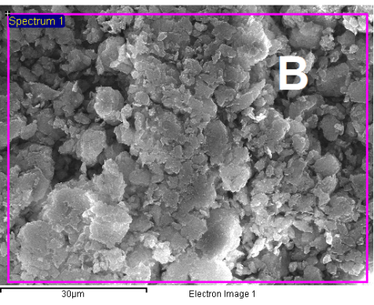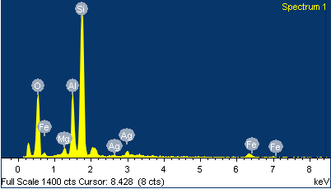

**Fig. S3.** EDS elemental composition of samples MMT-Ag and MH0.5-Ag.

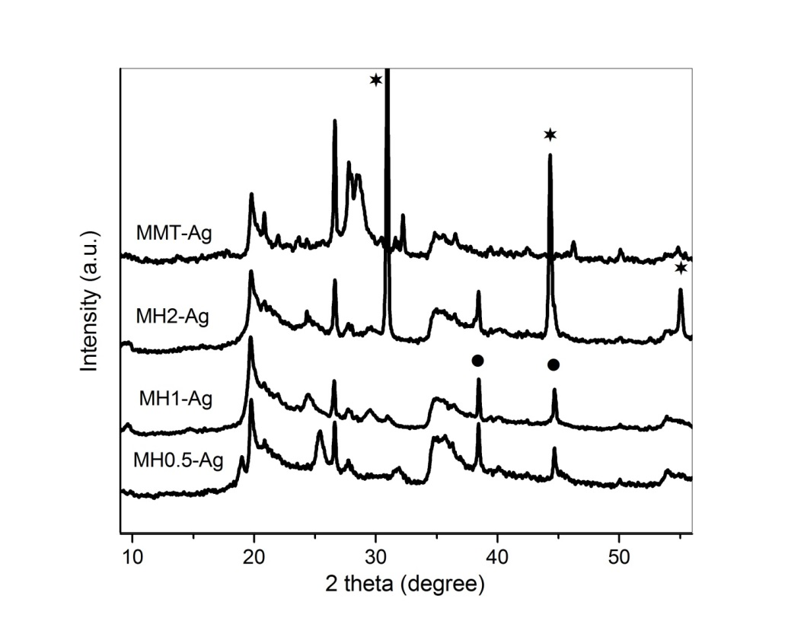

**Figure S4**. XRD patterns of indicated samples. Symbols indicated: (●) Ag0 and (*) AgBr.

**Table S1.** Dapp difference between the indicated samples

|  |  |  |
| --- | --- | --- |
| **Involved Samples** | **△Dapp without Ag**  **(nm)** | **△Dapp with Ag**  **(nm)** |
| **MMT- MH0.5** | 539±61 | 428±29 |
| **MH0.5- MH1** | 846±386 | 91±47 |
| **MH1- MH2** | 789±471 | 1619±230 |