Supporting Information
Ultra-quick synthesis of efficient hydrotalcite-like compound catalysts for VOCs oxidation
Synthèse ultra-rapide des matériaux dérivés des composés de type hydrotalcite comme catalyseurs efficaces pour l'oxydation des COVs

Cynthia Abou Serhal^{a,b}, Isabelle Mallardª, Christophe Poupinª,
Madona Labaki^{b}, Stéphane Siffert^{a*}, Renaud Cousin^{a*}

a Université du Littoral Côte d'Opale (ULCO), Unité de Chimie Environnementale et Interactions sur le Vivant (UCEIV, E.A. 4492), MREI, F-59140 Dunkerque, France
b Lebanese University, Laboratory of Physical Chemistry of Materials (LCPM)/PR2N, Faculty of Sciences, Fanar, P.O. Box 90656, Jdeidet El Metn, Lebanon
* Corresponding authors. E-mail addresses: renaud.cousin@univ-littoral.fr; stéphane.siffert@univ-littoral.fr; Tel.: +33-03-2865-8276; +33-03-2865-8256.

1. Adsorption/desorption N₂ isotherms
In order to obtain textural characteristics, nitrogen adsorption/desorption isotherms are carried out on all catalysts and are shown in Fig. S1.
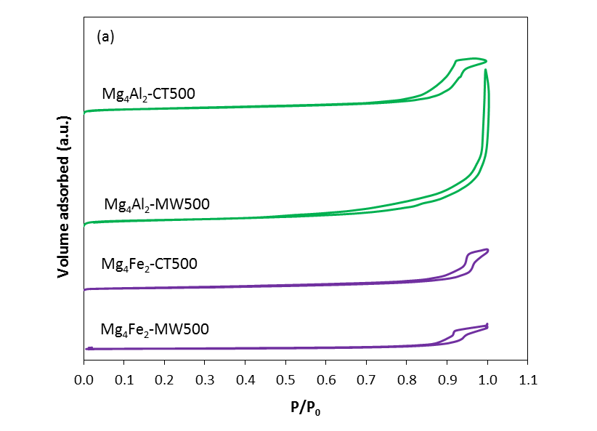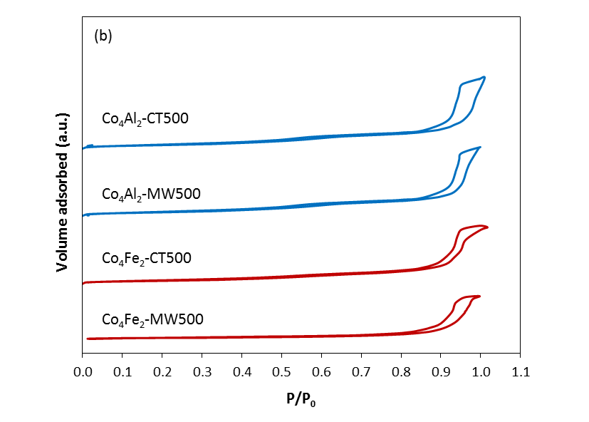
Fig. S1. Adsorption/desorption N₂ isotherms. (a) Mg₄Al₂ and Mg₄Fe₂ samples; (b) Co₄Al₂ and Co₄Fe₂ samples.

