**Supplementary information**

**Synthesis, crystal structure and DFT study of a zinc(II) complex containing terpyridine (Ter) and pyridine-2,6-dicarboxylic acid (Pydc) ligand: Analysis of interactions with amoxicillin**

*Adedibu C. Tellaa*, Joshua A. Obaleyea, Margaret D. Olawalea, Jean Marie Vianney Ngororabangab, Adeniyi S. Ogunlajab* and Susan A. Bournec*

## 

## Fig. S1: Colorless crystals of [Zn(II)(Ter)(Pydc)∙4H2O].



Fig. S2 TGA plot of 2,2′:6′,2′′-terpyridine



Fig. S3 TGA plot of pyridine-2,6-dicarboxylic acid

Fig. S4 Calibration Curve obtained from the absorption spectrum (256 nm) in the ultraviolent-visible spectral region for amoxicillin solution.

**Table S1.** Summary of various contacts and their contributions to the Hirshfeld Surface in [Zn(II)(Ter)(Pydc)∙4H2O]

|  |  |
| --- | --- |
| Types of contacts | Contributions in% |
| C···O | 6.8 |
| O···O | 6.0 |
| N···H | 2.9 |
| C···C | 7.6 |
| H···H | 17.9 |
| C···H | 12.1 |
| O···H | 46.0 |



Spectrum C extends to the near IR region. However, maximum absorbance was recorded at 551 nm.

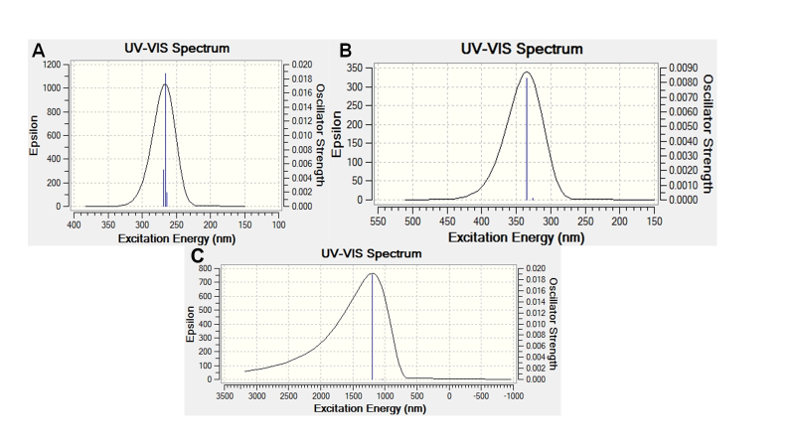

**Fig. S5**. The electronic spectrum of (A) [Zn(II)(Tpy)(Pydc)∙4H2O], (B) amoxicillin and (C) [Zn(II)(Tpy)(Pydc)∙4H2O]-amoxicillin.